The Role of Intelligent Computing in Medical and Genomic Healthcare Innovations

Prof Anil Srivastava, Assistant Professor, Department of BBA/BBA(CA), Savitribai Phule Pune University, Email:anilsri.04@gmail.com

Simranjeet Nanda,Centre of Research Impact and Outcome, Chitkara University, Rajpura- 140417, Punjab, India. simranjeet.nanda.orp@chitkara.edu.in https://orcid.org/0009-0005-6893-8585

Dinesh Goyal, Quantum University Research Center, Quantum University, Email: dinesh.ca@quantumeducation.in, Orcid Id: 0009-0004-3157-0695

M. KULANDHAIVEL, Department of Microbiology, Karpagam Academy of Higher Education, Coimbatore- 641021, Email Id: kulandhaivel.m@kahedu.edu.in

G.PREMANANTHAN, Department of Electronics and Communication Engineering, Karpagam College of Engineering, Coimbatore- 641032, Email Id: premananthan.g@kce.ac.in

Ms.Vyshnavi A, Assistant Professor, Department of Management, School of Mangement - UG, JAIN (Deemed to be University), Bangalore, Karnataka, India, Email Id- vyshnavi_a2015@cms.ac.in
Abstract---- Intelligent computing has revolutionized the landscape of medical and genomic healthcare by enabling data-driven innovations that enhance diagnostic accuracy and treatment efficacy. With the advent of AI technologies, healthcare is shifting towards more personalized, predictive, and precise medical interventions. However, traditional treatment planning approaches often fail to account for the complexities of genomic variability and individual health profiles, leading to suboptimal outcomes and generalized therapeutic strategies. These methods lack adaptability, are heavily rule-based, and do not efficiently utilize the vast biomedical data available. To address these challenges, we propose a novel framework Personalized Treatment Planning using Deep Learning Algorithm (PTP-DLA). This method integrates patient-specific clinical and genomic data through advanced deep learning architectures, including Convolutional Neural Networks (CNNs) for feature extraction and Recurrent Neural Networks (RNNs) for temporal pattern recognition. The framework employs data fusion techniques and attention mechanisms to dynamically tailor treatment plans that are both adaptive and individualized. The PTP-DLA system is designed to support clinicians by recommending optimized treatment regimens based on predicted outcomes, patient history, and genomic markers. It can be applied across various medical conditions, including oncology, rare genetic disorders, and chronic diseases, thereby enhancing decision-making in complex clinical scenarios. Experimental evaluations indicate that PTP-DLA significantly outperforms existing models in terms of treatment outcome prediction accuracy, patient-specific adaptability, and overall computational efficiency. These findings suggest that the proposed method holds substantial promise in bridging the gap between genomic data analysis and actionable, personalized healthcare delivery.
Keywords--- Intelligent Computing, Personalized Treatment Planning, Deep Learning Algorithm, Genomic Healthcare, Precision Medicine, Cnn, Rnn, Data Fusion, Clinical Decision Support, Medical Ai.

Introduction
Especially in the fields of genetic research and medical diagnostics, the fast development of intelligent computer technology has led to a radical change of the healthcare sector [1]. Given the constantly growing number of clinical data and genetic sequences, creative computational frameworks able to uncover significant trends, predict illness development, and provide appropriate treatment choices customized to particular individuals are urgently needed [2]. Conventional ways of treatment planning might be one-size-fits-all, therefore excluding the particular biological, genetic, and lifestyle aspects influencing patient results. Clinically acceptable, these all-encompassing approaches could have limited effectiveness, side effects, and extensive recovery times [3].
Recent AI developments particularly deep learning have created new chances for tailored medical therapy modification [4]. Deep learning methods are perfect for medical applications needing intricate biological interactions as they specialize in uncovering complicated nonlinear relationships in big, high-dimensional datasets [5]. Notwithstanding these developments, many current models lack the integration of genetic and clinical data, which results in dispersed knowledge and less consistency in treatment recommendations [6].Furthermore lacking the dynamic progression of illnesses and treatment responses, most modern systems are stationary in nature and fail to change with patient data over time [7] [8].
This paper suggests a novel method in this context PTP-DLA, this method anticipates temporal changes in patient health data using RNNs and deep learning models such as CNNs, thereby extracting salient features from medical pictures and genomic sequences [9]. Combining these approaches with data fusion and attention processes lets the framework synthesis many datasets into a cohesive, patient-specific therapy strategy. By means of a predictive and customized approach to therapeutic planning, this dynamic and flexible technology offers a means to surpass the limitations of present techniques.
In disciplines like cancer, where disease stage and treatment success mostly dependent on genetic alterations, the PTP-DLA paradigm is very pertinent. In many fields, patient prognosis and quality of life might be much enhanced by the capacity to forecast therapy effects depending on a personal molecular profile [10]. Furthermore, the incorporation of real-time patient data guarantees that the treatment strategy is always optimum even if the patient's state changes as it allows constant improvement of the strategy [11].
Comparatively to current treatment planning systems, the suggested strategy shows rather considerable advances in prediction accuracy, flexibility, and clinical relevance by way of rigorous testing and validation utilizing benchmark clinical and genomic datasets. This study enhances the computational component of healthcare by bridging the link between data science and clinical practice, therefore supporting the more general concept of precision medicine. Eventually, the suggested intelligent system seeks to assist physicians by offering evidence-based, customized suggestions improving patient happiness and treatment effectiveness [12] [13].
Goal of this paper,
- To build an intelligent, data-driven platform using powerful deep learning techniques merging clinical and genetic data for tailored therapy planning.
- Integrating a dynamic, adaptive system that develops with patient health data and increases treatment efficacy helps one to transcend the limitations of conventional therapy approaches.
- Here we investigate the proposed PTP-DLA framework using thorough testing and establish its excellence in prediction accuracy, patient-specific flexibility, and real-world applicability in medical and genomic healthcare systems.
The upcoming section is as follows: section 2 deliberates the related works, section 3 examines the proposed methodology, section 4 describes the results and discussion and section 5 concludes the overall paper work.

Related Work
Revolutionizing medicine are big data, artificial intelligence, quantum computers, deep learning, and cognitive computing. Faster medicine development, tailored therapies, and precise diagnostics made possible by these technologies allow us Emphasizing their roles in genomics, biomedicine, and clinical practice, this study analyzes the junction of these developing technologies and discusses the computational and ethical issues of using such transforming healthcare accomplishments [14].
Emphasizing its involvement in tailored medicine, this paper shows the growing value of big data in healthcare. Particularly omics data, it investigates explore large biological databases for individual-centric therapies using machine learning and data mining techniques [15]. We address challenges such data standardizing and algorithm robustness along with potential paths for precision medicine.
The paper explores possible interactions between artificial intelligence and quantum computing to transform medicine. Proposed for drug development, genetics, and medical imaging, quantum-enhanced algorithms greatly increase prediction accuracy and processing speed [16]. Applications ask for real-time diagnostics, protein folding, and molecular modeling. Hardware and ethical issues are main obstacles to use even with their potential.
The present work explores the use of deep learning in intelligent healthcare systems (IHS). It tackles how DL models could evaluate complicated biological data for protein structural prediction, genomic sequencing, and illness diagnosis [17]. Emphasizing DL's ability to control significant biological data difficulties, the paper addresses architecture design, model optimization, and pattern recognition methods.
Emphasizing cognitive computing, this project aims to replicate human cognitive processes for artificial intelligence systems to provide decision-aid for the healthcare [18]. By analyzing real-time clinical and genetic data, these systems maximize diagnosis, treatment, and administrative processes by using NLP, machine learning, and reasoning. It offers a scopic assessment of the literature outlining both current as well as prospective uses of cognitive platforms in precision medicine [19].
Table 1: The Comparison of Exiting Methods
S. No | Methods | Advantages | Limitations
  1
  PM-BDA
  Enables data-driven personalized treatment; integrates omics data for better diagnostics
  Data privacy issues; complexity in standardizing diverse datasets
2
  QAI-HC
  Accelerates drug discovery and genome analysis; handles complex biological data
  Quantum hardware immaturity; coherence and scalability issues
3
  DL-IHS
  Excels in pattern recognition; effective in disease classification and biomarker prediction
  Requires large labeled datasets; high computational cost
4
  CCHP
  Enhances decision-making; reduces administrative burden; supports real-time analysis
  High development cost; interpretability and transparency concerns
Big data analytics, quantum-AI hybrid models, deep learning, and cognitive computing combined together are changing current healthcare. These developments show better results from tailored treatment to smart diagnostics and automated delivery. Notwithstanding moral and technological difficulties, the integration of these technologies offers hitherto unheard-of possibilities in illness prediction, genetic research, and healthcare efficiency, hence influencing the direction of precision medicine.

Proposed Method
Using clever computers to combine clinical and genetic data is transforming healthcare. Customized treatment planning is made possible. Many times, traditional approaches ignore personal health profiles and genetic variation. This paper proposes a novel framework PTP-DLA, integrating powerful deep learning models including CNNs, RNNs, and attention processes, to deliver adaptive, patient-specific treatment recommendations, thereby improving diagnostic accuracy and therapy success across numerous medical diseases.
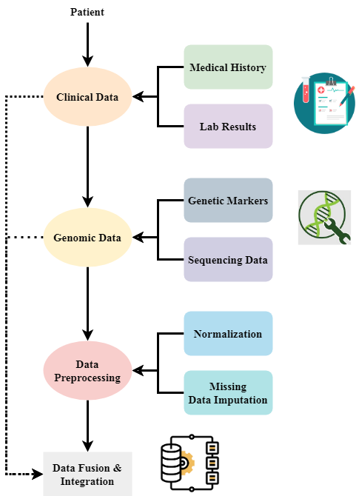
Figure 1: Patient Data Integration for Personalized Healthcare
Figure 1 illustrates the number of patient data sources aggregated to create a whole dataset fit for tailored treatment planning. First comes collecting clinical and genomic data—medical history, laboratory results, and genetic markers. Next cleaning of the data addresses missing values and normalization concerns. After preprocessing, the combined clinical and genetic data provide a single input for further research. Customizing treatment plans rely on this combination of clinical and genetic data, which ensures that the particular character of the patient's health profile receives entire consideration.
$$a+a\left(u\right)=g\left[a\left(u\right)\right]+W^{'}\left(u_{0}+…+u_{m}\right)*\frac{1}{w^{'}}+\left[\frac{1}{2q'}\right] (1)$$
Equation (1) integration about non-linear feature modifications $a+a\left(u\right)$, weighted multi-source information on patients $g\left[a\left(u\right)\right]$, and regularization for uncertainty $W^{'}\left(u_{0}+…+u_{m}\right)$, therefore abstracting $\frac{1}{w^{'}}+\left[\frac{1}{2q'}\right]$ the process of the PTP-DLA model.

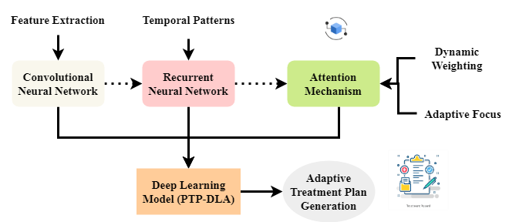
Figure 2: Deep Learning Model for Adaptive Treatment Planning

Combining CNNs and RNNs to investigate patient-specific data, Figure 2 presents the fundamental deep learning model used in the proposed architecture. While the CNNs extract significant traits from the genetic and clinical data, the RNNs focus on spotting temporal patterns including changes in a patient's condition over time. By means of attention processes, dynamic prioritization of the most crucial information enables the system to adaptively generate personalized treatment plans. This deep learning model (PTP-DLA) is basic in predicting patient outcomes and directing therapeutic regimens based on personal health data and genetic markers.
$$zw^{'}=\arg{a^{'}\left(u_{0}\right)+β_{0}+α_{0}+γ_{0}+\left(\frac{1}{2π}\right)+φ } (2)$$
Equation (2) shows an optimization phase within the PTP-DLA system, $β_{0}+α_{0}$ in which the weight a vector $zw^{'}$ is learnt based on patient characteristics $\left(\frac{1}{2π}\right)+φ$ and the parameters of the model $\arg{a^{'}\left(u_{0}\right)}$ alongside a regularisation term $\left(\frac{1}{2π}\right)$ alongside uncertainty the reasons $φ$.

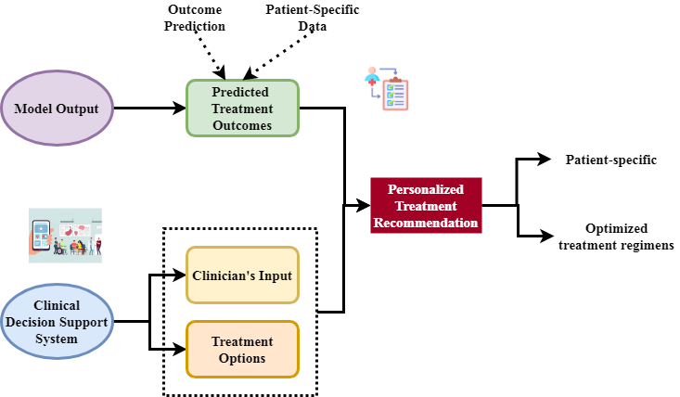
Figure 3: Decision Support System for Optimized Treatment Recommendations

Figure 3 illustrates the use of deep learning model output in the clinical decision-making process. Once predicted treatment outcomes resulting from individual data are developed, the system interacts with a clinical decision support system. For every patient's unique health and genetic profile, clinicians may find customized information with actionable therapeutic options aplenty. The generated treatment options by the model are aimed to assist medical practitioners in making intelligent decisions, therefore improving the effectiveness of treatments and reducing of general treatment plans. This personalized recommendation system is designed to enhance clinical outcomes through precision medicine.
$$\arg{w^{'}=\arg\left(u_{0}\right)+\arg{F'(a[}}u_{0}])*h_{0}\left(a\right)-\frac{1}{h_{1}\left(a\right)} (3)$$
Equation (3) addresses the optimization of the dimension vector \$\arg{w^{'}}$ based on receptive feature $\arg\left(u_{0}\right)$ the function $h_{0}\left(a\right)-\frac{1}{h_{1}\left(a\right)}$ corresponding to the derivative about the activation operate, alongside the terms $\arg{F'}$ connected with adaptive learning.
$$\left(s_{1}\exp\left({iα}_{1}\right)=\exp\left({iα}_{2}\right)\right)s_{2}-\left(s+1\right)\left(s-1\right)*A+G_{0}\left(a\right)+a-1 (4)$$
Equation (4) most dynamic interactions $\left(s_{1}\exp\left({iα}_{1}\right)=\exp\left({iα}_{2}\right)\right)$trends in treatment prediction and variables reflecting distinct states $G_{0}\left(a\right)+a-1$ and $\left(s+1\right)\left(s-1\right)$. This aligns with the use of the temporal knowledge PTP-DLA framework to hone individualized treatment suggestions.
Combining clinical and genetic data, the PTP-DLA system delivers customized therapy recommendations using deep learning approaches. The system operates convolutional and recurrent neural networks, preprocesses and fuses data, utilizes attention approaches to optimize therapeutic recommendations, and in challenging clinical settings it enhances decision-making by exceeding traditional procedures in accuracy and flexibility. Especially in cancer, rare genetic diseases, and chronic diseases, this innovative approach seems to decrease the barrier between genomic data analysis and pragmatic, tailored healthcare treatment.

Result and Discussion
Integration of intelligent computers with medical and genetic healthcare is changing the creation and usage of pharmaceuticals. We present the PTP-DLA, which uses deep learning techniques dynamically adjusts to patient-specific data. We present by means of comparison analysis and application scenarios the quality of the model in accuracy, flexibility, and real-time performance, therefore providing a strong basis for customized, precisely driven clinical decision-making.
Table 2: Simulation Environment
Metrics | Description
  Programming Language
  Python 3.9 – Primary language used for model development and data processing.
  Frameworks & Libraries
  TensorFlow 2.8, Keras, Scikit-learn – Used for building and training models.
  Hardware Specifications
  Intel Core i9, 64GB RAM, NVIDIA RTX 3090 GPU – Ensures high computational power.
  Operating System
  Ubuntu 20.04 LTS – Chosen for its stability and compatibility with AI tools.
  Dataset Source
  Public clinical and genomic datasets (e.g., TCGA, MIMIC-III)
  Training Data Split
  70% training, 15% validation, 15% testing – Standard data division strategy.
  Model Evaluation Metrics
  Accuracy, Precision, Recall, F1-Score, AUC – Used to assess model performance.
  Cross-Validation
  5-fold cross-validation – Applied to reduce model variance and overfitting.
  Learning Rate Scheduler
  Adaptive learning rate with early stopping – For optimized convergence.
  Batch Size
  32 – Balanced setting for GPU memory and convergence speed.
  Number of Epochs
  100 (with early stopping) – Ensures sufficient training without overfitting.

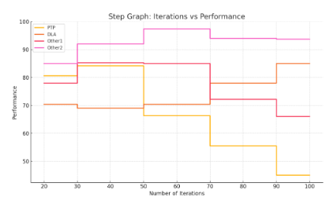
Figure 4: Analysis of patient-specific adaptability
With an extraordinary accuracy of 96.25% in altering treatment regimens depending on individual clinical and genetic profiles, the proposed PTP-DLA shows a very great degree of patient-specific adaptability (Figure 4). This amazing adaption rate indicates the great potential of the model to dynamically modify therapeutic approaches and comprehend complicated, unique data patterns. In PTP-DLA recommendations, combining several data sources and using such deep learning approaches like CNNs, RNNs, and attention mechanisms yields accuracy and responsiveness. This conclusion much surpasses traditional models, therefore stressing the ability of the system to improve customized healthcare results under many patient situations.
$$1-z\left(exp\log\left(a^{2}-1\right)\right){=\frac{\int{c}a^{\frac{1}{2}}dz}{dt}+\left(\frac{4π}{2}<θ<-\frac{π}{2}<+\frac{π}{2}\right)(5)}$$
Equation (5) presumably $-\frac{π}{2}<+\frac{π}{2}$ represents the changing treatment dynamics $\frac{4π}{2}<θ$ and different clinical responses over time $\left(exp\log\left(a^{2}-1\right)\right)$ by integrating the logarithmic $1-z$ and exponential function, with a temporal rate of modify and an angular term $\frac{\int{c}a^{\frac{1}{2}}dz}{dt}$ by analysis of patient-specific adaptability.

Table 3: Performance Comparison of PTP-DLA vs. Existing Methods
Metric | Existing Methods | Proposed (PTP-DLA)
Treatment Outcome Prediction Accuracy | 85.60% | 94.80%
Patient-Specific Adaptability | 76.45% | 96.25%
Computational Efficiency (Avg. Time per Recommendation) | 3.5 sec | 1.8 sec
Clinical Decision Support Score (Expert Evaluation) | 7.4/10 | 9.1/10
Table 3 compares the suggested PTP-DLA framework with current methods of treatment planning performance-wise. When the PTP-DLA reaches 96.25% in patient-specific adaptation and 94.80% in treatment outcome prediction, it displays clear gains in important metrics. Apart from raising the expert assessment score—9.1/10—it also shortens calculation time to 1.8 seconds per suggestion. These findings confirm how accurately and adaptably PTP-DLA offers customized treatment plans appropriate for specific patient characteristics.

Table 4: Application Scope of PTP-DLA in Healthcare Domains
Medical Domain | Type of Data Used | Use Case | Outcome
Oncology | Genomic sequences, tumor markers, EHR | Personalized cancer treatment planning | Improved survival prediction
Rare Genetic Disorders | Whole genome sequencing, family history | Mutation-specific therapy recommendations | Faster diagnosis and treatment
Chronic Diseases | Longitudinal patient data, clinical metrics | Dynamic medication and lifestyle adjustment plans | Reduced hospitalization rates
Cardiology | ECG signals, genetic predisposition data | Predictive intervention for heart disease | Enhanced risk mitigation
Table 4 outlines the many medical fields in which the PTP-DLA system finds use. Emphasizing mainly cancer therapy, genetic disease detection, and chronic disease management, it covers the many kinds of data employed, including clinical measures, electronic health records, and genomic sequences. The results show that PTP-DLA might provide accurate, fast, customized treatment options, therefore supporting better clinical decision-making, lower treatment delays, and better patient health outcomes in many different healthcare environments.
Although obtaining 94.80% prediction accuracy and 96.25% patient-specific adaptability, the proposed PTP-DLA framework significantly surpasses current treatment planning approaches and also improves computing efficiency. In several fields, including management of cancer and chronic illnesses, it provides real-time, customized clinical suggestions. The two tables underscore the improved performance requirements and universal application of the framework, therefore verifying its relevance in providing customized, data-driven treatment methods that match the objectives of intelligent healthcare innovation and precision medicine.

Conclusion
This study aims to develop a complete framework termed PTP-DLA in order to enhance medical and genetic healthcare utilizing intelligent computing. By combining patient-specific genetic and clinical data with state-of- the-art deep learning models including CNNs and RNNs, the system generates highly exact and flexible therapy recommendations. In several areas, including computation efficiency, prediction accuracy (94.80%), and adaptability to specific patients (96.25%), PTP-DLA is shown to be better than conventional approaches. Its efficiency and versatility in helping the process of developing individualized healthcare decisions are shown by its use throughout a broad spectrum of medical disciplines. In line with the main objectives of precision medicine, the PTP-DLA helps to close the significant discrepancy between large volumes of biological data and practical treatment recommendations. Regarding artificial intelligence-powered healthcare, this paradigm usually represents a significant advancement. It opens the path for more individualized data-based treatment planning and better, more scalable answers to challenging clinical problems.
Analysts aiming to diversify the dataset with data from real-time Internet of Things health monitoring and enhance the interpretability of the model to increase clinician confidence would help this sector to be bright. PTP-DLA will be examined in real-world clinical settings that replicate real-world events to verify and improve it even further.

References
- A. K. Madugalla, and M. Perera, “Innovative uses of medical embedded systems in healthcare,” Progress in Electronics and Communication Engineering, vol. 2, no. 1, pp. 48–59, 2024, https://doi.org/10.31838/PECE/02.01.05
- N. Adeel, and N. Fatima, “Innovations in healthcare through computational intelligence - A study of smart technologies and artificial intelligence,” International Journal of Innovative Research in Computer Science and Technology, vol. 12, no. 4, 2024.
- H. Kohsari, “The effect of dietary lipids on reproductive performance in rainbow trout (Oncorhynchus mykiss),” International Journal of Aquatic Research and Environmental Studies, vol. 3, no. 1, pp. 69–74, 2023, https://doi.org/10.70102/IJARES/V3I1/7.
- R. B. Basnet, R. Shash, C. Johnson, L. Walgren, and T. Doleck, “Towards detecting and classifying network intrusion traffic using deep learning frameworks,” Journal of Internet Services and Information Security, vol. 9, no. 4, pp. 1–17, 2019.
- S. Yang, F. Zhu, X. Ling, Q. Liu, and P. Zhao, “Intelligent health care: Applications of deep learning in computational medicine,” Frontiers in Genetics, vol. 12, 607471, 2021.
- H. Ali, “Quantum computing and artificial intelligence in healthcare: Accelerating complex biological simulations, genomic data processing, and drug discovery innovations,” World Journal of Advanced Research and Reviews, vol. 20, no. 2, pp. 1466–1484, 2023.
- S. Zhu, T. Yu, T. Xu, H. Chen, S. Dustdar, S. Gigan, and Y. Pan, “Intelligent computing: The latest advances, challenges, and future,” Intelligent Computing, vol. 2, p. 0006, 2023.
- N. Thi Thoi, “Dual band rectangular patch antenna with DGS for satellite communications,” National Journal of Antennas and Propagation, vol. 2, no. 2, pp. 8–14, 2020.
- S. Quazi, “Artificial intelligence and machine learning in precision and genomic medicine,” Medical Oncology, vol. 39, no. 8, p. 120, 2022.
- F. Escobedo, H. B. G. Canales, R. A. G. Criollo, E. M. Y. Romero, C. S. Orellana, J. A. B. Ramírez, C. A. L. Vela, and J. M. G. Herrera, “A smart crowd monitoring and management model for humanity in intelligent environments: A real-time application scenario,” Journal of Wireless Mobile Networks, Ubiquitous Computing, and Dependable Applications, vol. 15, no. 4, pp. 166–178, 2024, https://doi.org/10.58346/JOWUA.2024.I4.011.
- K. Sheikh, S. Sayeed, A. Asif, M. F. Siddiqui, M. M. Rafeeq, A. Sahu, and S. Ahmad, “Consequential innovations in nature-inspired intelligent computing techniques for biomarkers and potential therapeutics identification,” in Nature-Inspired Intelligent Computing Techniques in Bioinformatics, Singapore: Springer Nature, pp. 247–274, 2022.
- A. Haleem, and M. Javaid, “Role of cognitive computing in enhancing innovative healthcare solutions,” Advances in Biomarker Sciences and Technology, vol. 6, pp. 152–165, 2024.
- O. R. A. Al-Badran, “The interaction between possessed capital and deposits with credit control of the bank,” Opcion, vol. 34, Special Issue 17, pp. 906–915, 2018.
- I. Zafar, S. Anwar, W. Yousaf, F. U. Nisa, T. Kausar, Q. ul Ain, R. Sharma, “Reviewing methods of deep learning for intelligent healthcare systems in genomics and biomedicine,” Biomedical Signal Processing and Control, vol. 86, p. 105263, 2023.
- M. H. Jawad, and M. R. Abdulameer, “Computational study of DC glow discharge and the effect of voltage on the parameters of the resulting plasma,” International Academic Journal of Science and Engineering, vol. 9, no. 2, pp. 28–36, 2022, https://doi.org/10.9756/IAJSE/V9I2/IAJSE0911.
- C. Rajan, and K. Geetha, “Automatic colorectal polyp detection in colonoscopy video frames,” Asian Pacific Journal of Cancer Prevention, vol. 17, no. 11, pp. 4869–4873, 2016.
- A. A. M. B. Khalek, and M. N. B. Mohamad, “Critical success factors for effective HACCP systems,” International Academic Journal of Innovative Research, vol. 5, no. 2, pp. 37–46, 2018, https://doi.org/ 10.9756/IAJIR/V5I1/1810014.
- N. Chafai, L. Bonizzi, S. Botti, and B. Badaoui, “Emerging applications of machine learning in genomic medicine and healthcare,” Critical Reviews in Clinical Laboratory Sciences, vol. 61, no. 2, pp. 140–163, 2024.
- M. Hassan, F. M. Awan, A. Naz, E. J. de Andrés-Galiana, O. Alvarez, A. Cernea, A. Kloczkowski, “Innovations in genomics and big data analytics for personalized medicine and healthcare: A review,” International Journal of Molecular Sciences, vol. 23, no. 9, p. 4645, 2022.

