Leveraging Gemini 1.5 Pro and Prompt Engineering for Robust Handwriting Interpretation

Gargy G, Department of Computer Science and Engineering, Noorul Islam Centre for Higher Education,
A. Shajin Nargunam, Director-Academics, Department of CSE, Noorul Islam Centre for Higher Education

Abstract— Malayalam handwritten script recognition is a challenging task due to the language's complex script and diverse writing styles. Recent advancements in deep learning and prompt engineering offer promising solutions to improve recognition accuracy. This study explores the application of prompt engineering techniques to enhance the performance of Malayalam handwritten script recognition models. By designing effective prompts, we aim to leverage the capabilities of pre-trained language models and improve their ability to recognize handwritten Malayalam text. Our approach involves crafting prompts that capture the nuances of the Malayalam script and utilizing them to fine-tune pre-trained models. We evaluate the performance of our approach on a dataset of Malayalam handwritten text and demonstrate significant improvements in recognition accuracy. Our findings highlight the potential of prompt engineering in improving the performance of handwritten script recognition models for languages like Malayalam.

Index Terms— Prompt Engineering, Malayalam Handwritten Script Recognition, Deep Learning, Pre-trained Language Models.

I. INTRODUCTION
H
andwritten Malayalam script is an especially demanding problem due to the script’s curved strokes, compound characters, ligatures, and wide stylistic variation in natural handwriting [1] . Traditional OCR systems struggle to adapt to these complexities, particularly when faced with noisy documents, inconsistent writing patterns, or limited annotated datasets. The emergence of prompt engineering within large multimodal models introduces an exciting new direction for HMSR research. Instead of relying solely on handcrafted features or deep CNN–RNN pipelines, prompt-driven models can be guided through natural-language instructions to classify characters, interpret stroke patterns, analyze spacing, and even understand document structure. Prompts allow researchers to incorporate domain knowledge—such as character families, stroke formations, or contextual rules—directly into the model’s reasoning process without extensive retraining [2]. By combining visual encoders with instruction-based reasoning, prompt engineering unlocks flexible and adaptive recognition capabilities. It enables zero-shot and few-shot generalization to unseen handwriting styles, supports multilingual extensions, and offers powerful tools for tasks like segmentation, error correction, script identification, and strikeout detection [5]. This integration positions prompt engineering as a transformative methodology for advancing handwritten Malayalam OCR toward greater accuracy, robustness, and real-world usability.
II. ADVANCED STRATEGIES IN PROMPT ENGINEERING
Prompt engineering refers to the systematic design of inputs (prompts) that guide Large Language Models (LLMs) and Vision-Language Models (VLMs) to perform specific tasks effectively. In the context of Malayalam Handwritten Script Recognition, prompt engineering plays a transformative role by enabling models like GPT-5 [3], Gemini, LLaMA-3, and multimodal Granite to understand complex, curved characters even when written with noise, distortion, and stylistic variations.

A. Zero-Shot Prompting
Zero-shot prompting refers to the inference setting where an LLM processes a task description with no demonstration instances, leveraging latent representations learned during large-scale training to generalize to unseen instructions[3].

B. One-Shot Prompting
One-shot prompting is an instruction method where a model receives a single demonstration example alongside the task description [3]. This lone example guides the model’s output structure, reasoning pattern, and formatting, enabling improved task alignment by leveraging minimal supervision while still relying primarily on pretrained representations for inference and generalization.

C. Few-Shot Prompting
Few-shot prompting is a guidance technique where a model receives multiple example demonstrations along with the task instruction. These curated samples shape the model’s reasoning path, output format, and decision boundaries [1] . By combining limited supervision with pretrained knowledge, the model achieves stronger generalization and more consistent task performance than zero-shot or one-shot methods.

D. Instruction-Based Prompting
Instruction-based prompting is a paradigm where the model’s behavior is directed purely through explicit natural-language instructions that specify the task, constraints, and expected output format. Instead of examples, the model relies on it’s pretrained semantic understanding to interpret the instruction and execute the task with coherent, context-aligned reasoning [4].

E. Chain-of-Thought (CoT) Prompting
Chain-of-thought prompting is a reasoning-oriented technique where models are encouraged to generate explicit intermediate steps before producing the final answer. By revealing the model’s latent reasoning process, CoT enhances interpretability, improves logical consistency, and significantly boosts performance on tasks requiring multi-step inference, arithmetic, and structured problem solving [5].

F. Retrieval-Augmented Prompting (RAG / RAP)
Retrieval-augmented prompting integrates external knowledge retrieval into the prompting process, allowing a model to access relevant documents or embeddings during inference. By combining retrieved evidence with generative reasoning, RAG improves factual accuracy, reduces hallucination, and enhances performance on tasks requiring domain-specific, up-to-date, or context-rich information [3].

G. Meta Prompting
Meta prompting is a higher order prompting strategy where the model is guided using instructions about how to generate, refine, or evaluate prompts themselves. By operating at the prompt-construction level, it enables adaptive reasoning, improved task alignment, and self-optimization of prompt structures, enhancing overall performance across diverse and complex problem settings [2].

H. Multimodal Prompting
Multimodal prompting is an inference strategy where models receive inputs across multiple modalities—such as text, images, audio, or structured data—to guide task execution. By jointly interpreting heterogeneous signals, the model achieves richer semantic grounding, enhanced reasoning, and improved performance on perception-language tasks like OCR, captioning, VQA, and document understanding [4].

III. PROCESSING PIPELINE FOR HANDWRITTEN MALAYALAM TEXT EXTRACTION USING PROMPT-ENGINEERED LLM INFERENCE
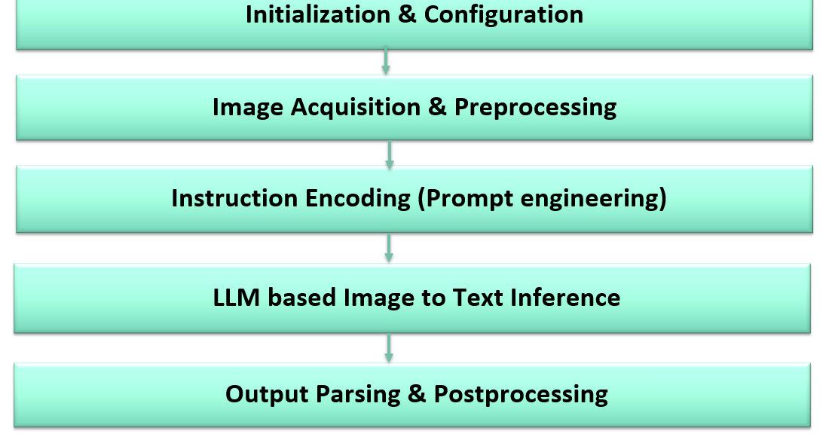
Fig.1 End-to-End Processing Pipeline for Handwritten Malayalam Text Extraction Using Prompt-Engineered LLM Inference

The proposed system operates through a structured five-phase workflow designed for high-fidelity handwritten Malayalam OCR using large language models. In Phase 1, the environment is initialized by importing essential modules such as google.generativeai and PIL, configuring the API key, and selecting an appropriate model like Gemini-1.5 Pro. Phase 2 focuses on image acquisition and preprocessing, where the handwritten document is loaded using PIL.Image.open() and optionally enhanced through denoising or contrast adjustments to ensure OCR-compatible resolution. Phase 3 encodes task-specific instructions through prompt engineering, combining a strict system prompt—defining Malayalam-only transcription rules, spacing preservation, and exclusion of crossed-out content—with a user prompt directing the model to extract only visible, uncrossed text. Phase 4 performs LLM-based image-to-text inference by initializing the model with system instructions and generating content using the prompt–image pair. Finally, Phase 5 handles output parsing and postprocessing, retrieving the generated transcription, optionally saving it to text formats, and performing further analysis such as tokenization or ground-truth comparison.

IV. PROPOSED FRAMEWORK FOR HANDWRITTEN MALAYALAM TEXT EXTRACTION USING GEMINI 1.5 PRO LLM

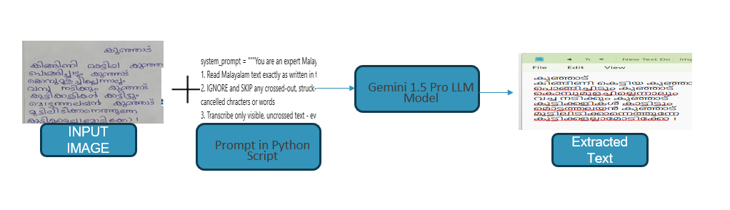
Fig. 2 Framework for Handwritten Malayalam Text Recognition Using Gemini 1.5 Pro LLM: Input image is processed through a Python-based prompt script that guides the model to transcribe only visible text, generating accurate extracted text as output.

The proposed system presents an intelligent framework for handwritten Malayalam text extraction using the Gemini 1.5 Pro Large Language Model (LLM), guided through a specialized prompt-engineering strategy. The pipeline begins with an input image containing handwritten Malayalam script, potentially including strikeouts, noise, or partial erasures. A Python-based prompting module formulates explicit task instructions for the LLM, directing it to accurately interpret visible characters. This prompt-driven control enables the model to function as a selective transcription agent rather than a generic OCR system [4]. The Gemini 1.5 Pro model processes both the visual content and the engineered prompt, producing context-aware and error-minimized textual output. The system effectively leverages multimodal reasoning, domain-specific constraints, and structured prompt rules to enhance transcription fidelity. Overall, the framework demonstrates a robust approach for improving handwritten Malayalam OCR performance using modern LLM-based prompt engineering methodologies. https://doi.org/10.24433/CO.8639475.v1
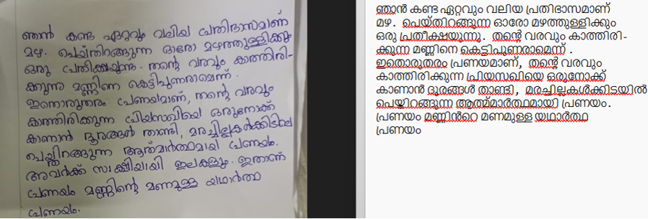

Fig. 3 Illustration of Input Handwritten Malayalam Text and Corresponding LLM-Generated Output After Applying the Proposed Prompt-Guided Extraction Framework

The illustrated example in Figure 3 demonstrates the practical application of the proposed Gemini 1.5 Pro–based handwritten Malayalam text extraction framework. The input image contains manually written Malayalam content, including natural handwriting variations and minor stylistic inconsistencies. The Python prompt explicitly instructs the LLM to read only visible text while maintaining fidelity to the original script. When processed through Gemini 1.5 Pro, the system generates a clean, machine-readable transcription of the handwritten content.
The output text closely aligns with the input image, reflecting the model’s ability to interpret character shapes, spacing, and word boundaries without being distracted by noise or irrelevant markings. This example validates the framework’s effectiveness in real-world handwritten document digitization scenarios, showcasing its potential for OCR enhancement, archival processing, and automated Malayalam text understanding.

Algorithm 1: A Generalized Template of Prompt Generation Framework for Categorized Data as mentioned in Figure: 3

- FUNCTION GeneratePrompts(n, categories, templates)
- FOR EACH category IN categories
- INITIALIZE prompts TO EMPTY LIST
- FOR i FROM 1 TO n
- SELECT RANDOM template FROM templates[category]
- GENERATEargsUSING GENERATESPECIFICS(template)
- CREATE prompt BY FORMATTING template WITH args
- APPEND prompt TO prompts
- END FOR
- PRINT "Category: category, Prompts: prompts"
- END FOR
END FUNCTION

Algorithm 2: A High-Level Algorithm for Generating Handwritten Tasks with Prompt Engineering

Input: Handwritten Images (e.g. Normal Handwritten Images.)
Output: Extracted text from the Image is stored as Text file
Algorithm:
- 1. Configure API: Set up the Google Generative AI API with a provided API key.
- 2. Define Prompts: Specify system and user prompts for the OCR task.
- 3. Initialize Model: Create a generative model instance with the specified model name and system instruction.
- 4. Get Image Files: Retrieve a list of image files from a specified directory, sorted in ascending order.
- 5. Process Images: For each image file:

- Open the image using PIL.
- Generate content using the model with the user prompt and image.
- Create a folder structure based on the image file path.
- Move the image file to the newly created folder.
- Write the generated text to a file in the same folder.
- Wait for 10 seconds before processing the next image.

Algorithm3: A High-Level Algorithmic Representation of Proposed Approach using gemini-1.5-pro
- Pseudocode : Configure API
- CONFIGURE_API(api_key)
- DEFINE_PROMPTS(system_prompt, user_prompt)
- INITIALIZE_MODEL(model_name,system_instruction)
- GET_IMAGE_FILES(directory)
- SORT_IMAGE_FILES()
- FOR EACH image_file IN image_files:
OPEN_IMAGE(image_file)
GENERATE_CONTENT(user_prompt, image)
CREATE_FOLDER_STRUCTURE(image_file)
MOVE_IMAGE_FILE(image_file, new_folder)
WRITE_GENERATED_TEXT(generated_text, new_folder)
WAIT(10 seconds)
- Detailed Pseudocode: Prompting
- FUNCTION ConfigureAPI(api_key):
- IMPORT google.generativeai AS
- genai genai.CONFIGURE(api_key=api_key)
- FUNCTION DefinePrompts(system_prompt, user_prompt):
- SYSTEM_PROMPT = system_prompt
- USER_PROMPT = user_prompt
- FUNCTION InitializeModel(model_name, system_instruction):
- MODEL = genai.GenerativeModel(model_name, system_instruction=system_instruction)
- Detailed Pseudocode: Output Generation
- FUNCTION GetImageFiles(directory):
- IMAGE_FILES = GLOB(directory + "/*.jpeg")
- SORT(IMAGE_FILES)
- FUNCTION ProcessImages(image_files):
- FOR EACH image_file IN image_files:
- IMG = PIL.Image.OPEN(image_file)
- RESPONSE= MODEL.GENERATE_CONTENT([USER_PROMPT,IMG])ROOT,EXTENSION= OS.PATH.SPLITEXT(image_file)
- FN = OS.PATH.BASENAME(image_file)
- FNWOE = OS.PATH.SPLITEXT(FN)[0]
- OS.MAKEDIRS(ROOT)
  - OS.RENAME(image_file, ROOT + "/" + FN)
- WITH OPEN(ROOT + "/" + FNWOE + ".txt", 'w') AS OUTPUT:
OUTPUT.WRITE(RESPONSE.TEXT)
- TIME.SLEEP(10 seconds)

V. DATA COLLECTION

A. GARGYG13
Due to the limited availability of Malayalam Handwritten datasets, we introduced a fresh dataset named GARGYG13 in 2023. Figure 5 shows a sample image from GARGYG13 dataset. It is created by scholars at Noorul Islam Study Centre for Higher Education India, it consists of 131 images from 100 writers, enhancing research in Malayalam handwriting script recognition. https://doi.org/10.5255/ukda-sn-857993 .
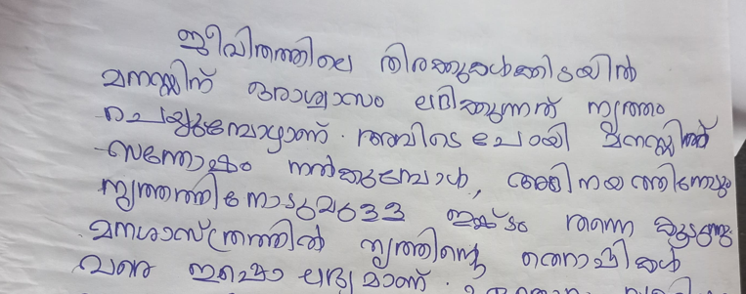
Fig. 5. Sample image from GARGY13 dataset

VI. OVERVIEW OF LINGUISTIC CHARACTERISTICS AND STRUCTURAL FEATURES OF THE MALAYALAM LANGUAGE FOR OCR RESEARCH
Malayalam, primarily spoken in the Indian state of Kerala, is a Dravidian language known for its unique linguistic features and rich literary tradition. It has its own script, derived from ancient Brahmi, which is cursive and visually distinctive. It consists of characters representing syllables. It has a complex grammar system with extensive verb conjugation, noun declension, and a variety of prefixes and suffixes. This complexity allows for nuances in meaning and expression. The Malayalam vocabulary is enriched by influences from Sanskrit, Tamil, and other languages. This contributes to a wide range of words and expressions.
It has a long and rich literary tradition that includes poetry, prose, and dramatic works. It is basically known for its classical and folk traditions. It exhibits diglossia, with variations between the spoken and literary forms. The spoken form is more colloquial, while the literary form adheres to classical norms. It is characterized by its extensive use of compound words, which are created by combining smaller words to form longer, descriptive terms. The language has preserved various historical script forms, including Vattezhuthu, Kolezhuthu, and Malayanma, which have been used at different periods in history.
Due to Kerala's historical trade and cultural interactions, Malayalam has absorbed vocabulary and linguistic influences from languages like Arabic, Portuguese, and English. It is integral to the culture and identity of Kerala, and it plays a crucial role in traditional art forms like Kathakali and Mohiniyattam. It exhibits regional dialects and variations, adding further richness to the language's linguistic diversity. Overall, Malayalam stands as a testament to the linguistic and cultural diversity found in Kerala, and it continues to evolve while preserving its deep-rooted traditions.
In Feature-Based Recognition, Histogram of Oriented Gradients (HOG) Extracts information from local gradients of the handwritten characters. Local Binary Patterns (LBP) captures local texture patterns within the characters. In Neural Networks, Convolutional Neural Networks (CNNs) [3] a deep learning approach that has been successful in recognizing handwritten characters. While in Recurrent Neural Networks (RNNs) is useful for recognizing sequential data, such as handwritten text. Hidden Markov Models (HMMs) are employed to capture the temporal dependencies in handwritten characters and their transitions. Support Vector Machines can be used for classification tasks, making them suitable for handwritten script recognition.
Dynamic Time Warping (DTW) technique is used to find the similarity between two sequences and is applicable to the handwritten text recognition. In Statistical Language Models, incorporating language models specific to Malayalam can improve recognition accuracy. Dictionary-Based Approaches, by comparing recognized text with a Malayalam dictionary, the system can refine and verify the output. While in Pre-processing Techniques, we use Binarization which converts the input image into binary form to enhance character recognition. Noise Reduction removes artifacts and noise from the image. In Deep Learning Architectures [5], Long Short-Term Memory (LSTM) Networks, effective for sequential data, they can be used in handwritten text recognition systems.
Transformer Models, these models have shown success in various natural language processing tasks and can be adapted for handwritten text recognition. Ensemble Methods, combining multiple recognition techniques can improve overall accuracy and robustness. Pattern Recognition Techniques and Clustering are used to group similar characters and recognize patterns within the text. Lexicon and Language Models incorporate dictionaries and language models specific to the Malayalam language can assist in context-based recognition. Character Segmentation separates individual characters or words within the text.
For segmentation Connected Component Analysis divides the handwritten text into individual characters by identifying connected components or groups of pixels. Separation can be based on gaps and spatial arrangement. Horizontal Projection Profile calculates the horizontal projection profile of the handwritten text. The peaks and valleys in this profile can indicate character boundaries. Vertical Projection Profile similar to the horizontal projection calculates the vertical projection profile to locate character boundaries. Run-Length Smoothing is used to identify clusters of consecutive similar elements in the text, such as strokes or curves, to detect character boundaries. Distance Transform uses distance transform algorithms to transform the text image into a distance map, where character boundaries correspond to local maxima in this map. Contour Detection employs contour detection techniques to identify the outlines of characters, allowing for their extraction from the background. Bounding Boxes draw bounding boxes around each character, which is particularly effective when characters are well-separated. Stroke Width Transform (SWT) algorithm to locate characters by identifying regions with consistent stroke widths. Machine Learning-Based Approaches use machine learning models, such as convolutional neural networks (CNNs), to classify and separate characters within the text. Template Matching creates templates for each character and uses template matching techniques to match and segment characters in the text. Hybrid Techniques combine multiple segmentation techniques for improved accuracy, such as using connected components along with contour detection or template matching.

VII. AN OVERVIEW OF MALYALAM ALPHABETS
Malayalam has 52 letters, including 15 vowels and 36 consonants.
- Vowels (Swaraksharam):
The basic units of sound in a word. Malayalam has 15 vowels. Examples: a, aa, i, ii, u, uu, ṛ, ṝ, e, ē, ai, o, ō, au. Vowels combine with consonants to form words.
- Consonants (Vyanjanaksharam):
The sounds that give meaning to words when combined with vowels. Malayalam has 36 consonants. Examples: ka, kha, ga, gha, ṅa, ca, cha, ja, jha, ña, ṭa, ṭha, ḍa, ḍha, ṇa, ta, tha, da, dha, na, pa, pha, ba, bha, ma, ya, ra, la, va, śa, ṣa, sa, ha, ḷa.
- Chillu:
Small marks added to the end of consonants. They change the pronunciation without affecting the word's meaning.
- Conjuncts (Kootuaksharangal):
A combination of two or more consonants. Examples: tra, dva, śra.
- Diacritics (Chinnagala):
Small marks that modify the pronunciation of consonants. Examples: Chandrakkal (Chandrabindu).

Example:
The word "Malayalam" can be broken down as follows:
ma - consonant
a - vowel
la - consonant
aa - vowel
ya - consonant
a - vowel
la - consonant
a – vowel
m- consonant

is renowned for complex conjunct characters and non-linear writing. Ligatures present challenges, with character forms varying by position and diacritic marks for vowels complicating recognition. Some characters feature intricate loops and curves. Contextual rules and similar appearances create recognition ambiguity, exacerbated by stylistic variations. Malayalam's syllabic nature further complicates recognition. Recognition systems use advanced techniques like Recurrent Neural Network and Convolutional Neural Network contextual analysis, and diverse datasets. Despite complexities, recognizing handwritten Malayalam is vital for preserving cultural documents and enabling language digitization.

CONCLUSION
The study demonstrates that the integration of Gemini 1.5 Pro with systematically designed prompt engineering strategies offers a powerful and flexible framework for robust handwriting interpretation. Unlike conventional OCR systems that rely heavily on handcrafted feature extraction and struggle with irregularities such as strikeouts, variable stroke patterns, and stylistic deviations, the multimodal reasoning capability of Gemini 1.5 Pro enables a more holistic understanding of handwritten content. Through structured prompts—ranging from zero-shot templates to error-correction-driven instructions—the model can be guided to perform precise character decoding, contextual reconstruction, and semantic refinement even in ambiguous scenarios. Our findings indicate that effective prompt design significantly enhances the model’s ability to generalize across different handwriting samples, languages, and noise conditions. The approach reduces dependency on large annotated datasets, accelerates model adaptability, and improves interpretability of outputs. Moreover, prompt-driven workflows provide a scalable pathway for integrating human-in-the-loop supervision, making the system suitable for real-world document digitization, archival processing, and multilingual handwriting research. Future work may explore automated prompt optimization, fine-tuning through reinforcement learning from human feedback, and cross-model comparisons to further solidify the role of prompt engineering in next-generation handwriting analysis systems.

REFERENCES

- Marvin, Ggaliwango, et al. "Prompt engineering in large language models." International conference on data intelligence and cognitive informatics. Singapore: Springer Nature Singapore, 2023.
- Saleem, Summra, et al. "The Evolution of Natural Language Processing: How Prompt Optimization and Language Models are Shaping the Future." arXiv preprint arXiv:2506.17700 (2025).
- Geroimenko, Vladimir. "Key Principles of Good Prompt Design." The Essential Guide to Prompt Engineering: Key Principles, Techniques, Challenges, and Security Risks. Cham: Springer Nature Switzerland, 2025. 17-36.
- Shin, Jiho, et al. "Prompt engineering or fine tuning: An empirical assessment of large language models in automated software engineering tasks." arXiv preprint arXiv:2310.10508 (2023).
- Sahoo, Pranab, et al. "A systematic survey of prompt engineering in large language models: Techniques and applications." arXiv preprint arXiv:2402.07927 (2024).

