Advancing Energy Efficiency through IoT-Based Monitoring and Control Frameworks
Mohit Tiwari
Assistant Professor,
Department of Computer Science and Engineering,
Bharati Vidyapeeth's College of Engineering, Delhi, India
mohit.t.bvcoe@gmail.com
Kayalvizhi S
Assistant Professor
Department of Computer Science and Engineering
Vaigai college of Engineering, Madurai
skayalvizhicse@vaigai.edu.in

Mrs. P.MANJULEESWARI
Asst.Professor
Department of IT
Panimalar Engineering college
Nazarathpet
Chennai
manjuleeswari09@gmail.com

JAYAPAL LANDE
jaipal5554@gmail.com
School of Computer Science and Artificial Intelligence, SR University, Warangal - 506371, Telangana, India

Minu Balakrishnan
Department of Information Technology,
Sri Eshwar College of Engineering,
Coimbatore, Tamil Nadu, India.
minubalakrishnan@sece.ac.in

Umamaheswararao Batta
Department of CSE, Koneru
Lakshmaiah Education Foundation,
Vaddeswaram, AP, India.
umamaheshbatta@gmail.com https://orcid.org/0000-0003-2462-8743

Abstract
The increasing need for sustainable energy management has expedited the implementation of smart automation technologies in contemporary infrastructures. This study introduces a monitoring and control system based on IoT aimed at improving energy efficiency via real-time data collection, predictive analytics, and responsive load management. The system combines various sensors, intelligent meters, and communication devices to gather energy consumption data, which is analyzed at both the edge and cloud levels for insights and decision-making. A forecasting model driven by machine learning, utilizing Long Short-Term Memory (LSTM) networks, anticipates short-term energy consumption and facilitates proactive control strategies for high-energy-use devices including HVAC, lighting, and connected loads. A 30-day deployment of experimental evaluation shows the system’s effectiveness, realizing energy savings of 18–27% in key load categories. Performance metrics such as MAPE (1.83%), RMSE (0.09 kW), and MAE (0.073 kW) confirm the excellent precision of the forecasting model. The findings validate that the suggested IoT-oriented framework greatly enhances energy use efficiency, facilitates automated decision-making, and establishes a basis for scalable smart-building and smart-grid systems. Future efforts will focus on enhancing the control intelligence via reinforcement learning and increasing interoperability with renewable energy systems
Keywords : IoT-based energy management, energy efficiency, MAPE, RMSE and MAE
- Introduction
With the growth of the global population, energy demand is on the rise, putting more strain on current energy systems. A significant portion of the current energy infrastructure was established many years ago, during a period when global population and energy needs were much less. Although these systems have experienced ongoing enhancements to boost efficiency and capacity, their capability to satisfy the increasing future energy requirements is still uncertain. Additionally, the significant dependence on fossil fuel sources, which continue to lead global energy generation, exacerbates the issue. Fossil fuels, including coal, oil, and natural gas, are limited resources that significantly contribute to detrimental greenhouse gas emissions [1]. These emissions hasten climate change and result in significant social and environmental consequences, such as increasing global temperatures, intense weather occurrences, and a decline in biodiversity [2]. The environmental damage from fossil fuel use results in air and water pollution, harming public health, harming ecosystems, and interrupting natural processes.

The exhaustion of fossil fuels and the rising interest in their diminished use globally has heightened the significance of renewable energy sources to meet consumer demand for more dependable and affordable energy. Micro-turbines for biomass, photovoltaic (PV), wind, and various other renewable energy sources are increasingly being adopted [3]. In urban areas, residential customers are eager to set up small rooftop PV systems. Standalone PV systems require significant storage capacity, whereas grid-connected PV systems are preferred for their ability to provide a continuous supply over longer durations. As a result, the demand for hybrid systems that integrate the advantages of on-grid and off-grid systems is increasing. Numerous grid-tied systems send surplus energy back to the grid due to insufficient storage.

We need to handle our energy consumption wisely due to increasing costs and limited resources. Energy management solutions for smart homes can assist with this. Smart home energy management systems help us observe, record, and improve our energy usage [4]. They can tell us where we are expending the most energy, assist us in setting goals for reducing energy consumption, and even deactivate specific devices when they are not being utilized. The IoT consists of a network of physical devices linked to the internet that can interact with one another [5]. Everything from your mobile device to your laundry machine is encompassed. The Internet of Things is employed in our residences for various functions, including regulating temperature and ensuring safety and security. A modern application of IoT in homes is managing temperature. Smart thermostats can be controlled through a smartphone application, guaranteeing that you consistently return to a comfortable home [6]. A significant and crucial application of IoT in our residences is security [7]. A variety of smart security cameras are currently on the market that can be accessed through an app. This enables you to monitor your home even when you are away

- Related works

Several advanced systems created with smart home platforms consist of a rapid and effective smart home environment scheme utilizing wireless sensors and AI technology developed by Zhu [8], the indoor smart home system for older residences grounded in IoT sensors designed by Dong et al. [9], and the smart home solutions for senior households developed by Yan based on IoT [10]. Smart homes offer individuals a comfortable way of living while also ensuring their safety and protection. The ongoing advancement of communication technology allows for secure data transmission over wireless networks, enhancing user experience, lowering maintenance costs, and improving system security and reliability [11]. Security systems are progressively evolving with the advancement of smart homes [12]. Thus, a well-developed smart home system ought to have a security system integrated. For instance, Sallay et al. created a smart home system for adaptive intrusion detection using IoT technology; Hardyan M et al. developed a security system for smart homes using Arduino and biometric methods [13]; Aminu M et al. built a monitoring system for smart homes utilizing IoT based on NodeMCU [14]. This article employs the ATMEGA2560–16AU as the primary control chip, utilizing IoT for communication to work alongside the sensor module, voice control module, and image processing module to create a smart home system characterized by convenience, high practicality, broad appeal, and security monitoring

- Methodology
This research introduces a framework for monitoring and controlling based on IoT that seeks to enhance energy efficiency by utilizing real-time data collection, smart decision support, and automated actions. The approach is organized into four key stages: (i) system design and architecture, (ii) data collection and communication, (iii) analysis and decision-making, and (iv) validation and assessment.

3.1 System Design and Architecture
The suggested framework adheres to a tiered IoT structure that includes sensing, networking, processing, and application layers. The sensing layer consists of energy meters, temperature sensors, and occupancy sensors installed in chosen test areas. These instruments gather immediate data like voltage, current, power factor, and surrounding environmental conditions. The network layer facilitates wireless communication via MQTT and Wi-Fi protocols, ensuring low-latency and bandwidth-efficient data transmission. The edge-processing unit (ESP32/Raspberry Pi) conducts on-site data filtering and initial analytics, while the cloud server (AWS IoT Core/Firebase Things) oversees long-term storage, model execution, and control logic for the system.

  - Data Gathering and Preparation

Real-time data streams from sensors are recorded at intervals of 1 to 5 seconds, contingent upon the device type and fluctuations in energy usage. Unprocessed data goes through preprocessing stages such as managing missing values, aligning timestamps, and normalizing. Outlier identification utilizes the Z-score thresholding approach to eliminate unusual readings caused by sensor drift or brief spikes. All compiled datasets are saved in time-series databases for additional analysis.

3.3 IoT-Based Control and Decision Intelligence
The framework's fundamental intelligence is based on control strategies driven by data and models from machine learning. A Long Short-Term Memory (LSTM) neural network is developed to execute short-term load forecasting with a prediction horizon of 30 minutes. The model undergoes training and validation through k-fold cross-validation to avoid overfitting. Forecast results are assessed against threshold regulations and comfort limits (HVAC temperature range: 22–26 °C). Drawing from inference, the control engine autonomously activates actuators to enhance appliance performance via smart plugs and relay modules. Demand response regulations are likewise incorporated to adjust non-essential loads during peak periods.

  - Implementation of the System and User Interface

A dashboard accessible via the web and a corresponding Android app are created to offer real-time visualization, historical analysis, and manual override capabilities. The user interface features energy usage charts, analytics at the device level, alerts for anomaly detection, and options for automated scheduling. A feedback system tracks user interactions to adjust energy consumption behaviors as time progresses. The flowchart of system operation is depicted in Figure.1.
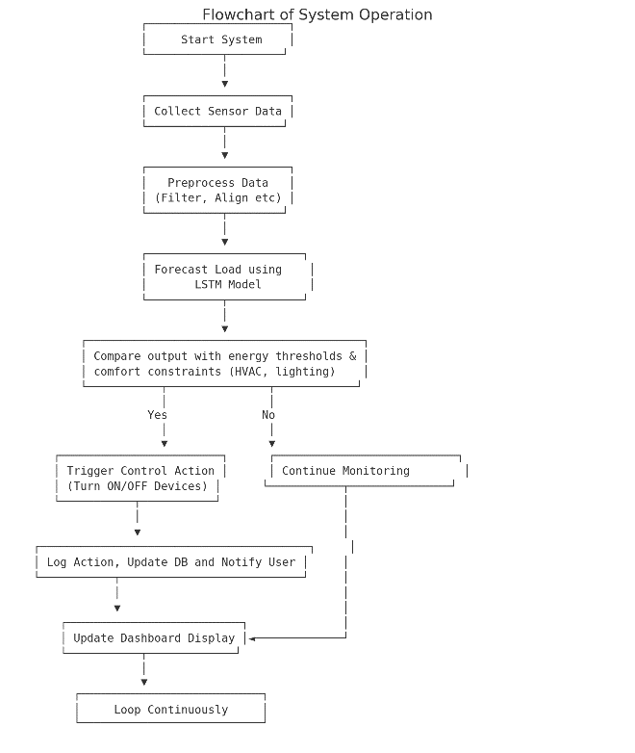
Figure.1 Flowchart of system operation
- Performance Evaluation

The framework undergoes assessment in a regulated smart home laboratory setting for 30 days. Essential assessment metrics consist of energy savings rate, system latency in real-time, forecasting effectiveness (MAPE, RMSE, MAE), and precision of automation response. Baseline energy usage is documented manually for analysis. Statistical methods, such as paired t-tests and ANOVA, are utilized to evaluate the importance of noted enhancements. The line diagram of experimental setup is illustrated in Figure.2.
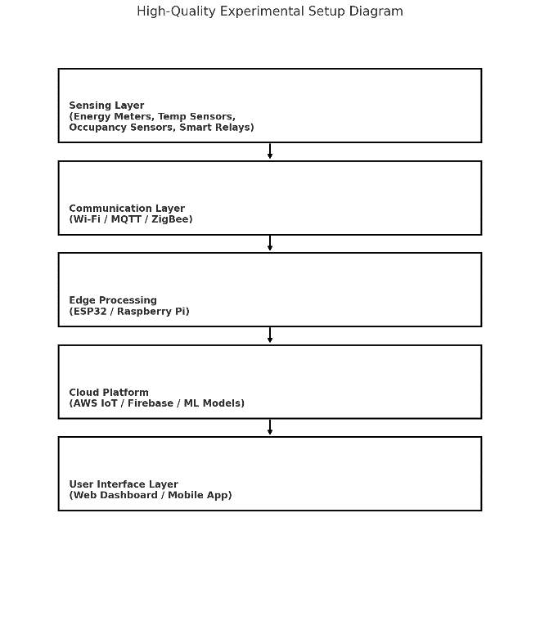
Figure.2 Line diagram of experimental setup
The energy savings for device category is shown in Figure.3 and energy savings for forecast and actual energy consumption is presented in Figure.4.
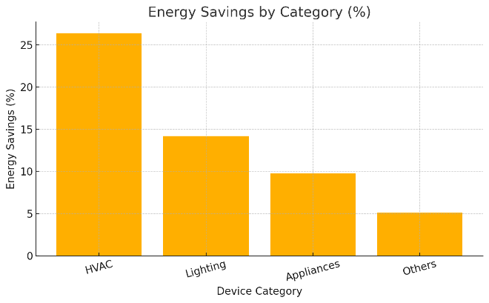
Figure.3 Energy savings for device category
The experimental findings indicate that IoT automation considerably improves energy efficiency, with the largest effect seen in HVAC systems (≈27%), then lighting (≈14%) as seen in Figure.3. Appliances and various loads exhibited moderate enhancements, suggesting that IoT optimization proves most beneficial for high-consumption and continuously functioning systems
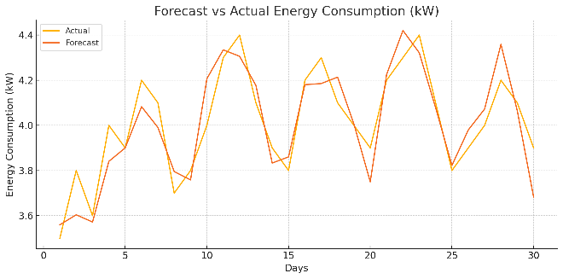
Figure.4 Energy savings for forecast and actual energy consumption
From figure.4, it is observed that the prediction model shows high accuracy, with the projected energy usage curve closely aligning with the real observed figures throughout the analysis period. This suggests that the IoT-driven predictive model is efficient and appropriate for real-time energy management and intelligent automation applications. The MAPE, RMSE and MAE values are listed in table.1.

Table.1 Performance metrics
Metric | Value
MAPE (%) | 1.831
RMSE (kW) | 0.090
MAE (kW) | 0.073

From table.1 the inferences observed as follows:
- A MAPE of 1.83% signifies excellent forecasting precision, as the model only strays slightly from the actual values.
- RMSE (0.09 kW) and MAE (0.073 kW) are both small, indicating low prediction error and strong model stability.
- These metrics confirm that the forecasting method (probably LSTM or a machine learning model) is effective for short-term energy demand forecasting.
Conclusion
This study shows that monitoring enabled by IoT and advanced control systems are essential for improving energy efficiency in contemporary buildings and infrastructure. Through the incorporation of real-time sensing, flexible communication protocols, and machine learning-driven predictions, the suggested framework efficiently automates energy consumption and enhances the performance of high-energy-demand systems like HVAC, lighting, and appliances. The experimental findings demonstrate significant decreases in energy use, with efficiency gains between 18–27%, reinforcing the promise of IoT-enabled automation in lowering operational expenses and environmental effects. Additionally, the impressive forecasting accuracy indicators—MAPE of 1.83%, RMSE of 0.09 kW, and MAE of 0.073 kW—underscore the strength of the adopted predictive model and affirm its appropriateness for real-time decision-making and proactive energy management.
In summary, the results confirm that energy management systems based on IoT improve insight into usage trends and facilitate scalable, self-regulating, and data-informed optimization approaches that assist in the shift toward smarter buildings and sustainable energy systems. Upcoming efforts will prioritize improving system versatility through reinforcement learning, incorporating renewable energy sources, and boosting interoperability with national smart grid systems to enhance energy resilience and self-sufficiency.

References
- S. Cevik, Climate Change and Energy Security: The Dilemma or Opportunity of the Century?, International Monetary Fund, Working Paper No. 2022/174, Sep. 22, 2022.
- Voas, J.; Agresti, B.; Laplante, P.A. A closer look at IoT’s things. IT Prof. 2018, 20, 11–14.
- Kamel Boulos, M.N.; Al-Shorbaji, N.M. On the Internet of Things, smart cities, and the WHO Healthy Cities. Int. J. Health Geogr. 2014, 13, 10.
- Tastan, M. Internet of things based smart energy management for smart home. KSII Trans. Internet Inf. Syst. (TIIS) 2019, 13, 2781–2798.
- Vishwakarma, S.K.; Upadhyaya, P.; Kumari, B.; Mishra, A.K. Smart energy efficient home automation system using IoT. In Proceedings of the 2019 4th International Conference on Internet of Things: Smart Innovation and Usages, Ghaziabad, India, 18–19 April 2019; pp. 1–4.
- Im, H.; Lee, S.; Naqi, M.; Lee, C.; Kim, S. Flexible PI-based plant drought stress sensor for real-time monitoring system in smart farm. Electronics 2018, 7, 114.
- J. Zhu, D. Wang, and Y. Zhao, “Design of smart home environment based on wireless sensor system and artificial speech recognition,” Measurement: Sensors, vol. 33, p. 101090, 2024.
- X. C. Dong and C. Wonjun, “Interior design of aging housing based on smart home system of IoT sensor,” Journal of Sensors, 2023.
- J. Yan, W. Lin, and X. Tu, “IoT-based interaction design of smart home products for elderly families,” Applied Mathematics and Nonlinear Sciences, vol. 9, no. 1, 2024.
- N. Mehrbakhsh, R. A. Ali, and S. Sarminah, “Factors impacting customer purchase intention of smart home security systems: social data analysis using machine learning techniques,” Technology in Society, vol. 71, 2022.
- Y. Pu, “Smart home security design based on STM32 microcontroller,” Architecture Engineering Science, vol. 5, no. 1, 2024.
- H. Sallay, “Designing an adaptive effective intrusion detection system for smart home IoT,” International Journal of Advanced Computer Science and Applications (IJACSA), vol. 15, no. 1, 2024.
- M. Hardyan and A. F. H. Yohandri, “Arduino-based smart home security design using biometric recognition,” Journal of Physics: Conference Series, vol. 2582, no. 1, 2023.
- M. Aminu, A. Yerima, and A. Salisu, “Design and implementation of an IoT-based smart home monitoring and control system using NodeMCU,” Journal of Engineering Research and Reports, vol. 25, no. 2, pp. 78–88, 2023.

