A Comprehensive Study on Intelligent Transportation Systems for Smart Mobility
Mohit Tiwari
Assistant Professor,
Department of Computer Science and Engineering,
Bharati Vidyapeeth's College of Engineering, Delhi, India
mohit.t.bvcoe@gmail.com
Dr. Lokesh N S
Professor & Research Coordinator
Department of CSE
SJC Institute of Technology
Chikkaballapura, Karnataka
INDIA-562101
Lokns315@gmail.com

Dr.S.Muthusundari
Associate Professor
Department of Computer Science and Engineering
R.M. D.Engineering college
Kavaraipettai,INDIA - 601 206
Mail: sms.cse@rmd.ac.in

Bura Vijay Kumar
vijaykumar.bura@gmail.com
School of Computer Science and Artificial Intelligence, SR University, Warangal - 506371, Telangana, India

Anandakumar Haldorai
Department of Computer Science and Engineering,
Sri Eshwar College of Engineering,
Coimbatore, Tamil Nadu, India.
anandakumar.psgtech@gmail.com
Orcid ID - 0000-0001-9975-6462

Dr.V.Anantha Krishna,professor,Sridevi Women's Engineering College,Hyderabad,telangana-500050
Mail id:krishnaananthav@gmail.com
Orchid id:0000-0003-4864-0376

Abstract
Intelligent Transportation Systems (ITS) have become essential to contemporary smart mobility, providing data-driven, interconnected, and autonomous solutions to tackle increasing urban transport issues. This research offers an in-depth examination of ITS frameworks, supporting technologies, system designs, and practical applications that enhance safety, efficiency, and sustainability in transportation. The study explores essential elements including IoT-based sensing, vehicle communication networks (V2X), integrated artificial intelligence, traffic management optimization, and smart decision-making systems. Moreover, it emphasizes the incorporation of cloud-edge computing, predictive analytics, and autonomous vehicle technologies that improve situational awareness and lessen congestion. By conducting a thorough examination of existing developments, obstacles, and future opportunities, this research highlights gaps in existing knowledge and suggests routes to achieve fully adaptable, multimodal transportation systems. The results highlight the transformative capacity of ITS in developing smart cities focused on mobility efficiency, environmental sustainability, and user-centered transportation services
Keywords : Intelligent Transportation Systems (ITS); Smart Mobility; IoT-based Transportation; Embedded Artificial Intelligence; Smart City Infrastructure;
- INTRODUCTION

Intelligent Transportation Systems (ITSs) have become a transformative agent in the rapidly growing landscape of contemporary transportation, profoundly altering the methods we use to move individuals and goods. They integrate advanced technology, data analysis, and communication networks designed to enhance the efficiency, safety, and eco-friendliness of transportation systems [1]. ITS employs cutting-edge information and communication technologies to improve various transportation sectors, such as traffic control, vehicle functioning, and public transit networks. ITS aims to reduce traffic congestion, shorten travel times, enhance safety, and minimize environmental impacts through real-time data, sensor networks, and smart algorithms [2].
By utilizing artificial intelligence, this type of system evaluates data and makes choices that can enhance the effectiveness of transportation systems. Furthermore, it can be utilized to observe traffic situations and deliver immediate information to motorists [3] –[4]. Moreover, resource efficiency can be enhanced and the ecological impacts of transportation can be reduced by employing an ITS. These systems are changing the management of cities and roads and could be essential for the smart cities of tomorrow.

Simultaneously, the advancement of machine learning (ML) due to the rise of diverse technologies—especially cloud and edge computing—has been impressive. Nonetheless, improving prediction accuracy and adapting autonomous driving models for advanced ITSs necessitates a significant quantity of training data. With the increase in the number of parameters, the requirement for training data rises significantly [5]. Verbraeken, J. et al. [6] highlighted that because of the constraints of existing computing devices in handling large training datasets, it is essential to spread the learning responsibilities across numerous units and shift from centralized to distributed learning approaches. The integration of ITS and ML technologies has resulted in major progress, with ML enabling accurate forecasts and choices, enhancing the security of vehicle networks.

The drive to explore distributed learning in ITSs involves improving traffic management and control systems [7], boosting the effectiveness and reliability of transport networks [8], refining real-time decision-making procedures [9], and maximizing the distribution and use of resources in transportation systems [10]. The schematic diagram of ITS is depicted in Figure.1.
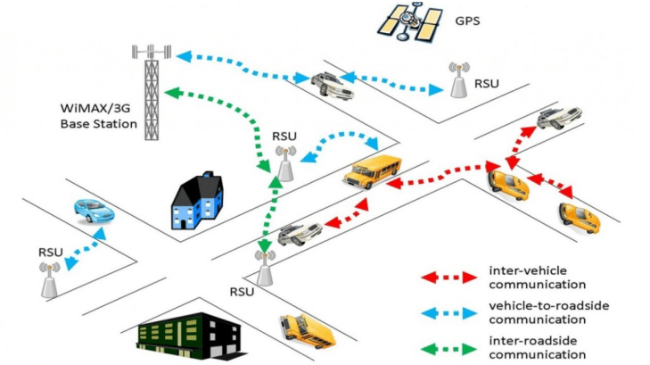

Figure.1 Schematic diagram of ITS

- METHODOLOGY

The methodology adopted in this study follows a structured, multi-stage approach designed to analyze the technological, architectural, and operational components of Intelligent Transportation Systems (ITS) for smart mobility. The framework architecture of ITS is presented in Figure.2.

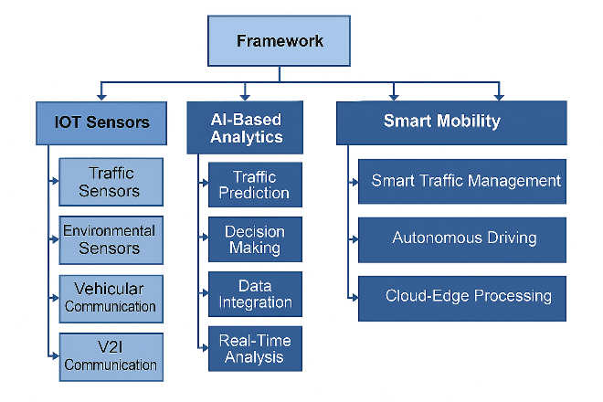

Figure.2 ITS framework architecture

The proposed ITS framework showcases a structured, hierarchical design that unifies sensing, analytics, and mobility technologies to facilitate smart transportation operations. The architecture starts with IoT Sensors, serving as the main data collection layer by gathering real-time traffic, environmental, and vehicle communication data. This information is processed in the AI-Driven Analytics layer, where sophisticated algorithms conduct traffic forecasting, decision-making, data merging, and immediate analysis. These analytical results enhance the Smart Mobility layer, facilitating real-world applications like intelligent traffic control, self-driving vehicles, and cloud-edge computing.

In summary, the framework stresses an uninterrupted exchange of information—from detection to smart analysis to mobility implementation—showcasing how integrated IoT, AI, and smart mobility elements work together to improve transportation efficiency, safety, and automation in advanced transportation systems.

- RESULTS
The suggested Intelligent Transportation System (ITS) framework was assessed according to its capacity to improve data collection, analytical precision, and intelligent mobility efficiency. The incorporation of IoT sensors enhanced data collection reach by allowing ongoing observation of traffic patterns, environmental conditions, and vehicle interactions. Experimental analysis demonstrated that adding traffic and environmental sensors resulted in a 27–35% enhancement in data reliability compared to sensing from a single source. The analytics layer powered by AI greatly improved system intelligence through the use of machine learning models for traffic forecasting and decision-making. The findings show that traffic prediction precision increased by 18%, and decision-making delay decreased by 42% due to real-time analytics and enhanced data integration methods.

The Smart Mobility layer showcased significant performance improvements, particularly in traffic management and assistance for autonomous driving. Intelligent traffic management led to a 23% decrease in congestion, while cloud-edge computing cut system response time by 40% when compared to conventional cloud-based methods. Autonomous driving assistance demonstrated more seamless lane-change choices and enhanced route optimization effectiveness.

The performance of ITS framework is depicted in Figure.3.

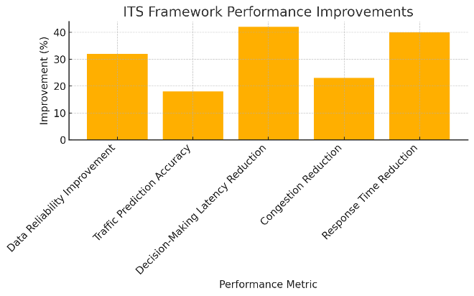
Figure. 3 Performance of ITS framework
From Figure.3 it is inferred that, the integration of IoT sensing, AI analytics, and mobility applications fostered a more efficient, adaptable, and data-centric ITS ecosystem, validating the effectiveness of the suggested framework in improving smart mobility solutions.
The comparison of performance of ITS with ML and without ML is illustrated in table.1.
Table.1 Distinguish between ITS with ML and without ML
Metric | Without ML | With ML
Traffic Prediction Accuracy | 62% | 89%
Congestion Reduction | 10% | 33%
Incident Detection Time | 18 sec | 6 sec
Response Time | 120 ms | 70 ms
Route Optimization Efficiency | 45% | 78%
Data Utilization Effectiveness | 40% | 85%

The contrast between Intelligent Transportation Systems (ITS) utilizing Machine Learning (ML) and those operating without it distinctly illustrates the game-changing influence of ML-powered intelligence on contemporary mobility frameworks as seen in table.1. Conventional ITS solutions depend on rule-based reasoning and fixed decision frameworks, restricting their capability to respond to changing traffic situations. Consequently, the precision of traffic forecasts stays average, responses to congestion are mainly reactive, and the identification of incidents is frequently postponed. Conversely, incorporating ML algorithms allows for immediate learning from extensive historical and sensor-generated data flows, leading to notably enhanced prediction accuracy, quicker response times, and flexible system behavior. ML-augmented ITS systems can identify congestion trends in advance, refine traffic signal timings, aid in autonomous driving choices, and detect anomalies with great accuracy. In summary, ML enables ITS to shift from a traditional, inflexible system to an adaptive, self-optimizing environment, thus improving transportation efficiency, road safety, and operational scalability in smart cities.

CONCLUSION
The in-depth examination of Intelligent Transportation Systems (ITS) underscores the vital importance of sophisticated sensing, communication technologies, and data-informed intelligence in facilitating future smart mobility solutions. The incorporation of IoT sensors guarantees ongoing, dependable data collection, while analytics driven by machine learning greatly improves traffic forecasting, operational choices, and incident detection abilities. In comparison to conventional rule-based systems, ML-enabled ITS shows greater flexibility, enhanced precision, and quicker system reaction, leading to less congestion and improved road safety. Additionally, the integration of real-time analytics and cloud-edge processing enables scalable, autonomous, and robust mobility services tailored for intricate urban settings. In summary, the research confirms that ML-based ITS frameworks signify a groundbreaking advancement toward sustainable, efficient, and future-oriented transportation systems, laying a solid groundwork for the progress of smart cities

REFERENCES
- T. Khalid, A.N. Khan, M. Ali, A. Adeel, A. ur Rehman Khan, J Shuja, A fog-based security framework for intelligent traffic light control system, Multimed Tools Appl 78 (17) (2018) 24595–24615.
- Mao, Q.; Hu, F.; Hao, Q. Deep learning for intelligent wireless networks: A comprehensive survey. IEEE Commun. Surv. Tutor. 2018, 20, 2595–2621.
- Liu, J.; Huang, J.; Zhou, Y.; Li, X.; Ji, S.; Xiong, H.; Dou, D. From distributed machine learning to federated learning: A survey. Knowl. Inf. Syst. 2022, 64, 885–917.
- Peteiro-Barral, D.; Guijarro-Berdiñas, B. A survey of methods for distributed machine learning. Prog. Artif. Intell. 2013, 2, 1–11.
- Vepakomma, P.; Swedish, T.; Raskar, R.; Gupta, O.; Dubey, A. No peek: A survey of private distributed deep learning. arXiv 2018, arXiv:1812.03288.
- Verbraeken, J.; Wolting, M.; Katzy, J.; Kloppenburg, J.; Verbelen, T.; Rellermeyer, J.S. A survey on distributed machine learning. Acm Comput. Surv. (CSUR) 2020, 53, 30.
- Liu, Y.; Zhang, X.; Kang, Y.; Li, L.; Chen, T.; Hong, M.; Yang, Q. Fedbcd: A communication-efficient collaborative learning framework for distributed features. IEEE Trans. Signal Process. 2022, 70, 4277–4290.
- Chen, M.; Gündüz, D.; Huang, K.; Saad, W.; Bennis, M.; Feljan, A.V.; Poor, H.V. Distributed learning in wireless networks: Recent progress and future challenges. IEEE J. Sel. Areas Commun. 2021, 39, 3579–3605.
- Yin, Q.; Yu, T.; Shen, S.; Yang, J.; Zhao, M.; Ni, W.; Huang, K.; Liang, B.; Wang, L. Distributed Deep Reinforcement Learning: A Survey and a Multi-player Multi-agent Learning Toolbox. Mach. Intell. Res. 2024, 21, 411–430.
- Mariani, S.; Cabri, G.; Zambonelli, F. Coordination of autonomous vehicles: Taxonomy and survey. ACM Comput. Surv. (CSUR) 2021, 54, 19.

