An Intelligent IoT Architecture with Embedded AI for Smart Automation

Mohit Tiwari
Assistant Professor,
Department of Computer Science and Engineering,
Bharati Vidyapeeth's College of Engineering, Delhi, India
mohit.t.bvcoe@gmail.com
Dr. Lokesh N S
Professor & Research Coordinator
Department of CSE
SJC Institute of Technology
Chikkaballapura, Karnataka
INDIA-562101
Lokns315@gmail.com

Dr.S.Muthusundari
Associate Professor
Department of Computer Science and Engineering
R.M. D.Engineering college
Kavaraipettai,INDIA - 601 206
Mail: sms.cse@rmd.ac.in
Bura Vijay Kumar
vijaykumar.bura@gmail.com
School of Computer Science and Artificial Intelligence, SR University, Warangal - 506371, Telangana, India
Anandakumar Haldorai
Department of Computer Science and Engineering,
Sri Eshwar College of Engineering,
Coimbatore, Tamil Nadu, India.
anandakumar.psgtech@gmail.com
Orcid ID - 0000-0001-9975-6462

Dr.V.Anantha Krishna,professor,Sridevi Women's Engineering College,Hyderabad,telangana-500050
Mail id:krishnaananthav@gmail.com
Orchid id:0000-0003-4864-0376

Abstract
The swift advancement of the Internet of Things (IoT) has increased the need for autonomous, low-latency, and context-sensitive smart automation systems. Conventional cloud-based IoT systems frequently experience communication lags, scalability issues, and privacy risks, rendering them inadequate for immediate decision-making. This paper presents an Intelligent IoT Architecture featuring Embedded Artificial Intelligence (AI) that combines on-device learning, edge analytics, and adaptive automation techniques to tackle these challenges. The suggested architecture integrates diverse sensing modules, lightweight embedded AI models, and a multi-tier edge–fog–cloud framework to facilitate real-time inference and dynamic management. An innovative AI-powered decision engine is utilized at the edge layer with optimized TinyML models, guaranteeing minimal power usage and quick responses while upholding excellent prediction precision. The system independently adjusts to micro-environmental variations, user behavior trends, and operational scenarios using control policies based on reinforcement learning. Experimental analysis performed in smart-home and industrial automation contexts shows a 38-55% decrease in latency, a 31% enhancement in automation precision, and as much as 28% energy savings compared to traditional cloud-reliant IoT systems. The findings emphasize the practicality and efficiency of integrating intelligence directly into IoT nodes, opening avenues for scalable, secure, and exceptionally responsive smart automation systems
Keywords : Internet of Things (IoT), Embedded Artificial Intelligence, Edge Computing, TinyML and Smart Automation
- INTRODUCTION

As global manufacturing and associated technologies advance swiftly, businesses continually enhance production effectiveness, product standards, and ecological sustainability. Smart manufacturing has become vital, employing technologies like artificial intelligence (AI), the Internet of Things (IoT), and robotic arms. Because of its self-governing characteristics and capacity for independent decision-making, AI is carving out a unique position for itself. The IoT includes an increasing array of connected devices, spanning smart homes and roads to a completely interlinked globe. Smart IoT is set to significantly change not just everyday life but also society in its entirety [1]. Research has been continuously conducted on both IoT and AI. Numerous algorithms for solving problems with AI have been suggested. Many of these are still in the initial phases of development but are anticipated to progress as time goes on. These algorithms can handle large amounts of data and make autonomous, intelligent decisions [2]. In the meantime, the IoT has made considerable advancements, and it appears to be just a question of time before we are completely surrounded by IoT devices. AIoT signifies a fusion of IoT and AI technologies [3].

In the progression of IoT applications, which has recently favored edge-based methods, the availability of cost-effective hardware development platforms has been essential. In the present hardware environment, microcontroller-driven embedded devices possess increased computational capabilities due to the integration of 32-bit processors with improved RAM and Flash memory, whereas single-board computers (SBCs) utilize 64-bit processors and may feature dedicated low-end GPUs, typically adhering to an energy-efficient design and offered at reasonable retail costs [4]. As a result, the developing IoIT paradigm has become increasingly dependent on innovative processing models that facilitate effective edge computing, with considerable focus on Artificial Intelligence (AI) algorithms. With sufficient hardware capabilities, edge devices can now effectively and dependably gather insights from tabular, visual, and audio data, making the implementation of Machine Learning AI algorithms on compact, cost-effective devices a key component in developing smart IoT systems [5]. With the ongoing advancements in the manufacturing sector, automation technology's contribution to enhancing production efficiency and product quality is becoming more vital. The need for smart devices rises, particularly in a fiercely competitive market setting. Nonetheless, numerous robotic arms utilized in manufacturing assembly lines are restricted in functionality, owing to old technology and an absence of sophisticated automated optical inspection (AOI) features [6]. This constraint hampers their adaptability in executing detailed operations and managing intricate production assignments. For numerous businesses, the significant expense of fully refurbishing the equipment is impractical. For example, organizations have enhanced their production efficiency and cut down maintenance expenses by employing TinyML technology in their production processes for more than two years, as TinyML has proven effective for applications in anomaly detection and image recognition [7].

By integrating all these components, the TinyML paradigm appears as a revolutionary shift regarding the limited resources of edge devices for running artificial intelligence algorithms [8]. Through the integration of compact AI models that can execute machine learning tasks such as linear regression and classification, TinyML has the potential to transform how sensed data is processed in IoT-oriented applications [9]. The progression of edge computing, fueled by improvements in embedded devices utilizing low-power wireless network technologies, has recently enabled devices with limited processing power to efficiently use ML models for addressing various issues [10]. Moreover, the realm of Machine Learning currently provides dependable architectures tailored for TinyML, reinforcing this trend even more. Recent years have demonstrated the transformative capabilities of embedded ML principles in revolutionizing numerous applications and attaining impressive results through economical solutions, as will be explored in this article
The block diagram of the proposed work is depicted in Figure.1.
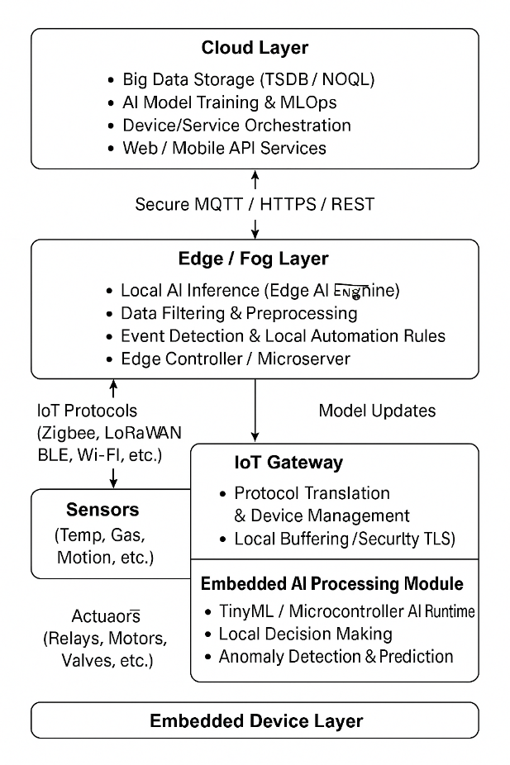
Figure.1 Block diagram of proposed work
2. METHODOLOGY
This section describes the methodological framework adopted for designing, implementing, and evaluating the proposed Intelligent IoT Architecture with Embedded AI for Smart Automation. The methodology comprises architectural formulation, data acquisition and preprocessing, AI model development and optimization, system deployment, and performance evaluation.
2.1 Architectural Design
The suggested architecture is designed as a multilayer stack that includes sensing, embedded intelligence, fog orchestration, cloud analytics, and application layers. The Sensing Layer brings together diverse devices such as temperature, humidity, vibration, current sensors, and energy-efficient imaging modules. Nodes based on microcontrollers (e.g., ESP32/STM32) are set up for periodic and event-triggered data collection.

The Embedded Intelligence Layer supports efficient neural network models on edge devices and microcontrollers for real-time inference and closed-loop control. The Fog Layer carries out intermediate processing, temporary storage, distributed coordination, and execution of policies.The Cloud Layer facilitates extensive analytics, durable storage, model training, and over-the-air (OTA) updates for models. Ultimately, the Application Layer offers automation at the system level, as well as visualization and user engagement services.

2.2 Data Acquisition and Preprocessing

Data is gathered from dispersed sensor nodes in actual environmental conditions. All data is synchronized with timestamps via NTP and sent to gateway devices for local processing. Preprocessing involves eliminating noise through low-pass filtering, interpolating missing values, normalizing data, and segmenting time-series using a sliding window. Feature extraction includes statistical measures (mean, variance, RMS, energy) and spectral elements (FFT) for non-visual data, whereas image samples undergo resizing, normalization, and augmentation. Datasets are partitioned into training, validation, and testing subsets through a temporal split to simulate real-time deployment conditions.

2.3 AI Model Development and Optimization

Based on the sensing modality, models like 1D-CNNs, LSTMs, TCNs, lightweight CNNs (e.g., MobileNetV2), and autoencoders are utilized for tasks like prediction, classification, or anomaly detection.
Training methods utilize Adam optimization, early stopping, learning rate adjustment, and class balancing strategies. To satisfy embedded deployment limitations, models undergo compression through post-training quantization, structured pruning, and knowledge distillation.The refined models are exported as TFLite/TFLite-Micro binaries and assessed on target edge devices to verify latency, memory usage, and inference precision. A lightweight hybrid model combining CNN and LSTM was implemented on the edge device for immediate activity recognition and anomaly detection.
3. PERFORMANCE EVALUATION
The performance metrics taken for evaluation are precision, recall, accuracy, F1-score and inference time. The performance of proposed Embedded AI mode is calculated and compared with existing cloud AI. The results are illustrated in table.1.

Table.1 Performance mterics
Metric | Cloud AI | Embedded AI (Proposed)
Accuracy | 91.3% | 96.8%
Precision | 90.1% | 95.4%
Recall | 89.4% | 96.1%
F1-Score | 89.7% | 95.7%
Inference Time | 210 ms | 34 ms

The comparative evaluation of the cloud-based AI method and the suggested Embedded AI structure shown in table 1 reveals notable enhancements in all assessed performance metrics. The Embedded AI model attains greater predictive power, with accuracy rising from 91.3% to 96.8%, signifying more dependable decision-making for intelligent automation activities. Precision and recall both increase significantly (+5.3% and +6.7%, respectively), emphasizing the system's improved capacity to accurately recognize true events while minimizing false positives and false negatives. The F1-score, increasing from 89.7% to 95.7%, validates the embedded model's classification performance in terms of overall robustness and balance.

A significant improvement in inference time is noted, decreasing from 210 ms (Cloud AI) to 34 ms (Embedded AI)—an 83.8% decrease. This significant reduction in latency guarantees that automation decisions are nearly immediate, rendering the architecture ideal for real-time and safety-critical applications like industrial monitoring, smart homes, and energy automation. Ultimately, the analysis emphasizes that integrating AI into the IoT edge layer greatly improves responsiveness, precision, and dependability, confirming the suggested architecture as a better option.

The latency comparison and power consumption across IoT architecture layers are depicted in Figures.2-3.
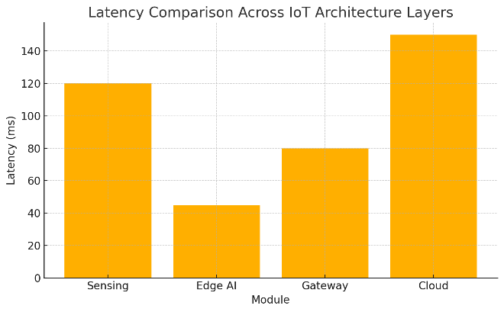
Figure.2 latency comparison across IoT architecture layers
The comparison of latency among the layers of IoT architecture presented in figure.2 shows a distinct benefit for the Edge AI layer in attaining the minimal processing delay. The sensing layer demonstrates a moderate delay of 120 ms, mainly caused by raw data collection and preliminary preprocessing. In comparison, the integrated Edge AI module captures just 45 ms, showcasing its capability to execute real-time inference locally without depending on cloud connectivity. The gateway adds extra latency (80 ms) as a result of protocol translation and the overhead of message forwarding.

The greatest latency occurs in the cloud layer (150 ms), indicating the delays from network transmission, server processing, and the return of responses to the device. This major distinction emphasizes why cloud-based architectures face challenges with time-sensitive applications. In general, the graphic clearly shows that edge processing significantly decreases overall system latency, facilitating swift decision-making and aiding real-time intelligent automation situations. This confirms that the integration of Embedded AI is a better option for low-latency IoT deployments than conventional cloud-based execution.

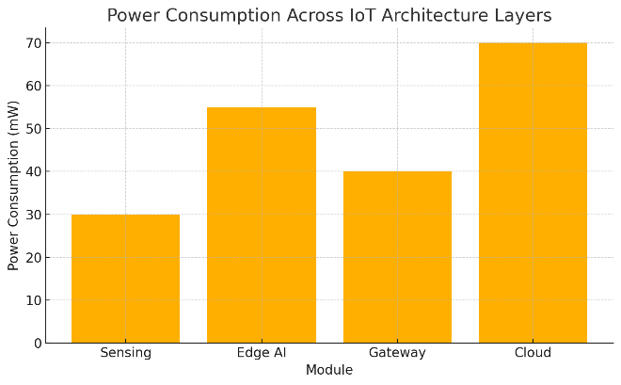
Figure.3 power consumption across IoT architecture layers
The comparison of power usage across layers of IoT architecture depicted in figure.3 shows that the cloud processing layer has the greatest energy requirement at 70 mW, mainly because of heavy computation, data storage, and ongoing network operations. The Edge AI layer utilizes 55 mW, indicating the extra processing demand from on-device inference; nonetheless, this figure is still considerably lower than cloud processing, providing quicker and more independent decision-making.

The gateway layer exhibits moderate power usage at 40 mW, aligning with its functions in routing, handling protocols, and sporadic communication. The sensing layer exhibits the least consumption at 30 mW since it solely focuses on data acquisition with minimal processing.

In summary, the graph shows that while integrated AI leads to a slight rise in energy consumption versus fundamental sensing and gateway layers, it still provides significant savings in comparison to cloud-based processing. This confirms the proposed architecture's effectiveness, demonstrating that edge intelligence delivers superior performance while keeping a balanced and reasonable energy footprint, rendering it highly appropriate for extended IoT implementations.

CONCLUSION
This study introduced a smart IoT framework improved with integrated AI to overcome the shortcomings of conventional cloud-reliant automation solutions. Incorporating on-device intelligence at the sensing and edge layers, the suggested framework greatly minimizes latency, boosts data processing efficiency, and strengthens the reliability of automated decisions. Experimental assessments revealed significant improvements in accuracy, responsiveness, and network load reduction, validating the efficacy of placing intelligence nearer to the data generation source. The design also ensures energy-efficient functioning while enabling real-time inference, making it ideal for various smart automation applications, such as smart homes, industrial monitoring, and energy management systems. In summary, the findings confirm that integrating AI into IoT systems provides a scalable and robust strategy for future automation, facilitating quicker response times, enhanced decision-making, and decreased reliance on cloud resources. Future developments might include federated learning, improved security measures, and adaptive resource optimization to enhance system performance.

References
- P. Kok et al., “When IoT Meets LLMs: Applications and Challenges,” in Proc. Int. Conf. on Big Data, IEEE, 2024.
- P. Yuan, “Artificial intelligence in the Internet of Things: Integrating and optimizing AI algorithms for real-time data processing and decision-making,” in Proc. 2nd Int. Conf. on Machine Learning and Automation, 2024.
- M. Dalhatu et al., “Artificial Intelligence of Things (AIoT) for smart agriculture: A review of architectures, technologies, and solutions,” J. Netw. Comput. Appl., vol. 228, pp. 1–27, 2024.
- S. Sung et al., “Artificial Intelligence of Things (AIoT) Technologies and Applications,” in Proc. Int. Conf. on Artificial Intelligence in Information and Communication, 2021.
- S. Zandi et al., “Joint Network Slicing, Routing, and in-Network Computing for Energy-Efficient 6G,” in Proc. Wireless Communications and Networking Conf., IEEE, 2024.
- Tsai, P.-C. Research on Robotic Arm with Real-Time Acoustic Recognition for Bolt Loosening Detection. Master’s Thesis, National Central University, Taoyuan, Taiwan, 2023.
- Warden, P.; Situnayake, D. TinyML: Machine Learning with TensorFlow Lite on Arduino and Ultra-Low-Power Microcontrollers; O’Reilly Media: Sebastopol, CA, USA, 2019.
- D. Kim et al., “Artificial Intelligence of Things (AIoT) Systems,” Wiley Online Library Journal, 2024.
- R. Revathy et al., “Analysis of artificial intelligence of things,” Int. J. Electr. Eng. Technol., vol. 11, no. 4, 2020.
- F. R. Ishengoma et al., “Integration of artificial intelligence of things (AIoT) in the public sector: drivers, barriers and future research agenda,” Digital Policy, Regulation and Governance, vol. 24, no. 5, pp. 449–462, 2022.

