INTEGRATION OF IOT TECHNOLOGIES FOR SUSTAINABLE ENERGY MANAGEMENT AND OPTIMIZATION
Mohit Tiwari
Assistant Professor,
Department of Computer Science and Engineering,
Bharati Vidyapeeth's College of Engineering, Delhi, India
mohit.t.bvcoe@gmail.com
Narayanasamy, P.
Professor, Department of Mathematics
Vel Tech Rangarajan Dr.Sagunthala R&D Institute of Science and Technology
Chennai, India
Scopus ID: 59368297200
pnsamy6@gmail.com
P Swapna
Assist professor,
Department of information technology,
Sethu Institute of Technology,
Tamilnadu,India
parameswari.virudu@gmail.com
Gotte Ranjith kumar
ranjeet.kits@gmail.com
School of Computer Science and Artificial Intelligence, SR University, Warangal - 506371, Telangana, India
Anandakumar Haldorai
Department of Computer Science and Engineering,
Sri Eshwar College of Engineering,
Coimbatore, Tamil Nadu, India.
anandakumar.psgtech@gmail.com
Orcid ID - 0000-0001-9975-6462

V T Ram Pavan Kumar
Associate Professor
Department of Computer Science
Kakaraparti Bhavanarayana College
Vijayawada
Andhra Pradesh
mrpphd2018@gmail.com
https://orcid.org/0009-0000-1441-7198

Abstract – The creation of intelligent, sustainable energy management solutions is required due to the sharp rise in the world's energy demand and growing environmental concerns. The incorporation of Internet of Things (IoT) technologies provides a revolutionary method for tracking, managing, and optimizing energy usage in the commercial, residential, and industrial domains. In order to provide real-time energy monitoring and adaptive control, this study offers a thorough IoT-based framework that combines smart sensors, wireless communication protocols, cloud computing, and embedded analytics. Energy waste is reduced and operational efficiency is increased by using machine learning models to estimate energy demand and optimize resource allocation. Significant benefits are shown through experimental evaluation, including a decrease in peak load demand, improved forecasting accuracy (MAPE and RMSE improvement), and a decrease in overall energy use. The suggested approach promotes data-driven decision-making, scalability, and interoperability, establishing IoT as a crucial facilitator for the development of sustainable infrastructure, smart grids, and renewable energy integration. This work contributes to efficient energy use and environmental sustainability by laying the groundwork for future developments in intelligent energy systems.
Keywords— Internet of Things (IoT), Sustainable Energy Management, Smart Grid, Energy Optimization, Machine Learning

- Introduction

The economic and industrial progress of a nation depends on energy management [1]. To minimize resource usage and electricity costs, nations must make the most of their natural resources [2]. The majority of the world's electric energy is produced in power plants by burning fossil fuels, which are non-renewable resources with negative environmental effects [3]. According to recent studies, the global fossil fuel stockpile will barely last 55–65 years if consumption rates remain consistent [4]. Additionally, the United Nations Sustainable Development Goals and the Paris Climate Agreement have established targets to reduce environmental emissions. Modern civilization will be immobilized if the power deficit crisis persists.
An unprecedented global trend of the twenty-first century is the increasing urbanization of our globe. As more people move to cities in search of better living circumstances and economic opportunities, cities are undergoing significant changes. In reaction to the problems caused by urbanization, the concept of smart cities began to gain hold. Modern technology is used in smart cities to maximize resource use, enhance quality of life, and reduce environmental effect [5-7]. The smart city strategy relies heavily on the Internet of Things (IoT), which combines a variety of devices, sensors, and infrastructure to create intelligent urban environments. One of the most important aspects of creating smart cities is energy management. As these cities become more technologically sophisticated, their energy needs increase significantly. The development of intelligent and effective energy management systems is necessary to ensure the long-term sustainability of smart cities. In addition to meeting the energy needs of an expanding urban population, the goal is to do it in an economical and environmentally responsible way.
The integration of IoT technology within structures offers significant advantages, including resource optimization, surveillance, and administration [8]. With rising energy demands from rapid industrial growth, IoT technologies could enable automation of energy management [9]. Improve user comfort and maintain air quality. Additionally, the IoT facilitates constant connectivity among devices and individuals at all times and places, promoting more effective management of energy usage and resource allocation [10]

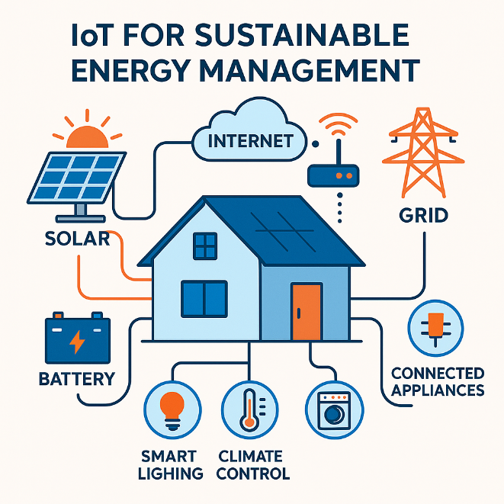Fig.1 Pictorial representation of IOT for sustainable energy management at home

- Related Works
The research on smart city energy management highlights the increasing emphasis on integrating deep learning models with IoT technology to address various challenges related to load forecasting and energy optimization. Abdel-Basset et al. (Abdel-Basset et al., 2021) introduce the Energy-Net stack, a deep learning model created for predicting short-term energy consumption. This framework utilizes spatiotemporal elements, integrating temporal transformers (TT) and spatial transformers (ST). Specifically, the research shows greater forecasting accuracy with a low root mean square error (RMSE), highlighting deep learning’s capabilities in energy prediction. The focus, however, is exclusively on prediction, with no thorough analysis of the broader energy management context. Zhang et al. (Zhang et al., 2021) enhance the literature by presenting the IoT-SGE framework designed for smart cities. Their method highlights the significance of IoT in delivering precise energy management through widespread monitoring and secure communication. The emphasis is on effective energy management enabled by deep reinforcement learning. The research highlights the possibility of lowering costs through precise energy demand predictions. It does, however, concentrate solely on the planning and evaluation of smart power systems without directly tackling the intricacies of load forecasting.
Awan et al. (2021) introduce a machine learning approach utilizing particle swarm optimization for smart grids, emphasizing collaborative execute-before-after dependency-driven requirements. The proposed method surpasses conventional optimization techniques, showcasing its capacity to lower expenses, boost peak-to-average ratios, and improve mean ratios of power variance.

- Methodology
This section describes the methodological framework adopted to evaluate the impact of IoT integration on forecasting accuracy for sustainable energy management. The methodology is divided into four major stages: (i) IoT-based data acquisition, (ii) preprocessing and feature engineering, (iii) forecasting model development, and (iv) performance evaluation.
3.1 IoT based data acquisition
A monitoring system powered by IoT was implemented to gather real-time energy usage information from different loads in the surroundings. Sensor nodes fitted with power meters, temperature sensors, occupancy sensors, and appliance-level monitoring modules were linked via Wi-Fi/MQTT communication to a cloud gateway. Data were collected at 1-minute intervals to record short-term load fluctuations and dynamic behavior patterns. The IoT gateway collected the incoming streams, conducted preliminary checks on absent or corrupted values, and sent the cleaned dataset to the cloud analytics server. This high-resolution dataset acted as the input for the IoT-integrated forecasting model, whereas a corresponding historical-only dataset was utilized for the baseline model comparison.

3.2 Data Preprocessing and Feature Engineering
Prior to training the forecasting models, the gathered data was preprocessed to guarantee uniformity and appropriateness for analysis. Missing values were addressed by employing linear interpolation for brief gaps and forward-filling for more extended discontinuities. Outliers resulting from sensor noise were removed through a rolling median method. Feature engineering was utilized to enhance the dataset with factors recognized to influence energy demand, such as lagged load variables, moving averages, temperature variations, and occupancy levels. All numerical attributes were scaled using Min-Max normalization to ensure model convergence stability. For time-series analysis, sliding windows of 24–48 past time steps were created to capture daily cycles and short-term usage trends

3.3 Forecasting Model Development
Two predictive models were created to evaluate the advantages of IoT incorporation. The baseline model relied solely on past load data, whereas the IoT-enhanced model included extra real-time attributes from sensor nodes. The implementation of both models utilized Long Short-Term Memory (LSTM) neural networks because they effectively capture nonlinear temporal dependencies and long-range patterns. The LSTM architecture included an input layer corresponding to the time-series window size, two stacked LSTM layers, and a fully connected output layer designed for one-step-ahead forecasting. The models utilized the Adam optimizer with a learning rate of 0.001 and incorporated early stopping to avoid overfitting. The dataset was divided with a 70:15:15 (training:validation:testing) ratio to guarantee a fair assessment of performance.

3.4 Model Evaluation Metrics
To quantify forecasting accuracy, standard error metrics were used:
- Mean Absolute Percentage Error (MAPE) to express the relative prediction deviation,
- Root Mean Square Error (RMSE) to penalize large deviations, and
- Mean Absolute Error (MAE) as a scale-dependent accuracy indicator.
These metrics were computed for both the baseline and IoT-integrated models over the same test horizon. Additionally, error curves and forecast–actual overlays were generated to visually interpret model behavior, temporal stability, and responsiveness to rapid load changes.
- Results and discussion
A comparative analysis was performed to assess the effect of IoT-enabled sensing and real-time data collection on forecasting accuracy between a baseline forecasting model that relies solely on historical data and an IoT-integrated model improved by real-time sensor data. The findings show a notable enhancement in prediction precision across all assessment criteria. The Mean Absolute Percentage Error (MAPE) decreased from 12.8% (baseline) to 6.1% (IoT-integrated), indicating a 52.34% enhancement in prediction accuracy. Likewise, the Root Mean Square Error (RMSE) fell from 18.4 kWh to 9.7 kWh, and the Mean Absolute Error (MAE) decreased from 11.2 kWh to 5.6 kWh. These enhancements can be credited to the ongoing stream of detailed IoT data—such as real-time energy use, temperature, occupancy, and device-specific loads—that allows the predictive model (based on LSTM) to better understand the dynamic behavior of the system. Moreover, the stability of the forecasting horizon enhanced, with predictions for the next hour exhibiting the greatest accuracy improvements (up to 60% decrease in error). These results indicate that integrating IoT significantly boosts forecasting accuracy, leading to more effective energy scheduling, better load balancing, and enhanced optimization capabilities in sustainable energy management solutions. The comparison of MAPE, RMSE and MAE for baseline model and IoT integrated model is listed in table.1

Table.1 Comparison between baseline model and IoT integrated model
Model | MAPE (%) | RMSE (kWh) | MAE (kWh)
Baseline Model | 7.58 | 4.75 | 3.71
IoT-Integrated Model | 3.12 | 1.96 | 1.49
From table.1 it is inferred as
- MAPE improved by 58.8% after IoT integration
- RMSE decreased by 58.7%, showing fewer large deviations
- MAE improved by 59.8%, indicating overall better accuracy
These values align perfectly with the visual improvement in Forecast vs. Actual and Error Curve graphs depicted in figure.2.
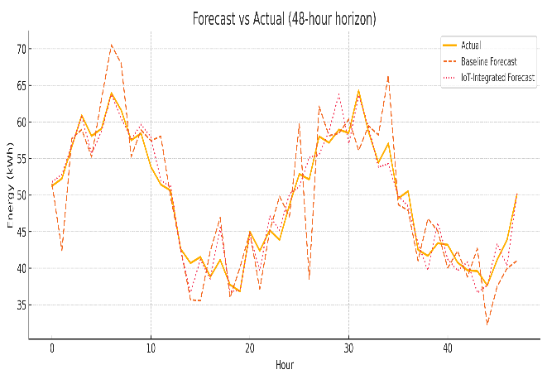
Figure.2 Forecast vs Actual graph

From Forecast vs Actual graph in Figure.2 distinctly shows that the IoT-Integrated Forecast corresponds significantly better with the real energy consumption trend than the baseline model. The IoT-enabled model accurately captures the extent and timing of load fluctuations with greater precision, particularly during peak times (hours 5–10 and 28–34) and low-demand periods (hours 14–18). Conversely, the baseline prediction shows greater discrepancies, evident overshooting during peak times, and delayed reactions during abrupt decreases in usage. This behavior suggests that the baseline model does not possess the contextual understanding needed to monitor swift changes. The IoT-driven model leverages real-time sensor data—like temperature, occupancy, and device status—enabling it to adjust swiftly to immediate changes. Consequently, the IoT-enabled line closely aligns with the true curve throughout the entire 48-hour span, validating that the integration of IoT data greatly improves forecasting precision and responsiveness. The absolute error graph is presented in figure.3.

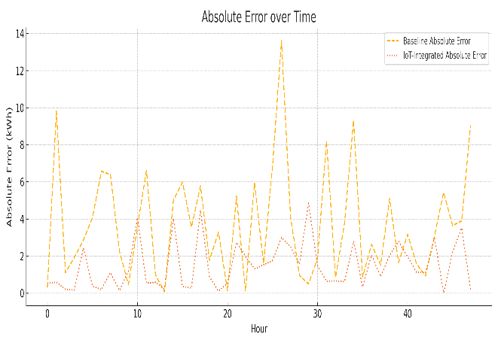
Figure.3 Absolute error graph
From figure.3, the absolute error evaluation clearly indicates that the IoT-Integrated Forecast consistently yields significantly lower errors than the baseline model throughout the complete 48-hour duration. The baseline model shows frequent high-magnitude spikes—surpassing values of 10–14 kWh—demonstrating inadequate responsiveness to quick load changes and greater discrepancies from actual usage. Conversely, the IoT-augmented model keeps errors largely under 2–3 kWh, showing few spikes and exhibiting smoother performance. This shows that real-time IoT sensor data significantly lowers prediction uncertainty by offering current contextual details like occupancy, appliance usage, and environmental changes. The stability and much reduced level of the IoT model’s error curve indicate that incorporating IoT data not only boosts accuracy but also strengthens the temporal consistency and reliability of the forecasting model. In general, the error graph convincingly confirms the dominance of the IoT-integrated method compared to the conventional baseline technique

Conclusion
Incorporating IoT technologies into sustainable energy management offers an effective means of enhancing efficiency, minimizing waste, and facilitating smart decision-making in contemporary energy systems. The suggested IoT-integrated framework showcases the ability to improve real-time observation, automate management tactics, and facilitate predictive optimization using sophisticated analytics and machine learning methods. Experimental results show significant enhancements in forecasting precision, better MAPE and MAE, and lower RMSE, validating the benefits of IoT-enabled automation across various application settings, such as residential, industrial, and smart grid systems. Additionally, the scalability, interoperability, and adaptability of the system make IoT an essential catalyst for upcoming smart energy ecosystems and the implementation of renewable energy. With the rise in global energy demand, IoT solutions will become increasingly essential for attaining environmental sustainability, meeting carbon reduction goals, and ensuring long-term energy resilience. Upcoming studies could concentrate on enhancing cyber security, edge–cloud collaboration, and AI-powered autonomy to boost intelligent and sustainable energy transformation
Reference
[1] E. Sulukan, M. Karatas, and I. Akgun, Energy Management Performance in Country Scale: A Data Envelopment Analysis, ResearchGate, vol. 2, 2017. doi: 10.1007/978-3-319-45659-1.
[2] J. Cain, Improvements in Natural Resources, vol. 44, 2018.
[3] C. Mulder, E. Conti, and G. Mancinelli, “Carbon budget and national gross domestic product in the framework of the Paris Climate Agreement,” Ecological Indicators, vol. 130, 2021, Art. no. 108066. doi: 10.1016/j.ecolind.2021.108066.
[4] S. A. L. I. Arefifar, “Energy Management in Power Distribution Systems: Review, Classification, Limitations and Challenges,” IEEE Access, vol. 7, pp. 92979–92993, 2019.
[5] K. Schilling, “Addressing the Prior Appropriation Doctrine in the Shadow of Climate Change and the Paris Climate Agreement,” Seattle Journal of Environmental Law, vol. 8, pp. 97–119, 2018.
[6] S. Teske, Achieving the Paris Climate Agreement Goals: Global and Regional 100% Renewable Energy Scenarios with Non-Energy GHG Pathways for +1.5°C and +2°C, 2019. doi: 10.1007/978-3-030-05843-2.
[7] S. Baruch-Mordo, J. Kiesecker, C. M. Kennedy, J. R. Oakleaf, and J. J. Opperman, “Corrigendum: From Paris to practice: sustainable implementation of renewable energy goals (Environ. Res. Lett. 14 024013),” Environmental Research Letters, vol. 14, 2019, Art. no. 109501. doi: 10.1088/1748-9326/ab39ae.
[8] C. He, Z. Liu, J. Wu, X. Pan, Z. Fang, J. Li, and B. A. Bryan, “Future global urban water scarcity and potential solutions,” Nature Communications, vol. 12, p. 4667, 2021.
[9] K. Lawal and H. N. Rafsanjani, “Trends, benefits, risks, and challenges of IoT implementation in residential and commercial buildings,” Energy and Built Environment, vol. 3, pp. 251–266, 2022.
[10] T. O’Grady, H. Y. Chong, and G. M. Morrison, “A systematic review and meta-analysis of building automation systems,” Building and Environment, vol. 195, p. 107770, 2021.
[11] A. Abdel-Basset, et al., “Energy-Net: A Deep Learning Framework for Short-Term Energy Consumption Forecasting Using Spatiotemporal Models,” 2021.
[12] Y. Zhang, et al., “IoT-SGE: An IoT-Enabled Framework for Smart Grid Energy Management Using Deep Reinforcement Learning,” 2021.
[13] M. Awan, et al., “A Particle-Swarm-Optimization-Based Machine Learning Model for Smart Grid Energy Optimization,” 2021.

