Predictive Modeling of Climate Conditions Using Machine Learning Approaches
Apeksha Koul¹  School of CSET, Bennett University,  Greater Noida, India  apekshakoulo9@gmail.com | Yogesh Kumar²  Department of CSE, School of Technology  Pandit Deendayal Energy University  Gandhinagar, India  Yogesh.Kumar@sot.pdpu.ac.in |  | Hani Attar³  Faculty of Engineering,  Zarqa Univeristy, Jordan.  Hattar@zu.edu.jo |  | Zakaria Che Muda⁴  Faculty of Engineering and Quantity Surveying INTI-IU University, Nilai, Malaysia  zakaria.chemuda@newinti.edu.my
Parvathaneni Naga Srinivasu⁵  Amrita School of Computing, Amrita Vishwa Vidyapeetham, Amaravati, India  parvathanenins@gmail.com |  | Muhammad Umair Manzoor⁶  School of Engineering  RMIT University, Melbourne, Australia  muhammad.umair.manzoor@rmit.edu.au |  | Muhammad Fazal Ijaz⁷  Centre for Artificial Intelligence Research and Optimization (AIRO),  Design and Creative Technology, Torrens University Australia, Melbourne, Australia  muhammadfazal.ijaz@torrens.edu.au

Abstract: Accurate climate condition detection plays a crucial role in understanding long-term environmental changes and predicting future climate behavior. By analysing variations in temperature, precipitation, and atmospheric trends, it becomes possible to identify global warming patterns and their regional impacts. This paper analyses global and regional climate anomaly trends using traditional time-series and machine learning models, including Linear Regression, Ridge Regression, Random Forest, ARIMA, and Holt-Winters. The dataset is used which contains temperature anomalies relative to the 1951–1980 baseline, to forecast trends up to 2030. The results indicate a consistent rise in global temperatures across all models, confirming ongoing human-driven warming. The Holt-Winters model achieved the highest accuracy (MAE = 0.1868, RMSE = 0.2083, MAPE = 13.13%), effectively capturing long-term trends, while ARIMA also performed competitively. Random Forest excelled in capturing non-linear regional patterns, particularly for Australia, Brazil, and Germany, where MAPE values ranged from 15–26%. Integrating statistical and machine learning models improves forecasting accuracy and supports evidence-based climate resilience planning.
Keywords: Global warming trends, Statistical climate forecasting, Random Forest climate modelling, Climate anomaly prediction, Holt-Winters exponential smoothing

- INTRODUCTION
Climate is defined as the long-term average of the weather patterns in each area, usually analysed over a period of at least 30 years and including such factors as temperature, precipitation, humidity, and atmospheric circulation [1]. Quite distinctive from weather, which reflects short-term atmospheric conditions, climate characterizes the expected or typical state of the atmosphere over extended timescales. The climate of a region is influenced by latitude, altitude, atmospheric and oceanic circulation, and proximity to large water bodies [2]. Multiple internal processes and external forcings, including volcanic activity, solar variability, orbital cycles, and human-driven emissions, continually shape the climate system [3].
Recent IPCC assessments show that human activities have unequivocally warmed the atmosphere, ocean, and land, driving rapid changes in the cryosphere and biosphere. These changes are increasingly influencing key sectors, including agriculture, health, energy, water resources, and infrastructure [4]. As a result, continuous climate monitoring has become essential for sustainable development and climate resilience. Intelligent control approaches, such as those used in advanced energy management systems for electric vehicles to optimize energy use and improve efficiency, can similarly support energy conservation and greenhouse applications, thereby contributing to climate change mitigation [5]. With a global average temperature that was +0.98°C above the 20th-century average, June 2025 became the third warmest. And while it may not have been as warm as 2023 or 2024, it did mark the 49th successive June with above-average temperatures. Europe and Asia ranked in fifth place tied with 1995, North America was eighth, and Africa was ninth, while even the other continents had above-average warmth. Although the Arctic anomaly remained high (+1.20°C), it was the lowest since 2017- a detail that reflects short-term variability rather than a reversal of long-term warming trends [6] (Fig 1).

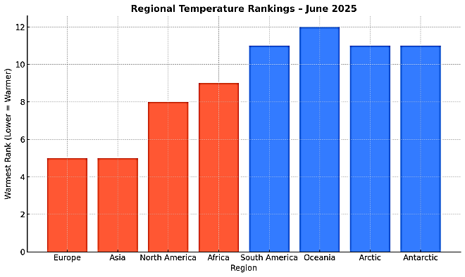
Fig. 1. Regional Temperature Rankings for June 2025 [5]
According to WMO projections, global temperatures are expected to remain close to the record levels up to 2029, adding to climate-induced risks in ecosystems, economies, and the society. The chance of having at least one year exceed 2024 as the hottest ever by 80% is 86% possible with reference to one of them surpassing 1.5 degrees since the pre-industrial; 70% for the 2025–2029 five-year average to exceed the 1.5°C target temporarily—these extended metrics highlight the rapid pace of warm-up in recent times [7]. The traditional ways of investigating climate condition predictions mostly depend on numerical and statistical modeling. Numerical Climate Models, such as General Circulation Models (GCMs) and Earth System Models (ESMs), are the most complex methods employed in the study of the climate, as they are based on a set of physical equations to represent the interactions of the atmosphere, oceans, land, and ice [8]. These models can give us a long-term overview of the main climate variables like temperature and precipitation, but they need a lot of computing power and are subject to some limitations regarding spatial resolution, parameterization mistakes, and uncertainties in boundary conditions [9]. However, the statistical and empirical methods have developed based on historical data which they used to draw inferences about the correlations between different climatic events; nevertheless, once the occurrence of some events becomes nonlinear or rare, their prediction power will be greatly diminished. Traditional models faced some obstacles in terms of their application at the regional scale, especially about data unavailability or very high computation costs [10]. The developments in Artificial Intelligence (AI), predominantly through machine learning and deep learning, are proving to be the right solution to these problems, as they can learn complex non-linear relationships from large datasets and adapt to diverse predictive tasks [11]
In this paper, we develop a machine learning–based framework for predicting climate conditions using historical and environmental data.

- RELATED WORK
Climate forecast in recent times has been expected with a lot of research, with like a wide usage of traditional statistical techniques, however, in comparison to extensive efforts for present-day machine learning for climate challenges.
Kadkhodazadeh et al. (2022) [12] used machine-learning models to predict reference evapotranspiration and demonstrated that nonlinear models outperform traditional regression under climate-change scenarios as such, their results showed that nonlinear approaches outperformed methods based on traditional regression. Vaughan et al. (2021) [13] introduced convolutional conditional neural processes (convCNPs) to improve local climate downscaling, particularly for extreme events. Similarly, Khaira et al. (2024) [14] integrated machine learning with atmospheric WRF model outputs to improve snowfall forecasts in the Northeast U.S., demonstrating that hybrid physics-based and data-driven models outperform conventional methods. Extending ML applications to environmental hazards, Aryal et al. (2022) [15] evaluated various ML models for predicting aeolian dust events, showing that non-linear models capture dust concentration dynamics better than linear approaches, though extreme events were slightly underestimated.
In the extreme hydrological points, Shi et al. (2023) [16] proposed FloodGTN, a graph-transformer network that models spatiotemporal water-level dynamics and achieves significantly higher accuracy than traditional approaches. Traditional models, Flood-GTN, presented some improvement in accuracy. On the water quality side, Rahat et al. (2023) [17] suggested monitoring river TSSs through LSTM models and remote sensing data to capture time scale from daily to seasonal and climate change. With an array of machine learning models, Lu et al. (2025) [18] found that CNN models best captured groundwater-level fluctuations, with annual precipitation emerging as the strongest predictor. In terms of four model types, the CNN had the best R (2) = 0.9924 with RMSE 0.1832. Automatically, Average Annual Precipitation, Soil Moisture, and Evapotranspiration had positive impacts on GWL. On hydrological forecasting, Zhang et al. (2024) [19] employed machine-learning-based post-processing techniques to Subseasonal-to-Seasonal precipitation forecasts to yield imp0roved skills in ESP. The study concluded that extended ML principles to air quality, Lei et al. (2022) [20] found that ML approaches such as RF, GB, and SVR accurately predict concentration of pollutants in Macao even during the COVID-19 epidemic, underlining the robustness of ML in diverse environmental conditions.

- METHODOLOGY
The methodology for this study focuses on predicting climate conditions using machine learning techniques. All experiments were conducted in Python 3.10 using scikit-learn 1.2.2 for machine-learning models and stats models 0.14.0 for ARIMA and Holt–Winters. Data handling and plotting were performed with pandas 1.5.3 and matplotlib 3.6.2. The models were executed on a workstation with an Intel Core i7 CPU and 32 GB RAM, which provided sufficient resources without requiring GPU support. It involves a structured workflow as shown in Fig 2.
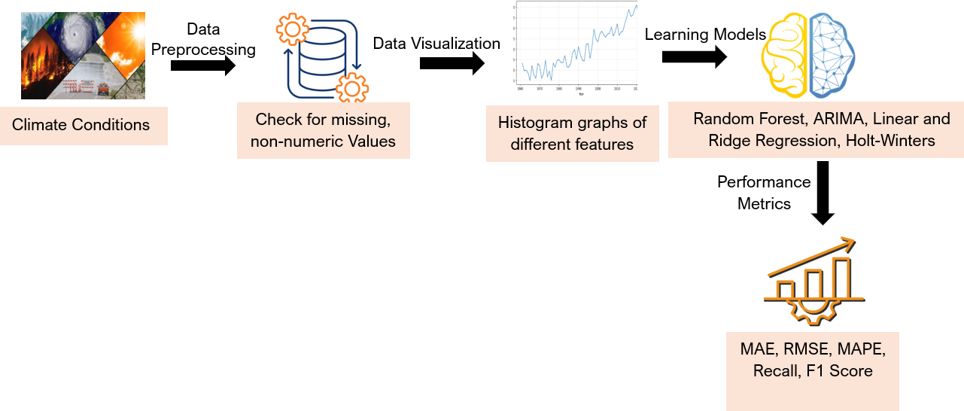
Fig. 2. Proposed Machine Learning Framework for Climate Condition Prediction
- Dataset: The dataset of Climate change indicators contains annual temperature anomalies observed at a global level in countries all over the world with a base period of 1951-1980. It consists of country identification (name, ISO2, ISO3) and yearly temperature deviations, based on historical deviations from the surface temperature, thus indicating the surface temperature changes over time. Following the dataset of itself, most of the information concerns the global or regional climate trend analysis, temperature patterns prediction, and climate change impacts study [21].
- Data Preprocessing: The climate dataset was carefully prepared before use for time-series forecasting. The original CSV file contained climate indicators with separate columns for years (like F1950, F1951, etc.) along with country information. So, the data was taken out of this wide format onto a long format by melting, essentially creating three standard-columns - Country, Year, and Value (temperature anomaly). All missing values were dropped to keep the dataset reliable, and the year labels were cleaned up and converted to integers for an accurate timeline. The data was then sorted by country and year for the preservation of chronological data. Some new helper functions were prepared for extracting sequences of anomalies, but those in global and country; the values were then scaled with the Standard Scaler method. The above steps have culminated in creating a very neat dataset that could be utilized straight away for an exact time-series model and visualization.
- Data Visualization: We employed diverse data visualizations to explore the historical temperature anomaly globally and regionally, which were essential in obtaining some preliminary understanding of climate trends where they traced the patterns of warming, regional variations, and rates of change over time.
The global temperature anomaly 1960-2023 as illustrated by Fig. 3 in the context of comparing the year-over-year departure of the global average temperature from a historical normal. The plot clearly shows rapidly ascending global mean temperatures, mostly occurring after the 1980s, culminating to nearly +1.5°C in 2023. This strongly signals that long-term global warming, very largely a result of human-induced activities, including the lethal emissions of greenhouse gases and massive deforestation, is occurring. Science will agree in stating this as a rather self-evident fact, given the reports that reached the international arena, notably the IPPC's. This is in line with the urgent action that the world needs to pursue to mitigate global warming beneath 1.5°C or 2°C in alignment with the Paris Agreement.
The temperature anomalies in India, Australia, and Germany from the year 1960 to 2023 have been thoroughly discussed in Fig. 4. The three countries' temperature curves exhibit a similar rising pattern starting from 1960. The steepness of the rise can be seen most in Germany, whereby anomalies usually surpass +2.5 °C in the last few years. The temperature in Australia is also largely rising but the rise in India is not that quick. Thus, it indicates that this global phenomenon i.e. climate change is, in fact, regionally different in terms of intensity and pattern depending on the geographical factors, urbanization, and local climate systems. Hence, the graph clearly stresses the need for climate strategies that each country will have to adopt individually, which are going to be comprising both mitigation (reducing emissions) and adaptation (upgrading infrastructure and agricultural practices) approaches to the specific climate challenges that each country is facing, particularly those in regions that are rapidly being heated, like Germany.
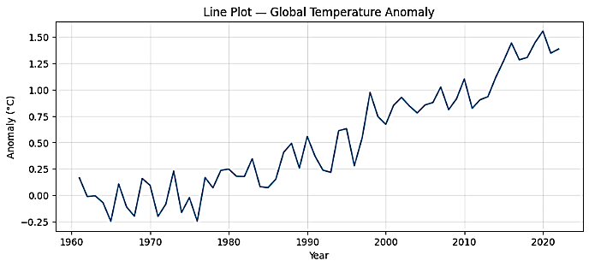
Fig. 3. Global Temperature Anomaly Trend (1960–2023)

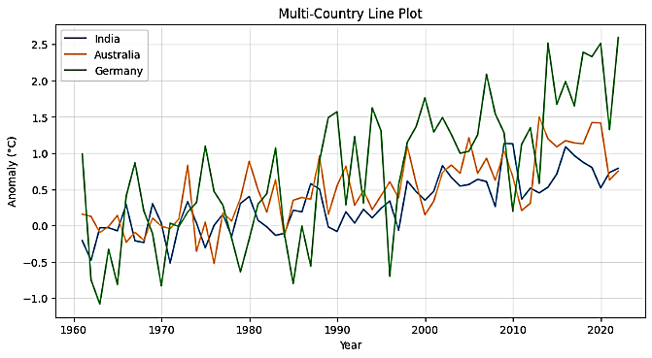
Fig. 4. Temperature Anomaly Trends for India, Australia, Germany (1960–2023)
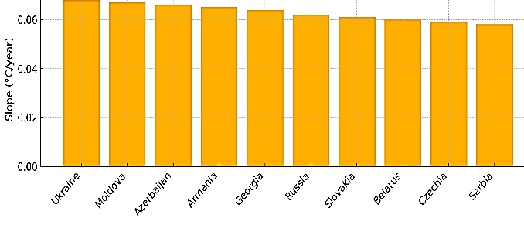
Fig. 5. Top 10 Countries with Fastest Warming Rates
Fig. 5 shows the 10 countries experiencing the quickest pace of warming according to the slope of the temperature anomaly per year. These countries-in which one finds Ukraine, Moldova, Azerbaijan, and Armenia, are claimed undergoing the fastest warming annually. In contrast to previous charts where the absolute value of anomalies was described, this graph depicts rate of change, which impacts where increases in temperature are the fastest. This explains why this graph is very important: to give a view into climate acceleration rather than just its current states. Any nation that has a more-than-average slope of warming might likely face more severe droughts, biodiversity loss, ecosystem collapse, or other climate induced stress. As such, this visualization is of considerable importance to climate vulnerability assessment and thereby informs the distribution of international funds, adaptation planning, and risk mitigation. This is particularly true now that some regions might not have the resilience or resources to cope with such rapid environmental changes.
Fig. 6 shows another set of temperature anomaly predictions over a broader geographical set that might be called upon by a different statistical or machine learning algorithm. The graph, like the first, depicts the historical data in blue, test predictions in orange, and projections in green; shaded below is an 80% confidence interval. In contrast to the Holt-Winters forecast, the prediction's trend appears more stabilized or more oscillating as opposed to an upward futuristic climb. This could signal a model that emphasizes shorter-term variations or trend smoothing. With a greater confidence interval, it suggests a higher degree of uncertainty in the future temperature predictions made, pointing out the variability that may exist with climate projections, based on any given forecasting method.
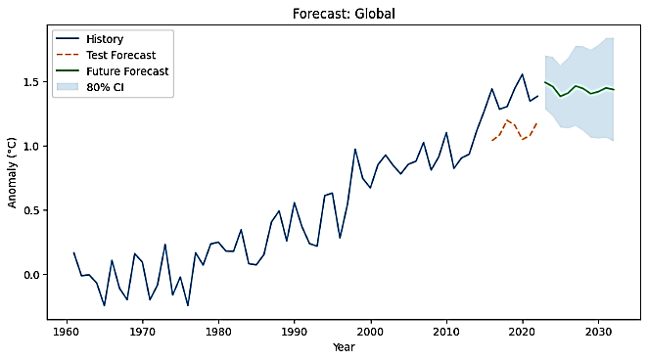
Fig. 6. Global Temperature Forecast using Machine Learning Model Variant
- Applied Classifiers: Various statistical and machine learning models are used to predict climate anomalies. The specific hyperparameters used in each model were tuned to increase performances while Table 1 lists models as well as their corresponding configuration.
Table 1: Hyperparameters of different models
Model | Hyperparameters
ARIMA | $( p, d, q )$ (auto-searched within ranges$: ( p ∈[0,3], d ∈[0,2], q ∈[0,3] ))$
Holt-Winters | Trend = "add", Damped Trend = True, Seasonal = None (since annual data, no seasonality)
Linear Regression | No explicit hyperparameters (basic regression model)
Ridge Regression | Alpha = 1.0 (regularization strength), Solver = default (scikit-learn)
Random Forest | n_estimators = 400, max_depth = None, random_state = 42 (default for reproducibility)
In climate condition prediction, several statistical and machine learning models are widely used due to their ability to handle temporal trends, seasonal patterns, and complex interactions among climate variables. ARIMA (AutoRegressive Integrated Moving Average) is a classical time-series model that captures temporal dependencies by combining autoregressive (AR), moving average (MA), and integration (I) components. The AR component uses past observations$\left(X_{t}=ϕ_{1}X_{t-1}+…+ϕ_{p}X_{t-p}+ϵ_{t}\right),$ while the MA component accounts for past forecast errors $\left(X_{t}=θ_{1}ϵ_{t-1}+…+θ_{q}ϵ_{t-q}+ϵ_{t}\right)$, and differencing ensures stationarity of the series [22]. ARIMA is particularly effective for climate variables with trends and non-stationary behavior, such as long-term temperature or rainfall patterns. Holt-Winters exponential smoothing extends simple exponential smoothing to include trend and seasonality, using $\left(L_{t}=α\frac{X_{t}}{S_{t-m}}+\left(1-α\right)\left(L_{t-1}+T_{t-1}\right)\right)$ for the level, $\left(T_{t}=β\left(L_{t}-L_{t-1}\right)+\left(1-β\right)T_{t-1}\right)$ for the trend, and $\left(S_{t}=γ\frac{X_{t}}{L_{t}}+\left(1-γ\right)S_{t-m}\right)$ for seasonality, with forecasts computed as $\left(\hat{X}t+h=\left(L_{t}+hT_{t}\right)St-m+h\backslash bmodm\right)$ [22]. This model is ideal for capturing recurring climate cycles, such as monsoon rainfall or seasonal temperature variations. Ridge regression, a regularized version of linear regression, adds a penalty term $\left(\sum_{i=1}^{n}{{\left(y_{i}-\hat{y_{i}}\right)}^{2}} +λ\sum_{j=1}^{p}{β_{j}^{2}}\right)$ to control for multicollinearity and overfitting, which is common in climate datasets with correlated features [23]. Hence, it is especially appropriate for prediction of a variable experiencing extreme weather or climate variability. Linear regression models the direct linear relationship between climate predictors and the target variable $\left(Y=β_{0}+β_{1}X_{1}+…+β_{n}X_{n}+ϵ\right)$, providing interpretability of how individual factors like humidity, wind speed, or greenhouse gas concentration affect temperature or precipitation. It has been also successfully applied in other domains, where the model expresses the dependent variable as a weighted sum of multiple features [24].

- RESULTS
In this section, the possibilities of forecasting models in terms of performance measures are evaluated with the use of MAE, RMSE and MAPE. The evaluation may be seen as a comparative assessment of the accuracy and effectiveness of competing methods applicable to the forecasting of weather and other climatic anomalies in the world and at the level of a country.
Table 2: Comparative Performance of Forecasting Models
Model | MAE | RMSE | MAPE (%)
ARIMA | 0.2184 | 0.2473 | 15.29
Holt-Winters | 0.1868 | 0.2083 | 13.13
Linear Regression | 0.2550 | 0.2712 | 18.04
Ridge Regression | 0.2551 | 0.2712 | 18.05
Random Forest | 0.2130 | 0.2302 | 14.98
In Table 2, among the models tested, the Holt-Winters method performs the best, achieving the lowest MAE (0.1868), RMSE (0.2083), and MAPE (13.13%), indicating its strong capability in capturing seasonal and trend components in the global data. The ARIMA model, on the other hand, delivers performance that is just the same as Holt-Winters with an MAE of 0.2184 and MAPE of 15.29% as compared the latter. Conversely, simple Linear and Ridge Regression give the worst performance (MAPE around 18.04–18.05%), indicating that the patterns of global temperature may be too complex and simple linear relationships will not work. The Random Forest model, however, is above both linear models by a margin of 1.5% MAPE as it takes advantage of the non-linear nature of the data. This comparison draws attention to the necessity of model selection that considers temporal dynamics in climate-related variable forecasting.
Table 3: Country-wise Performance of Forecasting Models for predicting climate conditions
Country | Model | MAE | RMSE | MAPE (%)
India | Holt-Winters | 0.175 | 0.221 | 20.68
India | Linear Reg. | 0.164 | 0.210 | 19.89
India | Ridge Reg. | 0.164 | 0.210 | 19.89
India | Random Forest | 0.225 | 0.255 | 25.82
Australia | Holt-Winters | 0.309 | 0.326 | 30.26
Australia | Linear Reg. | 0.298 | 0.317 | 30.19
Australia | Ridge Reg. | 0.298 | 0.317 | 30.19
Australia | Random Forest | 0.220 | 0.282 | 25.14
Brazil | Holt-Winters | 0.221 | 0.243 | 18.19
Brazil | Linear Reg. | 0.226 | 0.254 | 17.73
Brazil | Ridge Reg. | 0.226 | 0.254 | 17.73
Brazil | Random Forest | 0.179 | 0.208 | 15.45
Germany | Holt-Winters | 0.655 | 0.771 | 29.52
Germany | Linear Reg. | 0.701 | 0.804 | 31.05
Germany | Ridge Reg. | 0.701 | 0.804 | 31.05
Germany | Random Forest | 0.482 | 0.596 | 26.41
South Africa | Holt-Winters | 0.344 | 0.468 | 24.85
South Africa | Linear Reg. | 0.352 | 0.475 | 25.12
South Africa | Ridge Reg. | 0.352 | 0.475 | 25.12
South Africa | Random Forest | 0.310 | 0.420 | 23.06
Table 3 provides a comparative evaluation of four forecasting models—Holt-Winters, Linear Regression, Ridge Regression, and Random Forest—across five countries: India, Australia, Brazil, Germany, and South Africa. As far as India is concerned, Linear and Ridge Regression models have slightly outperformed Holt-Winters on MAE and RMSE metrics while achieving each a MAPE of 19.89%, with Holt-Winters in close second with a MAPE of 20.68%. However, Random Forest here performed poorly with the highest MAPE of 25.82%, suggesting that linear models could be good for India's somewhat stable trends in anomalies. Then, clearly, Random Forest is the best performing model for Australia with a much lower MAPE of 25.14% while the other models, including Holt-Winters and regression variants, had huge MAPE values of over 30%, which might be a sign that the traditional models could not cope with the climate variability in Australia.
The given situation is a complete opposite to the Brazilian case wherewith Random Forest competing with Holt-Winter and regression, had its errors the lowest in magnitude (MAE: 0.179, RMSE: 0.208, MAPE: 15.45%) like among the others; however, the former is slightly more precise than these other techniques. This points out to the capability of Random Forest to decipher patterns of data which are nonlinear and less predictable to some extent. On the contrary, Germany is a more difficult case all over the place, no matter what model is used, as evidenced by the higher MAE and MAPE values. Yet again, the Random Forest leads but with a MAPE of 26.41% which is significantly better than Holt-Winters (29.52%) and regression models (31.05%) indicating its effectiveness in areas with volatile or extreme climate anomalies. In South Africa lastly, Random Forest still has its constant advantage with a MAPE of 23.06% which is the lowest of all and thus, it shows its ability to adapt to diverse climatic trends by beating Holt-Winters (24.85%) and both regression models (25.12%).
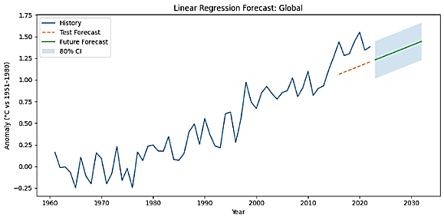
(a)
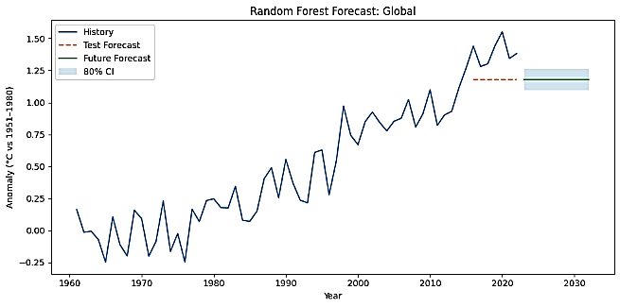
(b)
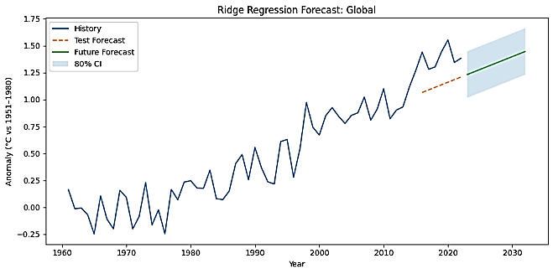
(c)
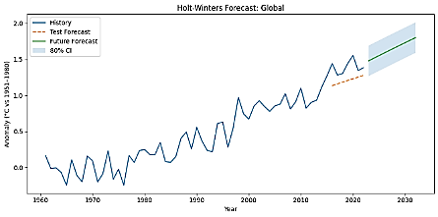
(d)
Fig. 7. Global Climate Anomaly Forecasts using Multiple Models (a) Linear Regression forecast; (b) Ridge Regression forecast; (c) Random Forest forecast; (d) Holt–Winters exponential smoothing forecast.
As shown in Fig. 7, the blue line indicates the past global temperature anomalies in relation to the 1951–1980 period. The orange dashed line shows the predicted range of the test, which starts from 2016 and goes about two-thirds of the way to 2030, while the green line in each sub-figure depicts the anomalies expected by 2030. In all models, most clearly in Figure 7(c) the 80% confidence interval is provided to measure the forecast uncertainty. Fig. 7(a) shows that the Linear Regression model predicts a constant upward movement of global temperatures even beyond the year 2030. On the other hand, the confidence intervals, which are quite wide when compared, indicate a great deal of uncertainty regarding long-term predictions. Fig. 7(b) shows a Random Forest model that produces somewhat level forecasts. The model’s conduct is conservative, as it mainly relies on the data patterns and thus doesn’t visualize any aggressive long-term trends; this results in projections that are narrower but less realistic. The Ridge Regression model, depicted in Fig. 7(c), acts much like linear regression, albeit with regularization incorporated to lessen overfitting. It certainly perceives the general warming movement, yet still, broader intervals are shown, pointing to the trade-off between bias and variance. In contrast, the Holt–Winters model is seen in Fig. 7(d) as being able to accurately capture the long-term temperature trend. The past period (1960-2020) confirms a gradual warming trend, and the forecast for 2020-2030 is also an increase in temperatures. The 80% confidence interval, which is shaded, indicates the area of future anomalies that can be considered possible.

V. CONCLUSION
The rising temperature anomaly trends confirmed a general warming, thus growing impacts of climate change across regions and confirmation of the indiscriminate warming. Among the models compared, Holt-Winters proved to be the most efficient overall, capturing trends and temporal patterns accordingly. Linear and Ridge Regression gave satisfactory results for the overall warming trend, while Random Forest proved superior in short-term forecasting but fell short for the long-term forecast because of overfitting. However, despite the rich inferences that can be made, this paper suffers from a limitation arising from the focus mainly on temperature anomalies and the omission of other key climate variables such as greenhouse gas concentrations, oceanic oscillations, and land-use variables. The use of annual data prevents us from detecting short-term departures and extreme events. In future work, these issues will be addressed by ingesting multidimensional climate predictors and using state-of-the-art deep learning architectures such as LSTM and ConvLSTM. The proposal of combining ensemble methods with informed AI is aimed at enhancing the reliability and realism of models thus contributing to the better accuracy of climate forecasting and the planning of resilience.
REFERENCES
- Haldar, Sayantan, et al. "Trend analysis of long-term meteorological data of a growing metropolitan city in the era of global climate change." Total Environment Research Themes 7 (2023): 100056.
- The Global Climate System. Learn Science at Scitable, Nature, 2025.
- von der Heydt, Anna S., et al. "Quantification and interpretation of the climate variability record." Global and Planetary Change 197 (2021): 103399.
- Kogan, Felix. "The IPCC reports on global warming and land changes." Remote Sensing Land Surface Changes: The 1981-2020 Intensive Global Warming. Cham: Springer International Publishing, 2023. 67-79.
- Goh, Ren Xiang, et al. "AI Based Control System for Electric Vehicles with Predictive Maintenance and Adaptive Energy Management." 2025 21st IEEE International Colloquium on Signal Processing & Its Applications (CSPA). IEEE, 2025.
- “Assessing the Global Climate in June 2025.” National Centers for Environmental Information (NCEI), 10 July 2025, https://www.ncei.noaa.gov/news/global-climate-202506
- “Global Climate Predictions Show Temperatures Expected to Remain at or Near Record Levels in Coming 5 Years.” World Meteorological Organization, 20 June 2025, https://wmo.int/news/media-centre/press-releases
- Reichle, David E. “Climate and Climate Models.” Elsevier eBooks, 2023, pp. 389–452, doi:10.1016/b978-0-443-18775-9.00010-3.
- Lenderink, Geert, et al. "A pseudo global warming based system to study how climate change affects high impact rainfall events." Weather and Climate Extremes (2025): 100781.
- Shah, Fahad, and Ayyoob Sharifi. "Climate models for predicting precipitation and temperature trends in cities: A systematic review." Sustainable Cities and Society (2025): 106171.
- Haq, Mohd Anul, et al. "Analysis of environmental factors using AI and ML methods." Scientific Reports 12.1 (2022): 13267.
- Vaughan, Anna, et al. "Convolutional conditional neural processes for local climate downscaling." Geoscientific Model Development Discussions 2021 (2021): 1-25.
- Khaira, Ummul, et al. "Integrating physics-based WRF atmospheric variables and machine learning algorithms to predict snowfall accumulation in Northeast United States." Journal of Hydrology 644 (2024): 132113.
- Aryal, Yog. "Evaluation of machine-learning models for predicting aeolian dust: A case study over the southwestern USA." Climate 10.6 (2022): 78.
- Shi, Jimeng, et al. "Graph transformer network for flood forecasting with heterogeneous covariates." arXiv preprint arXiv:2310.07631 (2023).
- Rahat, Saiful Haque, et al. "Remote sensing-enabled machine learning for river water quality modeling under multidimensional uncertainty." Science of The Total Environment 898 (2023): 165504.
- Lu, Xinyong, et al. "Data-driven insights into climate change effects on groundwater levels using machine learning." Water Resources Management 39.7 (2025): 3521-3536.
- Zhang, Lujun, Shang Gao, and Tiantian Yang. "Adapting subseasonal-to-seasonal (S2S) precipitation forecast at watersheds for hydrologic ensemble streamflow forecasting with a machine learning-based post-processing approach." Journal of Hydrology 631 (2024): 130643.
- Lei, Thomas MT, et al. "Using machine learning methods to forecast air quality: A case study in Macao." Atmosphere 13.9 (2022): 1412.
- Climate Change Indicators.” Kaggle, dataset by TarunRM09, 2025
- Dimri, Tripti, Shamshad Ahmad, and Mohammad Sharif. "Time series analysis of climate variables using seasonal ARIMA approach." Journal of Earth System Science 129.1 (2020): 149.
- Lallawmzuali, Marina, and Sundararajan Muniyan. "Rainfall prediction in Mizoram using the modified Holt Winters method." Theoretical and Applied Climatology 156.2 (2025): 125.
- Jisha, G. "Enhanced weather prediction with feature engineered, time series cross validated ridge regression model." 2024 Control Instrumentation System Conference (CISCON). IEEE, 2024.
- Hamzehei, Sahand, et al. "Predicting the total Unified Parkinson’s Disease Rating Scale (UPDRS) based on ML techniques and cloud-based update." Journal of Cloud Computing 12.1 (2023): 12.

