From Automation to Autonomy: The Role of Agentic AI in Industry 5.0

Parvathaneni Naga Srinivasu  Amrita School of Computing,Amrita Vishwa Vidyapeetham, Amaravati, India  parvathanenins@gmail.com | Abey Jose  School of Allied Health, University of Limerick, Ireland  abey.jose@ul.ie | Ayman Amer  Faculty of Engineering, Zarqa Univeristy, Jordan. Aamer@zu.edu.jo | Zakaria Che Muda  Faculty of Engineering and Quantity Surveying INTI-IU University, Nilai, Malaysia  zakaria.chemuda@newinti.edu.my
Ananth Madireddy  Amrita School of Computing, Amrita Vishwa Vidyapeetham, Amaravati, India  m_ananth@av.students.amrita.edu | V Lakshmi Chetana  Amrita School of Computing, Amrita Vishwa Vidyapeetham, Amaravati, India  s_lakshmichetana@av.amrita.edu | Yogesh Kumar  Department of CSE,  School of Technology,  Pandit Deendayal Energy University, Gandhinagar, India  yogesh.kumar@sot.pdpu.ac.in | Muhammad Fazal Ijaz  Centre for Artificial Intelligence Research and Optimization (AIRO),  Design and Creative Technology, Torrens University Australia, Melbourne, Victoria, Australia  muhammadfazal.ijaz@torrens.edu.au

Abstract— ​‍​‌‍​This​‍​‌‍​‍‌​‍​‌‍​‍‌ research is about Agentic AI (AAI), which is a key component of Industry 5.0, especially for smart, flexible, and human centered manufacturing. The paper presents key concepts and develops a structured framework that demonstrates how AAI can enhance decision-making while reducing resource consumption, ultimately leading to greener factories. Instead of being theoretical, the paper provides a step-by-step, practical plan for implementing the integration of machines, sensors, and digital tools to facilitate smooth data flow. From a system perspective, the paper identifies the essential components that enable the systems to operate autonomously, depending on the current situation. Once deployed, these configurations continuously monitor the factory operations but also enable instant and accurate actions at a very high level. This capability is not limited to defect detection or breakdown prediction, but also extends to upgrading entire workflows. To assess the feasibility of this integration, a SWOT analysis has been presented, outlining the potential benefits and the most significant obstacles related to the utilization of AAI. The analysis reveals that autonomous systems constitute the core of developing highly flexible, efficient, and capable industrial networks that enable seamless collaboration.
Keywords— Adaptive Intelligence, Agentic AI, Industry 5.0, Intelligent Manufacturing, SWOT Analysis.

Introduction
The​‍​‌‍​‍‌​‍​‌‍​‍‌ act of factories shifting from traditional processes to the use of autonomous machines is largely visible in factory operations. The equipment, which is a mere tool in the traditional setup, now operates independently, guided by live data and intelligent systems, without requiring human intervention with talent management [1]. Older setups might have seemed fast, but they were not reliable , based on fixed methods. Everything is now fast, flexible, responsive, and dominated by constant feedback [2]. There is considerable interest in environmental conservation, and people work harder to save the environment, even when it is challenging. The use of humans in combination with smart systems as a workforce is the norm, and in most cases, people can adapt faster than the systems. Tailor-made solutions are getting common very quickly, thus, the updates are very fast, but the resources are being used in a more efficient manner which is very similar to the old way of making, just much more precise this ​‍​‌‍​‍‌​‍​‌‍​‍‌time[3].
The increasing complexity of global manufacturing frameworks has necessitated the development of solutions that go beyond automation, focusing on efficiency and productivity. An old AI could only do the same tasks until someone helps. Now, these smarter models are able to change very quickly, changing their plans when the things change or when they get the new information [4]. I have seen simulations in which the system changes as people move, as if it predicts what will they do next. Since it always looks at its surroundings, it moves tasks at the same time, and it does not ask to figure out what is next, but it keeps everything going even if users are tired, looking for something to do during difficult calls ​‍​‌‍​‍‌​‍​‌‍​‍‌[5].
The use of AAI following the rules of Industry 5.0 changes the essential operational metrics, which have the deepest impact. There are production systems that can change as well as be capable of self adjustment to the variations in raw material, machine output, and consumer demand when AAI is incorporated [6]. AAI improves workflows and manages robotic work in real time. Such flexibility allows customers to access the most crucial parts of the market in a more convenient way.That, in turn, makes it feasible to personalize things on a broad scale with considerable agility. The new value thresholds in adaptability include reduced resource waste, minimized downtime through predictive maintenance, and innovative ways to generate revenue through customized and on-demand services.
Using AAI in accordance with the principles of Industry 5.0 also alters the most critical operational indicators [7]. The production systems become more flexible and can change more easily if the material, machine, and customer requirements change. The AAI enhances workflows and organizes work robotically in real-time. This style of flexibility enables people to interact more effectively with the most important part of the market. That makes it easy to create personal things for more people, and makes it easier to do so. The new threshold of value for adaptability is reduced waste of resources, less time lost due to predictive maintenance, and new ideas to generate income on a personal and as-needed basis. It does so by increasing the system's flexibility, allowing it to adapt to shifts in material availability, machine productivity, and consumer preferences. By introducing AAI, work processes become more efficient and the robotic work is guided in real time even in ambient intelligence systems [8].
Such flexibility guarantees a more efficient interaction with the main customer segments. As a result, one can scale personalization and still keep a high level of agility[2]The new operational thresholds include: reduced resource wastage, minimized downtime through predictive maintenance, and innovative revenue streams via tailored, immediate services. A comprehensive overview of such major and minor domains under the AAI in Industry 5.0 is presented in Figure 1.
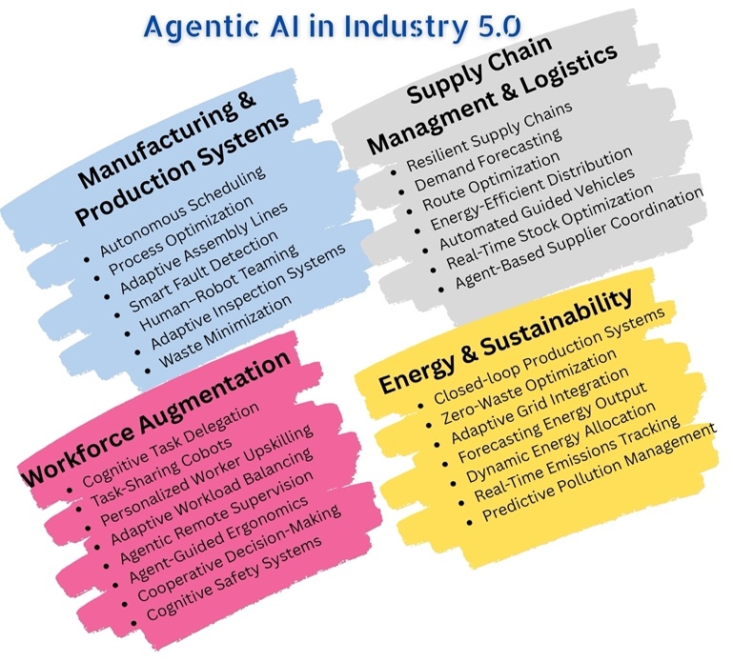
- Figure representing various domains in Industry 5.0 through AAI.
The following are the contributions of the current study.
- The study presents the role of the AAI framework in Industry 5.0, highlighting its fundamental architectural components and how they are being integrated seamlessly for human-centric models.
- The study examines the key components of the AAI environment and outlines the decision-making process and communication mechanisms among these components.
- Strengths, weaknesses, opportunities, and threats associated with Agentic AI in Industry 5.0 are discussed, which would assist in developing the future perspective models.
The overall manuscript is arranged as follows, Section 2 presents the Background of the AAI technology in Industry 5.0, and the fundamental architecture, along with the working mechanism is discussed in Section 3. Section 4 discusses the SWOT analysis on integrating the AAI in Industry 5.0 technology. Section 5 presents the conclusion and future research scope in the field of AAI.

Background
The major components of AAI architecture include the sensing, cognitive, adaptation, interaction, and governance layers. Each layer has well-defined responsibilities concerning the autonomy, human-centricity, resilience, and sustainability [7] in Industry 5.0. The roles and responsibilities of each layer are listed below.
- Sensing layer forms the foundation for the AAI framework in Industry 5.0 settings by enabling continuous interaction between the physical and digital environments. It integrates various IoT devices, sensors, cyber-physical systems, and human-centric sensors to capture real-time data on the states of the machines, working conditions, environmental conditions, dynamics of the supply chain, and the safety of the workers[8]. The primary responsibility is to ensure that the context-aware information, provides accurate, timely, and multi-modal data streams that would assist the high-level reasoning and decision-making layers. By incorporating human input, such as stress, or ergonomics monitoring, the layer that’s supports operational efficiency and aligns with the human vision of Industry 5.0 [4]. The sensing layer acts as critical entry point supporting security while maintaining accurate data flow, consistent performance, enable smooth connection between varied industrial setups[6].
- ​‍​‌‍​‍‌​‍​‌‍ ‌‍ cognitive layer is smart center of the AAI system, which converts sensor data into valuable insights for making decisions. The system does not rely on goal-setting tools alone but rather on reasoning based on context and using adaptable planning methods that allow the system to move beyond fixed rule-based systems and adapt dynamically to a changing factory environment[3]. Moreover, in the context of Industry 5.0, it facilitates the integration of high performance with human aspects, thus, enabling machines to consider employee well-being and stability versus productivity. Hence, this layer provides the logical basis for self-governed actions, thus, converting simple inputs into thoughtful, context-aware ​‍​‌‍​‍‌​‍​‌‍​‍‌outputs.
- The adaptation layer essentially keeps the AAI system going by employing smart algorithms, experience-based learning, or real-time feedback to change agent actions that will happen in part when production changes or the usage patterns vary. Agents are not going to be fixed, instead they are slowly getting more in line with new inputs or changed conditions by continuous adjustments.
- Hence, the operation gets stronger under pressure while the efficiency increases over time. In Industry5.0 ecosystems, this dynamic layer is instrumental in enabling customized production, prediction-based maintenance, or eco-friendly material handling. This element better connects the system with the company and users’ needs by employing devices that facilitate continuous updating and fine-tuning. Consequently, the AAI configuration is stable, flexible, and ready for future ​‍​‌‍​‍‌​‍​‌‍​‍‌challenges[9].
- ​‍​‌‍​‍‌​‍​‌‍​The interaction layer acts as the interface between agents, humans, and other external systems that are located at the production line, thus, it is responsible for a smooth communication and cooperation among them in Industry 5.0 ecosystems. The primary function of the interaction layer is to facilitate human-AI collaboration, enabling agents to support human decision-making in a manner that remains transparent, trustworthy, and practical. Furthermore, this layer provides the functionalities of multi-agent coordination thus, a distributed agent system can negotiate internally, knowledge transformation, and by interacting in manufacturing, logistics, energy optimization, or any other domains, collaboratively solve complex problems that span multiple domains. The interaction layer is the component responsible for ensuring that both humans and machines will have more meaningful, context-aware ​‍​‌‍​‍‌​‍​‌‍​‍‌interactions. The diagram denoting all the aforementioned layers in the AAI model is presented in Figure 2.
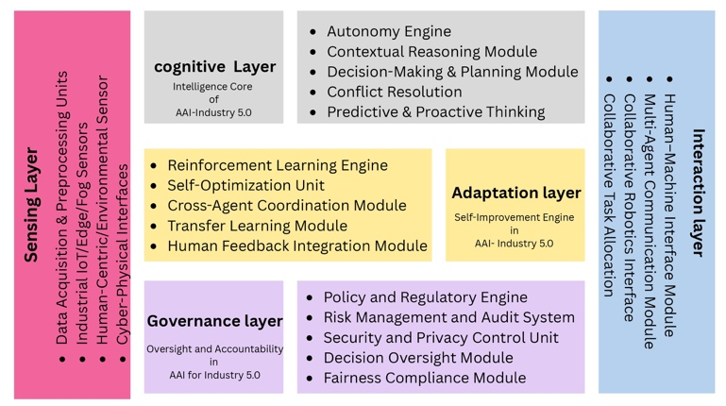
- Layered architecture of the AAI model in Industry 5.0 settings.
- The governance layer oversees multiple activities in AAI settings and serves as a regulatory backbone for the AAI framework, ensuring that autonomous operations remain aligned with the human-centric, ethical, and sustainable principles of Industry 5.0. Its key job is to make sure that agents are trustworthy, open, and accountable by using tools like explainability, auditability, and compliance monitoring. This layer also ensures safety, cybersecurity, privacy-preserving controls, and safeguards human operators and sensitive industrial data. The layer ensures autonomous decision-making concerning societal values, environmental goals, and worker well-being[4]. It is the moderator who ensures that autonomy is responsible and that there is a balance between innovation, resilience, and ethical oversight in Industry 5.0 ecosystems.

Working Mechanism of aai
Initially, each department within the AAI structure, as depicted in the figure, represents an abstraction of the AI model's functioning in Industry 4.0, which aims to achieve a higher, more intelligent level of productivity. Each layer is a repository of functions that originate from different disciplines and complement one another to form a continuous loop of sensing, thinking, adapting, communicating, and managing. The layers would not function sequentially but rather interactively, implying that they would jointly make decisions, distribute roles, and determine the division of tasks to ensure that industrial processes are not only efficient and robust but also human-centric [9].
A. Collaborative Dynamics Among Layers
In the Agentic AI framework for Industry 5.0, the communication among the sensing, cognitive, governance, and interaction layers is a well-organized and dynamic data flow that ensures both effectiveness and human-centric results. The sensing layer monitors and receives data from different IoT-enabled machines, sensor-equipped areas, and human-centric operators. Eventually, the cognitive layer receives the data and through a combination of reasoning, inference, and predictive analytics, it locates the patterns in the data and generates decision alternatives. When the data has been analyzed, the adaptation layer would be the one to determine the strategy priorities, identify the workflows, and allocate the resources to the system thus, satisfying the real-time needs of a flexible and resilient way of doing ​‍​‌‍​‍‌​‍​‌‍​‍‌tasks.
The governance layer is essential for the coordination of different activities. In essence, it would monitor and grant the decisions made in different levels that are in accordance with ethical standards, environmentally safe practices, and company regulations. On the other hand, the interface layer serves as a connecting link that joins the AI ecosystem with the outside world, allowing human users, devices, or industrial systems to interact with each other without difficulty [4]. Moreover, it contributes to making the outputs more comprehensible, thus laying the ground for the feedback to come from the sensing layer, which constitutes the closed feedback loop. AAI in Industry 5.0, via this complex and multi layered communication network, is still capable of making independent decisions which are in line with the law of the land, with each layer being the specialist in its functions and at the same time, being able to cooperate with the other layers in performing tasks that are transparent, adaptive, and human aligned.
It's​‍​‌‍​‍‌​‍​‌‍​‍‌ quite vital that the AAI's cognitive and sensing layers communicate with each other because they're the ones that actually convert the raw environmental inputs into the outcomes that can be executed. The sensing layer is always open to receive different streams of data from the machines, sensors, and human inputs, and then it sends them in real-time to the cognitive layer. The reasoning engines and predictive models of high sophistication take the information to uncover the patterns, to detect the anomalies, and to come up with the insights that are aware of the context. The uninterrupted flow of information is what makes it possible for the cognitive layer to get accurate and timely contextual information from the environment, thus allowing it to make the decisions that are followed by the processes of adaptation, governance, and interaction at different levels of the system. The communication between the components of each layer is shown in Figure ​‍​‌‍​‍‌​‍​‌‍​‍‌3.
- Algorithm for communication between the perception layer and the cognitive layer.
Algorithm 1: Communication between senso layer and the cognitive layer
Input: Raw data $D$ from sensors, and other IoT devices.
$K_{b}←KnowledgeBase$,$H_{d}←HistoricData$
Output: Actionable insights $I$for decision-making.
Initialize Sensing Layer $S$ and Cognitive Layer $C$
while the system is active, do
$$D←S.collectdata(environment)$$
$$D'←S.preprocess(D)$$
Transmit $D'→C$
$$C∙FuseData(D^{'},K_{b},H_{d})$$
$$Features←C.ExtractFeatures(D')$$
$$Predictions←C.ApplyModels(Features)$$
$$I←C.GenerateInsights(Predictions)$$
Send $I→Adaptation Layer for execution$
if Feedback is available, then
Update $(S,C)$
end if
end while

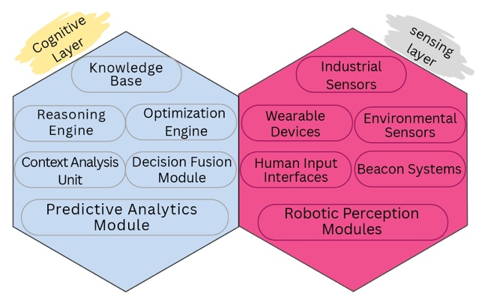
- The figure represents the cognitive and sensing layer components involved in communication.
Communication among the cognitive, adaptation, and governance layers is the core of responsible and efficient decision-making processes in AAI for Industry 5.0. The cognitive layer generates insights that enable informed decisions based on sensed data from the sensor layer, which are then transmitted to the adaptation layer for implementation through process reconfiguration, resource allocation, and workflow optimization [10]. However, before execution, the governance layer supervises communication to ensure all decisions comply with desired goals. The figure illustrating the layer and the parts that are responsible for communication is presented in Figure 4.
- Algorithm for communication among cognitive, Adaptation, and Governance layers.
Algorithm 2: Communication among cognitive, adaptation, and governance layers
Input: Insights $I$ from Cognitive Layer
$K_{b}←KnowledgeBase$,$H_{d}←HistoricData$, $S_{d}←Sensor data$
Output: Executed Actions $K$ with Governance Compliance
Initialize Cognitive Layer $C$, Adaption Layer $A,$ and Governance Layer $G$
While system is active do
$$I←C.GenerateInsights(S_{d},K_{b},H_{d})$$
$$D←C.formulate_descision(I)$$
if $G∙validate\left(D\right)=True$ then
$$A∙ReceiveDecision(D)$$
$$A∙ReconfigureProcesses(D)$$
$$A∙AllocateResourcesD)$$
$$A∙OptimizeWorkflows(D)$$
$$A∙Execute task()$$
$$A∙Feedback←A∙GenerateFeedback()$$
Send $A_{Feedback}→C,G$
else
$$G∙Updatedecision(D)$$
Notify $C$ to refine the decision process
end if
$$G.LogDecision(D,outcome,Compilence status)$$
end while

Conversations among the cognitive and interaction layers is critically, making AAI systems more human centered and effective. cognitive layer would process the acquired data, perform reasoning, and generate decisions. In contrast, the interaction layer ensures these decisions are clearly conveyed to human users and the external systems [8]. This communication happens through interfaces such as dashboards, natural language processing, or multimodal systems that translate complex cognitive outputs into understandable insights and actionable instructions . The input from end users, as well as operators, gathered through the interaction layer is communicated to the cognitive layer, which helps in making more precise decisions, thereby facilitating the adaptation of strategies to increase the accuracy . This uninterrupted flow of data constitutes the basis of the efficient collaboration between humans and AI and fosters trust and enhances the usability in Industry 5.0 settings [7].
- Algorithm for communicating to the Interface Layer
Procedure 3: Communication among cognitive, adaptation, and governance layers
Input: Decision $D$ from Cognitive Layer
Output: User Instructions $U$ through Interaction Layer
Initialize Cognitive Layer $C$, Adaptation Layer $A,$ and Governance Layer $G$
While the system is active, do
$$D←C.GenerateDecision(S_{d},K_{b},H_{d})$$
$$D_{Adapted}←A∙AdaptDecision(D, Context,Resources)$$
Send $D_{adapted}→G$ for validation
if $G∙validate\left(D\right)=True$ then
$$Final_{inst}←G.EnforceCompilance(D_{adapted})$$
$$I∙MapInstruction({Final}_{inst})$$
$$I∙DisplayInstruction({Final}_{inst})$$
$$U_{Feedback}←I.CollectUserFeedback()$$
Send $U_{Feedback}→C,A$
else
$$G∙Updatedecision(D_{adapted})$$
Notify $C$ to refine decision process
end if
$$G.LogDecision(D,outcome,Compilence status)$$
end while

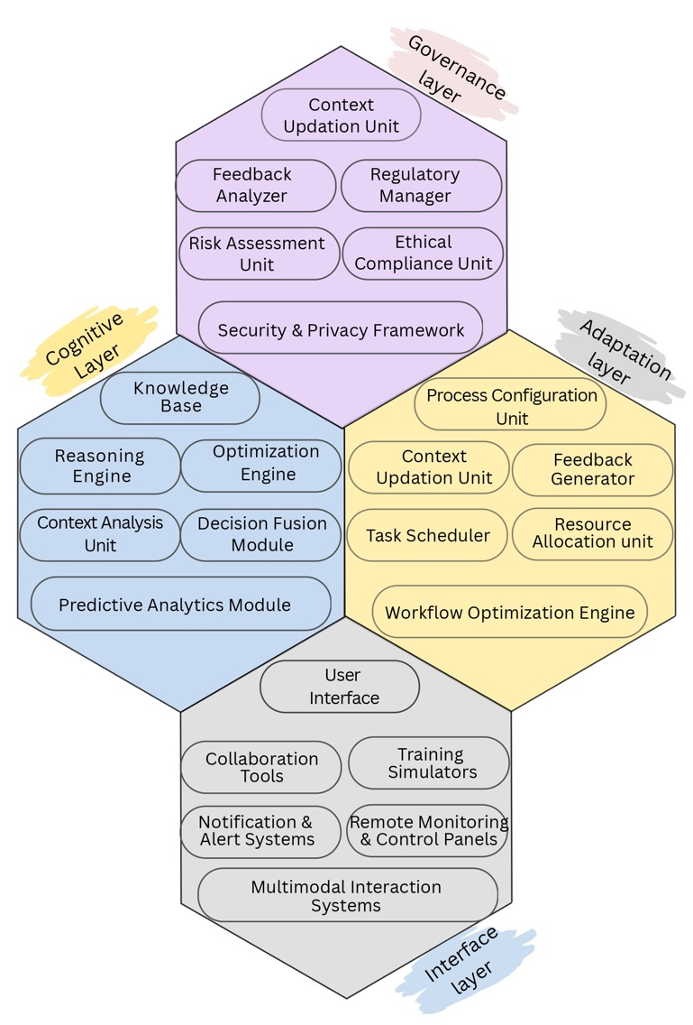
- Figure representing the components of cognitive, adaptation, governance layers involved in communication.

SWOT Analysis
This section of the manuscript presents a SWOT analysis which demonstrates both the advantages and disadvantages of using Agentic AI in Industry 5.0 [10]. The analysis provides a framework to assess its practical viability and the prospective avenues related to the technology.

Strengths
Agentic AI is one of the core technologies in the layer of human centered intelligence and sustainable transformations in industry that drives the 5.0 paradigm of an industrial society and has a lot of decisive positive effects . AI can improve the co-working of people and machines, be able to make decisions on their own as well as in context, and remain adaptable in a changing environment. AAI improves the effectiveness of industrial activities through the facilitation of multi-agent coordination, predictive intelligence, and continuous learning. It also promotes sustainability, scalability, and transparency. In addition, it provides explainability features, safety, and risk management, which foster trust and accountability, and facilitate the system's performance to remain stable. These capabilities transform AAI into a pivotal technology that enables human-centered intelligence and sustainable transformations in industry through continuous learning and adaptive management, thereby reducing downtime, resource waste, and process inefficiencies. AAI makes production systems faster and more efficient by facilitating the creation of conditions in which people and intelligent agents can collaborate easily .

Weaknesses

Agentic AI in Industry 5.0 faces several challenges, including exorbitantly high implementation costs, significant technical complexity, and a strong dependence on reliable data sources. There are problems like coupling with older systems, higher energy consumption, and shortage of skilled workers, only a few examples of the issues that prevent it from being deployed effortlessly.

C. Opportunities
By​‍​‌‍​‍‌​‍​‌‍​‍‌ smartening automation, AAI in Industry 5.0 generates numerous opportunities for AAI to interact with humans and machines as well as to use predictive intelligence for a complete revolution of the industrial sectors [3]. In addition, it is by far similar to what the planet desires to do in order to survive; providing clean technologies and better managing resources, thus ensuring sustainability of production. Furthermore, AAI not only facilitates a smoother interaction between different entities but also impels companies to innovate, enhances the personal aspect of products and infuse the creativity field with an infinite number of novel ​‍​‌‍​‍‌​‍​‌‍​‍‌ideas[2]. All of these talents together make industries more resilient, competitive, and ready for potential difficulties in the long run.

D. Threats
The AAI model has considerable potential in Industry 5.0, but it also faces numerous threats that may render it less acceptable and less likely to be adopted. It is concerned about cybersecurity vulnerabilities, data breaches, and the misuse of autonomous decision-making, which could compromise industrial operations and erode confidence among stakeholders. The rapid pace of technological change may exceed the rules that govern it, leaving significant gaps in compliance and governance. [1] Additionally, the possibility of job loss, the workforce's reluctance to adapt, and ethical concerns in decision-making could all make it more challenging to persuade people to adopt it.

Conclusion
This paper highlights the growing role of Agentic Artificial Intelligence in Industry 5.0, necessitating more intelligent, efficient, and human centered industrial systems. It describes the way in which autonomous, context aware agents can be used to decision making and gives the composition of the AAI model and what each of its layers does. A SWOT analysis is conducted to assess the strengths and challenges of AAI adoption, thereby helping to identify areas where further research is needed. In general, AAI is a strong enabler of increased industrial productivity, safety, sustainability, and human machine collaboration. The next steps should include on the fly case studies to gauge system performance in fluctuating scenarios and in-depth analysis of system capabilities such as scalability, security, and reliability.
References

- Chaudhary, Narendra Singh, et al. "AI and the Future of Talent Management: Revolutionizing Workforce Strategies for a Dynamic World." Global Work Arrangements and Outsourcing in the Age of AI, edited by Mohit Yadav, et al., IGI Global Scientific Publishing, 2025, pp. 297-316. https://doi.org/10.4018/979-8-3373-1270-5.ch017
- I. Trunina, M. Bilyk and Y. Yakovenko, "Artificial Intelligence from Industry 5.0 Perspective: Threats and Challenges," 2023 IEEE 5th International Conference on Modern Electrical and Energy System (MEES), Kremenchuk, Ukraine, 2023, pp. 1-5, doi: 10.1109/MEES61502.2023.10402468.
- E. Mukul and M. Güler, "An Integrated Hesitant Fuzzy-based SWOT Analysis for Industry 5.0 Technology Evaluation," 2024 8th International Symposium on Innovative Approaches in Smart Technologies (ISAS), İstanbul, Turkiye, 2024, pp. 1-6, doi: 10.1109/ISAS64331.2024.10845640.
- A. K. Pati, "Agentic AI: A Comprehensive Survey of Technologies, Applications, and Societal Implications," in IEEE Access, doi: 10.1109/ACCESS.2025.3585609.
- A. Khamis, "Agentic AI Systems: Architecture and Evaluation Using a Frictionless Parking Scenario," in IEEE Access, vol. 13, pp. 126052-126069, 2025, doi: 10.1109/ACCESS.2025.3590264.
- Tiwari, Alok. 2025. "Beyond Automation: The Emergence of Agentic Urban AI" Automation 6, no. 3: 29. https://doi.org/10.3390/automation6030029
- Francesco Piccialli , Diletta Chiaro , Sundas Sarwar , Donato Cerciello , Pian Qi , Valeria Mele. "AgentAI: A Comprehensive Survey on Autonomous Agents in Distributed AI for Industry 4.0." Expert Systems with Applications, vol. 291, 2025, p. 128404, https://doi.org/10.1016/j.eswa.2025.128404.
- Vourganas, Ioannis, Hani Attar, and Anna Lito Michala. "Accountable, responsible, transparent artificial intelligence in ambient intelligence systems for healthcare." Intelligent healthcare: infrastructure, algorithms and management. Singapore: Springer Nature Singapore, 2022. 87-111.
- Brohi, Sarfraz, Qurat-ul-ain Mastoi, N. Z. Jhanjhi, and Thulasyammal Ramiah Pillai. 2025. "A Research Landscape of Agentic AI and Large Language Models: Applications, Challenges and Future Directions" Algorithms 18, no. 8: 499. https://doi.org/10.3390/a18080499
- M. Sharma, A. Tomar and A. Hazra, "From Connectivity to Intelligence: The Game-Changing Role of AI and IoT in Industry 5.0," in IEEE Consumer Electronics Magazine, doi: 10.1109/MCE.2024.3470340.
- Adel, A. Future of industry 5.0 in society: human-centric solutions, challenges, and prospective research areas. J Cloud Comp 11, 40 (2022). https://doi.org/10.1186/s13677-022-00314-5

