Gate Control System Using Automatic Number Plate Recognition Based on Machine Learning

Nima Tshering
Electronics and Communication Engineering Department
College of Science and Technology,
Royal University of Bhutan
Phuentsholing, Bhutan
nimatshering7789@gmail.com
Tenzin Dorji
Electronics and Communication Engineering Department
College of Science and Technology,
Royal University of Bhutan
Phuentsholing, Bhutan
tenzindorji5088@gmail.com
Tirthaman Rasaily
Electronics and Communication Engineering Department
College of Science and Technology,
Royal University of Bhutan
Phuentsholing, Bhutan
tirthaman.rasaily@gmail.com
Pema Zangmo
Electronics and Communication Engineering Department
College of Science and Technology,
Royal University of Bhutan
Phuentsholing, Bhutan
pemazangmo.cst@rub.edu.bt
Ugyen Dorji
Electronics and Communication Engineering Department
College of Science and Technology,
Royal University of Bhutan
Phuentsholing, Bhutan
udeey1999@gmail.com
Kazuhiro Muramatsu
Electronics and Communication Engineering Department
College of Science and Technology,
Royal University of Bhutan
Phuentsholing, Bhutan
kazuhiromuramatsu.cst@rub.edu.bt

Abstract—A gate control system using ANPR (Automatic Number Plate Recognition) is very popular, as many companies offer various gate control options. Typically, the ANPR-based gate control system captures images of license plates with cameras and converts the images into characters using OCR (Optical Character Recognition). Then, the extracted number is checked against a database; if it matches, the gate opens; if not, it stays closed. In this paper, we develop a machine learning-based gate control system using ANPR. First, the system captures images of approaching vehicles with a camera. Next, the YOLOv8 algorithm is used to detect license plates and vehicles. Then, a license plate image is extracted and converted to text with OCR. The vehicle number is compared to the stored number in a database. Finally, the gate opens if the vehicle number matches; otherwise, it remains closed. Our machine learning-based gate control system demonstrates high accuracy and effectiveness in detecting license plates and vehicles. It has been thoroughly tested, with 2,395 detections in total, of which 2,370 were correct and 48 were incorrect, achieving an accuracy of 97.99%.
Keywords—gate automation, ANPR, computer vision, machine learning, YOLOv8

Introduction
ANPR (Automatic Number Plate Recognition) for automatic gate operation marks a major improvement in access control technology. Traditional gate access methods are increasingly challenged by issues of reliability and security, with manual processes and access cards being especially vulnerable to errors and breaches. ANPR technology, originally designed for law enforcement, provides a strong solution by automatically reading and recording license plate numbers with cameras and advanced algorithms [1].
Automated systems for recognizing and processing license plates, known as ANPR and LPR (License Plate Recognition) systems, have become essential in improving security and efficiency across various fields. This literature review examines recent advancements in ANPR and LPR technologies, highlighting three notable studies that showcase different approaches and accomplishments in the field.
Qadri and Asif [2] developed an OCR (Optical Character Recognition) based ANPR system designed to identify license plates using real-world images and implemented it in MATLAB. The system works through three main stages: image capture, plate extraction, and character recognition, utilizing OCR algorithms and yellow search techniques. This method aims to improve security in controlled environments by quickly processing images captured by sensors and cameras, managed by a microcontroller. The study suggests improvements such as using higher-resolution cameras and applying affine transformations to boost OCR accuracy.
Yaacob et al. [3] proposed a template-matching-based automatic gate system designed to manage traffic flow and improve campus security. Their system achieves impressive accuracy rates: 91.58% for plate identification, 93.11% for character segmentation, and 80.25% for character recognition. Their paper discussed challenges such as character proximity and complex backgrounds, which can significantly affect system performance. By effectively addressing these issues, the system proved its robustness in accurately identifying and processing license plates, which is essential for reliable access control and security.
Jamtsho et al. [4] developed an advanced LPR system tailored for Bhutanese environments. The system uses YOLOv2 (You Only Look Once version 2) for license plate detection and applies CCA (Connected Component Analysis) for character segmentation. To manage variations in plate formats and character shapes, the authors incorporated Hu's moments and the Centroid Difference method, achieving an impressive accuracy of 94.6% with a random forest classifier in the WEKA (Waikato Environment for Knowledge Analysis) platform. This high accuracy highlights the system's ability to effectively recognize and classify license plates across different environmental and operational conditions.
The above literature review highlights important advancements and methods in ANPR and LPR systems. These studies demonstrate innovative techniques in image processing, character recognition, and system integration that aim to improve security, efficiency, and reliability in access control applications. Careful evaluation and performance metrics emphasize the importance of solid system design and algorithm optimization for achieving high accuracy and operational effectiveness.
In this paper, we introduce machine learning into the gate control system using ANPR. We utilize the YOLOv8 algorithm to detect license plates and vehicles [5],[6]. First, the system captures images of approaching vehicles with CCTV (Closed-Circuit Television) cameras. Next, the YOLOv8 algorithm detects vehicles and license plates. Then, a license plate image is extracted and converted to text by OCR. After that, the vehicle number is compared with the number plate information stored in a database. Finally, the gate opens if the vehicle number matches the stored one; otherwise, it remains closed.
This paper consists of six sections. Section 2 describes the system architecture. Section 3 explains the YOLOv8 model. Software development is discussed in Section 4. Section 5 describes hardware implementation. Section 6 presents the results and discussion. Finally, the conclusion is provided in Section 7.

System Architecture
Our system consists of two CCTV cameras, a PC, an Arduino UNO microcontroller board, a single-channel relay, a PoE switch, and a boom barrier gate. In addition, we include an NVR (Network Video Recorder). Fig. 1 provides an overview of our gate control system using ANPR.
The steps of the system are as follows:
- Live streaming video is transmitted from two CCTV cameras to the PC through the PoE switch. In addition, the video is stored on the NVR.
- The video is processed to extract only number plates using machine learning.
- The extracted number plate images are converted into text by OCR.
- The text-based number plates are compared with the information stored in a database.
- If the vehicle number matches the stored one, the PC sends a control signal to open the gate via Arduino UNO, and the gate opens automatically.
- If the vehicle number does not match, an administrator can open the gate manually.

YOLOv8 Model
In this section, we describe the YOLOv8 model for license plate and vehicle detection, highlighting how this advanced model meets our specific requirements [7]. The recent version of YOLO has been enhanced with several improvements that have significantly increased its robustness and speed in object detection.
We use a pre-trained YOLOv8 model for vehicle detection, making it ideal for real-time applications. In addition, we train our own YOLOv8 model specifically for number plate detection. To accomplish this, we utilize a wide variety of number plate images gathered from the Kaggle website and Roboflow, which include different types, sizes, and orientations. The trained model achieves an mAP (mean Average Precision) of 99%, a precision of 97.6%, and a recall of 97.1%.
The key features and architecture of the YOLOv8 model are outlined below.

Enhanced Architecture
There are significant changes in the architecture of YOLOv8, both in the backbone of the network and the head, to significantly enhance feature extraction and improve detection rates. For size and shape of objects, an advanced layer coordination scheme combining convolutional networks and CSPNet (Cross Stage Partial Networks) is used. For predictions, the head employs anchor-free detection to
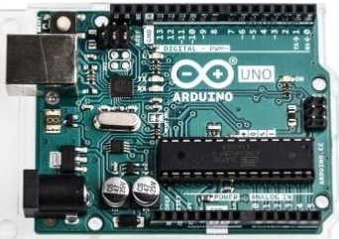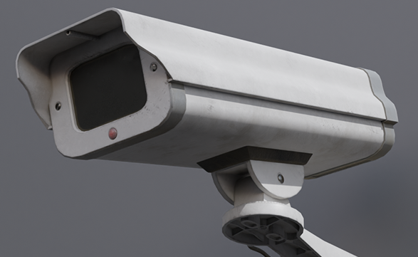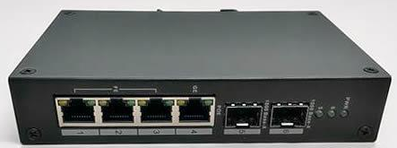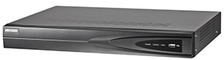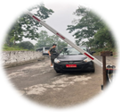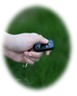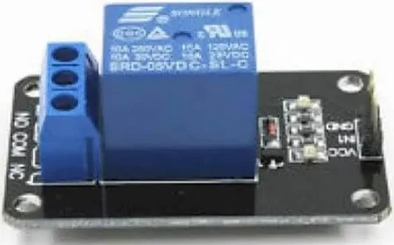
Vehicle arrival
Vehicle departure
CCTV cameras
PoE switch
NVR
Ethernet cable
PC
Registered
Not registered
Arduino UNO
Boom barrier gate
Command to open/close gate
Manual control
Remote control key
Single channel relay
- Overview of our gate control system using ANPR.
enhance accuracy. These improvements give YOLOv8 higher performance metrics compared to previous versions.

Real-Time Performance
This is especially true for YOLOv8, as it was built to deliver high detection accuracy without lengthy processing times. It could impact real-time performance. Optimization efforts lower the system's load. This ensures that even when analyzing high-resolution images, it does not consume excessive computational resources. As a result, it is ideal for use in AV (Audio Visual), video monitoring, and real-time video processing where speed and accuracy are essential.

User-Friendly
The YOLOv8 model features user-friendly interfaces that allow for easy integration and testing without need of programming skills. COCO (Common Objects in Context) offers comprehensive documentation, complete with step-by-step instructions and simplified interfaces. These resources support common tasks such as data upload and import, model training and deployment, and results visualization. These streamlined processes facilitate broader adoption of YOLOv8, making its applications more accessible in today’s world.

Framework Compatibility
It is highly versatile and compatible with leading deep learning development environments such as PyTorch and TensorFlow. This compatibility helps users maximize the benefits of each platform, like easy debugging in PyTorch or scalability in TensorFlow. The design of the provided model allows for easy deployment into different environments and flexibility between various frameworks, which is important in current research and development as well as in large-scale production systems where YOLOv8 can be used.

YOLOv8 Architecture
The YOLOv8 architecture is divided into two main parts: the backbone network and the detection head. Each part consists of multiple layers and modules that work together to perform feature extraction and object detection [8].
The feature extraction is performed by the backbone, which is designed using a stack of convolutional layers and C2F (Coarse-to-Fine) modules. The architecture of the backbone network is described as follows:
- Conv Layers: The initial convolutional layers are used to extract basic features from the input.
- C2F Modules: Shortcuts that link features boost the effectiveness of representation, allowing the model to learn multiscale features more efficiently.
- SPPF (Spatial Pyramid Pooling Fast): Combining features at different scales enhances the model's capability to detect objects of various sizes.
The detection head is configured for predictions, including the final object detection layers:
- Conv Layers: Proceed with processing beyond the feature extraction stage.
- Concat and Upsample: Improve detection by combining features from different layers and scales.
- Detect Layers: Generate predictions for the ends that should include bounding boxes, object classes, and segmentation masks.

Implementation and Performance of YOLOv8
For vehicle detection, we use a pre-trained YOLOv8 model, which is very fast and effective at identifying millions of vehicles with high accuracy. The model serves as the foundation of our system, ensuring dependable performance across all test scenarios.
The YOLOv8 model has been retrained for number plate detection using a custom dataset that includes 21,174 training images, 2,048 validation images, and 1,020 testing images, along with an additional 250 captured images. The model's performance after training on this dataset shows the following metrics: Average Precision 99%, Precision 97.6%, and Recall 97.1%. These metrics demonstrate the model's ability to detect and locate number plates accurately.

Software Development
In this section, we discuss software development, including machine learning and GUI (Graphical User Interface). We begin with the YOLOv8 machine learning model.

Data Collection
In developing the ANPR system based on YOLOv8, we carefully collected a diverse dataset essential for robust model performance. Using web scraping, we obtained 24,492 images from Kaggle and Roboflow for training the number plate recognition model. These images are divided into 2048 for validation, 1020 for testing, and 21,174 for training. Additional 250 hand-captured images are split between the training and validation sets to increase variability and improve the model's robustness. For vehicle detection, we use a pre-trained model based on the COCO dataset, which includes 118,287 training images, 5,000 validation images, and 20,288 test images [9]. This thorough approach helps ensure our ANPR system can accurately recognize and process license plates in various real-world conditions.

Data Preprocessing
After compiling a diverse dataset from various sources, careful preprocessing is essential to optimize it for training the YOLOv8 model. The initial steps involve thorough data cleaning using OpenCV to remove duplicates and improve image quality, ensuring dataset integrity and readiness for effective model training. Following that, annotation using tools like CVAT (Computer Vision Annotation Tool) and Roboflow focuses on accurately labeling objects of interest, especially number plates, to reduce ambiguity and support robust model learning.
To increase dataset variability and improve model generalization, a variety of augmentation techniques are applied. This includes image flipping, rotation, and adjustments to brightness, contrast, and saturation levels. By introducing these variations, the dataset mimics diverse real-world scenarios, thereby boosting the YOLOv8 model’s adaptability and performance across different environmental conditions. Overall, these preprocessing techniques are essential for preparing the dataset for training, providing the model with a solid foundation to achieve accurate and reliable license plate detection and localization in challenging real-world environments.

Model Training
After data preprocessing, it is necessary to train the model for number plate detection by setting parameters such as weights and epochs and loading the directory where the training dataset is saved. We use 100 epochs and a batch size of 8 during training. The mean average precision achieved is 99%, with a precision of 97.6% and a recall of 97.1%. Fig. 2 shows the training progression results through graphs. These graphs display the decreasing training and validation losses as epochs increase, indicating that the model is learning well. Additionally, the precision improves with more epochs, reflecting increased accuracy as training progresses. The model is then tested again with the training set to verify performance, resulting in the same high precision level.

Model Testing
After training the model, it is tested again using the training set for verification. Fig. 3 shows the recognition of the number plate location, and Fig. 4 presents the test results.

Database Management System
We adopt MySQL as the DBMS (Database Management System) within the ANPR architecture. MySQL plays a vital role in managing and organizing data collected from live video feeds and processed number plate recognition [10]. The system utilizes structured tables such as registered number plates, detected number plates (entry and exit), and daily records to systematically store information like vehicle identifiers and timestamps. Figs. 5-7 show the registered number plate table, the detected number plate entry table, and the daily records table, respectively. MySQL’s capabilities ensure data integrity, efficient query performance for vehicle tracking, and scalability for future system expansion. Security features protect sensitive vehicle information, contributing to a robust and reliable ANPR solution.
MySQL enables efficient tracking of vehicle entries and exits through organized data storage and retrieval systems. It supports SQL queries to quickly access specific information, such as vehicle movements based on timestamps and number plates. The DBMS maintains data accuracy through constraints, indexes, and transactional support, ensuring precise and consistent vehicle tracking records. Its scalability allows smooth adjustment to higher vehicle volumes, maintaining operational efficiency. MySQL’s security features protect vehicle data from unauthorized access, ensuring privacy compliance and increasing overall reliability in managing vehicle access within the premises.

GUI Development
To improve user accessibility, a user-friendly web interface has been developed for the ANPR system. This interface allows users to register license plates without accessing the database directly. Additionally, it provides a feature that enables the user to keep daily records and view the last five entries across all database tables, namely: Registered license plates, Detected license plate entries, Detected license plate exits, and Daily records. The GUI offers an intuitive platform for users to interact with the ANPR system, enhancing overall usability and convenience. The framework used to develop this web-based GUI is a Flask application. It utilizes Python, HTML, and CSS as its core languages. Fig. 8 shows the developed GUI.

Hardware Implementation
After completing software development, we implement the hardware described in Section 2. In particular, we focus on the installation of the camera and boom barrier gate in this section, because camera positioning is crucial for the accuracy of our gate control system.

Camera Installation Setup
The cameras are strategically installed at the gate, approximately four feet high. One camera faces the entry side, while the other faces the exit point, each mounted on an identical pole. This setup provides complete video coverage for vehicle monitoring, including processing and license plate recognition. During installation, many factors are considered to optimize the cameras’ performance.
- Field of View: The cameras certainly have a clear, unobstructed view of incoming and outgoing vehicles.

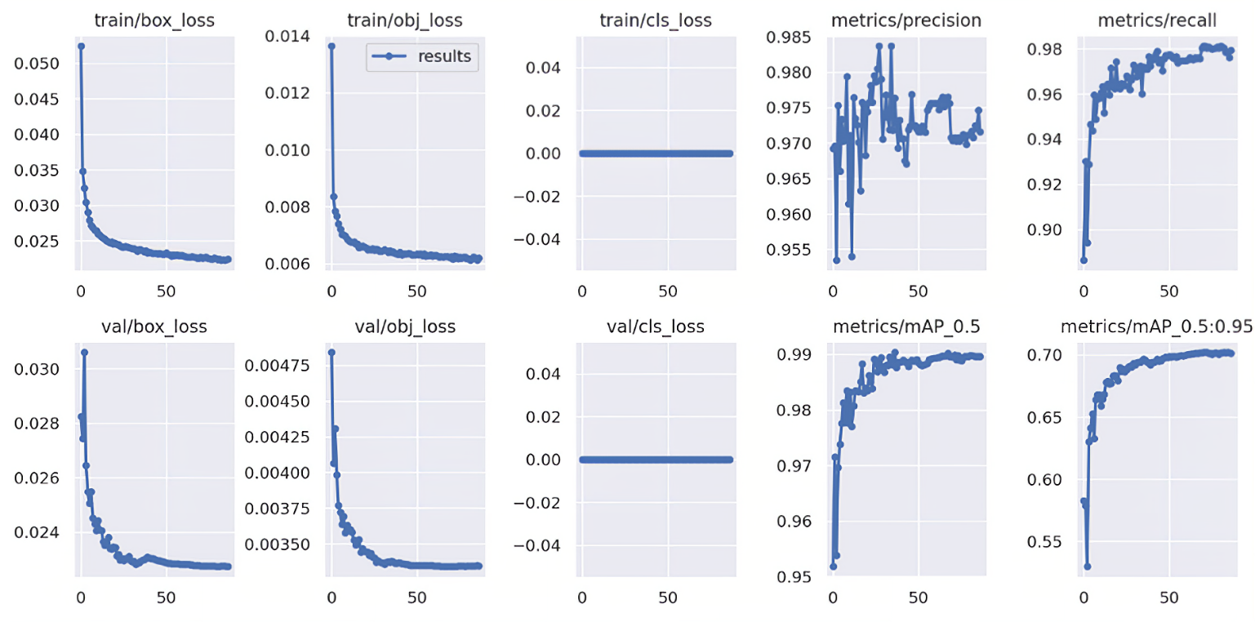
- Training progression results of the model.

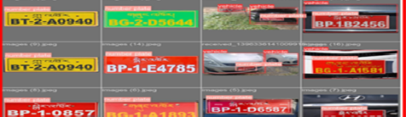
- Testing dataset of number plates.
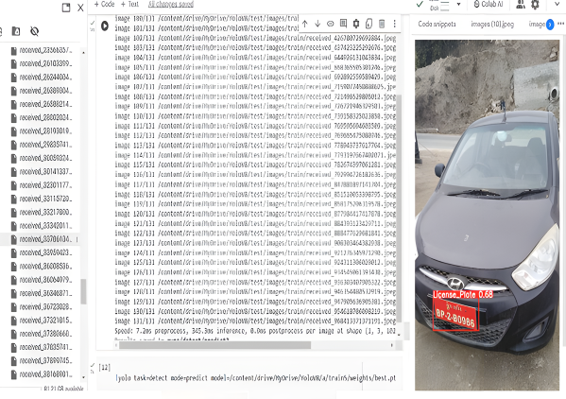
- Model test results for verification.
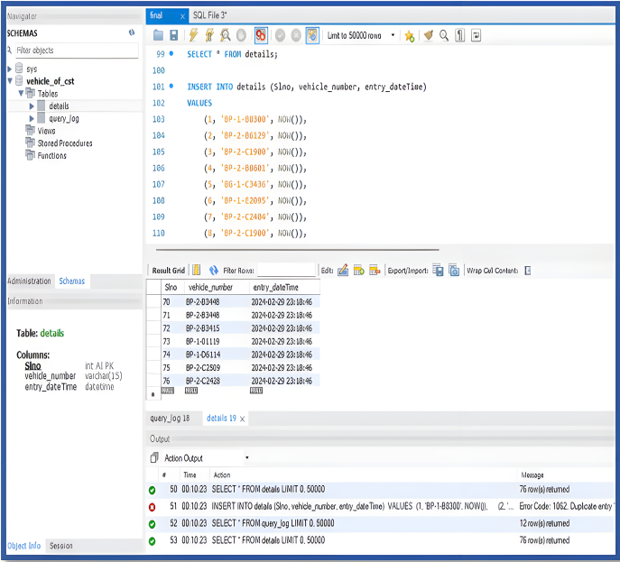
- Registered number plate table.
- Lighting Conditions: Accounting for changing lighting conditions, such as day and night visibility, the IR night time vision feature is effectively utilized.
- Weatherproofing: Ensuring the cameras are protected from environmental factors such as rain, dirt, and extreme temperatures, the camera has waterproof functionality.
- Cable Management: Proper routing and securing of CAT6 cables are done to prevent damage and ensure reliable connectivity.
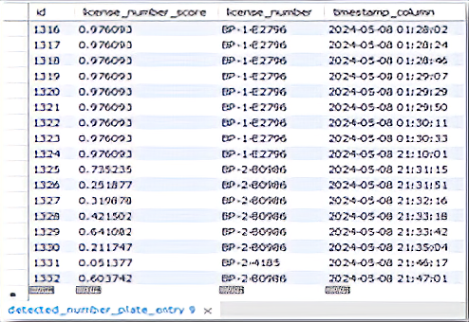
- Detected number plate entry table.
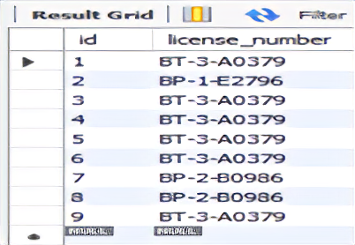
- Daily record table.
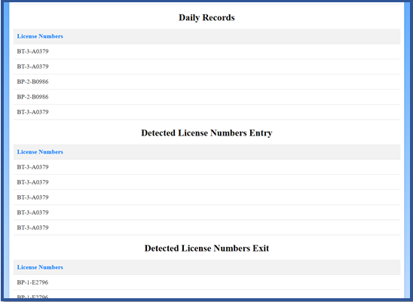
- Developed GUI for the system.
- Power Supply: A PoE switch is used to supply power and network connectivity to the cameras via a single cable, simplifying the installation process.

Camera Position Setting Results
To identify the best camera settings, we conducted a series of tests at different distances and angles. Table I summarizes the results. Here, we mounted the camera at 4.2 feet height.
According to Table I, no readings of the number plate occur in test cases 1-3. This is due to the inappropriate camera angles that are higher than forty-five degrees. These angles cause the number to be skewed and not correctly read. We address this issue by adjusting the camera height, distance from the vehicle, and the camera angle, which are optimized through multiple trials to achieve correct detections at 4.2 feet
- Camera Position Setting Results
Test Case | Distance from Camera (ft) | Camera Angle (Degrees) | Confidence Score
1 | 15 | 0 | No Reading
2 | 13 | 0 | No Reading
3 | 11 | 0 | No Reading
4 | 8 | 0 | 97.42%
5 | 8 | 15 | 97.61%
6 | 8 | 30 | 39.62%
7 | 7 | 15 | 97.62%
8 | 7 | 15 | 97.62%
9 | 7 | 15 | 97.62%
10 | 7 | 15 | 97.62%

height, 7 feet distance, and 15 degrees perspective.

Boom Barrier Gate Installation
Before gate installation, we perform a thorough site evaluation to decide the placement of boom barrier. For which we build cemented base where the screws are installed to hold the boom barrier.
Finally, we securely mount the base unit on a concrete foundation to ensure balance. The stage, horse gear transmission, and curved crank arm three-link structure are then assembled, following the manufacturer's guidelines [11].

Results and Discussion
Initially, our gate system exhibited very high delay times when using the CPU; processing times ranged from 3 to 4 minutes, with an average inference speed of 110 milliseconds per frame. This delay was eliminated by switching to a GPU (NVIDIA GeForce GTX 1650), which achieved 89.94 FPS, fully satisfying the high-speed detection requirements of industrial applications [12]. The GPU reduced processing time significantly and made it ten times faster, averaging only ten milliseconds per frame for inference. The increase in processing speed was mainly due to the CUDA (Compute Unified Device Architecture) driver— a processing speed-up technology exclusive to GPUs, while the rest of the code remained unchanged [13]. Additionally, we implemented frame-skipping logic, which further reduced processing delays, bringing the actual processing time down to 8-12 seconds.
Thus, the developed gate control system demonstrates proficiency, high accuracy, and high speed in detecting license plates and vehicles. The system underwent rigorous testing, with a total of 2,395 detections, of which 2,370 were correct and 48 were incorrect, resulting in an accuracy level of 97.99%. Processing time ranged from 8 to 12 seconds, enabling it to operate effectively in real-time applications.
The vehicle was detected using the pre-trained YOLOv8 model on the COCO dataset, which contains 118,287 training images, 20,288 testing images, and 5,000 images used for validation.
Regarding the number plate recognition system, the YOLOv8 model was trained on a dataset of 21,174 images, with a test set of 1,020 pictures and a validation set of 2,048 images on the RoboFlow platform. It demonstrates impressive performance metrics, with a mAP of 99%, precision of 97.6%, and recall of 97.1%. In other words, the model shows a high level of accuracy and reliability in detecting license plates in images.

Conclusion
We successfully developed an automatic gate control system using ANPR with a 97.99% accuracy rate. This innovation simplifies access control, removing the need for manual supervision and boosting security. Future plans include vehicle classification and advanced algorithm development to improve system performance and broaden capabilities in access management and security.

Acknowledgment
The authors are thankful to Electronics and Communication Engineering Department, College of Science and Technology, Royal University of Bhutan for financial support.

References
- Lubna, N. Mufti, and S. A. A. Shah, “Automatic number plate recognition: A detailed survey of relevant algorithms,” Sensor, vol. 21, no. 9, Apr. 2021, Art. no. 3028. doi: 10.3390/s21093028.
- M. T. Qadri and M. Asif, “Automatic number plate recognition system for vehicle identification using optical character recognition,” 2009 International Conference on Education Technology and Computer, Singapore, 2009, pp. 335–338, doi: 10.1109/ICETC.2009.54.
- N. L. Yaacob, A. A. Alkahtani, F. M. Noman, A. W. M. Zuhdi, and D. Habeeb, “License plate recognition for campus auto-gate system,” Indonesian J. Elect. Eng. Comput. Sci., vol. 21, no. 1, pp. 128–136, Jan. 2021, doi: 10.11591/ijeecs.v21.i1.pp128-136.
- Y. Jamtsho, P. Riyamongkol, and R. Waranusast, “Bhutanese license plate recognition using Hu’s moments and centroid difference,” 2019 4th International Conference on Information Technology (InCIT), Bangkok, Thailand, 2019, pp. 1–6, doi: 10.1109/INCIT.2019.8912128.
- S. Nehar, S. Teja, L. Vattikuti, S. V. Chintala, S. Tummalapalli, and M. Eda, “Automatic number plate recognition,” Amer. J. Electron. Commun., vol. 4, no. 3, pp. 16–23, Jan. 2024, doi: 10.15864/ajec.4304.
- A. Al Noman, N. J. Mila, A. H. Bornil, A. Mazumder, N. Khan, and M. H. I. Bijoy, “BanglaPlate: Automated vehicle number plate detection and recognition using YOLOv8,” 2025 International Conference on Electrical, Computer and Communication Engineering (ECCE), Chittagong, Bangladesh, 2025, pp. 1–6, doi: 10.1109/ECCE64574.2025.11013529.
- M. Sohan, T. Sai Ram, C. V. Rami Reddy, “A review on YOLOv8 and its advancements,” in Proc. Int. Conf. Data Intelligence and Cognitive Informatics (ICDICI 2023), Jan. 2024, pp. 529–545, doi: 10.1007/978-981-99-7962-2_39.
- RangeKing, “Brief summary of YOLOv8 model structure.” GitHub. Accessed: Aug. 1, 2025. [Online.] Available: https://github.com/ultralytics/ultralytics/issues/189
- S. Cepni, M. E. Atik, and Z. Duran, “Vehicle detection using different deep learning algorithms from image sequence,” Baltic J. Modern Comput., vol. 8, no. 2, pp. 347–358, Aug. 2020, doi: 1022364/bjmc.2020.8.2.10.
- S. Gopikrishnan, A. K. Madduru, K. Karamsetty, and D. R. Ravuri, “Smart parking system with automated vehicle log using Haar cascade classifier ANPR,” in Proc. Int. Conf. Comput. Intell. in Data Sci. (ICCIDS 2023), Jul. 2023, pp. 266–286, doi: 10.1007/978-3-031-38296-3_21.
- Smarttie India Enterprise, “Barriers.” Smarttie India Enterprise Accessed: Aug. 1, 2025. [Online.] Available: https://www.smartie.in/products/barriers
- Z. Wu, Y. Zhang, Z. Zhang, F. Shen, L. Li, X. He, H. Zhong H, and Y. Zhou, “An improved YOLOv8n-Bbased method for detecting rice shelling rate and brown rice breakage rate,” Agriculture. vol. 15, no. 15, Jul. 2025, Art. no. 1595. doi: 10.3390/agriculture15151595.
- D. Kirk, “NVIDIA CUDA software and GPU parallel computing architecture,” in Proc. 6th Int. Symp. Memory Management (ISMM’07), Oct. 2007, pp. 103–104, doi: 10.1145/1296907.1296909.

