Implementation of Remote Monitoring and Control Functions on Conventional 3D Printer

Kelden Sherab Lhamo
Instrumentation and Control Engineering Department
College of Science and Technology,
Royal University of Bhutan
Phuentsholing, Bhutan
keldenlhamo7@gmail.com
Tshering Wangmo
Instrumentation and Control Engineering Department
College of Science and Technology,
Royal University of Bhutan
Phuentsholing, Bhutan
tshering513wangmo@gmail.com
Ngawang Choejor Wangdi
Instrumentation and Control Engineering Department
College of Science and Technology,
Royal University of Bhutan
Phuentsholing, Bhutan
ngawangchoejorw@gmail.com
Kazuhiro Muramatsu
Electronics and Communication Engineering Department
College of Science and Technology,
Royal University of Bhutan
Phuentsholing, Bhutan
kazuhiromuramatsu.cst@rub.edu.bt
Srijana Ghalley
Instrumentation and Control Engineering Department
College of Science and Technology,
Royal University of Bhutan
Phuentsholing, Bhutan
srijanaghalley7@gmail.com

Abstract—The main issues with traditional 3D printing technology are human involvement, physical contact, and limited remote control capabilities. A drawback of this 3D printing is that it is not fully automated or accessible to the public, which slows down the process. This paper aims to design and develop a remote 3D printing system to improve the standard process. The system also includes wireless connectivity, allowing users to upload design files wirelessly to the printer, eliminating the need for USB flash drives or SD cards. Additionally, incorporating a camera module allows the printing process to be streamed in real-time via a dedicated website or mobile app. Our system consists of the original QIDI Tech 1 3D printer, a PC, a Raspberry Pi 4 Model B 4GB, and the Raspberry Pi camera module v2. The QIDI Tech 1 3D printer features a closed-source motherboard with an ATmega 2560 microcontroller. Software development is divided into frontend and backend. The frontend, visible to users, manages the user interface and interactions. It is built with HTML (HyperText Markup Language) for content structure, JavaScript for interactivity, and CSS (Cascading Style Sheets) for styling, all within the React JavaScript framework. The backend manages server-side operations and hardware interactions, including the 3D printer. Its core is the REST (REpresentational State Transfer) API (Application Programming Interface), which connects various services.
Keywords—remote 3D printing, wireless connectivity, real-time monitoring, Raspberry Pi, REST API

Introduction
The use of 3D printing technology has transformed the world by introducing new and innovative ideas to the market. The ability to create complex shapes from digital models and produce objects with intricate geometries has affected manufacturing, prototyping, and even surgery [1]. However, some issues still persist today, particularly concerning accessibility, convenience, and remote control. One challenge is how to transfer design files to traditional 3D printers. The usual method involves physically transferring data via thumb drives or SD cards, which, besides being logistically cumbersome, cannot be easily integrated into digital processes.
To overcome these limitations, we present a unique solution: a remote 3D printer system. The idea is to establish a wireless connection for 3D printers, enabling design files to be sent from computers, smartphones, or tablets via the Internet. In addition to streamlining the printing process, our system enables users to initiate, monitor, and schedule printing jobs from any location, thereby removing geographical barriers.
Furthermore, we integrate a camera module into a 3D printer system. The camera streams real-time visuals of the printing process to users through their dedicated web platform or mobile app. Its features include monitoring, displaying print progress, and providing a platform for error detection, troubleshooting, and quality assurance before completing a print job.
The integration of wireless connectivity and real-time monitoring is set to revolutionize the additive manufacturing industry. Specifically, it links the physical and digital worlds, allowing users to design, start, and manage the creation of objects through an easy-to-use interface accessible from anywhere worldwide. In this context, we aim to enhance the overall goal of making 3D printing more accessible and to strengthen connections among various manufacturing entities.
For this purpose, we utilize IoT and temperature sensors for remote monitoring, with cloud computing providing access, storage, and data processing via the Internet. Additionally, we focus on cybersecurity to ensure secure operations and data protection. Moreover, we aim to enhance 3D printing by enabling remote control via Wi-Fi connectivity.
This paper consists of six sections. Section 2 covers the literature review. The system architecture is explained in Section 3. Hardware configuration is described in Section 4, which also includes software development. Section 5 presents the results. Finally, Section 6 provides the conclusion and future scope.

Literature Review
3D printing, or additive manufacturing, involves creating a 3D object from a digital model by adding material layer by layer [1]. The technology emerged in the early 1980s, with the first documented photopolymer rapid prototyping system appearing in 1981 [2]. In 1984, Charles Hull, founder of 3D Systems Inc., developed a prototype based on SLA (StereoLithography) technology [3]. Originally, the process was costly and not widely accessible. However, in the early 2000s, prices decreased, allowing 3D printers to be adopted across various industries [4]. Despite their global popularity, there are no records of remote 3D printers in Bhutan. Remote 3D printing involves operating and overseeing a 3D printer from a distance. This can be achieved using a variety of software, hardware tools, and equipment.
Industry 4.0 combines digital and physical worlds, utilizing technologies like IoT (Internet of Things), AI, and cloud computing [5]. Thus, it enables real-time monitoring and control for 3D printing.
Andrade et al. [6] investigated expanding access to 3D printing through the Internet. They identified software like 3DPrintBox and OctoPrint, which enable remote printer control. OctoPrint, their preferred choice, is open-source and highly customizable, supported by a strong community [7]. In addition, Gujar et al. [8] showed how to print things remotely and monitor or aspects of a 3D printer using Raspberry Pi and Octoprint.
In 2020, remote printing was introduced for the dddrop smart module, enabling comprehensive management of 3D printing through both mobile and desktop applications. It includes live monitoring via a built-in camera, with the option to record footage for later review. Users can also receive email updates on print job status, allowing them to track progress without constantly being near the printer [9]. Similarly, we design a 3D printer with remote-controlled camera monitoring.
Bernal et al. [10] addressed challenges with Universidad Cooperativa de Colombia’s 3D printing equipment by proposing a remote access laboratory. Their prototype used a Melephant Make block 3D printer with an open-source design and high XY resolution. The system, managed through a computer application developed with XAMPP Control Panel and NetBeans, enables remote printer access and monitoring via webcams. This setup streamlines laboratory activities, despite some slight inefficiencies due to physical contact. In contrast, our focus is solely on creating a remote 3D printer, different from their laboratory-centered approach.
Kakade et al. [11] used IoT for real-time monitoring of open-ware FDM (Fused Deposition Modeling) 3D printers to fix common issues like material jamming and reliability problems. They proposed an IoT-based system for remote control and problem detection during printing. They used the Raspberry Pi for a web interface and OctoPrint for G-code transmission. A rotary encoder and load cell were added for material flow and weight sensing. Unlike their focus on solving FDM limitations, we improve remote functionality with a custom web interface.

System Architecture
Our system is composed of the original QIDI Tech 1 3D printer, a PC, the Raspberry Pi 4 Model B 4GB, and the Raspberry Pi Camera Module v2. The QIDI Tech 1 3D printer uses a closed-source motherboard with an ATmega 2560 microcontroller. Fig. 1 provides an overview of our implementation of remote monitoring and control for the 3D printer using the Raspberry Pi 4.
The Raspberry Pi 4 is connected to the 3D printer using a USB A to B cable to establish a physical connection between the Pi and the printer's control board. Additionally, the Raspberry Pi camera is attached to the Pi with an FPC (Flexible Printed Circuit) camera cable. Lastly,
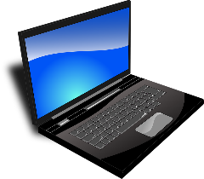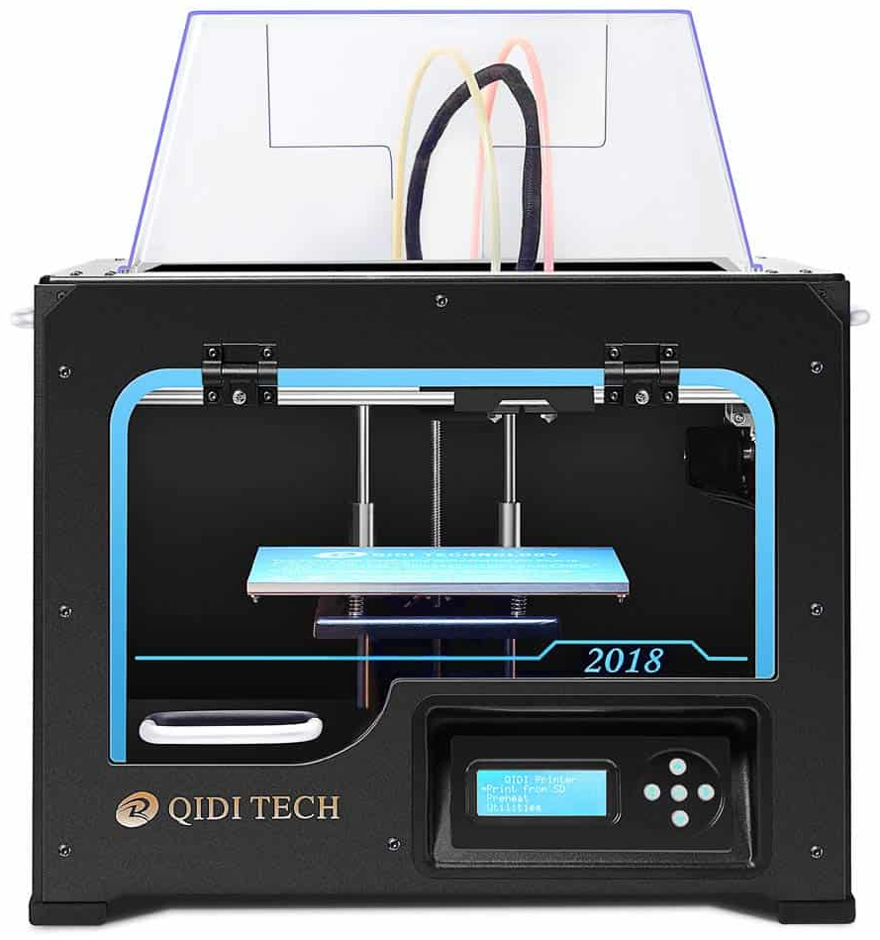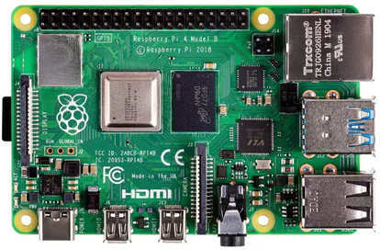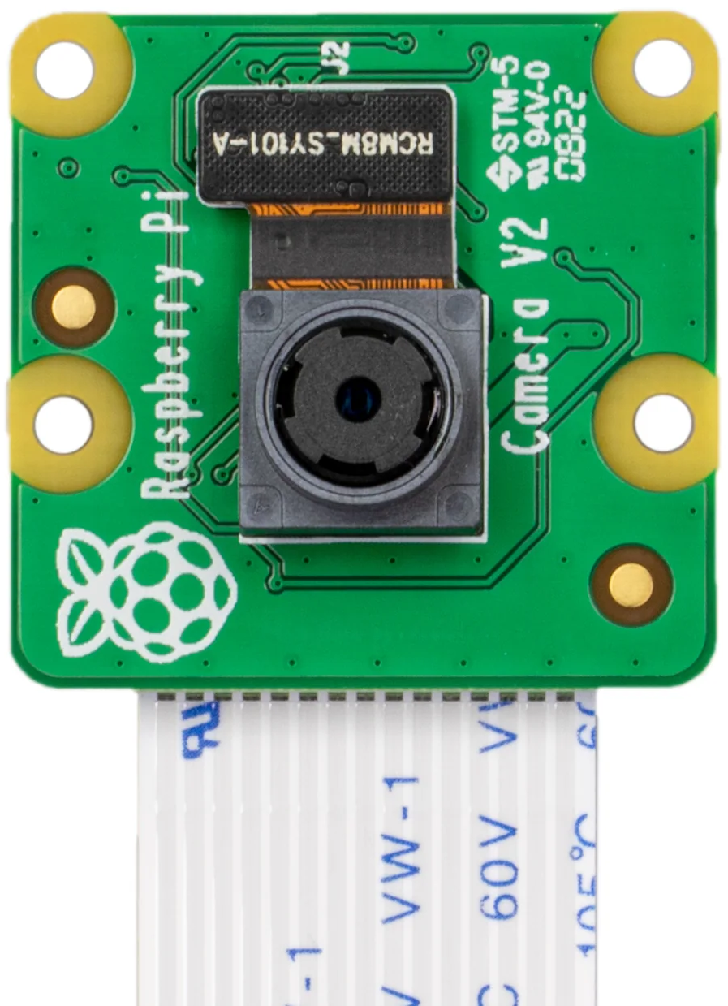
- System overview.
communication between the Raspberry Pi 4 and the PC is maintained via Wi-Fi.
In monitoring the printing process, the camera captures a real-time video stream and sends it to the Pi via the FPC cable. Then, the Raspberry Pi transmits the video stream to the PC over Wi-Fi. Finally, the printing process appears on the PC.
The printer temperature is monitored as follows: First, the motherboard on the 3D printer sends the temperature data to the Raspberry Pi via USB cable. Then, it is transmitted from the Pi to the PC over Wi-Fi. Finally, the temperature is displayed on the PC.
In the case of remote control, the user sends commands from the PC to the Raspberry Pi 4 via Wi-Fi. Then, they are transmitted from the Pi to the motherboard of the 3D printer through the USB cable. Finally, the motherboard manages the printing process based on the commands.

Software Development
In this section, we describe the details of software development for our 3D printing system.

Software Architecture
Fig. 2 shows the overall software architecture. The frontend, visible to users, manages the user interface presentation and interaction. It is built with HTML (HyperText Markup Language) for content structure, JavaScript for interactivity, and CSS (Cascading Style Sheets) for styling, all within the React JavaScript framework.
The backend manages server-side functions and hardware communication, including the 3D printer. Its core is the REST (REpresentational State Transfer) API (Application Programming Interface), which connects various services [12]:
- Printer Service: Handles print tasks and monitors status.
- File Manager: Manages files and uploads.
- Temperature Service: Monitors and controls temperature.
- Camera Service: Streams live video.
- Target Settings Service: Adjusts printer settings.

- Over all software architecture.
JavaScript is used on the server side. The frontend communicates with the backend through the REST API. For example, uploading a 3D model triggers the File Manager to save the file and sends commands to the Printer service to start printing.

API Analogy
Imagine being in a restaurant, sitting in a chair, and looking at the menu to decide what to order. In a digital environment, this is similar to a user interaction with a website or app on a device. The REST API can be seen as a waiter who takes the user's request to the backend server system, which functions like the kitchen. This backend system handles the requests and prepares the necessary responses.
It begins with the user selecting an item or making a request through the client interface. This request is then sent via the REST API, which verifies its validity before forwarding it to the backend server system. The data processing occurs on the backend, where computations, data manipulation, or communication with databases and other services happen to generate a response. The REST API then returns this response to the client interface, similar to a waiter bringing food to a table. See Fig. 3.
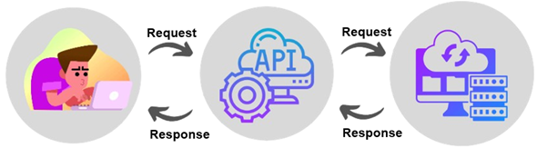
- API analogy.

Backend (Server)
The backend manages server-side operations and interacts with hardware devices like the 3D printer. The core component of the backend is the REST API, which defines how the frontend communicates with the server. The REST API provides several server-side services: the Printer service, which handles print tasks and their status; the File Manager, responsible for managing files and uploads; the Temperature service, used for controlling and monitoring the printer’s temperature; the Camera service, which provides a live video stream from the printer; and the Target Settings service, for adjusting printer settings. Additionally, JavaScript is used on the server side, as indicated by a small box labeled “JavaScript”.
The communication between system elements is based on information exchange between the frontend and backend using the REST API. Users interact with the frontend UI (User Interface), which communicates with the backend services. For example, when a user uploads a 3D model file through the frontend, the File Manager service is triggered to save the file and sends a message to the Printer service to begin printing.

UI (User Interface)
The UI includes several functional parts, each handling a specific aspect of the 3D printing process.

Sign-in / sign-up page: To access the webpage, users are asked to sign up and then sign in for security reasons. We use Firebase Authentication to verify users with their email addresses and passwords for sign-in [13].

Temperature control: This control panel allows users to set the temperatures of the toolhead 1, toolhead 2, and bed of the 3D printer. Fig. 4 shows a flowchart of the temperature control.
The process begins with the execution of the TempTarget component. During this phase, state variables are declared and initialized to control the temperatures of the tool heads and the bed, as well as the corresponding LED colors. These variables are useful for monitoring and displaying the current

- Flowchart of temperature control.
temperatures and indicating whether these temperatures are within limits. After initialization, the component calls the temperature control functions, which are designed to manage changes in the temperatures of Tool Head 1, Tool Head 2, and the Bed. These functions enable the active control of temperature within the application by increasing or decreasing temperatures based on user inputs.
In addition, the component sets target temperatures for Tool Head 1, Tool Head 2, and the Bed. It uses HTTP POST requests through Axios to communicate with the server and adjust these temperatures as needed. After handling these basic functions, the component provides the necessary temperature controls in the user interface. These controls allow users to manage the temperature and set target temperatures for Tool Head 1, Tool Head 2, and the Bed, making temperature management more convenient and user-friendly. Finally, once the rendering process is complete, the component is no longer needed, and its lifecycle ends, providing users with a way to monitor and regulate temperatures within the application.
Fig. 5 shows the output of temperature target settings for the bed and extruders.

Temperature monitoring: Temperature can be monitored using the temperature gauge, as shown in Fig. 6. Also, a flowchart of the temperature gauge display is shown in Fig. 7.
The process begins by declaring state variables for temperatures using the React hook called useState. These variables, namely bedTemperature, tool0Temperature, and tool1Temperature represent the temperature data retrieved from the API. In a useEffect hook, an asynchronous function named fetchData is defined to handle data fetching. This function makes an Axios GET request to the specified API URL. When the response is received, it parses the data to obtain the bed and tool temperatures, and updates the state variables with the received values, ensuring the component always has the latest temperature information.
To make the temperature data in real time, the useEffect hook sets an interval to call the fetchData function every 2 seconds. Also, the hook includes a cleanup function to clear the interval and prevent memory leaks. When the component loads, the gauge elements are drawn to display the temperatures, updating to reflect the new values. This process of fetching data, updating the state, and rendering the UI
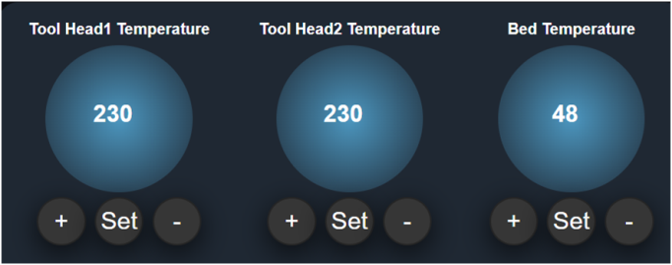
- Temperature control panel.
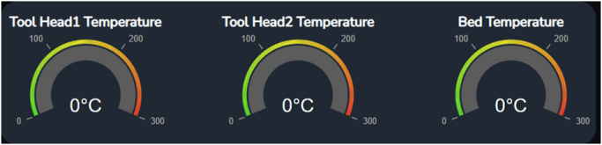
- Temperature gauge.

- Flowchart of temperature gauge display.
makes temperature monitoring fast and accurate, providing a real-time visualization of the bed and tool temperatures.
In addition, temperature can be visualized as a historical graph, as shown in Fig. 8.
The process begins with initializing the TempChart component, where state variables: chartData, loading, and error are declared using the useState hook. When the component renders, useEffect hook manages side effects. Inside this hook, the fetchData function is created and invoked to retrieve temperature data from the API. This action involves making a GET request to the specified API URL with Axios. When a response is received, the data is processed as follows. If it is valid, temperature data is extracted and used to update the state variables, loading is set to false, and any previous errors are cleared. If the response is invalid or an error occurs, the error state is set to an appropriate message, and loading is set to false.
To ensure that the temperature data being displayed is current, an interval to call the fetchData function is set to two seconds inside the useEffect hook. This allows for frequent updates of the temperature readings. The component’s rendering depends on the loading and error states. If loading is true, a message “Loading...” is displayed, and the line chart is rendered with the gathered data. If an error occurs, on the
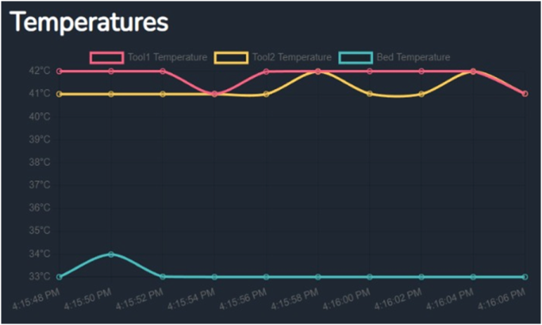
- Historical temperature graph.
other hand, the error message is shown. Thus, the component’s rendering process is completed, providing a live graphical display of temperature information.

Printing progress: A progress bar, detailed status, and remaining print time of the ongoing print job are shown in Fig. 9. In addition, a flowchart of the printing status display is shown in Fig. 10.

File management and details: Users can upload G-code files and manage print jobs, as shown in Figs. 11 and 12. File details can also be displayed. See Fig. 13.

Functional buttons: Function buttons are available to pause, resume, and cancel the printing process whenever the user needs to do so, as shown in Fig. 14.

Live camera feed: A real-time video stream of the printing process is displayed as shown in Fig. 15.
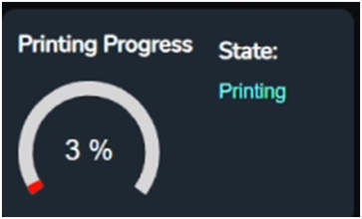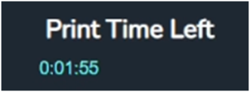
- Printing status and printing time left..

- Flowchart of printing status display.
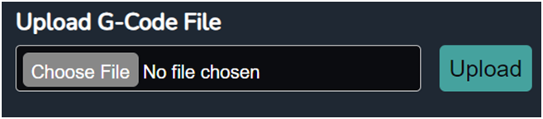
- File upload.
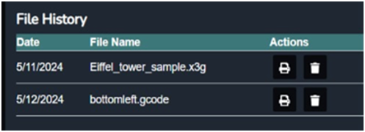
- File history.
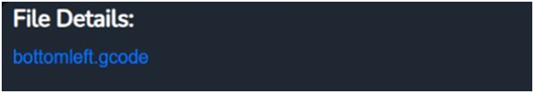
- File details.
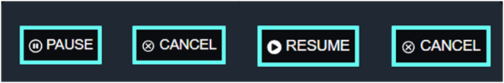
- Pause, Resume and Cancel Buttons.
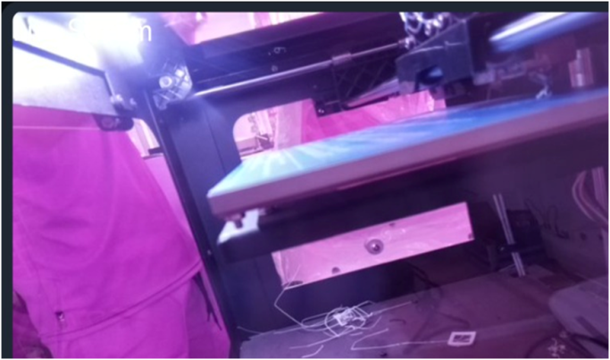
- Live camera feed.

Results
As shown in Figs. 16 and 17, the locally accessible web page displays a temperature graph for the hot end, bed, and chamber to help control and monitor 3D printing. Beneath the graph, dials show the current temperature for precise adjustments. On the right side, there are sections including “Printing Progress” for pausing or canceling print jobs, “File Details” for G-code file information, and “File History” for past printed files. A live camera feed enables remote observation of the printing process.
This interface enables efficient and successful 3D printing by integrating detailed data visualization and control. It allows users to 3D print G-code files via Wi-Fi, monitor the printing process remotely, and adjust functions such as temperature.
After deploying the web page, printing was attempted from the webpage, and several models were created via Wi-Fi during this process, as shown in Fig. 18.
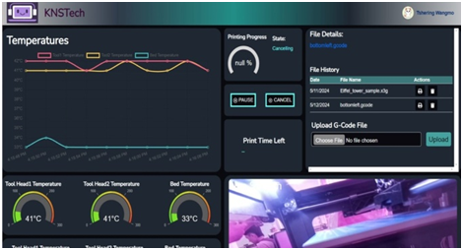
- Developed web page for remote 3D printing (1).
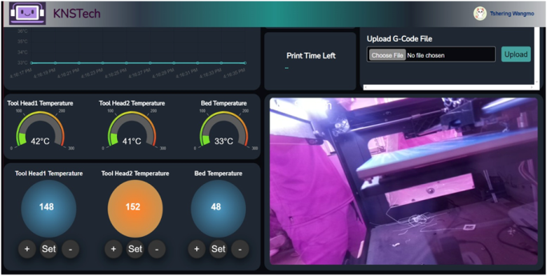
- Developed web page for remote 3D printing (2).
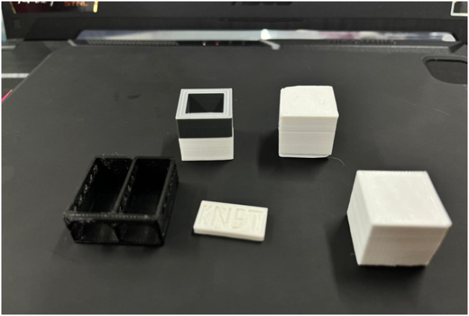
- Successful 3D printing.

Conclusion and Future Scope
The integration of 3D printing with wireless technology and real-time monitoring demonstrated how technological progress was shaping a more connected manufacturing future. Our system exemplified Industry 4.0 by seamlessly connecting the digital and physical worlds. Using the Raspberry Pi and cameras, it turns 3D printing into a remotely controlled art form.
As future scope, we outline the following four points:

On-premise server: Hosting the webpage on an on-site server will provide improved functionality and resource management compared to outsourcing. It requires robust security to ensure data protection and restricted access.

DNS (Domain Name System) integration: Integrating DNS services will enable users to access the webpage using easy-to-remember names. Dynamic DNS updates DNS records with IP (Internet Protocol) changes to maintain constant availability, while security and redundancy features ensure reliability and backup options.

WAN (Wide Area Network): Expanding network connectivity for remote access will improve system scalability by enabling users to connect from different locations.

Multiple 3D printer connection: Managing multiple 3D printers through the webpage will be possible by connecting up to three printers to a single Raspberry Pi via USB ports.

Acknowledgment
The authors thank the Electronics and Communication Engineering Department at the College of Science and Technology, Royal University of Bhutan, for their financial support. They also appreciate Mr. Koji Yamada, JICA (Japan International Cooperation Agency) Expert, for allowing the use of the QIDI Tech 1 3D printer.

References
- B. Berman, “3-D printing: The new industrial revolution,” Business Horizons, vol. 55, no. 2, pp. 155–162, Mar./Apr. 2012, doi: 10.1016/j.bushor.2011.11.003.
- H. Kodama, “Automatic method for fabricating a three-dimensional plastic model with photo hardening polymer,” Rev. Sci. Instrum., vol. 52, no. 11, pp. 1770–1773, Nov. 1981, doi: 10.1063/1.1136492.
- C. Hull, “Apparatus for production of three-dimensional object by stereolithography,” U.S. Patent 4 575 330, Mar. 11, 1986.
- M. Bazli. H. Ashrafi, A. Rajabipour, and C. Kutay, “3D printing for remote housing: Benefits and challenges,” Automat. Construction, vol. 148, Apr. 2023, Art. no. 104772, doi: 10.1016/j.autcon.2023.104772.
- H. Lasi, P. Fettke, H. G. Kemper, T. Feld, and M. Hoffman, “Industry 4.0,” Bus. Inf. Syst. Eng., vol. 6, pp. 239–242, Jun. 2014, doi: 10.1007/s12599-014-0334-4.
- T. F. Andrade, P. Abreu, M. T. Restivo, M. F. Chouzal, B. F. Santos, and J. Rodrigues, “Enhancing a 3D printer with online access,” Int. J. Interact. Mobile Technol. (iJIM), vol. 11, no. 5, pp. 44–55, Jul. 2017, doi: 10.3991/ijim.v11i5.7069.
- J. M. Arrieta, “Improvement and addition of features in 3D printing Open Source Software OctoPrint,” Trabajo Fin de Grado / Proyecto Fin de Carrera, E.T.S.I. y Sistemas de Telecomunicación (UPM), Madrid, Spain, Jul. 11, 2016. [Online]. Available: https://oa.upm.es/44473/8/TFG_JAVIER_MARTINEZ_ARRIETA.ppd
- M. P. Gujar, Y. Shinde, R. Madaki, and S. Nadaf, “IoT based 3D Printer,” Int. Res. J. Eng. Technol. (IRJET), vol. 6, no. 4, pp. 1015–1020, Apr. 2019. [Online]. Available: https://www.irjet.net/archives/V6/i4/IRJET-V6I4217.pdf
- dddrop, “Remote 3D Printing Using the dddrop Smart Module,” dddrop. Accessed: Aug. 1, 2025. [Online]. Available: https://dddrop.com/remote-3d-printing-using-the-dddrop-smart-module/
- B. Bernal, C. Amaya, J. Perdomo, and F. Simanca, “Design of a remote 3D printing laboratory prototype to be implemented at the Universidad Cooperativa de Colombia,” Turkish J. Comput. Math. Educ. (TURCOMAT), vol. 12, no. 10, pp. 7687–7696, Apr. 2021, doi: 10.17762/turcomat.v12i10.5730.
- S. Kakade, A. Mulay, and S. Patil, “IoT-based real-time online monitoring system for open ware FDM printers,” Materials Today: Proc., vol. 67. no. 2, pp. 363–367, Jul. 2022, doi: 10.1016/j.matpr.2022.07.210.
- M. Massé, REST API Design Rulebook: Designing Consistent RESTful Web Service Interfaces. Sebastopol, CA, USA: O'Reilly Media, 2011.
- P. J. Chougale and V. Yadav, and A. Gaikwad, “Firebase – overview and usage,” Int. Res. J. Modernization Eng. Technol. Sci. (IRJMETS), vol.3, no. 12, pp. 1178-1183, Dec. 2021. [Online]. Available: https://www.irjmets.com/uploadedfiles/paper/volume_3/issue_12_december_2021/17917/final/fin_irjmets1640499489.pdf

