Lightweight EMG Gesture Recognition Using Mixed-Precision Convolutional Neural Networks

Siyuan Shen
School of Integrated Circuits
Southeast University
Nanjing,China
220236584@seu.edu.cn
Hao Liu*
School of Integrated Circuits
Southeast University
Nanjing,China
nicky_lh@seu.edu.cn

Abstract—Convolutional neural networks (CNNs) are widely used in EMG-based motion recognition but typically incur high computational and memory costs, limiting deployment on edge or wearable platforms. To address this challenge, this paper proposes a lightweight CNN model based on mixed-precision quantization. By assigning different bit-widths (2/4/8 bits) to each network layer according to its sensitivity to precision, the proposed method significantly reduces both model size and inference complexity while maintaining classification performance. Specifically, we design a CNN model targeting five-class EMG gesture recognition based on the Ninapro DB1 dataset. The original model achieves an accuracy of 92.68% under FP32 precision, with a model size of 252.4 KB. By applying a layer-wise mixed-precision quantization strategy combining post-training quantization (PTQ) and quantization-aware training (QAT), the model is compressed to 36.58 KB (6.9× compression) with only a 3.1% accuracy drop. Hardware deployment on a RISC-V-based Milk-V Duo platform confirms the proposed approach’s suitability for embedded applications, achieving a 5.94× speedup over FP32 inference and a 1.65× improvement over INT8. These findings demonstrate the method’s potential for efficient, real-time EMG recognition in edge computing environments.
Keywords—EMG signal detection, convolutional neural network, mixed-precision quantization, gesture recognition, hardware-friendly

Introduction
With the rapid advancement of artificial intelligence and wearable technologies, Hand Gesture Recognition (HGR) has gained significant attention in fields such as bionic control, virtual reality, human-computer interaction (HCI), and rehabilitation medicine [1]. In recent years, electromyography (EMG)-based gesture recognition has emerged as a mainstream approach. EMG signals are electrical activities generated by skeletal muscles during contraction, which faithfully reflect the control commands from the nervous system to the muscles. As such, EMG serves as a vital physiological signal for decoding motion intentions. Among them, surface EMG (sEMG) is more commonly used in practical applications due to its non-invasive acquisition, ease of use, and suitability for real-time monitoring [2], playing an important role in constructing natural and responsive human-machine interfaces.
Despite the advantages of EMG signals in capturing muscle activity, challenges persist due to their high inter-subject variability, low signal-to-noise ratio (SNR), and poor repeatability. Effective EMG feature extraction and classifier selection are key to overcoming these issues. Traditional machine learning methods often rely on manual feature engineering, which is computationally expensive and lacks adaptability. Recently, Convolutional Neural Networks (CNNs) have demonstrated remarkable performance in both feature extraction and classification of EMG signals. CNNs can automatically learn class-specific features through convolutional layers, eliminating the need for complex preprocessing algorithms. Moreover, the hierarchical structure of CNNs allows for progressive feature abstraction and high-dimensional integration, thereby enhancing the modeling capability for complex EMG signals and improving robustness against noise and individual variability.
However, CNNs are intrinsically computationally and memory intensive. The increasing number of parameters and operations significantly raises demands on storage, memory bandwidth, and energy consumption [3][4], making them unsuitable for direct deployment on resource-constrained edge devices or wearable systems. To address this, recent studies have focused on model compression and acceleration techniques for CNNs that aim to reduce complexity while maintaining accuracy. Representative methods include pruning [5], quantization [6], and knowledge distillation [7]. Among them, quantization—which replaces floating-point parameters with low-bit fixed-point representations—is a key strategy for lightweight model design, effectively reducing storage requirements and computational cost.
Notably, mixed-precision quantization has attracted growing interest in recent years. Studies have shown that different layers in a CNN exhibit varying sensitivities to quantization precision [8][9]. Uniform quantization with a fixed bit-width often fails to balance model size and accuracy. Mixed-precision quantization addresses this issue by assigning different bit-widths (e.g., 2/4/8 bits) to different layers based on their sensitivity, thereby reducing memory access and computation while preserving model accuracy. This approach achieves a higher energy-efficiency ratio and is considered a promising direction for energy-efficient embedded deployment.
In summary, this paper addresses the challenge of efficient CNN-based EMG gesture recognition by proposing a lightweight mixed-precision quantization method that maintains high accuracy while significantly reducing model complexity. The main contributions are as follows:
- High-Accuracy Lightweight Model Design: We design a CNN for five-class gesture recognition based on the Ninapro DB1 dataset. The model adopts a stacked convolutional block structure and achieves 92.68% accuracy with only 64,626 parameters and a model size of 252.4 KB.
- Network Structure Optimization: We replace fully connected (FC) layers with global average pooling (GAP) and a maximum-value comparator, which together perform dimensionality reduction and classification, significantly reducing computational and memory overhead.
- Mixed-Precision Quantization Strategy and Validation: A layer-wise mixed-precision scheme combining PTQ and QAT compresses the model from 252.4 KB to 36.58 KB (6.9× reduction) with only a 3.1% accuracy drop, demonstrating strong effectiveness for EMG recognition.
- Hardware Deployment and Efficiency Verification: The quantized model is deployed on a RISC-V-based Milk-V Duo platform using a custom inference engine, achieving 5.94× and 1.65× latency improvements over FP32 and INT8 models respectively, confirming its suitability for edge deployment.
This work demonstrates the efficiency and practicality of mixed-precision quantization for EMG recognition tasks and provides a viable technical pathway for building intelligent EMG sensing systems targeting low-power edge computing and wearable deployments.

Related Works
Electromyography (EMG) signals have been widely used in applications such as gesture recognition, bionic control, and medical rehabilitation. Traditional machine learning methods—such as Random Forests, Decision Trees, and Support Vector Machines (SVMs) [10]–[13]—typically rely on handcrafted time-domain and frequency-domain features. While these methods can achieve basic classification performance, they are heavily dependent on feature engineering and exhibit limited generalization capability, making them unsuitable for deployment in low-power embedded systems.
With the advancement of deep learning, Convolutional Neural Networks (CNNs) have become the mainstream approach for EMG classification, thanks to their strong capability for automatic feature extraction and robustness [14]. Hu et al. [15] proposed a CNN-RNN hybrid architecture enhanced with an attention mechanism and designed a novel sEMG image representation, improving accuracy on the NinaPro DB1 dataset from 83.5% to 86.8%. Wei et al. [16] built a multi-view CNN framework to model sEMG channel information in parallel, and further boosted performance through a view-fusion module, achieving an accuracy of 88.2%. Chen et al. [17] introduced a transfer learning approach that fine-tunes only the fully connected layers for new users, resulting in nearly 19% accuracy improvement on the CapgMyo and NinaPro DB1 datasets.
To further enhance feature representation, Ozdemir et al. [18] transformed sEMG signals into three time-frequency images (STFT, CWT, and HHT) and used a pretrained ResNet-50 for classification, achieving 94.41% accuracy under cross-user conditions. Other studies have focused on architectural optimization and improved generalization. Xiong et al. [19] proposed a GLF-CNN model that fuses local and global information, achieving an average accuracy of 88.34% across multiple datasets—more than 40% higher than prior methods. Shi et al. [20] addressed multi-user generalization with an unsupervised domain adaptation framework based on CORAL alignment, achieving over 90% cross-user accuracy even with calibration from just two gestures.
However, the increasing complexity of deep models has led to a rapid growth in computation and storage demands, which poses a significant challenge in resource-constrained environments such as wearable and edge devices. As a result, model compression techniques have become essential to improve deployment efficiency and hardware adaptability. Buteau et al. [21] implemented an 8-bit quantized HD EMG gesture recognition system on TPU, systematically evaluating four quantization strategies. The best performance was achieved using root quantization with local fine-tuning, resulting in a 91.71% accuracy—an improvement of 0.96% over the floating-point model. Lu et al. [22] used TensorFlow Lite to apply 8-bit quantization, reducing the sEMG model size from 772 KB to 73 KB, maintaining over 85% accuracy while supporting low-latency edge inference.
More recently, mixed-precision quantization has emerged as an effective solution for further improving compression efficiency. Huang et al. [23] proposed a Layer-wise Sensitivity-based Mixed-Precision Quantization (LSMQ) method, which improved the Top-1 accuracy of VGG16 by 7.31% while reducing model size by 3.4%. Wang et al. [24] designed and implemented the DPUmxp architecture supporting 2-bit and 8-bit mixed-precision quantization for weights and activations, achieving a peak performance of 58.9 TOPS on hardware. However, most existing EMG classification studies remain focused on pruning and fixed-precision quantization, with limited systematic exploration of mixed-precision strategies.

Methodology

Network Architecture
The proposed CNN for EMG gesture recognition consists of eight stacked convolutional blocks (Block1–Block8), followed by a dropout layer, a Global Average Pooling (GAP) layer, and a simple comparator, as illustrated in Fig. 1. Each convolutional block includes a convolutional layer, batch normalization layer, activation function layer, and a max-pooling layer. All blocks share the same kernel size, pooling window, and stride settings, which simplifies both software and hardware implementations.
To prevent overfitting, a dropout layer with a drop rate of 0.2 is applied after the final convolutional block, randomly deactivating 20% of the neurons during training. To further reduce model complexity and computational cost, the architecture eliminates fully connected layers and the softmax function. Instead, a Global Average Pooling layer followed by a maximum value comparator is used. The final classification result is determined by the index of the channel with the maximum activation value.
TABLE I summarizes the complete hierarchical configuration of the proposed EMG-CNN network, which consists of eight stacked convolutional blocks. As shown in Fig. 2, the classification accuracy tends to saturate once the number of convolutional blocks reaches eight, and further increasing network depth brings diminishing returns while introducing unnecessary computational overhead. Therefore, considering the trade-off between model performance and architectural complexity, we empirically fix the number of convolutional blocks to eight.

- Specific Structural Parameters of CNN
 | Conv  Kernel*Number | Conv  Padding and Stride | Max Pool Kernel*Number | Max Pool  Stride
Block1 | 7*8 | 5,2 | 7*1 | 2
Block2 | 7*16 | 5,1 | 7*1 | 2
Block3 | 7*32 | 5,1 | 7*1 | 2
Block4 | 7*32 | 5,1 | 7*1 | 2
Block5 | 7*32 | 5,1 | 7*1 | 2
Block6 | 7*64 | 5,1 | 7*1 | 1
Block7 | 7*64 | 5,1 | 7*1 | 1
Block8 | 7*5 | 5,1 | 7*1 | 1

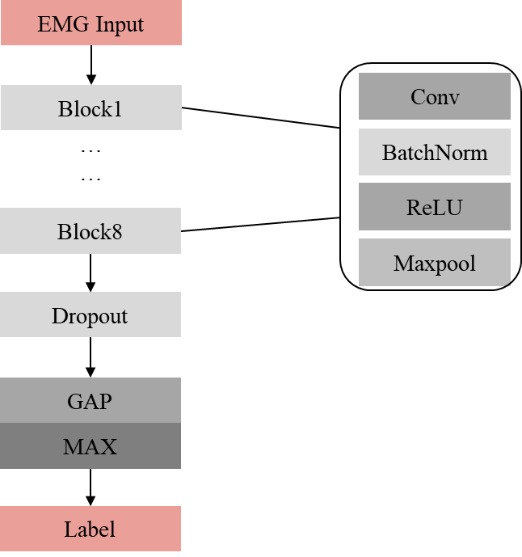
- EMG_CNN network architecture
Given that surface EMG (sEMG) signals are temporally correlated, non-stationary, and typically contaminated with noise, they present additional challenges due to their small amplitudes (in the microvolt range), strong individual variability, and time-varying properties. To effectively capture discriminative features, the network must balance local pattern extraction with sufficient temporal coverage. Hence, we adopt 1D convolutional layers with a kernel size of 7 as the backbone structure. This kernel width provides a suitable receptive field to cover one complete Motor Unit Action Potential (MUAP) cycle in the sEMG signal, enabling effective mid-range temporal feature learning. It also avoids the pitfalls of small kernels (which lack contextual information) and excessively large kernels (which lead to redundant parameters), thereby improving recognition accuracy while maintaining model efficiency.
Most convolutional layers adopt a stride of 1 to preserve temporal resolution, while a few shallow layers use a stride of 2 for down-sampling to reduce feature length and computation. All convolutional layers apply zero-padding of size 5, slightly larger than conventional “same-padding,” to mitigate edge
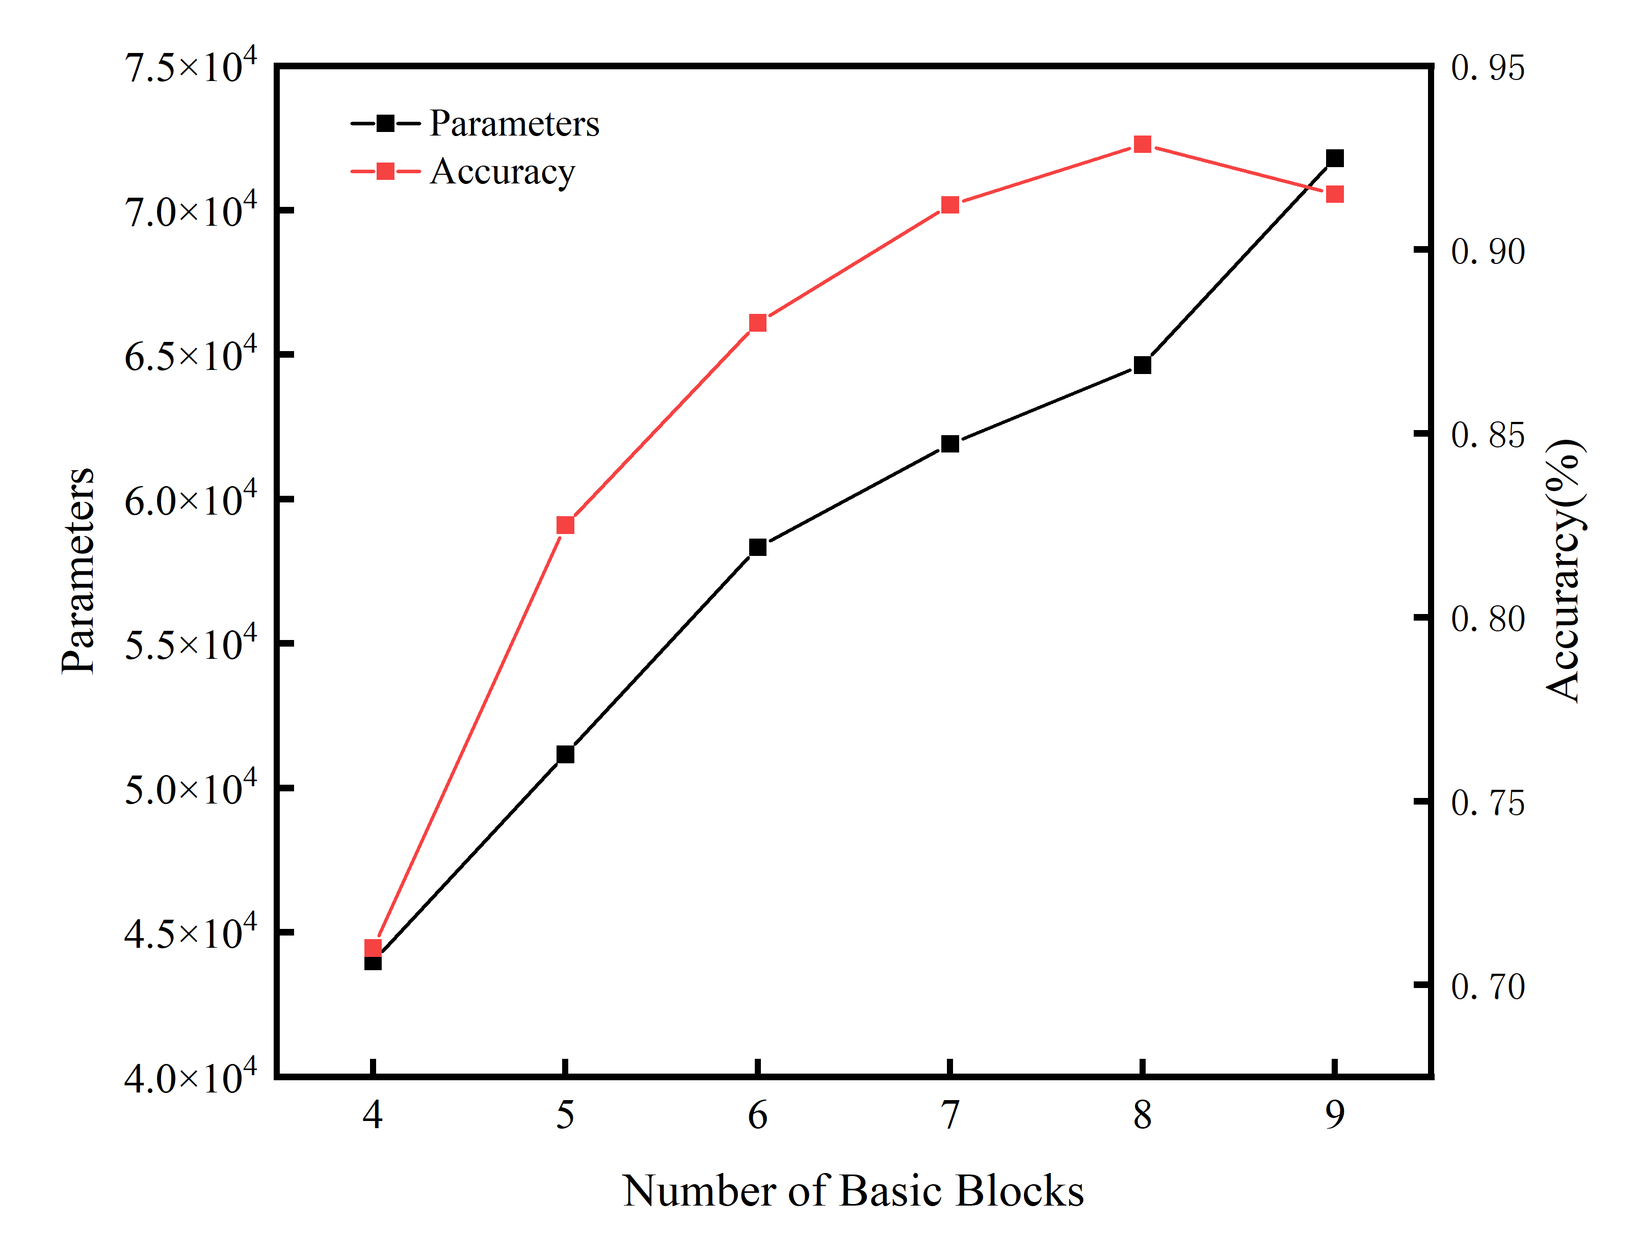
- Impact of network depth on parameter size and classification accuracy
feature loss, maintain feature alignment, and enhance pooling and multi-scale feature fusion in later stages.
TABLE II summarizes the output shape of each module in the EMG-CNN. The input is a single-channel temporal signal with shape (1, 1, 900). After passing through eight convolutional blocks and a dropout layer, the tensor shape becomes (1, 5, 7). The Global Average Pooling (GAP) layer then reduces each of the five channels to a scalar, yielding a 5-dimensional feature vector. A MAX layer performs an argmax operation on this vector to produce the final class index (ranging from 0 to 4). The GAP + MAX structure efficiently replaces fully connected layers and softmax, reducing computation and parameters while maintaining strong classification performance.

Mixed-Precision Quantization
Mixed-Precision Quantization is an effective compression technique proposed to address the high energy consumption and computational complexity of neural network models. Unlike conventional uniform-precision quantization methods, mixed-precision quantization dynamically assigns different bit-widths to different network layers based on their sensitivity to precision, aiming to achieve a trade-off between performance and resource consumption. Specifically, layers that are more sensitive to precision—such as input, output, or
key feature extraction layers—are assigned higher bit-widths
- Output Shapes of CNN
Block | Output Shape
EMG Input | (1, 1, 900)
Block1 | (1, 8, 223)
Block2 | (1, 16, 111)
Block3 | (1, 32, 55)
Block4 | (1, 32, 27)
Block5 | (1, 32, 13)
Block6 | (1, 64, 11)
Block7 | (1, 64, 9)
Block8 | (1, 5, 7)
Dropout | (1, 5, 7)
GAP | (1, 5)
MAX | (1)
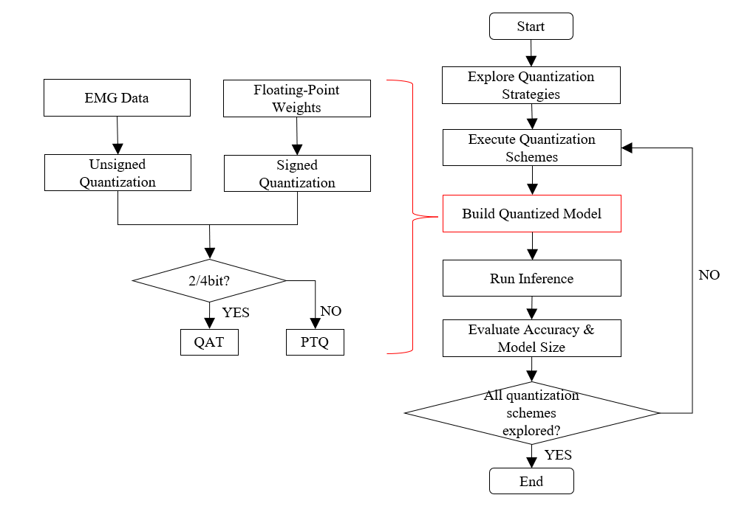
- Workflow of mixed-precision quantization
- Algorithmic pseudocode of mixed-precision quantization
(e.g., 8-bit), while intermediate or redundant layers with lower sensitivity are quantized using reduced bit-widths (e.g., 4-bit or even 2-bit).
In this study, we adopt a layer-wise mixed-precision quantization strategy based on PyTorch. Both weights and activations are quantized using 2/4/8-bit precision. Considering that activation quantization typically has a greater impact on model accuracy than weight quantization, configurations where activation bit-width is smaller than weight bit-width (e.g., 2b×4b, 2b×8b, 4b×8b) are excluded. Furthermore, based on prior studies [25] and our observations on throughput-accuracy trade-offs, asymmetric quantization strategies—i.e., high-bit weights with low-bit activations—generally perform worse than symmetric ones. Therefore, only symmetric combinations (2b×2b, 4b×4b, and 8b×8b) are retained in this work.
Fig. 3 illustrates the overall pipeline of the proposed mixed-precision quantization method. Using convolutional layers as quantization units, we define the candidate bit-width set as {2-bit, 4-bit, 8-bit} and exhaustively enumerate all possible 8-layer bit-width configurations, yielding 3⁸ = 6,561 strategies in total. For configurations involving 2-bit or 4-bit quantization, we apply Quantization-Aware Training (QAT); for pure 8-bit configurations, we adopt Post-Training Quantization (PTQ).
Prior to quantization modeling, we load the pretrained full-precision model and fuse convolutional (Conv), batch normalization (BN), and activation (ReLU) layers to simplify the network structure and reduce inference complexity. The quantized model is then converted and deployed for inference on a CPU platform. For each bit-width configuration, we evaluate and record the classification accuracy and model size (weighted by bit-width, measured in KB). Finally, candidate configurations offering a favorable balance between accuracy and compression are selected and retained.
Symmetric quantization is applied to weights with per-channel calibration using PerChannelMinMaxObserver, while activations are quantized asymmetrically to better handle non-negative ReLU outputs, with ranges estimated by HistogramObserver or MovingAverageMinMaxObserver. Fig. 4 depicts the algorithmic structure of the quantization procedure. Given the input data $\text{x}$ and quantization bit-width $\text{b}$, the scaling factor $\text{S}$ is first computed from the data's dynamic range. The input is then normalized by dividing it by $\text{S}$. Each normalized value is subsequently projected onto the nearest quantization level in terms of Euclidean distance, thereby establishing a correspondence between the original and quantized domains. Finally, the selected quantization level is multiplied by the upper bound–derived scaling factor to obtain the final quantized output.

Experiments

Dataset and Preprocessing
This study utilizes the NinaPro DB1 dataset (Non-Invasive Adaptive Prosthetics), one of the most widely used surface electromyography (sEMG) datasets. It contains high-resolution sEMG and kinematic recordings obtained from participants with diverse demographic and health backgrounds while they performed a set of predefined hand gestures. NinaPro DB1 is extensively used in prosthetic control, gesture recognition, and motor intent decoding research.
NinaPro DB1 includes data from 27 intact subjects who repeated 52 different hand gestures and resting postures. These gestures span three exercise groups: basic finger movements, isotonic/isometric hand postures, and functional grasp and wrist activities. The original data are stored in MATLAB (.mat) files containing synchronized multi-sensor recordings, labels, and repetition markers. The sEMG signals were sampled at 100 Hz using Otto Bock electrodes equipped with integrated signal-conditioning circuitry, including approximately 14,000× amplification, bandpass filtering, and RMS rectification.
For the purposes of this study, five commonly used gestures were selected for classification. Each gesture recording was first segmented into distinct action intervals based on the annotated labels. Then, a sliding window approach was applied to further divide each segment into multiple temporal samples. The window length was set to 0.5 seconds with a 70% overlap between adjacent windows. All channels were concatenated along the time axis to form multi-channel temporal inputs, ensuring sufficient training data for each gesture and yielding input samples of appropriate size for the CNN model.
Finally, the processed dataset was split into training and validation sets with a ratio of 8:2, maintaining class balance across splits to support robust model training and evaluation.

Evaluation Metrics
In EMG signal classification tasks targeting edge devices and wearable systems, two primary metrics are used to evaluate algorithm performance: accuracy and model size. These metrics jointly reflect the trade-off between classification effectiveness and deployment efficiency under resource constraints.
Accuracy measures the classification performance of the model and is defined as the proportion of correctly classified samples to the total number of test samples. The calculation formula is as follows:
$$\begin{aligned}\text{Accuracy} \text{=} \frac{\text{TP} \text{+} \text{TN}}{\text{TP} \text{+} \text{TN} \text{+} \text{FP} \text{+} \text{FN}}\#\left(\text{1}\right)\end{aligned}$$
Model Size quantifies the memory footprint of model parameters, expressed in kilobytes (KB). The size is computed using the following formula:
$$\begin{aligned}{\text{P}}^{\text{i}}\text{ =}{\text{ K}}_{\text{H}}\text{ ×}{ \text{K}}_{\text{W}}\text{ ×}{\text{ C}}_{\text{out}}\text{ ×}{\text{ C}}_{\text{in}}\#\left(\text{2}\right)\end{aligned}$$
$$\begin{aligned}\text{model size} \text{=} \frac{\sum_{\text{i} \text{=} \text{1}}^{\text{n}}{\left({\text{P}}^{\text{i}} \text{+} \text{bias}\right) \text{×} \text{fixpoint}}}{\text{8} \text{×} \text{1024}}\#\left(\text{3}\right)\end{aligned}$$
where:$\text{ n}$ is the total number of layers, ${\text{K}}_{\text{H}}$ and ${\text{K}}_{\text{W}}$represent the height and width of convolution kernels, ${\text{C}}_{\text{in}}$and ${\text{C}}_{\text{out}}$are the input and output channel dimensions, $bias$is the number of biases per layer, $\text{fixpoint}$ is the fixed-point precision used for parameter quantization.
This dual-metric evaluation provides a comprehensive view of both classification performance and hardware deployability.

Mixed-Precision Evaluation
Based on the proposed CNN architecture, we evaluated the classification performance of the model under various manually designed mixed-precision quantization configurations. The goal was to identify the optimal trade-off between model size and classification accuracy by exploring different quantization schemes. The study normalizes both accuracy and model size, as shown in (4) and (5), with the model size being processed with inverse normalization.
$$\begin{aligned}{\text{A}}^{\text{'}} \text{=} \frac{ \text{A} \text{-}{ \text{A}}_{\text{min}}}{{\text{A}}_{\text{max}} \text{-} {\text{A}}_{\text{min}}}\#\left(\text{4}\right)\end{aligned}$$
$$\begin{aligned}{\text{S}}^{\text{'}} \text{=} \text{1} \text{-} \frac{\text{S} \text{-} {\text{S}}_{\text{min}}}{{\text{S}}_{\text{max} }\text{-} {\text{S}}_{\text{min}}}\#\left(\text{5}\right)\end{aligned}$$
Where $\text{A}$ is the accuracy, ${\text{A}}_{\text{max}}$is the maximum accuracy, and ${\text{A}}_{\text{min}}$ is the minimum accuracy. $\text{S}$ is the model size, ${\text{S}}_{\text{max}}$is the maximum model size, and ${\text{S}}_{\text{min}}$ is the minimum model size.
We selected quantization schemes with accuracy above 80% for scoring, where ${\text{A}}_{\text{max}} \text{=} \text{92.48\%}$, ${\text{A}}_{\text{min}} \text{=} \text{80.18\%}$, ${\text{S}}_{\text{max}} \text{=} \text{62.62KB}$, ${\text{S}}_{\text{min}} \text{=} \text{31.23KB}$. Considering the trade-off between deployment efficiency and model accuracy, we used a weighted evaluation strategy (accuracy weight: 0.6, model size weight: 0.4) to select the quantization configuration. This ensures the lightweight model suitable for edge devices while maintaining good recognition performance. The comprehensive scoring function is as follows:
$$\begin{aligned}\text{Score} \text{=} \text{0.6} \text{×} {\text{A}}^{\text{'}} \text{+} \text{0.4} \text{×}{ \text{S}}^{\text{'}}\#\left(\text{6}\right)\end{aligned}$$
Table III displays the top ten mixed-precision quantization results based on evaluation scores. After considering both model size and accuracy, we ultimately selected the quantization scheme [8, 4, 8, 4, 8, 4, 4, 4], achieving a quantization accuracy of 89.58% and a model size of 36.58 KB.
- Mixed-Precision Quantization Results
Quantization Scheme | Accuracy  (%) | Model Size  (KB) | Score
[8,4,8,4,8,4,4,4] | 89.58 | 36.58 | 0.788
[8,4,8,8,8,4,4,4] | 89.78 | 40.09 | 0.751
[8,8,8,4,8,8,4,4] | 90.77 | 44.02 | 0.748
[8,8,8,8,4,4,4,8] | 89.15 | 38.11 | 0.747
[8,8,8,8,4,4,4,4] | 88.79 | 37.02 | 0.744
[8,4,4,4,8,4,4,4] | 88.19 | 34.84 | 0.743
[8,8,8,8,8,4,4,4] | 89.58 | 40.53 | 0.736
[8,4,4,8,8,4,4,4] | 88.95 | 38.34 | 0.734
[8,8,8,8,8,8,4,4] | 91.06 | 47.52 | 0.716
[8,8,8,8,8,8,4,4] | 90.76 | 46.87 | 0.711

Result and comparision
The proposed CNN-based EMG hand gesture classification model, trained on the Ninapro DB1 dataset, achieves an accuracy of 92.68% under full-precision (FP32), with 64,626 parameters and a model size of 252.4 KB. After applying a manually designed layer-wise mixed-precision quantization strategy of [8, 4, 8, 4, 8, 4, 4, 4], the model size is reduced to 36.58 KB, achieving a 6.9× compression ratio, while maintaining a classification accuracy of 89.58%.
As shown in TABLE Ⅳ, compared to recent works based on the same dataset, our full-precision model improves accuracy by 4.48% to 7.68%. Furthermore, the quantized model achieves higher compression ratios than the fixed-bit quantization methods used in [24][25], while retaining competitive recognition performance.
Overall, the proposed mixed-precision quantization strategy enables effective model compression while preserving accuracy, demonstrating strong potential for embedded deployment in resource-constrained edge computing scenarios.

- Comparison with Other State-of-the-Art Models
Work | Dataset | Bitwidth(W/A) | Accuracy(%) | Memory(KB)
CNN-RNN[15] | Ninapro DB1 | 32/32 | 86.8% | -
MV-CNN[16] | Ninapro DB1 | 32/32 | 88.2% | -
TinyML[21] | EMaGer-A | 8/8 | 91.71% | 73.76
EffiE[22] | NinaPro DB5 | 8/8 | 85.00% | 73
Ours(before quantification) | Ninapro DB1 | 32/32 | 92.68% | 252.4
Ours(after quantification) | Ninapro DB1 | mix | 89.58% | 36.58
- Inference Latency and Speedup on RISC-V CPU
Platform | Frequency (GHz) | Bit-width | Latency (ms) | Speedup
RISC-V CPU | 1 | 32 | 152.16 | 1×
RISC-V CPU | 1 | 8 | 42.27 | 3.60×
RISC-V CPU | 1 | mix | 25.63 | 5.94×

Embedded Deployment
We implemented the deployment and inference of a CNN model on the Milk-V Duo development board. The Milk-V Duo is equipped with a dual-core RISC-V T-Head C906 CPU and an INT8-capable hardware accelerator (TPU) with a peak performance of 1 TOPS. Since the TPU only supports computation with a minimum bit-width of 8 bits, we chose to perform the deployment entirely on the CPU to enable more flexible low-bit quantization strategies.
Specifically, we first exported a full-precision (FP32) model trained in PyTorch to the ONNX format and built a deployment environment on the Milk-V Duo using ONNX Runtime via cross-compilation. This allowed us to successfully run both FP32 and INT8 inference models on the device. To further explore model compression and inference acceleration, we proposed a customized 4/8-bit mixed-precision deployment scheme. Using Python scripts, the weights of each layer were quantized to either 4-bit or 8-bit formats and packed into byte-aligned .bin files. We then cross-compiled the C++ inference code using the riscv64-linux-gnu-g++ toolchain and deployed the executable to the development board. During runtime, the system dynamically loads quantized weights from the .bin files, decodes them according to the mixed-precision strategy, and performs convolutional computations, thereby enabling efficient low-bit CNN inference on an embedded RISC-V platform.
The performance results are shown in Table V. Using the FP32 model as the baseline (latency: 152.16 ms), the INT8 model reduced the inference latency to 42.27 ms, achieving a 3.60× speedup while maintaining accuracy. In comparison, our proposed mixed-precision deployment further reduced the latency to 25.63 ms, yielding a 5.94× speedup over the FP32 model and a 1.65× improvement over the INT8 model. These results demonstrate that the proposed mixed-precision quantization scheme effectively compresses the model size and improves inference efficiency, making it well-suited for deployment on resource-constrained edge devices.

Conclusion
This study presents a lightweight EMG-based hand gesture recognition model optimized through mixed-precision quantization. The proposed convolutional neural network (CNN) contains only 64.6K parameters with an original model size of 252.4 KB. By applying a manually designed layer-wise quantization strategy [8, 4, 8, 4, 8, 4, 4, 4], the model is compressed to 36.58 KB—a 6.9× reduction—while maintaining a competitive recognition accuracy of 89.58%. Deployment experiments on the RISC-V-based Milk-V Duo platform further verify the method’s suitability for embedded scenarios, achieving a 5.94× speedup over the FP32 baseline and a 1.65× improvement compared to the INT8 model. Overall, the proposed approach provides an effective balance between accuracy, model compactness, and inference efficiency, demonstrating strong potential for EMG-based gesture recognition on resource-constrained edge devices.
Despite the promising results, this work is limited to a single dataset (Ninapro DB1) and one hardware platform (RISC-V CPU). Future work will focus on improving generalization across datasets and exploring deployment on a broader range of hardware platforms, including the design of dedicated accelerators. Additionally, we plan to investigate hybrid compression strategies that combine pruning and quantization to achieve more compact and efficient models.

References
- Lorena Isabel Barona López, Francis M. Ferri, Jonathan Zea, Ángel Leonardo Valdivieso Caraguay, Marco E. Benalcázar, CNN-LSTM and post-processing for EMG-based hand gesture recognition, Intelligent Systems with Applications, Volume 22, 2024, 200352,ISSN 2667-3053.
- Yongyu Jiang, Christine Chen, Xiaodong Zhang, Chaoyang Chen, Yang Zhou, Guoxin Ni, Stephanie Muh, Stephen Lemos, Shoulder muscle activation pattern recognition based on sEMG and machine learning algorithms, Computer Methods and Programs in Biomedicine,
Volume 197, 2020, 105721, ISSN 0169-2607.
- V. Sze, Y. -H. Chen, T. -J. Yang and J. S. Emer, " Efficient processing of deep neural networks: a tutorial and survey," in Proceedings of the IEEE, vol. 105, no. 12, pp. 2295-2329, Dec. 2017, doi: 10.1109/JPROC.2017.2761740.
- VERHELST M, MOONS B. Embedded deep neural network processing: algorithmic and processor techniques bring deep learning to IoT and edge devices [J]. IEEE Solid-State Circuits Magazine, 2017, 9(4): 55-65.
- HE Y, KANG G, DONG X, et al. Soft filter pruning for accelerating deep convolutional neural networks [M]. 2018.
- A. Jain, P. Goel, S. Aggarwal, A. Fell and S. Anand, "Symmetric k-means for deep neural network compression and hardware acceleration on FPGAs," in IEEE Journal of Selected Topics in Signal Processing, vol. 14, no. 4, pp. 737-749, May 2020, doi: 10.1109/JSTSP.2020.2968810.
- L. Wang and K. -J. Yoon, "Knowledge distillation and student-teacher learning for visual intelligence: a review and new outlooks," in IEEE Transactions on Pattern Analysis and Machine Intelligence, vol. 44, no. 6, pp. 3048-3068, 1 June 2022, doi: 10.1109/TPAMI.2021.3055564.
- ZHEN D, YAO Z, GHOLAMI A, et al. HAWQ: Hessian aware quantization of neural networks with mixed-precision [M]. 2019.
- GUO X, HUANG Y, CHENG H-P, et al. Exploration of automatic mixed-precision search for deep neural networks [M]. 2019.
- LI T, ZHOU M. ECG classification using wavelet packet entropy and random forests [J]. Entropy, 2016, 18: 285.
- AYAR M, SABAMONIRI S. An ECG-based feature selection and heartbeat classification model using a hybrid heuristic algorithm [J]. Informatics in Medicine Unlocked, 2018, 13: 167-75.
- SHARMA M, TAN R-S, ACHARYA U R. Automated heartbeat classification and detection of arrhythmia using optimal orthogonal wavelet filters [J]. Informatics in Medicine Unlocked, 2019, 16: 100221.
- YANG H, WEI Z. Arrhythmia recognition and classification using combined parametric and visual pattern features of ECG morphology [J]. IEEE Access, 2020, 8: 47103-17.
- M. A. A. Al-qaness and S. Ni, "TCNN-KAN: Optimized CNN by kolmogorov-arnold network and pruning techniques for sEMG gesture recognition," in IEEE Journal of Biomedical and Health Informatics, vol. 29, no. 1, pp. 188-197, Jan. 2025, doi: 10.1109/JBHI.2024.3467065.
- Hu Y, Wong Y, Wei W, et al. A novel attention-based hybrid CNN-RNN architecture for sEMG-based gesture recognition[J]. PloS one, 2018, 13(10): e0206049.
- W. Wei, Q. Dai, Y. Wong, Y. Hu, M. Kankanhalli and W. Geng, "Surface-electromyography-based gesture recognition by multi-view deep learning," in IEEE Transactions on Biomedical Engineering, vol. 66, no. 10, pp. 2964-2973, Oct. 2019, doi: 10.1109/TBME.2019.2899222.
- X. Chen, Y. Li, R. Hu, X. Zhang and X. Chen, "Hand gesture recognition based on surface electromyography using convolutional neural network with transfer learning method," in IEEE Journal of Biomedical and Health Informatics, vol. 25, no. 4, pp. 1292-1304, April 2021, doi: 10.1109/JBHI.2020.3009383.
- Mehmet Akif Ozdemir, Deniz Hande Kisa, Onan Guren, Aydin Akan, Hand gesture classification using time–frequency images and transfer learning based on CNN, biomedical signal processing and control, Volume 77, 2022, 103787, ISSN 1746-8094.
- Xiong B, Chen W, Niu Y, et al. A global and local feature fused CNN architecture for the sEMG-based hand gesture recognition[J]. Computers in Biology and Medicine, 2023, 166: 107497.
- Shi H, Jiang X, Dai C, et al. EMG-based multi-user hand gesture classification via unsupervised transfer learning using unknown calibration gestures[J]. IEEE Transactions on Neural Systems and Rehabilitation Engineering, 2024
- É. Buteau, G. Gagné, W. Bonilla, M. Boukadoum, P. Fortier and B. Gosselin, "TinyML for real-time embedded HD-EMG hand gesture recognition with on-device fine-tuning," 2024 46th Annual International Conference of the IEEE Engineering in Medicine and Biology Society (EMBC), Orlando, FL, USA, 2024, pp. 1-6, doi: 10.1109/EMBC53108.2024.10781755.
- J. Lu, P. Liang, J. C. Rhim, X. Zhang and Z. Qin, "EffiE: efficient convolutional neural network for real-time EMG pattern recognition system on edge devices," 2023 11th International IEEE/EMBS Conference on Neural Engineering (NER), Baltimore, MD, USA, 2023, pp. 1-5, doi: 10.1109/NER52421.2023.10123741.
- Y. Huang et al., "LSMQ: a layer-wise sensitivity-based mixed-precision quantization method for bit-flexible CNN accelerator," 2021 18th International SoC Design Conference (ISOCC), Jeju Island, Korea, Republic of, 2021, pp. 256-257, doi: 10.1109/ISOCC53507.2021.9613969.
- J. Wang, S. Fang, X. Wang, J. Ma, T. Wang and Y. Shan, "High-performance mixed-low-precision CNN inference accelerator on FPGA," in IEEE Micro, vol. 41, no. 4, pp. 31-38, 1 July-Aug. 2021, doi: 10.1109/MM.2021.3081735.
- Liu W, Lin J, Wang Z. A precision-scalable energy-efficient convolutional neural network accelerator [J]. IEEE Transactions on Circuits and Systems I: Regular Papers, 2020, 67(10): 3484 – 3497.

