The Analysis of Effect Code Smells Family on Software Security Using SonarQube Tool
Hamed Fawareh  Software Engineering Dept. Faculty of IT  Zarqa University, Jordan  fawareh@zu.edu.jo | Sohaip Mwafq Khlifat  Software Engineering Dept. Faculty of IT  Zarqa University, Jordan  sssk200912@gmail.com

Abstract— in the current technological era, security is one of the most important requirements that must be met by systems, devices, and electronic programs because of the frequency of unwanted attacks on personal data. While there are numerous factors that could influence it, the code smells are the most significant. These smells have been explained and detailed to their families before academics and security specialists selected them as the most common. The most prominent family among these was discovered to be the Bloaters family. The findings of using a SonarQube tool on the data after the form was evaluated were not all the same. The lengthy technique is the most prevalent and conspicuous member of its category. Whereas previous studies focused on establishing a connection between the smells of code and security, this study aimed to determine the most common odors that impact security. Whether or not a scent is identified, it is Recording all detected smells ensures comprehensive security analysis.

Keywords- Code Smells, Software security, SonarQube tool, Bloasters.

Introduction
Large-scale technological advancements in the contemporary period have increased people's and governments' reliance on technology. These days, technology is a must in our everyday existence. People's dependence on manual labor and lack of confidence in these advancements make it difficult for them to stay up with them. A lack of experience and a fear of financial and personal information are the causes of this lack of confidence. This gives rise to the most significant human anxieties of our day, and focusing on security while fully considering every aspect of contemporary technology that may cause dread or cause people to become less productive with it is one of the most effective methods to address these issues [1].
The process of identifying, minimizing, and safeguarding software systems against vulnerabilities is known as software security [2]. The system or programs become weaker or have more gaps in them for a variety of reasons. These vulnerabilities include the lack of a firewall, anti-virus software, and other security-enhancing hardware. Moreover, the source code is one of the primary ways that penetration operations exploit or track the gaps that now exist [3].
Numerous research demonstrate that hackers are able to attack and penetrate the source code. Attackers concentrate on any flaws or secret places in a source code that are vulnerable to intrusion attempts and attacks. These circumstances are known as "code smells [4]. One reason for the poor quality of source code, which makes it simpler to infiltrate computers and programs, is code smells [5]. The most prominent families of code smells are examined in this thesis, together with the proportion of influence that each family member has on vulnerabilities and the degree of code security that results from their presence in the source code. Furthermore, it demonstrates how it could make it easier to employ contemporary hacking techniques, which exclusively use the source code to compromise and alter the system's vulnerabilities [6].
The designing stage of the software development process is crucial to the development of the system. Due to inexperience or multiple programmers working on the same project, a programmer may unintentionally introduce a code smell when creating the code [7]. Whether it be an Internet website or application, the existence of flaws in the program makes it easier for it to be manipulated or penetrated. Code odors come in several forms and varieties, including the lengthy technique. Some of these have an impact on or encourage the development of vulnerabilities that can aid in program or website hacking. Additionally, since it is a form of hacking, it may result in the addition of code that makes it easier to perform actions other than breaking into the user's computer [8]. For instance, fishing relies on sending a concealed code to a website or any link that becomes active when accessed; this code is entirely mingled with the source code, making it challenging to detect [9]. The length of the generator code expands as a result of the huge source code, and numerous code smells that were overlooked or not detected during program writing are present. The impact of these smells on security is often underestimated because they all have varying degrees of influence and code degradation.

Code smell
Code smells are defined as any characteristic in a program's source code that may signal a deeper problem [2]. It's difficult to say what is and isn't a code smell because it varies by language, developer, and development approach [16]. Also, code smells are indicators and signals within the code that imply a design flaw, which is not regarded as a software mistake in and of itself, and we may encounter programs with these smells that work just fine without any issues.
Elkhail and Cerny, have used the Of Code Smells to Security Vulnerabilities method to determine the association between code odors and software vulnerabilities. The research covers the open-source implementation of technologies under the Apache Tomcat software and the impact of code smells on software security [26]. Alenezi and Akour Exploring the connection between design smells and security Vulnerabilities Software quality tries to ensure that all aspects of the generated software are of high quality [10]. Ghafari Adient and Nierstrasz, studied security smells in Android. Numerous vulnerabilities have been shown to be created by insecure programming practices, according to study [11]. Muse, et. al. focus on the prevalence, impact, and evolution of SQL code smells in data-intensive systems. Smells are inadequate software engineering solutions to frequently occurring software system issues [13].
In software development, we place a strong emphasis on quality and best practices. When we don't start a project from scratch, we frequently encounter code smells. Martin Fowler defined what a code smell is one day: it's a surface symptom that usually indicates a deeper problem in the software system [13]. One of the wonderful things about code smells is that even untrained people can detect them, even if they lack the knowledge to determine whether or not there is a true problem or how to fix it. Many firms have "code smells of the week," where engineers are asked to seek the stench and report it to the team's senior members. It's easier to do it one fragrance at a time, which is an effective method of progressively teaching team members to become better programmers [14].
The design flaws that make the system difficult to maintain and raise the likelihood of new faults, etc. Code odors indicate that your code needs to be refactored for better extendibility, readability, and supportability [15]. The most common code smells are divided into five family mapper code smells and twenty-two family members, as shown in Table I.
Table I: Code Smells family mapper.
Bloaters | Long Method  Large Class  Primitive Obsession  Long Parameter List  Data Clumps
Object-Orientation Abusers | Switch Statements  Temporary Field  Refused Bequest  Alternative Classes with Different Interfaces
Change Preventers | Divergent Change  Shotgun Surgery  Parallel Inheritance Hierarchies
Dispensable | Comments  Duplicate Code  Lazy Class  Data Class  Dead Code  Speculative Generality
Couplers | Feature Envy  Inappropriate Intimacy  Message Chains  Middle Man

Software Security via Code Smell
Software security is a term used to describe how to protect software against malicious assaults and other risks posed by hackers so that it can keep running properly in the face of such dangers. Security is necessary for availability, authenticity, and integrity [17]. Security software is any software that is designed to detect, prevent, stop, and repair damage performed by outsiders on your computer or network. Security software may be focused on stopping attacks from reaching their intended target, limiting the damage that assaults can cause if they do reach their intended target, and tracking the harm that has been done so that it can be corrected. Security software changes in tandem with the nature of harmful code, making it the most important method of protection [18].
Firewall: It is the device that companies or institutions install to protect the security of their programs and files from third-party penetration and theft, and it is specifically placed between the organization's internal network and the Internet, so that undesirable parties who infiltrate the organization's internal computer some company don't use the firewall because of the expensive cost or because it requires experts or specialists to manage [19].
Antivirus: Antivirus software stops malware from inflicting damage on your device by finding, quarantining, and/or destroying malicious code. Modern antivirus programs automatically update themselves to protect against the most recent malware and viruses, however, because some of these programs are costly, some businesses do not download upgraded versions of them, which provide protection and address gaps that did not exist in previous versions [20].
Antispyware: Anti-spyware software is a sort of program that is designed to prevent and detect the installation of undesirable spyware programs, as well as to remove them if they are already installed [21].
Network Security: Network security guards against breaches, invasions, and other threats to your network and data. This is a comprehensive term that covers hardware, software, procedures, laws, and settings about network use, accessibility, and overall threat prevention [22].
Of course, there are more protection methods, but these are the most famous and most used. Some of these methods are usually not enough for many reasons, which leads to finding loopholes for hackers and privacy violators. So, it is necessary to know the other penetration methods that depend on the source code, which is one of the main goals of hackers and the most important reason.

SonarQube Tool
The SonarQube tool was utilized in this study to obtain the necessary data since SonarQube is a tool for automatically reviewing your code to find bugs, weaknesses, and code smells. To enable continuous code inspection throughout your project branches and pull requests, it may be integrated with your current process [23]. Standard development procedure in SonarQube include developers create, merge, and test their code on a DevOps platform using an IDE (preferably Sonar Lint to get immediate feedback in the editor). An integrated SonarQube scanner examines the outcomes as the enterprise's continuous integration (CI) tool checks out, compiles, and executes unit tests [24] [25]. The scanner uploads the findings to the SonarQube server, which then notifies developers via email, Sonar Lint notifications in the IDE, and decoration on the pull or merge requests (when using Developer Edition and above) [24]. There are a lot of SonarQube requirements on the computer where you intend to run SonarQube. Java (Oracle JRE or OpenJDK) must be able to be installed, and there are several further prerequisites:
SonarQube hardware requirements: Languages SonarQube TOOL can analyze hardware requirements for SonarQube.
Before learning about the languages that SonarQube supports, the tool's analysis steps and some of the frequently asked questions about them will be clarified [25] [26].
SonarQube analyzing: After installing the SonarQube platform, you're prepared to set up a scanner and start making projects. You must install and set up the scanner that is best for your needs to accomplish. SonarQube automatically creates a project after its initial investigation. However, you have the choice of providing your project via Administration Settings or the + menu item, which is accessible to users with project creation privileges, if you need to make changes to it before its initial examination [24]. SonarQube can analyze up to 29 different languages. Quality measurements and problems will be the analysis's output (in instances where coding rules were broken). What is examined will change, though, depending on the language.
SonarQube TOOL can analyze hardware requirements for SonarQube. Analyzable languages: the language analysis offered by SonarQube varies depending on the version you are using. Here are a few sample languages, together with their specifications [27][28]. The most significant of these was the explanation of the use of the SonarQube tool and its most important specifications and methods of dealing with it to facilitate the examination and confirm its accuracy.

Results and discussion
This section explains the results that have been reached in this research, which were divided into two parts. The first part explained the results of the form using a survey for 50 experts in the field, the most important questions, and its analysis. The second result obtains from SonarQube tools.

Experts Survey Results
This section discusses the form's query and the findings of its examination which contains 6 questions about code smells in the following explain the result on details as shown in figure 1. The following more discussion:
Q1. What is the most common type that shows up in the source code? When the results were compiled, the two most popular communities were reached, which are bloaters, whose rate reached 62%, while the percentage of object-oriented people reached 20%. After asking the experts about the faces of various, the most common family of code smell families was reached, as the percentage of the answer in this question reached 100%. The outcomes are displayed in the figure1.
Q2. What form of Bloater Perpetrators do you think are the most popular? The most frequent bloater perpetrators were found using this query. The long approach produced a massive class and long parameter of 14% and a percentage of about 62%, indicating its success. The percentage of each is displayed in the following image.
Q3. What are an object orientation group’s most frequent offenders among its members? The switch statement is the query most concerned with objects, with a proportion of 68%. First position went to switch statements, which were followed by classes with various interfaces at a rate of 14% apiece.
Q4. What do you think are the predominant categories of change preventers and perpetrators? Here is a schematic that shows the three most common members of the Change Preventers Perpetrators family.
Q5. What kind of disposable perpetrators do you think are the most popular? The graphic below shows the three Disposable Perpetrators that are by far the most typical.
Q6. In your perspective, what kind of coupler perpetuators exist? According to the analysis, the Long Method is the most common member of the Bloaters family in the current software industry, but this does not mean that it has the greatest influence on safety; it can affect the quality of components for sure, and it was found that this is the case through the questions that were posed. The most prominent family was the focus of the investigation because the proportion of the presence of particular families and their most prominent forms was attained in the code. After that, numerous people from the remaining families were subjected to the inspection using tools [30 [31].

SonarQube result and Analysis
Throughout this part, I'll demonstrate the results of using several tools on a sample of randomly selected source code. These conclusions were reached after analyzing the sample code.

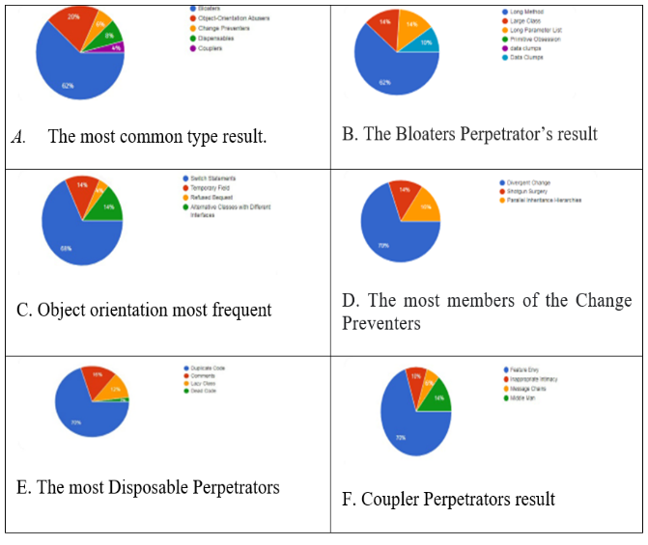
Fig. 1. Experts Survey Results
The research starts by giving a broad explanation of what the results revealed, as well as the mistakes and risks that the code has. The percentage from each clarified after the findings have been reviewed:
- Wherever bugs came, they were average and reached 289
- There were no direct code gaps at all.
- Security hotspots and their connections 21
- After the examination, the smell of the code reached 178.
The results of the code will be made clearer by identifying the smells of the extracted code when they have been publicly disclosed. The following are some of the smells that emerged in the code after the study: clarification of their types, which surfaced during the code analysis, and the percentage of influence of some of them on security if they had an effect:
Dead code: An inquiry revealed that the Dispensable family, one of the three most common families, was the home of the dead code type and that the code was present as shown in Figure 2 Even if it doesn't appear to have a direct impact on security, not using a variable, parameter, field, method, or subclass is one of the errors that can reduce the overall quality of the code.
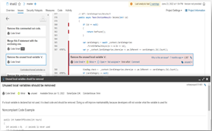
Fig. 2. SonarQube Dead Code Result
DuplicateCode: One of the most common types of disposables is duplicate code, and in this instance, it was found in the form of a mouth, where several methods have the same name and physical appearance. This is one of the most popular forms of duplicate code used by programmers since it focuses on copying and pasting to save time and effort. The biggest dangers that poor programming might bring. Figure 3 shows SonarQube duplicate code result.
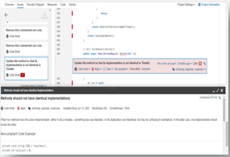
Fig. 3. SonarQube Duplicate Code Result
Large Class: One of the most common families in the code, the Bloaters family, includes a large class as one of its members. This smell is obvious because it manifests as a class with a large amount of code, making it challenging to maintain and improve. Figure 4 shows SonarQube Large class result.

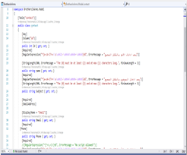
Fig. 4. SonarQube the large class result
Long Method: In contrast to flaws or general security, the study of a long method-containing code segment showed that it has a substantial impact on the writing and quality of the code as shown in figure 5.
Comments: When well-meaning writers discover their code isn't clear or intuitive, they usually include comments. Comments in these cases act as a deodorant to cover up the scent of the possibly corrupt code. Try changing the code structure so that comments are not necessary if you believe that a code remnant cannot be understood without them as shown in figure 6.
Speculative Generality: There is no use of a class, method, class, or parameter. Programmers are requested to include a comment to explain the rationale for the addition since some of these situations affect the structure of a code and may cause it to significantly degrade its qualities. Figure 7 shows SonarQube Speculative Generality result.

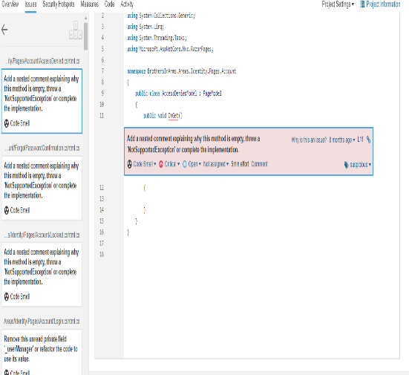

Fig. 5. SonarQube Long Method Result

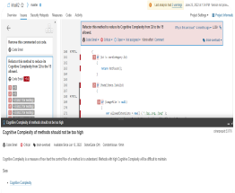
Fig. 6. SonarQube Comment Result
Message Chains: A communications chain is started when a client requests one item, the object requests another, and so forth. The client must maneuver through the class hierarchy as a result of these chains. Any changes to these relationships need to modify the client. In this instance, it might occur as in the figure where a tool has been used to charge and discharge the safety and where safety or its requirements were neglected during the process, weakening the security. This is one of the scents that impact security and can be employed in a way as shown in figure 8.
SQL: A database is a crucial part of the design of an information system, and the way it manages data determines the main features of the system. When working with the database, the way the program manages it or communicates with it is also extremely important. Consequently, the implementation of such a communication layer must be reliable and efficient. the dialect Database queries are typically performed using SQL. Because query strings included in program code are typically formed by numerous programming constructs that make it challenging for developers to understand the statement that is finally submitted to the database, advanced techniques rely on them (or their dialects). It might be a contributing factor to code smells brought on by improper and error-prone database usage. Because it had the biggest influence on security after analysis, with a percentage of 1.5, and because it was one of the top results to appear in the search, results from applying SQL to the source code revealed that it is one of the most harmful code smells on security. The newly identified fragrances that have been designated as code odors must therefore be given special consideration and taken into account when writing the code. Figure 9 shows SonarQube SQL result.

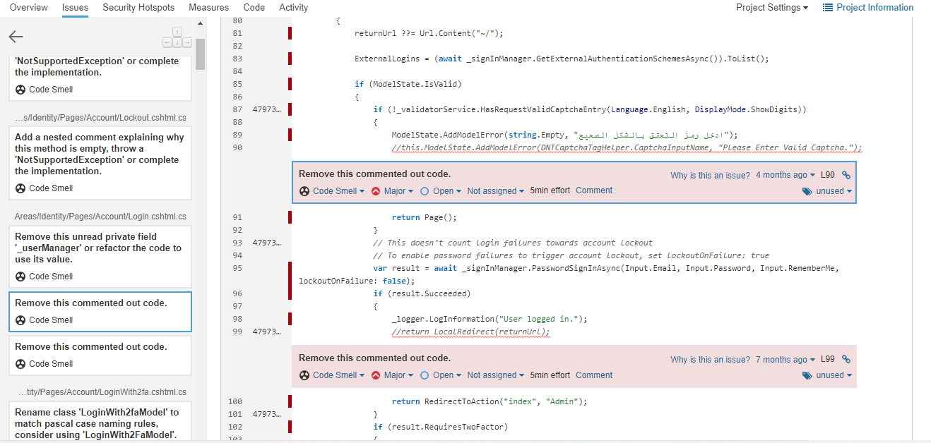
Fig. 7. SonarQube Speculative Generality Result
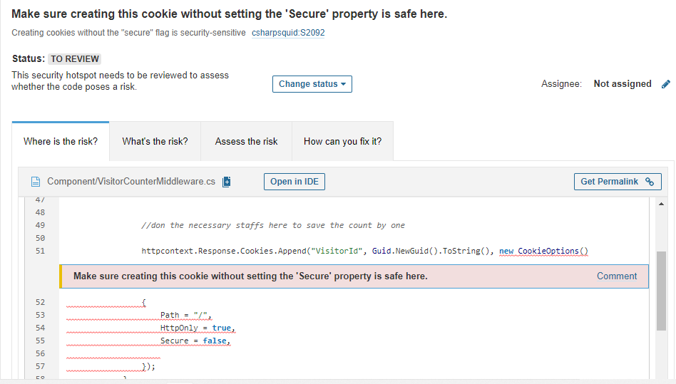
Fig. 8. The Massage Chain Result
The most common families were found to be Bloaters, with Long Methods being the most common member, once the form's research was finished. A family with duplication codes was found to have the most common scents, according to some of the results. Temporary offenders it stands out the most from the group, and despite the fact that there are many potential hazards brought on by other individuals, it was found that the smells with the greatest impact on safety are SQL and massage chains. This was determined by comparing some of the findings with the data from SonarQube.

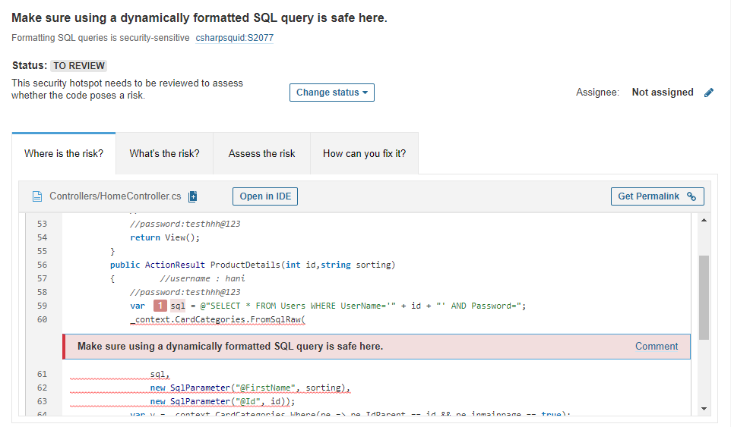
Fig. 9. SonarQube SQL Result

Conclusion
In conclusion the research that was done for this study is summarized rather than focusing on proving a connection between the smells of code and security, this study aimed to identify the most common scents that impact security. Using a form completed by safety specialists and code smell experts, the most notable common smells in the neighborhood market were determined. Additionally, the study of code smells with their families and their connection to security was conducted. SQL queries and message chains are the main techniques for extracting the security threats that present the most problem, according to the analysis and application of the data to the SonarQube tool. It was the most effective smell in the end, even though it wasn't the most well-liked scent among families.

References
- ‏ Hamed J. Fawareh, Y. Al-Smadi, H. Aljawawdeh, F. A. Fawareh, F. Alshraiedeh, and A. Elrashidi, “An empirical study on measuring the impact of code smells on web applications,” in Proceedings of the 2023 International Arab Conference on Information Technology, Amman, Jordan, 2024
- Dissanayaka, A. M., Mengel, S., Gittner, L., & Khan, H. (2020, March). Vulnerability prioritization, root cause analysis, and mitigation of secure data analytic framework implemented with mongodb on singularity linux containers. In Proceedings of the 2020 the 4th International Conference on Compute and Data Analysis (pp. 58-66).‏
- Kancharla Nagababu, S Ananthi, Neeraj Sunheriya, Venkata Siva Prasad Ch, J Jayanthi, Hamed J. Fawareh, “Experimental Evaluation of Cross-Platform Recognition of Identical and Unknown Users over Social Networking Environment”, 2024 International Conference on Innovative Computing, Intelligent Communication and Smart Electrical Systems (ICSES)
- Janczewski, L., & Colarik, A. (Eds.). (2007). Cyber warfare and cyber terrorism. IGI Global.‏ DOI: 10.4018/978-1-59140-991-5
- Gupta, A., Suri, B., & Misra, S. (2017, July). A systematic literature review: code bad smells in java source code. In International Conference on Computational Science and Its Applications (pp. 665-682). Springer, Cham.‏
- Walenstein, A., & Lakhotia, A. (2007). The software similarity problem in malware analysis. In Dagstuhl Seminar Proceedings. Schloss Dagstuhl-Leibniz-Zentrum für Informatik.‏
- Hamed J. Fawareh, Y. Al-Smadi, R. Saadeh, F. A. Fawareh, A. Elrashidi, and H. M. Al-Shdaifat, “A comparative study between agile and waterfall methodologies during software development process,” in Proceedings of the 2023 International Arab Conference on Information Technology, Amman, Jordan, 2024.
- Hamed J. Fawareh, H. Al-Shdaifat, M. Al-Refai, F. A. Fawareh, and M. Khouj, “Investigates the impact of ai-generated code tools on software readability code quality factor,” in Proceedings of the 2023 International Arab Conference on Information Technology, Amman, Jordan, 2024
- Mannan, Umme Ayda, ”Investigating the Effects of Design Quality in OSS Projects”, Thesis,
Oregon State University, 2021.
- Alenezi, M., & Akour, M., “Exploring the Connection between Design Smells and Security Vulnerabilities, International Journal of Innovative Technology and Exploring Engineering, 9(8):449-452, 2020, DOI: 10.35940/ijitee.H6508.069820
- Ghafari, M., Gadient, P., & Nierstrasz, O. (2017, September). Security smells in android. In 2017 IEEE 17th international working conference on source code analysis and manipulation (SCAM) (pp. 121-130). IEEE.
- Muse, B. A., Rahman, M. M., Nagy, C., Cleve, A., Khomh, F., & Antoniol, G. (2020, June). On the prevalence, impact, and evolution of SQL code smells in data-intensive systems. In Proceedings of the 17th international conference on mining software repositories (pp. 327-338).
- Tamilselvan, P., & Wang, P. (2013). Failure diagnosis using deep belief learning based health state classification. Reliability Engineering & System Safety, 115, 124-135
- Hamed J. Fawareh, Y. Al-Smadi, M. Hassan, F. A. Fawareh, and A. Elrashidi, “Software code de-compilation techniques and approaches: A comparative study,” in Proceedings of the 2023 International Arab Conference on Information Technology, Amman, Jordan, 2024
- Vashisht, R. (2022). An Empirical Analysis of Code Smelling and Code Restructuring in Python. In Virtual Technologies and E-Collaboration for the Future of Global Business (pp. 203-214). IGI Global.
- Lerner, G. H., “Collaborative turn sequences: Sentence construction and social action”, In book: Conversation Analysis (pp.225-256), DOI:10.1075/pbns.125.12ler
- Arcoverde, R., Garcia, A., & Figueiredo, E. (2011, May). Understanding the longevity of code smells: preliminary results of an explanatory survey. In Proceedings of the 4th Workshop on Refactoring Tools (pp. 33-36).‏
- Phillips, A. C. N., Reichley, S. R., Ware, C., & Griffin, M. J. (2017). “Edwardsiella ictaluri infection in Pangasius catfish imported from West Bengal into the Southern Caribbean”. Journal of Fish Diseases, 40(6), 743-756.
- Lyu, M. R., & Lau, L. K. (2000, October). Firewall security: Policies, testing and performance evaluation. In Proceedings 24th Annual International Computer Software and Applications Conference. COMPSAC2000 (pp. 116-121). IEEE.‏
- Dwight Horne, “Green Cybersecurity: An Evaluation of Antivirus Energy Consumption and Implications for Sustainable‏”, Security and Management and Wireless Network, 23rd Intergantional conference, SAM2024 and ICWN 2024, July 22-25, 2024, USA Las Vegas.
- Brand gravity, “why line extensions of national brands attract one another and line extensions of store brands repel one another”, Thesis, Macquarie University, 2016.
- ‏ Kanwar, A., Mohee, R., Carr, A., Ortlieb, K., & Sukon, K. (2019). A neo-institutionalist approach to understanding drivers of quality assurance in ODL: The case of the Open University of Mauritius. International Review of Research in Open and Distributed Learning, 20(4), 79-98.
- Marcilio, D., Bonifácio, R., Monteiro, E., Canedo, E., Luz, W., & Pinto, G. (2019, May). Are static analysis violations really fixed? a closer look at realistic usage of sonarqube. In 2019 IEEE/ACM 27th International Conference on Program Comprehension (ICPC) (pp. 209-219). IEEE.
- .Fontana, F. A., Roveda, R., & Zanoni, M. (2016, April). Tool support for evaluating architectural debt of an existing system: An experience report. In Proceedings of the 31st Annual ACM Symposium on Applied Computing (pp. 1347-1349).‏
- Hamed J. Fawareh and H. Al-Shdaifat, “Investigating ai-generated code on the impact on software efficiency code quality factor,” Sustainable Data Management, Book Subtitle: Navigating Big Data, Communication Technology, and Business Digital Leadership. Volume 1, chapter 8, ISBN978-3-031-83910-8, 2025.
- Elkhail, A. A., & Cerny, T. (2019, May). On relating code smells to security vulnerabilities. In 2019 IEEE 5th international conference on big data security on cloud (Bigdata Security), IEEE Intl Conference on High Performance and Smart Computing, (HPSC) and IEEE intl conference on intelligent data and security (IDS) (pp. 7-12). IEEE.
- Hamed J. Fawareh and Haya Momani, “The Effect of Using the Scrum Framework in the Design an Stakeholder Reliability”, Book chapter, Artificial Intelligence in the Digital Era, Economic, Legislative and Media Perspectives, volume 159, Springer, 2025
- CG Balaji, Md Imran, S Vamsi Ujwala, Ajinkya P Edlabadkar, Hamed J. Fawareh, “An Improved Neural Classification Logic to Predict Kidney Disease Identification Using Medical Image Processing Principles”, 2024 International Conference on Innovative Computing, Intelligent Communication and Smart Electrical Systems (ICSES).
- M Tamilselvi, R Ashwini, S Ravi, Chadge Rajkumar, Hamed J. Fawareh, “Enhanced Model for Brain Tumor Detection Accuracy Using Inceptionresnetv2 compared to VGG19 and MobileNet Models”, 2024 International Conference on Innovative Computing, Intelligent Communication and Smart Electrical Systems (ICSES).
- Hamed J. Fawareh, Z. Jobair, A. Alswalmh, and A. Suliman, “The evaluation of e-learning system based on the d&m model,” International Journal of Engineering Trends and Technology, 2024, 72(11), pp. 80–90.
- Jawawdeh, Hamed J. Fawareh, R. Salman, S. Raed, and H. Alazzeh, “Ethical considerations in ai-driven HCI systems in software engineering,” in Proceedings of the 2023 International Arab Conference on Information Technology, Amman, Jordan, 2024.

