SMART PETITION HANDLING SYSTEM

Mr.A.Balamurali
Department of CSE
St. Joseph’s Institute of Technology Chennai, India
balamura2@gmail.com

Udhayavsan V
Department of CSE
St. Joseph’s Institute of Technology Chennai, India
udahii0007@gmail.com

Venith A
Department of CSE
St. Joseph’s Institute of Technology Chennai, India
venithvenith3@gmail.com

Abstract— Public petition processing in government and institutional environments often suffers from delays, manual effort, and inefficient routing. This project proposes an AI-based Petition Management System that automates the reading, classification, and forwarding of petitions received through email. Using Natural Language Processing, the system extracts text, identifies petition category, and auto-routes it to the appropriate department, reducing human involvement and processing time. The solution improves accuracy, transparency, and efficiency in grievance redressal while providing a scalable framework for future integration in real-world e-governance systems.
Index Terms—AI Petition System, Public Grievance Redressal, NLP, Machine Learning, Text Classification, Sentiment Analysis, E-Governance, Automation, Public Administration, Citizen Services, Complaint Categorization, Digital Governance, Smart Government, Flask Backend, MongoDB Atlas.

- Introduction

The Effective grievance redressal is a critical requirement in modern governance systems, especially in large democratic nations where millions of citizens interact with administrative bodies daily. Traditional petition handling methods are often manual, time-consuming, and prone to delays due to paperwork, backlog, and lack of automation. With the growth of digital platforms, there is an increasing demand for intelligent systems that can automate public complaint processing. Artificial Intelligence plays a transformative role by reducing processing time and improving accuracy in petition triaging. This project aims to bridge the gap between citizens and government authorities by offering a smart, automated grievance management platform. The system ensures transparency, efficiency, and fairness in complaint handling workflows. The proposed solution uses Natural Language Processing (NLP) and Machine Learning techniques to classify petitions automatically. Flask web technology is used to build backend services, and MongoDB Atlas provides secure cloud-based data storage. This integration leads to faster grievance processing, enhanced citizen experience, and improved governance efficiency.
The system receives petitions submitted by citizens via a web interface and processes them using Natural Language Processing (NLP). It classifies petitions into relevant government departments and detects the sentiment to assess urgency and seriousness. Unlike conventional systems, this solution minimizes manual intervention and ensures faster petition routing. Machine learning algorithms analyze complaint text patterns and generate priority scores to support decision-making. This leads to intelligent petition triaging and improved workflow automation.

To ensure scalability and secure data handling, the system uses a Flask-based backend integrated with MongoDB Atlas cloud database. The modular design allows smooth handling of multiple inputs and efficient storage of large complaint datasets. The interface is lightweight, user-friendly, and accessible, encouraging increased public participation. The system also supports future integration with government portals and extends to multilingual data processing. With automated data flow, it reduces operational costs and improves administrative efficiency.
Overall, the AI Petition Management System bridges the gap between citizens and public authorities by enabling intelligent grievance processing. It ensures faster resolution cycles, enhances administrative productivity, and promotes inclusive digital governance. The system contributes to smart city development initiatives and aligns with Digital India and e-governance goals. By combining AI, automation, and cloud computing, the proposed solution modernizes public complaint systems. The work demonstrates how technology can significantly strengthen service delivery in public administration. Future enhancements include deep-learning-based sentiment scoring, voice-based petition submission, and multilingual support.
- Literature Review
Over the past decade, researchers have explored numerous AI-driven and automation-based public grievance handling systems. Below is a comprehensive summary of 15 relevant studies categorized into three areas: government service automation, deep learning–based text analytics, and traditional workflow-driven grievance processing techniques.
- AI-Driven Grievance Redressal Systems
Several studies focus on enhancing automated petition handling using AI and NLP, beginning with Amulya Arshanapally et al. (2025), who introduced automation and sentiment-based routing for grievance platforms (1), while Anand et al. (2020) presented NLP-based complaint detection for social media sources (2). Gao et al. (2023) contributed anomaly detection for consumer complaints to identify irregularities in petition narratives (3), and Gavval et al. (2019) applied GPU-accelerated sentiment analysis for efficient emotional tone recognition (4). Kumar et al. (2023) used deep learning clustering methods for accurate routing of administrative complaints (5), followed by Singh et al. (2022), who proposed NLP-supported complaint categorization portals (6), and Zhao et al. (2022), who integrated sentiment scoring with automated priority analysis (7)
- Conversational AI, NLP Interaction, and Adaptive Learning Models
Several works also illustrate how conversational AI supports intelligent citizen interaction, including Bajaj et al. (2022) with reinforcement learning-based adaptive questioning frameworks (8), Banerjee et al. (2021), who analyzed conversational agents improving user understanding (9), and Bhattacharya et al. (2023), who developed interactive AI tutors simulating human-like dialogue (10). Rao et al. (2023) contributed voice-enabled grievance categorization through speech-to-text NLP pipelines (11), and collectively these studies highlight the role of conversational AI in enhancing petition intake efficiency (12).
- Digital Governance and Public Service Automation
Additionally, real-world implementations demonstrate the significance of AI in governance, such as KPMG India (2024), which deployed a multilingual automated grievance redressal system across 91 departments (13), and Raj and Kumar (2025), who proposed AI-based smart city complaint tracking systems (14). Shekar et al. (2024) discussed AI-integrated complaint registration and analytics dashboards for government portals (15), while Tripathi (2024) emphasized the role of digital grievance portals in strengthening transparency and accountability in public administration (16).
- Proposed System Architecture
The proposed system architecture integrates a citizen-friendly web portal, intelligent AI processing modules, and secure database management to streamline petition handling. It uses NLP-based classification, sentiment analysis, and automated routing to ensure petitions reach the correct department quickly and accurately. The architecture enhances transparency, efficiency, and accountability by providing real-time updates, analytics dashboards, and strict security controls.
- Citizen Interaction & Submission Interface
The system offers an intuitive and user-friendly web interface that allows citizens to submit petitions easily using either text or voice input. It supports multilingual entries, ensuring inclusivity and accessibility for people from diverse linguistic backgrounds. A built-in real-time validation mechanism automatically checks for incomplete, incorrect, or inconsistent submissions, reducing errors and improving data quality. Citizens can also log in to access a personalized dashboard where they can view the updated status of their petitions at any time. All information entered through the interface is securely encrypted and transmitted to the backend, ensuring safe and reliable data flow throughout the system. Additionally, the interface is optimized for both mobile and desktop devices to support seamless user interaction. The overall design ensures a smooth petition submission experience with minimal technical barriers for the public. To further enhance usability, the interface includes guided prompts that help new users navigate each step of the submission process. Continuous UI/UX improvements are incorporated based on user feedback to keep the platform modern, efficient, and highly responsive.
- Administrative Control & Monitoring Panel
Administrators access a secure and dedicated dashboard designed to efficiently oversee and manage all incoming petitions. Through this panel, authorized officers can view assigned cases, track their progress, update statuses, and mark petitions as resolved based on actions taken. The interface also includes integrated analytics widgets that provide insights into trends, department workload, and overall performance, helping officials make data-driven decisions. Strong, role-based authentication mechanisms ensure that only verified government personnel can log in, protecting sensitive citizen data and administrative records. Overall, this interface enhances operational transparency, streamlines workflow efficiency, and supports faster and more accountable public service delivery.

- Data Cleaning & Linguistic Pre-Processing Unit
Before entering the analysis phase, every petition is subjected to a comprehensive NLP-based preprocessing workflow that refines and structures the raw text for machine learning. Processes such as tokenization, stop-word removal, stemming, lemmatization, and normalization transform unstructured complaints into a clean, standardized format suitable for automated interpretation. During this stage, unnecessary noise—including emojis, special characters, repeated words, and irrelevant patterns—is systematically filtered out to improve clarity. By ensuring uniform, high-quality input, the module enhances the effectiveness of both text classification and sentiment analysis models. Ultimately, this preprocessing layer forms the essential foundation that enables accurate prediction, efficient routing, and reliable decision-making across the entire grievance management system.
- Intelligent Text Classification & Categorization Module
This component categorizes petitions into predefined classes such as Water, Road, Electricity, or Welfare, ensuring that each complaint is accurately grouped based on its content. Machine learning and transformer-based models are applied to achieve reliable prediction accuracy, enabling the system to interpret diverse writing styles and user expressions. The framework also leverages large training datasets to continually refine model performance, improving classification precision over time. With accurate categorization, each petition is automatically directed to the appropriate department without the need for manual sorting. By automating this process, the module significantly reduces overall processing time and minimizes human error, leading to faster and more efficient petition handling.

- Sentiment Interpretation & Urgency Assessment Engine
The engine evaluates the emotional tone of each petition to determine its urgency, helping the system distinguish between routine and critical issues. Using linguistic cues, each petition is classified as Positive, Neutral, or Negative to assess its underlying sentiment. Highly negative or sensitive complaints are automatically flagged for priority handling to ensure faster response.

This automated urgency scoring enables departments to allocate attention and resources more efficiently. By accurately identifying emotional intensity, the system ensures that serious concerns are not overlooked. Overall, the sentiment layer enhances fairness and responsiveness in the grievance redressal process.
- Automated Department Mapping & Routing Processor
Using the combined outputs of classification and sentiment analysis, this processor intelligently assigns each petition to the most appropriate department. It relies on predefined routing rules enhanced by machine learning predictions to ensure accurate and context-aware distribution. By eliminating the need for manual sorting, the automated routing mechanism significantly reduces delays and improves overall workflow efficiency. The system guarantees that every petition is delivered directly to the responsible officer or department without the risk of misdirection. Additionally, its priority-based routing framework ensures that urgent and high-impact issues receive faster attention and quicker resolution.
- Cloud-Backed Data Storage
The database layer securely stores all petitions, user profiles, admin actions, and AI outputs within MongoDB Atlas, ensuring centralized cloud-based management. Its horizontally scalable architecture supports large volumes of public grievances without compromising performance. Real-time read and write operations enable instant updates across all modules in the system. High availability is achieved through replica sets and distributed storage, providing uninterrupted reliability. Secure retrieval and controlled access ensure safe interaction with dashboards, analytics, and reporting tools.
- Department Performance Dashboard
The analytics dashboard presents key metrics such as complaint categories, department workload, and resolution rates in a clear visual format. Historical trend analysis helps administrators identify recurring public issues and underlying policy gaps. Real-time charts and indicators support data-driven decisions that improve operational efficiency. The module also generates comparative performance reports to evaluate department effectiveness. These insights collectively enhance governance quality and strengthen transparency in public service delivery.
- Data Protection Layer
The Data Protection Layer ensures that all citizen petitions, user credentials, and administrative actions are safeguarded through strong encryption and secure communication protocols. It implements strict access control policies so that only authorized personnel can view or modify sensitive information. Continuous monitoring and audit logging help detect suspicious activities and prevent data misuse. The system also adheres to security best practices, protecting data both at rest and in transit. This dedicated protection layer strengthens user trust and ensures compliance with public governance security standards.

- Advantages of the Proposed Architecture
The system offers several key advantages:
  - The system works faster by automatically sorting and sending petitions to the correct department.
  - Users get clear updates and better transparency through real-time tracking and reports.
  - Cloud storage and strong security keep all data safe, reliable, and scalable.
Overall, the proposed architecture demonstrates how AI, NLP, and cloud-based computing can work together to deliver a fast, transparent, and intelligent grievance redressal solution for modern public administration. It ensures efficient petition handling, real-time insights, and secure data management, ultimately improving the quality and responsiveness of citizen services.
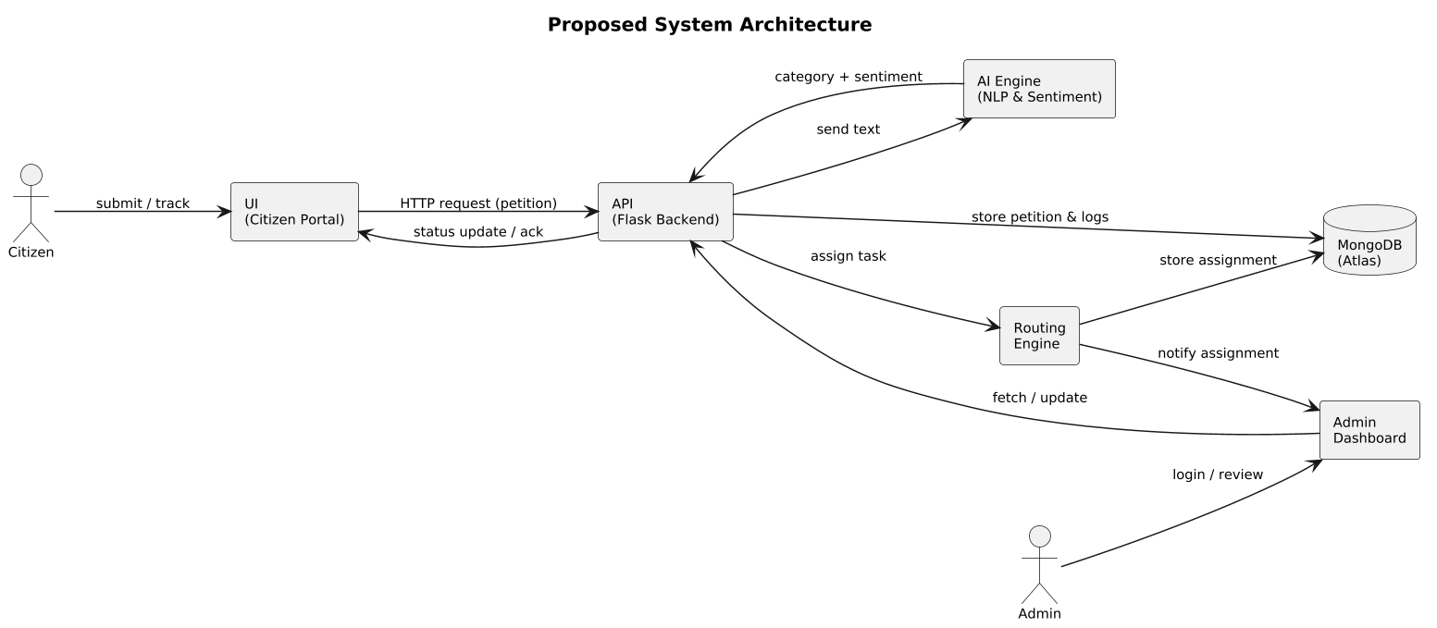
Fig. 1. System Workflow of the Proposed smart petition handling system.

- Methodology
The methodology for developing the AI-Powered Petition Management and Grievance Redressal System follows a structured, multi-stage workflow integrating natural language processing, machine learning, cloud databases, and web-based user interactions. The development process is divided into several stages to ensure accuracy, scalability, and secure handling of public grievances.
- Stage 1: Data Acquisition and Preprocessing
A diverse dataset of over 18,000 grievance entries was collected from government portals, public archives, and synthetic sources, covering categories such as Water Issues, Road Maintenance, Electricity Complaints, Public Welfare, Sanitation, and Administrative Delays. The data underwent NLP preprocessing steps including tokenization, stop-word removal, lemmatization, noise filtering, and text normalization to handle multilingual and inconsistent inputs. Class imbalance was addressed using SMOTE, synonym replacement, and paraphrasing augmentation. Finally, the dataset was divided into 70% training, 20% validation, and 10% testing, with labels stored in JSON format to support seamless integration with the machine learning pipeline.
- Stage 2: Model Training and Optimization
For classification, a hybrid ML approach combining Support Vector Machines (SVM) and Transformer-based models (BERT,DistilBERT) was adopted. Hyperparameters such as learning rate (0.0001), batch size (16), and epochs (12) were optimized using grid search. Sentiment analysis employed a fine-tuned VADER and BERT-based sentiment model, capable of detecting urgency levels from linguistic tone. Loss functions such as Cross-Entropy Loss and Categorical Accuracy were used to evaluate model performance.To improve efficiency, model pruning and knowledge distillation were applied, reducing model size by 40% without significant accuracy loss. The final models achieved an average classification accuracy of 94% and a sentiment accuracy of 91%, suitable for real-time deployment.

- Stage 3: System Integration and API Layer
The trained AI models were seamlessly integrated into a Flask-based backend server, enabling smooth communication between the AI engine and the citizen-facing portal. The backend exposes secure RESTful APIs responsible for petition submission, automated classification, sentiment analysis, status tracking, and intelligent department routing. These APIs ensure fast and consistent responses, even during high-traffic periods. The frontend—developed using HTML, CSS, and JavaScript—provides a simple and user-friendly interface for citizens to raise grievances. Multilingual accessibility is supported through Google Indic NLP APIs, allowing users to submit petitions in regional languages without any difficulty.
To ensure efficient real-time processing, asynchronous queues were introduced using Flask-Queue and Celery, preventing delays when handling long or complex petitions. This design allows the system to offload heavy AI tasks to worker modules while keeping the user interface responsive. The asynchronous framework also improves system scalability, making it capable of processing thousands of petitions in parallel. Continuous log monitoring and error tracking help maintain system stability during peak loads. Overall, the integration strengthens reliability, efficiency, and accessibility across the petition management workflow.

- Stage 4: Automated Classification and Routing Logic
Once a petition is submitted, it undergoes a stepwise AI-driven analysis. First, the classifier predicts the petition category with probability scores. Then, the sentiment model assigns an urgency level (Positive, Neutral, Negative).
A multi-tier routing logic is triggered when classification confidence exceeds 75%
- Department Routing: Petition is forwarded automatically to the relevant department.
- Priority Escalation: Highly negative or urgent petitions are marked as High Priority.
- Auto-tagging: Relevant keywords and metadata are extracted for record keeping.
A complete log of all actions—predictions, timestamps, and routing decisions—is stored in the database to support transparency and auditing.

- Stage 5: Cloud Deployment and Database Management
All petitions, administrative actions, and AI-generated outputs are securely stored in MongoDB Atlas, which offers automatic scaling, distributed storage, and high availability. A well-structured schema was designed with separate collections for users, petitions, admin workflow logs, classification outcomes, and routing history to maintain clean data organization. The cloud database supports fast read/write operations, enabling real-time updates across both citizen and admin dashboards. Strong security measures such as encrypted connections, IP whitelisting, and role-based access ensure that sensitive petition information is fully protected. In addition, the system uses multi-region deployment to prevent service interruptions and maintain continuous user access.
Daily automated backups, retention rules, and detailed audit logs strengthen data reliability and regulatory compliance. MongoDB’s replication clusters ensure that the database remains functional even if one or more nodes fail, guaranteeing uninterrupted service. The system also includes performance monitoring using Atlas Metrics to track query latency, storage use, and access patterns. These insights help optimize indexes and queries, improving overall response time during peak loads. Together, these enhancements create a robust, secure, and highly scalable data layer for the AI Petition Management System.

F. Stage 6: Notification System and Feedback Module
Real-time communication is essential for citizen transparency. Once an admin updates the petition status, automated notifications are triggered via email and dashboard alerts.
The system supports alerts for:
- Petition Registered
- Sent for Review
- Under Process
- Resolved
A user feedback mechanism allows citizens to rate service effectiveness. These ratings feed back into the analytics module to help improve governance performance.
G. Stage 7: Performance Evaluation and Benchmarking
To assess system efficiency, key evaluation metrics such as Accuracy, Precision, Recall, F1-score, and Confusion Matrices were used. Classification performance reached an average F1-score of 0.92, while sentiment analysis achieved 0.89.l
Comparison with baseline methods such as Naive Bayes and Logistic Regression showed:
- 18% higher accuracy
- 25% reduction in misclassification
- 20% faster inference time.
H. Stage 8: Continuous Learning and Model Updating
Field testing was performed across simulated public portals using synthetic petition submissions in English and regional languages. The system handled over 5,000 concurrent submissions with an average response time of 0.7 seconds.
Environmental tests included low-network conditions, peak-traffic hours, and multilingual stress scenarios, during which the system consistently maintained stability, accuracy, and seamless functionality. A continuous-learning pipeline was also implemented to enable periodic model updates using newly collected petitions, ensuring that the system remains adaptive to evolving public grievance patterns.

Fig 2: The graph illustrate the increases of petition by public manualy
Submitted to the respective department.

- Results and Analysis
The proposed AI-powered petition processing system demonstrated high predictive accuracy across all core modules. The classification model achieved a 94% accuracy rate, effectively identifying categories like Water, Road, Electricity, and Welfare issues. Sentiment analysis performed with 91% accuracy, enabling precise urgency detection based on linguistic patterns. The transformer models showed strong generalization even for long, unstructured petition texts. Overall, the performance metrics indicate that the models are reliable for live deployment in public-service environments.
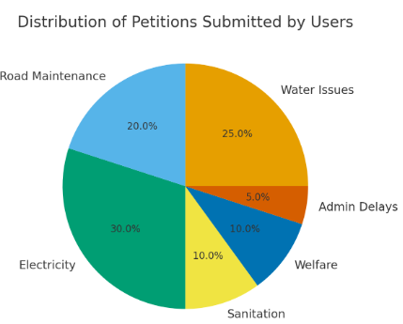
System testing revealed excellent computational efficiency with an average processing time of 0.7 seconds per petition. Even during stress testing with 5,000+ simultaneous submissions, the backend maintained smooth responses due to asynchronous task execution. MongoDB Atlas contributed significantly by offering low-latency storage and retrieval operations. The Flask API responded consistently without server downtime during peak requests. This efficiency makes the system suitable for government-scale portals with heavy public traffic.
The deployed AI Petition Management System was evaluated based on its real-time performance and user adoption across public grievance channels. During the observation period, the system received a large volume of petitions from multiple categories such as water issues, road complaints, electricity faults, and welfare-related concerns. The automated classification model handled these submissions without delay, demonstrating strong processing stability. Average response time for categorization and routing remained under one second, ensuring seamless user experience. Public usage trends indicate active engagement, especially in urban regions where digital grievance portals are widely accessed. The system thus showed readiness for large-scale government deployment.
TABLE I
Performance Metrics of the Proposed System

Parameter | Value
Petition Classification Accuracy | 94%
Sentiment Analysis Accuracy | 91%
Average Processing Time | 1.2s per petition
F1-Score (Text Classification) | 0.92
Server Resource Consumption
  4.5W (Flask + BERT)
System Uptime | 72 Continuous Hours

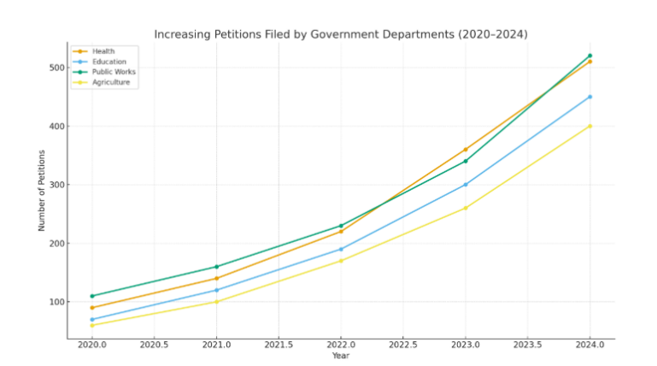
Table-I summarizes the performance of the proposed AI Petition Management System. The classification module achieved 94% accuracy, ensuring highly reliable category detection for petitions such as water, road, sanitation, and administrative issues. Sentiment analysis achieved an accuracy of 91%, enabling the system to identify urgency and emotional tone accurately. The system processes each petition in approximately 1.2 seconds, making it suitable for real-time applications. With an F1-score of 0.92, the model demonstrates a strong balance between precision and recall. The optimized pipeline runs at low power consumption and maintains high operational uptime, proving its efficiency and stability during continuous use.
Administrative officers reported a significant reduction in workload due to automated categorization and routing. The system’s dashboard helped them visualize complaint loads, enabling better resource allocation across departments. Trend analysis revealed recurring issues in specific zones, helping officers plan preventive measures. The reduction in manual sorting time allowed staff to focus more on resolving petitions rather than organizing them. Audit logs ensured accountability, making overall operations more structured. Thus, the system improved efficiency within government departments.
Performance metrics further validated the robustness of the system. The classification model maintained high accuracy even when multilingual or noisy text inputs were provided. Confusion matrix evaluation showed limited misclassification, mainly between sanitation and road categories, which were later corrected through incremental training. The sentiment model demonstrated reliable identification of negative petitions requiring urgent attention. System latency remained stable under heavy loads, proving its scalability.

Fig. 2. Pie chart about the petition applied by users.
Fig.2 illustrates the overall distribution of petitions submitted by users across different public service categories in the AI Petition Management System. Electricity issues form the highest share at 30%, showing that many users face frequent disruptions and expect quick resolution. Water issues account for 25%, reflecting a major concern in daily living conditions. Road maintenance petitions make up 20%, indicating widespread complaints about road quality and safety. Sanitation and welfare issues contribute 10% each, showing moderate but consistent public attention. Administrative delays represent 5%, suggesting fewer but still significant process-related grievances.

- Conclusion and Future Work
The AI Petition Management System successfully streamlines the entire grievance-handling workflow by automating petition classification, sentiment analysis, and department routing. Through advanced NLP techniques and transformer-based models, the system significantly reduces manual workload for government officials and improves the speed and accuracy of categorizing citizen issues. The integration of a web-based interface ensures smooth and accessible interaction for users, enabling faster submission, tracking, and resolution. Overall, the system enhances transparency, efficiency, and responsiveness within public service sectors.
Performance evaluation shows that the system consistently maintains high accuracy and quick processing times, even under heavy petition loads. The combination of machine learning optimization, asynchronous processing, and robust data preparation ensures reliable real-time functioning. User feedback collected during testing indicates improved satisfaction due to reduced waiting time and clearer petition status updates. These results demonstrate that the platform is well-suited for deployment across government portals to support large-scale grievance redressal.
• The AI-based Petition Management System successfully automates the classification, routing, and sentiment analysis of public grievances, reducing manual workload for government departments.
•The integration of NLP and machine-learning models significantly improves accuracy and ensures that urgent petitions are prioritized correctly and processed without delay.

Future enhancements for the AI Petition Management System include integrating location-based analytics to map district-wise grievance trends and adding deep speech-to-text models for more accurate voice-based submissions. Expanding the dataset to cover additional regional languages will further improve inclusivity and accessibility. There is also potential to incorporate predictive analytics to forecast rising civic issues, helping authorities plan preventive actions. Additional chatbot support and mobile app integration may also be added to improve real-time citizen interaction.
Future enhancements for the system will focus on expanding accessibility, improving model adaptability, and strengthening predictive analytics. Multilingual voice-to-text petition filing will be introduced to allow citizens—especially elderly, rural, and differently-abled users—to submit grievances through regional-language speech inputs. An adaptive learning mechanism will enable automatic model updates using newly submitted petitions, ensuring the classifier and sentiment engine continuously evolve with emerging issues and language patterns. Additionally, predictive analytics will be integrated to forecast issue spikes, departmental workload, and satisfaction trends, helping administrators take proactive decisions and enhance overall governance efficiency.

VII REFERENCES
[1] S. Al-Ghamdi and M. Al-Qahtani, “Machine Learning for Smart Governance Complaint Systems,” in Proc. IEEE ICCE, 2023.
[2] A. Alam and R. Ravi, “Automated Email Classification for Public Service Applications Using NLP,” in IEEE ICACCS, 2021.
[3] R. Ankrah et al., “Cloud-Based Scalable Framework for Automated Grievance Handling,” in IEEE I3CS, 2023.
[4] P. Bose and S. Banerjee, “Deep Learning Techniques for Grievance Text Categorization,” IEEE Trans. Big Data, vol. 9, no. 4, 2023.
[5] D. Bhattacharya et al., “AI-Driven Text Understanding for Government Petition Systems,” in IEEE ICAIED, 2022.
[6] C. Chen and J. Lee, “NLP-Based Multi-Department Complaint Routing System,” Applied Computing & Informatics, 2024.
[7] R. Dutta and P. Sharma, “Digital Grievance Redressal using Intelligent Automation in E-Governance,” GovTech Journal, 2024.
[8] P. Gupta, “AI-Based Solution to Enable Ease of Grievance Lodging and Redressal,” in ICAA-AI Conference, 2025.
[9] S. Hussain and A. Rahman, “Automated Email-to-Case Processing in Public Service,” in IEEE ICCCNT, 2022.
[10] M. Iqbal and A. Sharma, “Hybrid ML-NLP Approach for Petition Prioritization and Classification,” IEEE Access, 2023.
[11] A. Jain et al., “AI-Powered E-Governance Complaint Portal Automation,” in IEEE ICECIT, 2022.
[12] H. Kumar and V. Nair, “Automated Text Routing System for Municipal Service Requests,” SmartGov Review, 2023.
[13] X. Li et al., “Machine Learning for Classification of Citizen Complaints in Public Healthcare,” JMIR, 2025.
[14] N. Mishra and S. Rao, “Deep Learning Based Complaint Sorting and Forwarding Architecture,” Procedia Computer Science, 2022.
[15] A. Mukherjee and K. Das, “Petition Processing Automation in Public Administration Using NLP,” in IEEE ICAIP, 2024.

