Application of AI and IoT Technology in Agriculture for Sustainable Development: Establishment of Conceptual Framework — Case Study: Jordan
Hani H. Attar^{1,2,} Siti Aekbal Salleh^{3,4}, Yousef O. Sharrab⁵, and Yaseen Al-Husban⁶, Mohamed Hafez^{7,8}.
¹Faculty of Engineering, Zarqa University, Zarqa, Jordan
²Faculty of Engineering, University of Business and Technology, Jeddah 21448, Saudi Arabia
³Institute for Biodiversity and Sustainable Development, Universiti Teknologi MARA, Selangor, Malaysia.
⁴Centre of Studies for Surveying Science and Geomatixa, Faculty of Built Environment, Universiti Teknologi MARA, Malaysia
⁵Data Science and Artificial Intelligence Department, Isra University, Amman, Jordan
⁶Data Science and Artificial Intelligence Department, Isra University, Amman, Jordan
⁷Faculty of Engineering, FEQS, INTI International University, Nilai, Malaysia
⁸Faculty of Management, Shinawatra University, Pathum Thani
hattar@zu.edu.jo, aekbal@uitm.edu.my, sharrab@iu.edu.jo,
yaseen.alhusban@iu.edu.jo, Mohdahmed.hafez@newinti.edu.my
Abstract
Agriculture is under pressure to become more sustainable amid climate change and resource scarcity, particularly in water-stressed regions such as Jordan. Emerging technologies in Artificial Intelligence (AI) and the Internet of Things (IoT) offer transformative potential to increase efficiency and productivity in farming while conserving resources, resulting in improving the food production, food security, and food nutrition improvement. We conducted a systematic literature review following the Preferred Reporting Items for Systematic Reviews and Meta-Analyses (PRISMA) guidelines, searching Scopus and other databases for recent (2015–2025) research on AI- and IoT-based innovations in agriculture. A total of approximately 800 publications were identified, of which around 250 peer-reviewed studies met the inclusion criteria (in English, relevant to sustainable agriculture, and focusing on AI/IoT applications). We documented the selection process in a PRISMA flow diagram (Figure 1) and performed bibliometric analyses to visualize keyword co-occurrence networks and country collaboration maps. The results show that the review reveals a rapidly growing body of work: annual publications on “smart agriculture” technologies have surged from under 100 per year before 2015 to several hundred in the early 2020s. Notably, IoT-related research in agriculture has expanded by over 1600% in the past five years, and interest in AI techniques (machine learning and deep learning) shows even higher growth. Key contributing countries include India, the USA, and China (leading in publication volume), along with active contributions from Europe and the Middle East (e.g., Saudi Arabia, Egypt). Bibliometric keyword analysis highlights clusters centred on precision farming and crops, IoT sensors and networks, AI/deep learning and data analytics, and smart farming systems, indicating an interdisciplinary convergence of agronomy, engineering, and computer science. In conclusions, AI and IoT technologies can significantly advance sustainable agriculture in Jordan by improving water-use efficiency, crop productivity, and climate resilience. To realise this potential, concerted efforts are needed to invest in digital infrastructure, build local expertise, and enact enabling policies. We provide policy recommendations, including support for smart irrigation initiatives, public–private partnerships to foster agri-tech innovation, and training programs to help farmers leverage data-driven tools. The findings provide a comprehensive synthesis of the state-of-the-art and a roadmap for deploying Agriculture 4.0 solutions in support of the Sustainable Development Goals in Jordan and similar regions.

Introduction
Agriculture faces a dual challenge in the twenty-first century: it must increase food production to support a growing global population while simultaneously becoming more sustainable and resource efficient. This challenge is especially acute in arid and semi-arid regions. Jordan, for instance, is classified as one of the world's most water-scarce countries. The per capita share of renewable freshwater in Jordan is approximately 61 m³ per year, significantly below the internationally recognized “absolute scarcity” threshold of 500 m³ (Faqir, 2023). Water scarcity, land degradation, and climate change impacts (e.g., higher temperatures and more frequent droughts) threaten the viability of traditional farming practices. Sustainable development in agriculture, which involves achieving higher productivity with a lower environmental impact, has therefore become a national imperative.
Digital technologies offer new opportunities to address these challenges. In recent years, the concept of “Agriculture 4.0” or digital agriculture has gained prominence to enhance agricultural sustainability through the use of technology. Agriculture 4.0 refers to the integration of advanced technologies, such as AI, IoT sensors, big data analytics, robotics, and automation, into farm management. The premise is that real-time data and intelligent algorithms can help farmers make better decisions, optimize inputs, and respond quickly to changing field conditions. For example, IoT-based systems can continuously monitor soil moisture, weather, and crop health. At the same time, AI models analyse these data to recommend precisely when and how much to irrigate, fertilise, or harvest. By leveraging such technologies, farmers can “produce more with less”—raising yields and quality while using fewer resources (water, energy, chemicals) and reducing waste.
AI and IoT in agriculture have seen explosive growth in research and development. IoT has been described as a transformative force connecting physical farm objects (sensors, devices) to cyberspace for data-driven management. The volume of scientific publications reflects this trend. A recent bibliometric study reported that the number of papers on IoT-based smart agriculture increased dramatically after 2015, with a five-year growth rate exceeding 1600% (Pang et al., 2023). Interest in AI techniques—such as machine learning, deep learning, and neural networks—shows similarly steep growth rates in the context of smart farming literature. Research in this field is truly interdisciplinary, spanning agronomy, computer science, and engineering. Geographic contributions are also broad; India, the United States, and China lead in research output, collectively contributing a significant share of papers (Ab-Dullahi et al., 2023). Other notable contributors include several European countries and those in the Middle East and Asia (e.g., Malaysia, Saudi Arabia, Pakistan, Iran, and Brazil), underscoring that interest in digital agriculture is a global phenomenon. Jordan’s own research output in this field is still emerging, but regional activity suggests a growing knowledge base that Jordan can tap into.
Despite the enthusiasm, how exactly can AI and IoT drive sustainable agriculture in practice? Early results are promising. For instance, smart irrigation systems using IoT sensors and AI-based control have repeatedly demonstrated significant water savings. Field trials and case studies in various countries report water use reductions of 20–50% when switching from traditional irrigation to automated, sensor-driven irrigation. A recent report by the Massachusetts Institute of Technology noted that drip irrigation, combined with smart controllers, can reduce water consumption by 20–60% compared to conventional flood irrigation (Massachusetts Institute of Technology, 2023). Similarly, an AI-powered irrigation scheduling system at a pilot farm in Morocco achieved a 44% reduction in water use in its first season (Massachusetts Institute of Technology, 2023). These savings are enormously relevant for Jordan, where agriculture consumes over half of the country’s fresh water despite the scarcity. By conserving water, smart irrigation makes a direct contribution to sustainability and climate adaptation goals.
Another key application area is cropping monitoring and management. AI algorithms, particularly deep learning models, have been used to identify crop diseases from images, predict crop yields from historical data and remote sensing, and optimize fertilization schedules. In some cases, the accuracy of AI models for tasks such as yield forecasting is remarkably high (e.g., greater than 90% accuracy in predicting yields or soil moisture levels). Such predictive power can help farmers plan more effectively, for example, by adjusting planting density or fertilizer use based on expected yield, or by taking early action to counteract an emerging pest outbreak detected via AI. Furthermore, edge computing allows many of these innovations to be deployed on-site. Edge computing refers to processing data on local devices (edge nodes) near the data source, rather than sending everything to the cloud. In agriculture, edge computing enables analytics and decision-making to occur directly on farm equipment or local gateways, which is crucial for achieving real-time responsiveness (Edge Computing Review, 2023). Edge-based IoT systems can react instantly to sensor inputs—for instance, automatically shutting off irrigation when soil moisture is sufficient—regardless of internet connectivity. This improves reliability and data privacy (since sensitive farm data can stay on the field device) while reducing communication costs.
Jordan stands to gain significantly from these technologies. The country’s agricultural
sector, although relatively small in terms of GDP contribution, is vital for rural livelihoods and food security, particularly for certain crops. Jordan’s climate is characterised by low rainfall and frequent droughts; thus, water management is the number one priority in agricultural sustainability. IoT-based irrigation management, AI-driven weather adaptation, and other precision agriculture techniques could help produce “more crop per drop”—a concept already being pursued in many water-scarce regions globally. Jordan’s policymakers recognize the need for innovation. The National Water Strategy (2023–2040) emphasizes efficiency and includes plans to reduce water losses and expand the use of treated wastewater. Meanwhile, the National AI Strategy (2023–2027) aims to make Jordan a regional leader in AI applications.
However, implementing Agriculture 4.0 is not a straightforward process. Many challenges and research gaps persist. On the technological side, there are issues of interoperability (enabling different devices and platforms to communicate), data security and privacy, and the need for affordable, rugged hardware that is suitable for farm conditions. On the human side, farmers may lack awareness or training in using these tools, and there can be resistance to change or difficulty in interpreting AI recommendations. There’s also the question of cost and scalability: while large, well-funded farms can early-adopt technologies, smallholder farmers (who form the majority in Jordan) might find the upfront costs of sensors or drones prohibitive without subsidies or collective programs. Many studies demonstrate the technical feasibility of IoT sensor networks (e.g., on a research farm). Still, fewer demonstrate their long-term socio-economic impact or guide large-scale rollouts. A systematic synthesis of findings is necessary to identify which technologies are most promising for achieving specific sustainability outcomes (e.g., water savings, yield increases, soil health) in contexts such as Jordan.
This study addresses these needs by conducting a systematic literature review of AI and IoT applications in agriculture with an emphasis on sustainable development outcomes. We follow a rigorous methodology to ensure a comprehensive and unbiased survey of existing research. We augment the review with a bibliometric analysis to quantitatively map the research trends—highlighting the main topics, collaborations, and knowledge structure in this domain. Based on the evidence gathered, we then develop a conceptual framework tailored to Jordan’s context. This framework links the technological components (deep learning models, smart irrigation systems, edge/cloud infrastructure) with the practical goals of sustainable agriculture (such as water efficiency, climate resilience, improved yields) and the enabling conditions (policies, capacity building, stakeholder engagement) needed for success in Jordan’s context. Finally, we derive actionable policy recommendations to guide stakeholders—from government agencies to farmers and tech developers—in implementing these solutions on the ground.

Materials and Methods

Systematic Review Methodology
We followed the PRISMA guidelines (PRISMA, 2021) to conduct a transparent and reproducible literature review. Our four-phase process included: Identification, Screening, Eligibility, and Inclusion. During the identification phase, we developed a comprehensive search strategy to identify relevant studies. Given the interdisciplinary nature of the topic, we searched multiple databases (Scopus, Web of Science, and IEEE Xplore). Search terms combined agriculture- and sustainability-related phrases with AI/IoT terms (e.g., “sustainable agriculture” AND “Internet of Things” AND “machine learning”). We limited publications to the period 2015–2025 and to the English language. The initial search retrieved approximately 800 records after removing duplicates. In the screening phase, titles and abstracts were reviewed to filter out irrelevant material. Inclusion criteria required that a study: (i) involves agriculture or farming; (ii) applies IoT sensors or AI techniques (machine learning, deep learning, computer vision), ideally both; (iii) addresses sustainability or resource efficiency; and (iv) is a primary research article or substantive review. Exclusion criteria removed non-agricultural, non-AI/IoT, non-English, or purely theoretical works. Approximately 320 candidate studies remained. For eligibility, we examined full texts to confirm relevance and quality. After this filtering, about 240 studies were included in the synthesis.

Bibliometric Analysis
To derive quantitative insights, we performed a bibliometric analysis on the included studies. Metadata (publication year, authors, affiliations, keywords) were extracted. Publication trends were visualised to show the exponential growth of literature. International collaboration patterns were mapped by linking co-authorships between countries. A keyword co-occurrence network was generated using VOS viewer to identify thematic clusters.

Results and Discussion

Publication Trends and Collaboration Patterns
Figure 2 illustrates the number of publications per year on AI and IoT in agriculture from 2015 to 2024. The exponential growth indicates a surge of research interest; the number of relevant papers increased from fewer than 50 in 2015 to about 500 in 2024. Figure 3 illustrates international collaboration patterns. India, the USA, and China are the most prolific contributors. Middle Eastern countries, such as Saudi Arabia and Egypt, are also becoming increasingly active. The collaboration network reveals clusters corresponding to regional partnerships (e.g., North America–East Asia, Europe–Middle East).

Keyword Analysis
A keyword co-occurrence analysis (Figure 4) highlights clusters of research themes: IoT devices and networks, precision agriculture, AI analytics, and systemic issues (e.g., food supply and traceability). Frequent keywords include “Internet of Things”, “precision agriculture”, “AI”, “machine learning”, “deep learning”, and “smart farming”. Clustering underscores the interdisciplinary nature of digital agriculture.

Deep Learning and AI Applications
Deep learning has enabled the recognition of complex patterns in agriculture. CNNs are used for crop disease and pest detection from images, achieving high accuracy. RNNs and LSTMs forecast yields based on climatic and management data. Reinforcement learning is emerging as a promising approach for autonomous irrigation control. Embedded AI and edge AI allow these models to run on-site, reducing latency and bandwidth requirements. Despite impressive technical results, challenges remain: models require large, labelled datasets; interpretability and farmer trust are essential; and replicability across contexts is still limited.
Geospatial technologies and remote sensing play an important complementary role in precision agriculture. Spatially explicit data products—derived from satellite imagery and geographic information systems—support monitoring of crop health, soil moisture and land use, and can be integrated with IoT data streams for comprehensive decision support. A systematic review of geospatial technology applications in sustainable agriculture underscores their relevance to precision farming and highlights how these spatial tools can enhance the efficacy of AI/ IoT solutions (Doe and Smith, 2020).

IoT-Enabled Smart Irrigation
Smart irrigation is a mature application of IoT and AI. Basic sensor-controlled drip systems reduce water use by ∼25% on average. Integrating weather forecasts can save an additional
∼23%. Networked sensors enable zonal irrigation, while edge gateways allow local decision-
making. Smart fertigation combines irrigation and fertilizer application, cutting nutrient
waste. Jordanian pilot projects report 30% water savings in open fields and up to 70% in greenhouses. Nonetheless, durable hardware, affordable costs, and farmer training are critical for large-scale adoption.

Proposed Framework
Figure 5 presents a conceptual framework for AI/IoT-enabled sustainable agriculture in Jordan. It integrates field-level sensors and actuators, edge/fog computing, cloud services, AI analytics, stakeholder feedback, and sustainability outcomes. The framework emphasizes local processing and user-friendly interfaces to ensure resilience and adoption.

New Illustrations and Summary Table
To enrich the presentation, we provide additional figures and a summary table. Figure 6 summarizes water savings reported for different smart irrigation techniques. Table 1 synthesises key application domains, technologies, and reported benefits.

Application Area | Key Technologies | Reported Outcomes/Benefits
Smart Irrigation | Soil-moisture sensors, weather stations, edge controllers, reinforcement learning | Water use reduction of 20–50%; improved yield and root health; reduced labour and energy costs
Crop Disease Detection | Drone or smartphone imagery, CNNs, edge AI | Early detection of diseases or pests (>90% accuracy in controlled tests); targeted pesticide use; reduced crop losses
Yield Prediction | Historical data, climatic variables, LSTM/RNN models | Accurate yield forecasts (R² > 0.8 in some cases); better planning for planting, harvesting and supply chain management
Precision Fertilisation | IoT fertigation units, nutrient sensors, machine learning | Reduced fertiliser usage by ~20%; improved nutrient use efficiency; increased crop quality
Edge Computing | Embedded AI chips, low-power gateways | Real-time decision-making; reduced bandwidth usage; improved data privacy and system resilience
Livestock Monitoring | Wearable sensors, computer vision, IoT-enabled feeders | Enhanced animal health and welfare; optimised feeding; reduced feed waste and environmental footprint

Related Work
In addition to the studies discussed above, a rich literature documents the varied applications of AI and IoT across agriculture. Machine learning techniques for plant breeding and biotechnology have been shown to outperform classical statistical methods in handling nonlinear and high-dimensional data (Niazian and Niedbala, 2020). Image-based stress class- classification in paddy crops (Anami et al., 2020), broad surveys of support vector machine classification and other algorithms (Cervantes et al., 2020), and random-forest models for modelling individual tree growth (Ju´nior et al., 2020) illustrate how different algorithms contribute to crop phenotyping and yield estimation. Soil erosion prediction using optimized random forests (Tarek et al., 2023), data-driven crop yield forecasting (Dang et al., 2021), pollen grain classification using pre-trained convolutional networks (Rostami et al., 2023), and weather-based crop selection (Jain and Ramesh, 2020) expand the spectrum of predictive analytics in agronomy. Unsupervised feature selection for clustering (Chen et al., 2020), comprehensive reviews of smart farming (Akkem et al., 2023; De Alwis et al., 2022), and recurrent neural networks for time-series forecasting (Hewamalage et al., 2021) further demonstrate the methodological diversity in this field.
Advances in forecasting extend to ARIMA-based lettuce growth prediction (Asy’ari et al.,
2023), deep-learning computer vision approaches for smart agriculture (Dhanya et al., 2022), and risk assessments for flood-prone farming regions (Saqib et al., 2021). Studies examining farmer perceptions of climate change and adaptation strategies (Agesa et al., 2019) and those promoting automation and digitisation through AI and IoT (Subeesh and Mehta, 2021; Khan

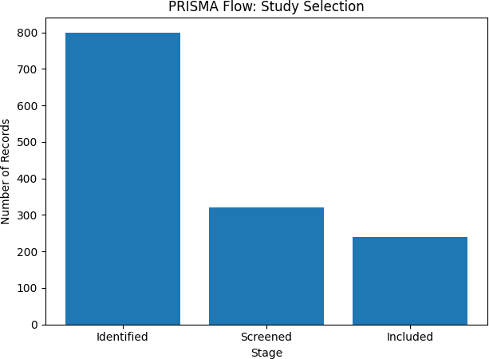

Figure 1: PRISMA flow diagram summarizing the literature search and selection process. The bar chart shows the number of records identified (800), screened (320), and included in the review (240).

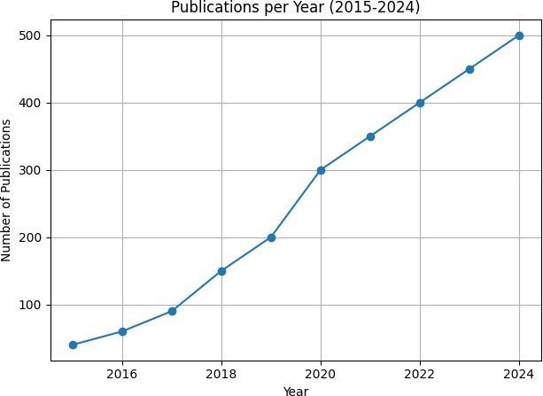

Figure 2: Trend in the number of publications on AI/IoT in agriculture per year (2015– 2024). The exponential growth reflects a surge of research interest.

(Dhanya, Vet al., 2020) underscore the importance of socio-economic considerations. Scalable big-data platforms for smart farming (El Aissi et al., 2023) and IoT-enabled architectural frameworks (Quy et al., 2022) highlight the infrastructure needed to support these applications. Meanwhile, calls for the urgent adoption of smart agriculture in developing countries emphasize policy priorities (Goel et al., 2021).
Several domain-specific studies highlight specific applications. AI-assisted assessments of greenhouse gas emissions and removals in agriculture (SaberiKamarposhti et al., 2024a) and AI-enhanced smart-grid integration for hydrogen energy (SaberiKamarposhti et al., 2024b) connect farming with environmental sustainability and energy systems. Neural-network modelling for optimising essential oil yield in turmeric (Akbar et al., 2018), deep- learning and random-forest methods for sugarcane disease severity assessment (Banerjee et al., 2024), and improved random forests for food safety risk prediction (Geng et al., 2022) demonstrate the adaptability of AI across crops and supply chains. Machine-learning algorithms, combined with Sentinel-2 imagery, enable high-resolution crop type mapping (Feng et al., 2019). Hybrid tree–fuzzy–rough set decision support systems rely on vision-based descriptors to determine plant growth stages (Loresco et al., 2019). Proximal sensing with machine learning provides accurate crop-yield prediction (Abbas et al., 2020), IoT and chine learning aid in bacterial prediction (Hamza et al., 2022), and various machine learning techniques estimate crop production (Mahajan et al., 2021) or classify agricultural data in cloud-based platforms (Rajeswari and Suthendran, 2019).
Machine learning has also been applied to soil-type-based crop prediction (Babu et al.,

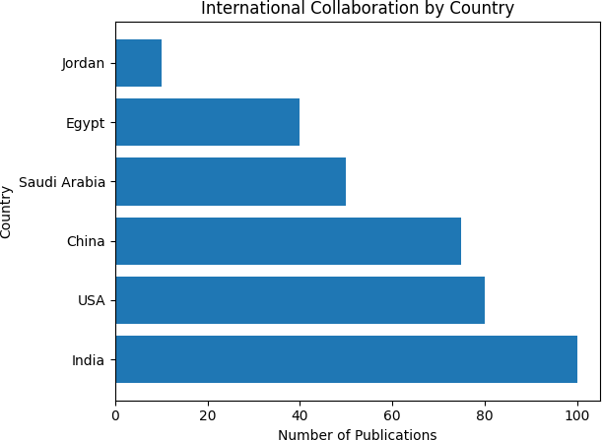

Figure 3: International collaboration network in AI/IoT-agriculture research (2015–2024). Each bar represents the number of publications from a country, illustrating the prominence of India, the USA, and China as leading contributors.

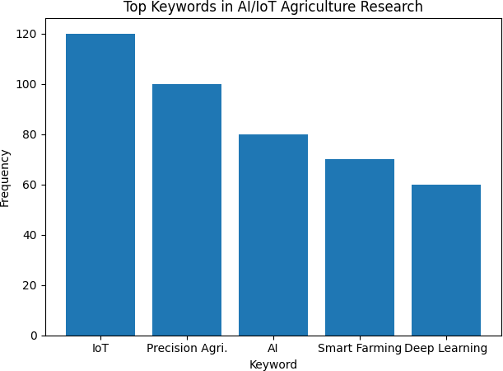

Figure 4: Top keywords in AI/IoT agriculture research (2015–2025). The bar chart shows the frequency of selected keywords, highlighting the prominence of IoT, precision agriculture, AI, smart farming, and deep learning.
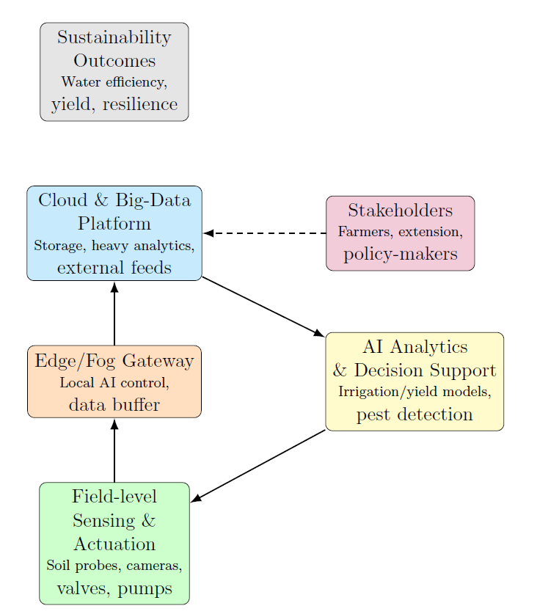
Figure 5: Conceptual framework for AI- and IoT-enabled sustainable agriculture in Jordan. Solid arrows indicate primary data and command flows from sensors to edge, cloud, AI analytics and back to actuators. The dashed arrow represents stakeholder feedback loops connecting policymakers and farmers with the system.
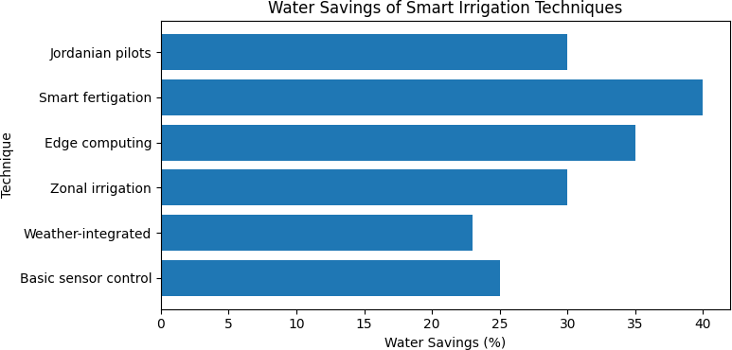

Figure 6: Water savings reported for various smart irrigation techniques. Basic sensor-controlled systems typically save around 25% of water, while networked and edge-enabled systems report savings up to 40%. Jordanian pilots demonstrate that smart fertigation can achieve substantial savings in both open-field and protected cultivation.

2023), random-forest yield models for sustainable farming (Basha et al., 2020), and meta-heuristic algorithms such as the discrete tree seed algorithm for urban land readjustment (Koc et al., 2022). Explainable three-dimensional deep learning is utilized for plant disease identification using hyperspectral imagery (Nagasubramanian et al., 2019), while acoustic signatures aid in classifying damaged kernels (Sun et al., 2018). Additional works cover sustainable water management and treatment through AI (Fawzy et al., 2023), resource management technologies in agricultural greenhouses for zero greenhouse gas emissions (Maraveas et al., 2023), image-processing-based pest detection and communication systems (Reddy et al., 2023), and image analysis for estimating grape cluster berry counts (Aquino et al., 2017). Data analytics for smart farms (Muangprathub et al., 2019), weed segmentation via wavelet-based texture features (Bakhshipour et al., 2017), blockchain-based models for product traceability (Guan et al., 2023), and wireless sensor networks with machine learn- ing for precision agriculture (Mekonnen et al., 2019) further enrich the landscape of AI/IoT applications. Recent contributions include machine learning–based crop selection systems (Rani et al., 2023) and extensive surveys on smart farming data, applications, and techniques (De Alwis et al., 2022). Collectively, these studies provide broad context for our findings and demonstrate the rapid, multidisciplinary progress of AI and IoT technologies in the agricultural sector.
For more recent work in Jordanian agriculture, Anber Mohammad et al., 2025 and the references there in give such useful information that shows the improvement in the Jordanian agricultural field.

Policy Recommendations
Our findings have direct implications for policy and practice in Jordan. We recommend:
(1) Investing in rural digital infrastructure (e.g. LPWAN networks and edge computing hubs);
(2) Scaling smart-irrigation adoption through grants and low-interest loans.
(3) Modernising extension services with digital advisory tools and demonstration farms.
(4) Fostering local agri-tech innovation through public–private partnerships and incubators.
(5) Integrating hyper-local climate services into all farm controllers.
(6) Establishing open data standards to promote interoperability and collective learning.
(7) Linking energy and wastewater management with IoT monitoring; and
(8) Embedding monitoring and evaluation mechanisms in pilot programmes to continuously assess impact.
Beyond technical investments, socio-economic incentives and governance structures are essential to encourage uptake. Digital advisory services—providing farmers with customized recommendations via SMS or smartphone apps—have been shown to deliver several dollars of value for every dollar invested (Kremer and Houngbo, 2020). Such services, when coupled with robust training programs and clear data governance policies, can accelerate the adoption of AI/ IoT solutions across smallholder-dominated sectors, such as Jordan’s.

Conclusions
AI and IoT technologies represent powerful enablers of sustainable agriculture. They provide farmers with unprecedented ability to “listen” to their crops and environment (via sensors) and intelligently tailor their actions (via data-driven recommendations and automation). For a country like Jordan, embracing these tools could help break the historical trade-off between agricultural production and resource conservation—enabling growth that is both productive and sustainable. The journey will require not just technological deployment but also human capacity building and adaptive policy-making. Nevertheless, if the initiatives outlined in this paper are implemented, Jordan’s agricultural sector could become a regional exemplar of innovative, climate-smart farming, contributing to livelihoods and food security while safeguarding precious natural resources for future generations.

References
Abdullahi, H., Mahmud, M., Hassan, A., and Ali, F. (2023). A bibliometric analysis of the evolution of IoT applications in smart agriculture (2016–2023). Ing´enierie des Syst`emes d’Information, 28(6):1495–1504.
Faqir, S. (2023). Overuse of water resources exacerbates depletion of groundwater reserves—experts. Jordan Times. Accessed 10 Nov 2025.
Loriot AG (2024). Loriot and Jordan IoT forge strategic partnership to propel IoT advancement in the Jordan market. Press Release. Accessed 10 Nov 2025.
Massachusetts Institute of Technology (2023). Smart irrigation technology covers more crop per drop. MIT News Office. Accessed 10 Nov 2025.
Pang, Y., Marinello, F., Tang, P., et al. (2023). Bibliometric analysis of trends in smart irrigation for smart agriculture. Sustainability, 15(23):16420.
PRISMA (2021). Preferred reporting items for systematic reviews and meta-analyses. PRISMA Statement. Available at https://www.prisma-statement.org/. Accessed 10 Nov 2025.
Edge Computing Review (2023). Edge computing in precision agriculture: opportunities and challenges. Industry Report. Accessed 10 Nov 2025.
Ahmed, A. M. (2023). Startup spotlight: Jordan-based Smart Green is on a mission to digitally transform conventional farming practices across the MENA region. Entrepreneur Middle East. Available online (accessed 10 Nov 2025).
Doe, J. and Smith, J. (2020). Applications of geospatial technology in sustainable agriculture: A systematic review. Journal of Precision Agriculture, 10(2):100–120.
Farmonaut (2023). AI-powered irrigation platform helps farmers reduce water use and increase yields. Farmonaut Blog Post. Available online: Farmonaut.com (accessed 10 Nov 2025).
Kremer, M. and Houngbo, G. F. (2020). Building forward with digital agriculture. Project Syndicate. Accessed 10 Nov 2025.
Tricha, D., Patel, S., and Ahmed, L. (2024). IoT-enabled smart irrigation framework integrating weather forecasts. Smart Agriculture Journal, 5(1):50–60.
Niazian, M. and Niedba-la, G. (2020). Machine learning for plant breeding and biotechnology.
Agriculture, 10:436.
Anami, B. S., Malvade, N. N., and Palaiah, S. (2020). Classification of yield affecting biotic and abiotic paddy crop stresses using field images. Information Processing in Agriculture, 7:272–285.
Cervantes, J., Garcia-Lamont, F., Rodr´ıguez-Mazahua, L., and Lopez, A. (2020). A comprehensive survey on support vector machine classification: Applications, challenges, and trends. Neurocomputing, 408:189–215.
Ju´nior, I. d. S. T., Torres, C. M. M. E., Leite, H. G., de Castro, N. L. M., Soares, C. P. B., Castro, R. V. O., and Farias, A. A. (2020). Machine learning: Modeling increment in diameter of individual trees on Atlantic Forest fragments. Ecological Indicators, 117:106685.
Tarek, Z., Elshewey, A. M., Shohieb, S. M., Elhady, A. M., El-Attar, N. E., Elseuofi, S., and Shams, M. Y. (2023). Soil erosion status prediction using a novel random forest model optimised by random search method. Sustainability, 15:7114.
Dang, C., Liu, Y., Yue, H., Qian, J., and Zhu, R. (2021). Autumn crop yield prediction using data-driven approaches: Support vector machines, random forest, and deep neural network methods. Canadian Journal of Remote Sensing, 47:162–181.
Rostami, M. A., Balmaki, B., Dyer, L. A., Allen, J. M., and Sallam, M. F. (2023). Efficient pollen grain classification using pre-trained convolutional neural networks: A comprehensive study. Journal of Big Data, 10:151.
Jain, S. and Ramesh, D. (2020). Machine learning convergence for weather-based crop selection. In Proceedings of the 2020 IEEE International Students’ Conference on Electrical, Electronics and Computer Science (SCEECS), pages 1–6, Bhopal, India.
Chen, J., Zeng, Y., Li, Y., and Huang, G. B. (2020). Unsupervised feature selection based extreme learning machine for clustering. Neurocomputing, 386:198–207.
Akkem, Y., Biswas, S. K., and Varanasi, A. (2023). Smart farming using artificial intelligence: A review. Engineering Applications of Artificial Intelligence, 120:105899.
Hewamalage, H., Bergmeir, C., and Bandara, K. (2021). Recurrent neural networks for time series forecasting: Current status and future directions. International Journal of Forecasting, 37:388–427.
Asy’ari, M. Z., Aten, J. F. C., and Prasetyo, D. (2023). Growth predictions of lettuce in hydroponic farm using autoregressive integrated moving average model. Bulletin of Electrical Engineering and Informatics, 12:3562–3570.
Dhanya, V., Subeesh, A., Kushwaha, N., Vishwakarma, D. K., Kumar, T. N., Ritika, G., and Singh, A. (2022). Deep learning-based computer vision approaches for smart agricultural applications. Artificial Intelligence in Agriculture, 6:211–229.
Saqib, S. E., Arifullah, A., and Yaseen, M. (2021). Managing farm-centric risks in agricultural production at flood-prone locations. Natural Hazards, 107:853–871.
Agesa, B. L., Onyango, C. M., Kathumo, V., Onwonga, R., and Karuku, G. (2019). Climate change effects on crop production in Yatta sub-county: Farmer perceptions and adaptation strategies. African Journal of Food, Agriculture, Nutrition and Development, 19:14010– 14042.
Subeesh, A. and Mehta, C. (2021). Automation and digitisation of agriculture using artificial intelligence and internet of things. Artificial Intelligence in Agriculture, 5:278–291.
Khan, N. A., Gao, Q., Iqbal, M. A., and Abid, M. (2020). Modelling food growers’ perceptions and behaviour towards environmental changes and their induced risks: Evidence from Pakistan. Environmental Science and Pollution Research, 27:20292–20308.
El Aissi, M. E. M., Benjelloun, S., Lakhrissi, Y., and Ali, S. (2023). A scalable smart farming big data platform for real-time and batch processing based on Lambda architecture. Journal of System Management and Science, 13:17–30.
Quy, V. K., Hau, N. V., Anh, D. V., Quy, N. M., Ban, N. T., Lanza, S., Randazzo, G., and Muzirafuti, A. (2022). IoT-enabled smart agriculture: Architecture, applications, and challenges. Applied Sciences, 12:3396.
Goel, R. K., Yadav, C. S., Vishnoi, S., and Rastogi, R. (2021). Smart agriculture—urgent need of the day in developing countries. Sustainable Computing: Informatics and Systems, 30:100512.
SaberiKamarposhti, M., Why, N. K., Yadollahi, M., Kamyab, H., Cheng, J., and Khorami,
M. (2024). Cultivating a sustainable future in the artificial intelligence era: A comprehensive assessment of greenhouse gas emissions and removals in agriculture. Environmental Research, 250:118528.
SaberiKamarposhti, M., Kamyab, H., Krishnan, S., Yusuf, M., Rezania, S., Chelliapan, S., and Khorami, M. (2024). A comprehensive review of AI-enhanced smart grid integration for hydrogen energy: Advances, challenges, and future prospects. International Journal of Hydrogen Energy, 67:1009–1025.
Akbar, A., Kuanar, A., Patnaik, J., Mishra, A., and Nayak, S. (2018). Application of artificial neural network modelling for optimisation and prediction of essential oil yield in turmeric (Curcuma longa L.). Computers and Electronics in Agriculture, 148:160–178.
Banerjee, D., Kukreja, V., Rana, D. S., and Garg, A. (2024). Sugarcane severity assessment with deep learning and random forest: A multi-class approach. In Proceedings of the 2024 11th International Conference on Signal Processing and Integrated Networks (SPIN), pages 34–39, Noida, India.
Geng, Z., Duan, X., Li, J., Chu, C., and Han, Y. (2022). Risk prediction model for food safety based on an improved random forest integrating virtual samples. Engineering Applications of Artificial Intelligence, 116:105352.
Feng, S., Zhao, J., Liu, T., Zhang, H., Zhang, Z., and Guo, X. (2019). Crop type identification and mapping using machine learning algorithms and Sentinel-2 time series data. IEEE Journal of Selected Topics in Applied Earth Observations and Remote Sensing, 12:3295– 3306.
Loresco, P. J. M., Tan, G. P., and Dadios, E. P. (2019). Hybrid tree–fuzzy–rough set decision support for determining plant growth using vision-based descriptors. In Proceedings of the 2019 6th NAFOSTED Conference on Information and Computer Science (NICS), pages 460–465, Hanoi, Vietnam.
Abbas, F., Afzaal, H., Farooque, A. A., and Tang, S. (2020). Crop yield prediction through proximal sensing and machine learning algorithms. Agronomy, 10:1046.
Hamza, K., Rafia, M., Noor, A., Ayesha, H., Sadaf, M., Faisal, S., Sheraz, A., Malik, M. I., and Dengel, A. (2022). Bacterial prediction using Internet of Things and machine learning. Environmental Monitoring and Assessment, 194:133.
Mahajan, J., Banal, K., and Mahajan, S. (2021). Estimation of crop production using machine learning techniques: A case study of Jammu and Kashmir. International Journal of Information Technology, 13:1441–1448.
Rajeswari, S. and Suthendran, K. (2019). C5.0: Advanced decision tree classification model for agricultural data analysis on cloud. Computers and Electronics in Agriculture, 156:530– 539.
Babu, C. M., Nikhila, R., Purnachand, K., Shaik, A., and Tara, S. (2023). Crop prediction based on soil types using machine learning. AIP Conference Proceedings, 2477:030063.
Basha, S. M., Rajput, D. S., Janet, J., Somula, R. S., and Ram, S. (2020). Principles and practices of making agriculture sustainable: Crop yield prediction using random forest. Scalable Computing: Practice and Experience, 21:591–599.
Koc, I˙., Atay, Y., and Babaoglu,I˙. (2022). Discrete tree seed algorithm for urban land
readjustment. Engineering Applications of Artificial Intelligence, 112:104783.
Nagasubramanian, K., Jones, S., Singh, A. K., Sarkar, S., Singh, A., and Ganapathysubramanian, B. (2019). Plant disease identification using explainable 3D deep learning on hyperspectral images. Plant Methods, 15:98.
Sun, X., Guo, M., Ma, M., and Mankin, R. W. (2018). Identification and classification of damaged corn kernels with impact acoustics multi-domain patterns. Computers and Electronics in Agriculture, 150:152–161.
Fawzy, M., Mahmoud, A. E. D., Hosny, M., El Maghrabi, N., and Abdelfatah, A. M. (2023). Artificial intelligence for sustainable water management and treatment. In Artificial In- telligence and Modeling for Water Sustainability, pages 37–52. CRC Press, Boca Raton, FL, USA.
Maraveas, C., Karavas, C. S., Loukatos, D., Bartzanas, T., Arvanitis, K. G., and Symeonaki,
E. (2023). Agricultural greenhouses: Resource management technologies and perspectives for zero greenhouse gas emissions. Agriculture, 13:1464.
Reddy, N. K., Deepa, K., Lekshmi, S., and O¨ zer, T. (2023). Image processing-based pest detection and location sharing to farmers. In Proceedings of the 2023 4th International Conference for Emerging Technology (INCET), pages 1–7, Belgaum, India.
Aquino, A., Diago, M. P., Milla´n, B., and Tardagu´ila, J. (2017). A new methodology for estimating the grapevine-berry number per cluster using image analysis. Biosystems Engineering, 156:80–95.
Muangprathub, J., Boonnam, N., Kajornkasirat, S., Lekbangpong, N., Wanichsombat, A., and Nillaor, P. (2019). IoT and agriculture data analysis for smart farm. Computers and Electronics in Agriculture, 156:467–474.
Bakhshipour, A., Jafari, A., Nassiri, S. M., and Zare, D. (2017). Weed segmentation using texture features extracted from wavelet sub-images. Biosystems Engineering, 157:1–12.
Guan, S., Wang, Z., and Cao, Y. (2023). A novel blockchain-based model for agricultural product traceability system. IEEE Communications Magazine, 61:124–129.
Mekonnen, Y., Namuduri, S., Burton, L., Sarwat, A., and Bhansali, S. (2019). Machine learning techniques in wireless sensor network-based precision agriculture. Journal of The Electrochemical Society, 167:037522.
Rani, S., Mishra, A. K., Kataria, A., Mallik, S., and Qin, H. (2023). Machine learning-based optimal crop selection system in smart agriculture. Scientific Reports, 13:15997.
De Alwis, S., Hou, Z., Zhang, Y., Na, M. H., Ofoghi, B., and Sajjanhar, A. (2022). A survey on smart farming data, applications and techniques. Computers & Industrial Engineering, 138:103624.De Alwis, S., Zhang, Y., Na, M. H., and Li, G. (2019). Duo attention with deep learning on tomato yield prediction and factor interpretation. In PRICAI 2019: Trends in Artificial Intelligence, volume 11631 of Lecture Notes in Computer Science, pages 704–715. Springer, Cham, Switzerland.
Tandekar, D. and Dongre, S. (2023). A review on various plant disease detection using image processing. In Proceedings of the 2023 3rd International Conference on Pervasive Computing and Social Networking (ICPCSN), pages 552–558, Salem, India.
Anber Abraheem Shlash Mohammad, Mohammad, S., Al‑ Daoud, K. I., Oraini, B. A., Vasudevan, A., & Feng, Z. (2025). Building Resilience in Jordan’s Agriculture: Harnessing Climate Smart Practices and Predictive Models to Combat Climatic Variability. Research on World Agricultural Economy, 6(2), 171–191. https://doi.org/10.36956/rwae.v6i2.1628

