Feature-Based Fundus Image Processing for Diabetic Retinopathy Diagnosis

Ramy M. Bahy
Technical Research Center, Cairo, Egypt
ramymbahy@gmail.com.eg

Ahmed Samir
Department of Electronics and Communication Engineering
Uruk University Ahmed.S.ahmed@ururk.edu.iq

Zakaria Che Muda Prof. Ir Dr
Faculty of Engineering
Quantity Surveying INTI-IU University
Nilai, Malaysia
zakaria.chemuda@newinti.edu.my

Abstract: Diabetic retinopathy (DR) is a common and serious complication of diabetes, recognized as one of the leading causes of vision impairment and blindness among diabetic individuals worldwide. Timely and accurate detection is critical for preventing irreversible vision loss and enabling early medical intervention. In this study, we present an automated image processing-based approach designed to detect early signs of diabetic retinopathy using retinal fundus images. The strategy involves preprocessing to enhance image quality, feature extraction to detect key indicators such as microaneurysms and hemorrhages, and classification to evaluate the severity of the disease. Experimental results proved that the proposed approach achieves high performance, making it suitable for large-scale diabetic screening programs. This approach can significantly support ophthalmologists by reducing diagnostic workload and improving consistency in identifying early stages of diabetic retinopathy. Furthermore, the proposed method aligns with the United Nations Sustainable Development Goals by promoting good health and well-being through accessible and scalable early-diagnosis healthcare solutions.

Keywords: Diabetic retinopathy, Image processing, Fundus Images, Feature extraction, Automated detection systems

- INTRODUCTION
Diabetic retinopathy is a complication of diabetes that affects the retina, potentially leading to blindness if left undetected and untreated. Traditional diagnosis relies on manual inspection of fundus images by ophthalmologists, which is time-consuming and subject to human error. Automated detection systems based on image processing can provide consistent and rapid diagnosis, especially beneficial in areas with limited access to specialists [1].
Image processing approaches provide a straightforward, explainable, and efficient solution for detecting diabetic retinopathy, particularly in settings where computational resources and labeled data are limited. While modern machine learning (ML) and deep learning (DL) methods may offer higher accuracy in some cases, image processing remains a strong and practical choice for initial screening systems and low-resource environments [2].
Relying on image processing methods for detecting retinopathy from fundus images often requires less computational power. It can run on standard hardware, making it ideal for low-resource or remote settings. Moreover, unlike deep learning approaches, classical image processing techniques don't require thousands of labeled images, which are often expensive and time-consuming to obtain. Furthermore, image processing techniques provide visual cues and step-by-step reasoning (e.g., edge detection, segmentation), which makes it easier for clinicians to interpret and validate the results. These methods typically involve simple mathematical operations, resulting in quicker image analysis, which is ideal for real-time or high-throughput screening [3].
Detection approaches for diabetic retinopathy from fundus images can be categorized into four primary methodologies. First, traditional manual diagnosis, which ophthalmologists perform by visually inspecting fundus images, is time-consuming and depends on the ophthalmologist's experience. Second: Machine Learning (ML), which utilizes handcrafted features and classifiers (e.g., SVM, KNN) to detect DR. Third: Deep Learning (DL), which relies on neural networks (especially Convolutional Neural Networks, or CNNs) that learn features automatically from data. Fourth: Hybrid approaches that combine image processing with ML/DL for enhanced performance. Although this approach is more effective as it combines the advantages of both image processing and ML/DL approaches, it is considered a time-consuming and more complex approach [4].
The proposed technique for detecting diabetic retinopathy from fundus images involves three main steps: image acquisition and pre-processing, feature extraction, and classification. The overall structure of the proposed image processing-based detection of diabetic retinopathy from fundus images is shown in Figure 1. An automated image processing-based approach is proposed, primarily designed to detect early signs of diabetic retinopathy using retinal fundus images. The strategy involves preprocessing to enhance image quality, feature extraction to detect key indicators such as microaneurysms and hemorrhages, and classification to evaluate the severity of the disease. This paper is organized as follows: Section 1 presents the introduction, followed by a discussion of related work in Section 2. Section 3 discusses and explains the proposed technique of image processing-based detection of diabetic retinopathy from fundus images, while Section 4 describes the experimental work and results. The conclusion is provided in Section 5. And finally, the future work in this research area is presented in Section 6.

Fundus image acquisitions
Image pre-processing
(e.g., contrast enhancement)
noise reduction)
Featureextraction
(e.g., Microaneurysms, Hemorrhages, Exudates)
Classification
(e.g., Decision tree)
Diabetic retinopathy severity

Figure 1. Overall structure of the proposed image processing-based detection
of diabetic retinopathy from fundus images

- RELATED WORK
Diabetic Retinopathy (DR) is a significant cause of blindness. Early detection through automated methods using image processing techniques has been extensively studied over the past decades. Several approaches have been proposed, ranging from traditional image processing techniques to deep learning-based systems, which utilize retinal fundus images for classification and segmentation tasks. Early work focused on preprocessing and feature extraction techniques to enhance and identify key pathological features such as microaneurysms, hemorrhages, and exudates. For instance, a system that uses a combination of image preprocessing, blood vessel segmentation, and a k-nearest neighbor classifier to detect red lesions was proposed in [5]. A development of an automatic method for detecting microaneurysms using a combination of mathematical morphology and contrast enhancement techniques was introduced in [6]. With the rise of machine learning, researchers began employing classification algorithms for DR detection. Utilizing a support vector machine (SVM) to classify regions in fundus images as microaneurysms based on hand-crafted features was implemented in [7]. While effective, these methods heavily relied on accurate feature extraction, which is sensitive to image quality and inter-patient variability. Recent advances in deep learning, especially convolutional neural networks (CNNs), have significantly improved DR detection performance. A deep learning model trained on a large dataset of labeled fundus images, achieving performance comparable to ophthalmologists, was introduced in [8]. Their model leverages a CNN architecture to directly learn discriminative features from raw image data, bypassing the need for manual feature engineering. Some recent techniques have employed Hybrid Deep Learning (HDL) models, which combine V3 and VGG16 architectures, to detect early signs of diabetic retinopathy DR) [9]. Transfer learning and domain adaptation were used in deep transfer learning to develop an automated DR detection system suitable for remote areas. By leveraging pre-trained models, that approach addressed challenges related to limited data availability and variability in image quality [10]. A recent study proposed a hybrid model that integrates morphological image processing with deep learning techniques to classify diabetic retinopathy DR) stages. The approach involved segmenting blood vessels, localizing optic discs, and detecting lesions such as microaneurysms and hemorrhages, achieving an overall accuracy of 96.83%. [11]. A novel method combining object detection using YOLOv8 and machine learning classifiers for diabetic retinopathy DR) diagnosis was implemented. It depends on detecting regions of interest and classifying them based on pathological signs; their approach achieved an accuracy of 84%, highlighting its potential for deployment in resource-limited settings [12]. A FPGA-based implementation of image enhancement and edge detection algorithms tailored for diabetic retinopathy (DR) images was proposed. The approach utilizes Sobel edge detection to identify critical features such as blood vessels and lesions in fundus images. The enhancement techniques applied include contrast adjustment and histogram equalization to improve image quality [13]. A hybrid model combining morphological image processing and Inception v3 deep learning techniques was proposed in [14] to diagnose diabetic retinopathy (DR) from fundus images.

- THE PROPOSED IMAGE PROCESSING-BASED DETECTION OF DIABETIC RETINOPATHY FROM FUNDUS IMAGES
This section provides a detailed description of the proposed image processing-based technique for the automatic detection of diabetic retinopathy signs from retinal fundus images. After fundus image acquisition, the proposed technique passes through main steps: fundus images pre-processing such as contrast enhancement, feature extraction to detect the indicators such as microaneurysms, hemorrhages, and exudates, and finally, classification process to evaluate the severity of the disease which helps ophthalmologists in writing a more accurate report.

3.1. Fundus image pre-processing
The input image $I\left(x,y\right)$is firstly converted to a grayscale image $I_{gray}\left(x,y\right)$. Converting color images to grayscale images simplifies the algorithm in the following steps. Whereas, color images (typically RGB) have three channels (Red, Green, Blue), which increases the data size and processing time. On the contrary, grayscale images have only one channel, making them simpler and faster to process. Besides, grayscale images focus on structure and texture in images and preserve this structure without the distraction of color information.
After converting the input image to a grayscale image, CLAHE (Contrast Limited Adaptive Histogram Equalization) is applied to enhance contrast [15]. The CLAHE is commonly used in medical image enhancement, which suffers from low contrast, uneven lighting, or subtle features. The CLAHE is based on histogram equalization as follows:
$S_{k}=\left(L-1\right).\sum_{j=0}^{k}{\frac{n_{j}}{MN}}$ (1)

Whereas, $S_{k}$ is the new grayscale level, $L$ is the number of possible intensity levels, $M× N$ is the number of possible intensity levels and $n_{j}$ is the number of pixels with intensity $j$ in the tile. The output image from this step is enhanced image $I_{E}\left(x,y\right)$.
The last step in fundus images pre-processing is background removal using circular masking [16].
A circular region (centered on the retinal fundus image) is kept. Everything outside the circle (i.e., background, borders,artifacts) is removed or masked out and set to black (zero intensity).
For a pixel at position$(x,y)$, the circular mask $M(x,y)$ is:

$M\left(x,y\right)=\left\{\begin{aligned}1 if \sqrt{{(x-x_{c})}^{2}+{(y-y_{c})}^{2}} \\ 0 Otherwise\end{aligned}\right.≤r$ (2)
Then the masked image is:${ I}_{masked}\left(x,y\right)=I_{E}\left(x,y\right).M\left(x,y\right)$
Whereas, $I\left(x,y\right)$ is the original image, $M(x,y)$ is the circular image and $I_{masked}\left(x,y\right)$ is the output image with the background removed.

3.2. Blood Vessel Detection
Vessel detection in fundus images is a crucial step in providing accurate indicators of DR. The detection is performed through the following steps:
- Apply a Gaussian filter $G\left(x,y\right)$on the pre-processed fundus image $I_{masked}\left(x,y\right)$ to reduce noise and smooth the image, preparing it for further processing. This helps in reducing false edges and minor artifacts before vessel enhancement.
$G\left(x,y\right)=\frac{1}{2πσ^{2}}e^{-\frac{x^{2}+y^{2}}{2σ^{2}}}$ (3)
where, $σ$ controls the amount of smoothness (usually around 1: 2 for vessel images). The output image from this step is filtered image $I_{G}\left(x,y\right)$.
- Apply a matched filter to enhance the vessel image $I_{G}\left(x,y\right)$. The matched filter convolves the image with a kernel shaped like a vessel (e.g., 1D Gaussian) and then amplifies areas that match the shape, i.e., blood vessels. It is applied in multiple orientations (0° to 180°) to catch ships in different directions.
$I_{mat}\left(x,y\right)=I_{G}\left(x,y\right). *h\left(x,y\right)$ (4)
where, $h\left(x,y\right)$ is the matched filter kernel and $I_{matched}\left(x,y\right)$ is the output filtered image.
- Using morphological operations to refine edges in $I_{mat}\left(x,y\right)$. Morphological operations, such as erosion, dilation, opening, and closing, remove noise, bridge broken vessels, thin thick vessels, and fill small gaps. The output image from this step is a morphological $I_{mor}\left(x,y\right)$.
- Extracting vessel map by creating a binary mask through using thresholding to convert the image to binary, where 1 (white) indicates a blood vessel and 0 (black) indicates the background. The output image from this step is binary-mapped image $I_{map}\left(x,y\right)$.

3.3. Optical disk removal
The Optical Disc (OD) is a bright circular region where blood vessels converge.It often resembles exudates (another bright lesion type), which can confuse DR detection algorithm. So, if it is not removed from the retinal fundus images, the model will give a false detection as a sign of DR.
Optical disk removal is performed by detecting a bright circular region using an intensity threshold and then removing it from the image to avoid false positives. This can be done by using a circular mask $M\left(x,y\right)$.

3.4. Microaneurysm and Hemorrhage Detection
Microaneurysm and hemorrhage detection is a crucial step in diabetic retinopathy DR) diagnosis and an important indicator of the disease's presence. The microaneurysm detection is performed through the following steps:
- Using Top-Hat filtering on the mapped vessels image and after the OD process to enhance small dark lesions like microaneurysms by removing uneven illumination and emphasizing dark spots in the image. There are two types of Top-Hat filtering: White Top-Hat (WTH), which emphasizes bright spots, and Black Top-Hat (BTH), which emphasizes dark spots. For microaneurysms, the black top-hat transform is used.
$BTH\left(I_{mapped}\right)=Closing \left(I_{mapped}\right)-I_{mapped}$ (5)
Closing process is performed by dilation followed by erosion with a Structuring Element (SE), which is a disk-shaped with a size slightly larger than microaneurysms (e.g., radius 8–12 pixels).
- Detection of small circular dark spots based on shape (round) and intensity (dark) by applying a thresholding to the top-hat result to isolate candidate dark spots and then a blob detection (connected component analysis) to find individual spots that resemble Microaneurysm.
- Labeling detected spots is then performed because not all blobs are true, and some may be noise, veins, or artifacts. Classifying or labeling candidates’ spots is based on size: slight (a few pixels in diameter, e.g., 5:15 pixels) and contrast: difference in intensity between the place and its surroundings. Whereas, for each candidate region:
$Contrast=I_{background}-I_{spot}$ (6)
Where, $I_{spot}$ is the mean intensity inside the detected spot and $I_{background}$ is the mean intensity in a surrounding ring. Higher contrast refers to more likely a microaneurysm.
The hemorrhage detection is performed through the following steps:
- Segment lesions using region growing. A segmentation method starts from a seed point and adds neighboring pixels that have similar intensity or color.
- Using the canny edge detector to detect the boundaries of hemorrhages to separate them from vessels or background. A Canny edge detector is used because it is sensitive to dark blobs, such as hemorrhages, and works well after region growing to refine lesion edges.
- Filtering based on shape and size. Whereas tiny areas refer to noise, and vast regions refer to the optic disc or blood vessels. Area-based filtering is used to keep regions with an area between 50:500 pixels. Hemorrhages are usually round or oval, so circularity is used to filter out elongated regions (like vessels) [17].

$Circularity=\frac{4.π×Area}{{Perimeter}^{2}}$ (7)
Values near 1 refer to a circular shape, and lower values refer to an elongated shape, which is likely not a hemorrhage.
The output from this step is a binary map of detected labeled microaneurysms and hemorrhage features.

3.5. Classification Rule
Classification of detected features in fundus images is the final and most crucial step, which determines the severity levels of DR. The classification process is performed on the binary map of detected labeled microaneurysms and hemorrhage features as follows:
- Counting the number and type of detected features (detected spots) to quantify how many abnormalities (lesions) are present in the retinal fundus image. This step is easily performed by counting the labeled dark spots in the fundus image.
- Using threshold-based logic to assign DR stage to classify the severity of DR into standard clinical grades using simple rules based on the number of lesions and types of lesions.
Whereas: 0: 1 lesion indicates No DR (Normal), 2:5 small lesions indicate mild DR, 6 20 lesions indicate moderate DR, and more than 20 lesions indicate severe DR. Figure 2 illustrates the detailed structure of the proposed image processing-based technique for automatically detecting signs of diabetic retinopathy in retinal fundus images.

Pre-Processing
RGB to Grayscale
CLHE
Circular Mask
$$I_{masked}\left(x,y\right)$$
Decision Report
Binary Mask
I (x,y)
$$I_{E}\left(x,y\right)$$
$$I_{gray}\left(x,y\right)$$

Blood Vessel Detection
$$I_{mat}\left(x,y\right)$$
$$I_{G}\left(x,y\right)$$
GussianFilter
Morph.
operation
MatchedFilter

$$I_{Mor}\left(x,y\right)$$
Microaneurysm Detection
$$I_{map}\left(x,y\right)$$
Optical DiskRemoval
$$I_{map}\left(x,y\right)$$

Black Top-HatFilter
Segmentation
Thresholding + Labeling
Canny Filter
Shape-Size Filtering

Hemorrhage detection
Binary-Labeled Features
Classification Rule

Figure 2. Detailed structure of the proposed technique of image processing-based detection of diabetic retinopathy from fundus images

- EXPERIMENTAL WORK AND RESULTS
In this research, 1000 fundus images (3000 × 3000 pixels) belonging to 39 classes with varying severity levels, ranging from normal to highly severe cases, are used to evaluate the accuracy and efficiency of the proposed technique. This dataset is derived from the Joint Shantou International Eye Centre (JSIEC) in Shantou, China. These images are a small subset of the total 209,494 fundus images used for training, validation, and testing algorithms in the research area of automatic detection of signs of diabetic retinopathy [18]. For accurate and fair judgment on the proposed technique the selected 1000 fundus images are divided into four groups and each group consists of 250 images that are equally represent the stages of the DR. This is because of the difficulty in detection and giving a proper decision about the DR stage is increasing as the DR stage is rising and this is because of variability and overlapping features in advanced DR stages. Figures 3, 4, 5, and 6 visually illustrate all the pre-described steps of the proposed technique, as shown in a screenshot taken from the output result of the MATLAB code, which was implemented to verify the proposed algorithm for automatically detecting signs of diabetic retinopathy in retinal fundus images. The input retinal fundus images shown in Figure 3(a), Figure 4(a), Figure 5(a), and Figure 6(a) are selected as an example from the dataset. These four images represent different stages of diabetic retinopathy DR) and correspond to the normal (No DR detected), mild DR, moderate DR, and severe DR stages, respectively.
The results, which demonstrate the accuracy and efficiency of the proposed technique in detecting and determining the stage (severity degree) of diabetic retinopathy DR), are presented in Table 1.
As shown in Table 1 for the No DR stage, the model achieved the highest performance, with an accuracy of 98%. This indicates that the system is highly effective in correctly identifying healthy retinal images. On the other hand, the lowest performance is observed in the Severe DR stage, with an accuracy of 90%, which is comparable to that of the No DR stage. This is because of the increased variability and overlapping features in advanced DR stages, which make classification more challenging. However, the proposed technique still provides an efficient and robust solution with an overall accuracy of 93.75%, which can surely assist ophthalmologists in the accurate and immediate diagnosis of DR.

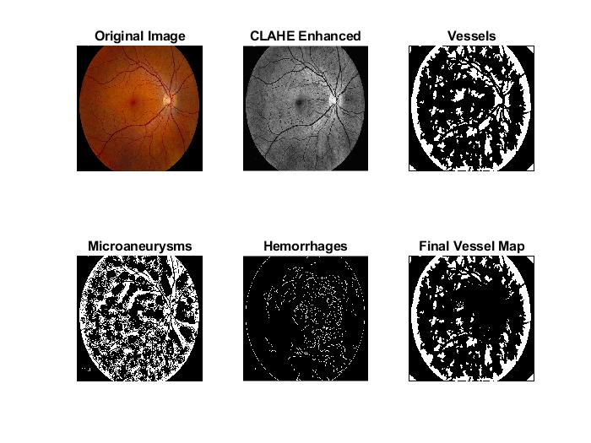
Figure 3. The output results of No DR detected

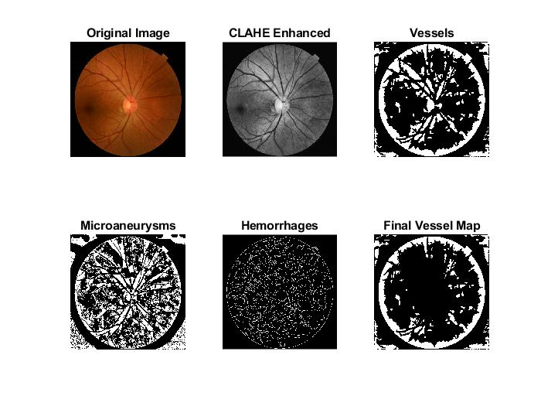
Figure 4. The output results of Mild DR stage

Table 1. Accuracy of the proposed technique

Stage | True prediction | False prediction | Accuracy (%)
No DR | 98 | 2 | 98
Mild | 95 | 5 | 95
Moderate | 92 | 8 | 92
Severe | 90 | 10 | 90
Overall Accuracy |  |  | 93.75

$Accuracy (\%)= \frac{True prediction}{Total number of used images}×100$ (8)
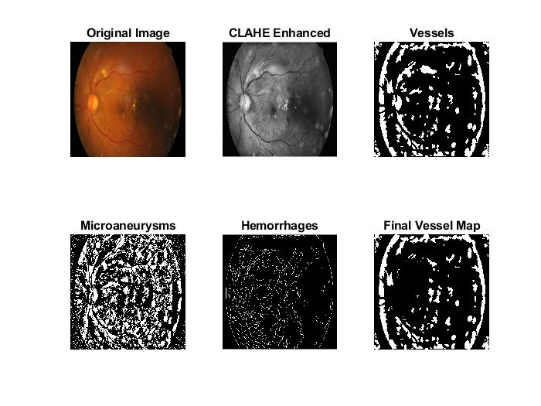
e
d
b
a
f
c
Figure 5. The output results of Moderate DR stage

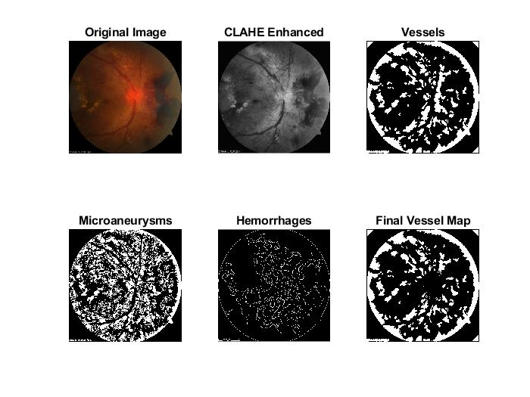
Figure 6. The output results of Severe DR stage

- CONCLUSION

Research in DR detection from fundus images has progressed from classical image processing and machine learning approaches to sophisticated deep learning models. However, image processing techniques still have advantages over complex and time-consuming ML or DL methods.
The experimental results demonstrated that the proposed image processing-based technique for automatically detecting signs of diabetic retinopathy from retinal fundus images yields efficient, accurate, and robust results, enabling ophthalmologists to make precise and rapid diagnoses of DR.
The experimental results showed that the experiments performed on a dataset of 1000 fundus images with different severity degrees, varying from typical cases to highly severe cases, gave accurate results, and the percentage of successful diagnoses (overall accuracy) was 93.75%.
- FUTURE WORK
The current study is limited by dataset size and diversity. So, expanding the dataset to include images from different populations, imaging devices, and varying image qualities could enhance model generalizability and robustness. Moreover, developing a real-time diagnostic tool that integrates with clinical workflows would be a significant step forward. This would involve optimizing processing speed and ensuring high sensitivity and specificity in a real-time setting. Additionally, extending the system to detect other retinal conditions, such as glaucoma or age-related macular degeneration, could increase its value for ophthalmic screenings.

REFERENCES

[1] A. Chakraborty and A. K. Kar, “Swarm Intelligence: A Review of Algorithms,” in Nature-Inspired Comput. Optim. Model, ” Optim. Sci. Technol., Springer, 2017, pp. 475–494.
[2] Q. Li et al., “An Enhanced Grey Wolf Optimization Based Feature Selection Wrapped Kernel Extreme Learning Machine for Medical Diagnosis,” Comput. Math. Methods Med., vol. 2017, pp. 1–15, 2017, doi: 10.1155/2017/9512741.
[3 ] M. Bhulakshmi and D. S. Rajput, “A systematic review on diabetic retinopathy detection and classification based on deep learning techniques using fundus images,” PeerJ Computer Science, vol. 10, p. e1947, Apr. 2024.
[4] S. Ur Rehman Khan, M. N. Asim, S. Vollmer, and A. Dengel, “AI-Driven Diabetic Retinopathy Diagnosis Enhancement through Image Processing and Salp Swarm Algorithm-Optimized Ensemble Network, ” arXiv preprint arXiv:2503.14209, March 2025.
[5] G. M. Friesen, T. C. Jannett, M. A. Jadallah, S. L. Yates, S. R. Quint, and H. T. Nagle, “A comparison of the noise sensitivity of nine QRS detection algorithms,” IEEE Trans. Biomed. Eng., vol. 37, no. 1, pp. 85–98, 1990, doi: 10.1109/10.43620.
[6] P. S. Hamilton and W. J. Tompkins, “Compression of the ambulatory ECG by average beat subtraction and residual differencing,” IEEE Trans. Biomed. Eng., vol. 38, no. 3, pp. 253–259, Mar. 1991, doi: 10.1109/10.133206.
[7] M. Achieng and E. Ruhode, “The Adoption and Challenges of Electronic Voting Technologies Within the South African Context,” Int. J. Manag. Inf. Technol., vol. 5, no. 4, pp. 1–12, Nov. 2013, doi: 10.5121/ijmit.2013.5401.

[8] D. Cansell, J. P. Gibson, and D. Méry, “Refinement: A Constructive Approach to Formal Software Design for a Secure e-voting Interface,” Electron. Notes Theor. Comput. Sci., vol. 183, pp. 39–55, Jul. 2007, doi: 10.1016/j.entcs.2007.01.060.
[9] Bahy, Ramy M., Jafar Ababneh, Hani Attar, Mohammad Al-Hihi, Mohamed Hafez, and Ahmed Solyman. "Fingerprint Authentication Method using Two Steps Verification Algorithm." In 2024 25th International Arab Conference on Information Technology (ACIT), pp. 1-5. IEEE, 2024.
[10] M. F.M.Mursi, G. M. R. Assassa, A. Abdelhafez, and K. M. Abo Samra, “On the Development of Electronic Voting: A Survey,” Int. J. Comput. Appl., vol. 61, no. 16, pp. 1–11, Jan. 2013, doi: 10.5120/10009-4872.
[11] K. Vassil, M. Solvak, P. Vinkel, A. H. Trechsel, and R. M. Alvarez, “The diffusion of internet voting. Usage patterns of internet voting in Estonia between 2005 and 2015,” Gov. Inf. Q., vol. 33, no. 3, pp. 453–459, Jul. 2016, doi: 10.1016/j.giq.2016.06.007.
[12] F. Zhang and Y. Lian, “QRS Detection Based on Multiscale Mathematical Morphology for Wearable ECG Devices in Body Area Networks,” IEEE Trans. Biomed. Circuits Syst., vol. 3, no. 4, pp. 220–228, Aug. 2009, doi: 10.1109/TBCAS.2009.2020093.
[13] N. Valaei, S. R. Nikhashemi, H. Ha Jin, and M. M. Dent, “Task Technology Fit in Online Transaction Through Apps,” in Optimizing E-Participation Initiatives Through Social Media, IGI Global, 2018, pp. 236–251.
[14] M. Merri, D. C. Farden, J. G. Mottley, and E. L. Titlebaum, “Sampling frequency of the electrocardiogram for spectral analysis of the heart rate variability,” IEEE Trans. Biomed. Eng., vol. 37, no. 1, pp. 99–106, 1990, doi: 10.1109/10.43621.
[15] A. Reza, “Realization of the Contrast Limited Adaptive Histogram Equalization (CLAHE) for real-time image enhancement,” J. VLSI Signal Processing Syst. Signal Image Video Technol., vol. 38, pp. 35–44, Nov. 2004.
[16] L. Wang, M. Fei, and T. Yang, “Circular Mask and Harris Corner Detection on Rotated Images,” in Advanced Computational Methods in Life System Modeling and Simulation, M. Fei et al., Eds. Singapore: Springer, 2017, vol. 761, pp. 52–61.
[17] J. Zunić, K. Hirota, and P. L. Rosin, “A Hu invariant as a shape circularity measure,” Pattern Recognition Letters, vol. 53,
pp. 8–13, Jan. 2015.
[18] T. J. McGill and J. E. Klobas, “A task–technology fit view of learning management system impact,” Comput. Educ., vol. 52, no. 2, pp. 496–508, Feb. 2009, doi: 10.1016/j.compedu.2008.10.002.
[19] Yadav, D. P., Deepak Kumar, Anand Singh Jalal, Ankit Kumar, Kamred Udham Singh, and Mohd Asif Shah. "Morphological diagnosis of hematologic malignancy using feature fusion-based deep convolutional neural network." Scientific Reports 13, no. 1 (2023): 16988.
[20] Flayeh, Azhar Kassem, Bourair Al-Attar, Mohanad Sameer Jabbar, Lateef Abd Zaid Qudr, Jamal Fadhil Tawfeq, and Poh Soon JosephN. "A Secure Proposed Method for Real-Time Preserving Transmitted Biomedical Signals Based on Virtual Instruments." Mathematical Modelling of Engineering Problems 10, no. 6 (2023).

