Data-Driven Eco-Mobility Planning: An ITS Framework for Batna’s Urban Transport System

Hadjira Sakhri
dept. of architecture
Mohamed Khider Biskra University
Biskra, Algeria
https://orcid.org/0000-0003-0798-6485

Fateh Enouar Mamache
Laboratory of Advanced Mechanics University of Science and Technology Houari Boumediene.
Algiers, Algeria
fmamache@usthb.dz

Borhane Eddine Bakroune
dept. of Architecture
University of Batna 1
Batna, Algeria

Mohamed Hafez

Faculty of Engineering FEQS

INTI-IU-University

Nilai, Malaysia
mohdahmed.hafez@newinti.edu.my

Ahmed Solyman
Department of Engineering
Glasgow Caledonian University
Glasgow, United Kingdom
ahmed.solyman@gcu.ac.uk

Moussa Sakhri
dept. of mechanical engineering
University of Batna 2
Batna, Algeria
Moussasakhri.ia@gmail.com

Abstract—This study examines Batna’s urban mobility problems and proposes a data-driven eco-mobility framework using Intelligent Transportation Systems (ITS). It combines field observations with traffic-flow analysis on National Road 77 between the city center and Hamla extension. Results reveal severe congestion, with peak flows reaching 49.2% of capacity, reflecting heavy dependence on private cars and weak public transport. To address this, the paper proposes an integrated plan built on: (1) urban redevelopment with smart materials, (2) an ITS-supported multimodal system including hybrid buses and a tramway, and (3) smart green infrastructure. The strategy is expected to cut congestion, lower environmental impacts, and improve transport efficiency. Overall, the study argues that an ITS-based integrated approach can transform mobility in Batna and serve as a model for similar semi-arid cities, supporting SDG 11 by enabling cleaner, inclusive urban transport.

large-scale infrastructure projects completed and others still under development. These efforts aim to improve efficiency, accessibility, and national connectivity to support economic growth. However, continued urban population growth and the steady increase in private vehicle ownership have led to escalating levels of energy consumption, chronic congestion, and harmful greenhouse gas (GHG) emissions. The heavy reliance on internal combustion engine vehicles not only strains urban infrastructure but also contributes directly to air quality degradation, negatively impacting public health.
According to the International Energy Agency [9], the transport sector in Algeria accounts for approximately 34% of total energy consumption and nearly 30% of national CO₂ emissions, amounting to an estimated 45.1 million tons of CO₂ in 2022. Addressing these high-energy and environmental

Index Terms—Eco mobility, Intelligent transport system, elec- tric vehicle, urban sustainability, accessibility

- Introduction
Intelligent Transportation Systems (ITS) leverage advanced technologies such as artificial intelligence, machine learning, the Internet of Things (IoT), and big data analytics to opti- mize traffic management, enhance safety, and fundamentally reduce environmental impacts [1]. These systems are cru- cial for transitioning from traditional cities to smart cities, especially given the dramatic expansion of urban areas and the projected increase in road traffic globally. The World Health Organization (WHO) projects that by 2050, nearly 70% of the world’s population will reside in urban centers, intensifying the demand for efficient, sustainable, and reliable transport networks. This global trend places immense pressure on existing infrastructure, demanding a paradigm shift in how urban mobility is planned and managed.
Over the past two decades, the Algerian transport sector has undergone significant structural transformation, with several
costs is essential for Algeria to meet its national sustainability targets and international climate commitments. Although the Algerian government has invested heavily in expanding mass transit systems, including metro lines, tramways, and regional air networks, the country’s transport and land-use policies continue to face major challenges related to sustainability, multimodal integration, and urban mobility efficiency [6]. Specifically, there is a pronounced gap between the provision of infrastructure and the adoption of modern, data-driven mobility solutions that prioritize ecological performance.
In light of these critical challenges, the development of a comprehensive eco-mobility framework robustly supported by Intelligent Transportation Systems (ITS) offers a vital pathway toward achieving sustainable urban mobility goals [2]. ITS technologies integrate advanced data collection, com- munication, and control systems to enhance transport ef- ficiency, safety, and environmental performance [1]. When combined with eco-mobility principles such as electric and hybrid propulsion, multimodal integration, demand-responsive transit, and smart green infrastructure ITS can support the creation of low-carbon, adaptive, and user-centered mobility

networks. This synergistic approach is necessary to ensure that infrastructure investments translate into genuinely sustainable outcomes.
This study specifically aims to propose an ITS-based eco- mobility framework tailored to the unique socio-geographical context of Batna city, located in northeastern Algeria. The research focuses on optimizing the high-demand transport corridor connecting the city centre with the rapidly developing Hamla area. By analyzing current traffic flow and capacity utilization, the study intends to develop an integrated planning solution that enhances transport efficiency while minimizing the environmental and structural impacts of urban growth.
- Methodology
This study employs a rigorous mixed-methods approach that combines quantitative field observation and analytical modeling to accurately assess existing mobility conditions and develop a forward-looking Intelligent Transportation System (ITS)-based eco-mobility framework for the city of Batna. The adoption of the mixed-methods design is critical, as the quantitative phase (traffic counting and flow rate calculation) provides empirical evidence of the congestion severity, while the qualitative phase (systemic analysis and planning proposal) allows for the context-specific integration of technology and urban design principles [2]. The entire methodological pro- cess is organized into three main, interconnected stages: data collection, rigorous quantitative analysis, and comprehensive planning proposal development.
- Case Study
The study area is located in Batna City, the capital of the Aure`s region, situated in northeastern Algeria. Batna experiences a cold semi-arid climate and has seen rapid demo- graphic expansion. The focus is specifically on the new urban extension areas in the southern part of Batna, known as Hamla 1, Hamla 2, and Hamla 3. These neighborhoods are among the fastest-growing residential zones and play a crucial role in linking the city center with emerging urban extensions. Their rapid, often unplanned, expansion has resulted in increased traffic density and reduced transport efficiency, making them a high-priority corridor for mobility assessment and sustainable planning (Fig. 1).
The investigation centers on National Road No. 77 (RN 77), which serves as the main transport corridor connecting the Hamla districts with the city center. RN 77 is a critical 3- kilometer, two-way roadway, essential for both local residents and regional commuters. Public transport along this axis is currently insufficient, relying on unreliable bus lines (No. 3 and No. 5). The primary structural constraint is the railway level-crossing on RN 77 (Fig. 2). This intersection causes the road to be closed for one to two minutes, three times daily during critical peak commuting hours (e.g., 7:00 a.m. and 4:00 p.m. peaks). These recurrent interruptions not only cause significant congestion and travel delays but also highlight a major structural limitation of the corridor that must be addressed through infrastructural intervention.

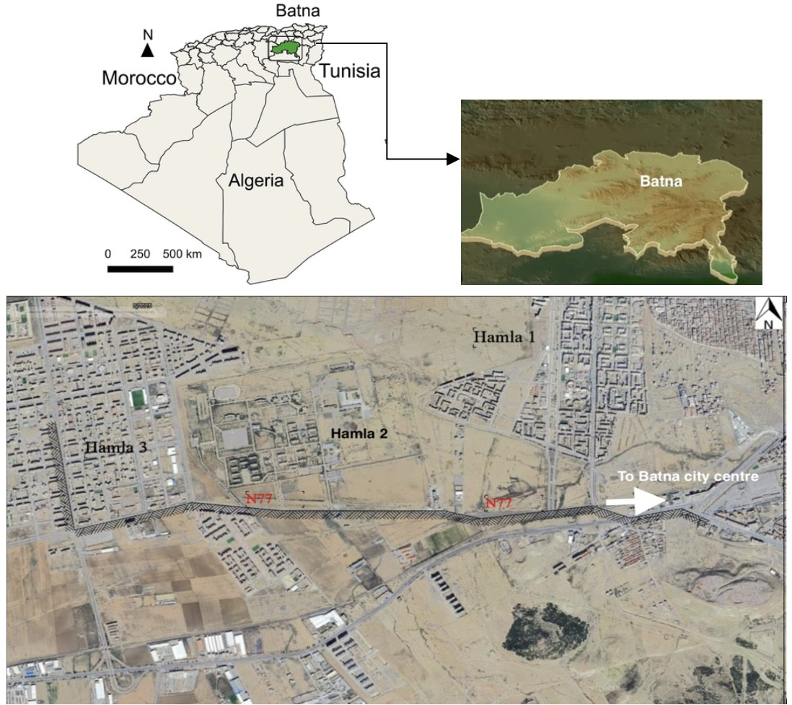
Fig. 1. Case study location
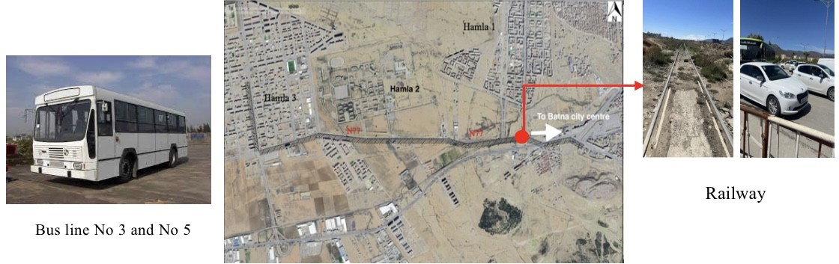

Fig. 2. Intersection between the railway line and National Road No. 77

- Data Collection and Analysis
  - Site Observation: Direct traffic counts were conducted using mobile phone counters to measure vehicular flows directed toward Batna city center and the Hamla districts. The observation was carried out on a sunny day, February 27, 2025, during critical peak hours at 8:00 a.m., 12:00 p.m., and 4:00
p.m. Counts were meticulously recorded in 15-minute intervals to capture traffic dynamics and accurately determine peak flow rates. Two strategic axes were selected for observation:
    - Axis 1: Located at the end of the main road crossing Hamla 3, monitoring bidirectional traffic entering and exiting the district.
    - Axis 2: Positioned at the complex intersection separating Hamla 1 and Hamla 3, monitoring flows toward three distinct destinations: Hamla 1, Hamla 3, and Batna city center.
This dual-axis approach enabled a crucial comparative analysis of internal neighborhood flows versus the dominant regional flows toward the city center (Fig.3). The recorded traffic included private cars, buses, motorcycles, and commercial vehicles, forming the empirical dataset for subsequent flow rate analysis.
  - Data Analysis and Planning Proposal Development: The collected traffic volume data was subjected to rigorous quantitative analysis to determine the operational Flow Rate

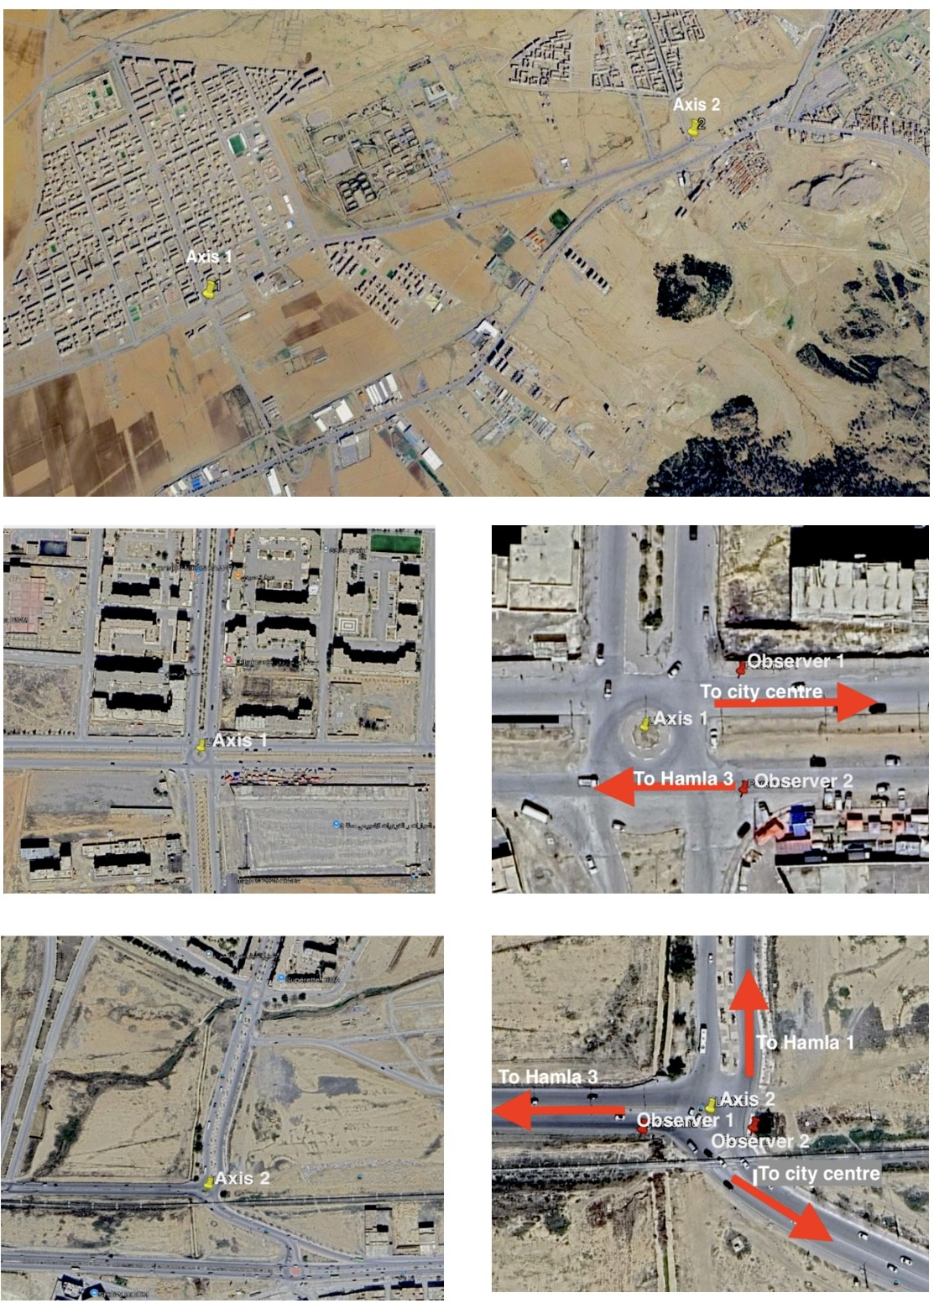
To align with the 15-minute observation period, Q_{max} is expressed as:
Q_{max} = 975 (veh/15min) (1)
The flow rate percentage was then calculated using the relationship:

Fig. 3. Spatial locations of observation points along Axes 1 and 2

(%) relative to the road’s theoretical capacity (Q_{max}), as detailed in Section III. This analysis provided clear evidence of congestion severity. Based on the empirical findings and identified structural bottlenecks (the level crossing and lack of public transport), the final stage involved developing the com- prehensive ITS-based eco-mobility proposal. This proposal was strategically focused on three key, interdependent areas:
- designing integrated multimodal stations (tram-bus hybrid stops), ii) incorporating advanced ITS technologies (real- time passenger information, integrated ticketing, and smart charging infrastructure for hybrid buses), and iii) urban design interventions (such as grade separation and smart materials) to fundamentally promote multimodal and sustainable mobility across the corridor.
- Results and Discussion
  - Traffic Flow Calculation
The traffic flow rate was determined using the standard traffic engineering model, which compares the actual ob- served flow (Q_{actual}) with the maximum theoretical capac- ity (Q_{max}) of the studied road segment [3]. The maximum capacity of a two-way road with a single 8-meter lane is 6500 (veh/h).
Flow rate = Qactual × 100 (2)
Qmax
This formula quantifies the operational efficiency of each road section relative to its maximum theoretical capacity [3].
  - Observation Results and Flow Analysis
Detailed analysis of traffic counts across the two axes reveals critical mobility patterns. For Axis 1 (Table 1), the morning peak (8:00 a.m.) shows a flow rate of 34.3% toward Batna city center, confirming high outbound commuting. At 12:00 p.m., traffic stabilizes around 30% in both directions, indicating a partial redistribution of travel for midday ac- tivities. The evening peak at 4:00 p.m. is the most acute, reaching 42.1% toward the city center, confirming significant bidirectional traffic load and reinforcing the radial commuting structure of Batna’s urban mobility.

TABLE I
Vehicle Counts and Flow Rates along Axis 1

Axis 1 | 8:00 a.m  (15 min) | 12:00 p.m  (15 min) | 04:00 p.m  (15 min)
Number of vehicles
To Hamla 3 | 210 | 280 | 320
To city  centre | 335 | 297 | 411
Flow Rate %
To Hamla 3 | 21 | 28.7 | 32.8
To city  centre | 34.3 | 30.4 | 42.1

Axis 2 (Table 2) consistently registered higher flows, con- firming its role as the main connector. The peak occurred at 4:00 p.m., with 480 vehicles toward the city center, resulting in a flow rate of 49.2%. This indicates near-saturation levels and severe congestion during the evening return peak [3]. The minimal flow toward Hamla 1 (8.5% to 6.8%) confirms weak connectivity or the utilization of an alternative route through Kechida, diverting part of the traffic. Axis 2 consistently regis- ters higher traffic counts and flow rates than Axis 1, confirming its role as the main regional outlet. Critically, only three collective buses toward Hamla 3 and one toward Hamla 1 were recorded during the observation, underscoring the extreme lack of public collective transport and the overwhelming reliance on private vehicles, which directly contributes to the severe congestion [6].
  - Planning Proposal
The planning proposal adopts an Intelligent Transportation System (ITS) framework that integrates infrastructure, technol- ogy, and environmental sustainability into three complemen- tary levels.

TABLE II
Vehicle Counts and Flow Rates along Axis 2

Axis 2 | 8:00 a.m  (15 min) | 12:00 p.m  (15 min) | 04:00 p.m  (15 min)
Number of vehicles
To Hamla 3 | 233 | 345 | 317
To city  centre | 300 | 270 | 480
To Hamla 1 | 83 | 95 | 67
Flow Rate %
To Hamla 3 | 23.8 | 35.3 | 32.5
To city  centre | 30.7 | 27.9 | 49.2
To Hamla 1 | 8.5 | 9.7 | 6.8

    - Urban Redevelopment and Spatial Reorganization: This intervention focuses on restructuring the urban fabric using smart infrastructure. This includes the use of self-healing asphalt to minimize road repairs, reduce CO₂ emissions from maintenance, and limit traffic disruption (Fig. 4). The urban redevelopment plan serves as the physical and digital founda- tion for the deployment of ITS technologies [11].
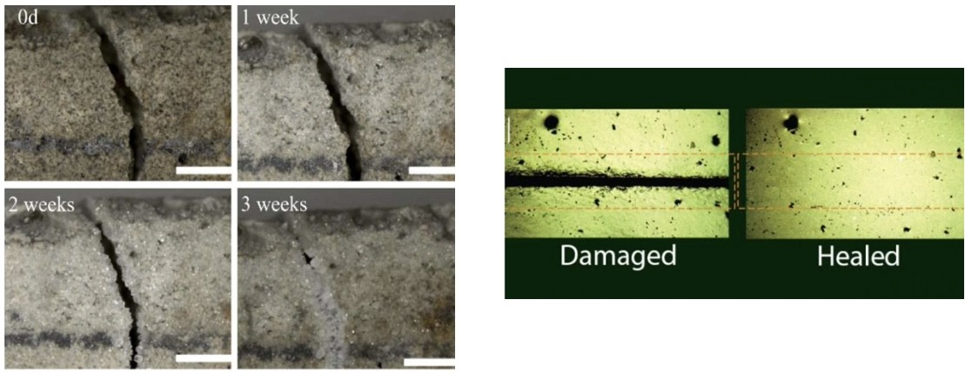

Fig. 4. Self-healing asphalt technology used for road surface maintenance[13]

    - ITS-Enabled Multimodal Transportation System: This level introduces a multimodal network combining hybrid buses and a tramway line, both coordinated under a centralized ITS management platform [1]. This integrated system aims to reduce dependence on private vehicles and optimize energy consumption. The hybrid buses utilize dual thermal and elec- tric power systems (Table 3), offering reduced emissions and operational noise [4].

TABLE III
Key technical specifications of hybrid buses

Element | Description
Type | Hybrid bus
Power system | Dual: internal combustion engine (diesel or gasoline) + elec-  tric motor
Battery type | Lithium-ion – NiMH
Charging method | Through regenerative braking or while the engine is running
Fuel tank capacity | 200 to 300 liters (depending on model)
Electric range | Only 2 to 20 km (depending on hybrid system)
CO2 emissions | 30% to 50% lower compared to conventional buses
Maintenance | Less frequent than regular buses (due to reduced fuel con-  sumption from the thermal engine)
Passenger capacity | Between 70 and 120 passengers (depending on size and  design)
Manufacturers | Volvo – Mercedes-Benz – MAN – BYD – Toyota – Scania
Service life | 12 to 15 years (depending on use and maintenance)
      - ITS-Based Location and Management of Bus Stops: Bus stops are equipped with solar panels, smart ticketing, real- time digital passenger information displays, and surveillance cameras, all seamlessly connected to the central ITS platform [8]. At the Hamla 3 terminus, a solar-powered charging and control station is proposed, integrating smart energy man- agement and vehicle diagnostics systems for efficient fleet monitoring and maintenance via ITS telematics [4].
      - Tramway Line: The proposed tramway line extends from Hamla 3 through Hamla 2 and 1 toward the Batna city center [10]. The three primary stations are equipped with advanced ITS technologies (e-ticketing, real-time dis- plays). Crucially, the tramway and hybrid bus systems are fully integrated within the centralized ITS platform, enabling synchronized scheduling, coordinated route management, and optimized energy consumption across the network. The Hamla 3 terminal functions as a multimodal interchange hub (Fig. 5).

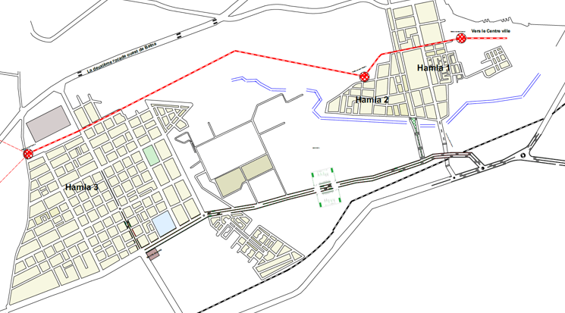

(a)

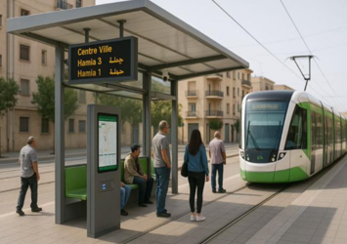
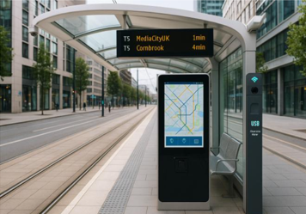

(b)

Fig. 5. (a) Proposed tramway line from Hamla 3 to Batna city centre, showing tram stations in red point. (b) 3D visualization with ITS technologies by authors
    - Traffic Optimization via Grade Separation: To resolve the recurrent congestion and safety risks at the railway level crossing on RN 77, a grade-separation solution is proposed. This involves constructing a road bridge over the tracks to allow vehicular traffic to circulate unimpeded [7] (Fig.6). This configuration is expected to significantly improve traffic fluidity, reduce waiting times, and enhance overall safety.
    - Smart Green Infrastructure and Environmental Integra- tion: Green corridors are planned along transport routes, inte- grating vegetation strips, permeable pavements, and bioswales. These corridors host smart irrigation systems and air quality sensors that feed continuous data to the central ITS platform. Through in situ observation along the 3 km stretch, only around 20 trees were recorded. Tree species adapted to Batna’s semi-arid climate (Oriental Beech, Washington Palm, Olive

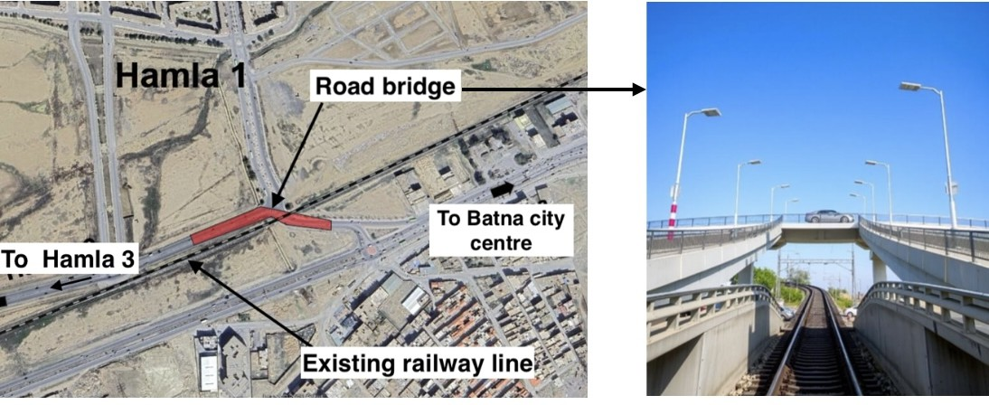

Fig. 6. Schematic representation of the proposed bridge solution for the road– railway crossing

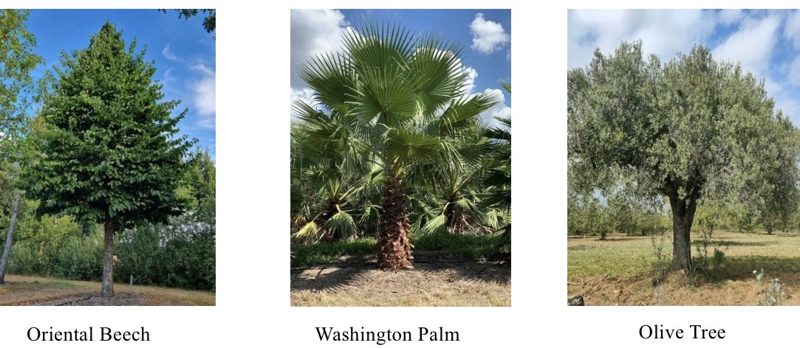
Tree) are proposed to enhance ecological resilience (Fig. 7) [9].
benefits of switching to the new ITS-enabled public transport system to ensure high adoption rates.
- Data and Technology Partnerships: Foster strategic collaboration with local research institutions and inter- national technology providers for the development of real-time data analytics and predictive modeling tools [1], [5].
- Sustainability Monitoring: Mandate rigorous and con- tinuous monitoring of key performance indicators (KPIs) such as emission levels, average travel speed, and public transport ridership to ensure long-term sustainability and performance optimization [2].
In conclusion, this study contributes a holistic vision for the future of Batna’s urban mobility. The proposed ITS-based eco-mobility framework not only addresses current transport challenges but also establishes a scalable and replicable model for sustainable urban development across Algerian and North African cities [6].

Fig. 7. Proposed tree species for urban green infrastructure

- Conclusion
This study confirms that Batna’s urban mobility is highly car-dependent, with key corridors experiencing severe con- gestion (peak 49.2% on Axis 2) due to a critical lack of reliable public transport. The proposed ITS-based eco-mobility strategy integrates urban redevelopment, a multimodal ITS- enabled transport network, and smart green infrastructure, providing a comprehensive, integrated solution. The central ITS platform ensures dynamic scheduling, real-time control, and efficient resource utilization, transforming the fragmented system into an integrated, data-driven, and sustainable network [1], [4], [6]. The proposed system leverages intelligent tech- nologies not merely as tools for operational management but as catalysts for systemic urban transformation [2], [15].
- Recommendations
- Institutional Implementation: Establish a dedicated inter-sectoral ITS management unit responsible for the deployment and continuous operation of the multimodal network and smart infrastructure components.
- Pilot Project Deployment: Utilize the Batna–Hamla 3 corridor as a proof-of-concept pilot zone for the rapid deployment of hybrid bus lines and the smart ticketing infrastructure.
- Public Engagement and Awareness: Conduct compre- hensive public awareness campaigns emphasizing the
References
- A. Smith, B. Johnson, and C. Williams, “Smart Cities and Intelligent Transportation Systems: A Comprehensive Review,” IEEE Transactions on Intelligent Transportation Systems, vol. 23, no. 5, pp. 4123-4145, 2022.
- M. Anderson and K. Brown, “Sustainable Urban Mobility in Developing Countries: Challenges and Solutions,” Sustainable Cities and Society, vol. 76, p. 103456, 2022.
- R. Davis and S. Wilson, “Traffic Flow Analysis and Congestion Man- agement in Urban Areas,” Transportation Research Part A: Policy and Practice, vol. 156, pp. 123-145, 2022.
- P. Martinez and L. Garcia, “Hybrid and Electric Vehicles in Public Transport: Environmental and Economic Impacts,” Journal of Cleaner Production, vol. 345, p. 131112, 2022.
- T. Thompson and M. Harris, “IoT and Real-Time Monitoring in Public Transportation Systems,” IEEE Internet of Things Journal, vol. 9, no. 12, pp. 9876-9890, 2022.
- Salman, Adil M. "Enhancing quality of service in IoT through deep learning techniques." Periodicals of Engineering and Natural Sciences 11, no. 3 (2023): 68-77.
- J. White and A. Clark, “Urban Planning and Sustainable Mobility in Arid Regions,” Journal of Urban Planning and Development, vol. 148, no. 2, p. 04022012, 2022.
- K. Lee and D. Kim, “Grade Separation Solutions for Urban Railway Crossings,” Journal of Transportation Engineering, vol. 148, no. 4, p. 04022013, 2022.
- S. Taylor and R. Moore, “Green Infrastructure and Climate-Adaptive Urban Design,” Landscape and Urban Planning, vol. 224, p. 104432, 2022.
- International Energy Agency, “World Energy Outlook 2022,” IEA Pub- lications, Paris, 2022.
- M. Roberts and P. Adams, “Tramway Systems as Sustainable Urban Mobility Solutions,” Transportation Research Record, vol. 2676, no. 5,
pp. 345-360, 2022.
- H. Chen and W. Wang, “Advanced Materials in Road Construction: Self- Healing Asphalt Technology,” Construction and Building Materials, vol. 324, p. 126578, 2022.
- Algerian Ministry of Transport, “National Transport Strategy 2030,” Government of Algeria, 2021.
- Islam, M. M., Hoque, N., Islam, M., & Ibney Gias, I. (2022). An Experimental Study on the Strength and Crack Healing Performance of E. coli Bacteria‐Induced Microbial Concrete. Advances in Civil Engineering, 2022(1), 3060230.
- Henderi, H., R. Irawatia, I. Indra, D. A. Dewi, and T. B. Kurniawan. "Big Data Analysis using Elasticsearch and Kibana: A Rating Correlation to Sustainable Sales of Electronic Goods." HighTech and Innovation Journal 4, no. 3 (2023): 583-591.

