A Slot-Optimized Microstrip Patch Antenna for Non-Invasive Blood Pressure Monitoring

Mohammed E. Yassin
Electronics and Communications Engineering Department
Akhbar Elyom Academy
6th October City, Egypt M.ezzat@akhbaracademy.edu.eg

Eman S.Abass
Faculty of computer and Artificial intelligence, Al Reyada university, On leave from Department of Electrical engineering, Communication Program, MTI University, Egypt
Eman.Salah@rst.edu.eg

Prof. Ir Dr Zakaria Che Muda
Faculty of Engineering
Quantity Surveying
INTI-IU University
Nilai, Malaysia
zakaria.chemuda@newinti.edu.my

Ahmed Samir
Department of Electronics and Communication Engineering
Uruk University Ahmed.S.ahmed@ururk.edu.iq
Abdalrahman H. El-Gendy
Electronics and Communications Engineering Department
Akhbar Elyom Academy
6th October City, Egypt
A.gendy999@gmail.com

Shaimaa A. Mohassieb
Electrical Engineering (Electronics and Communications) Department
October 6 University
6th October City, Egypt
Shaimaa.Mohassieb.eng@o6u.edu.eg

Abstract— This paper introduces a compact inset-fed microstrip patch antenna optimized for non-invasive blood pressure monitoring in the 2.4 GHz ISM medical band. The design features a rectangular patch with integrated slot modifications and an oval-defected partial ground, designed to enhance bandwidth and impedance matching. Fabricated on an FR-4 substrate (ε_{r} = 4.4, tanδ = 0.025), the antenna demonstrates a simulated return loss of -70 dB, a bandwidth of 550 MHz, and a simulated peak gain of 4.4 dBi. Experimental measurements closely match the simulated results. On-body evaluations at various arm positions show consistent frequency shifts corresponding to changes in blood pressure, confirming the antenna’s potential for continuous, cuffless biomedical monitoring.This work supports SDG 3 (Good Health and Well-Being)—notably target 3.4 on reducing premature mortality from non-communicable diseases—by delivering a low-cost, non-invasive microstrip patch antenna for continuous, cuffless blood-pressure monitoring in the 2.4 GHz ISM band.
Keywords— Blood pressure monitoring, Microstrip patch antenna, Non-invasive sensing, Biomedical telemetry, and On-body measurements.

Introduction
Hypertension affects more than 1.2 billion adults globally and remains the leading preventable cause of cardiovascular disease, stroke, and kidney failure [1], [2]. Although highly prevalent, conventional cuff-based methods for measuring blood pressure are often uncomfortable, inconvenient, and unsuitable for continuous monitoring [3], [4]. These drawbacks have fueled growing interest in Non-Invasive Blood Pressure Monitoring (NIBPM) technologies. Leveraging wearable sensors, optical techniques such as photoplethysmography, and radio-frequency (RF) microstrip antennas, NIBPM enables real-time, cuff-free monitoring that is both more comfortable and patient-friendly [5]-[8]. By facilitating continuous data collection and improving the early detection of hypertensive events, NIBPM plays a vital role in advancing personalized and preventive healthcare [18].
Recent developments in microstrip antenna technology for non-invasive blood pressure monitoring have underscored the importance of achieving stable resonance, high sensitivity, and compliance with biomedical safety standards. Antenna designs operating within the 2.3-2.6 GHz ISM band, such as planar Yagi–Uda structures [9], wideband Vivaldi antennas [10], and metamaterial-based monopoles [11], rely on variations in S-parameters to detect physiological changes, including shifts in pulse transit time and arterial properties. While flexible, body-conforming substrates offer advantages in wearability, they also present significant design challenges. These include inconsistent dielectric properties and thickness variations that can lead to frequency shifts, reduced performance under bending, and degradation of gain or bandwidth [12]-[14]. Furthermore, long-term durability and biocompatibility of such materials under real physiological conditions remain insufficiently validated [12]. In contrast, rigid substrates like FR-4 are valued for their mechanical stability, precise fabrication, and consistent electromagnetic performance traits that make them highly suitable for biomedical sensing applications [15], [16]. Experimental work, including both in-vivo and phantom-based testing, demonstrates that well-optimized antennas on rigid substrates can closely match simulated performance, reinforcing their viability for accurate, continuous, and cuffless blood pressure monitoring [20].
This study presents the design, simulation, and experimental evaluation of a compact inset-fed microstrip patch antenna explicitly developed for non-invasive blood pressure monitoring in the 2.4 GHz ISM band. The proposed antenna integrates a slot-modified radiating patch with an oval-shaped defected partial ground to improve both impedance bandwidth and radiation efficiency. Fabricated on a 76 × 59.5 mm FR-4 substrate, the prototype achieved a measured bandwidth of 532 MHz and a peak gain of 4.4 dBi. Its cost-effective construction, mechanical durability, and high sensitivity to physiological changes position it as a strong candidate for continuous, cuff-free blood pressure monitoring in healthcare applications[19] .

Antenna Design And Simulation
The microstrip patch antenna was designed to fulfill the specific requirements of on-body blood pressure monitoring within the 2.4 GHz ISM band. Key design goals included maintaining stable radiation performance in proximity to human tissue and achieving a broad impedance bandwidth to support reliable signal transmission. FR-4 was chosen as the substrate due to its consistent dielectric properties (ε_{r} = 4.4), moderate loss tangent (tanδ = 0.025), and cost-effectiveness for mass production. The substrate was configured with a thickness of 1.6 mm and planar dimensions of 76 × 59.5 mm². Full-wave electromagnetic simulations, combined with iterative parametric optimization in CST Microwave Studio, were used to fine-tune the antenna geometry targeting improved impedance matching, bandwidth, and, before proceeding to fabrication.
The top view of the proposed microstrip patch antenna, illustrated in Figure 1(a), is implemented on a rectangular FR-4 substrate with overall dimensions W_{S} and L_{S}. The radiating patch features a main width (W_{P}) and length (L_{P}), both of which are optimized to ensure resonance at 2.4 GHz. A central feed line measuring W_{F} in width and L_{F} in length extends from the bottom edge of the substrate into the patch using an inset-fed configuration, providing a precise 50 Ω impedance match. To enhance performance, the patch incorporates two symmetrical vertical slots that form a U-shaped contour; each slot is defined by its width (W_{P2}) and depth (L_{P2}). Additionally, an elliptical slot is placed at the center of the patch to manage surface current distribution, expand bandwidth, and improve impedance characteristics. The entire geometry is symmetrically aligned along the vertical axis to maintain balanced current flow and ensure stable radiation behavior.
The bottom view of the proposed microstrip patch antenna, shown in Figure 1(b), reveals a partial ground plane occupying the lower portion of the FR-4 substrate. The ground plane features a gently curved upper edge that transitions smoothly into the dielectric surface, an intentional design choice to optimize surface current distribution and minimize the propagation of unwanted surface waves. Centrally aligned with the feed line is an enlarged circular slot, serving as a key element in the defected ground structure (DGS) to extend bandwidth and improve impedance matching. Just below the feed line, a narrow rectangular slot (W_{g2} × L_{g2}) extends downward from the circular slot toward the substrate’s lower edge. This slot further redirects ground current flow, contributing to enhanced radiation efficiency. A complete list of design parameters is provided in Table I.

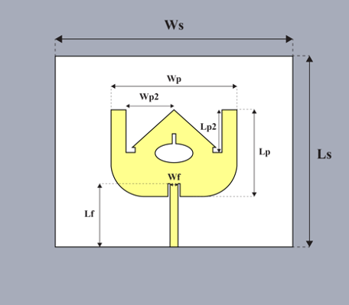
(a)
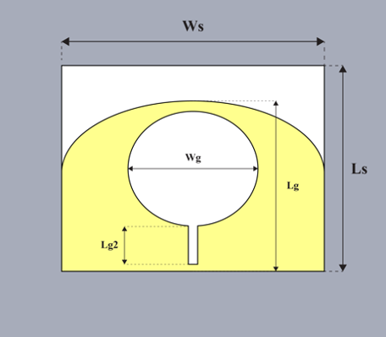
(b)
Fig. 1 Proposed antenna design. (a) Front view, and (b) Back view .
TABLE I. Design parameters of the proposed antenna
Design Parameter | Length (mm) | Design Parameter | Length (mm)
L_{s} | 59.5 | L_{g} | 49.2
W_{s} | 76 | W_{g} | 19
L_{p} | 27 | L_{p2} | 13.3
W_{p} | 39.2 | W_{p2} | 15
L_{f} | 20.2 | L_{g2} | 11
W_{f} | 2.8 | W_{g2} | 3
The antenna design evolved through four progressive stages, as illustrated in Figure 2. In the initial configuration (Stage 1, Fig. 2a), a standard rectangular microstrip patch was used, which failed to exhibit any resonant behavior beyond the -10 dB threshold, as shown in the return loss plot in Figure 3. In Stage 2 (Fig. 2b), the integration of dual symmetrical slots in the patch and the use of an inset-fed configuration over a partial ground plane introduced additional current paths. This modification yielded a resonant response with a return loss of -22 dB at 2.4 GHz, surpassing the -10 dB benchmark. Stage 3 (Fig. 2c) further enhanced performance by adding a circular slot in the ground plane and an elliptical aperture at the center of the patch, resulting in dual-mode operation. This adjustment expanded the -10 dB impedance bandwidth to approximately 490 MHz, achieving a minimum S₁₁ value of around -28 dB. In the final stage (Stage 4, Fig. 2d), two additional rectangular slots were embedded one within the elliptical patch aperture and another inside the circular ground slot to optimize surface current distribution further. This resulted in a significantly deeper return loss of -58 dB at 2.4 GHz, extending the -10 dB bandwidth to approximately 500 MHz.
 | 
 | 
 | 
 | (c)
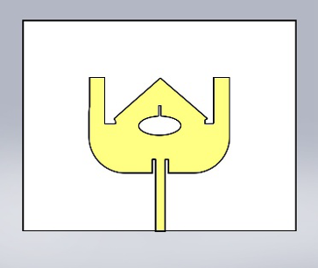 | 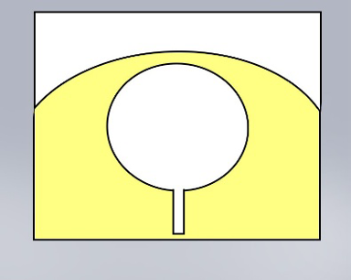
 | (d)
Fig. 2 The design procedure of the proposed antenna (a)step 1, (b) step 2, (c) step 3, and (d)step 4.
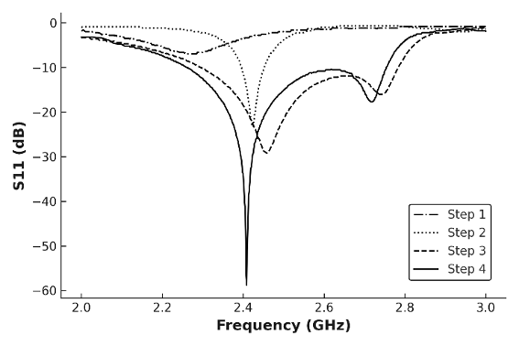
Fig. 3 The simulated return loss results of the design steps.

Simulation And Measurement Results
Based on the finalized design, the antenna was fabricated using standard photolithographic techniques. A photograph of the fabricated prototype is shown in Figure 4. To evaluate its performance, the input reflection coefficient was measured using a ROHDE & SCHWARZ ZVA 67 vector network analyzer. Additionally, the radiation pattern and gain characteristics were assessed in a controlled environment using an NSI 700S-30 anechoic chamber.
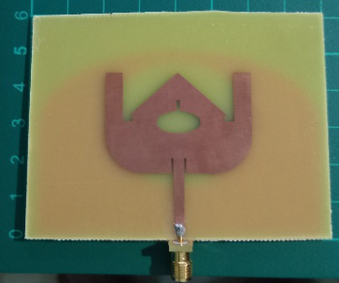  (a) | 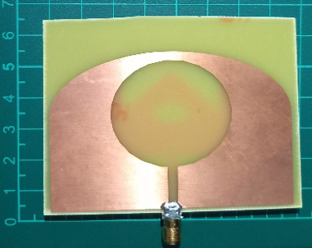  (b)
Fig. 4 Photograph of fabricated antenna. (a) front view, and (b) back view.
The simulation and measurement results of the proposed antenna in free space are presented in Figures 5 through 7. As shown in Figure 5, the simulated response demonstrates excellent impedance matching at 2.4 GHz, achieving a return loss of -70 dB and a bandwidth of 492 MHz. In comparison, the free-space measurements indicate a resonance range from 2.18 to 2.73 GHz, yielding a slightly broader bandwidth of 550 MHz. Figure 6 displays simulated and measured radiation patterns in both the E- and H-planes. These patterns exhibit a bi-directional shape with good symmetry. Minor deviations in the measured curves, relative to the simulations, are attributed to fabrication tolerances and variations in the measurement setup. Figure 7 illustrates the simulated realized gain across the 2.0-3.0 GHz frequency range. The gain steadily increases from approximately 1 dBi at 2.0 GHz to a peak of 4.4 dBi near 2.45 GHz, maintaining values above 4 dBi across most of the ISM band. Beyond 2.7 GHz, however, the gain drops sharply-falling below -4 dBi around 2.8 GHz indicating strong performance within the desired band and limited radiation efficiency outside of it.
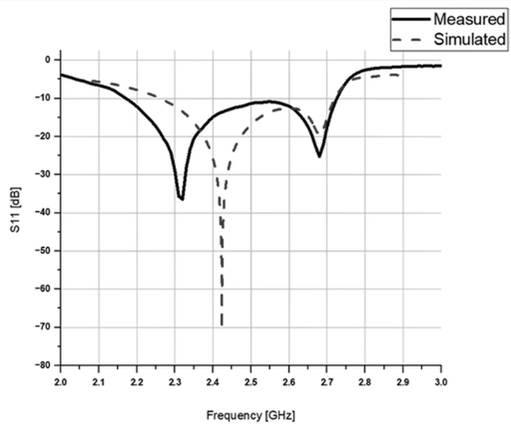
Fig. 5 The simulated and measured reflection coefficient.
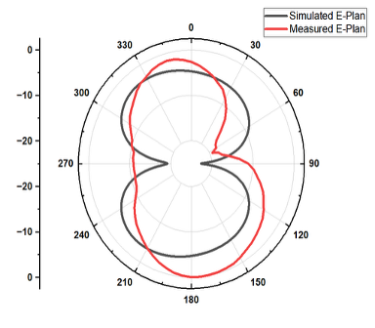  (a) | 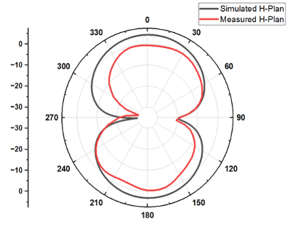  (b)
Fig. 6 The simulated and measured radiation pattern (a) E-plan, and (b) H-plan.
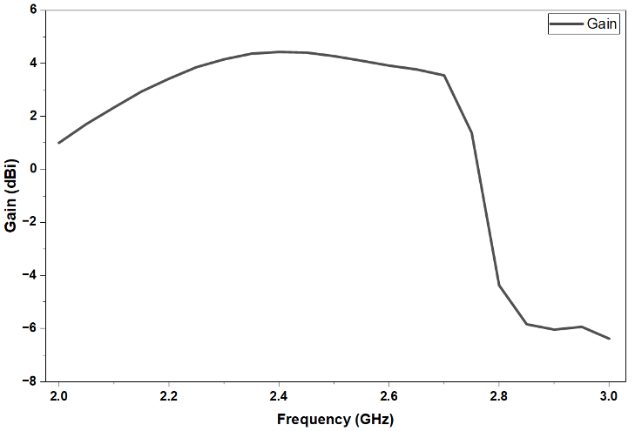
Fig. 7 The simulated gain.
This subsection presents the direct on-body evaluation of the proposed antenna, focusing on its practical performance under realistic conditions for biomedical monitoring. Blood pressure fluctuations within the brachial artery significantly affect blood flow dynamics and the physiological behavior of surrounding tissues. As pressure varies, changes in arterial diameter and elasticity alter the propagation of pressure and pulse waves thereby influencing how body-worn antennas absorb and reflect electromagnetic signals. These interactions offer a promising non-invasive pathway to detect dynamic shifts in blood pressure. As shown in Figure 8, the upper arm consists of multiple anatomical layers, including skin, subcutaneous fat, muscle, bone, and the brachial artery each contributing differently to the local dielectric environment. By leveraging this layered physiological structure, the proposed microstrip antenna was tested directly on the human arm to assess its sensitivity to tissue composition and pressure-induced dielectric variations.
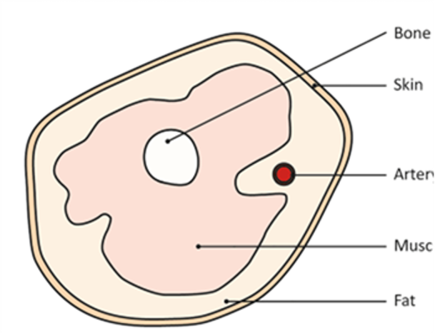
Fig .8 Upper Arm Physiological Components: Bone, Muscle, Fat, Artery, Skin [17].
To assess the antenna’s performance under varying anatomical conditions, return loss measurements were carried out at three distinct positions on the upper arm, as illustrated in Figure 9. Position 1 was located along the lateral side of the humerus; Position 2 was placed slightly toward the posterior side of the upper arm, near the long head of the triceps; and Position 3 was situated directly above the brachial artery, close to the insertion point of the biceps tendon. These locations were selected to expose the antenna to different tissue compositions, including varying amounts of skin, fat, muscle, bone, and vascular structures, which influence the local dielectric environment. Figure 10 provides an example of the measurement setup for Position 1, where the fabricated antenna is affixed to the subject’s upper arm and connected to a Vector Network Analyzer (VNA) to capture return loss data.
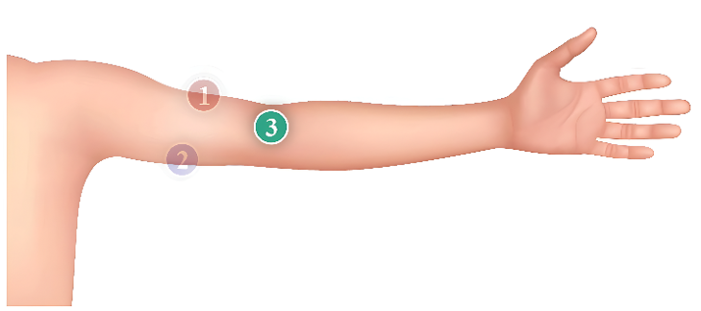
(a)

(b)
Fig.9 Positions of the Patch Antenna on the Human Arm for Blood Pressure Monitoring (a) back view of the arm. (b) front view of the arm.
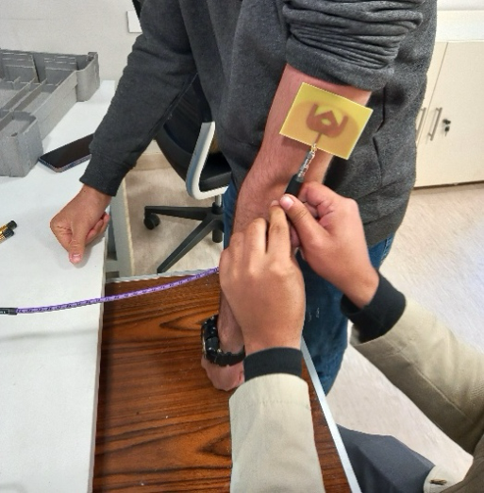
Fig.10 Measurement of antenna return loss on the side of the arm (position 1).
As shown in Figure 10, measurements were conducted at all three arm positions on two individuals with differing blood pressure levels: Person A, with normal blood pressure (107/63 mmHg), and Person B, with elevated blood pressure (131/80 mmHg). For Person A, the S₁₁ curves across all positions (Figure 11) resonated within the 2.4-2.6 GHz range, displaying narrow bandwidths and consistent return loss values indicating stable antenna performance in a normotensive condition. In contrast, the measurements for Person B revealed a noticeable leftward shift in resonant frequency at all three positions, along with minor variations in return loss magnitude. This frequency shift reflects the influence of elevated blood pressure on the dielectric properties of surrounding tissues, which affects the antenna’s impedance matching. These findings confirm the antenna’s sensitivity to physiological changes and reinforce its potential as a non-invasive tool for monitoring blood pressure variations.
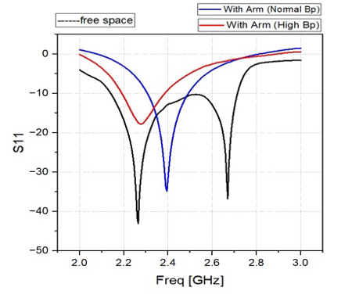
(a)
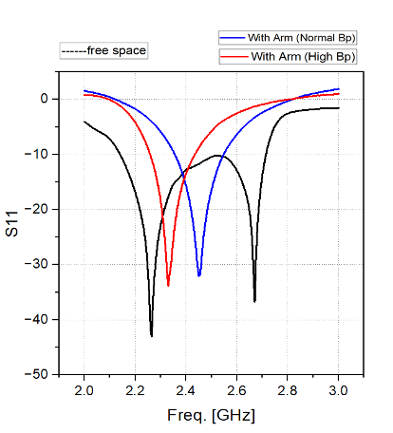
(b)
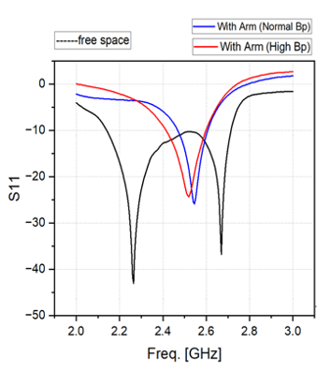
(c)
Fig.11 S₁₁ Measurement Results in Free Space, Normal Pressure, and High Pressure (a) Position 1 (b) Position 2 (c) Position 3.
Among the three tested positions, Position 2, located slightly toward the back of the upper arm near the long head of the triceps, exhibited the greatest shift in resonant frequency (S₁₁) between normal and elevated blood pressure conditions. This heightened sensitivity is likely due to its balanced exposure to both vascular and muscular tissues, which amplifies dielectric variations in response to pressure changes. In contrast, Position 1, being closer to the bone, showed reduced sensitivity, while Position 3, despite being directly above the brachial artery, produced a more modest frequency shift. Based on these observations, Position 2 is identified as the most effective placement for reliable, non-invasive blood pressure monitoring.

Conclusion
This study presented a slot-optimized microstrip patch antenna designed for non-invasive blood pressure monitoring in the 2.4 GHz ISM band. The fabricated prototype achieved an impedance bandwidth of 550 MHz, and a peak gain of 4.4 dBi demonstrating strong alignment with simulation results. On-body evaluations at three different arm positions confirmed the antenna’s sensitivity to blood pressure variations, with the placement near the brachial artery producing the most noticeable frequency shift between normotensive and hypertensive states. These findings highlight the antenna’s mechanical robustness, cost-effectiveness, and reliable performance, making it a strong candidate for continuous, cuff-free blood pressure monitoring in wearable healthcare applications.

References
[1] World Health Organization, “Hypertension,” Fact Sheet, 2023. [Online].https://www.who.int/news-room/fact-sheets/detail/hypertension
[2] B. Zhou et al., “Worldwide trends in hypertension prevalence and progress in treatment and control from 1990 to 2019: a pooled analysis of 1201 population-representative studies,” The Lancet, vol. 398, no. 10304, pp. 957–980, 2021.
[3] K. O'Brien et al., “International protocol for validation of blood pressure measuring devices,” Blood Press. Monit., vol. 7, no. 1, pp. 3–17, 2002.
[4] L. Niiranen et al., “Office, home and ambulatory blood pressures as predictors of cardiovascular risk,” Hypertension, vol. 45, no. 5, pp. 846–853, 2005.
[5] D. Dey et al., “Cuffless Blood Pressure Estimation Using PPG and Deep Learning,” IEEE J. Biomed. Health Inform., vol. 27, no. 1, pp. 55–64, Jan. 2023.
[6] M. K. ElAbbasi et al., “Wearable Blood Pressure Sensing Using Microstrip Patch Antennas,” Sensors, vol. 22, no. 11, p. 3996, 2022.
[7] Y. Wang et al., “A Review of Wearable Cuffless Blood Pressure Monitoring Techniques,” Sensors, vol. 21, no. 16, p. 5289, 2021.
[8] N. Zhang et al., “Flexible Antenna-Based Wireless Sensor for Continuous Blood Pressure Monitoring,” IEEE Trans. Antennas Propag., vol. 70, no. 3, pp. 2124–2133, Mar. 2022.
[9] A. Nella, R. W. Aldhaheri, J. B. Kamili, and N. M. Sobahi, “A non-invasive method of glucose monitoring using FR4 material based microwave antenna sensor,” Sci. Eng. Compos. Mater., vol. 30, no. 1, pp. 1–13, 2023.
[10] S. Yang et al., “A compact wideband Vivaldi antenna for non-invasive glucose monitoring,” Micromachines, vol. 15, no. 11, p. 1389, 2024.
[11] D. N. Elsheakh, E.-H. Mohamed, and A. R. Eldamak, “Blood glucose monitoring biosensor based on multiband split-ring resonator monopole antenna,” Biosensors, vol. 15, no. 4, p. 250, 2025.
[12] J. Jeyalakshmi, S. Janakiraman, and P. Shanmugam, “Recent trends in flexible substrate antennas for biomedical applications,” Int. J. RF Microw. Comput.-Aided Eng., vol. 34, no. 3, 2024.
[13] R. Marimganti, P. K. Sharma, and M. Agarwal, “Performance analysis of conformal antennas for wearable health monitoring,” IETE J. Res., early access, 2023.
[14] P. Jattalwar, S. K. Sharma, and B. K. Kanaujia, “Wearable textile antenna: design and performance considerations,” J. Electromagn. Waves Appl., vol. 34, no. 13, pp. 1748–1764, 2020.
[15] M. K. ElAbbasi et al., “Wearable blood pressure sensing using microstrip patch antennas,” Sensors, vol. 22, no. 11, p. 3996, 2022.
[16] Y. Wang et al., “A review of wearable cuffless blood pressure monitoring techniques,” Sensors, vol. 21, no. 16, p. 5289, 2021.
[17] Lee, B., Jeong, JH., Hong, J. et al. Correlation analysis of human upper arm parameters to oscillometric signal in automatic blood pressure measurement. Sci Rep 12, 2022.
[18] Ahmed, Samir, Taisir Ismail, Hani Attar, Mohamed Hafez, Ahmed Solyman, and Ramy Said Agieb. "Comparative Study of Circular and Rectangular Microstrip Patch antennas in Wi-Fi Band." In 2023 2nd International Engineering Conference on Electrical, Energy, and Artificial Intelligence (EICEEAI), pp. 1-9. IEEE, 2023.
[19] Flayeh, Azhar Kassem, Bourair Al-Attar, Mohanad Sameer Jabbar, Lateef Abd Zaid Qudr, Jamal Fadhil Tawfeq, and Poh Soon JosephN. "A Secure Proposed Method for Real-Time Preserving Transmitted Biomedical Signals Based on Virtual Instruments." Mathematical Modelling of Engineering Problems 10, no. 6 (2023).
[20] Dewi, Deshinta Arrova, Rajermani Thinakan, Malathy Batumalay, and Tri Basuki Kurniawan. "A model for pervasive computing and wearable devices for sustainable healthcare applications." International Journal of Advanced Computer Science and Applications 14, no. 10 (2023).

