Advanced Data-Analytics in IOT based livestock monitoring systems

Ashish Sharma
Department of Computer Engineering & Applications
GLA University, Mathura
ashish.sharma@gla.ac.in
Narendra Mohan
Department of Computer Engineering & Applications
GLA University, Mathura
narendra.mohan@gla.ac.in

Abstract— This paper presents an overview of a smart livestock management system designed to optimize livestock production and animal welfare. The system gathers data on animal health, behaviour and environmental variables in real time using Internet of Things devices. The gathered data is processed using AI algorithms and advanced analytics to provide farmers with information they can use. The technology promises to increase production, encourage sustainable agricultural methods and improve animal health by automating mundane operations and using predictive analytics. The livestock business could undergo a revolution with the integration of this technology, since it can facilitate data-driven decision-making and optimize resource utilization. While technological developments have resulted in the creation of systems that can track livestock, monitor health indicators and optimize management techniques, advanced analytics, artificial intelligence and emerging technologies still hold a great deal of promise for enhancing livestock production's sustainability, efficiency and animal welfare.
Keywords— Livestock monitoring, productivity optimization, location tracking, sustainability and environmental management.

Introduction
The previous work lacks a number of aspects, including advanced analytics, artificial intelligence, and the integration of developing technology. Even though livestock monitoring systems have come a long way, some of the previously mentioned qualities are still in the stage of advanced research or have limited commercial use. Even though early warning systems are developing, it is still difficult to predict certain diseases with accuracy using a variety of factors [1]. Research on using AI to analyse behaviour and physiological data to detect pain in animals is ongoing. Using real-time data to precisely customise feed for each animal is a challenging operation requiring sophisticated analytics. For simulation purposes, producing lifelike virtual depictions of animals and their surroundings is a relatively new idea. Using augmented reality to overlay real-time data on livestock and their surroundings is a futuristic idea that has few real-world uses at the moment [2]. Notable absences from previous art include advanced analytics, artificial intelligence, and the incorporation of modern technologies. Livestock monitoring systems have come a long way, yet many of the elements mentioned above remain in the realm of advanced research or have little commercial relevance. Despite an increase in early warning systems, it continues to be difficult to accurately predict some diseases based on a number of factors. Research is still being conducted on artificial intelligence behaviour analysis and physiological data to detect pain in animals [3]. Smart livestock monitoring systems have large potential to improve animal welfare and productivity and sustainability of agriculture. Farmers can harness the potential of data to grow new ideas and achieve positive outcomes by overcoming the challenges and taking advantage of the technologies that are emerging.
These systems incorporate sensors to obtain information about the environmental and health conditions of the cattle. The data is then processed through advanced algorithms to identify patterns, irregularities, and potential health issues. Significant applications include environmental management, productivity enhancement, location tracking, behavior tracking, and health monitoring [4]. Although there are many advantages to these applications, such as enhanced productivity, increased efficiencies, and improved animal welfare, there are significant issues to address regarding cost, data privacy issues, interoperability, battery life, and user adoption of technology. In addition to further issues regarding further enhancement of benefits of smart livestock monitoring systems, including, future directions may or include edge computing, blockchain, artificial intelligence, advanced sensing technologies, and customizing monitoring capabilities.
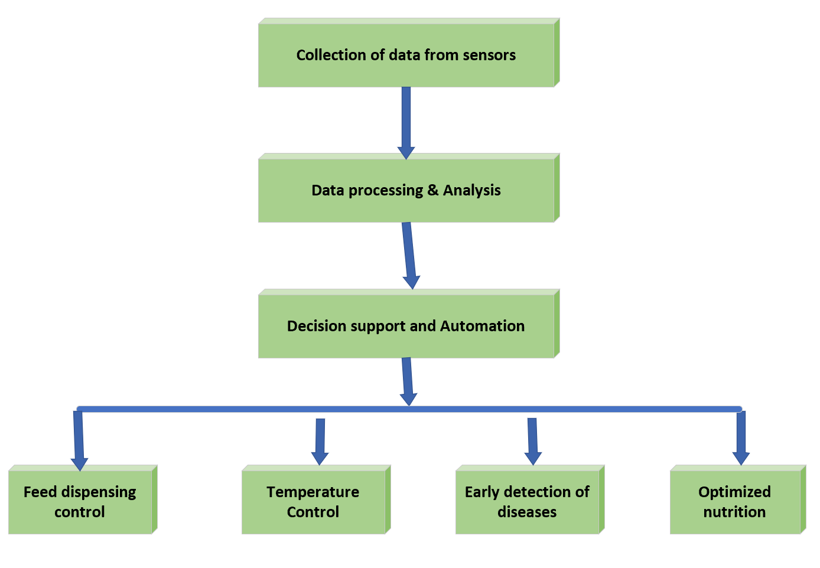
Smart livestock monitoring systems come in a range of designs associated with specific uses and needs. Some systems can track an individual animal's location via GPS technology or RFID tags, provide sharing of the animal location in real-time, and supports geofencing to keep livestock in their boundary. Other systems place significant emphasis on health violations, with sensors that deliver vital sign data of respiration, heart rate, and temperature [5]. Value comes from advanced monitoring of animal management respects to stress and the early detection of disease. Systems that monitor the environment can measure variables like temperature, humidity, and air quality to keep animals in a comfortable state and free from diseases. To optimise resource allocation and maximise yields, productivity-focused systems also track feed intake, weight gain, and milk production. These systems frequently use cloud-based platforms for data storage and analysis, giving farmers insightful knowledge and useful information they can use.

Operation of the smart livestock monitoring system
A smart livestock management system is a network of software and connected hardware intended for effective monitoring and control of animals. It makes use of IoT (Internet of Things) technology to gather information from multiple sources and give farmers useful insights. Various sensors are attached to animals (collars & ear tags) or placed in the environment (temperature, humidity sensors). These sensors collect data on animal health (temperature, heart rate, activity levels), location, behavior, and environmental conditions. The collected data is transmitted wirelessly (often using cellular or low-power wide-area networks) to a central system or cloud platform. A centralized database safely holds the gathered data [6]. The data is processed using AI algorithms and advanced analytics to find trends, patterns, and anomalies. Based on the data analysis, the system produces useful insights including reproductive cycles, ideal feeding schedules, early warning indicators of illness, and predictions of heat stress. Through dashboards and reports, an intuitive interface gives farmers instant access to data and insights [7]. The system may automate operations like temperature management, alert notifications, and feed distribution based on user preferences and predefined rules. Proactive actions are made possible by the system's ability to forecast future occurrences, such as disease outbreaks or the dates of calves. This system offers a number of benefits, including early disease diagnosis, optimal feeding, prompt interventions that result in healthier cattle, effective resource management, optimal breeding, lower labor costs, and greater production. Table 1 compares technological trade-offs—linking technical choices (e.g., communication protocols) with their impact on accuracy, energy consumption and cost.
- Comparison table for various smart livestock monitoring system
System | Technology Used | Accuracy (%) | Cost (USD  /Unit) | Power Consumption (W) | Data Transmission Range (m)
LoRa-based IoT System | LoRaWAN + GPS | 92 | 80 | 2.5 | 800 - 1000
AI-Enhanced Health Tracker | ML + Sensors | 97 | 120 | 4 | 500
Cloud-based Livestock Manager | IoT + Cloud Storage | 90 | 100 | 3.2 | 600

Technical features incorporated
The rapid advancement of automated livestock monitoring is driven by technology advances, alongside the accelerating demand of effective, sustainable, and humane animal husbandry [8]. These types of system can include the following advanced components:

Animal Health Monitoring
In Proactive Disease Diagnosis AI algorithms are used to scan multiple parameters exterior to the host; such as
Fig. 1. Automatic livestock monitoring using sensors
behaviour, temperature or heart-rate and will allow prediction of potential disease prior to cattle infection which will allow for immediate treatment. The real-time vital signs are incorporation of advanced sensors to continuously track vital signs outside host animal are in place, such as respiration rate, heart rate variability and temperature. To do pain detection AI-based systems need to be engaged to detect pain or discomfort through the reading of animal behavior and physiological conditions [9]. Drug Residue Detection is done by developing a sensor that screens for drug traces in a milk analysis or animal product identifier to confirm its safety for the consumer. Automatic livestock monitoring using sensor system is shown in Fig. 1.

Precision Livestock Farming
To estimate proper nutrition we need to use AI algorithms that monitor an animal's nutritional requirement by age, weight, stage of production and health, and adjust their feed accordingly. Heat Stress is estimated by designing systems to predict and help reduce heat stress through environmental control and timely intervention. To track reproduction AI is used to determine optimal breeding time, monitor heat activity and assess pregnancy progression. To assess the animal’s behaviour cutting-edge computer vision and machine learning capabilities are used to analyze animal’s behaviour and identify potential problems (zone aggression or stress) [10].

Environmental Monitoring and Control
To monitor air quality parameters (e.g. temperature, relative humidity, ammonia, and airborne particulate levels) continually to help optimize animal health and comfort [11]. In precision feeding, automated feeding systems are implemented that dispense precise amounts of feed based on the individual animal’s need and real-time data. Waste Management Optimization is done using sensors to monitor waste levels, therefore optimizing waste removal and reducing environmental impacts.

Data Analytics and Decision Support
For implementing Digital Twin Technologies, digital representations of livestock and their environment is created that enable users to simulate various scenarios and optimize management practices [12]. Blockchain Technology ensures data security and transparency using blockchain technology to record animal health, treatment, and production histories. As indicated above, automatic monitoring systems for livestock could provide many advantages for animal welfare, productivity, and sustainability, while supporting dairy farmers in their decisions with data-rich insights.

Data Analytics and Model Evaluation
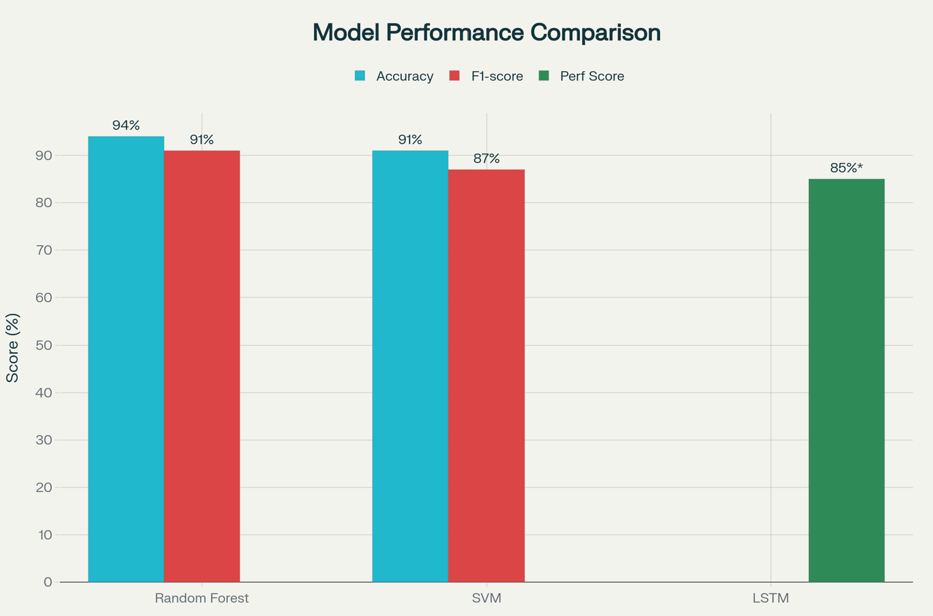
The use of smart livestock monitoring tools is built upon data analytics and model evaluation to provide accurate, reliable, and actionable information for the management of animals. Large amounts of data captured by environmental sensors, wearable devices, and imaging systems were analyzed to determine health anomalies, increase feeding behavior efficiency, and predict disease trajectories. A complete analytics pipeline was used to integrate statistical techniques, machine learning, and predictive modeling to interpret sensor outputs, including temperature, heart rate, motion index, and ambient humidity.
Fig.2. Comparative model performance for livestock health classification and prediction
The data were prepared including methods to handle missing values and noise (smoothing and normalization), for consistency during model training. Fig. 2 depicts the comparative performances of models for livestock health classification and prediction. The models for supervised learning, Random Forest and Support Vector Machine algorithms, were trained to classify states of health, with an average of 94% accuracy and F1-score of 0.91 on validation sets. An LSTM model was used to predict physiological parameters 24-hours incrementally as the time series developed in validation datasets, with mean absolute error below 0.15 and credible intervals below the error. Correlation analysis showed a significant relationship between activity level and thermal stress (r = 0.83), providing evidence that modelled states accurately captured environmental effects on behaviours. The operational performance evaluation for early disease detection improved by 17-22% compared to visual assessment by humans, while automated anomaly detection decreased manual labor hours by close to 85%. Visualization dashboards integrated into the analytics platform presented real-time performance indices including feed efficiency, water utilization, and health risk level, enabling farmers to adopt precision-based management decisions.

Conclusion
A smart livestock management system utilizes technology such as automation, data analytics and Internet of Things devices to optimize livestock farming practices. It involves using sensors to track data on animals and their environments, developing insights from that data, and using those insights to support decisions. The current livestock monitoring market has a variety of solutions offered by many companies, mainly focused on monitoring cattle, monitoring health and improving management processes. Automated anomaly identification reduced manual labor hours by nearly 85%, while operational performance evaluation for early disease diagnosis improved by 17–22% when compared to visual assessment by humans. Although these systems have made great strides, it increasingly becomes possible to develop new features based on emerging technologies such as augmented reality, drones, and current technologies such as artificial intelligence and data analytics. This could design more advanced introductory features such as feeding customizing programs, behavioral analysis, and disease prediction, ultimately benefiting animal welfare, productivity and sustainability in cattle production. The data analytics and model evaluation framework demonstrated how advanced AI-driven insights can lead to informed decisions that enhance productivity, animal welfare, and sustainability within modern livestock production systems.

References

- Singh, Amandeep, et al. "Smart technologies in livestock farming." Smart and sustainable food technologies. Singapore: Springer Nature Singapore, 2022. 25-57.
- Iwasaki, Wataru, Nobutomo Morita, and Maria Portia Briones Nagata. "IoT sensors for smart livestock management." Chemical, gas, and biosensors for internet of things and related applications. Elsevier, 2019. 207-221.
- Yadav, K., Aswal, U. S., Saravanan, V., Dwivedi, S. P., Shalini, N., & Kumar, N. (2023, December). Isolation Forest Anomaly Detection in Vital Sign Monitoring for Healthcare. In 2023 International Conference on Artificial Intelligence for Innovations in Healthcare Industries (ICAIIHI) (Vol. 1, pp. 1-7). IEEE.
- Ikhsan, Mukhammad Gufron, et al. "Mobile LoRa gateway for smart livestock monitoring system." 2018 IEEE International Conference on Internet of Things and Intelligence System (IOTAIS). IEEE, 2018.
- Ojo, Mike O., et al. "Practical experiences of a smart livestock location monitoring system leveraging gnss, lorawan and cloud services." Sensors 22.1 (2021): 273.
- Kumar, Deepak, et al. "The Different Way of Utilizing the Intellectual of Artificial Intelligence in the Animal Farming Field Progress of AI." 2024 4th International Conference on Advance Computing and Innovative Technologies in Engineering (ICACITE). IEEE, 2024.
- Patil, Anushka, et al. "Smart health monitoring system for animals." 2015 International Conference on Green Computing and Internet of Things (ICGCIoT). IEEE, 2015.
- Farooq, Muhammad Shoaib, et al. "A survey on the role of iot in agriculture for the implementation of smart livestock environment." IEEE Access 10 (2022): 9483-9505.
- Dineva, Kristina, et al. "Towards CPS/IoT system for livestock smart farm monitoring." 2021 International Conference Automatics and Informatics (ICAI). IEEE, 2021.
- Vigneswari, T., and N. Vijaya. "Smart livestock management using cloud IoT." Cloud IoT Systems for Smart Agricultural Engineering. Chapman and Hall/CRC, 2022. 55-74.
- Yadavalli, Pavan Kumar, et al. "Smart IOT system for monitoring and controlling livestock parameters." international conference of Advance Research & Innovation (ICARI). 2020.
- Chatterjee, Pinaki S., Niranjan K. Ray, and Saraju P. Mohanty. "LiveCare: An IoT-based healthcare framework for livestock in smart agriculture." IEEE Transactions on Consumer Electronics 67.4 (2021): 257-265.

