Optimized Thermal Management of Lithium-Ion Batteries Using Compact Hybrid Cooling Systems

Ashish Sharma
Department of Computer Engineering & Applications
GLA University, Mathura
ashish.sharma@gla.ac.in
Narendra Mohan
Department of Computer Engineering & Applications
GLA University, Mathura
narendra.mohan@gla.ac.in

Abstract: Efficient thermal management is very critical for the performance, safety, and longevity of lithium-ion batteries in high-demand applications such as electric vehicles. This paper proposes a compact hybrid battery thermal management system that incorporates nanofluid-based cooling, phase change materials, and novel pulsed flow function to increase heat dissipation. The proposed system is composed of U-shaped microchannels with the incorporation of PCM/aluminum foam to achieve compactness with efficient thermal regulation. A validated model of thermal-fluid dynamics evaluates the effect of coolant type and flow rate, channel dimensions, and cooling direction on thermal performance. Results show that NC+PCM+EC hybrid cooling reduces maximum battery surface temperature by as much as 3.44°C relative to conventional liquid cooling, with only a 5% penalty in power consumption. The system also increases battery charge cycles by up to 6% to 15%, therefore boosting energy efficiency and safety of the vehicle tremendously. This study forms the foundation of next-generation cooling solutions for advanced battery applications.
Keywords： Li-ion Battery, capacity, electric vehicle, thermal management system, Pumping power consumption

Introduction
The primary energy source for new energy electric cars (EVs) is rechargeable batteries. Lithium-ion batteries are widely used among the various kinds of electrochemical batteries due to their low self-discharge rate, high power, high capacity, and energy density [1]. Lithium-ion batteries produce a substantial amount of heat during charging and discharging. The large number of cells in an EV battery pack are typically discharged at a high rate [2]. Without adequate thermal management, this can cause overheating and damage to the battery, thereby reducing capacity, power, life, and safety [3-5]. However, low temperatures outside the operating range also affect battery quality and safety in driving [6][7]. A battery thermal management system (BTMS) solution was proposed to maintain the stable operation of a new energy electric vehicle's power battery; BTMS is crucial for controlling the temperature of lithium-ion batteries. In general, BTMS fall into one of three categories: hybrid cooling systems, active cooling systems, or passive cooling systems. In order to run the many mechanical components (fans, pumps, etc.), the Systems with active cooling consume more energy.
With the aid of these mechanical mechanisms, the system then moves the cooling medium close to the heat source [10]. Liquid cooling [13] and air cooling [11][12] are common examples. The most popular active cooling technique among them is liquid cooling. This is because water is more cost-effective and has superior heat-dissipating qualities. Water serves as the coolant in the majority of liquid cooling systems. To counteract the temperature gradient effect brought on by high localized battery temperatures, Luo et al. [14] created a center-dispersed square spiral ring (SSR) microchannel liquid-cooling plate for power batteries. The findings demonstrated that, in comparison to the current serpentine channel, the battery's maximum temperature under the thermal management of the SSR channel is lower. Bao, et.al. [15] investigated ultra-thin wide DC channel cold plates (WCP) and compared them with serpentine, bifurcated, and U-channel cold plates. The test results indicate that the standard deviation of temperature of WCP was reduced at maximum by 47.51 %, 45.40%, and 65.08%. However, due to recent advancements in the nanotechnology of materials, a new heat transfer liquid cooling technology, which is referred to as nanofluids, has been developed and used for practical purposes. Nanofluids are prepared by suspending nanoparticles in the range of 10-50 nm in diameter in classical heat transfer fluids [16][17]. Numerous researchers have performed theoretical and experimental analytical studies of enhanced heat transfer using nanofluids [18]. Consequently, the battery temperature declined. As shown in the above curve, at higher Reynolds number values, the heat transfer is enhanced, however at the cost of pumping power. Cooling effect for the given nanofluid SiO2, the optimal value is described by the Reynolds number of 18000. Unlike this, however, a passive cooling system requires no additional supply of energy.
Passive cooling systems comprise PCM [21] and heat pipe cooling [22]. The material properties and fill volume impact the ability of PCM, which is the most prominent passive cooling technique, to dissipate heat. This is because PCM absorbs heat in the latent form of heat. The process of phase changes like melting or solidification involves significant amounts of energy stored in the form of latent heat. In lithium-ion BTMS,; under this condition, hybrid BTMS has optimal thermal management. Ultimately, the hybrid cooling system synergizes well with liquid and phase change cooling methods, especially for heat dissipation and energy storage, thereby maintaining good thermal performance without hindering battery effectiveness. Hybrid liquid cooling systems combining active liquid cooling with passive PCM cooling provide an effective solution to the lithium-ion battery thermal management problem. On the other hand, reviewing many studies on the concept of hybrid cooling systems in achieving battery thermal management shows that at high discharge rates, the fill volume of coolant and PCM in hybrid cooling is limited by the size and weight of the BTMS.
These restrictions speed up the PCM's rate of liquefaction, reduce the amount of convective heat transfer from the coolant during the discharge operation, and decrease the passive cooling period. From the perspective of practical application, EVs with high performance and a long range need a small hybrid cooling system. In this study, we propose a novel HBTMS coupling between PCM/aluminum foam and multi-inlet U-shaped microchannels. PCM/aluminum foam is used to embed the space between channels in order to achieve compactness. The battery module is devoid of cooling plates since the staggered microchannel/PCM layers are positioned in between rows of battery cells.
Improved thermal conductivity is achieved through the use of nanofluid cooling (NC) technology. For improved cooling (EC) with lower power consumption, a pulsed flow function is further developed. In order to optimize working circumstances, such as coolant type, cooling direction, channel height, inlet flow rate, and cooling scheme, a thermal-fluid dynamics model was created and verified by experiments. According to the data, the maximum temperature on the Li-HBTMS surface has, on average, dropped to 38.87°C using the novel upgraded approach of NC+PCM+EC. Compared to the traditional liquid cooling method, which yields a maximum surface temperature of 42.31°C, it is still 3.44°C lower. There is just a 5% increase in the system pumping power usage.This conclusion allows transforming the heat dissipation performance of the cooling schemes into the number of battery charges. The proposed hybrid cooling method of NC+PCM+EC is demonstrated to elevate the number of battery charges from around 6% to about 15% of a traditional liquid cooling method.

Methodology
A. System Design: U-Shaped Microchannels and PCM/Aluminum Foam Integration
To address the thermal management challenges of lithium-ion batteries, this study proposes a hybrid battery thermal management system (HBTMS) incorporating U-shaped microchannels and PCM/aluminum foam integration. The U-shaped microchannels are designed for efficient liquid cooling, while the gaps between the channels are filled with phase change materials (PCM) coupled with high-conductivity aluminum foam to ensure compactness and optimal heat dissipation. It staggers the arrangement of the microchannels and the layers of the PCM, thereby uniformizing cooling throughout the module without any extra cooling plates and further minimizes the system's size and weight. The 18650 cylindrical cells are used within the pack, and every cell is put in a conductive aluminum shell to have greater thermal conductivity.
B. Nanofluid Selection and Properties
Nanofluids, prepared by dispersing nanoparticles into a base fluid, have better thermal properties as compared to conventional coolants. Thus, the present work selected aluminum oxide (Al₂O₃) nanofluid because of its improved thermal conductivity and stability. At a minimum point for pressure drop, the further optimization of the nanofluid concentration was to ensure heat dissipation performance and viscosity. Thermophysical properties such as density, specific heat, thermal conductivity, and viscosity were included in the computational model. These kept the nanofluid suitable for effective heat transfer at any flow rate and temperature.
C. Development of Pulsed Flow Function for Enhanced Cooling
A pulsed flow was, therefore, developed to enhance cooling efficiency by inducing a step change in coolant flow rate to eliminate the thermal boundary layer hastening conjugate heat transfer. It consists of three stages: an initial phase of steady flow, a Gaussian pulse initiated during the PCM transition, and a plateau phase at reduced temperatures with a minimum power draw for pumping. The pulsed flow amplitude, frequency, and timing were simulated and optimized with respect to minimizing energy cost while maximizing temperature reduction.
D. Experimental Validation and Simulation Framework
The system design and cooling strategies as proposed were validated via experimental testing and computational simulation. The thermal-fluid dynamics model for simulating heat transfer characteristics and flow behavior of the HBTMS was constructed using COMSOL Multiphysics, incorporating realistic boundary conditions such as battery heat generation rate, coolant flow dynamics, and PCM phase change characteristics. Various experimental setups were manufactured and assembled to investigate cooling performance under varying flow rates, types of coolant, and discharge rates. Validation was done by cross-checking simulation results against experimental data, with maximum deviations within an acceptable range. This validation provided a solid basis for optimizing the design and operation of HBTMS.

RESULTS & DISCUSSION
A. Effect of Coolant Types on Thermal Performance
Different coolants were used in the study which included nanofluids and standard fluids like water and glycol. Experimental outcomes showed aluminum oxide (Al₂O₃) nanofluids to possess wonderful thermal performance by reducing maximum battery surface temperature to 40.32°C with minimal power consumption. Kerosene and ethanol were found to be less effective in heat dissipation with lower thermal conductivities compared to nanofluids and standard fluids.
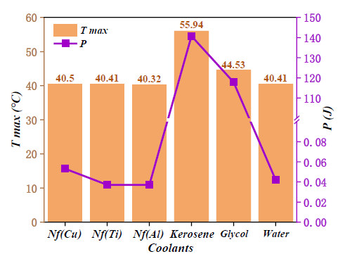
Figure 1: Maximum battery temperature and system pumping power for different coolants.
Table 1: Thermophysical properties of different coolants.
Coolants | $ρ$( Kg.m-3) | $c$(J.Kg-1.K-1) | $μ$(Pa.s)
Cu (Nf) | 1008 | 4135 | 0.00131
Ti (Nf) | 1003 | 4154 | 0.0009
Al (Nf) | 1002 | 4157 | 0.0009
Water | 998 | 4182 | 0.001
Glycol | 1071 | 3300 | 3.39
Kerosene | 785 | 2100 | 2.21

The maximum battery surface temperature and pumping power consumption were depicted for the six coolants in Figure 1. Among these coolants under test, the aluminum oxide (Al₂O₃) nanofluid displayed the best performance regarding heat dissipation: it achieved the lowest battery temperature at 40.32°C with moderate power consumption.
If you want effective heat dissipation, then use aluminum oxide (Al₂O₃) nanofluid among these tested coolants. Pumping medium is moderate with relatively low battery temperature of 40.32 degrees Celsius. In contrast, kerosene and ethanol showed higher battery temperatures due to their low thermal conductivities. Table 1 presents the thermophysical properties of these coolants, which indicate a wide range of thermal conductivity and viscosity values that significantly affect their performance.
B. Impact of Cooling Direction and Channel Dimensions
The U-shaped design was used to test the six cooling directions. The minimum maximum battery temperature of 40.34°C was for the fourth direction, positioned with inlets on either of the two outer sides; this is because the convective heat transfer is enhanced. For channel height variations, optimal cooling efficiency was obtained for a height of 7 mm, and minimal increase in power.
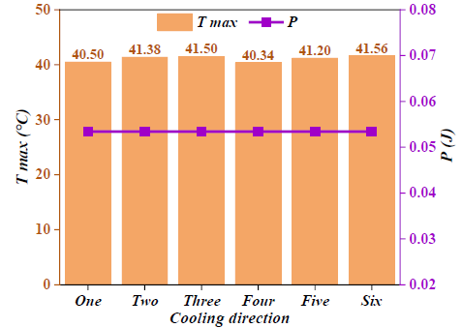
Figure 2: Maximum battery temperature and pumping power for different cooling directions.
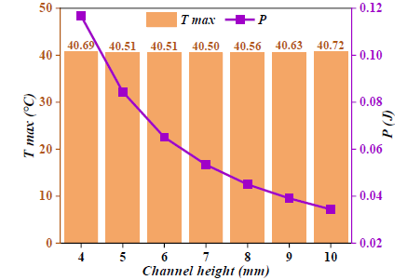
Figure 3: Battery temperature and power consumption for varying channel heights
Figure 2 shows the effect of cooling direction. For the fourth cooling direction, the maximum battery surface temperature achieved was the lowest at 40.34°C, because it has optimized convective heat transfer. Figure 3 illustrates how channel height affects thermal performance. The best balance between the cooling efficiency and power consumption is achieved at a height of 7 mm. The configuration reduces thermal resistance but does not compromise on reasonable energy efficiency.
C. Influence of Inlet Flow Rates and Pulsed Cooling Methods
It demonstrated the effectiveness of increasing the inlet flow rate in lowering the temperature of the battery surface; however, beyond 0.6 g/s, returns diminish. The pulsed flow method outperforms constant flow rates in terms of breaking the thermal boundary layer, allowing better heat transfer, and also a reduction in the rate of PCM liquefaction during the phase transition.
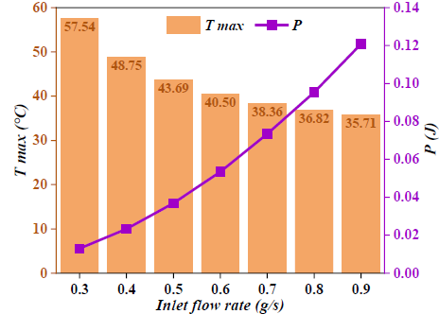
Figure 4: Maximum battery temperature and power consumption for different inlet flow rates.
Figure 4 illustrates the flow rate vs. battery surface temperature vs. power consumption relationship. The higher the flow rate, the lower the battery temperature, but this is achieved at the expense of a higher power consumption. This trade-off is addressed in the pulsed cooling technique, which is shown in Figure 5. It maintains the PCM liquefaction rates during phase transition lower, and thus the overall system efficiency is improved.
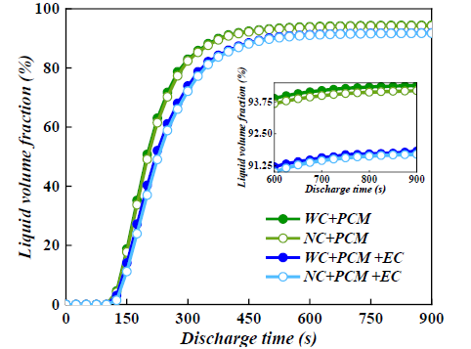
Figure 5: Liquid phase volume fraction of PCM for different cooling methods.
D. Comparative Analysis with Conventional Liquid Cooling Systems
The hybrid NC+PCM+EC system reduced maximum battery surface temperature by 3.44°C compared to the conventional liquid cooling for enhanced thermal management, with only a 5% increase in power consumption. The hybrid approach extended battery lifecycle by 6-15% as well, keeping it more energy-efficient and safe for high-performance applications.
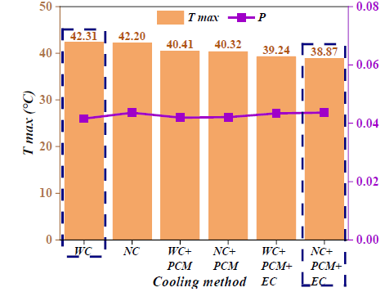
Figure 6: Comparison of battery temperature and power consumption for different cooling methods.
Figure 6: Hybrid NC+PCM+EC vs. traditional cooling methods Hybrid system lowered the average battery temperature by 3.44°C while increasing power consumption only by 5%.

Conclusion
This article introduces a compact hybrid battery thermal management system (HBTMS) that integrates U-shaped microchannels, phase change materials (PCM), and aluminum foam, augmented with a nanofluid cooling solution and pulsed flow functionality. The key results are:
- Aluminium oxide (Al₂O₃) nanofluid showed better thermal conductivity and achieved the lowest battery temperature of all the coolants tested.
- The fourth cooling direction combined with a 7 mm channel height had the best thermal performance with minimal energy consumption.
- It allowed the pulsed cooling method to reduce battery surface temperatures as it optimizes the PCM phase transitions and maintains energy efficiency.
- Compared to the liquid cooling, the NC+PCM+EC hybrid system decreased maximum battery temperatures by 3.44°C with an increase in only 5% power consumption, increasing charge cycles of a battery by 6-15%.
These developments suggest promising futures for hybrid cooling of lithium-ion batteries for both higher safety, efficiency, and lifetime in high-power applications. Future studies include optimization of pulsed cooling parameters in additional simulations and further experiments based on physical models over wide ranges of operating conditions.

REFERENCES
- Fathy A, Ferahtia S, Rezk H, Yousri D, Abdelkareem MA, Olabi AG. Optimal adaptive fuzzy management strategy for fuel cell-based DC microgrid, Energy. 247 (2022) 123447.
- Wilberforce T, Rezk H, Olabi AG, Epelle EI, Abdelkareem MA. Comparative analysis on parametric estimation of a PEM fuel cell using metaheuristics algorithms, Energy. 262 (2023) 125530
- Gandoman FH, Jaguemont J, Goutam S, Gopalakrishnan R, Firouz Y, Kalogiannis T, Omar N, Van Mierlo J. Concept of reliability and safety assessment of lithium-ion batteries in electric vehicles: basics, progress, and challenges, Appl. Energy. 251 (2019) 113343.
- Liu C, Wang Y, Chen Z. Degradation model and cycle life prediction for lithium-ion battery used in hybrid energy storage system, Energy. 166 (2019) 796–806.
- Feng X, Ren D, He X, Ouyang M. Mitigating thermal runaway of lithium-ion batteries, Joule. 4 (2020) 743–70.
- Zuo W, Zhang Y, E J, Huang Y, Li Q, Zhou K, Zhang G. Effects of multi-factors on performance of an improved multi-channel cold plate for thermal management of a prismatic LiFePO4 battery, Energy. 261 (2022) 125384.
- Y. Chen, M. Sang, W. Jiang, Y. Wang, Y. Zou, C. Lu, Z. Ma, Fracture predictions based on a coupled chemo-mechanical model with strain gradient plasticity theory for film electrodes of Li-ion batteries, Eng. Fract. Mech. 253 (2021) 107866
- Yang H, Li M, Wang Z, Ma B, A compact and lightweight hybrid liquid cooling system coupling with Z-type cold plates and PCM composite for battery thermal management, Energy. 263 (2023) 126026.
- Badhoutiya, A. and Yadav, A., 2017, May. Boost control for PV applications using impedance source inverter. In 2017 2nd IEEE International Conference on Recent Trends in Electronics, Information & Communication Technology (RTEICT) (pp. 1967-1970). IEEE.
- Chen K, Wu WX, Yuan F, Chen L, Wang SF. Cooling efficiency improvement of air-cooled battery thermal management system through designing the flow pattern, Energy. 167 (2019) 781–90.
- Park S, Jang DS, Lee D, Hong SH, Kim Y. Simulation on cooling performance characteristics of a refrigerant-cooled active thermal management system for lithium ion batteries, Int. J. Heat Mass Transfer. 135 (2019) 131–41.
- Luo W, Li H, Chu T, A numerical study of battery thermal management system with square spiral ring-shaped liquid cooling plate, Thermal Science and Engineering Progress. 45 (2023) 102120.
- Bao Y, Shao S, Numerical study on ultrathin wide straight flow channel cold plate for Li-ion battery thermal management, J. Energy Storage. 64 (2023) 107263.
- Kumar, Y., Enhanced performance of photovoltaic systems with LUO converter and modified P and O tracking algorithm. In Applications of Mathematics in Science and Technology (pp. 852-856). CRC Press.
- A.D. Tuncer, A. Khanlari, A. Sozen, E.Y. Gürbüz, H.I. Variyenli, Upgrading the performance of shell and helically coiled heat exchangers with new flow path by using TiO2/water and CuO–TiO2/water nanofluids, Int. J. Therm. Sci. 183 (2023) 107831.
- Liu S, Liu Y, Gu H, Tian R, Huang H, Yu T, Experimental study of the cooling performance of γ-Al2O3/heat transfer fluid nanofluid for power batteries, J. Energy Storage. 72 (2023) 108476.
- Husam Abdulrasool Hasan, Hussein Togun, Azher M. Abed, Naef A.A. Qasem, Aissa Abderrahmane, Kamel Guedri, Sayed M. Eldin, Numerical investigation on cooling cylindrical lithium-ion-battery by using different types of nanofluids in an innovative cooling system, Case Studies in Thermal Engineering. 49 (2023) 103097.
- Bai F, Chen M, Song W, Yu Q, Li Y, Feng Z, Ding Y. Investigation of thermal management for lithium-ion pouch battery module based on phase change slurry and mini channel cooling plate, Energy. 167 (2019) 561–74.
- Wu W, Yang X, Zhang G, Chen K, Wang S. Experimental investigation on the thermal performance of heat pipe-assisted phase change material based battery thermal management system, Energy Convers Manag. 138 (2017) 486–92.
- Yang H, Li M, Wang Z, Ma B, A compact and lightweight hybrid liquid cooling system coupling with Z-type cold plates and PCM composite for battery thermal management, Energy. 263 (2023) 126026.
- Kumar, Y., 2024, February. Comparative Study of Several Topology for PV-Based Inverters. In 2024 3rd International conference on Power Electronics and IoT Applications in Renewable Energy and its Control (PARC) (pp. 227-231). IEEE.
- Liu Z, Xu G, Xia Y, Tian S, Numerical study of thermal management of pouch lithium-ion battery based on composite liquid-cooled phase change materials with honeycomb structure, J. Energy Storage. 70 (2023) 108001.

