Anuurag Kanase Karan Tupe Ved Karanjkar
Department of Electronics and Department of Electronics and Department of Electronics and
Telecommunication Engineering, Telecommunication Engineering, Telecommunication Engineering, Vishwakarma Institute of Technology Vishwakarma Institute of Technology Vishwakarma Institute of Technology
Pune, INDIA Pune, INDIA Pune, INDIA
anuurag.kanase24@vit.edu karan.tupe24@vit.edu ved.karanjkar241@vit.edu

Shlok Katare Prof . Milind Tirmare
Department of Electronics and Department of Electronics and
Telecommunication Engineering Telecommunication Engineering
Vishwakarma Institute of Technology, Pune, INDIA Vishwakarma Institute of Technology, Pune, INDIA
shlok.katare24@vit.edu milind.tirmare@vit.edu

Doorbell System for Deaf People
Abstract— Innovation through the ages has provided mankind with solutions to difficulties, and made life more convenient and efficient process. Technology has brought in different eras in the daily lives of people ranging from electric cars to washing machines. It has also been a major factor in providing support to persons with disability.
The main purpose of this project is to allow a deaf person to understand and acknowledge important non-verbal sounds, such as ringing of the doorbell, for self-sufficiency. This system involves an RF Transmitter that sends signals whenever the doorbell is pressed. A user will be notified through a wearable device equipped with LED lights and a vibrating motor. An Arduino unit is used to control the entire system and thus provides effective and dependable communication between the doorbell and the wearable device..
Keywords— Arduino, Wireless module, vibrating motor, LED, Buzzer

I. Introduction
The innovations have constantly been aiding the people with difficulties in their daily lives. From the blind reading through smartphone to the mute person using eye-tracking speech generation, technical means made it possible for the non-verbal who want to speak their minds to get the message through. Technology has reached such a height that basic mobile apps enable us to monitor fitness, keep track of sleep, and perform several other amazing tasks. These have facilitated the lifestyle of every age group besides empowering the disabled through technology.

Hearing loss treatment is not inexpensive, and not everyone is capable of affording it. However, assistive technology helps the majority of such people to overcome their difficulties. For instance, voice therapy can be used by a person in order to make his/her voice louder, thus, the person can communicate better. Some organizations are offering such voicing training to both children and adults. Similarly, there are gloves equipped with technology that can transfer sign language to the spoken word, therefore, the deaf will have no problem interacting with others. These gloves have wireless communication (Bluetooth) and sensors that are responsible for taking the movements of the hand, interpreting it and then producing the corresponding words..

Being deprived of one of the five senses is quite a handicap to contend with. Just imagine being on a busy street in Mumbai and not hearing a sound; how dangerous and infuriating that could be? It was just that very scenario that inspired us to create this smart device, which helps hearing-impaired people react to doorbells. Our offering is a small, battery-powered visible and tactile signalling device that one can wear, which will inform the deaf when someone rings the doorbell. Just combining lights and vibrations as a solution in a simple manner is likely to make the everyday lives of such people a lot more hassle-free.

II. Literature Review
The evolution of assistive technology for persons with hearing loss has drawn much attention in the last few decades, especially in terms of doorbell alert systems. Traditional doorbell systems based on audio do not work for deaf people; therefore, other approaches are necessary using IoT, wireless technology, and wearable technology. This section covers a review of previous works on doorbell systems for persons with hearing loss, focusing on their approaches, functionalities, and drawbacks.

Shreeraksha et al. (2023) designed an Arduino-based controller that, when activated, triggers an LED indicator across the rooms and also sends a vibration alert through a mobile application [1]. The camera would capture the visitor's image and send it in real time to the user. Thus, this device integrated visual, tactile, and image-based alerts for maximum accessibility. The integration of a mobile phone allows remote visual verification of visitors. This design element furthered both security and independence for hearing-impaired users.

Patil et al. (2023) proposed an IoT-based home security system for the hearing impaired that offers 24-hour monitoring in 2023 [2]. It involves a wearable device capable of vibration and a mobile application that generates alerts upon the triggering of sensors. The system merges Pi camera visuals with Firebase-based data for real-time alerts. There are sensors for detecting motion, fire, gas, and even knocking at doors for enhanced safety. The architecture is such that without using sound, the hearing-impaired user is warned.

Malve & Morade, (2021) have also designed a Smart Doorbell using OpenCV on Raspberry Pi with real-time face recognition capabilities [3]. The system calls out the visitor's name through a speaker if the person is recognized. The unrecognized face is stored for further identification. The LBPH algorithm ensures the speedy and reliable matching of faces. This system can also be used for hearing and visually impaired people.

Girendra et al. (2023) presents a touchless doorbell using Arduino Uno and ultrasonic sensors [4]. This paper describes a contactless bell that automatically turns on the buzzer once someone is detected near the door without physical contact with the door. The device uses RF modules for wireless communication between transmitter and receiver. The system enhances hygiene and accessibility, especially for those unable to press buttons. It is an affordable and easily implementable solution.

Paidi et al. (2022) propose a wearable notification system using the nRF24L01 module for the hearing impaired [5]. The system vibrates, flashes an LED, and then displays a message when the doorbell is pressed. Network performance was tested for different data transmission rates indoors. Consistent response with 0.8 ms latency across rooms can be achieved at 250 Kbps. It proves to be reliable for indoor use while remaining portable and user-friendly.

Supraja and Bindusree (2019) presents a small, wearable Arduino-based alerting system for the hearing impaired [6]. An LED, vibrating motor, and LCD screen are used to display and convey the alerts of doorbells. It doesn't require the operations of sound. Hence, it can be used by deaf people. The simplicity and flexibility of Arduino make it more approachable than PIC-based systems. Cost-effectiveness and real-time updates are the main features.

Edwin and Magdaluyo (2019) uses modular components to implement a scalable and affordable IoT doorbell system for the hearing impaired [7]. It is integrated with the Raspberry Pi Zero gateway, XBee modules, and LED indicators. The system utilizes Node-RED for handling events and has been optimized for low-power, battery-operated devices. It also aims to stay below the mark of $50 per house installation. It strikes a balance between affordability, usability, and wireless integration.

Sah et al. 2024 proposed a no-contact smart doorbell with ultrasonic sensors and ESP32 webcam for motion detection and live streaming [8]. It provides real-time alerts to the homeowner through the Blynk app and ThinkSpeak platform. The system is equipped with LED lighting and speaker alarms to ward off intruders. Solar power provides the operational capability during outages. It focuses on health-conscious design post-COVID-19.

Raina et al. (2022) came up with a contactless IoT doorbell using an ultrasonic sensor to trigger a servo motor [9]. The servo in turn activates a mechanical switch to ring a traditional bell without any physical contact. This system was developed to reduce virus transmission during COVID-19. It is low-cost, retrofittable, and power-efficient. The design is developed by keeping hygiene, safety, and cost-effectiveness in mind.

Thakkar and Jain (2017) presents a low-cost, wearable Arduino and NRF24L01 module-based doorbell alert system for deaf users, it provides notification through LED, LCD, and vibration [10]. Thus, it is an accessible and wearable device. The circuitry for the development of such a warning system will not involve any complex infrastructure but only some simple embedded components. Performance comparison with other earlier versions using PIC solutions reflects well. The system can be reduced to a lightweight, wearable package suitable for daily use by differently-abled persons.

III. Methodology/Experimental

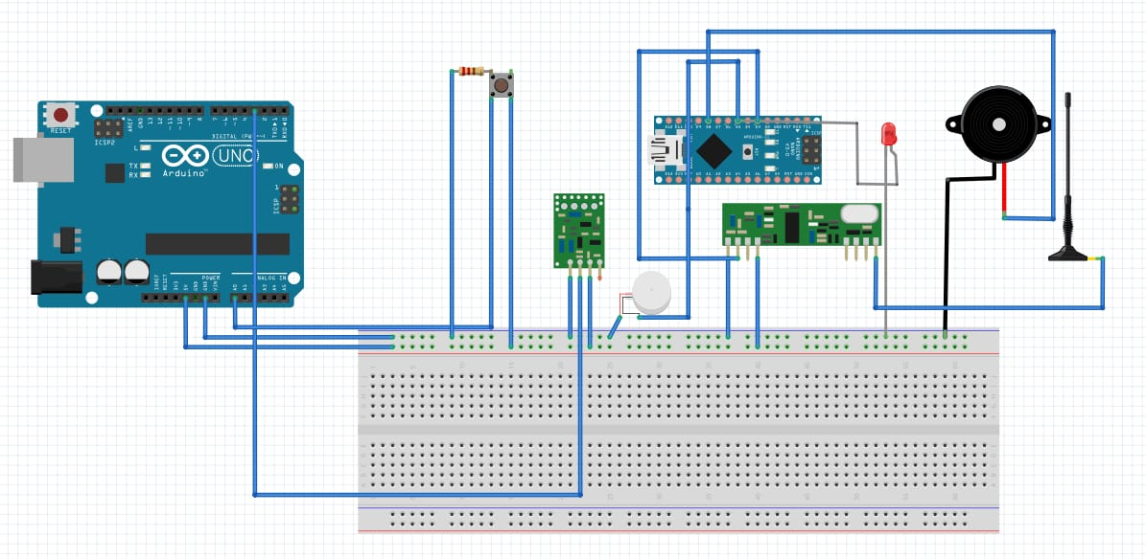
Figure 1 : Circuit Connections for Transmitter and Reciever Module
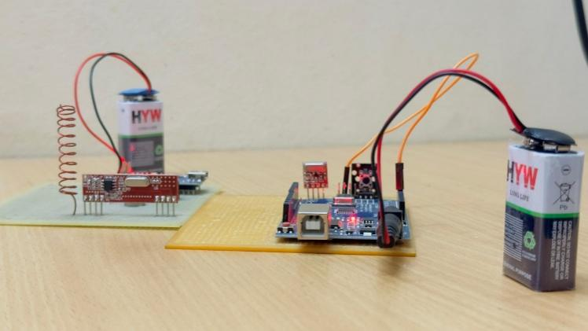
Figure 2 : Real Life Implementations

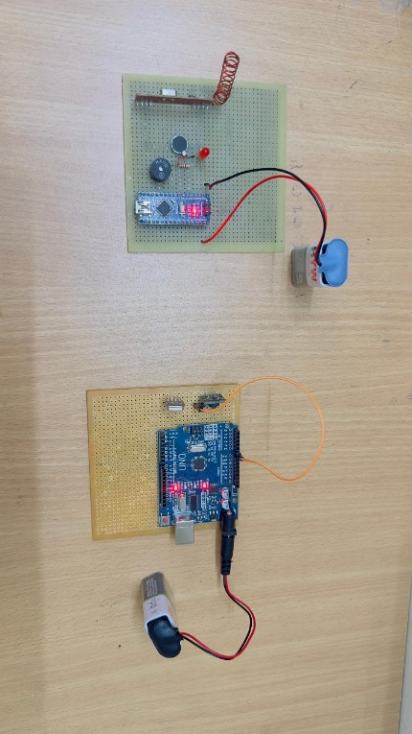
Figure 3: Real Life Implementations

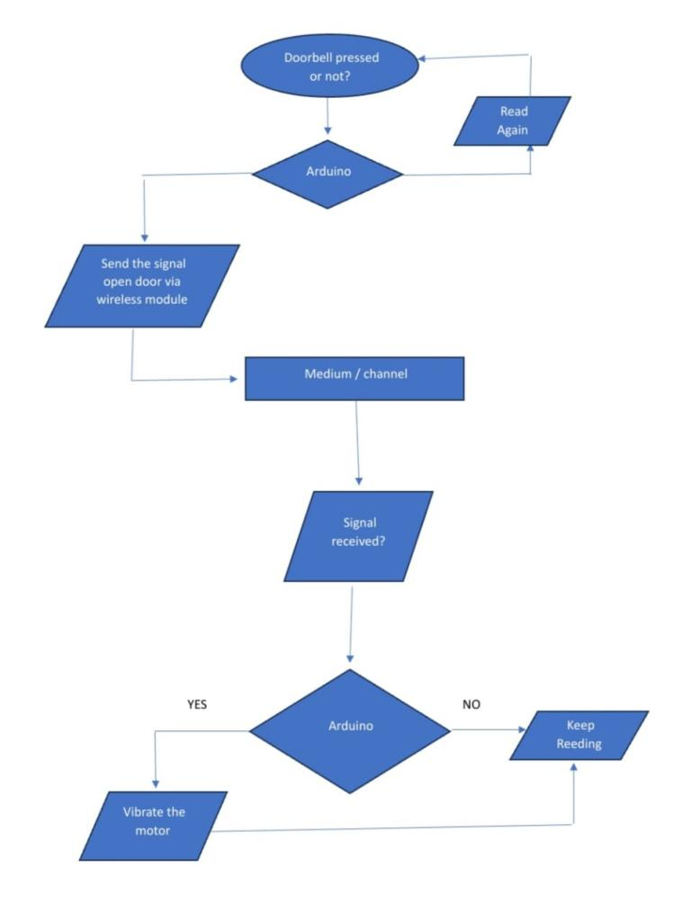
Figure 4: Flowchart

Results and Discussions
This Smart Doorbell System for Deaf People has been developed and tested with success. Indeed, it was confirmed to be a reliable system for both visual and haptic alerts. The evaluation of the system was done according to its detection accuracy, response time, usability, and user feedback.

A. System Performance
- Visual and Haptic Notifications:
- LED notifications were very prominent even during the day, hence effective notifications were provided.
- The vibration motor also created varying patterns of vibrations that the users could recognize easily, thus making the alerts clear.

- Response Time:
- On average, the system showed a response time of 20 milliseconds, which indicates that the receipt of notifications was nearly instantaneous after the detection of the guest.
- Arduino Uno could process many inputs simultaneously; therefore, it managed to operate stably without introducing significant delays.

B. User Feedback and Usability
• Ease of Use: The experimental participants found the system to be easy to use and hardly took any time in learning its usage.
- Effectiveness: People with the system said that they could get the alerts from LED easily and the vibrating alert was also very much distinct from other environmental sounds.

C. Limitations and Areas for Improvement
1. Power Consumption:
• The constant running of the LEDs and vibration motors would quickly deplete the power, assuming it is battery-powered.
- Optimization, such as the inclusion of low-power components and a sleep mode during periods of inactivity, could greatly increase battery life.

2. Haptic Feedback Customization
• Vibration settings for strength and length are preset and might not work to satisfy all customers.
- Future editions of the device might provide vibration patterns that can be customized via mobile application or device settings.

3. Standalone System Without Remote Notifications
• There is no place in this system for sending notifications to smartphones, as the commercial smart doorbells do.
- Integration of Bluetooth or Wi-Fi may allow app notifications for smartphones, thus making the system more accessible.

4. Limited User Testing Scope
• Only a few users have tested the system, and thus, it may not reflect the mixed needs of all users.
• If there is a user test conducted, targeting different age groups and levels of hearing impairment, the results would be more insightful for further improvements.

5. Aesthetic and Ergonomic Design
• The current design has sacrificed aesthetics for functionality; therefore, it may not look nice to some of the users or occupy too much space.
• Future designs will either focus more on light wristband models or integration of smartwatches to facilitate ease and mobility for end-users.

D. Comparison with Existing Solutions
• Unlike other smart doorbells in the market which depend on Wi-Fi and cloud notifications, this system works independently and is suitable for users in regions with poor internet connectivity.
• Moreover, the project is cheaper compared to high-priced assistive devices; thus, the affordability will be aimed at a greater population.

. ii Future Scope

The next few years are going to be pretty innovative in the field of smart doorbell systems for the deaf. The main areas to be dealt with include developing visitor identification using AI, integration with smart home devices, and improving notification methods such as haptic feedback and programmable LED notifications. Making the design efficient could also lead to making it a wearable device, while Cloud storage, low-power communication, and multi-sensor fusion could prove to be the factors of efficiency that make cost-effectiveness and scalability the main issues to consider for mass adoption. Addressing these aspects, future systems can provide better reliability, security, and convenience for hearing-impaired users.

III .Conclusion
The proposed system thus represents not only an immediate solution to the gap in accessibility for those with hearing impairments but also a basis on which future integrations of advanced technologies may be achieved. This includes sophisticated identification capabilities, remote monitoring, and more sophisticated feedback mechanisms for visitors. This will continue to advance the field of assistive technology in general while strengthening its contribution toward accessibility and independence among people with disabilities.

VII . Acknowledgment
First of all, the authors would like to thank the faculty members of Vishwakarma Institute of Technology, Pune, for guiding through the project. We also would like to express our gratitude towards the authors of the works cited here, as their major contributions to this area opened up new channels and provided a base for our study, i.e., through the insights gained.

References

[1] S. Shreeraksha, S. Shashanth, A. Shetty, and M. Shetty, "Doorbell System for Deaf Using IoT," 47th Series Student Project Programme (SPP), Yenepoya Institute of Technology, Mangaluru, India, 2023.
[2] R. S. Patil, G. Begum, S. N. Tanzeem, and S. S. Ithrath, "Home Security System for the Hearing Impaired," International Research Journal of Modernization in Engineering, Technology and Science (IRJMETS), vol. 5, no. 6, pp. 1479–1482, Jun. 2023.
[3] S. Malve and S. S. Morade, "Face Recognition Technology Based Smart Doorbell System using Python’s OpenCV Library," International Journal of Engineering Research & Technology (IJERT), vol. 10, no. 6, pp. 227–229, Jun. 2021.
[4] P. Girendra, K. Srivasthav, K. Vignesh, and Y. Srinivasulu, "Touchless Door Bell Using Arduino Uno," International Journal for Research in Applied Science & Engineering Technology (IJRASET), vol. 11, no. 1, pp. 1825–1831, Jan. 2023.
[5] Z. Paidi, H. E. Haliza, N. M. Zain, and M. Othman, "Development of a Notification System Using a Wearable Concept that Allows Hearing-impaired Person to Detect that their Doorbell has been Pressed using the nRF24L01 Wireless Module," International Journal of Academic Research in Business and Social Sciences, vol. 12, no. 12, pp. 2766–2777, Dec. 2022. DOI: 10.6007/IJARBSS/v12-i12/16069

[6] C. D. Supraja and V. Bindusree, "Door Bell Notification System for Deaf People using Arduino," Int. J. Innov. Technol. Explor. Eng. (IJITEE), vol. 8, no. 12S, pp. 1178–1180, Oct. 2019.

[7] S. Edwin and D. Magdaluyo, "Doorbell for the Hearing Impaired," Computer Engineering Senior Theses, Santa Clara University, Santa Clara, CA, USA, Jun. 2019. [Online]. Available: https://scholarcommons.scu.edu/cseng_senior/136

[8] A. K. Sah, R. Kumar, Tushar, D. Shikha, and G. Singh, "Automatic Smart Doorbell Using Ultrasonic Sensor and ESP32 Web Cam for Home Security," Int. Res. J. Mod. Eng. Technol. Sci. (IRJMETS), vol. 6, no. 4, pp. 8541–8545, Apr. 2024.

[9] S. Raina, V. P. Singh, M. S. Akhtar, S. R. Rishabh, and A. Singh, "Contactless IoT Doorbell," J. Emerg. Technol. Innov. Res. (JETIR), vol. 9, no. 5, pp. 33–35, May 2022.

[10] S. P. Thakkar and A. K. Jain, "Low Cost, Wearable Door-Bell Notification System for Deaf People using Arduino," Int. J. Eng. Trends Technol. (IJETT), vol. 51, no. 2, pp. 115–117, Sep. 2017.

[11] R. Shaikh, P. Sherbhai, M. Shaikh, and S. Pappu, "Low Cost Wearable Door Bell Notification System for Deaf People," International Journal of Innovative Research in Computer and Communication Engineering, vol. 8, no. 4, pp. 1024–1026, Apr. 2020.

[12] I. Torikpa, "Design and Construction of Electric Doorbell," ScienceOpen Preprints, DOI: 10.14293/S2199-1006.1.SOR-.PP6VMNU.v1, Dec. 2022.

