AI–6G Convergence: Architectures, Key Use Cases, and Challenges for Intelligent and Sustainable Networks

Mohamed Hafez
Faculty of Engineering FEQS
INTI-IU-University
Nilai, Malaysia
mohdahmed.hafez@newinti.edu.my

Mohamed Boumalkha
Department of Physics
Faculty of Sciences, Moulay Ismail University
Meknes, Morocco
med.boumalkha@gmail.com

Ahmed S.I. Amar
Egyptian Technical Research and Development Centre,
Cairo, 11618
Egypt
Ahmed.s.i.amar.adc@alexu.edu.eg

Tamer.kashef
Technical Research Centre,
Cairo, 11618
Egypt
tamer_elkashif2003@yahoo.com

Tamer Shamseldin
Technical Research Centre,
Cairo, 11618 Egypt
Tamer@alumni.purdue.edu
Eman Kandil
Electronic and Communications Engineering Department, MTI university, Cairo, Egypt
eman.abdelhamed@eng.mti.edu.eg

Abstract—The sixth generation (6G) of wireless communication systems is poised to transcend the performance-oriented objectives of 5G, evolving into an intelligent, adaptive, and context-aware network paradigm. Central to this transformation is the deep integration of Artificial Intelligence (AI) across all layers of the communication stack, enabling AI-native architectures that deliver self-optimization, self-healing, semantic understanding, and autonomous decision-making. This paper presents a comprehensive examination of the AI–6G convergence, beginning with an overview of AI-native design principles and the transition from AI-assisted to AI-intrinsic networks. Key use cases are explored, including intelligent extended reality, AI-driven digital twins, autonomous mobility, AI-augmented remote healthcare, joint communication and sensing, sustainable smart cities, intelligent network management, and industrial automation. We analyze the enabling technologies—such as edge AI computing, federated learning, reconfigurable intelligent surfaces, and terahertz communication systems—that are required to realize this vision. Furthermore, we discuss the core technical, ethical, and operational challenges that must be addressed to ensure that AI–6G systems are scalable, secure, explainable, and sustainable. The insights presented aim to guide researchers, industry practitioners, and policymakers in shaping a trustworthy and inclusive 6G ecosystem that aligns with global sustainability goals. This research focuses on applications such as sustainable smart cities, autonomous mobility, and augmented healthcare, directly advancing SDG-9 (Industry, Innovation, and Infrastructure) by building resilient and innovative infrastructure. Its overarching goals of sustainability and inclusiveness also support SDG-11 (Sustainable Cities and Communities).
Keywords—6G networks, Artificial Intelligence, AI-native architecture, intelligent connectivity, semantic communication, digital twins, edge AI, joint communication and sensing, reconfigurable intelligent surfaces, terahertz communications, sustainable smart cities.

Introduction
The continuous evolution of mobile communication technologies is steering the world toward the sixth generation (6G) of wireless networks—an anticipated paradigm shift set to revolutionize global connectivity. [1]. While fifth-generation (5G) systems primarily targeted enhanced mobile broadband (eMBB), ultra-reliable low-latency communications (URLLC), and massive machine-type communications (mMTC), 6G aspires to deliver intelligent connectivity by seamlessly integrating digital, physical, and biological domains through autonomous, context-aware, and data-driven infrastructures. [2], [3]. 6G is anticipated to deliver unprecedented capabilities, offering ultra-high data throughput, near-instantaneous end-to-end responsiveness, and exceptionally dense device connectivity, all while prioritizing energy efficiency and guaranteeing seamless worldwide coverage [4], [5]. Realizing these ambitious targets demands not only the exploration of novel spectral resources—such as sub-terahertz (>100 GHz) and terahertz (THz) frequency bands. [6], [7]—but also a fundamental architectural transformation toward pervasive intelligence and full automation [8]. In this context, Artificial Intelligence (AI) and Machine Learning (ML) are positioned not as auxiliary enablers, but as foundational pillars underpinning the very fabric of the 6G ecosystem. [9].
AI in 6G is envisioned as an embedded capability across all communication layers, including spectrum access, waveform design, beamforming, mobility management, security protocols, and resource orchestration [10], [11], [12]. Unlike prior generations where AI was applied in a top-down or ad hoc manner, 6G aims to develop AI-native architectures, where intelligence is distributed across the edge, core, and cloud in a federated, collaborative, and adaptive manner [13], [14]. This shift will enable networks that are self-optimizing, self-healing, self-securing, and context-aware, resulting in dramatic improvements in operational efficiency, user experience, and resiliency.

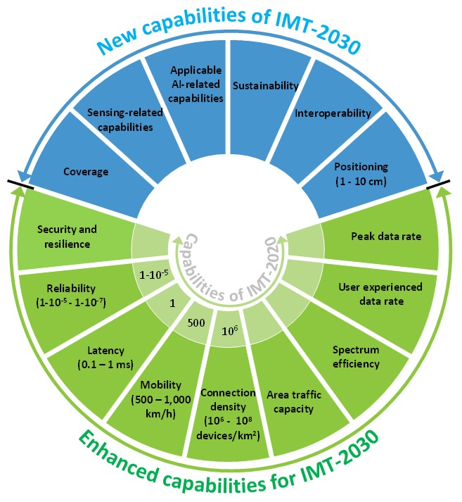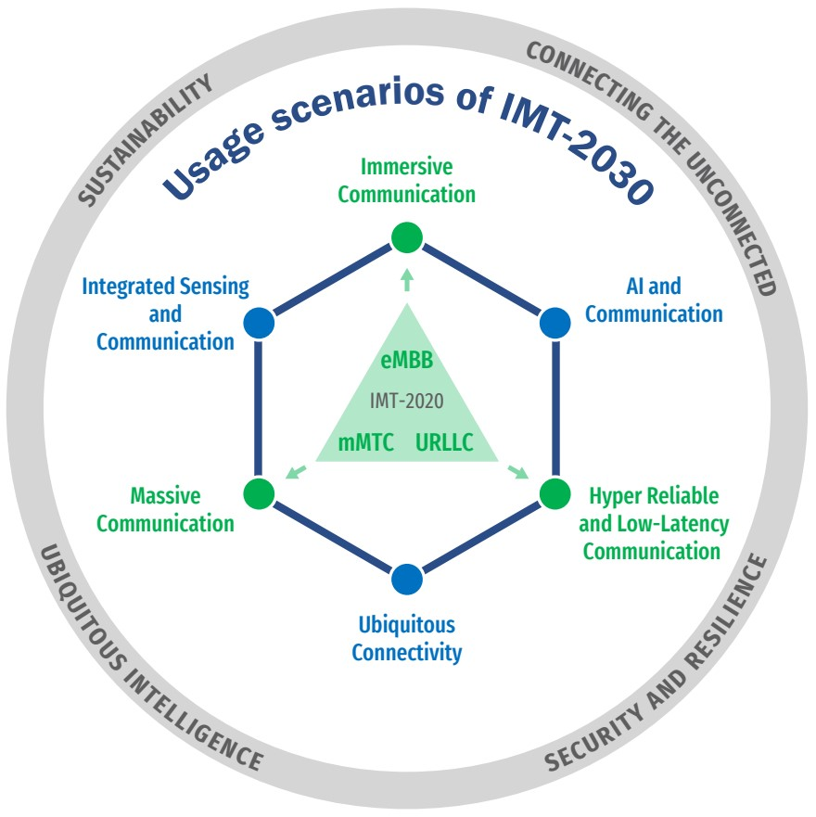
- (a) IMT-2030 usage scenarios and overarching design principles [20], illustrating the evolution from 5G’s three core scenarios to six, with new emphasis on AI integration and combined sensing–communication capabilities, framed by principles of sustainability, security, and ubiquitous intelligence. (b) Capabilities of IMT-2030 [20], featuring AI-driven processing, sustainability measures, and high-precision sensing, alongside significant advancements in data rate, latency, mobility, and network resilience.

Furthermore, the rise of semantic and goal-oriented communications—where the content and intent of data, rather than raw bits, drive the communication process—requires AI to understand, infer, and act upon complex data semantics [15], [16]. This new paradigm marks a departure from Shannon-centric communication models and underscores the critical role of natural language processing (NLP), knowledge graphs, and deep neural networks in enabling cognitive networking (Strinati et al., 2021) [17], [18]. Through AI-powered Joint Communication and Sensing (JCAS) [19], networks will simultaneously sense and transmit, enabling applications such as holographic telepresence, immersive XR, digital health monitoring, and tactile internet.
The integration of Digital Twins (DTs) and networked AI agents will further enable real-time network modeling, prediction, and control, serving as virtual replicas of physical network elements and environmental conditions. These twins, powered by data from thousands of sensors and user interactions, will provide a testbed for zero-touch service delivery, proactive fault detection, and autonomous reconfiguration [21], [22]. In addition, the spatiotemporal complexity of 6G environments—including Non-Terrestrial Networks (NTNs), UAVs, LEO satellites, and intelligent metasurfaces—necessitates AI models that can generalize across time-varying, high-dimensional datasets [23], [24].
However, this vision does not come without formidable challenges. First, there is a pressing need for lightweight, explainable, and privacy-preserving AI models that can operate under constrained edge environments and heterogeneous deployment scenarios [25]. Federated learning, split learning, and privacy-enhancing technologies (PETs) will be central to ensuring trust in AI models without compromising user data. Second, the dynamic, open nature of AI-enabled networks increases the attack surface for adversarial behaviors, necessitating new approaches in AI-driven security, intrusion detection, and zero-trust architectures [20]. Lastly, the success of 6G will depend on the ethical governance of AI systems, particularly regarding fairness, accountability, data sovereignty, and bias mitigation [26], [27].
Importantly, the evolution of 6G is being shaped in alignment with the United Nations Sustainable Development Goals (UN SDGs), particularly those related to digital equity, infrastructure innovation, and climate resilience [28]. AI-enhanced 6G infrastructure is expected to support remote education, telemedicine, agricultural automation, and environmental monitoring—thereby acting as a catalyst for global societal transformation.
In this paper, we delve into the symbiotic relationship between AI and 6G, beginning with an exploration of AI-native network design principles and key enabling technologies. We then examine specific use cases, including semantic communication, digital twins, edge AI, security automation, and context-aware network control. Our objective is to provide a holistic understanding of how AI will shape the design, deployment, and evolution of 6G systems—and what challenges must be addressed to fully realize this vision.

The AI–6G Fusion
Artificial intelligence is no longer a supporting actor in the communications world—it is set to become the lead. The 5G Vision Recommendation, published by the ITU-R in 2015, was built around three core use scenarios—eMBB, URLLC, and mMTC—supported by key performance indicators aimed

- Key Use Cases and Applications of AI in 6G.

primarily at enhancing the technical performance of mobile communication systems. At the time, the focus was on achieving faster speeds, greater reliability, and higher capacity, with little consideration for the integration of artificial intelligence as a central component of the network. However, technological developments have accelerated far beyond expectations. Milestones such as the historic 2016 AlphaGo match against Lee Sedol demonstrated AI’s strategic potential, while the rise of generative AI models like ChatGPT in 2023 revealed AI’s capability to transform the entire ICT ecosystem. These advances made it clear that AI is not merely a supportive tool but a transformative force with the potential to redefine the architecture and operation of future communication systems.
The integration of AI into 6G is expected to follow a two-phase evolution. The first phase, AI-assisted networks, will see AI embedded in network operations to enable self-monitoring, self-organization, self-optimization, and self-healing, thereby reducing human intervention while improving efficiency and resilience. The second phase will usher in AI-native networks, where AI becomes intrinsic to the network’s design and operation. In this stage, the network will function as both a communication system and a distributed AI computing platform, capable of performing inference, model training, and deployment at the edge. Such capabilities will allow 6G networks to dynamically optimize themselves and to deliver AI-powered services with unprecedented speed and precision.
This transformation is reflected in the usage scenarios and overarching principles of IMT-2030, as illustrated in Figure (a). Building upon the 5G foundation, 6G expands the three original scenarios into six: Massive Communication, Ubiquitous Connectivity, Hyper Reliable and Low-Latency Communication, Immersive Communication, AI and Communication, and Integrated Sensing and Communication. Surrounding these scenarios are four overarching aspects—Sustainability, Connecting the Unconnected, Security and Resilience, and Ubiquitous Intelligence—which emphasize that 6G is not only about improving technical performance but also about addressing global connectivity needs, ensuring trust, and embedding intelligence throughout the network. The inclusion of “AI and Communication” as a dedicated scenario marks a decisive shift towards making intelligence a native feature of the communication infrastructure.
Figure (b) further highlights the capabilities envisioned for IMT-2030, categorized into new and enhanced functions. New capabilities include AI-related processing at scale, sustainability measures, interoperability, high-precision positioning (1–10 cm), sensing-related features, and expanded coverage. Enhanced capabilities build on existing 5G strengths, with significant improvements in peak and user-experienced data rates, latency reduction to 0.1–1 ms, ultra-high mobility support, massive connection density, and increased spectrum efficiency. Notably, security and resilience are elevated to a core technical priority, reflecting the heightened importance of reliability in an AI-driven environment. Together, these capabilities redefine the network from a mere communication pipeline into a multifunctional, intelligent infrastructure capable of powering the AI-native applications of the 2030s.
In this sense, the meeting of AI and 6G is not a simple case of one technology supporting another—it is a deep convergence where communication networks themselves become AI-powered systems. This shift will ensure that 6G evolves in step with advances in artificial intelligence, enabling a new era of context-aware, adaptive, and autonomous connectivity.

Key Use Cases and Applications of AI in 6G
The integration of AI into 6G transcends mere efficiency enhancement—it is a strategic enabler of the next wave of digital transformation. By embedding intelligence natively into all layers of the 6G infrastructure, the network evolves from a passive data conduit into an active orchestrator of services, capable of adapting to context, understanding user intent, and interacting autonomously with its environment. This paradigm shift gives rise to a wide range of disruptive use cases, spanning sectors such as healthcare, industry, transportation, urban planning, and immersive media. Figure 2 illustrates the primary AI-driven use cases envisioned for 6G networks.Below, we detail the most promising and transformative use cases made possible by the convergence of AI and 6G, organized by domain and technical enablers.

Intelligent Extended Reality (XR)
Extended Reality (XR)—comprising Virtual Reality (VR), Augmented Reality (AR), and Mixed Reality (MR)—is projected to become a mainstream collaborative platform in the 6G era [29], [30]. Ultra-low latency (<1 ms), multi-Gbps throughput, and context-aware adaptability are prerequisites for delivering lifelike experiences. Recent research emphasizes the integration of multi-modal sensing, cloud-driven spatial mapping, and AI-powered semantic compression to minimize transmission load while maintaining perceptual fidelity . Machine learning models, including reinforcement learning, are being deployed to predict user head and body movements, dynamically adjust rendering quality, and optimize resource allocation in real time . Emerging testbeds demonstrate XR-driven holographic meetings, virtual classrooms, and immersive tourism, enabled by edge-deployed AI inference engines [31], [32].

AI-Driven Digital Twins (DTs)
Digital twins—virtual replicas of physical systems updated in real time with sensor and operational data—will be a linchpin of 6G applications [33], [34]. AI-powered DTs enable predictive analysis, system optimization, and scenario simulation for domains ranging from industrial automation to urban planning. Recent research proposes generative AI-based DT architectures capable of synthesizing realistic, context-aware environments for network optimization, smart city modeling, and supply chain resilience [35], [36], [37]. By leveraging generative AI, predictive machine learning, and real-time data fusion, AI-driven DTs in 6G not only mirror the present state of a system but also forecast future states, enabling autonomous adaptation and continuous improvement across critical infrastructures.

Autonomous Mobility and Vehicular Networks
AI-native 6G networks will underpin next-generation Cooperative Intelligent Transportation Systems (C-ITS), where vehicles, infrastructure, and pedestrians communicate seamlessly to enable zero-collision urban mobility [38]. AI enhances vehicular networks through trajectory prediction using spatiotemporal deep learning, cooperative decision-making, and sensor fusion across LIDAR, radar, and vision streams [39], [40]. Digital twin-based traffic simulations running over 6G testbeds, as demonstrated at recent technology expos, show how network-aware predictive control can reduce congestion and improve safety in real-world conditions [41].

AI-Augmented Remote Healthcare
Healthcare in the 6G era will benefit from pervasive connectivity and AI-enhanced diagnostics. AI models deployed at the edge can perform real-time anomaly detection on biosignals, assist in digital pathology through federated learning, and provide haptic feedback for telesurgery [20], [42]. Ultra-reliable low-latency communications will enable XR-guided surgical interventions, remote rehabilitation, and continuous patient monitoring, even in rural and underserved regions. Recent scenario studies highlight that AI-driven triage and predictive analytics can reduce emergency response times by up to 30 % in simulated healthcare networks [43].

Joint Communication and Sensing (JCAS)
6G is expected to integrate sensing capabilities directly into communication signals, enabling applications such as environmental mapping, passive security monitoring, and human activity recognition [44], [45]. AI models—including convolutional and recurrent neural networks—will interpret complex signal reflections, filter noise, and classify targets in real time. Demonstrations in industrial testbeds show robots navigating complex spaces using base-station sensing enhanced by AI inference, a clear example of Integrated Sensing and Communication (ISAC) enabling new forms of spatial intelligence [44].

Sustainable Smart Cities
AI-native 6G networks will function as the digital nervous system for smart cities, linking millions of sensors, vehicles, and control systems. Applications include AI-predicted traffic control, resource-efficient waste management, and adaptive energy grids. Emerging research demonstrates the use of reconfigurable intelligent surfaces (RIS) and non-terrestrial networks (NTNs) to extend urban intelligence to hard-to-connect areas, ensuring equitable access to city services [46], [47]. Generative AI-powered DTs are being trialed for city-wide simulations, enabling authorities to test urban policies and infrastructure designs virtually before deployment [48].

Intelligent Network Management and Security
The scale and complexity of 6G demand autonomous, AI-driven network management frameworks capable of zero-touch operation and zero-trust security [49], [50]. AI techniques such as graph neural networks (GNNs), meta-learning, and federated threat intelligence will enable self-configuration, anomaly detection, and rapid incident response [51]. Experimental platforms demonstrate AI-as-a-Service models that provide real-time optimization across heterogeneous network segments while maintaining strong privacy guarantees through decentralized learning paradigms [52].

Industrial Automation and AIoT
The AIoT paradigm—where billions of devices collaborate autonomously—will reach its full potential in 6G [53], [54]. In industrial settings, AI-enabled robots will coordinate in real time using shared digital twin environments, while predictive maintenance algorithms prevent downtime in manufacturing lines. Supply chains will achieve unprecedented resilience through AI-driven logistics routing and real-time asset tracking. Industry 5.0 concepts are being validated in large-scale testbeds, showing how edge AI and ultra-reliable low-latency communications (URLLC) can orchestrate autonomous factories and distribution hubs [55].
AI is not an auxiliary feature in 6G—it is its fundamental enabler. The convergence of AI with advanced communication technologies will allow 6G to serve diverse, dynamic, and demanding applications, from holographic collaboration and tactile telemedicine to zero-touch automation and planet-scale environmental sensing. These use cases not only reflect technical innovation but also reinforce the role of 6G as an engine for human-centric, sustainable development.

Challenges and research directions
While the fusion of AI and 6G holds unprecedented potential, realizing this vision demands overcoming significant technical, operational, and societal hurdles. These challenges span the full lifecycle of network design, deployment, and maintenance, and their resolution will determine whether AI–6G systems can fulfill their promise of sustainable, ubiquitous, and trustworthy connectivity.

Scalability and Computational Constraints
6G networks will operate at unprecedented scale, connecting billions of heterogeneous devices while supporting real-time AI inference and training at the edge. Achieving this requires ultra-efficient AI algorithms that can run on resource-constrained devices without sacrificing accuracy. Techniques such as model compression, neural architecture search for low-power hardware, and on-device federated learning must mature to meet the latency and energy efficiency demands of AI-native networks.

Data Availability, Quality, and Governance
AI models require massive amounts of diverse, high-quality data for training and adaptation. In a global 6G environment, ensuring data representativeness across geographies, device types, and application domains is non-trivial. Moreover, privacy regulations such as GDPR and evolving data sovereignty laws impose strict limitations on cross-border data sharing. Privacy-preserving learning paradigms—federated, split, and swarm learning—must evolve to operate under heterogeneous data quality and legal constraints.

Security and Robustness of AI Models
The introduction of AI into the network stack expands the attack surface for adversarial activities. AI models can be misled by adversarial inputs, poisoned datasets, or model inversion attacks, jeopardizing both network performance and user trust. Future research must focus on adversarially robust model architectures, AI-driven intrusion detection systems, and verifiable trust frameworks. The concept of zero-trust networking will require integration of continuous AI-based authentication and anomaly detection at all layers.

Explainability and Trustworthiness
The opacity of many AI models, particularly deep learning architectures, poses a barrier to their adoption in mission-critical 6G applications. Explainable AI (XAI) techniques must be integrated into the AI–6G design pipeline to enable transparent decision-making, regulatory compliance, and human oversight. This is particularly vital in sectors such as healthcare, autonomous transport, and defense, where AI-driven decisions have high stakes.

Sustainability and Energy Efficiency
Although AI can optimize network energy usage, AI model training and inference themselves can be highly energy-intensive. The environmental cost of large-scale AI–6G deployments must be minimized through energy-aware learning algorithms, renewable-powered edge/cloud infrastructure, and circular economy approaches for hardware lifecycle management.

Interoperability and Standardization
The global deployment of AI-native 6G will depend on open standards and interoperable frameworks to ensure seamless communication between heterogeneous devices, vendors, and network domains. International bodies such as ITU, 3GPP, and IEEE must develop unified AI–6G reference architectures, testing protocols, and compliance certification schemes to avoid fragmentation.

Ethical and Societal Implications
Embedding intelligence into global communications raises profound ethical questions around bias, equity, and societal impact. AI–6G governance frameworks must address fairness in service delivery, algorithmic accountability, and safeguards against misuse. Furthermore, the digital divide could widen if rural or underprivileged regions lack the infrastructure to benefit from AI–6G advancements, making inclusion-by-design a core design principle.
Research Directions :
- Hybrid AI Models – Combining symbolic reasoning with deep learning to improve explainability and generalization in dynamic network environments.
- Semantic-Aware Protocols – Developing communication protocols that incorporate intent-level semantics for goal-oriented networking.
- Distributed AI Marketplaces – Creating secure, decentralized platforms for exchanging AI models and datasets between network operators.
- Quantum-Assisted AI–6G – Leveraging quantum computing to accelerate model training and optimize spectrum allocation at scales beyond classical limits.
- Bio-Inspired Architectures – Designing AI–6G systems modeled on adaptive biological systems to enhance resilience and self-healing capabilities.

By addressing these challenges through interdisciplinary collaboration among AI researchers, communication engineers, policymakers, and ethicists, the AI–6G ecosystem can evolve into a robust, inclusive, and sustainable foundation for the hyperconnected society of the 2030s.

Conclusion
The convergence of AI and 6G wireless systems represents a defining technological milestone, reimagining communication networks as intelligent, adaptive, and autonomous infrastructures. Unlike previous generations, where intelligence was an add-on capability, 6G envisions AI as a foundational element embedded across all layers of the network stack. This shift enables transformative use cases—from immersive extended reality and digital twin–driven industrial optimization to zero-touch network management and sustainable urban ecosystems. Realizing this vision requires a multidisciplinary effort that spans advanced computing, next-generation communication hardware, privacy-preserving AI algorithms, and robust governance frameworks. Equally important are the ethical, societal, and environmental considerations that will shape public trust and equitable access to 6G benefits. As standardization efforts progress toward IMT-2030 and beyond, the collaborative integration of AI capabilities into 6G design will be critical to delivering secure, resilient, and human-centric connectivity. Through continued innovation and responsible deployment, AI–6G networks can become a catalyst for global digital transformation, bridging the physical, digital, and biological worlds in service of sustainable development.

References
[1] D. K. R. and S. Chavhan, “Shift to 6G: Exploration on trends, vision, requirements, technologies, research, and standardization efforts,” Sustainable Energy Technologies and Assessments, vol. 54, p. 102666, 2022, doi: https://doi.org/10.1016/j.seta.2022.102666.
[2] M. U. A. Siddiqui, H. Abumarshoud, L. Bariah, S. Muhaidat, M. A. Imran, and L. Mohjazi, “URLLC in beyond 5G and 6G networks: An interference management perspective,” IEEe Access, vol. 11, pp. 54639–54663, 2023.
[3] M. S. Akbar, Z. Hussain, M. Ikram, Q. Z. Sheng, and S. Mukhopadhyay, “6G survey on challenges, requirements, applications, key enabling technologies, use cases, AI integration issues and security aspects,” arXiv preprint arXiv:2206.00868, 2022.
[4] R. Chataut, M. Nankya, and R. Akl, “6G networks and the AI revolution—Exploring technologies, applications, and emerging challenges,” Sensors, vol. 24, no. 6, p. 1888, 2024.
[5] P. Valsalan, N. U. Hasan, I. Baig, M. Zghaibeh, U. Farooq, and S. Suhail, “Unleashing the potential: The joint of 5G and 6G technologies in enabling advanced IoT communication and sensing systems: A comprehensive review and future prospects,” J. Commun, vol. 19, no. 11, pp. 523–535, 2024.
[6] G. Valušis, A. Lisauskas, H. Yuan, W. Knap, and H. G. Roskos, “Roadmap of terahertz imaging 2021,” Sensors, vol. 21, no. 12, p. 4092, 2021.
[7] W. Jiang et al., “Terahertz communications and sensing for 6G and beyond: A comprehensive review,” IEEE Communications Surveys & Tutorials, vol. 26, no. 4, pp. 2326–2381, 2024.
[8] W. Jiang, B. Han, M. A. Habibi, and H. D. Schotten, “The road towards 6G: A comprehensive survey,” IEEE Open Journal of the Communications Society, vol. 2, pp. 334–366, 2021.
[9] K. Katsaros et al., “AI-native multi-access future networks-the REASON architecture,” IEEE Access, 2024.
[10] D. Sharma, V. Tilwari, and S. Pack, “An overview for Designing 6G Networks: Technologies, Spectrum Management, Enhanced Air Interface and AI/ML Optimization,” IEEE Internet Things J, 2024.
[11] H. Viswanathan and P. E. Mogensen, “Communications in the 6G era,” IEEE access, vol. 8, pp. 57063–57074, 2020.
[12] J. R. Bhat and S. A. Alqahtani, “6G ecosystem: Current status and future perspective,” Ieee Access, vol. 9, pp. 43134–43167, 2021.
[13] Q. Cui et al., “Overview of AI and communication for 6G network: fundamentals, challenges, and future research opportunities,” Science China Information Sciences, vol. 68, no. 7, p. 171301, 2025.
[14] S. P. Tera, R. Chinthaginjala, G. Pau, and T. H. Kim, “Towards 6g: An overview of the next generation of intelligent network connectivity,” IEEE Access, 2024.
[15] T. M. Getu, G. Kaddoum, and M. Bennis, “A survey on goal-oriented semantic communication: Techniques, challenges, and future directions,” IEEE Access, vol. 12, pp. 51223–51274, 2024.
[16] C. Chaccour, W. Saad, M. Debbah, Z. Han, and H. V. Poor, “Less data, more knowledge: Building next-generation semantic communication networks,” IEEE Communications Surveys & Tutorials, vol. 27, no. 1, pp. 37–76, 2024.
[17] E. C. Strinati and S. Barbarossa, “6G networks: Beyond Shannon towards semantic and goal-oriented communications,” Computer Networks, vol. 190, p. 107930, 2021.
[18] L. Mei et al., “A Survey of Context Engineering for Large Language Models,” arXiv preprint arXiv:2507.13334, 2025.
[19] T. Wild, V. Braun, and H. Viswanathan, “Joint design of communication and sensing for beyond 5G and 6G systems,” IEEE Access, vol. 9, pp. 30845–30857, 2021.
[20] D. N. E. W. R. ITU-R, “Framework and overall objectives of the future development of IMT for 2030 and beyond,” Int. Telecommu. Union (ITU) Recommendation (ITU-R), 2023.
[21] M. Sheraz, T. C. Chuah, Y. L. Lee, M. M. Alam, A. Al-Habashna, and Z. Han, “A comprehensive survey on revolutionizing connectivity through artificial intelligence-enabled digital twin network in 6G,” IEEE Access, vol. 12, pp. 49184–49215, 2024.
[22] S. Mihai et al., “Digital twins: A survey on enabling technologies, challenges, trends and future prospects,” IEEE Communications Surveys & Tutorials, vol. 24, no. 4, pp. 2255–2291, 2022.
[23] Y. Xiao et al., “Space-air-ground integrated wireless networks for 6G: Basics, key technologies and future trends,” IEEE Journal on Selected Areas in Communications, 2024.
[24] S. Mahboob and L. Liu, “Revolutionizing future connectivity: A contemporary survey on AI-empowered satellite-based non-terrestrial networks in 6G,” IEEE Communications Surveys & Tutorials, vol. 26, no. 2, pp. 1279–1321, 2024.
[25] S. Zhan, L. Huang, G. Luo, S. Zheng, Z. Gao, and H.-C. Chao, “A Review on Federated Learning Architectures for Privacy-Preserving AI: Lightweight and Secure Cloud–Edge–End Collaboration,” Electronics (Basel), vol. 14, no. 13, p. 2512, 2025.
[26] Y. Wu, “Ethically responsible and trustworthy autonomous systems for 6G,” IEEE Netw, vol. 36, no. 4, pp. 126–133, 2022.
[27] S. Shafaei et al., “Towards AI in 6G: Concepts, Techniques, and Standards,” IEEE Access, 2025.
[28] M. Matinmikko-Blue et al., “White paper on 6G drivers and the UN SDGs,” arXiv preprint arXiv:2004.14695, 2020.
[29] I. F. Akyildiz and H. Guo, “Wireless extended reality (XR): Challenges and new research directions,” ITU J. Future Evol. Technol, vol. 3, no. 2, pp. 1–15, 2022.
[30] F. Nadimi, P. Abdisarabshali, K. Borazjani, J. Chakareski, and S. Hosseinalipour, “Multi-Modal Multi-Task Federated Foundation Models for Next-Generation Extended Reality Systems: Towards Privacy-Preserving Distributed Intelligence in AR/VR/MR,” arXiv preprint arXiv:2506.05683, 2025.
[31] A. Patra, A. Pandey, V. Hassija, V. Chamola, and R. P. Mishra, “A Survey on Edge Enabled Metaverse: Applications, Technological Innovations, and Prospective Trajectories Within the Industry,” IEEE Access, vol. 12, pp. 125125–125144, 2024, doi: 10.1109/ACCESS.2024.3452184.
[32] R. Petkova, I. Bozhilov, A. Manolova, K. Tonchev, and V. Poulkov, “On the Way to Holographic-Type Communications: Perspectives and Enabling Technologies,” IEEE Access, vol. 12, pp. 59236–59259, 2024, doi: 10.1109/ACCESS.2024.3393124.
[33] A. Alkhateeb, S. Jiang, and G. Charan, “Real-time digital twins: Vision and research directions for 6G and beyond,” IEEE communications magazine, vol. 61, no. 11, pp. 128–134, 2023.
[34] M. Sheraz, T. C. Chuah, Y. L. Lee, M. M. Alam, A. Al-Habashna, and Z. Han, “A comprehensive survey on revolutionizing connectivity through artificial intelligence-enabled digital twin network in 6G,” IEEE Access, vol. 12, pp. 49184–49215, 2024.
[35] E. Mikołajewska, D. Mikołajewski, T. Mikołajczyk, and T. Paczkowski, “Generative AI in AI-based digital twins for fault diagnosis for predictive maintenance in Industry 4.0/5.0,” Applied Sciences, vol. 15, no. 6, p. 3166, 2025.
[36] A. Nechesov, I. Dorokhov, and J. Ruponen, “Virtual cities: From digital twins to autonomous ai societies,” IEEE Access, 2025.
[37] Z. Tao, W. Xu, Y. Huang, X. Wang, and X. You, “Wireless network digital twin for 6g: Generative ai as a key enabler,” IEEE Wirel Commun, vol. 31, no. 4, pp. 24–31, 2024.
[38] Tin, Ting Tin, Chong Min Kit, Samyew Theng, Nicholas Chan Wei Jie, C. H. U. N. G. San Wai, Teoh Chong Keat, Chaw Jun Kit, And Lee Kuok Tiung. "big data analysis: the influence of science and maths education on pregnancy outcomes: examining the mediating effects of cumulative gpa, birth control, and bad habits." journal of theoretical and applied information technology 101, no. 20 (2023)..
[39] M. Hasanujjaman, M. Z. Chowdhury, and Y. M. Jang, “Sensor fusion in autonomous vehicle with traffic surveillance camera system: detection, localization, and AI networking,” Sensors, vol. 23, no. 6, p. 3335, 2023.
[40] N. A. Madjid et al., “Trajectory prediction for autonomous driving: Progress, limitations, and future directions,” arXiv preprint arXiv:2503.03262, 2025.
[41] Y. Wang, Z. Su, S. Guo, M. Dai, T. H. Luan, and Y. Liu, “A survey on digital twins: Architecture, enabling technologies, security and privacy, and future prospects,” IEEE Internet Things J, vol. 10, no. 17, pp. 14965–14987, 2023.
[42] C. Suraci et al., “The next generation of eHealth: A multidisciplinary survey,” IEEE Access, vol. 10, pp. 134623–134646, 2022.
[43] A. Da’Costa, J. Teke, J. E. Origbo, A. Osonuga, E. Egbon, and D. B. Olawade, “AI-driven triage in emergency departments: A review of benefits, challenges, and future directions,” Int J Med Inform, p. 105838, 2025.
[44] Z. Liu et al., “Integrated sensing and edge AI: Realizing intelligent perception in 6G,” IEEE Communications Surveys & Tutorials, 2025.
[45] C. De Lima et al., “Convergent communication, sensing and localization in 6G systems: An overview of technologies, opportunities and challenges,” IEEE Access, vol. 9, pp. 26902–26925, 2021.
[46] M. Umer, M. A. Mohsin, A. Kaushik, Q.-U.-A. Nadeem, A. A. Nasir, and S. A. Hassan, “Reconfigurable Intelligent Surface-Assisted Aerial Nonterrestrial Networks: An Intelligent Synergy With Deep Reinforcement Learning,” IEEE Vehicular Technology Magazine, vol. 20, no. 1, pp. 55–64, 2025, doi: 10.1109/MVT.2024.3524745.
[47] S. Hashima, A. Gendia, K. Hatano, O. Muta, M. S. Nada, and E. M. Mohamed, “Next-Gen UAV-Satellite Communications: AI Innovations and Future Prospects,” IEEE Open Journal of Vehicular Technology, vol. 6, pp. 1990–2021, 2025, doi: 10.1109/OJVT.2025.3587028.
[48] Ahmadi Kamarposhti, Mehrdad, Raymond Ghandour, Mahmoud Abdel-Aty, Mohamed Hafez, Mohanad Alfiras, Shawkat Alkhazaleh, Ilhami Colak, and Ahmed Solyman. "Optimizing capacitor bank placement in distribution networks using a multi-objective particle swarm optimization approach for energy efficiency and cost reduction." Scientific Reports 15, no. 1 (2025): 12332..
[49] C. Benzaid and T. Taleb, “AI-driven zero touch network and service management in 5G and beyond: Challenges and research directions,” IEEE Netw, vol. 34, no. 2, pp. 186–194, 2020.
[50] G. Carrozzo et al., “AI-driven zero-touch operations, security and trust in multi-operator 5G networks: A conceptual architecture,” in 2020 European conference on networks and communications (EuCNC), IEEE, 2020, pp. 254–258.
[51] S. Mitra, T. Chakraborty, S. Neupane, A. Piplai, and S. Mittal, “Use of graph neural networks in aiding defensive cyber operations,” arXiv preprint arXiv:2401.05680, 2024.
[52] N. Syed, A. Anwar, Z. Baig, and S. Zeadally, “Artificial Intelligence as a Service (AIaaS) for Cloud, Fog and the Edge: State-of-the-Art Practices,” ACM Comput Surv, vol. 57, no. 8, pp. 1–36, 2025.
[53] M. Sheraz, T. C. Chuah, Y. L. Lee, M. M. Alam, A. Al-Habashna, and Z. Han, “A comprehensive survey on revolutionizing connectivity through artificial intelligence-enabled digital twin network in 6G,” IEEE Access, vol. 12, pp. 49184–49215, 2024.
[54] K. S. Awaisi, Q. Ye, and S. Sampalli, “A survey of industrial AIoT: Opportunities, challenges, and directions,” IEEE Access, 2024.
[55] E. Zeydan, S. S. Arslan, Y. Turk, T. Hewa, and M. Liyanage, “The Role of Mobile Communications for Industrial Automation: Architecture, Applications and Challenges,” IEEE Open Journal of the Communications Society, 2025.

.

