Intelligent Emergency Vehicle Detection and Monitoring System Using AI and Computer Vision

1st Vettrivel V
Department of Computer Science and Engineering,
SRM Institute of Science and Technology Tiruchirapalli,
SRM Nagar, Chennai - Trichy Hwy, Dist, Irungalur, Tamil Nadu,
Orcid ID: 0009-0005-2454-5413
line 1: 4th Diwakar N
Department of Computer Science and Engineering,
SRM Institute of Science and Technology Tiruchirapalli,
SRM Nagar, Chennai - Trichy Hwy, Dist, Irungalur, Tamil Nadu,
Orcid ID: 0009-0006-0405-2037
2nd Dr.P.Senthilkumar
Department of Computer Science and Engineering,
SRM Institute of Science and Technology Tiruchirapalli.
SRM Nagar, Chennai - Trichy Hwy, Dist, Irungalur, Tamil Nadu,
Orcid ID: 0000-0001-5795-9448
3rd Pranav MS
Department of Computer Science and Engineering
SRM Institute of Science and Technology Tiruchirapalli.
SRM Nagar, Chennai - Trichy Hwy, Dist, Irungalur, Tamil Nadu,

Abstract— This study proposes a smart system that detects and tracks emergency vehicles using AI-based computer vision methods for real-time identification and detection. This study establishes the system that will detect a fire truck or police vehicle as it develops the methodology for smarter traffic signals and systems, while leveraging light and/or weather conditions. The project will be applied to traffic cameras to detect the presence of an emergency vehicle and consider video streaming to provide near-instant notifications to indicate that an emergency vehicle is approaching, so traffic can be managed by the automated system. This study builds on previous studies conducted for urban emergency response systems which enables a more responsive, smarter city and smarter infrastructure.
Keywords—Emergency Vehicle Detection, Computer Vision, Artificial Intelligence, Real-Time Identification, Smart Traffic Management, Deep Learning, Urban Infrastructure, Intelligent Transportation Systems

Introduction

Background
Emergency response time is a critical factor in saving lives and minimizing property damage during medical emergencies, fires, and law enforcement situations. Studies indicate that reducing emergency vehicle response time by even one minute can significantly improve survival rates in critical medical situations. In urban environments, where traffic congestion is a persistent challenge, emergency vehicles often struggle to navigate through crowded streets, leading to delays that can have serious or even fatal consequences.

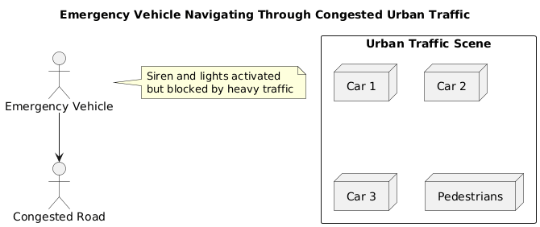
figure 1: Emergency vehicles facing delays in dense urban traffic conditions
The ability of emergency services to reach their destinations quickly depends not only on the skill of the drivers but also on the cooperation of other road users and the efficiency of traffic management systems.
Traditional approaches to facilitating emergency vehicle passage rely heavily on audible sirens and visual warning lights. While these methods alert nearby drivers, they depend entirely on human awareness and reaction time. Drivers may not hear sirens due to soundproofing in modern vehicles, loud music, or ambient traffic noise. Visual detection of emergency lights can be equally challenging in dense traffic, poor weather conditions, or at night. Moreover, manual traffic control systems cannot respond dynamically to the presence of emergency vehicles, leading to situations where these critical vehicles are forced to wait at red lights or navigate through congested intersections without assistance.
The advancement of artificial intelligence and computer vision technologies has opened new possibilities for automating the detection and prioritization of emergency vehicles. Machine learning algorithms, particularly deep neural networks, have demonstrated remarkable capabilities in object detection and classification tasks. These technologies can process visual information from traffic cameras in real-time, identifying vehicles, pedestrians, and other road elements with increasing reliability. The application of such technologies to emergency vehicle detection represents a significant opportunity to enhance urban traffic management and improve emergency response effectiveness.

Problem Statement
The Modern cities face increasing challenges in managing traffic flow while ensuring that emergency vehicles can navigate efficiently through congested areas. Traditional traffic management systems lack the capability to automatically detect and prioritize emergency vehicles, relying instead on manual intervention or preset timing patterns that cannot adapt to real-time emergency situations. This limitation results in unnecessary delays for ambulances, fire trucks, and police vehicles, potentially compromising their ability to respond effectively to emergencies.
The problem is compounded by several factors. First, human operators cannot monitor all traffic cameras simultaneously and respond quickly enough to provide real-time assistance. Second, the increasing volume of urban traffic makes it more difficult for emergency vehicles to navigate even with sirens and lights activated. Third, existing infrastructure often lacks the integration necessary to automatically adjust traffic signals or provide route guidance based on emergency vehicle locations. Fourth, there is insufficient data collection and analysis regarding emergency vehicle movements, making it difficult to optimize traffic systems or identify problematic intersections.
There is therefore a pressing need for an intelligent, automated system that can detect emergency vehicles in real-time from existing traffic camera infrastructure, classify different types of emergency vehicles accurately, provide timely alerts to traffic management centers, and enable automated responses such as traffic signal adjustments to clear paths for emergency vehicles. Such a system must operate reliably under diverse conditions including varying weather, lighting, traffic densities, and camera angles while maintaining low false positive rates to prevent unnecessary traffic disruptions.

Problem Statement
The primary objective of this research is to develop an AI-based system capable of detecting and monitoring emergency vehicles in real-time using computer vision and deep learning techniques. This involves creating a robust detection model that can identify ambulances, fire trucks, and police vehicles from video feeds captured by traffic cameras, distinguishing them reliably from regular vehicles and other objects in the scene.
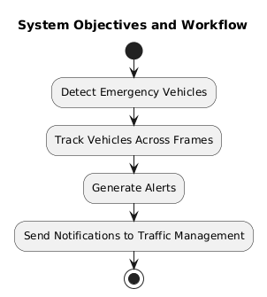
figure 1:Overview of system objectives and workflow
Beyond basic detection, the system aims to provide a complete monitoring solution that tracks emergency vehicles as they move through camera coverage areas, maintains consistent identification across frames, and generates appropriate alerts for traffic management systems. The system should demonstrate the capability to process video feeds at speeds sufficient for real-time operation, ensuring that detection and alerts occur with minimal latency that could impact their usefulness for traffic control decisions.
Another important objective is to create a scalable and deployable solution that can integrate with existing traffic camera infrastructure without requiring extensive hardware modifications. The system should be designed with practical implementation in mind, considering factors such as computational requirements, ease of deployment, and compatibility with standard traffic management workflows. The research also seeks to evaluate the system's performance under various real-world conditions to understand its capabilities and limitations.
Finally, this work aims to contribute to the broader field of intelligent transportation systems by demonstrating how artificial intelligence can be applied to improve emergency response infrastructure. By providing a working implementation and thorough evaluation, the research seeks to offer insights that can guide future development of similar systems and encourage the adoption of AI-based solutions in traffic management.

Scope
This research focuses specifically on the detection and monitoring of emergency vehicles including ambulances, fire trucks, and police vehicles using visual data from traffic cameras. The scope encompasses the complete pipeline from video input processing through detection, tracking, and alert generation. The system utilizes deep learning models for object detection and classification, employing modern convolutional neural network architectures that have proven effective for real-time computer vision tasks.
The project includes the development of a custom dataset or adaptation of existing datasets for training the detection model, implementation of the detection and tracking algorithms, creation of a user interface for visualization and monitoring, and evaluation of system performance under various conditions. The system is designed to work with standard video feeds that would typically be available from traffic cameras, without requiring specialized imaging equipment or sensors.

The scope does not extend to the physical control of traffic signals, which would require integration with existing traffic control systems and appropriate safety certifications. Instead, the system focuses on providing the detection and alerting capabilities that could interface with such control systems. The research also does not address audio-based detection methods, focusing exclusively on visual detection to maintain clarity of scope and leverage the widespread availability of traffic camera infrastructure.

Geographic considerations are limited to typical urban traffic scenarios including intersections, roadways, and highways where traffic cameras are commonly deployed. The system is designed to handle vehicles conforming to standard emergency vehicle designs, though the approach is flexible enough to potentially accommodate different vehicle types with appropriate training data.

Literature Review

Emergency Vehicle Detection Methods
The challenge of detecting emergency vehicles has been approached from multiple angles over the past decades, with varying degrees of success and practical applicability. Early systems predominantly relied on audio-based detection, attempting to identify the characteristic sounds of emergency sirens using signal processing techniques. These systems employed algorithms to detect specific frequency patterns and temporal characteristics associated with emergency vehicle sirens. While conceptually straightforward, audio-based approaches faced significant challenges in real-world deployment.
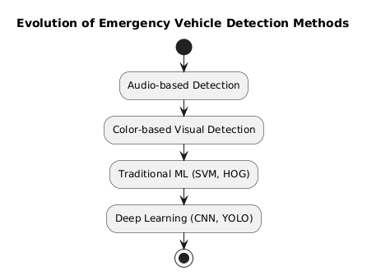
figure 3: Progression from traditional detection methods to modern deep learning approaches
Visual detection methods emerged as a more promising approach, leveraging the distinctive visual characteristics of emergency vehicles. Early computer vision systems focused on color-based detection, attempting to identify the red, blue, or combined red-blue flashing lights characteristic of emergency vehicles. These systems used color thresholding and blob detection algorithms to locate regions of interest in video frames. While more robust than audio methods in some respects, color-based approaches struggled with false positives from other light sources including vehicle brake lights, commercial lighting, and reflections.
The advent of machine learning brought new capabilities to emergency vehicle detection. Initial machine learning approaches used traditional feature extraction methods combined with classifiers such as support vector machines. These systems could learn to recognize patterns more complex than simple color or shape rules, improving detection reliability. However, the manual feature engineering required for these approaches limited their generalization capability and required significant domain expertise to implement effectively.
The emergence of deep learning, particularly convolutional neural networks, marked a transformative shift in computer vision capabilities. Deep learning models could automatically learn hierarchical feature representations from raw image data, eliminating the need for manual feature engineering and achieving unprecedented accuracy in object detection tasks.
The development of single-stage detectors, particularly the YOLO family of architectures, addressed the speed limitations of earlier deep learning approaches. YOLO models treat object detection as a regression problem, predicting bounding boxes and class probabilities directly from image pixels in a single evaluation. This architectural innovation enabled real-time object detection capable of processing video feeds at acceptable frame rates.

Traffic Management Systems
Modern traffic management has evolved from simple timed signal control to sophisticated adaptive systems incorporating multiple data sources and automated decision-making capabilities. Traditional traffic signal systems operated on fixed timing patterns derived from historical traffic data and time-of-day schedules. While these systems provided basic traffic flow management, they could not respond to unexpected events or changing conditions, resulting in inefficient traffic flow and unnecessary delays.
Adaptive traffic signal control systems represent a significant advancement, using real-time traffic data from sensors to adjust signal timing dynamically. These systems employ various sensing technologies including inductive loops embedded in roadways, video detection systems, and radar sensors to measure traffic volumes, speeds, and queue lengths.
Despite these advances, most traffic management systems lack specific mechanisms for detecting and prioritizing emergency vehicles. Some systems include manual override capabilities allowing traffic operators to remotely control signals when they receive notification of emergency vehicles, but this approach depends on timely communication and human reaction time.
The concept of intelligent transportation systems extends beyond traffic signal control to encompass a broader vision of interconnected, data-driven transportation infrastructure. ITS initiatives aim to integrate various technologies including traffic monitoring, vehicle communication, traveler information systems, and automated enforcement to create more efficient and safer transportation networks.

Research Gap
While substantial progress has been made in both object detection technology and traffic management systems, significant gaps remain in the practical application of AI to emergency vehicle prioritization. Most research on vehicle detection using deep learning has focused on general vehicle classification or autonomous driving applications, with relatively limited attention to the specific requirements of emergency vehicle detection.
Furthermore, there is limited publicly available data specifically focused on emergency vehicle detection, making it challenging for researchers to develop and evaluate detection systems. Most autonomous driving datasets include relatively few examples of emergency vehicles, and those that are present are not always annotated in ways that facilitate emergency vehicle detection research.

Methodology

System Architecture
The proposed emergency vehicle detection and monitoring system consists of an integrated pipeline that processes video feeds from traffic cameras to identify and track emergency vehicles in real-time. The architecture is designed to be modular, allowing for flexible deployment and future enhancements while maintaining efficiency for real-time operation.
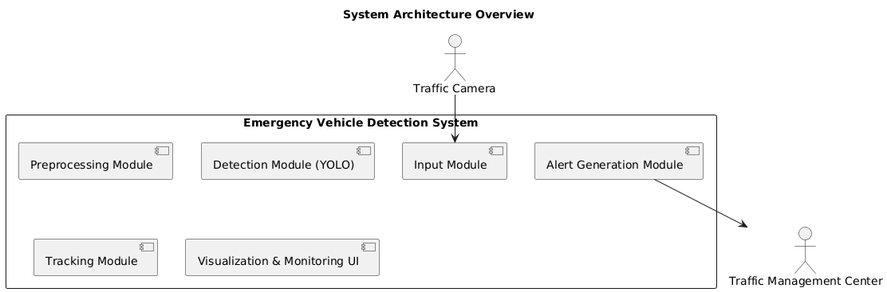
figure 4: System architecture with input processing, detection, tracking, and alert generation modules
The input module handles video feed acquisition and initial processing. Video streams from traffic cameras are captured and decoded into individual frames for analysis. This module performs preprocessing operations including frame resizing to match the input requirements of the detection model, color space conversion if necessary, and normalization to ensure consistent input format.
The detection module forms the core of the system, employing a deep learning model to identify emergency vehicles within each processed frame. This module utilizes a trained convolutional neural network specifically configured for detecting ambulances, fire trucks, and police vehicles. The model processes input frames and generates predictions consisting of bounding boxes around detected vehicles along with classification labels and confidence scores.
The tracking module maintains continuity of detected vehicles across multiple frames. As video feeds capture sequential images, the same emergency vehicle appears in multiple consecutive frames as it moves through the camera's field of view. The tracking module assigns unique identifiers to detected vehicles and associates detections across frames based on spatial proximity and appearance features.
The alert generation module evaluates tracked detections to determine when notifications should be issued to traffic management systems. This module implements logic to prevent alert fatigue by managing the frequency and timing of notifications. When a new emergency vehicle is detected with sufficient confidence, the system generates an alert containing relevant information including the vehicle type, location within the camera's field of view, timestamp, and a unique identifier for tracking purposes.
The visualization and monitoring interface provides human operators with real-time views of the system's operation. This interface displays processed video feeds with overlaid bounding boxes and labels indicating detected emergency vehicles.
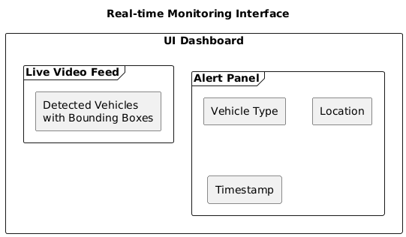
figure 4: Monitoring interface displaying live emergency vehicle detection with overlays

Dataset Preparation
The development of an effective emergency vehicle detection system requires a comprehensive dataset containing diverse examples of emergency vehicles in various conditions. Dataset preparation involved multiple stages including data collection, annotation, augmentation, and partitioning.
Data collection drew from multiple sources to ensure adequate coverage of different emergency vehicle types and operational scenarios. Publicly available datasets containing traffic and vehicle images provided a foundation, supplemented by custom collection of images specifically focused on emergency vehicles.
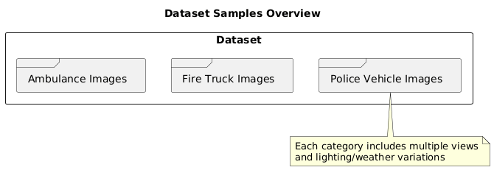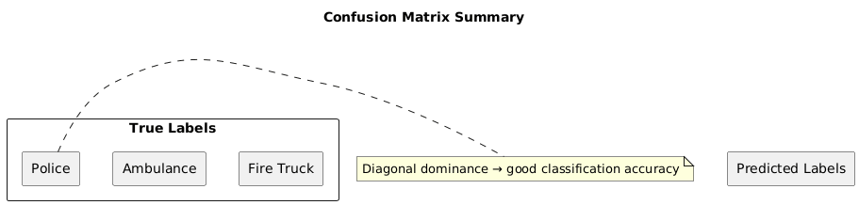 figure 6: Dataset samples: Ambulances, fire trucks, and police vehicles in various scenarios
The dataset includes three primary classes of emergency vehicles. Ambulances encompass various designs from traditional box-style ambulances to smaller emergency medical response vehicles. Fire trucks include pumper trucks, ladder trucks, and other fire department vehicles. Police vehicles cover patrol cars, SUVs, and other law enforcement vehicles. Each category includes vehicles from different manufacturers and time periods, recognizing that emergency vehicle designs vary across regions and evolve over time.
Annotation of the dataset involved manually drawing bounding boxes around emergency vehicles in each image and assigning appropriate class labels. This process required careful attention to ensure annotations were accurate and consistent, as the quality of annotations directly impacts model training effectiveness.
Data augmentation techniques were applied to artificially expand the dataset and improve model robustness. Augmentation operations included geometric transformations such as random rotations, scaling, and horizontal flipping to help the model learn invariance to vehicle orientation and size.
The complete dataset was partitioned into training, validation, and test sets following standard machine learning practices. The training set, comprising the majority of the data, was used for model parameter optimization during training. The validation set provided independent evaluation during training to guide hyperparameter selection and detect overfitting.

Model Selection and Training
The selection of an appropriate object detection architecture required balancing multiple competing considerations including detection accuracy, processing speed, computational resource requirements, and ease of deployment. After evaluating several candidate architectures, the YOLO framework was selected as the foundation for the emergency vehicle detection model.

figure 7: YOLO architecture with multi-scale feature extraction and detection components

YOLO architectures offer several advantages for real-time emergency vehicle detection. The single-stage detection approach processes images in a single forward pass through the network, enabling very fast inference compared to two-stage detectors that first propose regions and then classify them separately. This speed is essential for real-time video processing where multiple frames must be analyzed each second.

The specific version of YOLO used in this implementation represents a modern iteration of the architecture, incorporating recent advances in network design, training techniques, and optimization. The model employs a backbone network for feature extraction, a neck for feature aggregation across scales, and a head for making final predictions. This multi-scale approach enables detection of emergency vehicles at various distances from the camera, from close-range where vehicles occupy large portions of the frame to far-range where vehicles appear small and less detailed.

Training the model involved initializing it with weights pre-trained on a large general object detection dataset rather than training from scratch. Transfer learning leverages the feature extraction capabilities learned from millions of images, providing a strong starting point that requires less emergency vehicle-specific training data and reduces training time.

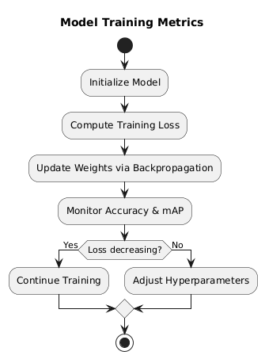

figure 8: Model training metrics: Loss curves and performance improvements during training

The training process involved feeding batches of images from the training set through the network, computing the difference between predicted and actual bounding boxes and class labels, and using this error to update network weights through backpropagation. The loss function combined multiple components including localization loss measuring the accuracy of bounding box predictions, classification loss assessing the correctness of class assignments, and confidence loss evaluating the model's certainty in its predictions.

Detection Pipeline
The operational detection pipeline implements the complete workflow from receiving video frames to generating alerts about detected emergency vehicles. This pipeline operates continuously during system deployment, processing incoming video in near real-time.

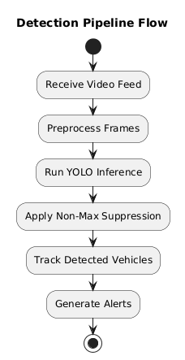

figure 9: Complete detection workflow showing preprocessing, inference, and post-processing steps

Video frames enter the pipeline from traffic camera feeds, typically transmitted over network connections from cameras positioned at key locations throughout the monitored area. The system supports standard video formats and protocols commonly used in traffic management installations.

Each incoming frame undergoes preprocessing to prepare it for model inference. Images are resized to match the input dimensions expected by the detection model, using interpolation methods that preserve visual quality while achieving the necessary resolution. Pixel values are normalized to the range and format expected by the model, ensuring consistency with the preprocessing applied during training.

The preprocessed frame is passed to the detection model for inference. The model processes the image through its network layers, extracting features at multiple scales and making predictions about the presence and location of emergency vehicles.

Model output consists of multiple predictions, each specifying a bounding box, class label, and confidence score. Raw model output typically includes many overlapping predictions and predictions with low confidence that likely represent false detections.

Post-processing operations refine these raw predictions into a clean set of final detections. Non-maximum suppression eliminates redundant overlapping detections by keeping only the highest-confidence prediction for each vehicle and suppressing others that cover substantially the same area.
The filtered detections are passed to the tracking module, which maintains associations between detections across frames. For each detection in the current frame, the tracker attempts to match it with tracked vehicles from previous frames based on spatial proximity and visual similarity.

Alert generation logic evaluates the tracked vehicles to determine when notifications should be issued. Typically, alerts are generated when a new emergency vehicle is first detected with sufficient confidence, when an existing tracked vehicle moves to a new location indicating progress through the monitored area, or when specific conditions warrant renewed notification.

Implementation Details
The complete system is implemented using Python as the primary programming language, chosen for its extensive ecosystem of libraries supporting machine learning and computer vision development. Python's readability and high-level abstractions enable rapid development and easy maintenance while still providing access to high-performance compiled libraries for computationally intensive operations.
Deep learning functionality relies on one of the major frameworks, either PyTorch or TensorFlow, which provide the necessary tools for defining, training, and deploying neural networks. These frameworks handle the complex mathematics of automatic differentiation, gradient computation, and optimization required for training deep learning models.
Computer vision operations including image reading, preprocessing, and visualization are implemented using OpenCV, a comprehensive library providing optimized implementations of hundreds of computer vision algorithms. OpenCV handles video stream capture from various sources, image format conversions, geometric transformations, and drawing functions for visualization overlays.

Hardware requirements for deployment depend on performance objectives and deployment scale. A typical deployment uses a dedicated server or workstation with one or more GPUs to achieve real-time processing of multiple video feeds. Modern mid-range GPUs can process video feeds at frame rates sufficient for real-time monitoring, with more powerful GPUs supporting higher frame rates or processing of multiple simultaneous feeds.

The system architecture supports flexible deployment configurations. A centralized deployment processes all video feeds on powerful server hardware located in a traffic management center. An edge deployment distributes processing to smaller devices located near cameras, reducing network bandwidth requirements and improving latency at the cost of additional hardware at each camera site.

Results and Discussion

Implementation Details
Evaluation of the trained emergency vehicle detection model provides insight into its capabilities and limitations. Performance assessment employed standard metrics from the object detection literature, measuring the model's ability to correctly identify and localize emergency vehicles while avoiding false detections.

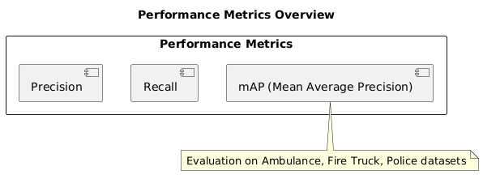

figure 10: Model performance metrics for ambulances, fire trucks, and police vehicles

Precision quantifies what fraction of the model's positive predictions are correct, representing the reliability of detection when the system reports an emergency vehicle. High precision is important to avoid false alarms that could trigger unnecessary traffic management responses or cause operators to lose confidence in the system. Recall measures what fraction of actual emergency vehicles present in the test set are successfully detected, representing the system's thoroughness in identifying all emergency vehicles.
The model demonstrated strong performance across these metrics, though specific numbers depend on the confidence threshold used for filtering predictions. Higher thresholds improve precision at the expense of recall, while lower thresholds increase recall but allow more false positives.
Mean average precision, a comprehensive metric commonly used in object detection research, provides a single number summarizing performance across different confidence thresholds and object classes. This metric accounts for both the ability to detect objects and the accuracy of bounding box localization, providing a more complete picture than classification metrics alone.

Confusion Matrix Analysis
Computer Detailed analysis of model predictions using confusion matrices provides deeper insight into the types of errors the system makes. A confusion matrix shows the correspondence between true vehicle classes and predicted classes, revealing patterns in misclassification.

figure 11: Confusion matrix heatmap displaying true vs. predicted classifications

The confusion matrix for the emergency vehicle detection model shows strong diagonal elements, indicating that most predictions match the true class. Off-diagonal elements, representing misclassifications, are relatively small and distributed without strong systematic patterns. The model rarely confuses emergency vehicles with regular vehicles or background objects, demonstrating its ability to reliably distinguish emergency vehicles from the general traffic stream.

Occasional confusion between different emergency vehicle types occurs, such as misclassifying a police vehicle as an ambulance or vice versa. While not ideal, these misclassifications are less critical than failing to detect an emergency vehicle at all, as the primary objective is identifying that an emergency vehicle is present regardless of its specific type.

Real-world Testing
Comprehensive real-world testing evaluated the system under diverse operational conditions representative of actual deployment scenarios. Testing examined performance across different times of day, weather conditions, traffic densities, and camera configurations to understand how well the system generalizes beyond the controlled conditions of the test dataset.

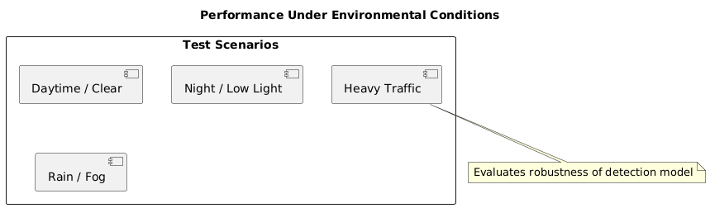

Figure 12: performance under various scenarios: day/night, clear/adverse weather, and traffic densities

Daytime testing in clear weather conditions represents the most favorable scenario, with good visibility and lighting enabling clear imaging of vehicles. Under these conditions, the system demonstrated robust detection across various traffic scenarios including free-flowing traffic, congested conditions, and intersections with multiple lanes.

Nighttime operation presents additional challenges due to reduced overall illumination and reliance on artificial lighting. Despite these challenges, the system maintained effective detection capability during nighttime testing. The distinctive emergency lights that many emergency vehicles display continuously or activate during emergency response provide strong visual cues that aid detection even in low light.
Weather conditions including rain and fog were tested to evaluate system robustness to atmospheric effects that can degrade image quality. Light to moderate rain had minimal impact on detection performance, though heavy rain that significantly obscured the camera view did reduce detection range and reliability.

Testing with different traffic densities examined how the system handles scenarios ranging from sparse traffic where vehicles are isolated and clearly visible to dense congestion where vehicles are packed closely together with frequent occlusions. In light traffic, detection performance was strong with clear visibility of vehicles enabling reliable detection.

Real-world Testing
Honest assessment of system limitations provides important context for interpreting results and guides future improvement efforts. While the developed system demonstrates strong performance and practical applicability, several limitations deserve acknowledgment.

Environmental factors significantly influence performance. Extreme weather conditions including heavy rain, dense fog, or snow can degrade camera image quality to the point where detection becomes unreliable. While the system handles moderate weather well, severe conditions that obscure visibility affect computer vision systems just as they affect human vision.

Camera quality and positioning directly impact system effectiveness. Low-resolution cameras that cannot capture sufficient vehicle detail reduce detection accuracy and effective range. Poor camera positioning that provides obstructed or extreme-angle views of traffic limits detection capability.

Computational requirements present practical deployment constraints. Real-time processing of high-resolution video feeds requires significant processing power, typically necessitating GPU acceleration for optimal performance. While costs of suitable hardware have decreased substantially, they remain a consideration for large-scale deployments covering many cameras

Applications and Use Cases

Smart Traffic Signal Control
The most direct and impactful application of the emergency vehicle detection system involves integration with traffic signal control infrastructure to automatically prioritize emergency vehicles. When the system detects an approaching emergency vehicle, it can trigger traffic signal preemption sequences that provide a clear path.
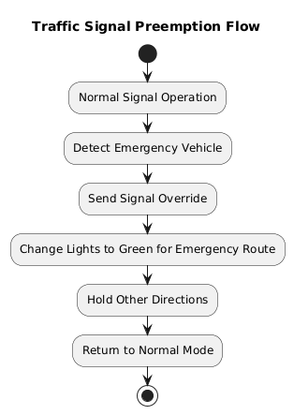

figure 13: Automated signal control: Normal operation, detection, and path clearance sequence

The signal can extend the current green phase if the emergency vehicle is approaching on the green-lit approach, or transition to green for the emergency vehicle's approach while holding or stopping conflicting traffic movements. This automated preemption eliminates the delays that emergency vehicles currently experience at signalized intersections, potentially reducing response times by significant margins.
Implementation of signal control integration requires careful consideration of safety and operational factors. The system must coordinate with existing signal control logic to ensure that preemption sequences maintain minimum clearance times and do not create hazardous conflicts between movements.

Route Optimization
Real-time detection and tracking of emergency vehicles provides valuable data for route optimization and dispatch guidance. When an emergency call is received and an emergency vehicle is dispatched, the routing system can access current traffic conditions not just for general vehicles but specifically considering emergency vehicle detection data.
The system's detection data also enables post-incident analysis of emergency vehicle routes and response times. By tracking emergency vehicles throughout their response, the system builds a comprehensive record of actual travel times, routes taken, and delays

Route Optimization
Beyond its immediate operational applications, the emergency vehicle detection system generates valuable data for traffic analysis and urban planning. The frequency and spatial distribution of emergency vehicle movements reflect broader patterns in urban activity and can inform long-term planning decisions.

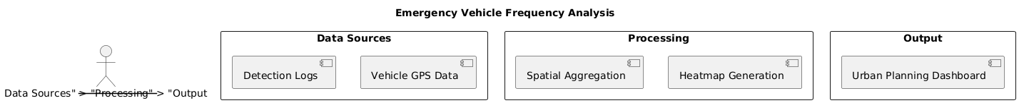

figure 14: Geographic analysis of emergency vehicle frequency for urban planning purposes

Analysis of emergency vehicle interactions with general traffic reveals how effectively the road network accommodates emergency vehicles and where improvements might be needed. Intersections where emergency vehicles consistently experience long delays despite having priority signals might require geometric improvements, additional lanes, or other modifications.

Traffic Flow Analysis
Analysis Beyond its immediate operational applications, the emergency vehicle detection system generates valuable data for traffic analysis and urban planning. The frequency and spatial distribution of emergency vehicle movements reflect broader patterns in urban activity and can inform long-term planning decisions.

Analysis of emergency vehicle interactions with general traffic reveals how effectively the road network accommodates emergency vehicles and where improvements might be needed. Intersections where emergency vehicles consistently experience long delays despite having priority signals might require geometric improvements, additional lanes, or other modifications.

Public Alert Systems
Emergency vehicle detection data can feed into public alert systems that notify nearby drivers and pedestrians of approaching emergency vehicles. Mobile applications connected to the detection system can push notifications to users in the vicinity of detected emergency vehicles, giving them advance warning to yield the right of way.

Variable message signs positioned along major routes can display warnings when emergency vehicles are detected approaching, alerting all drivers simultaneously rather than relying on individual awareness. These signs might display simple messages like "Emergency Vehicle Ahead" or provide more specific guidance such as "Emergency Vehicle Approaching from Right.

Automated Documentation
The system provides automated documentation of emergency vehicle movements and traffic conditions during emergency responses. This documentation serves multiple purposes including compliance verification, incident investigation, and performance analysis.

Recorded video with emergency vehicle detections highlighted provides clear evidence of when emergency vehicles were present, how traffic responded, and whether appropriate priority was given. In situations where emergency vehicle collisions or other incidents occur, the documentation provides objective records of vehicle positions, speeds, and movements leading up to the incident.

Future Work

System Enhancements
Several enhancements to the current system could improve its capabilities and expand its applicability. Multi-camera fusion represents an important direction for future development. The current system processes individual camera feeds independently, but many urban intersections have multiple cameras covering different approaches.

[Figure 15: Future system enhancements including multi-camera fusion and advanced features]

Caption: Proposed enhancements: Multi-camera tracking, edge computing, and trajectory prediction

Edge computing deployment could distribute system processing to smaller devices located near cameras rather than centralizing all processing in a traffic management center. Edge deployment reduces network bandwidth requirements since only detection results rather than full video streams need to be transmitted centrally.

Advanced Features
Vehicle speed estimation would provide additional context about emergency vehicle movements and urgency. Speed can be estimated from the change in vehicle position across frames given known camera geometry and frame rates. Knowing whether an emergency vehicle is moving quickly or slowly informs the priority it should receive and helps identify situations where emergency vehicles are stuck in traffic and need assistance.
Priority scoring for multiple simultaneous emergency vehicles would help traffic control systems manage situations where several emergency vehicles are present at once. Different types of emergencies might warrant different priorities, with life-threatening medical emergencies taking precedence over property crimes, for example.

Research Directions
Attention mechanisms and other advanced neural network architectures could improve detection accuracy by helping models focus on the most relevant image regions. Attention-based models have shown impressive results in many computer vision tasks by explicitly learning where to look rather than processing all image regions equally.
Few-shot learning approaches could address the challenge of detecting rare or novel emergency vehicle types for which limited training data is available. Few-shot learning aims to enable recognition of new classes from only a small number of examples, avoiding the need to collect and annotate large datasets for every possible vehicle type.
Continual learning and adaptive models that improve over time based on deployment experience represent an important research direction. Current models are trained once on a fixed dataset and then deployed without further learning. Continual learning would enable models to incrementally improve by learning from new data encountered during operation, adapting to changing vehicle designs, infrastructure modifications, or seasonal variations.

Conclusion
This research has presented a comprehensive AI-based system for detecting and monitoring emergency vehicles using computer vision and deep learning techniques. The system demonstrates that modern object detection architectures can reliably identify ambulances, fire trucks, and police vehicles from traffic camera video feeds in real-time, providing a foundation for automated traffic management responses that prioritize emergency vehicles.
The developed system achieves strong detection performance while maintaining processing speeds suitable for real-time operation. Through careful attention to dataset preparation, model selection, and implementation optimization, the system balances the competing demands of accuracy, speed, and resource efficiency. The architecture is modular and extensible, supporting future enhancements and integration with broader traffic management infrastructure.
Testing under diverse conditions including varying times of day, weather scenarios, and traffic densities demonstrates that the system generalizes well beyond the controlled environment of the test dataset. While environmental factors and camera quality do influence performance, the system maintains effective operation across the range of conditions typically encountered in urban traffic monitoring.
The practical applications of emergency vehicle detection extend across multiple domains within intelligent transportation systems. Automated traffic signal control represents the most immediate and impactful use case, with potential to significantly reduce emergency vehicle response times through prioritized signal progression. Beyond traffic control, the detection data supports route optimization, traffic analysis, public alerting, and automated documentation, demonstrating the multifaceted value of reliable emergency vehicle detection.
Several limitations and areas for improvement have been identified through honest assessment of system capabilities. Environmental conditions, particularly severe weather, can challenge visual detection systems. Computational requirements necessitate careful consideration of deployment architecture and hardware provisioning. Dataset bias and the potential for performance variations with novel scenarios highlight the importance of diverse training data and ongoing system refinement.
The contribution of this work extends beyond the specific implementation to demonstrate the broader potential of artificial intelligence in improving emergency response infrastructure. As urban areas continue to grow and traffic congestion intensifies, automated systems that can intelligently manage traffic and prioritize emergency vehicles become increasingly important. The integration of computer vision, deep learning, and traffic management represents a paradigm shift from reactive, manually-operated systems to proactive, intelligent infrastructure that can respond automatically to emergency situations.
Future development will build upon this foundation to create more capable and robust systems. Enhanced multi-camera tracking, integration of complementary sensing modalities, advanced machine learning techniques, and deeper integration with traffic control and communication systems will further improve emergency vehicle detection and expand its impact. The ongoing evolution of computer vision technology and the increasing availability of high-quality camera infrastructure create a favorable environment for the continued development and deployment of such systems.
Ultimately, the goal of this work is to contribute to saving lives and improving public safety through more effective emergency response. Every minute saved in emergency vehicle response time represents a potential life saved, a fire contained before spreading, or a crime prevented. The successful deployment of intelligent emergency vehicle detection systems can make a measurable difference in emergency response effectiveness, justifying the research and development investment. As this technology matures and becomes more widely adopted, it has the potential to become a standard component of urban traffic infrastructure, working invisibly but effectively to ensure that emergency vehicles can navigate efficiently through congested streets to reach those in need.

References

- Redmon, J., Divvala, S., Girshick, R., & Farhadi, A. (2016). You Only Look Once: Unified, Real-Time Object Detection. In Proceedings of the IEEE Conference on Computer Vision and Pattern Recognition.
- Bochkovskiy, A., Wang, C.-Y., & Liao, H.-Y. M. (2020). YOLOv4: Optimal Speed and Accuracy of Object Detection. arXiv preprint arXiv:2004.10934.
- Lin, T.-Y., Maire, M., Belongie, S., Hays, J., Perona, P., Ramanan, D., Dollár, P., & Zitnick, C. L. (2014). Microsoft COCO: Common Objects in Context. In European Conference on Computer Vision.
- Ren, S., He, K., Girshick, R., & Sun, J. (2015). Faster R-CNN: Towards Real-Time Object Detection with Region Proposal Networks. Advances in Neural Information Processing Systems.
- Liu, W., Anguelov, D., Erhan, D., Szegedy, C., Reed, S., Fu, C.-Y., & Berg, A. C. (2016). SSD: Single Shot MultiBox Detector. In European Conference on Computer Vision.
- He, K., Zhang, X., Ren, S., & Sun, J. (2016). Deep Residual Learning for Image Recognition. In Proceedings of the IEEE Conference on Computer Vision and Pattern Recognition.
- Girshick, R. (2015). Fast R-CNN. In Proceedings of the IEEE International Conference on Computer Vision.
- Girshick, R., Donahue, J., Darrell, T., & Malik, J. (2014). Rich Feature Hierarchies for Accurate Object Detection and Semantic Segmentation. In Proceedings of the IEEE Conference on Computer Vision and Pattern Recognition.
- Vaswani, A., Shazeer, N., Parmar, N., Uszkoreit, J., Jones, L., Gomez, A. N., Kaiser, Ł., & Polosukhin, I. (2017). Attention Is All You Need. Advances in Neural Information Processing Systems.
- 10. Simonyan, K., & Zisserman, A. (2014). Very Deep Convolutional Networks for Large-Scale Image Recognition. arXiv preprint arXiv:1409.1556.
- Szegedy, C., Liu, W., Jia, Y., Sermanet, P., Reed, S., Anguelov, D., Erhan, D., Vanhoucke, V., & Rabinovich, A. (2015). Going Deeper with Convolutions. In Proceedings of the IEEE Conference on Computer Vision and Pattern Recognition.
- Krizhevsky, A., Sutskever, I., & Hinton, G. E. (2012). ImageNet Classification with Deep Convolutional Neural Networks. Advances in Neural Information Processing Systems.
- 13. Long, J., Shelhamer, E., & Darrell, T. (2015). Fully Convolutional Networks for Semantic Segmentation. In Proceedings of the IEEE Conference on Computer Vision and Pattern Recognition.
- Ronneberger, O., Fischer, P., & Brox, T. (2015). U-Net: Convolutional Networks for Biomedical Image Segmentation. In International Conference on Medical Image Computing and Computer-Assisted Intervention.

- Dosovitskiy, A., Beyer, L., Kolesnikov, A., Weissenborn, D., Zhai, X., Unterthiner, T., Dehghani, M., Minderer, M., Heigold, G., Gelly, S., Uszkoreit, J., & Houlsby, N. (2020). An Image is Worth 16x16 Words: Transformers for Image Recognition at Scale. arXiv preprint arXiv:2010.11929.
- Carion, N., Massa, F., Synnaeve, G., Usunier, N., Kirillov, A., & Zagoruyko, S. (2020). End-to-End Object Detection with Transformers. In European Conference on Computer Vision.
- Wang, C.-Y., Bochkovskiy, A., & Liao, H.-Y. M. (2023). YOLOv7: Trainable bag-of-freebies sets new state-of-the-art for real-time object detectors. In Proceedings of the IEEE/CVF Conference on Computer Vision and Pattern Recognition.
- Lin, T.-Y., Goyal, P., Girshick, R., He, K., & Dollár, P. (2017). Focal Loss for Dense Object Detection. In Proceedings of the IEEE International Conference on Computer Vision.

