

SRM INSTITUTE OF SCIENCE AND TECHNOLOGY
(Deemed to be University u/s of UGC Act,1956)
Tiruchirappalli-6210105.

FACULTY OF ENGINEERING AND TECHNOLOGY

School of Computing

21CSC203P
ADVANCED PROGRAMMING PRACTICE

PROJECT REPORT

Register No. : RA2411008050091

Name of the Student: NERUPAMA

Semester : THIRD

Programme : B.Tech INFORMATION TECHNOLOGY

Academic Year : 2025-2026

BONAFIDE CERTIFICATE

Certified as the bonafide record of work done by: NERUPAMA,

Register No. RA2411008050091,(Semester/Year):(THIRD/SECOND) B.Tech. INFORMATION TECHNOLOGY, Programme in the project- based course 21CSC203P - Advanced Programming Practice at SRM Institute of Science and Technology, Tiruchirappalli Campus during the Academic Year 2025-2026.

Submitted for the End Semester Examination held on

Faculty In-charge Head of the Department Examiner-1 Examiner

SRM INSTITUTE OF SCIENCE AND TECHNOLOGY
(Deemed to be University u/s 3 of UGC Act 1956)

School of Computing

UNIVERSITY VISION

To emerge as a world-class University in creating and disseminating knowledgeand providing students a unique learning experience in science, technology, medicine, management and other areas of scholarship that will best serve the world and betterment of mankind.

UNIVERSITY MISSION
TO MOVE UP through international alliances and collaborative initiatives to achieve global excellence.

TO ACCOMPLISH A PROCESS to advance knowledge in a rigorous academic and research environment.

TO ATTRACT AND BUILD PEOPLE in a rewarding and inspiring environment by fostering freedom, empowerment, creativity and innovation.

Department of Information Technology

VISION

To become a world class School in importing high quality education and in providing students a unique learning and research experience in the field of Computer Science and Engineering and its related fields.

MISSION
- To impart knowledge in cutting edge technologies on par with industrial

standards

- Tocollaboratewithrenownedacademicinstitutionsinresearchanddevelopment
- To instill societal and ethical responsibilities in all professional activities

PROGRAMME EDUCATIONAL OBJECTIVES (PEO)

PEO1: Graduates will be able to perform in technical/managerial roles ranging from design, development, problem solving to production support in software industries and R&D sectors.
PEO2: Graduates will be able to successfully pursue higher education in reputed institutions.

PEO3: Graduates will have the ability to adapt, contribute and innovate new technologies andsystems in the key domains of Computer Science and Engineering.
PEO4: Graduates will be ethically and socially responsible solution providers and entrepreneurs in Computer Science and other engineering disciplines.

PROGRAMME OUTCOMES (PO)

PO 1: Engineering knowledge: Apply the knowledge of mathematics, science, engineering fundamentals, and an engineering specialization for the solution of complex engineering problems.
PO 2: Problem analysis: Identify, formulate, research literature, and analyse complex engineering problems reaching substantiated conclusions using first principles of mathematics,natural sciences, and engineering sciences.
PO 3: Design/Development of Solutions: Design solutions for complex engineering problemsand design system components or processes that meet the specified needs with appropriate consideration for public health and safety, and cultural, societal, and environmental considerations.
PO 4: Conduct investigations of complex problems: Use research-based knowledge and research methods including design of experiments, analysis and interpretation of data, and synthesis of the information to provide valid conclusions.
PO 5: Modern tool usage: Create, select, and apply appropriate techniques, resources, and modern engineering and IT tools including prediction and modelling to complex engineering activities with an understanding of the limitations.
PO 6: The engineer and society: Apply reasoning informed by the contextual knowledge to assess societal, health, safety, legal, and cultural issues and the consequent responsibilities relevant to the professional engineering practice.
PO 7: Environment and sustainability: Understand the impact of the professional engineeringsolutions in societal and environmental contexts, and demonstrate the knowledge of, and the need for sustainable development.
PO 8: Ethics: Apply ethical principles and commit to professional ethics and responsibilities and norms of the engineering practice.

PO 9: Individual and team work: Function effectively as an individual, and as a member or leader in diverse teams, and in multidisciplinary settings.
PO 10: Communication: Communicate effectively on complex engineering activities with theengineering community and with the society at large, such as being able to comprehend and write effective reports and design documentation, make effective presentations, and give and receive clear instructions
PO 11: Project management and finance: Demonstrate knowledge and understanding of theengineering and management principles and apply these to one’s work, as a member and leader in a team, to manage projects and in multidisciplinary environments.
PO 12: Life-long learning: Recognise the need for, and have the preparation and ability to engage in independent and life-long learning in the broadest context of technological change.

Mapping Program Educational Objectives (PEO) to Program Learning Outcomes (PLO)

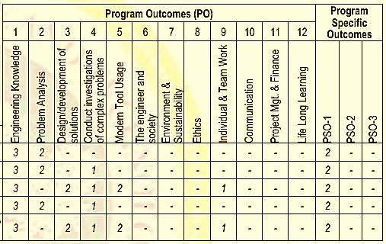

Course Outcomes (CO):
CO-1: Devise solutions to the various programming paradigm
CO-2: Express proficiency in the usage of structural, procedural, and Object-Oriented Program
CO-3: Determine the Java application using declarative, event, and graphical user interface paradigm
CO-4: Express proficiency in the usage of logic, functional, network, and concurrent Paradigm

CO-5: Determine the Python application using symbolic, automata-based, and graphical user interface programming paradigms
Instructional Objectives
- Understand the paradigm functionalities and their hierarchy.

- Knowledge on structural, procedural, and Object-Oriented Programming Paradigm.

- Proficiency in event, Graphical User Interface, and declarative Paradigm with a Java application.

- Extended knowledge on logic, functional, network, and concurrent Paradigm.

- Symbolic, Automata-based, and Event with a Python application.

ASSESMENT

Final Review (Report and Viva): 60 Marks

Project Implemetation (10)
Innovation & Presentation (5) Journal Publication(20)
/Communicated(10)/ Acceptance(15) Project Report (15) Viva(5)
l. No. | Criteria | Page No. | Max. Marks | Marks Obtained
PART 1: FORMATIVE ASSESSMENTS (20%)
1 | CLA – 01 |  | 10
2 | CLA – 02 |  | 10
PART 2: PROJECT BASED LEARNING (80%)
Review 0
3 | Project Selection, Problem Definition, UML Diagrams |  | 5
Review 1
4 | Use case 1: statement of your project use cases – type or wirte it |  | 5
5 | Use case 2: |  | 5
6 | Milestone 1: (Study of Existing System)  Milestone 2: (Proposal of Proposed System) |  | 5
Review 2
7 | Implementation of Use case 1: |  | 5
8 | Implementation of Use case 2: |  | 5
9 | Milestone 3: wirte or type of your project milestiones  Milestone 4:

UML Diagrams:

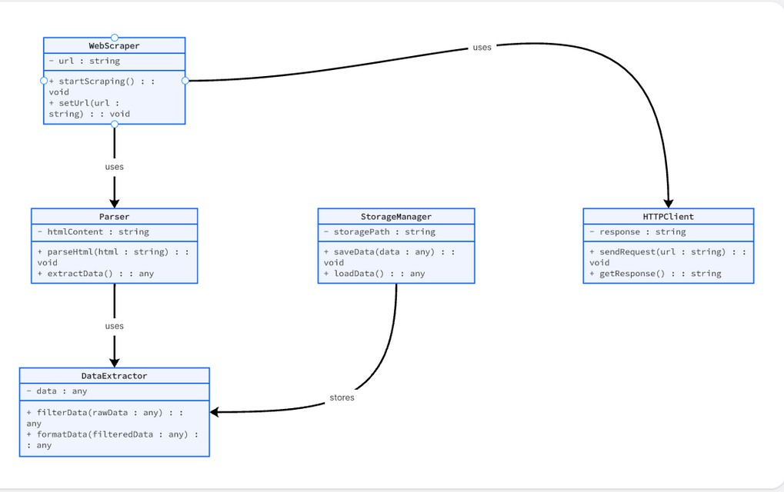

Sequence diagram:

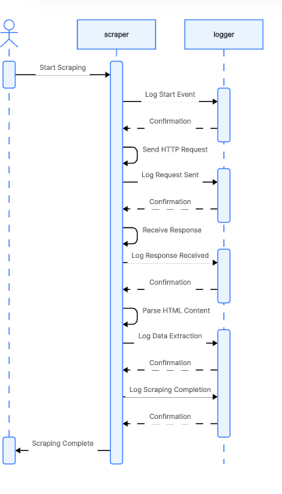

Architecture Diagram:

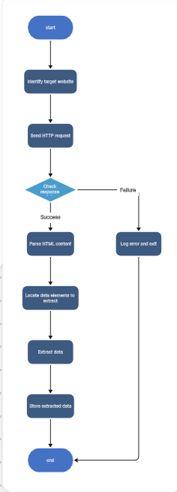

  - Use Case Diagram – Description

Preconditions:

    - The website to be scraped is accessible and allows data extraction (complies with its terms of service).

    - The system has internet connectivity.

    - The user has specified the target website URL and the type of data to be extracted.

    - Required libraries (e.g., JSoup, HttpClient, or Selenium) are installed and configured in the Java environment.
Postconditions:

    - The extracted data is successfully retrieved, parsed, and stored (in a database, CSV file, or JSON format).

    - The user can view or process the data for further use.

1. Milestone 1 & 2: description
Extracting Data from Website, also known as Web Scraping, is the process of automatically collecting or retrieving specific information from websites using a computer program. In a Java- based implementation, this is typically achieved through libraries such as JSoup, HtmlUnit, or Selenium Web Driver, which allow developers to connect to web pages, parse HTML content, and extract relevant data for analysis or storage.
The main objective of a web data extraction system is to automate the process of gathering structured data from unstructured web content. This data can then be stored in databases, spreadsheets, or other formats for further processing, visualization, or integration into other systems.

Milestone 3 & 4: Coding and Screen shoot
- Objectives:
- Identify the project’s purpose and scope.
- Define what type of data will be extracted (e.g., product info, news articles, prices).
- Select the target websites for data extraction.
- Research legal and ethical considerations of web scraping.

Deliverables:
- Project proposal document
- List of target websites
- Requirement specification report

import java.io.FileWriter;
import java.io.IOException;
import java.util.List; import org.jsoup.Jsoup;
import org.jsoup.nodes.Document; import org.jsoup.nodes.Element;

import org.jsoup.select.Elements;

public class Scraper {
public static void main(String[] args) { String url = "http://quotes.toscrape.com/"; try {
// Connect and fetch HTML
Document doc = Jsoup.connect(url).get();

// Select all quote elements
Elements quotes = doc.select(".quote"); StringBuilder html = new StringBuilder();

// Build HTML output
html.append("<!DOCTYPE html>\n<html>\n<head>\n"); html.append("<meta charset='UTF-8'>\n"); html.append("<title>Scraped Quotes</title>\n"); html.append("<style>\n");
html.append("body { font-family: Arial, sans-serif; background: #fafafa; padding: 20px; }\n");
html.append(".quote { background: #fff; border-left: 4px solid #4CAF50; padding: 10px; margin: 10px 0; }\n");
html.append(".author { color: #555; font-size: 0.9em; }\n"); html.append("</style>\n</head>\n<body>\n"); html.append("<h2>Quotes Scraped from Quotes.toscrape.com</h2>\n");

// Loop through and add quotes for (Element q : quotes) {
String text = q.select(".text").text();
String author = q.select(".author").text();
html.append("<div class='quote'><p>").append(text).append("</p>"); html.append("<p class='author'>— ").append(author).append("</p>
</div>\n");
}

html.append("</body>\n</html>");

// Save to HTML file
FileWriter writer = new FileWriter("output/result.html"); writer.write(html.toString());
writer.close();

System.out.println("✅ Scraping completed! Open 'output/result.html' to view the result.");

} catch (IOException e) { System.out.println("Error: " + e.getMessage());
}
}
}
output:
Quotes Scraped from Quotes.toscrape.com

“Life isn’t about getting and having, it’s about giving and being.”
- Kevin Kruse

“The purpose of our lives is to be happy.”
- Dalai Lama

Conclusion
The “Extracting Data from Website” project demonstrates how web data can be automatically collected, processed, and stored using Java technologies. By leveraging libraries such as JSoup, Selenium, or Http Client, the system efficiently retrieves structured information from unstructured web content. This automation reduces the need for manual data collection, saving both time and effort while improving accuracy and consistency.
The project highlights the importance of data extraction in today’s information-driven world, where organizations rely on real-time data for decision-making, analytics, and research. Through this implementation, users gain practical experience in web scraping, parsing HTML, handling HTTP requests, and managing data storage in various formats.
Overall, the system provides a reliable foundation for future enhancements, such as integrating machine learning for data analysis, handling dynamic websites more effectively, and scheduling automated scraping tasks. It serves as a valuable example of applying Java programming concepts to solve real-world data collection problems efficiently and ethically.

