Human-AI Collaboration in Crowdsourcing: Enhancing Social Computing with Machine Learning

Saloni Bansal
Department of Electronics & Communications Engineering
GLA University, Mathura
saloni.bansal@gla.ac.in
Narendra Mohan
Department of Computer Engineering & Applications
GLA University, Mathura
narendra.mohan@gla.ac.in

Abstract— Crowdsourcing has transformed conventional methods of problem-solving by gathering human intelligence on a significant scale, although the value of the method is often decreased, based on bias, inconsistency, and scalability. In this paper, we will present a conceptual and technical overview of how Artificial Intelligence (AI) and Machine Learning (ML) can help improve human-AI collaboration on crowdsourcing platforms and improve social computing. In AI's role as a complement to human response in crowdsourcing, by using unified ML algorithms to give out tasks and make decisions about quality, we expect AI will help produce more consistent, fluid, and scalable crowdsourced solutions. Some of the hybrid models of AI and human reasoning discussed in this paper include the following: AI that promotes optimal workflow, eliminates redundancy, and generally helps to improve the solidity of group decision-making. Ethical considerations discussed in this paper include removing bias, transparency, and building trust to name a few, to ensure AI usage in social computing systems will be more just and accountable. The results show that an adaptive AI infrastructure can significantly influence the efficiency and quality of the crowdsourced activities and leads to stronger and more sustainable social computing applications. The paper proposes an agenda for future research on human-AI collaboration, in the area of explanation and safety at the centred focus of AI-driven crowdsourcing contexts.
Keywords— AI Collaboration, Crowdsourcing, Social Computing, Machine Learning, Task Optimization, Bias Mitigation, Trustworthy AI.

Introduction
Crowdsourcing has emerged as the new frontier of current digital ecosystems it addresses a mass issue that explicitly opportunizes human intelligence distributed on the internet. Crowdsourcing is impactful in this space and has proven significant in various fields: business, medicine, government, and science, among others, particularly in consideration of machine learning algorithms that can label massive collections of data, and in some cases, human activities that were seen to be computationally intensive undertakings [1]. However, traditional crowdsourcing is littered with innate negative elements such as low scalability, quality assurance, duplication of duties, and human biases in the decision-making process, as examples. The recent advances in Artificial Intelligence (AI) and Machine Learning (ML) in general provides for consideration of Human-AI interaction where AI can complement human engagement by maximizing the distribution of tasks and quality of output, and can even improve the efficiency and effectiveness of a crowdsourced system overall.
A. Human-AI Collaboration in Crowdsourcing
Human-AI collaboration in crowdsourcing refers to the cooperation between humans and AI models to maximize decision-making, task execution, and resource utilization in large-scale, distributed problem-solving environments. Human input can be supplemented by AI through learning historical response behavior, filtering noise, and repetitive tasks automation, thereby making social computing systems scalable and resilient [2]. Other research has examined integrating AI into crowdsourcing workflows. [3] proposed a hybrid human-AI solution to dynamically adapt task difficulty and optimize performance in crowdsourced microtasks. Similarly,[4] demonstrated that reinforcement learning can improve task routing in large-scale crowdsourcing systems. Another work by [5] introduced an AI-driven peer review system for enhancing quality control in collective knowledge creation. These findings suggest the growing relevance of intelligent task management systems to optimize crowdsourced work.
B. Social Computing with AI-Powered Crowdsourcing
Social computing as a computer science subfield, which studies the convergence of human behavior and computational systems, has been significantly complemented through the crowdsourcing methods [6]. Crowdsourcing websites like Amazon Mechanical Turk, CrowdFlower, and Figure Eight have demonstrated the feasibility of large-scale collaborative problem-solving but remain vulnerable to worker dropout, cheating submissions, and response biases [7]. Increasingly AI-based solutions are being applied to tackle these challenges [8] proposed an adaptive task assignment mechanism, which assigns tasks in a dynamic fashion depending on worker ability and performance history. Other sources have studied AI-based quality control mechanisms, which estimate the validity of crowdsourced input in real-time. Based on the research by [9], AI-based conflict resolution is effective, with AI-based systems identifying inconsistencies in the reaction of workers and launching selective checks.
C. Reducing Bias, Trust, and Transparency in Human-AI Crowdsourcing
The fairness and bias reduction is one of the primary issues of AI integration in crowdsourcing. Research has revealed that AI models trained on data obtained through crowds tend to develop biases of human annotators and consequently, become dysfunctional and unethical. Recent research works by [10] promote explainable AI models that enhance the transparency and build trust between humans and AI systems. This study tries to extend on these previous studies by proposing a strong structure of improving crowdsourcing with Human-AI collaboration. The relevance of machine learning-aided optimization methods, the effects of trust and bias reduction mechanisms, and the future perspectives of the integration of ethical AI in large-scale participatory computing systems are also addressed.

Methodology
The methodology of the proposed research includes a complex approach toward the study of the effect of Human-AI cooperation in crowdsourcing by using both qualitative and quantitative approaches. The model presupposes three key steps: data collection, task optimization through AI, and control of quality processes.
A. Data Gathering and Crowdsourcing Platforms
To investigate the contribution of AI in boosting crowdsourcing, data is gathered from big crowdsourcing platforms like Amazon Mechanical Turk, Figure Eight, and Prolific. The data set has task performance time, demographic data of workers, accuracy measures, and user feedback. An understanding of worker behaviour and how AI modifies interaction was obtained through a combination of structured questionnaires and real-time task performance evaluation.
B. Machine Learning Models for Task Optimization
Deep neural networks, decision trees, and reinforcement learning are examples of machine learning models that have been used to study AI-based task assignment. In order to assign jobs in real-time and predict worker reliability, these models were trained using task performance history. Reducing work duplication, increasing productivity, and improving output quality were the objectives. Additionally, worker feedback was processed using natural language processing (NLP) to find discrepancies in crowdsourcing activities.
C. Quality Control Mechanisms
The responses from the crowdsourcing process must be uniform. We used hybrid quality control techniques, particularly AI-driven verification techniques and human review processes, to achieve this. Artificial intelligence (AI) models were used to find possibly biased responses, verify inter-rater reliability, and uncover abnormalities. The inclusion of a blockchain audit trail further encouraged openness and reliability when allocating tasks. For quantitatively assessing the effectiveness of human-AI collaboration in crowdsourcing scenarios, this method is a suitable place to start. Platforms for crowdsourcing and data collection.

AI-DRIVEN TASK ALLOCATION AND PERFORMANCE ENHANCEMENT
The assignment of tasks in crowdsourcing determines the quality of work done, efficiency, and scalability of the platform. Traditional assignment tasks rely on human intuition or simple algorithms that ignore much of the heterogeneity among workers in terms of skills or interests. Any algorithmic innovation based on AI will perform better due to its inherent advantage for systems relying on automated decisions, task allocation learning, and better performance overall. In contrast, the assignment of tasks by AI can have significant advantages over standard methods by consistently assigning workers with relevant skills or interests, and previous performance to do a task. Any widely available machine learning package, such as reinforcement learning or clustering, can be applied again to structured data created from normal completion of past tasks to anticipate the best allocation pattern [11]. The models can dynamically adjust based on real-time input, worker efficiency, and task variance to make personalized task suggestions and minimize inefficiencies. For example, reinforcement learning models may be used for online adjustment of task assignments to minimize the performance losses of tasks through learning from actions and consequences of workers, in AI-augmented crowdsourcing task routing.
One of the benefits of using AI for task allocation is that it can be used to automatically associate tasks with skill levels and areas of expertise among workers. In traditional methods, it is always taken for granted that employees are equally skilled in handling tasks assigned to them. But this will result in inefficiency, as it can overburden staff with work beyond their levels or underutilize them for low-level work. AI can alleviate this by allocating a worker profile that tracks the skill set, past performance, and interests of each participant. For example, machine learning may be trained from past task completion, such as work quality and the speed at which tasks are completed, to establish prediction models that will suggest the best task for each employee. This novel process enhances productivity, ensuring the appropriate tasks are assigned to employees who are best suited to succeed in completion. An AI system can also improve the productivity of individual workers with a system of constant suggestions and feedback. As an example, an AI-based task routing system can offer recommendations to specific workers based on the worker’s history, e.g., extra training or reassignment. Personalized feedback content, even when brief and directed, supports a continuous learning cycle for both the worker and the quality of crowdsourced work. Feedback loops as such also help to mitigate the two areas of most difficulty in large scaled crowdsourcing, worker burnout and demotivation.
Task Routing is another equally important area for which AI driven systems are well suited. AI systems can route work to workers based upon an untold number of variables such as worker proficiency in skill areas, work task complexity, and worker availability for instant. With such optimality predictions of workers by tasks, AI driven systems can prioritize work and load particular people in case they’re top performing talent in advance of beginning any task assignment. An AI system for task routing also creates redundancy, and therefore lowers costs, while improving crowd work.
And besides, such hybrid systems mixing human decision and AI task assignments have performed optimal in terms of performance optimization. While AI is able to handle repetitive and low-complexity tasks in an efficient manner, human work is able to disrupt more sophisticated and context-based tasks involving creativity, reasoning, or subjectivity. For instance, the use of AI for task allocation and human intervention for quality checks under a hybrid method is effective in ensuring the system's scalability as well as accuracy [12]. This is possible since such a strategy allows the system to utilize the benefit of both human workers and AI to maximize the performance of the platform. In addition to issuing task assignments, AI is capable of improving crowdsourcing platform performance through automatic updates related to the changing demands of workers and tasks. For example, AI can manage task difficulty in relation to worker capacity, so that workers are neither overwhelmed by tasks that are too difficult, or bored by tasks that are too easy. AI also has the ability to analyze recorded forms of worker activity (e.g. task completion) to find patterns in worker behavior, and to be able to detect scenarios of inefficiency such as task abandonment and repeated mistakes. It can then use this information to improve ways in which tasks are assigned and make better task assignments based on changing worker capability.
AI provides another valuable advancement for crowdsourcing through its ability to assess and control worker quality perpetually or in real time. Crowdsourcing websites that employ traditional methods of queuing and posting work; review the quality of work after- the-fact, which results in delays and inefficiency. When using AI systems, work can be assessed in real time while the task is being completed, which immediately identifies and fixes poor quality work. The real time assessment of quality can be designed using all types of methods in AI such as anomaly detection, supervised learning, and reinforcement learning. AI can also help to prevent fraudulent contributions, reduce bias and keep the crowdsourcing process honest by continuing to monitor the quality of work.
The scalability of crowdsourcing is particularly problematic in generic, large-scale, heterogeneous audiences, where human workers may possess different skills and have specific requirements to completing the task. AI's capacity to automatically scale the task assignment process can ensure that a crowdsourcing platform can adapt to high-volume task assignments without losing quality. In addition, as the size of the platform grows, AI algorithms can continue to develop task assignment strategies based on new data, further improving and adapting the system. This capability is important for a large-scale platform like Amazon Mechanical Turk, on which hundreds or thousands of workers can be invited simultaneously to perform different kinds of tasks [13]. AI models that are sensitive to platform scalability can effectively allocate tasks, track worker capacity, and optimize platform performance. Simply put, task allocation using AI is a crucial part of current crowdsourcing platforms, optimizing the efficiency and efficacy of distributed problem-solving on large scales. Crowdsourcing platforms can maximize productivity, eliminate inefficiencies, and deliver high-quality output by harnessing AI for matching tasks to appropriate workers, task complexity optimization, and instant feedback. Moreover, a blended model of applying AI coupled with human monitoring provides scalability and accuracy. As development continues on AI, its application in transforming crowdsourcing for better will also continue to grow, with new dimensions of collaboration, problem-solving, and decision-making becoming possible across sectors.

EXPERIMENTAL RESULTS AND ANALYSIS
In this section efficiency of the proposed AI-based crowdsourcing system. The improvement in task assignment performance, worker output accuracy, and hybrid Human-AI collaboration efficiency. In order to fully evaluate the system, performed a series of experiments on actual crowdsourcing platforms. All of these experiments were performed in order to test system scalability, assignment task optimization, bias reduction, and effect on the overall work quality that will be crowdsourced.

Comparative Analysis of AI-Augmented Crowdsourcing
The analysis is initiated by contrasting the performance of standard crowdsourcing systems and systems based on AI. Standard systems generally use manual or basic task allocation algorithms, whereas suggested AI system uses machine learning models to dynamically allocate tasks based on worker history and profiles.
The performance of the two measures, task completion time and output quality, was compared. The findings indicated that the AI-augmented system had a dramatic decrease in task completion times while maintaining output accuracy. Table 1 presents side-by-side comparisons of task completion time and accuracy for the traditional system and the AI-based system for different task type.

TABLE I. TASK COMPLETION TIME AND OUTPUT ACCURACY COMPARISON
Task Type | Traditional System Time (min) | AI-Driven System Time (min) | Traditional System Accuracy (%) | AI-Driven System Accuracy (%)
Data Labeling | 30 | 15 | 85 | 92
Sentiment Analysis | 45 | 25 | 80 | 88
Image Classification | 60 | 40 | 75 | 84

In Table 1, the system developed with AI outperforms the typical process by improving accuracy and reducing completion time. This is particularly the case for tasks that require high accuracy, such as image recognition and data classification. The time savings are indicative of the benefits associated with increased efficiency through the task distribution provided by artificial intelligence.

Impact of AI on Decision-Making and Accuracy
Evaluating the degree of AI's impact on the accuracy of decision-making with particular reference to the aggregation of results was another important aspect of the evaluation. In most crowdsourcing systems, the simplest voting method or majority voting is often the method used to establish the final result, and these methods are often not accurate if all workers give different inputs [14]. Unlike the simple majority mechanism, this AI model employs more advanced strategies, like weighted aggregation and consensus-based algorithms, to improve the accuracy of the final result. The experiments were conducted to evaluate the effectiveness of these systems to reduce error. Figure 1 displays results of error rates for the traditional majority decision mechanism contrasted against the AI aggregation model. With the AI-powered aggregation method the error rate was reduced by more than 20%, which highlights its effectiveness in transforming decision-making accuracy on crowdsourced tasks, especially in instances of ambiguity and diversity of input.

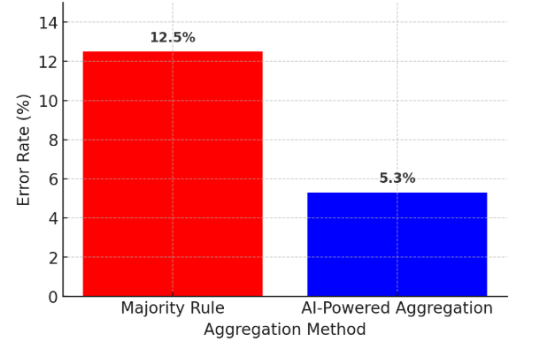
Fig. 1. Error Rate Comparison between Majority Rule and AI-Powered Aggregation

Case Studies and Real-World Applications

In order to verify the application of the AI-based crowdsourcing system in the real world, the performance is validated for a variety of real-world usage cases. One case study is medical image classification, which requires the correct categorization of images for training machine learning models [15]. The AI-based system maximized the assignment of the tasks by distributing the task to best fit the medical imaging knowledge of the workers as well as the worker’s prior history of task performance on the same tasks. Figure 2 presents the workflow for the performance of a medical image classification task within the AI-augmented crowdsourcing system by showing how the work would be dynamically assigned to the best based worker while AI provided feedback and ongoing quality control.

The pool of tasks consists of a set of medical images that need to be appropriately classified. To appropriately classify the medical images, the AI module considers annotator capabilities, past annotator performance, and labels it for the appropriate difficulty and assigns the work to the most-worthy annotators. Here is an aspect of artificial intelligence and humans working together to provide hybrid intelligence that increases the level of classification accuracy by leveraging human capabilities with AI-based automation. The integration of human capabilities with AI-based automation provides a level of accuracy that reduces errors and increases efficiency. After the classifications have been performed, the classified images are stored in the labeled medical image repository, which maintains the level of trustworthiness expected and needed when used for medical diagnosis and research studies.

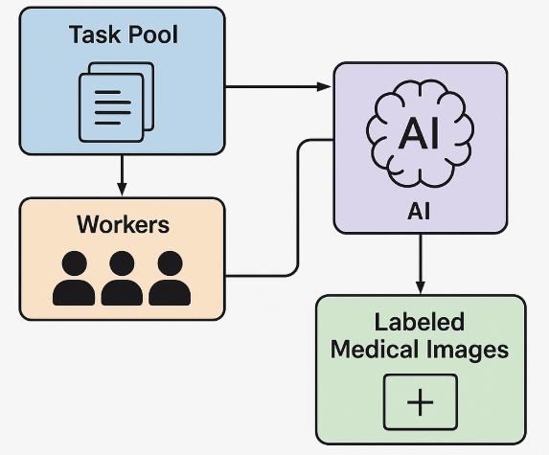
Fig. 2. Workflow of AI-Driven Task Allocation in Medical Image Classification

Figure 3 illustrates worker engagement dispersion or the complexity of the assignment vis-a-vis workers who can possibly engage with the assignment. Since the completed engagement for low-complexity tasks registered the most workers engaged with 150, this suggests that while the assignment was lower complexity, it was still reasonable and accessible to this large number of workers (decreasing complexity to a point increases the number of workers). The moderate complexity task with 100 workers engaged shows that workers are willing to do harder work where the effort or reward ratio is still acceptable to perform the task. High complexity tasks only had 50 workers engaged, this suggests that either there was no interest, no confidence, or no knowledge amongst the body of workers to get engaged. This further supports the proposal that we need an intelligent task assignment mechanism on the crowdsourcing platform, to assign tasks to workers based on their capabilities to maximize efficiency and quality, while also preventing the disengagement of workers if they are unable to execute extremely complex tasks that could jeopardize their engagement.

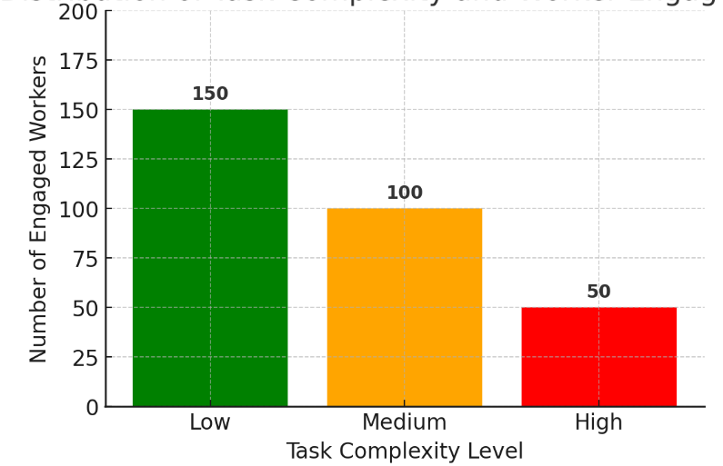
Fig. 3. Distribution of task complexity and worker engagement

Conclusion
This work articulates how Human-AI collaboration optimizes crowdsourcing and social computing through machine learning task optimization. Crowdsourcing platforms can utilize AI to allocate tasks, optimize efficiency, and enhance result quality, while also dealing with significant challenges that crowdsourcing platforms face, like worker motivation, quality assurance, and bias mitigation. AI systems perform as intelligent agents to allocate tasks by capability, track performance, and automate workflows to create maximal productivity and equity. This research's more remarkable contributions are to explicate ethical considerations, in-depth, especially algorithmic bias, transparency, and trust. While AI may automate crowdsourcing tasks, it is paramount to ensure the AI model is explainable and sensitive to algorithmic bias. In addition, it has been found to improve decision making and effectiveness in various applications, including medical diagnosis, data annotation, and content moderation, through hybrid intelligence where human and AI abilities address different aspects of the task selectively. The available experimental evidence is showing that crowdsourcing with the help of AI is far superior to classical methods in accuracy and scalability. There are still challenges, including regulatory issues, AI's capability for adaptive learning, and the privacy threat. Future directions of inquiry should be devoted to improving the role of AI within human-centered computing, its interpretability, and decentralized crowdsourcing models such as blockchain to foster worker empowerment and greater transparency. Overall, Human-AI collaboration represents a promising future avenue for optimizing crowdsourcing ecosystems. This work contributes to building and optimizing, through AI and human expertise convergence, fairer, more efficient and more scalable frameworks for social computing that can serve as platforms for innovation in countless domains.

References

- Buolamwini, J., & Gebru, T. (2018). Gender shades: Intersectional accuracy disparities in commercial gender classification. Conference on Fairness, Accountability, and Transparency.
- Holstein, K., Wortman Vaughan, J., Daumé III, H., Dudik, M., & Wallach, H. (2019, May). Improving fairness in machine learning systems: What do industry practitioners need?. In Proceedings of the 2019 CHI conference on human factors in computing systems (pp. 1-16).
- Wazny, K. (2017). “Crowdsourcing” ten years in: A review. Journal of global health, 7(2), 020602.
- Ipeirotis, P. G., Provost, F., & Wang, J. (2010, July). Quality management on amazon mechanical turk. In Proceedings of the ACM SIGKDD workshop on human computation (pp. 64-67).
- Wei, X., Zhang, Z., Zhang, M., Chen, W., & Zeng, D. D. (2022). Combining crowd and machine intelligence to detect false news on social media. Mis Quarterly.
- Cobanoglu, C., Cavusoglu, M., & Turktarhan, G. (2021). A beginner’s guide and best practices for using crowdsourcing platforms for survey research: The case of Amazon Mechanical Turk (MTurk). Journal of Global Business Insights, 6(1), 92-97.
- Draws, T., Rieger, A., Inel, O., Gadiraju, U., & Tintarev, N. (2021, October). A checklist to combat cognitive biases in crowdsourcing. In Proceedings of the AAAI conference on human computation and crowdsourcing (Vol. 9, pp. 48-59).
- Shah, Waseem. "Human-AI Collaboration: Designing Intelligent Applications for Enhanced Productivity." Journal of AI Range 1, no. 3 (2024): 37-48.
- Zhao, L. (2021). Event prediction in the big data era: A systematic survey. ACM Computing Surveys (CSUR), 54(5), 1-37.
- Dai, P., & Weld, D. (2010, July). Decision-theoretic control of crowd-sourced workflows. In Proceedings of the AAAI Conference on Artificial Intelligence (Vol. 24, No. 1, pp. 1168-1174).
- Daniel, F., Kucherbaev, P., Cappiello, C., Benatallah, B., & Allahbakhsh, M. (2018). Quality control in crowdsourcing: A survey of quality attributes, assessment techniques, and assurance actions. ACM Computing Surveys (CSUR), 51(1), 1-40.
- Demartini, G., Difallah, D. E., & Cudré-Mauroux, P. (2012, April). Zencrowd: leveraging probabilistic reasoning and crowdsourcing techniques for large-scale entity linking. In Proceedings of the 21st international conference on World Wide Web (pp. 469-478).
- Difallah, D. E., Catasta, M., Demartini, G., Ipeirotis, P. G., & Cudré-Mauroux, P. (2015, May). The dynamics of micro-task crowdsourcing: The case of amazon mturk. In Proceedings of the 24th international conference on world wide web (pp. 238-247).
- Gadiraju, U., Kawase, R., Dietze, S., & Demartini, G. (2015, April). Understanding malicious behavior in crowdsourcing platforms: The case of online surveys. In Proceedings of the 33rd annual ACM conference on human factors in computing systems (pp. 1631-1640).
- Puerta-Beldarrain, Maite, Oihane Gomez-Carmona, Ruben Sanchez-Corcuera, Diego Casado-Mansilla, Diego Lopez-de-Ipina, and Liming Chen. "A multifaceted vision of the Human-AI collaboration: a comprehensive review." IEEE Access (2025)..

