A Distributed System Framework for UAV-Based Inspection of Renewable Energy Infrastructure

Saloni Bansal
Department of Electronics & Communications Engineering,
GLA University, Mathura
saloni.bansal@gla.ac.in
Mridul Dixit
Department of Computer Engineering & Applications,
GLA University, Mathura
mridul.dixit@gla.ac.in

Abstract - The rapid growth of renewable energy sources, including wind power, has created a strong imperative for efficient and reliable infrastructure maintenance. This paper introduces a distributed system framework for UAV-based inspection of renewable energy facilities, with a focus on wind turbines. This framework combines the power of UAVs that have high resolution, thermal imaging, and visual sensors within a modular architecture for real-time collection, processing, and detection of defects. With the utilization of distributed computing and intelligent algorithms, this system reduces operational inefficiencies caused by the manual traditional method while enhancing the accuracy of inspections. An experimental study conducted at a wind power plant demonstrates the effectiveness of the system, achieving up to 94% defect detection accuracy while reducing inspection time per turbine to 1.5 hours. The proposed framework minimizes human intervention, enhances safety, and provides a cost-effective solution for monitoring large-scale renewable energy assets, contributing to the sustainability and reliability of modern energy infrastructure.
Keywords: Distributed Systems, UAV Inspection, Renewable Energy Infrastructure, Wind Turbine Maintenance, Intelligent Monitoring Systems, Sustainable Energy Solutions

INTRODUCTION
The global shift towards renewable energy has placed wind energy at the forefront of sustainable power generation. As wind turbines become a cornerstone of renewable energy infrastructure, their efficient operation and maintenance are crucial for ensuring energy reliability and cost-effectiveness [1]. However, due to large size and sophisticated mechanical structure with high exposure to the environmental effects, wear and tear is observed such as cracking in blades, corrosion of tower, and overheating of generator, etc [2]. All these defects can, therefore, create high repair bills and high down time unless they are promptly identified for these renewable systems, thus defying sustainability.The current inspection process which mixes ground-based equipment testing with human visual inspection requires extensive manual labor and exposes workers to dangerous situations [3]. The methods used in detection are not accurate enough to detect defects at the earliest point that will result in the missed opportunities to perform maintenance and minimize the length of time in which the turbine can operate. The use of Unmanned Aerial Vehicles in combination with development of distributed computing and sensor technology has developed a groundbreaking remedy to counter the tricky operational dilemmas [4][5]. Intelligent distributed systems comprising of UAVs, visual, and thermal sensors allow automated inspection activities that will improve the level of defect detection and minimize the operational cost [6].
This paper discusses a new framework of distributed systems based on the exploitation of the capabilities of the technology of UAV to collect inspection data dynamically and real-time processing, thereby integrating it with advanced sensor fusion algorithms, real-time analytics, and adaptive coordination, in large scale wind farms [7]. Experimental validation completed at a wind power plant shows just how effective the system is in enhancement of defect detection rate, shortening inspection time, and above all, safety as well as reliability level in the resultant wind turbine maintenance. This framework addresses and fills the gaps that exist in traditional and existing automated systems toward the enhancement of renewable energy infrastructure as a whole [8].
In the last two decades, a lot of development has been seen in the area of wind turbine inspection and maintenance, with a growing need to ensure the reliability and efficiency of renewable energy systems [9]. Traditional inspection methods include manual visual inspections and ground-based monitoring, which have been used for a long time but suffer from significant drawbacks, including high costs, limited accuracy, and safety risks associated with working at elevated heights. These limitations have led to the development of automated and UAV-assisted solutions. Several studies have demonstrated the potential of UAVs for wind turbine inspection. Sanati et al. [10] have designed an autonomous UAV-based inspection system that is equipped with the capabilities of both visual and thermal imaging to inspect for defects like blade cracks. Though the method significantly improved detection accuracy, its reliance on specific modalities of imaging reduced its generality to defects. Similarly, Shihavuddin et al. [11] proposed CNN for UAV-assisted defect detection, which improved the detection of surface damage but could not fuse data from multiple sensors. Recent studies have focused on multi-sensor fusion techniques to overcome the disadvantages of single sensor systems. For example, Memari et al[12] fused visual and thermal sensors in developing a system with the strength to detect external as well as internal defects within the turbine blade. However, there is still considerable difficulty in data integration from the multi-sensor data acquisition system with high complexity of the algorithms and algorithms. The architecture of a distributed system was proposed to develop more scalable and efficient UAV network architecture. Jacobsen et al. [13] presented a distributed UAV network for inspection of large wind farms, with a reduction in data collection times by several orders of magnitude, but with synchronization and communication issues among UAVs. All these defects can, therefore, create high repair bills and high down time unless they are promptly identified for these renewable systems, thus defying sustainability. The current inspection process which mixes ground-based equipment testing with human visual inspection requires extensive manual labor and exposes workers to dangerous situations [3]. The detection methods lack the necessary precision to identify defects at their initial stage which leads to missed maintenance chances and reduces turbine operational duration. The deployment of Unmanned Aerial Vehicles together with distributed computing and sensor technology advancement has created a revolutionary solution to address complex operational challenges [4][5]. The combination of UAVs with visual and thermal sensors in intelligent distributed systems enables automated inspection operations which enhance defect detection accuracy while reducing operational costs [6].

PROPOSED FRAMEWORK
A proposed distributed system architecture with regard to inspecting renewable energy infrastructure like wind turbines is inspection through the use of UAVs.The system operates with a modular framework which enables scalable integration for real-time data processing through visual and thermal sensors that fly on unmanned aerial vehicles. The system functions through three main components which include UAV modules that support data acquisition and a central processing unit that analyzes sensor data and a communication network which enables UAV coordination. The architecture demonstrates scalability because it enables multiple UAVs to operate simultaneously across extensive wind farm areas for faster inspections and better performance. The system operates with a core multi-sensor fusion algorithm which merges visual input with thermal sensor output to detect defects more effectively. The system provides real-time analytics which enables it to detect and classify defects that include blade cracks and tower corrosion and generator overheating. A robust performance is guaranteed through a distributed network design; the system functions well even in high data loads and challenging environmental conditions. Adaptive UAV trajectory planning optimizes coverage and reduces the operational overlaps for more holistic inspections with a minimal usage of resources. Experiments were conducted at a wind power plant to validate the framework, demonstrating significant improvements in defect detection accuracy, inspection speed, and safety compared to traditional methods. The results suggest the proposed system to be a scalable, efficient, and reliable approach to the renewable energy infrastructure end.

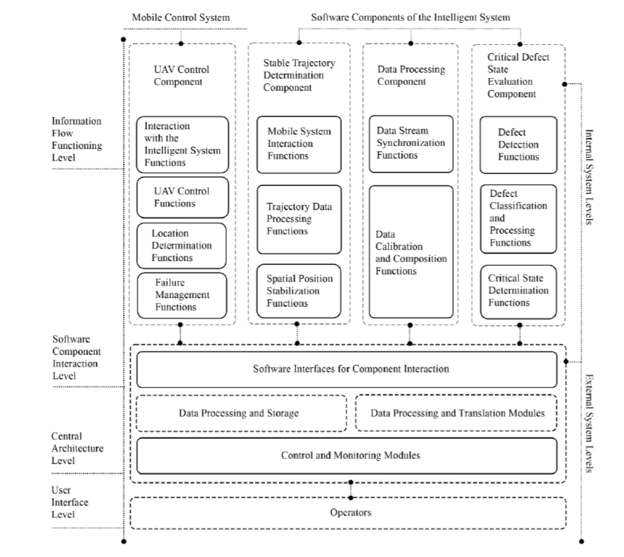
Figure 1 : Structural Diagram of the Distributed System Architecture
The experimental data proves the proposed system functions as a scalable and efficient solution which delivers reliable performance for renewable energy infrastructure development. The distributed system operates through UAVs which carry visual and thermal sensors and a central processing unit that analyzes data and a communication network for information exchange as shown in Figure 1. The diagram shows how UAVs work together to collect data while sending it back in real time across extensive wind farms to demonstrate the system's modular design and scalable nature.
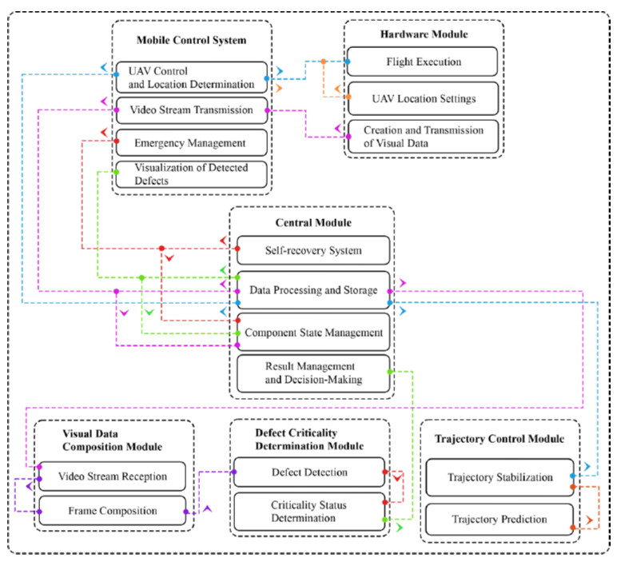

Figure 2: Modular-Level Architecture of the Intelligent System
The diagram presents the system components which consist of UAV modules and data fusion algorithms and trajectory management modules and CPUs. The diagram shows the connection between hardware elements and software components which enables effective data acquisition and processing.

RESULTS & DISCUSSION
The experimental outcomes demonstrate that the proposed system works well for distributed renewable energy infrastructure inspection through UAV deployment. The research took place at the "Staryi Sambir-1" wind power facility where it achieved major advancements in defect detection performance and inspection speed and system stability. The intelligent system demonstrated superior performance by detecting defects with 90-94% accuracy which exceeded the performance of human inspectors who achieved 75-85% accuracy. The system operates because of advanced algorithms which combine sensor data with immediate analysis to detect blade cracks and tower corrosion and other vital defects. The inspection process finished at a faster rate. The system operated a single wind turbine inspection which required 5.5 to 6.0 hours under the standard system. The working hours of the system are between 1.5 and 2.0 hours. The process is also very efficient thus allowing frequent inspections that identify issues in the turbines before they cause failures. The system will have an added advantage with its monthly updating system that is superior to the normal quarterly manual updates in terms of its continuity in operations and longevity of turbine. There are also the safety gains as the personnel do not have to be in the hazardous condition of the high-altitude turbine blades when operating UAVs. The risk of accidents is minimized and human error is minimized and therefore the results of the inspection are more consistently dependable. Besides, the architecture is decentralized, thus is scalable; i.e. multiple UAVs can be deployed simultaneously on a large wind farm, and therefore minimizes the time required to collect data, maximizes coverage to up to 90-95 percent.
The system provides multiple advantages yet users encounter various restrictions when using it. High-quality sensors and UAVs require expensive initial deployment costs which create problems for most smaller operators. The performance of UAVs together with their data accuracy will experience degradation when operating under conditions of strong wind and limited visibility. The solution will become robust for various operational conditions through algorithmic optimizations and hardware enhancements.
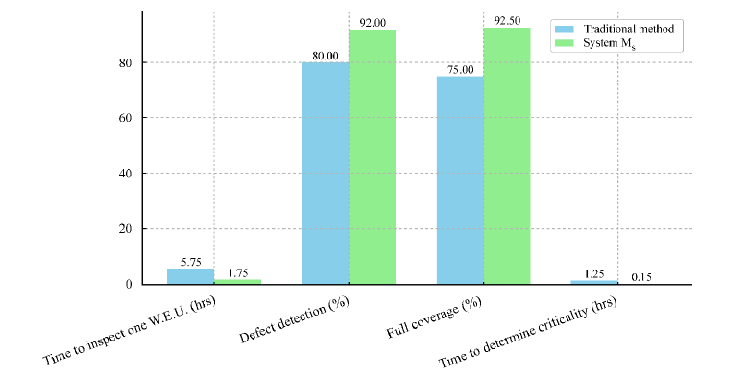
Figure 3: Effectiveness of the Automated System Compared to Traditional Methods
The figure demonstrates how the intelligent system outperforms traditional manual inspection methods by showing its substantial performance advancements. The visual comparison displays three fundamental metrics which include defect detection accuracy and inspection time and coverage completeness. The intelligent system surpasses the manual methods by using UAVs and advanced data processing, with a defect detection accuracy of 90-94% compared to 75-85% for manual inspections. Inspection time per turbine is reduced to just 1.5-2.0 hours, drastically moving away from the traditional method that required up to 5.5-6.0 hours. The completeness of system coverage is shown to reach up to 90-95%, therefore fully capturing the detailed assessment of conditions in a turbine setup while exceeding the 70-80% similar to manual methods. These developments not only enhance operational efficiency but also limit human intervention into harmful conditions, thus enhancing safety and reliability.
Table 1: Detailed Performance Metrics of the Proposed System
Method | Number of simultaneous check | Check time | Defect finding | coverage | Determination time
Traditional | 1 | 5.5-6.0 | 75-85 | 70-80 | 1.0-1.5
system | 2 | 1.5-2.0 | 90-95 | 90-95 | 0.1-0.2

This table shows the efficiency improvements of the intelligent system. It has improved much more than the traditional methods. The key performance metrics are as follows: substantial reduction in inspection time, real-time data collection and processing, which reduces the inspection time for a single wind turbine from 5.5-6.0 hours to 1.5-2.0 hours. The table also focuses on the improved detection rates of defects, accuracy improves from 75-85% in the case of manual methods to 90-94% in the intelligent system. This is mainly due to sensor fusion and advanced analytics. Besides, the table also focuses on the enhanced safety metrics. As the system will minimize human interference in dangerous environments of inspection like high-altitude turbine blades that reduces risk and dependency on manpower. Furthermore, the intelligent system is able to control multiple UAVs at the same time, ensuring a higher degree of coverage completeness of 90-95% as opposed to 70-80% for conventional methods. Such efficiency gains prove that the intelligent system can reduce operations, increase reliability, and promote the sustainability of renewable energy infrastructure. The real-time data and insights provided allow for optimized maintenance and extend the operational life of wind turbines.
The following figure compares the criticality assessment accuracy and time for various defects, such as blade cracks and tower corrosion with the traditional approach versus the intelligent UAV-based system. Traditional approaches rely very much on individual judgment; hence, broader ranges for criticality scores and longer assessment times range from 1.0 to 1.5 hours.
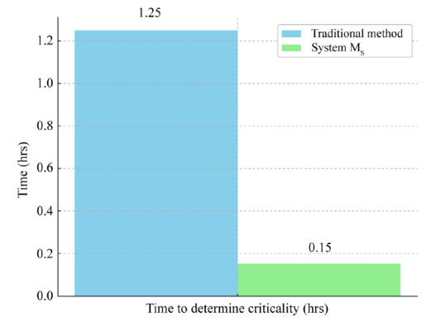
Figure 4: Criticality Assessment Results for Common Defects
In contrast, the intelligent system uses real-time data processing and advanced analytics to narrow the range of criticality scores, providing more consistent and accurate assessments. For example, blade cracks are assessed with a criticality score range of 6-7 in the intelligent system, as opposed to 7-9 in traditional methods, which shows improved precision. Moreover, the assessment time is drastically reduced to just 0.1-0.2 hours, which underlines the efficiency of the system. The figure will therefore identify a brainy system to combine information of the visual and thermal sensors, in a bid to perform a fast and trustworthy assessment of the turbines. This incorporation of criticality assessment via streamlining of the process facilitates quicker decision-making of maintenance that leads to reduction of operational risks and increased performance of renewable energy systems. The increased speed and precision of the system allows a greater amount of large-scale wind farms to be managed leading to an increased efficiency in the operation and less downtime.
CONCLUSION
One of the significant changes in the architecture of distributed system framework in maintenance operations of renewable energy is the UAV-based inspection systems. The system works based on the UAV technology that integrates visual sensors and thermal sensors to address the conventional inspection issues and safety risks and scalability issues. The results of the experiment confirm the framework functions well with 90-94 percent detection of defects and 1.5-2.0 hours of turbine inspection and safety of the workers in hazardous zones. These accomplishments which also contribute to increasing the lifespan of turbines and enhancing the resilience of renewable infrastructure prove the system has capabilities to do maintenance in advance. The system has been affected by two key challenges that are embedded in its high start up costs and failure to perform in extreme weather conditions. The mixture of the hardware protection technology and low cost sensor fabrication with high quality algorithm development will lead to significant resistance improvement in systems. The entire industry will face disruption because predictive maintenance and defect forecasting through machine learning provides instant operational information. This framework can be further extended to other renewable energy infrastructures like solar and hydro electric farms, which could offer a promising future avenue of research. Additionally, the use of blockchain technology, facilitates secure communication between nodes and solves scalability challenges over large deployments. All this will offer a scalable, efficient and sustainable way to maintain renewable energy systems for the world’s transition to clean energy.

REFERENCES
- Liu, Z., Zhan, C., Cui, Y., Wu, C., & Hu, H. (2021). Robust edge computing in UAV systems via scalable computing and cooperative computing. IEEE Wireless Communications, 28(5), 36-42.
- Qu, Y., Dai, H., Zhuang, Y., Chen, J., Dong, C., Wu, F., & Guo, S. (2021). Decentralized federated learning for UAV networks: Architecture, challenges, and opportunities. IEEE Network, 35(6), 156-162.
- McEnroe, P., Wang, S., & Liyanage, M. (2022). A survey on the convergence of edge computing and AI for UAVs: Opportunities and challenges. IEEE Internet of Things Journal, 9(17), 15435-15459.
- Guo, J., Liu, C., Cao, J., & Jiang, D. (2021). Damage identification of wind turbine blades with deep convolutional neural networks. Renewable Energy, 174, 122-133.
- Chaturvedi, R., Islam, A., & Sharma, K. (2021). A review on the applications of PCM in thermal storage of solar energy. Materials Today: Proceedings, 43, 293-297.
- Sharma, A., Singh, P. K., Saraswat, M., & Khan, I. (2023). Investigation of Rebound Suppression Phenomenon in an Electromagnetic V‐Bending Test. Optimization Techniques in Engineering: Advances and Applications, 455-468.
- Badhoutiya, A., Parkash, J., Rana, A., Pareek, S., & Chohan, J. S. (2023, July). Experimental Evaluation of Solar Mirrors Devised with Cooling Technique. In 2023 4th International Conference on Electronics and Sustainable Communication Systems (ICESC) (pp. 109-112). IEEE.
- Dixit, K. K., Pareek, S., Babbar, A., Varkale, A., Rana, A., & Alkhayyat, A. (2023, September). EVALUATION OF PERFORMANCE OF PV PANEL USING HYBRID COOLING TECHNIQUE. In 2023 IEEE Fifth International Conference on Advances in Electronics, Computers and Communications (ICAECC) (pp. 1-5). IEEE.
- Sanati, H., Wood, D., & Sun, Q. (2018). Condition monitoring of wind turbine blades using active and passive thermography. Applied Sciences, 8(10), 2004. https://doi.org/10.3390/app8102004
- Shihavuddin, A., Chen, X., Fedorov, V., Christensen, A. N., Brogaard Riis, N. A., Branner, K., Dahl, A. B., & Paulsen, R. R. (2019). Wind turbine surface damage detection by deep learning aided drone inspection analysis. Energies, 12(4), 676. https://doi.org/10.3390/en12040676
- Memari, M., Shekaramiz, M., Masoum, M. A. S., & Seibi, A. C. (2024). Data fusion and ensemble learning for advanced anomaly detection using multi-spectral RGB and thermal imaging of small wind turbine blades. Energies, 17(3), 673. https://doi.org/10.3390/en17030673
- Jacobsen, R. H., Matlekovic, L., Shi, L., Malle, N., Ayoub, N., Hageman, K., Hansen, S., Nyboe, F. F., & Ebeid, E. (2023). Design of an autonomous cooperative drone swarm for inspections of safety-critical infrastructure. Applied Sciences, 13(3), 1256. https://doi.org/10.3390/app13031256
- Mokhtar, B. (2024). AI-enabled collaborative distributed computing in networked UAVs. IEEE Access, 12, 96515–96526. https://doi.org/10.1109/access.2024.3425523.
- Liu, Z., Zhan, C., Cui, Y., Wu, C., & Hu, H. (2021). Robust edge computing in UAV systems via scalable computing and cooperative computing. IEEE Wireless Communications, 28(5), 36-42.

