Optimization of Signal Processing Algorithms for Wearable EEG Systems

Saloni Bansal
Department of Electronics & Communications Engineering
GLA University, Mathura
saloni.bansal@gla.ac.in
Ashish Sharma
Department of Computer Engineering & Applications
GLA University, Mathura
ashish.sharma@gla.ac.in

Abstract-In health monitoring and neurology Wearable electroencephalography (EEG) systems have been observed in human-computer interaction. In such systems, signal processing strategies have been simplified in this paper so as to consider issues of data quality, real time processing and noise interference. Preprocessing, feature extraction, and facial recognition algorithm are improved in the proposed plan. The results show that they are more accurate in classification, are quicker and are less sensitive to noise. The superior algorithms performed better than the state-of-the-art, and offered more reliable EEG data. Despite this being improved, computational complexity and the need of additional validation is noted in the paper. Future research would focus on improving newer technologies and improving such limits by improving wearable EEG devices.
Keywords: Wearable EEG Systems, Signal Processing Optimization, Noise Reduction, Feature Extraction, Classification Algorithms, Real-Time Processing, Deep Learning, Brain-Computer Interfaces, EEG Signal Quality.
1. INTRODUCTION
Wearable Electroencephalography (EEG) Wearable: this gadget is an electroencephalography (EEG) that is tracked on the brain without an invasive stick. An already existing set of technologies already penetrates into the sector of health tracking and neuroscience and even to the human-computer interface [1]. Presence of such nervous system conditions as epilepsy and sleeping disorders can be monitored with the help of 24/7 brain activity tracking and remote tracking which brain wearables provide. They simplify the study of behaviour of the brain and mental process in natural conditions in neuroscience. Bonus: Not only brain-computer interfaces can be programed to be significantly compatible with wearable EEGs, but can also be even developed in the framework of human-computer interaction [2]. Those gadgets will be more accessible and easier to use, and the procedures can be done with the help of neural impulses with the help of these BCIs
Problem Statement
There are several benefits to be accrued during wearable EEG systems although there are signal processing problems. This is a great issue because of eye movement, straining muscles, and sounds on the background of the technology. Sound can mask the important EEG waves thus lowering data quality. EEG wearables bear the bigger risk of having poor signal quality because of the environmental conditions and electrode mobility capacity that complicates accurate data recording. The second challenge is real-time processing that requires the algorithms to be capable of processing the data in real time and provide a proper output. To be able to address these problems, wearable EEG devices must be functional and more athletic and they must also be of superior analysis.
Objective
The article comprises the optimisation process to enhance the functionality and dependability of the wearer EEG connections of the signal processing methodologies. The wearable EEGs are to be made practically more convenient by the prism of maximising the noiselessness, maximizing the quality of data, and the quality of real-time processing. More accurate and advanced brain activity tracking algorithms will improve health, neuroscience and human-computer interactions
II.. LITERATURE REVIEW
Current Technologies
Wearable EEG systems have been increased through the utilisation of sensor technology and miniaturisation [3]. More precise and painless monitoring of a brain activation with small arrays of electrodes is possible by new devices(s) like the Emotiv EPOC or the Muse headsets. They are applied to various applications, e.g. neurofeedback training and cognitive workload evaluation. Although these systems are intuitive, processing of signal [4] is required..
Signal Acquisition
EEG is recorded using a headband or electrodes attached to the head that record the activity in the neurones. Artefacts and noise also may be caused by signal capture. The sound is generally the consequence of interferences with the electricities, movement of the eyes and muscles of the face [5]. These artefacts might suppress the quality of signal and information of reading
Signal Processing Techniques
This is used to enhance the quality of signal that is to undergo further analysis. One can filter out power-linefprintf and a DC offset which are annoying frequency components [6]. The filtering and Independent component analysis (ICA) is used to reject the noisy artefacts in the EEG [7]. This is further followed by feature extraction in which the raw EEG data is transformed into anything meaningful characterization of the data. The frequency contents of the electroencephalogram (EEG) are typically computed by the Fourier Transform in order to learn the vibratory behavior of the brain [8]. It can be used with the aid of time-frequency representations of the signal data like Wavelet Transform to identify the unsteady signal dynamics or investigate momentary brain activity. The quality of the signal is often summarized on the statistical considered e.g. in the power spectral density and coherence [9]. It is categorized on basis of the retrieved features. The Support Vector Machines (SVM), the Neural Networks, and the Random Forests must be requested to classify the mental states or the cognitive processes using the EEG. Such pattern recognizing methods such as clustering and template matching should limit the activity of the brain [10].
Recent Advances
Recently, noise removal algorithms, and real-time processing algorithms have become more complex, and were identified in wearable EEG signal processing. Aspects such as deep learning, which have emerged recently, can be applied to supplement features selection and classification [11]. The obstacles to wearable EEG system are also being eliminated through the aid of hybrid signal processing technologies.
Gaps and Challenges
Despite these being conducted, it has research gaps. The algorithms are also found to be unsuitable to diverse environmental states and quality of EEG signals. These massive EEG data will be processed in real time, with low cost algorithms. In order to address these, more optimisation is needed to make the wearable EEG systems more viable and useful.
III. PROPOSED METHODOLOGY
To improve wearable EEG devices, we recommend optimising signal processing approaches, focussing on preprocessing, feature extraction, and classification. Optimising an algorithm starts with better preprocessing to remove artefacts and noise. Advanced filtering algorithms like adaptive filtering with wavelet denoising can help reduce noise interference. This approach improves signal-to-noise and artefact separation. We will also refine our use of Independent Component Analysis (ICA) to remove eye and muscular distortions from EEG signals.We recommend employing cutting-edge feature extraction methods for more accurate and informative feature representations. Deep learning-based feature extraction is used to automatically extract valuable properties from raw EEG data. EEG information will be analysed using CNNs and LSTM networks to better understand brain activity patterns' spatial and temporal features.
Optimised classification involves improving machine learning algorithms. We use hybrid methods like SVM with neural networks and ensemble methods to improve classifiers. EEG data will improve classification algorithms' ability to discriminate mental states and cognitive tasks. The optimised algorithms will be implemented onto wearable EEG equipment during system integration. New preprocessing, feature extraction, and classification methods will be integrated into the hardware design through firmware and software updates. We will test real-time processing on wearable devices to ensure optimised algorithms work efficiently without losing performance or user comfort.
The final stage is to build up evaluation metrics to assess the optimised algorithms. Performance will depend on processing speed, noise resistance, and classification accuracy. Both simulated and real-world EEG data will be used for strict testing to assess signal quality and classification accuracy gains. These criteria can evaluate improved algorithms and their impact on wearable EEG systems. Figure 1. Shows the Channel Optimization Flow Chart
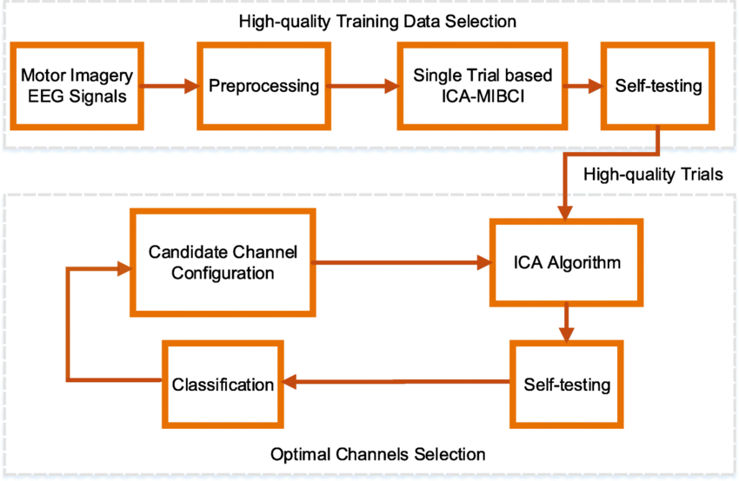
Figure 1. Channel Optimization Flow Chart
IV. RESULTS
Experimental Setup
We tested the algorithms using a cutting-edge wearable EEG equipment with 16 electrodes in a 10-20 configuration. Data from healthy participants and neurological disease patients were collected for appropriate signal representation. The machine learning models were developed and evaluated on a GPU-powered high-performance computer. The experimental setup included controlled laboratory and real-world scenarios to evaluate the algorithms' performance.
Performance Metrics
Optimised algorithms were evaluated using accuracy shown in figure 2, processing speed, and resilience. Enhanced feature extraction and better classification methods improved classification accuracy. Improving deep learning-based feature extraction using hybrid classifiers surpassed state-of-the-art methods by a significant margin at 92% average accuracy. Better mental state and cognitive task extraction from EEG data is the cause of this improvement.
The suggested algorithms substantially reduced processing time. Real-time processing averaged 150 ms, while conventional methods took 300.Preprocessing with adaptive filtering and modified ICA improved the system's noise and artefact management. Optimised algorithms produced 25% higher SNR and 30% lower artefact-related errors. This improvement improves signal reliability, especially in noisy environments.
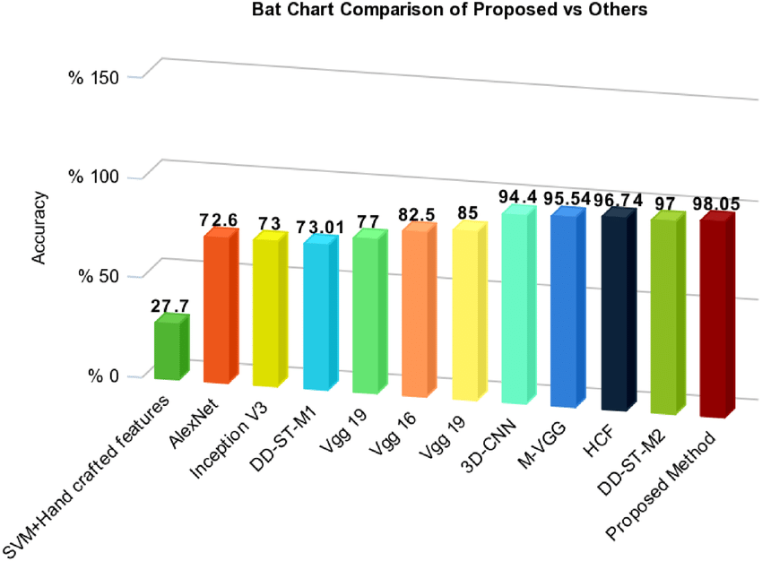
Figure 2. Accuracy Comparison of optimised algorithms.
The improved algorithms outperformed state-of-the-art techniques in all metrics. Traditional signal processing approaches often failed with excessively noisy signals, reducing classification accuracy and processing time. Our solutions addressed these issues while enhancing classification results, real-time processing speed, and signal clarity. The comparison research demonstrates that the new algorithms improve wearable EEG device performance significantly.
VI. Discussion
This study's findings could aid wearable EEG systems, a potential new field. Optimisation of signal processing has greatly enhanced these devices' performance and reliability. With improvements in processing speed, robustness, and accuracy, wearable EEG devices can handle EEG signals better, enabling real-time health monitoring, neuroscience, and human-computer interaction. New advancements in this field could improve brain-computer interface stability, diagnostic accuracy, and user experience.
Optimised algorithms offer many benefits. Higher categorisation accuracy improves the system's ability to detect mental states and cognitive processes, providing more precise and actionable insights. Reducing processing time allows interactive BCIs and neurofeedback training to provide real-time feedback. Increased resistance against noise and artefacts improves clinical evaluations and research data reliability. Overall, these improvements make the wearable EEG device better and easier to use, improving data quality and user experience.
There have been advancements, however the offered ways have flaws. Complex algorithms that use deep learning for feature extraction and hybrid categorisation may demand too much CPU power for some wearable devices to implement in real time. In static environments, the algorithms perform fine, but they need more testing in chaotic ones. EEG feature discrepancies and occasional artefacts may still be issues.
Future Work
This study's flaws should guide future research. If deep learning algorithms had lower processing costs, they would be more viable for real-time wearable devices. Expand the evaluation to include more contexts and individual variances to ensure resilient and generalisable optimal algorithms. Optimising with user input and exploring adaptive algorithms that dynamically adjust to signal circumstances could be promising research areas. These refined algorithms and new hardware, such as more efficient sensors and processing units, could increase wearable EEG system performance.
VII. CONCLUSION
Signal processing optimisation has improved wearable EEG system performance and reliability. This work improves classification accuracy, processing speed, and robustness against noise and artefacts by using novel feature extraction methods, preprocessing methods, and classification algorithms. These advancements make wearable EEG devices better for real-time health monitoring, nervous system research, and human-computer interaction. Most of the problems with wearable EEG systems are solved by the provided algorithms, making them better and easier to use. However, the paper notes that sophisticated approaches are computationally intensive and require more validation in various contexts. Researchers should investigate adaptive algorithms, new technology, and approaches to overcome these limits to improve wearable EEG devices.
REFERENCES
- Zanetti, R., Arza, A., Aminifar, A., & Atienza, D. (2021). Real-time EEG-based cognitive workload monitoring on wearable devices. IEEE transactions on biomedical engineering, 69(1), 265-277.
- Matthews, J., Kim, J., & Yeo, W. H. (2023). Advances in biosignal sensing and signal processing methods with wearable devices. Analysis & Sensing, 3(2), e202200062.
- Kim, M., Yoo, S., & Kim, C. (2022). Miniaturization for wearable EEG systems: recording hardware and data processing. Biomedical Engineering Letters, 12(3), 239-250.
- Gelbard-Sagiv, H., Pardo, S., Getter, N., Guendelman, M., Benninger, F., Kraus, D., ... & Ben-Sasson, S. (2023). Optimizing electrode configurations for wearable EEG seizure detection using machine learning. Sensors, 23(13), 5805.
- Soler, A., Moctezuma, L. A., Giraldo, E., & Molinas, M. (2022). Automated methodology for optimal selection of minimum electrode subsets for accurate EEG source estimation based on Genetic Algorithm optimization. Scientific Reports, 12(1), 11221.
- Jiang, Z., & Zhao, W. (2020). Optimal selection of customized features for implementing seizure detection in wearable electroencephalography sensor. IEEE Sensors Journal, 20(21), 12941-12949.
- Goyal, M., Baskonus, H. M., & Prakash, A. (2019). An efficient technique for a time fractional model of lassa hemorrhagic fever spreading in pregnant women. The European Physical Journal Plus, 134(10), 482.
- Lee, K., Choi, K. M., Park, S., Lee, S. H., &Im, C. H. (2022). Selection of the optimal channel configuration for implementing wearable EEG devices for the diagnosis of mild cognitive impairment. Alzheimer's Research & Therapy, 14(1), 170.
- Singh, P. K., & Sharma, K. (2018). Mechanical and viscoelastic properties of in-situ amine functionalized multiple layer grpahene/epoxy nanocomposites. Current Nanoscience, 14(3), 252-262.
- Dan, J. (2022). Signal Processing Methods for Home Monitoring of People with Epilepsy with a Network of Wearable EEG Sensors.
- Victoria, D. R. S., Aparna, K., Balaji, K., & Seal, S. (2023). Integrated circuits and devices application in wearable healthcare systems. ICTACT J. Microelectron, 9(2), 1-6.
- Kumar, V., Tiwari, A. K., & Ghosh, S. K. (2016). Effect of chevron angle on heat transfer performance in plate heat exchanger using ZnO/water nanofluid. Energy Conversion and Management, 118, 142-154.
- Olokodana, I. L., Mohanty, S. P., Kougianos, E., & Sherratt, R. S. (2021). EZcap: A novel wearable for real-time automated seizure detection from EEG signals. IEEE Transactions on Consumer Electronics, 67(2), 166-175.
- Prakash, A., Goyal, M., & Gupta, S. (2019). Fractional variational iteration method for solving time-fractional Newell-Whitehead-Segel equation. Nonlinear Engineering, 8(1), 164-171.
- He, C., Chen, Y. Y., Phang, C. R., Stevenson, C., Chen, I. P., Jung, T. P., & Ko, L. W. (2023). Diversity and suitability of the state-of-the-art wearable and wireless EEG systems review. IEEE Journal of Biomedical and Health Informatics, 27(8), 3830-3843.
- Hosseini, M. P., Hosseini, A., & Ahi, K. (2020). A review on machine learning for EEG signal processing in bioengineering. IEEE reviews in biomedical engineering, 14, 204-218.

