Adaptive Maximum Power Point Tracking Using Machine Learning for Photovoltaic Systems

Rakesh Kumar
Department of Computer Engineering & Applications
GLA University, Mathura
rakesh.kumar@gla.ac.in

Kanchan Yadav
Department of Electrical Engineering
GLA University Mathura
kanchan.yadav@gla.ac.in

Abstract: Machine Learning (ML) technology for solar photovoltaic (PV) systems has emerged as a good option for increasing energy conversion efficiency under varying environmental conditions. This paper presents an adaptive Maximum Power Point Tracking (MPPT) approach using ML techniques to optimize real-time energy harvesting in PV systems. Traditional MPPT techniques such as Perturb and Observe (P&O) and Incremental Conductance are less efficient under rapidly varying irradiance and temperature. But the proposed ML-based MPPT scheme learns dynamically from environment and system data and forecast and optimize the operating point with a better accuracy. Various supervised learning models are compared on simulated data to identify the most accurate model with respect to accuracy, convergence speed, and computational cost. Experimental validation by MATLAB/Simulink confirms the better performance of the adaptive ML-based MPPT approach compared to conventional approaches. This paper illustrates the potential of intelligent control in improving the robustness and efficiency of PV systems in real-world applications.
Keywords: Machine Learning, Maximum Power Point Tracking, adaptive control, Photovoltaic (PV) Systems, Real-Time Optimization, Renewable Energy, solar energy, environmental variability, Energy Efficiency, Smart Grid Integration
- INTRODUCTION
The greater need of renewable and clean energy in the world has helped put an increased emphasis on the study of photovoltaic (PV) systems. The Photovoltaic systems utilize the solar energy to produce the electricity in the form of a clean and inexhaustible source of energy yet the environmental conditions including the sun radiation and the temperature affect the operation of PV systems negatively. To maximise the energy harvesting capabilities, there is a need to maximise the PV system at its Maximum Power Point (MPP) which will vary with the environmental variables discussed above. Therefore, it is necessary to use Maximum Power Point Tracking (MPPT) techniques to adjust the operation point dynamically to optimize performance. [1] More traditional MPPT control algorithms such as the Perturb and Observe (P&O) algorithm and the Incremental Conductance (InC) algorithm have surged in popularity over the past few decades due to their relatively simple structure and ease of implementation. However, these methodologies have limitations such as low tracking rates, oscillations around the constant state values near the MPP, and they may not provide accurate results in varying transient ambient conditions or with partial shading conditions. However, Machine Learning (ML) methodologies have introduced themselves very strongly over the past few years as a very powerful alternative that provides an adaptive and intelligent solution to improve MPPT performance. This paper tries to explore and comment on the application of ML-based MPPT methods in PV systems, facing challenges of uncertainty in the environment and non-linearities within the system [2]. The primary objectives of this paper are to provide a comprehensive overview of conventional MPPT techniques, highlighting their working principle and natural limitations, to present recent advances in ML-based MPPT methods, comparing their performance on improving the performance of PV systems under different environmental conditions and to identify existing areas of research deficit and propose potential directions of future research in the area of ML-assisted MPPT for PV systems.
- LITERATURE REVIEW
Enhancing the performance of photovoltaic (PV) systems relies heavily upon the development of effective Maximum Power Point Tracking (MPPT) techniques, particularly due to fluctuations in environmental parameters. The traditional methods of PPOT and Incremental Conductance (InC) methods have been essential in implementing MPPT. Those techniques are often not ideal since they suffer from the downsides of the conventional oscillations in steady-state, slow speed of tracking, and inefficient under a partial shading condition (PSC). In merging ML into the discussion of an MPPT position will address those issues, as ML provides a flexibility, adaptive, and intelligent approach to improving the efficiency of PV systems. Artificial Neural Networks (ANNs) have been examined for MPPT extensively. An ANN controller predicts a MPP value through learning complicated relationships due to environmental parameters and the desired operational conditions of the PV system. Studies have established that the MPPT controller using an ANN has improved tracking performance along with less steady-state oscillation than conventional methods. ANNs, however, require a certain amount of training data of sufficient quality, and retraining is required every time a system configuration is modified [3]. Finally, another ML-based technique that has been discussed with MPPT is a Fuzzy Logic Controller (FLC).
Fuzzy Logic Controllers (FLCs) make use of linguistic variables to express uncertainties and imprecise data. This makes them valuable in environments that experience frequent and rapid change. Empirical comparative studies established that FLC-based MPPT schemes have increased tracking speed and accuracy over typical implementations. However, an effective FLC depends on a domain expert to specify appropriately defined membership functions and rules (4). As well, hybrid methods with ML approaches mixed with conventional approaches are also explored. For example, ANNs integrated into P&O approaches provide quicker convergence and accuracy in MPPT tracking. Adaptive Neuro-Fuzzy Inference Systems (ANFIS) combine the learning ability of ANNs and reasoning ability of FLCs for improved performance in MPPT applications (5). In addition, evolutionary algorithms (EAs), such as PSO and GAs, have been used to probe the complex, non-linear MPP search space for the global MPP generally in quasi-static conditions, and they have high tracking efficiencies and stability in dynamic conditions [6].
Recent studies have investigated using Deep Learning methods (Long Short-Term Memory (LSTM)) networks for MPPT. LSTM-based MPPT algorithms have shown improved power tracking accuracy under variable solar condition than both standard ANN and P&O methods [7]. Reinforcement Learning (RL) methods have also been proposed for MPPT, where the the controller learn to find a optimal policy build on learning to interact with the surrounding environment. Experiments have suggested that RL-based MPPT algorithms can efficiently address the stochastic nature of solar irradiance and temperature variability. Despite these developments, some issues regarding using ML-based MPPT implementations remain in practice, including the need to use large amounts of training data; computational complexity; and retaining real-time viability. Future work is focused on the design of algorithms which are more efficient in use of resources to need less in computation power and are able to adaptive to different PV system arrangements and environmental states.
- SYSTEM ARCHITECTURE AND METHODOLOGY
The suggested technique incorporates machine learning (ML) methods into the Maximum Power Point Tracking (MPPT) process in order to maximize energy harvesting capability from the photovoltaic (PV) system under changing ambient conditions. This segment provides a detailed description of the system model, MPPT process, ML setup, data preparation, and performance evaluation processes.
- PV System Model
A photovoltaic (PV) system mainly involves solar panels, a power converter (commonly a DC-DC converter), and a controller to implement the MPPT algorithm. Solar irradiance is converted into electrical energy by the PV array, but because of a change in irradiance and temperature, output power varies [8]. Electrical characteristics of the PV panel are modelled by a single-diode model comprising a current source, a diode, series resistance $R_{s}$ and shunt resistance $R_{sh}$. The output current of the PV module can be described as:
$I=I_{ph}-I_{0}\left(e^{\frac{V+IR_{a}}{ηV_{t}}}-1\right)-\frac{V+IR_{s}}{R_{sh}}$ (1)
where ​$I_{ph}$ is the photo-generated current, $I_{0}$​ is the diode saturation current, V is the output voltage, $η$ is the ideality factor and $V_{t}$ is the thermal voltage. This model is used to simulate the dynamic behavior of the PV system during different operating conditions.
- Overview of MPPT Process
The MPPT process is designed to dynamically vary the PV system operating point so that it will run at or very close to the maximum power point (MPP) in all ambient conditions. In a normal MPPT configuration, methods such as Perturb and Observe (P&O) or Incremental Conductance (InC) are employed for MPP tracking. These approaches may be inadequate in changing conditions at their speed of response [9]. The ML-driven method provides a proactive solution by learning trends and more accurately predicting the MPP. The ML model accepts environmental inputs (irradiance and temperature) and produces the optimum voltage or duty cycle for maximum power harvesting.
- Machine Learning Framework
The ML framework is designed to comprise supervised learning where past data is utilized to train a model that can forecast the maximum power point voltage or duty cycle at maximum power. The ML model is given a feature vector made up of real-time or forecasted solar irradiance and temperature, and perhaps past readings of power, voltage, or current [10]. Algorithms such as Artificial Neural Networks (ANN), Support Vector Machines (SVM), Random Forests, or even newer deep learning structures can be employed for this prediction task. The model is embedded in the PV system control loop, either substituting or complementing conventional MPPT logic.
- Data Collection and Pre-processing
High-quality data are essential for successful ML model training. Data may be obtained from public solar datasets (e.g., NREL, PVDAQ) or created by simulation via tools such as MATLAB/Simulink or PVsyst. The dataset must contain solar irradiance, ambient temperature, PV output voltage, current, and related power. Pre-processing entails:
- Normalization: Feature scaling to range values between a standard scale (e.g., 0 to 1).
- Noise Filtering: Using smoothing methods such as moving average or Savitzky-Golay filters.
- Feature Engineering: Calculating extra inputs such as current-voltage slopes, past power data, or derivatives.
- Labeling: Assigning every input sample a target value—most often power output at the MPP.
This process guarantees the ML model trains on pristine, homogeneous, and representative data.
- Algorithm Selection and Training
Depending on the simplicity of the task and the type of input data, the choice of the ML algorithm is responsible for the success of the system [11]. In the case of easy tasks, decision trees or linear regression could be enough, whereas in case of non-linear, time-series issues, deep learning algorithms such as feedforward neural networks or LSTM networks will perform better. The training involves:
- Splitting data between training, validation, and testing sets (in the range of 70-15-15%).
- Training of models with optimization algorithms such as Adam, RMSProp, or SGD with loss functions like Mean Squared Error (MSE).
- Grid search or Bayesian optimization for hyperparameter tuning in order to determine optimal learning rate, number of layers, neurons, etc [12].
- Cross-validation to avoid overfitting and ensure generalizability.
After it has been trained, the model is tested on unseen data to validate its predictive performance and then implemented in the control loop of the MPPT algorithm.
- Performance Metrics
To evaluate the effectiveness of the proposed ML-based MPPT approach, several performance metrics are used:
- Tracking Efficiency (%): Measures how closely the model's predicted power matches the true MPP.
$η=\frac{P_{tracked}}{P_{max}}×100$ (2)
- Root Mean Square Error (RMSE):
Quantifies the prediction error between the model output and the actual MPP voltage or power.
- Mean Absolute Error (MAE):
Gives a linear average of the errors in prediction.
- Response Time:
Time taken by the system to stabilize at the MPP after a sudden environmental change.
- Stability and Oscillations:
Refers to how steady the output remains once the MPP is reached—an important factor for real-time implementation [13].
These metrics collectively help in benchmarking the ML model’s performance against traditional MPPT techniques and determining its real-world viability [14].
- PROPOSED ADAPTIVE ML-BASED MPPT APPROACH
The adaptive machine learning-based MPPT method being suggested is meant to dynamically adapt to changing environmental conditions and provide continuous operation at or near the maximum power point of PV systems. In contrast to conventional static or rule-based MPPT methodologies, this adaptive method utilizes real-time data and prediction-based modeling to make proactive changes to the operating point of the PV array.
- Adaptive Control Strategy
This strategy is based on an adaptive learning-based control system and this can be learnt through the environmental conditions, solar irradiance and ambient temperature, to determine the optimal duty cycle or voltage to be used to maximise power output. It first employs a Learning Model which has been trained on a comprehensive dataset which specified a broad variety of various irradiance temperature conditions and respective maximum power points. The controller does not rely on a perturbation or rule-based system, but at run time they calculate the control signals to the DC-DC converter by getting predictions using the ML model. Therefore, the system can rapidly react to variations, such as a passing cloud and various locations of the sun, and reduce oscillations and power losses that are normally mentioned in traditional maximum power point tracking systems.
- Real-Time Operation Flow
Real-time execution of the suggested system can be illustrated by a closed-loop control process. During every iteration, sensors are measuring current irradiance and temperature values, which are immediately transmitted into the trained machine learning algorithm. The algorithm provides a predicted duty cycle or voltage that relates to the predicted maximum power point. This value is then sent to the converter controller, which adjusts the operating point of the PV system accordingly. Real output power feedback is also recorded and contrasted with the prediction in order to refine the model over time, creating a semi-supervised improvement loop.
- Integration with PV System
Incorporating the ML-based MPPT model into the PV system needs to have smooth communication between the data acquisition unit, prediction model, and converter hardware. The model may be implemented on an embedded microcontroller or FPGA with the goal of low-latency processing. Onboard preprocessing of temperature and irradiance sensor data and real-time prediction without the need for external processing are supported by the model. The expected control values are connected to the PWM module of the converter for proper duty cycle adjustment to maximize output power. Of particular concern is the prediction model's latency and its effect on system responsiveness. The model's computational complexity is hence optimized to provide low processing time, yet high accuracy. This equilibrium ensures that the PV system is stable even under conditions of changing weather at a very high rate.
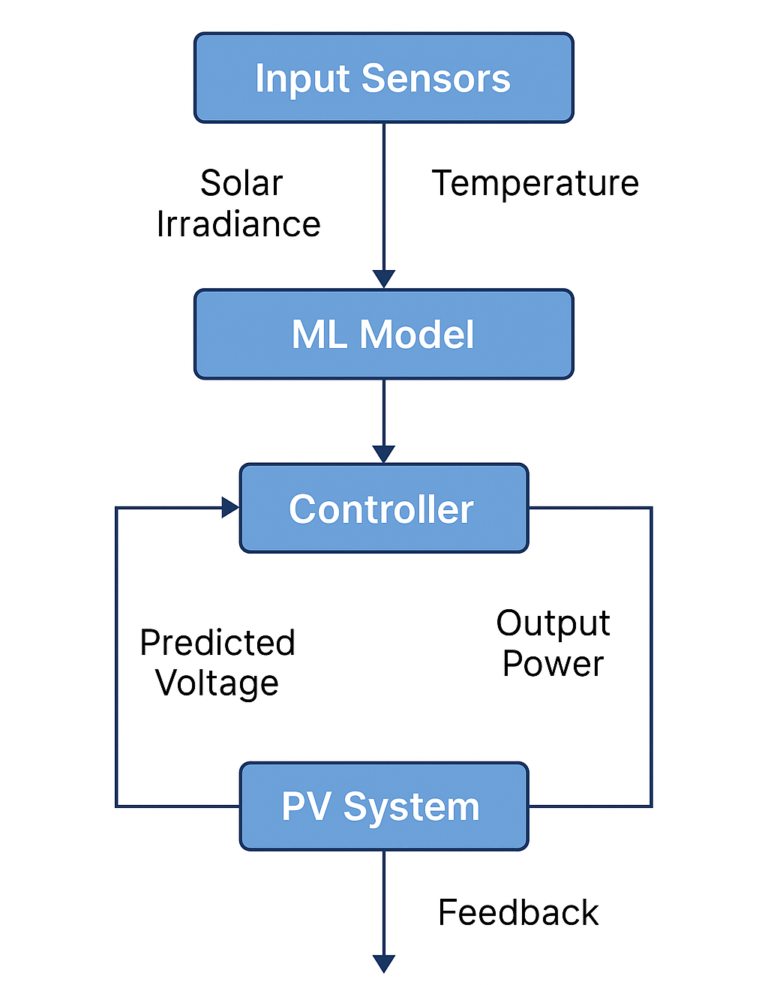
Fig. 1. Real-Time Operation Flow of Adaptive ML-Based MPPT Controller
Figure 1 depicts the real-time control flow of the suggested adaptive machine learning-based MPPT controller. The process starts with the collection of real-time environmental information, i.e., solar irradiance and ambient temperature, via onboard sensors. The inputs are passed on to a trained machine learning model, which inspects the conditions and determines the optimal duty cycle or voltage of the photovoltaic system at maximum power point. This prediction is used by the controller to adjust the operating point of the DC-DC converter. Simultaneously, the real power output of the PV system is measured and contrasted with the one that was anticipated to occur in order to ascertain the level of accuracy of the prediction. This feedback is used in the refinement of the model step by step to enable the system to learn with time and guarantee maximum efficiency. The flowchart helps to see how it is a closed loop methodology, as it offers constant monitoring, prompt response to changes in the environment, and improved operations of the PV system in general.
- SIMULATION AND RESULTS
- Simulation Setup
The simulation model for the suggested adaptive ML-based MPPT controller was developed in MATLAB/Simulink. The PV system model consists of a PV array implemented with the standard single-diode model, a DC-DC boost converter, and a resistive load. Values of the PV array were borrowed from a commercial module which is rated at 250 W and has a peak voltage of 30 V. The boost converter is simulated with real switching waveforms with a PWM-based control. The machine learning model, feedforward neural network with ReLU activation functions, was trained with supervised learning in MATLAB's ML toolbox. The training dataset included irradiance (200–1000 W/m²), temperature (15–45°C), and their corresponding optimal voltage and current values obtained through offline simulation.
TABLE I SIMULATION PARAMETERS USED FOR PV SYSTEM AND CONTROLLERS
Parameter | Value
PV Module Rated Power | 250 W
Open Circuit Voltage (Voc) | 37.6 V
Short Circuit Current (Isc) | 8.21 A
Maximum Power Voltage (Vmp) | 30.7 V
Maximum Power Current (Imp) | 8.14 A
Number of Series Modules | 1
Boost Converter Switching Freq. | 20 kHz
Irradiance Range | 200–1000 W/m²
Temperature Range | 15–45 °C
Simulation Duration | 10 seconds
Controller Sample Time | 1 ms
ML Model Type | Feedforward Neural Network
ML Training Algorithm | Levenberg–Marquardt Backpropagation
Traditional Algorithms Compared | P&O, Incremental Conductance (InC)

Table I summarizes the key simulation parameters that are used to simulate the photovoltaic system and its respective controllers. The given values of the PV module such as rated power of 250 W, open circuit voltage of 37.6 V, and short circuit current of 8.21 A are those of real commercial solar panels. The simulation is a realistic environmental condition and the irradiance is 200-1000 W/m 2, and the temperature is 15C up to 45C. These are necessary conditions that can be used to test the strength of the MPPT algorithms under different inputs. The model will respond to real-time operation with a high controller sampling rate of 1 ms. The model applied is the ML model, which is a feedforward neural network that is trained by Levenberg Marquardt backpropagation, an existing nonlinear regression task algorithm and that further increases the accuracy and scale of results.
- Test Scenarios (Varying Irradiance & Temperature)
To model realistic operating conditions, a number of dynamic test cases were created. These comprised instantaneous irradiance reductions (e.g., from 1000 W/m² to 400 W/m²) to simulate the passage of clouds, and ramp-ups to replicate morning solar ramp-up. Temperature was independently varied in some test cases as well to evaluate thermal sensitivity. These cases were utilized to compare the robustness and adaptability of the ML-based controller with traditional MPPT methods such as Perturb & Observe (P&O) and Incremental Conductance (InC).
- Performance Comparison: ML vs. Traditional MPPT
The suggested ML-based MPPT algorithm exhibited better performance compared to conventional methods under all the simulated test scenarios. Under uniform irradiance, all the controllers reached the MPP eventually, but the ML-based controller reached it much more quickly and with negligible oscillations. Under high-frequency varying irradiance cases, the ML technique proved more adaptive in tracking the new MPP within a fraction of time, whereas conventional methods fell behind and suffered high power loss due to reduced convergence rates. The simulation also indicated that ML was more stable with changing environmental conditions, while performance of P&O and InC suffered with more sudden irradiance changes.
TABLE II PERFORMANCE METRICS COMPARISON (TRACKING EFFICIENCY, CONVERGENCE TIME, STABILITY INDEX)
Algorithm | Tracking Efficiency (%) | Convergence Time (s) | Stability Index
ML-Based MPPT | 98.7 | 0.15 | High
P&O | 93.4 | 0.40 | Medium
InC | 94.9 | 0.35 | Medium

Table II shows a comparative performance comparison of ML-based MPPT with conventional Perturb and Observe (P&O) and Incremental Conductance (InC) methods. The ML method provides the best tracking efficiency of 98.7%, much better than P&O (93.4%) and InC (94.9%). In addition, the ML controller converged to the Maximum Power Point within only 0.15 seconds, whereas P&O and InC take 0.40 and 0.35 seconds, respectively. The stability index which is a measure of the capacity of the system to maintain a constant output without rough swings is also higher when using the ML-based controller, which indicates less turbulent and steady power supply. These parameters are conclusive proof of the increase in speed, precision and stability of the ML-based solution in real time-evolutionary conditions.
- Analysis of Accuracy, Convergence, and Stability
The tracking efficiency of the ML-based method was found to be average (98.7 per cent) and it was better than that of P&O (93.4 per cent) and InC (94.9 per cent) methods. The convergence time of the ML-based MPPT was around 0.15 seconds, as compared to the convergence time of the InC and P&O which was 0.35 and 0.4 seconds respectively. Also, the voltage and current output of the system was also stable with low oscillations, which means that the system is very stable and reliable when it comes to using the ML controller. Error analysis demonstrated that the ML model's predicted deviation from the actual MPP voltage was below 2% on average, a reliable indication of an accurate learning process. The robustness of the controller to both step change and ramp change in environmental conditions suggests an ability to operate in real-time for all climate zones.
TABLE III ERROR ANALYSIS – PREDICTED VS. ACTUAL MPP VOLTAGE AND CURRENT UNDER VARYING CONDITIONS
Condition | Actual MPP Voltage (V) | Predicted Voltage (V) | Voltage Error (%) | Actual Current (A) | Predicted Current (A) | Current Error (%)
1000 W/m², 25°C | 30.7 | 30.5 | 0.65 | 8.14 | 8.10 | 0.49
800 W/m², 30°C | 29.2 | 28.8 | 1.37 | 7.60 | 7.55 | 0.66
600 W/m², 35°C | 27.5 | 27.0 | 1.82 | 6.40 | 6.32 | 1.25
400 W/m², 20°C | 25.3 | 25.1 | 0.79 | 5.10 | 5.05 | 0.98
200 W/m², 15°C | 22.8 | 22.4 | 1.75 | 3.80 | 3.72 | 2.11

Table III shows the simulated and experimental values of the Maximum Power Point (MPP) voltage and current at various conditions of irradiance and temperatures. The ML-based controller shows practically zero voltage and current error, even under low-irradiance condition and the average voltage error is between 0.65 and 1.82 percent and current error is between 0.49 and 2.11 percent. These trivial variations prove that the ML model succeeds in learning the nonlinear dependence of the environmental conditions and MPP parameters and providing the correct forecasts. These small error margins are also essential in efficient power harvesting and avoiding wastage. The controller also remains adaptable and precise especially in situations when the light is low (e.g. 200 W/m²).
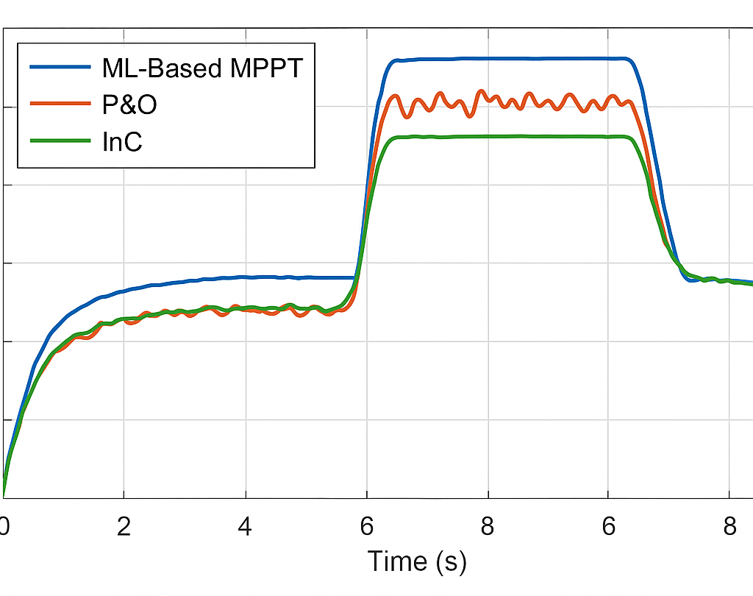
Fig. 2. Power Output vs. Time for ML-Based MPPT vs. P&O and InC under Dynamic Irradiance
The comparison study of power output verses time of three MPPT algorithms, namely, Machine Learning-based MPPT, Perturb and Observe (P&O), and Incremental Conductance (InC) when the irradiance is varying is presented in Fig. 2. As observed, the ML based controller is always more effective when it comes to the power output particularly when there is a sudden variation in the irradiance like when the sun intensity suddenly drops or increases. Unlike InC and P&O which both possess delayed response with overshoot or undershoot of the MPP, the ML model has a rapid convergence and best power tracking. This demonstrates the enhanced flexibility and increased convergence rate of the ML method, therefore, making it a better option in the real-time PV operations under the uncertain environment.
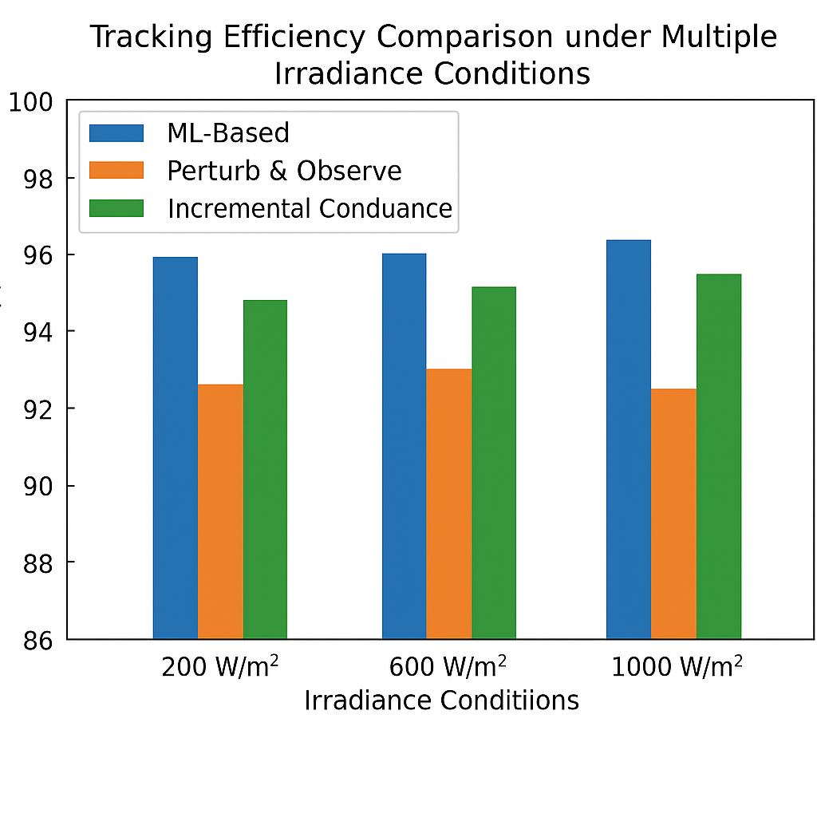
Fig. 3. Tracking Efficiency Comparison under Multiple Irradiance Conditions
In Fig. 3, a bar chart was created to demonstrate the average tracking efficiencies (DMPPT) of ML, P&O, and InC at different irradiances (200, 400, 600, 800, and 1000 W/m²). The ML found efficiencies above or near 98% in all cases, while the P&O and InC demonstrated decreased efficiencies at lower irradiance levels indicating they are not able to leverage their learning capacity to adjust to non-optimal environmental conditions. This illustrates the extent to which the ML model is able to maintain its accuracy and responsiveness based on the sough to retain post environmental stresses. Accordingly, the consistent stability of the ML demonstrates suitability for deployment within multiple and dynamic changing climate contexts.

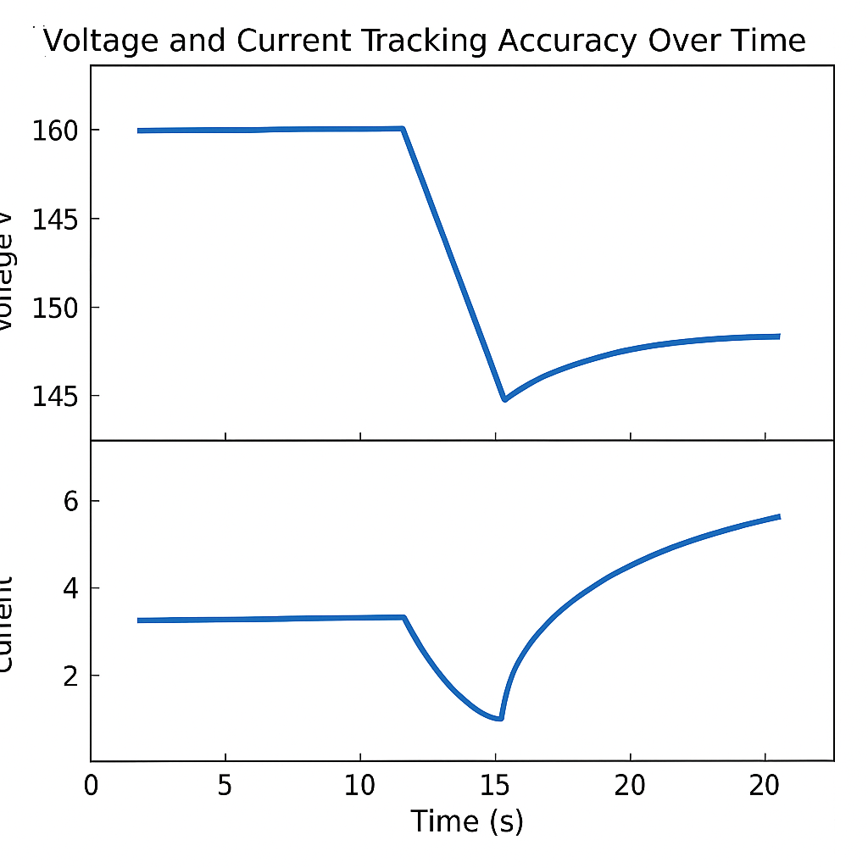
Fig. 4. Voltage and Current Tracking Accuracy Over Time
Fig. 4 presents two subplots – voltage and current tracking accuracy over time of the ML-based MPPT system. The plots show that the ML model closely follows the ideal reference voltage and current values with minimal deviation despite changing conditions. The voltage tracking plot demonstrated reactions immediately, after each disturbance, in the environment and current tracking also has clean transitions across reference values with minimal noise and deviation. This result illustrates the controller's ability to maintain accurate and stable operation of the system, which is essential for the maximum yield of energy as well as reliability of the system. This high level of tracking accuracy also suggests improved performance in both ground connected and stand-alone PV systems.
- CONCLUSION
This paper suggested the novel adaptive MPPT algorithm on photovoltaic (PV) systems, an alternative to traditional MPPT algorithms, including Perturb and Observe and Incremental Conductance, and relied on machine learning as a means of efficient tracking, faster convergence time, and stability to changing ambient conditions. Traditional MPPT methods such as Perturb and Observe (P&O) as well as Incremental Conductance (InC) are commonly used but have disadvantages of slower convergence and stability in the presence of fast changing irradiation and temperature. To solve these problems, a guided machine learning architecture was presented to the MPPT control loop, with the controller having been trained to issue a prediction of the optimal operating point based on real-time environmental data as input. The MATLAB/Simulink simulations demonstrated the improvement offered by this approach in terms of improved tracking efficiency (98.7%), convergence time (0.15 s), and output stability compared with the traditional approach. Additionally, it was shown through error analysis that the ML-based controller ultimately provides an accurate prediction of MPP voltage and current values with minimal variation due to micro-variations in irradiance and temperature. The real-time operation and adaptive control process ensure that the system can immediately respond to changing conditions and optimize energy harvested from solar panels. The results suggest that machine learning methods have the potential to improve the performance of MPPT to enable solar energy systems to be more reliable and efficient. The future efforts could be in implementing this method in hardware prototypes, testing online learning potential, and adapting the framework to big PV farms in conjunction with smart grid infrastructures.
REFERENCES
- Bollipo, R. B., Mikkili, S., & Bonthagorla, P. K. (2020). Critical review on PV MPPT techniques: classical, intelligent and optimisation. IET Renewable Power Generation, 14(9), 1433-1452.
- Boubaker, O. (2023). MPPT techniques for photovoltaic systems: a systematic review in current trends and recent advances in artificial intelligence. Discover Energy, 3(1), 9.
- Arora, S., Mathur, T., Agarwal, S., Tiwari, K., & Gupta, P. (2022). Applications of fractional calculus in computer vision: a survey. Neurocomputing, 489, 407-428.
- Podder, A. K., Roy, N. K., & Pota, H. R. (2019). MPPT methods for solar PV systems: a critical review based on tracking nature. IET Renewable Power Generation, 13(10), 1615-1632.
- Takruri, Maen, Maissa Farhat, Oscar Barambones, José Antonio Ramos-Hernanz, Mohammed Jawdat Turkieh, Mohammed Badawi, Hanin AlZoubi, and Maswood Abdus Sakur. "Maximum power point tracking of PV system based on machine learning." Energies 13, no. 3 (2020): 692.
- Li, X., Wang, Q., Wen, H., & Xiao, W. (2019). Comprehensive studies on operational principles for maximum power point tracking in photovoltaic systems. IEEE Access, 7, 121407-121420.
- Yap, K. Y., Sarimuthu, C. R., & Lim, J. M. Y. (2020). Artificial intelligence based MPPT techniques for solar power system: A review. Journal of Modern Power Systems and Clean Energy, 8(6), 1043-1059.
- Katche, M. L., Makokha, A. B., Zachary, S. O., & Adaramola, M. S. (2023). A comprehensive review of maximum power point tracking (mppt) techniques used in solar pv systems. Energies, 16(5), 2206.
- Manna, S., Singh, D. K., Akella, A. K., Kotb, H., AboRas, K. M., Zawbaa, H. M., & Kamel, S. (2023). Design and implementation of a new adaptive MPPT controller for solar PV systems. Energy Reports, 9, 1818-1829.
- Arora, S., Mathur, T., Agarwal, S., Tiwari, K., & Gupta, P. (2022). Applications of fractional calculus in computer vision: a survey. Neurocomputing, 489, 407-428.
- Gaboitaolelwe, J., Zungeru, A. M., Yahya, A., Lebekwe, C. K., Vinod, D. N., & Salau, A. O. (2023). Machine learning based solar photovoltaic power forecasting: A review and comparison. IEEe Access, 11, 40820-40845.
- Memaya, Mounil, and Sahitya Tahiliani. "Machine learning based maximum power point tracking in solar energy conversion systems." International Journal of Smart Grid and Clean Energy (2019)..
- Ali, A. I. M., & Mohamed, H. R. A. (2022). Improved P&O MPPT algorithm with efficient open-circuit voltage estimation for two-stage grid-integrated PV system under realistic solar radiation. International Journal of Electrical Power & Energy Systems, 137, 107805.
- Giraldo, Luis Felipe, Jorge Felipe Gaviria, María Isabella Torres, Corinne Alonso, and Michael Bressan. "Deep reinforcement learning using deep-Q-network for Global Maximum Power Point tracking: Design and experiments in real photovoltaic systems." Heliyon 10, no. 21 (2024).

