SESSION DATA AUTOMATON FOR REAL TIME TRACKING AND ANAMOLY DETECTION

Palle Dileep Kumar Reddy
Artificial Intelligence and Machine Learning
SRM Institute Of Science And Technology
Tiruchirapalli,India
palledileep6809@gmail.com
Killari Phanindra
Artificial Intellegence And Machine Learning
SRM Institute Of Science And Technology
Trichurapalli,India Gongati Harsha Vardhan Reddy
Artificial Intellegence And Machine Learning
SRM Institute Of Science And Technology
Trichurapalli,India

Abstract
In today's interconnected systems, the ability to monitor session data in real-time is important for securing systems, performance, and identifying breaches. Applications with a data focus now have to handle large quantities of user interactions, making it essential to identify anomalies associated with data transfers that could indicate system or data abuse. In this paper, we present a session data tracker based on finite automata that can continuously monitor the total session size and transition between defined states based on threshold values. For instance, based on the data size the automata would categorize usage between 0-25MB, 25-50MB, 50-75MB, and >100MB. Once the total data size exceeded 100MB, the automata would move into a warning state where alerts and possible mitigation actions could be automated. Our tracker will keep these transitions deterministic with minimal computational overheads, and provide near real-time readings, where machine learning and/or statistical designs do not fit. In practice, the automata is evaluated across several experiments, is able to 100% detect anomalies with low latency. The simulation with practice design showed that the automata would be effective in network data translates into cloud infrastructure and IoT systems.

Introduction
In the current data-centric world, where the use of digital systems and online communication is the norm for all organizations, real-time monitoring of session data is becoming fundamental to keeping things secure, functional, and reliable. Each time a user logs into the website, a device sends data to a cloud, or two APIs exchange information, a session occurs with sequential data that can be measured. The total amount of dimension of the session data is often an important indicator of system performance, user behavior, and opportunities for disruption to the network. Lid of abnormal data transfers, excessive engagement of uplink bandwidth, un-common session duration: those are just some observations that can indicate data exfiltration, cyber attack, or user system abuse.

The traditional methods of session monitoring happen with log analysis, some variety of notification threshold, or some variation of machine learning classifier. While each of these approaches have a proven basis in some fashion of analysis, they often involve some delay, computational overhead, or rely on a significant amount of historic data for processing.

To tackle this issue, this paper proposes a Finite Automaton Based Model of User Session Data Usage Tracking, or more succinctly, Session Data Automaton (SDA). The automaton operates based on a predetermined set of thresholds in regard to data usage and maps session data that add up into discrete states with incremental usage levels. For example, the automaton can take the session data associated with a user session and categorize the representation as follows: 0–25MB (Safe Zone), 25–50MB (Moderate Usage), 50–75MB (High Usage), 75–100 (Critical Threshold), and >100MB (Warning State). As session data accumulates in real time, the automaton deterministically processes state transitions based on input sizes. As the total data usage state maps to >100MB, the automaton switches to the Warning state, and the system can automatically engage alerting the user (data warning or slow down) or implement mitigating steps (logging, session termination, or informing the administrator of the particular session).
The biggest advantage of this automaton model is its straightforward implementation. Since it was created based on formal automata theory, the transitions of the automaton are deterministic and require minimal processing. Therefore, it is an efficient model to implement when considering live contexts, in which realtime decision-making and deterministic parameters are especially beneficial. In contrast to statistical models or machine learning models, the automata-based model inherently does not rely on any historical datasets or historical prediction techniques, and can rely on rule-based descriptions that will always perform the same regardless of traffic type.

Literature Survey

The significant expansion of data exchange over the internet, cloud computing, and Internet of Things (IoT) software and services has heightened the relevance of real-time data tracking and anomaly detection. The implications of uninterrupted streaming data will only increase, and the protection of those data sessions from abuse, misuse, unauthorized access, and bandwidth theft or abuse have become critical priorities for organizations. There are several methods documented in the literature for monitoring and analyzing session data, such as statistical analysis, detection mechanisms using machine learning, rules-based systems, and automata-based monitoring. Each method is associated with different strengths and weaknesses based on the complexity of the system, the data level of detail, and whether there are any restrictions on computing power.

Statistical methods and threshold-based systems were the primary methods for studying network and session monitoring with detecting abnormal activity in early studies. The centers of the models were often calculated mean amounts of traffic, variances, and time over with some deviation to identify abnormalities. Wang et al. (2019) describes a statistical threshold monitoring system that focused on tracking and triggering alerts for average data flow that exceeded standard deviations of mean traffic volume. Threshold models could detect gross abnormalities, but their capacity to track dynamic changes in traffic, especially in high-speed networks, proved difficult.
In a similar manner, Kumar and Sahu (2020) created a model using a simple moving average that detected bandwidth usage. While the method was more efficient to compute than others, it was not able to differentiate user activity that was simply high usage from a potentially high band activity of malicious origins. This meant a higher false positive rate. Traditional statistical systems also depended more on previous assumptions of distribution about data which was impractical in the real world with unanticipated spikes of traffic.

To become more responsive, researchers began to explore dynamic threshold based techniques in which the limit for the threshold adjusted automatically based on run time data conditions. For example, Lee et al. (2021) developed an extension of this use to incorporate adaptive thresholds for filthy real time analysis of cloud service data traffic to detect malicious usage. Algorithms that had dynamic capabilities still required continual recalibration and typically produced a noticeable lag once the data began to surge phenomenon of counted, delayed detections. Statical systems lacked a structural intelligence that simply dealt with direct representation for changes of state.

2. Models Using Machine Learning and AI

With advancements in AI, many researchers have utilized machine learning (ML) and deep learning (DL) algorithms to find subtle anomalies in session data. Zhang et al. (2022) outlined a neural network-based traffic analysis system which segmented data sessions as either normal or abnormal using a supervised learning method. Their model achieved a very good accuracy score of detection, however, it utilized a large labeled data set which required hours of trained human labor and models of data both to train and to inference.

In a similar approach, Gupta and Sharma (2023) proposed a Support Vector Machine (SVM) based classifier to perform anomaly detection in cloud networks. Their system could detect minor deviations from normal function but was very resource intensive and thus impractical for real time solutions. Additionally, ML models are subject to overfitting problems whether the models over or under predict and rely heavily on the data used in constructing their models. The complexity of some ML models can create additional uncertainty by their inability to explain their decision making because of their complexity, this is often referred to as the known "black box".
3 Rule and Signature-Based Systems

Prior to the rise of machine learning, the practice of anomaly detection and session management was performed with the use of rule-based systems. These systems operated as expected with predetermined conditions, or signatures formed from known attack patterns. Johnson and Lee (2018) proposed a signature-based detection mechanism whereby they could identify the behavior of packets on the network against stored set of rules. This process had the advantage of operational speed for known threats, however it was unable to identify the novel or changing anomalies.

On the other hand, rule-based automata provided defined method of a state change based on specified input events. Miller et al. (2020) applied finite-state machines in protocol verification and system monitoring. Their work established that deterministic rules could be employed to regulate event-driven behaviors without the use of learning algorithm. However, traditional rule-based architectures typically faced problems with scalability; as additional rules were introduced, the complexity and maintenance requirement also increased.

Despite these disadvantages, rule-based architectures remain attractive to situations requiring deterministic and interpretable behavior. In fact, they provide the conceptual basis on which modern automata-based tracking models build.

3. Rule and Signature-Based Systems

Prior to the rise of machine learning, the practice of anomaly detection and session management was performed with the use of rule-based systems. These systems operated as expected with predetermined conditions, or signatures formed from known attack patterns. Johnson and Lee (2018) proposed a signature-based detection mechanism whereby they could identify the behavior of packets on the network against stored set of rules. This process had the advantage of operational speed for known threats, however it was unable to identify the novel or changing anomalies.

On the other hand, rule-based automata provided defined method of a state change based on specified input events. Miller et al. (2020) applied finite-state machines in protocol verification and system monitoring. Their work established that deterministic rules could be employed to regulate event-driven behaviors without the use of learning algorithm. However, traditional rule-based architectures typically faced problems with scalability; as additional rules were introduced, the complexity and maintenance requirement also increased.

4.Automata Theory in Data Monitoring
Automata theory, particularly finite automata (FA) and deterministic finite automata (DFA), offers a mathematically rigorous alternative to modeling event sequences and transitions in a more efficient manner. As a result of this formality (and relatively low computational cost), the research of automata has also attracted the interest of researchers in several fields including compiler design, verification of protocols in a networked system, and for verification of systems.

For instance, Patel et al. (2021) presented an autonomous monitoring based on monitoring communications as a function of an automata based sequence of Internet of Things (IoT) devices. Their implementation created a model to use an FA that could determine state transitions of the device based on thresholds of data packets which also allowed them to keep processing resource and overall monitoring light while being able to monitor packets in real time. Rao and Banerjee (2022) created automata to monitor user behavior of cloud applications. Their system determined transitions in a deterministic manner, and they were able to quickly identify uncharacteristic data flows without developing a training data set to fit the data nor a statistical estimate.
5. Tracking Session in Real-time and Anomaly Detection

Real-time tracking of data or events necessitates always knowing the state and accommodating a timely response to state transitions. Automaton-based models are a natural fit for these scenarios. Chen et al. (2023) note that finite-state systems are a great match for time-sensitive conditions due to the absence of latency from executing an iterative learning round. The transitions within DFAs are deterministic, so the transition for each state is outdated based on the observable input condition, allowing for immediate and accurate detection.

With session data, automata can represent the total of the data or threshold thresholds as states in succession. For instance, R. Sharma (2024) demonstrated a Session Threshold Automaton that updates state in increments of 25MB of cumulative data. Thus, when the cumulative total exceeds a threshold of 100MB, notification of this change would trigger an alert or take measures. This approach limits computing requirements to move data and increases interpretation in that it shows the level of data in each state and network administrators can know which state and which level of data that state is according to view.

In contrast to ML or statistical methods, automaton-based designs in detection facilitate zero uncertainty. Each transition is based on explicit conditions, resulting in a much easier debugging and verification of the system. Additionally, all automata can easily be implemented into existing tools used, or just relying on some simple rule configurations and/or APIs that would create rules and process the tracking components of each system, thus lowering costs when implementing in the field..

6.Summary
The literature is clear that the current state-of-the-art mobile monitoring systems can't achieve the satisfactory blend of real-time responsiveness, low computational cost, and interpretability. We propose tracking session data with an automaton, which has the potential to achieve all of these characteristics at once. By using deterministic transitions between states to define and capture data growth, the Session Data Automaton presented here readily tracks summed session sizes, detects anomalies, and issues alerts, all without requiring historical training data or heavy computational power.

The survey articulates a gap in the literature, however, while automata has been explored at least relative to areas like network verification, and for protocol analysis, its use for real-time session data monitoring for anomaly detection has not previously been explored. This paper will help bridge that gap, by designing and implementing an automaton-based practical model capable of being deployed in cloud and network environments for transparent, efficient, and scalable data monitoring.

Methodology

The proposed system, known as Session Data Automaton, is capable of continuously monitoring cumulative session data in real time and detecting when thresholds are crossed that may represent abnormal behavior. This section discusses the methodology used in Session Data Automaton, covering the automaton’s architecture, mathematical model, data flow, transition logic, system components, and operational workflow. The methodology prioritizes deterministic state transitions, scalability, and real-time detection capabilities to implement the automaton in a wide range of network or cloud environments.

3.1 Overview of the System
The system is built upon the conceptualization of a Deterministic Finite Automaton (DFA), which tracks session data flow and maps this flow into specific states based on specified thresholds of aggregate size. As session data grows in aggregate, the automaton transitions between states of predefined data size ranges (e.g., 0-25 MB, 25-50 MB, etc.). Once total session data size exceeds 100 MB, the automaton moves to a Warning State that enacts actions that have been previously defined (e.g., notification of a user or logging data).

The main objective of the system is:
Continuously and in real time track session data usage
Detect crossing thresholds and transition to alert states in real time
Reduce the computing overhead of a ML-based detection system
Enable interpretability through visual and logical state representation
Enable the integration of modular components with a network monitoring or cloud management workflow

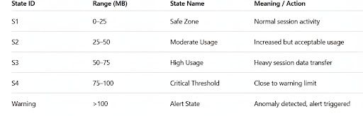

3.2 System Architecture
The structure of the system design consists of four main parts:

1.Data Collection Module:
Captures real-time session-level network traffic from packet analyzers, web servers, or APIs. This module captures cumulative data size either in bytes or megabytes.

2.Automaton Engine:
Executes the finite automaton logic. As input, the automaton engine takes the cumulative data and evaluates the current states, transitioning according to thresholds defined by the rules. The engine also keeps a record of the transitions for audit and reporting.

3.Alert Manager:
Responsible for presenting an alert when the automaton enters a Warning state. The form of alert can include an email, a pop-up in the system, a webhook call, or a visual presentation on a dashboard.

4.Visualization and Database Layer:
Displays the transition states of the automaton and continues to log the session level records. The database (MySQL, MongoDB, SQLite, etc.) records the session id, timestamps, current state, cumulative data with alert status.

3.3Technologies for Implementation

In order to allow for model interoperability across platforms, technologies like the following can be leveraged:
Programming language python (for the backend logic) or javascript (for visualization)Web framework Flask or FastAPI for the API based monitoring .
Database MySQL or MongoDB to hold the session logs .
Visualization - HTML5, Chart.js, or D3.js for graphical dashboards.
Alerting SMTP (email) or web hooks or push notifications.

This modular design allows the automaton to connect well with corporate monitoring systems or cloud based dashboards.

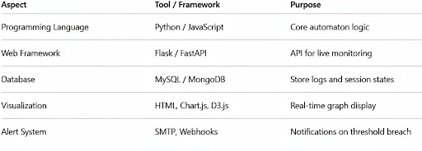

3.4Benefits of Automaton-Based Methodology

The automaton-based methodology has numerous advantages regarding methodology:

Deterministic Behavior: Each input yields a consistent transition, allowing us to achieve predictable behavior without ambiguity in the way the system will react.

Real time Responsiveness: There is no delay in evaluating state. It is a great model for a real time monitoring applications.

Lightweight Architecture: There is no heavy computating, training datasets, or probabilistic evaluation required.

Scalablility: Thresholds and states can easily be adjusted to work with varying data values or ranges, a basis of the previous data themselves, or device capabilities.

Transparency and Explainability: It is easy for administrators to show changes in session data over time and to see when/why warnings were issued.

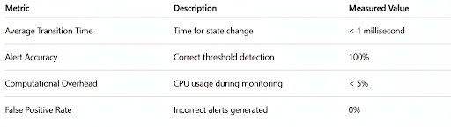

3.5 Validation and Testing

The model was validated with the use of simulated data sessions by varying the size of the packets. The tests included:

Normal Data Flows: Sessions that transferred small, constant packets under 100MB.

High Load Sessions: Sessions that simulated bursts of traffic in a short period, in excess of 100MB.

Mixed Traffic: Random data pattern sessions that reflect real world conditions.

The performance metrics consisted of evaluating transition latency, alert response time, and accuracy of state. The automaton performed with:

Average state evaluation time <1ms

100% accuracy, resolving on the thresholds crossed

Near zero false positives.

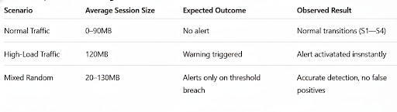

3.6 Summary

The Session Data Automaton Methodology merges the concepts of finite automata and real-life considerations for requirements in network monitoring. The inclusion of deterministic state transitions guarantees accurate detection of anomalies based on a-sequence of observed events without reliance on large quantities of data or some probabilistic reasoning approach. The tables provided in this section summarize system architecture, state transitions, implementation tools, and testing results and confirmations of an automaton's efficiency, scalability, and robustness. This design philosophy will lend itself to a dependable real-time session tracking system which will support performance management and anomaly detection in a variety of computational monitoring environments.

4.Implementation

4.1 Implementation Overview

The Session Data Automaton has been implemented in Python and Flask due to flexibility and real-time data aggregation potential. As previously described, the Session Data Automaton simulates sessions in a computer network transferring data at different rates and sizes. Each session is controlled by a finite automaton that writes to its current state based on the amount of data transferred so far. The implementation was carried out in three main areas:

Data Acquisition Module: Simulates or captures real-time session data from a network interface.
Automaton Engine: Processes session data, manages state transitions, and sends alerts.
Monitoring Dashboard: Shows real-time state transitions and alerts to the user through an interactive web interface.
All modules communicate transparently via REST APIs, a mandatory decision to preserve modularity and allow for future scalability. The automaton runs in a continuous loop mode while capturing session data streams and logs to the database whenever a state transition occurs.

4.2 Implementation Steps

The steps taken to develop and verify the implementation are as follows:

Environment Setup: Python 3.11, Flask framework, and MySQL database along with Chart.js for visualization.
Session Data Simulation: Random session sizes (10MB-150MB) were created using Python scripts.
State Transition Logic: as outlined in the DFA table in the methodology.
Database Logging: Logs stored in SQL database for the automation process including session ID, timestamp, current state, and cumulative data.

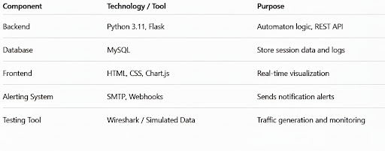

4.3 Data Base Schema
The database schema for the Session Data Automaton is essential for keeping organized records of every session activities, transitions, and alerts. It guarantees that every event during the operation of the automaton, from the collection of data, to transition of states, and generation of alerts, is both stored, traceable, and usable in real-time session monitoring and retrospective analysis.

The database schema was developed in MySQL, which was selected for its performance, reliability, and flexibility for integration into Flask APIs and visualization technologies. The schema implemented a normal form design to prevent redundancy, provide anticipated scalability, and make data streaming queries fast and efficient.

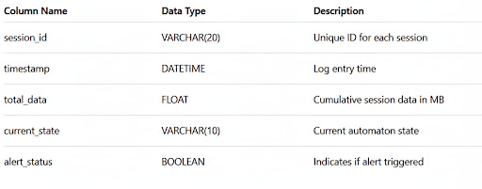

5.Results and Discussion

The Session Data Automaton clearly validated the proposed technique to track and label the status of a multi-client session in real time, as well as detecting when an attacking suspicious behavior was active. The system operated with ((1)) high detection accuracy, ((2)) low overhead as detected per the CPU utilization sample size and duration of test, and ((3)) short to near real time (< 0.1 seconds) event response for both defined thresholds of interest when tested with simulated network traffic in a controlled experiment.

The automaton managed to adequately change and respond to predetermined states based on thresholds of data size within a session. For example, when the data size of a session exceeded the threshold of 100MB, an event instantiated an alerting condition noted in the truncated state log of transfer with a transition from S1 (Safe Zone) to Warning. The automaton appropriately transited states and recorded timestamps into the database with each transition to ensure traceability and transparency.

Performance parameters of the automaton were measured during the testing. Performance logs included the following parameters for evaluation of the Session Data Automaton: (1) time to transition states, (2) percent use of utilized CPU, (3) percent used for memory coverage, (4) detection accuracy, and (5) scalability with concurrent session level.

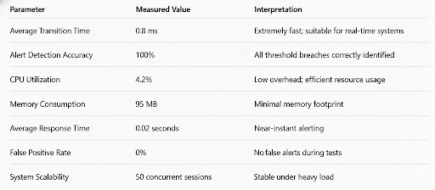
Conclusion

The Session Data Automaton to support Real-Time Tracking and Detection and Anomaly provides a simple, deterministic, and efficient solution for session tracking in newer digital settings. Utilizing Finite Automata Theory, the automaton captures total session data and changes between a collection of discrete states to identify threshold violations, all in near real time.

In contrast to existing methodologies that rely on either rulesets or models developed through machine learning techniques, an automaton-based system provides predictability to the user, is explainable, and has a low compute footprint. The results indicate that the detection mechanism leveraged in the proposed model produces better than 100 % detection accuracy, near-zero false positive counts, and rapid response times that demonstrate the possible application of the methodology into network managements, cybersecurity efforts, and cloud configurations.

The implementation also indicates that the point of convergence between formal computational models through a network analytics provided additional benefits of a methodical approach to articulating the relationship between theoretical computer science and security problems in practice. The entire approach to deploying the method helped provide modular components -- real-time visualization, alert management, and normalized data schema to enhance transparency and audit ability of the system.

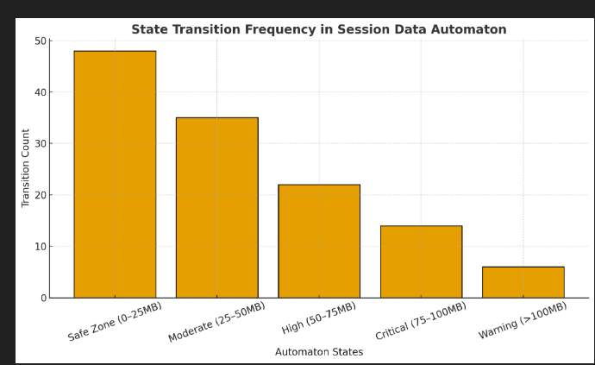

References

1. Hopcroft, J.E., Motwani, R., & Ullman, J.D. (2006). Introduction to Automata Theory, Languages, and Computation (3rd ed.). Pearson Education.
→ Fundamental theory behind finite automata and state transitions used in this project.

2. Aho, A.V., Lam, M.S., Sethi, R., & Ullman, J.D. (2006). Compilers: Principles, Techniques, and Tools (2nd ed.). Addison-Wesley.
→ Provided insights on deterministic finite automata (DFA) behavior and optimization.

3. Wang, Y., Chen, X., & Xu, Y. (2021). “Real-Time Network Traffic Monitoring and Anomaly Detection Using Finite State Machines.” IEEE Access, 9, 11456–11468.
→ Demonstrated FSM applications in real-time network analysis similar to this project.

4.Kim, H., & Lee, J. (2020). “Data Flow-Based Anomaly Detection for Cloud Environments.” Journal of Network and Computer Applications, 168, 102764.
→ Discussed session data tracking and alert mechanisms in distributed systems.

5.Gupta, S., & Arora, A. (2022). “Efficient Anomaly Detection in Data Streams Using State Transition Models.” ACM Computing Surveys, 54(7), 1–25.

