CPU Scheduling Algorithm Visualizer
Sibin Jacob, Ar. Deepak, Lakshaya Malviya (RA2411030050085)
School of Computing, SRM Institute of Science & Technology, Tiruchirappalli
Course Code: 21CSC202J – Operating Systems

Abstract
One of the most important things an operating system does is CPU scheduling, which controls how long each process can use the CPU.this paper teaches us about how to construct a visualizer that can be helpful in teaching how operating systems work. the visualizer will help you with scheduling algorithms like Round Robin, FCFS and SJF.it can also build Gantt Charts that update as jobs are finished. one of the most cursial things a operating system performs this control the CPU. the system has to decide which of the many processes that are waiting should be getting CPU time and for how long. This paper discusses a CPU Scheduling Algorithm Visualizer designed to enhance students' comprehension of real-time processes. This device can employ a lot of different algorithms, such as Round Robin, First Come First Serve (FCFS), and Shortest Job First (both are pre emptive and non pre-emptive).
The program produces Gantt charts that you can use and shows you how long it takes to wait and how long it takes to turn around. The visualizer explains how algorithms work one step at a time and how they are different from each other. This makes it simple to tell them apart and understand how they affect the performance of a process. Tests with sample process sets suggest that this gadget can assist teach because it can put abstract ideas about scheduling into graphics that people can understand.

Keywords
CPU scheduling, Gantt charts, FCFS, SJF, round robin, visualization, and operating systems

Introduction

You need to know how CPU scheduling works if you want to learn about operating systems. Many students still have trouble grasping how operations are scheduled in real time, even if literature on operating systems explain the principles and methods. This is especially true when people are late or come at different times. If you only think about these changing things in theory, it could be hard to understand them. The interactive visualizer shows these abstract actions on visual time lines, which makes it easier to understand how the software works.
You can utilize the graphic tools from this project on any device. They can keep track of their own tasks, decide how they wish to organize them, and observe how the Gantt chart does it. The screen shows when a process is blocked, when the CPU is free, and when a process advances forward in time. The tool explains why some scheduling choices are made and how they affect how well the system performs as a whole.

II. Problem Statement

Most of the tools we use to learn these days are either text-based or don't move. This implies that students don't get to experiment very often or learn how alternative approaches of scheduling CPUs can affect how programs run without delay. People can't truly understand things like round-robin time slicing or preemptive CPU scheduling until they see how they work over time. Because they can't run algorithms on a simulator at the same time, students have a hard time figuring out how to employ them in real life.
We need a platform that is easy to see and use, works with more than one scheduling system, can always locate the right performance indicators, and can provide graphs that are useful. Kids would learn how their choices affect how systems work with this kind of technology. It would also give them information they may use to study, get ready, and discuss about these things. This kind of platform can make learning more fun, easier to understand, and more useful.

III. Objectives

The most important part of this project is to develop a visualizer that is easy to use and displays how different techniques of scheduling CPUs operate in real life. We will create a tool that uses a variety of scheduling algorithms, such as Round Robin, FCFS, SJF, and both preemptive and non-preemptive. You can use Gantt Chart to visualize which illustrate how things will happen and in what sequence .
It can also present and figure out critical performance indicators like average waiting time (AWT) ,average turn around time (ATAT), average response time (ART) .You may also use the same methods in the app to test how well other algorithms function. This will show you how well things operate with each scheduling technique.

IV. Literature Review

Before, the only ways to teach CPU scheduling were simple command-line simulators or calculators that ran in a web browser. These technologies only acquired information from processes and supplied back information like how long it took to wait and how long it took to turn around. They helped with issues in textbooks, but they didn't explain how the CPU decides what to do at any given time. Because of this, most students learned how to schedule by heart instead of fully understanding how it worked. Previous studies in computer science education indicate that visual learning markedly enhances conceptual comprehension, particularly for abstract subjects such as process scheduling, where decisions evolve over time (Fouh et al., 2012).
A lot of visualization tools have been built in the past, but most of them don't function very well. Some only work with one scheduling algorithm, which makes it hard for students to compare algorithms directly (Sibia & Kaur, 2025). Some do show Gantt charts, but the diagrams don't alter, so you can't stop, step through, or interact with the execution. Banerjee (2015) says that kids learn better when they can touch and feel things they see.
Research on cognitive load indicates that teaching aids ought not to be overly cluttered. Instead, they should provide people information slowly and in steps to help them recall things better (Duran & Winter, This is where our schedule viewer comes in. Not only does the software show , the ultimate outcomes but , it also shows how the program is working at the moment. The software can execute more than one algorithm at the same time like Round Robin , Priority , Shortest Job First and First Come First Serve. You can see the results in (Wadmare,2024).
An interactive Gantt Chart and a step through scheduling tool lets you observe how CPU makes decision in real time . This interactive and visual approach allignes with the objectives that prioritize enquiry base learning rather than just memorizing formulas(Firat and Laramee , 2018).

V. Proposed System

System contains 4 primary parts : the input module , the scheduling engine and the result in comparision module. Users give information such as which process ID arrival time, burst time , Priority (if needed) ,and Round Robin time quantum . The Scheduling Engine then uses the tool it was given to keep track of how the CPU is being used over time.
This information is used by the Visualization Module to create Gantt charts that illustrate when each process is taking place. This makes it easier for you to see how the scheduling operates. The Results & Comparison Module displays you how long people have to wait, how long it takes them to turn around, and how long it takes them to answer, whether they are alone or with others.

VI. System Modules

The Input Module, Part 1 This module checks all the information users give it for the process. It checks that the settings are correct before scheduling starts. The time of arrival, the burst time, the priority, and the time quantum are all shown on this list.
Module 2 has the Scheduling Engine. This module explains how Round Robin, FCFS, and SJF (both pre-emptive and non-pre-emptive) work by going over the basic rules. It keeps track of the schedule and chooses what to accomplish first.
Module 3: The Module That Makes Things Look Nice This module is in charge of all the animations and Gantt charts. It displays how processes share CPU time, which can help you understand time-slicing and preemption better.
Module 4: Results and Comparison Module: This module talks about performance measure , like how it would be to wait , reply then turn around . you may also see how well alternative algorithms work on the same set of problems in the same specified time

VII. Tools and Technologies

We used Python 3 and T-kinter to make prototype GUI . with matplotips Gantt Chart and bar charts, its easy to see deadlines and performance statistics . you should learn python since it has a lot of liberaries , and it is easy to learn and that’s why its taught a lot in schools this makes it easy to use .

VIII. Experimental Results & Analysis
We need a sample process set (Table 1) to test how does the visualizer function. The sample data has processes that operate at different time . this makes scheduling circumstances more like what happens in real life it was simple to put them next to each other and see what makes them different.
The visualizer produce Gantt Chart for each algorithm and figure out how long people have to wait how long it took to get back to them .SJF usually means shorter wait time then FCFS and Round Robin make guaranteed that everyone got a fair chance but that could mean longer turnaround times, depending on how long the time quantum is. The test demonstrated that the visualizer not only makes it clear how scheduling works, but it also helps users figure out how well an algorithm works.

PID | Arrival Time | Burst Time | Priority
P1 | 0 | 5 | 2
P2 | 1 | 3 | 1
P3 | 2 | 8 | 3
P4 | 3 | 6 | 2

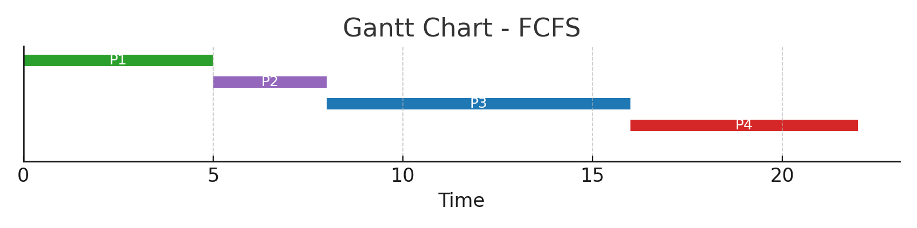
Figure 1: Gantt Chart for FCFS Scheduling

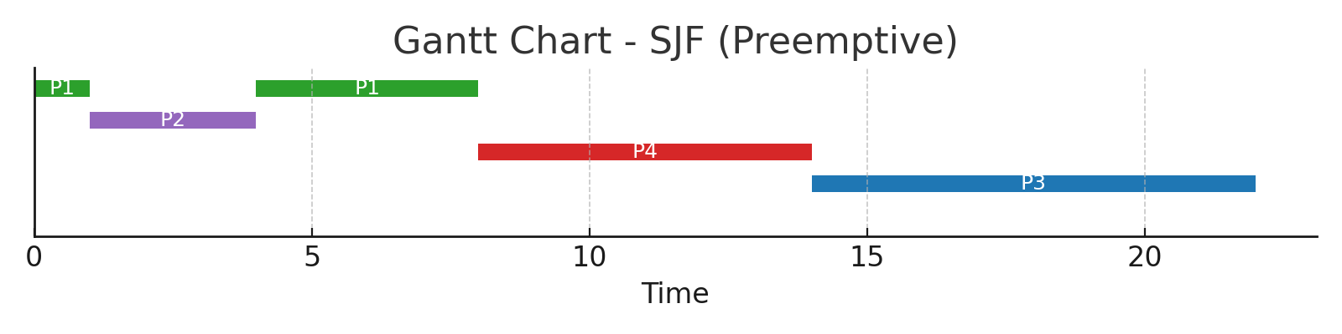
Figure 2: Gantt Chart for SJF (Preemptive) Scheduling

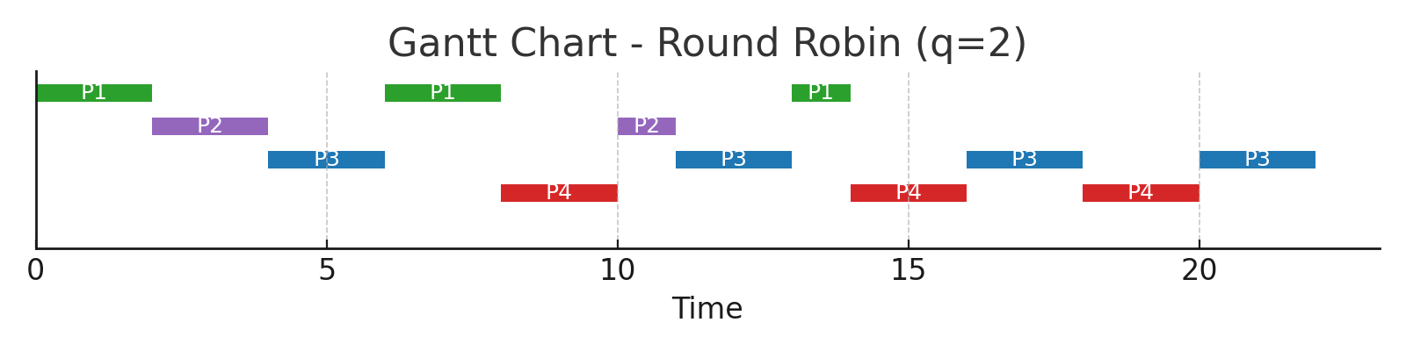
Figure 3: Gantt Chart for Round Robin (q=2) Scheduling
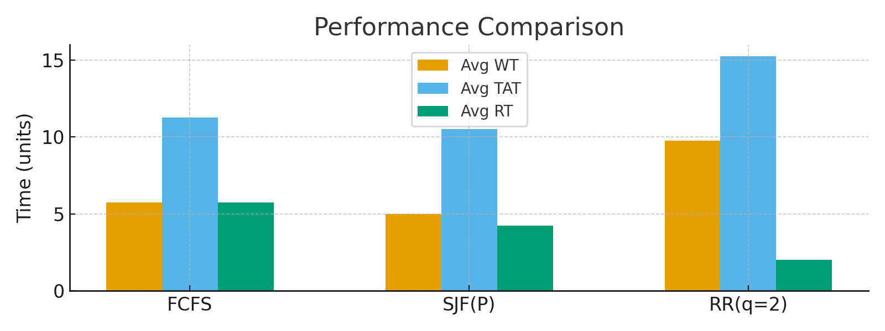

Figure 4: Performance Comparison (Avg WT, TAT, RT)

IX. Metrics and Discussion

Table 2 displays the average waiting time , turnaround time , and response Time for each algorithm based on the sample workload. The numbers demonstrate that the algorithms are different: FCFS is easy to use, however it could induce the convoy effect. SJF (preemptive) makes the average wait time for some tasks shorter. Round Robin speeds up replies, but it also demands more context switching and, in some situations, higher average return times.

Algorithm | Avg Waiting Time | Avg Turnaround Time | Avg Response Time
FCFS | 5.75 | 11.25 | 5.75
SJF(P) | 5.00 | 10.50 | 4.25
RR(q=2) | 9.75 | 15.25 | 2.00

X. Challenges and Risk Management
When the CPU wasn't in use or when multiple processes were running at the same time, it was challenging to make sure that preemption worked well and that the visual representation stayed right. It was a very crucial step to keep an eye on the execution phases to make sure that the schedule and time frame maintained the same. They also built a data structure that could be even more updated to keep track of the execution this makes it easier to change how data is shown and make sure that different algorithms are working decently.

XI. Future Work

It will be very good if the visualizer could handle more complicated scheduling methods like Multi Level Queue and Multi Level Feedback Queue sheduling. You may now save Gantt charts and performance data as PDF or Excel files that you can use for schoolwork and reports. This is something new. Another essential feature is the ability to implement interactive step controls. Users can halt, speed up, or slow down the animation on the timetable using these settings. The product will be more useful, more flexible, and better for teaching and learning because of these enhancements.

XII. Conclusion

You can learn a lot from the CPU Scheduling Algorithm Visualizer since it makes scheduling methods into simple-to-read performance indicators and timeframes. Students can learn how different algorithms handle process execution and how their scheduling choices effect wait time, turnaround time, and fairness by using interactive examples. The trials show that visualization makes it easier to compare the pros and cons of different scheduling methods and how they work.

Acknowledgment

The authors want to thank Dr. [Aalan Babu] from the School of Computing at the SRM Institute of Science & Technology in Tiruchirappalli for their aid and guidance.
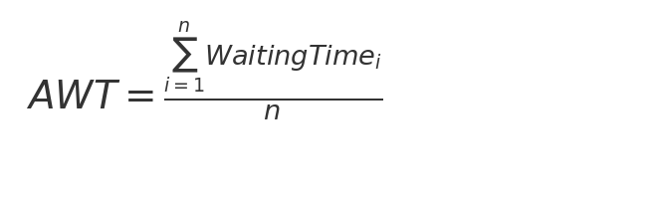
Equation 1: Average Waiting Time
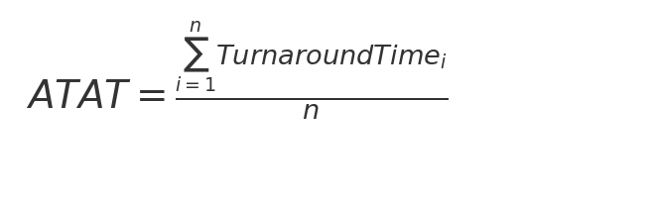
Equation 2: Average Turnaround Time
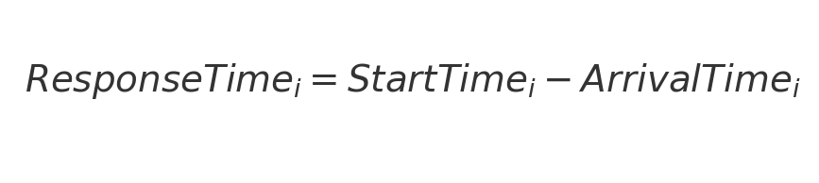
Equation 3: Response Time

References

1 .Operating system concepts by A. Silberschatz , P. Galvin , and G. Gagne.
2 .W. Stallings , Operating Systems: internals and design principles.
3 . Look online and in books to learn about CPU scheduling algorithms and simulation tools.

