Design a Real-Time Embedded Traffic Controller Using Priority Queues and Preemptive Scheduling on ARM Architecture

KAVITHA. G
SRM IST Trichy
Dept. of Cyber Security
RA2411030050019
kg8907@srmist.edu.in
PAVITHRA SARAVANAN
SRM IST Trichy
Dept. of Cyber Security
RA2411030050059
ps8037@srmist.edu.in
ROSHINI.P
SRM IST Trichy
Dept. of Cyber Security
RA2411030050001
rp2915@srmist.edu.in

Abstract:
Managing traffic well is a big problem in cities today, where more cars on the road cause traffic jams and delays. The goal of this project is to design and build a real-time embedded traffic controller that works by scheduling tasks based on priority. The system has an embedded microcontroller that uses sensors to keep an eye on traffic density and change signal timings based on what is happening in real time. Lanes with more cars or emergency vehicles get priority, which keeps traffic moving smoothly and cuts down on wait times. The proposed system improves traffic management, makes roads more efficient, and uses less fuel by combining real-time processing with smart decision-making. The design shows how embedded systems and priority-based algorithms can be used to make smart, adaptable, and energy-efficient traffic control systems.
Keywords
Real-time system, Embedded system, Traffic control, Priority scheduling, Microcontroller, Intelligent transportation, Sensor-based control, Adaptive traffic management, Smart city, Automation.

1.Introduction
In contemporary cities, efficient traffic management has emerged as a key concern due to the fast pace of urbanization and the ongoing rise in the number of vehicles. Traditional traffic control systems frequently result in congestion, fuel waste, and longer travel times because they are unable to adjust to changing traffic conditions and operate on set time intervals. Real-time embedded traffic controllers have become a clever way to get around these problems.
Using real-time sensor data, this project's priority-based embedded traffic control system effectively manages traffic flow. The system gives priority to lanes with heavy traffic or emergency vehicles by dynamically adjusting signal timings based on the vehicle density at each intersection.

2. Related Work
Several researchers and developers have proposed intelligent traffic control systems to overcome the limitations of conventional fixed-time signal systems. Traditional traffic lights operate on pre-set timers, which do not adapt to varying traffic conditions, resulting in congestion and inefficient road usage. To address this, recent studies have explored the use of embedded systems, sensor networks, and real-time algorithms to enhance traffic signal efficiency. Some works have utilized infrared or ultrasonic sensors to detect vehicle density and adjust signal timing dynamically. Others have implemented microcontroller-based systems (such as Arduino or Raspberry Pi) integrated with traffic sensors to create cost-effective and adaptive control mechanisms. Research has also shown that priority scheduling algorithms can be applied to manage emergency vehicles and heavily loaded lanes, improving making traffic flow better and cutting down on wait times.
Also, traffic management systems based on machine learning and the Internet of Things (IoT) have been suggested to figure out traffic patterns and make smart choices. But these systems usually need a lot of computing power and a complicated network. The suggested system is based on a real-time embedded solution that uses priority scheduling. This makes it easier, faster, and more useful for use in real life at city intersections.
3. Synthesis and Relevance :
In order to create an intelligent traffic control system that dynamically adjusts to road conditions, this project combines the fundamental ideas of real-time processing, priority-based scheduling algorithms, and embedded system design. The system uses a variety of components, such as sensors, microcontrollers, and signaling units, to efficiently detect and manage traffic. The embedded controller continuously counts the number of cars on each road segment and adjusts signal timing based on priority. This ensures that priority is given to emergency vehicles or lanes with higher traffic density. The project demonstrates how real-time embedded solutions can enhance system responsiveness and road efficiency while effectively addressing real-world urban traffic problems by integrating these technologies.
The urban issues of today are at the heart of this project's significance. Cities suffer from extreme traffic jams, delays, and pollution as a result of the fast rise in the number of vehicles and the inadequate road infrastructure. Conventional fixed-time traffic signal systems are unable to adjust to changes in traffic in real time. This gap is filled by the suggested real-time embedded traffic controller, which provides a clever, economical, and energy-efficient substitute that can be used in both urban and small towns. Better emergency response is also guaranteed by its use of priority-based control. Because of this, the system is extremely pertinent to the development of smart cities, intelligent transportation systems (ITS), and sustainable urban growth.
3.1 System Objectives
Goals of the System
The main goal of this project is to design and build a real-time embedded traffic controller that efficiently manages traffic flow by giving different lanes priority-based control based on how traffic is moving at the time. The goal of the system is to use automation and smart decision-making to cut down on traffic jams, make better use of the roads, and make traffic flow more smoothly overall.
Main Goals
To make a real-time embedded system that controls traffic
Make a system that uses a microcontroller to keep an eye on traffic all the time and change the traffic lights based on sensor data in real time.
To set up priority scheduling for better signal control
Use an algorithm that gives lanes with more vehicles or emergency vehicles like ambulances and fire trucks a higher priority.
To cut down on traffic jams and wait times
Make the signal switching process better so that cars spend less time waiting, which will keep traffic moving smoothly and steadily at intersections.
To make safety and dealing with emergencies better
Give emergency vehicles immediate green lights so they can get through quickly and safely without any help from people.
To make sure it works well and is cost-effective
Use cheap embedded hardware like Arduino, sensors, and LEDs so that the system can be easily set up in different cities and expanded to more junctions.
Other Goals
To cut down on pollution and make fuel more efficient
The system's goal is to cut down on unnecessary fuel use and emissions by cutting down on the time cars spend waiting at traffic lights.
To give smart city apps a base to build on
Set up a framework that can be used with IoT, cloud computing, or AI technologies to manage traffic intelligently on a large scale.
To make it possible for adaptive and independent operation
Make sure the system works on its own, changing signal timings based on real-time data and changing road conditions.
To make the system more reliable and work better in real time
Make sure that all tasks, such as collecting and processing data and controlling signals, are done within strict real-time limits to ensure accuracy and safety.
3.2 System architecture
Structure of the System
- A general idea of what it is
There are distributed intersection controllers (embedded units) in the system that read sensor data, run a real-time priority scheduler, and control traffic lights. Controllers can connect to a central server for monitoring, logging, or coordinating city-wide activities if they want to.
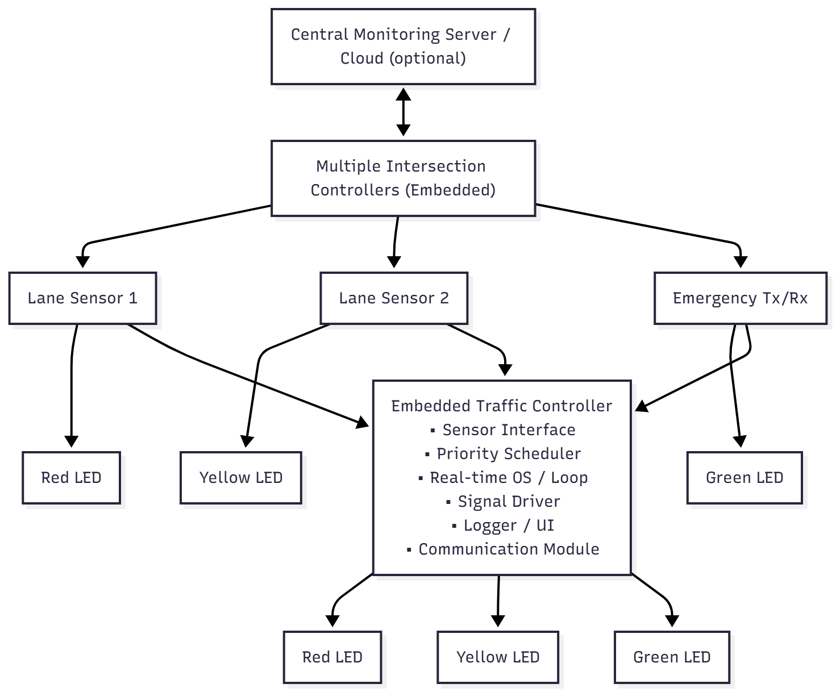

2. Parts of the hardware (for each intersection)

Microcontroller or SoC: ARM Cortex-M (STM32), ESP32, Raspberry Pi (for more computing power), or Arduino (for simple prototypes).

Sensors:
Inductive loop sensors OR
Ultrasonic or infrared sensors
Camera and image-processing module (if using Pi)
Optional: RFID, DSRC, Bluetooth, or V2X receiver for emergency or public vehicles.
Signal Driver: To turn on lights, use a relay driver or a transistor/MOSFET driver with opto-isolation. The voltage can be 24V or 230V, depending on the traffic lights.
Real-Time Clock (RTC): for putting timestamps on logs.
The Communication Module (optional) can use Wi-Fi, GSM/LTE, LoRa WAN, or wired Ethernet.
Power Supply: a DC regulated supply; think about using a UPS or solar + battery for backup.
HMI or Maintenance Interface: a small screen and buttons or a serial/USB port for setting up and troubleshooting.
Emergency Transmitter/Receiver: to give ambulances and police priority.

3. Software Architecture (parts)
HAL, or Hardware Abstraction Layer
APIs for sensor readings (debouncing, filtering)
GPIO and driver interfaces for lights
Drivers for communication, like UART, SPI, I2C, and Wi-Fi
Scheduler / OS in Real Time
You can use either a simple cooperative real-time loop with timers or an RTOS like Free RTOS or Zephyr.
Tasks: Getting sensor data, deciding which tasks are most important, controlling signals, communicating, logging, and watching over everything
Module for Making Priority Decisions
Uses the priority algorithm (see below for more information)
Keeps track of lane states, queue lengths, and emergency flags
Module for controlling signals
Turns scheduling decisions into safe signal changes with amber timing and all-red intervals.
Sets safety limits, such as minimum green, maximum green, and inter-green.
Module for Communication and Coordination
Local logging to SD/flash and optional reporting to a central server
Peer-to-peer communication to coordinate traffic at nearby intersections
Watchdog and Fault Management
Checks the health of sensors, the communication link, and the power status
Safe fallback to fixed-time control if something goes wrong
Setting up and using the UI
EEPROM/flash memory for parameters: minimum and maximum green and yellow times, and priority weights
Interface for maintenance (web UI or serial console)
4. Suggested structure for the Priority Scheduling Algorithm
Inputs:
q_ i = the number of vehicles in lane i divided by the density of vehicles in lane i (from sensors)
E_ i = emergency flag for lane i (yes or no)
t_ wait _ i is the time that the oldest car in lane i has to wait.
Priority Score (for example):
If E_i is true, then priority_ i is either +∞ or a very large constant (absolute preemption).
Otherwise, priority_ i = w1 * q_ i + w2 * t_ wait_ i
w1 and w2 are adjustable weights that let you choose between throughput and fairness.
Logic for making decisions:
At each decision epoch (every T_ decision, e.g., 1s), compute priority_ i for all lanes.
Choose the lane(s) with the highest priority that don't break any safety rules.
Before switching, make sure to follow the min _green and max_ green times and the inter_ green (all-red) times.
If there is an emergency, quickly but safely switch to the emergency lane (yellow + all-red as needed).
Avoiding Starvation and Fairness:
Add aging: slowly raise the priority of lanes that have been waiting too long.

Limit the length of green lights so that other directions don't run out of gas.
5. Timing and Real-Time Limits
Time to make a decision: 0.5–2 seconds (depends on how quickly the sensors respond and how traffic changes)
For ultrasonic and IR sensors, the polling rate is 5 to 10 Hz. For loop detectors, it is always on.
Safety for Signal Transition:
Yellow time: usually 3 to 5 seconds (can be changed)
The all-red gap lasts from 0.5 to 2 seconds, depending on the shape of the intersection.
Min green: 10–15 seconds to let cars speed up
Max green: 60 to 120 seconds, depending on how traffic flows
Hard real-time tasks include emergency preemption and signal transitions.
Soft Real-time Tasks: Logging, reporting from afar, and ML inference (if there is any)
6. Data Flow (for each cycle)
Sensors → HAL → Task for Getting Sensors
Preprocessing: filter, debounce, and guess the length of the queue
The Priority Decision Module takes preprocessed inputs and chooses a lane and a green duration.
The Signal Control Module starts safe state transitions by applying yellow, all-red, and then green.
The logging/telemetry module keeps track of events, and the communication module can send data to the server if you want it to.
Fault Detection keeps an eye on sensors and, if necessary, resets modules or switches to fallback mode.

7. Protocols and Interfaces
GPIO (digital), ADC (analog), and UART/I2C/SPI for smart sensors are examples of sensor interfaces.
Light Control: Relay board/driver through GPIO with opto-isolation
Talking to People from Afar:
Use REST over HTTP(S) or MQTT for the cloud.
A simple binary protocol for links with low bandwidth
TLS for safe connections (if you're using IP)
V2X / Emergency:
DSRC/WAVE standard or custom short-range radio for giving priority to emergency vehicles
Maintenance: USB/Serial console; web UI served by an embedded web server (if the MCU supports it)
8. Safety and Fault Tolerance
Watchdog Timer: A hardware watchdog for the MCU that can fix software hangs
Safe Fallback Mode:
If the sensor fails or communication is lost, switch to a conservative fixed-time cycle.
Give a visible signal (blink mode) for maintenance
Extra:
Two sensors per lane or sensor fusion (loop + ultrasonic) to cut down on false negatives
Diagnostics:
Self-test at startup; regular checks on sensor health
Power Outage:
UPS or battery backup; a smooth shutdown to a safe state
9. Things to think about for security
Authentication for remote configuration (password or certificate)
When you connect to the central server, the communication is encrypted (TLS/MQTT over TLS).
To stop injection and malformed packets, all external inputs must be checked.
Tamper detection for controllers is part of physical security.
10. Coordination at multiple intersections and scalability
Local-first architecture: each intersection must be able to work on its own; the cloud is not required.
Different ways to coordinate:
Decentralized: nearby controllers share only a little bit of information (like the next green time) to move the corridor forward.
Centralized: A central server calculates the global schedule and sends out setpoints (this needs reliable communication).
Time synchronization: NTP/GPS for coordinated timing if corridors need exact offsets
Load scaling: use edge servers or other powerful hardware for machine learning inference or city-wide optimization.
11. Plan for Testing and Validation
Unit tests for HAL, logic for scheduling, and safety limits
Hardware-in-the-loop (HIL): test real-time responses by simulating lights and sensors
Field tests:
Start with one junction in a controlled setting.
Compare metrics like average wait time, throughput, and emergency clearance time to a fixed-time baseline.
Stress tests: sensor failure, loss of communication, power glitches, and emergency injections
Performance measures:
Average time each vehicle has to wait
Throughput (vehicles per hour)
Time to clear emergency vehicles
Time it takes for the system to read a sensor and change the light
12. Implementation Roadmap (phases that are suggested)
Prototype: Arduino/ESP32 with ultrasonic sensors and LEDs; simple logic for setting priorities
Pilot: STM32/ESP32 with real signal drivers at a controlled intersection, logging, and a user interface
Improvement: Add communication, RTC, redundancy, and solid-state drivers
Scale: Work with cloud monitoring and coordination of nearby intersections
Advanced: Include ML prediction, V2X support, solar power, and a formal safety certificate.
13. Example Configuration Parameters (adjustable)
Time to make a decision: 1 s
Minimum green = 10 seconds
Max green is 60 seconds.
4 seconds for yellow
All red = 1 s
Priority weights: w1 (queue) = 0.7 and w2 (wait) = 0.3
Timeout for emergency preemption is 30 seconds.

4. Conclusion
The project "Design a Real-Time Embedded Traffic Controller Using Priority" shows how embedded systems and real-time scheduling can be used to make traffic management in cities better. The system uses sensor technology, a microcontroller, and a control algorithm based on priority to keep an eye on traffic density and change the timing of signals as needed. This makes sure that lanes with a lot of traffic or emergency vehicles are given priority, which makes traffic flow more smoothly and cuts down on congestion.
The proposed system's results show that being able to change things in real time is very important for effective traffic control. This design is different from traditional fixed-time signal systems because it is more flexible and responsive, which greatly cuts down on the amount of time people have to wait at intersections. It also helps save energy and cut down on pollution by making cars spend less time idling. Also, using embedded hardware makes the system cheap, dependable, and ready for use in the real world, especially in developing areas.
This project shows how important it is to use embedded control mechanisms with priority scheduling algorithms to make transportation systems automated. The method not only makes traffic flow better, but it also makes emergency response faster and safer on the roads. The system is a great model for smart city traffic management apps because it is simple, scalable, and works in real time.
To sum up, this work offers a useful and new way to deal with one of the most common problems in cities: traffic jams. It uses real-time embedded technology to connect traditional traffic control systems with modern intelligent transportation systems. This will make cities smarter, safer, and more sustainable in the future.
5. Work in the Future
The proposed real-time embedded traffic controller successfully regulates traffic flow through priority scheduling; however, there exists considerable opportunity for further advancement and improvement. Future work can focus on making the system smarter, more connected, and able to handle more users to meet the needs of modern city infrastructure.
5.1 Combining with IoT and Cloud Technology
Future versions of the system could include Internet of Things (IoT) connectivity, which would let traffic controllers in different parts of a city talk to each other and share data through a central cloud network. This would let you keep an eye on multiple intersections from afar, analyze data, and get updates in real time. Authorities can also use cloud integration to keep an eye on traffic patterns, handle emergencies, and improve traffic coordination across the city.
5.2 Using AI and machine learning
AI and machine learning algorithms can be added to the system to make it smarter. These algorithms can use past data and real-time inputs to guess how traffic will flow. These algorithms can automatically change the timing of signals and set priorities in real time, even before traffic gets heavy. If the traffic system used predictive modeling, it would be more proactive than reactive, which would greatly improve efficiency and response time.
5.3 Talking to emergency and public vehicles
Vehicle-to-infrastructure (V2I) communication systems could be added in the future. These systems would let emergency vehicles like ambulances, fire trucks, and police cars send signals to the controller. The controller would give that lane the highest priority right away, making sure that traffic could flow freely. This feature could make emergency response times much faster and save lives.
5.4 Integration of Smart Cities
The proposed system can be a key part of smart city frameworks, where it works with other automated systems like tracking public transportation, managing parking, and keeping an eye on the environment. Cities can better coordinate, be more environmentally friendly, and use resources more efficiently by linking traffic control to larger urban management systems.
5.5 Design that uses solar power and saves energy
Future designs could use solar power systems to run traffic controllers on their own to help the environment. Low-power sensors and energy-efficient embedded hardware can cut down on operating costs and keep the system running even when the power goes out. This makes the system more reliable and better for the environment.
5.6 Better User Interface and Data Visualization
Traffic authorities can make a graphical interface or mobile app that is easy to use so they can watch, control, and study traffic behavior in real time. Dashboards that show traffic flow, signal status, and levels of congestion would help people make decisions and keep the system running more quickly.
5.7 Coordination across multiple intersections and scalability
The system is currently set up to control only one junction. Future improvements should focus on multi-junction synchronization, which is when several intersections work together smartly to control the flow of traffic in the whole city. Coordinated signal systems can help keep traffic moving and make travel routes better for cars.
References
1. Keil µVision RL-ARM. (n.d.). Pre-emptive Scheduling in the RTX Kernel. ARM/Keil.
2. “Implementing Real-Time Operating Systems.” (n.d.). Geeks for Geeks.
3. The Embedded New Testament. (n.d.). Scheduling Algorithms for Real-Time Systems.
4. “Reduce Pre-emption Overhead in Real-Time Embedded Systems.” (n.d.). Microcontroller Tips.
5. Kanchi University. (n.d.). Lecture Notes: ARM Architecture & Embedded Systems.
6. MRCET. (n.d.). Embedded Systems Design – Pre-emptive Scheduling & Priority Based.
7. Embedded Related. (n.d.). Task priorities and RTOS scheduling on embedded systems.
8. Wikipedia. (n.d.). Fixed-Priority Pre-emptive Scheduling.

