Microprocessor Based Automatic Door Opener

Talari Karthikeya Gadadesi.Kalyan S.G.S.V.Ganesh
RA241106050030 RA2411026050027 RA2411026050055
Department of AIML Department of AIML Department of AIML

Abstract –
The study describes in detail the prototype development of an automated smart door control system that combines automated control with microprocessor logic (Arduino). In particular, the smart door system provides for the automatic opening and closing of doors upon human detection, reducing physical touching and advancing hygiene. Motion detection of humans is accomplished using ultrasonic and passive infrared (PIR) sensors, and ultimately the sensors relay their data to an Arduino Uno microcontroller. The Arduino Uno microcontroller processes the data and thereafter controls a direct current (DC) motor through a motor driver circuit. The design of the prototype was performed using the Arduino IDE and simulation software (Proteus), and the study outlined the then results. The results showed detection of human motion with accuracy, smooth operation of the doors, and reliability of functionality consequent to use in public buildings as libraries, hospitals and offices.
Keywords: Automation, Arduino Uno,
Ultrasonic Sensor, PIR Sensor, Microcontroller, Motor Driver, Touchless System.

I.INTRODUCTION
In recent years, automation has affected many aspects of human activity, ranging from household convenience to industrial efficiency. One example of this kind of application is the automatic door opening system, which provides a creative and contactless method of controlling entry and exit in commercial, residential, and institutional settings. A microprocessorequipped automatic door opener ensures enhanced security and user convenience by offering precise, reliable, and programmable control over door operations.
Basic electronic circuits and mechanical relays, which had limited flexibility and

needed manual calibration, were the mainstays of early automatic door implementations [3], [10]. Modern systems now use devices like Arduino, PIC, and STM32 microcontrollers to achieve smooth actuation and real-time decision-making due to the advancement of microcontroller and sensor technologies [4, 6, 14]. Multiple sensors, such as RFID modules, infrared (IR), or ultrasonic sensors, can be integrated into these systems to detect authorised access or human presence and activate the door mechanism appropriately [5, 7, 8].
Libraries, hospitals, offices, and other public buildings are using more and more microprocessor-based door openers. This is important because it reduces physical contact, especially after COVID-19 [1], [8]. Recent research has also looked into using deep learning and computer vision to improve door status monitoring and recognising human intentions [6, 11, 12]. This makes systems smarter and more adaptable, so they can respond to how people act in a natural way.

II.RELATED WORK

Numerous prior studies have assessed various designs of automated doors. For example, Thae Hsu Thoung and Dr. Zin Ma Ma Myo suggested an Arduino-assisted automatic door intended for libraries with an additional entry counter and real-time clock component. Similarly, Indradev Kumar et al. designed an automatic ultrasonic sensorbased system to create a contactless door application for pandemic scenarios. Furthermore, Jitendra Chaudhary and Hemraj Kumawat constructed an automatic door controller using a microprocessor that sensed motion with LDRs and a Z80 CPU while also controlling speed. The current system combines some of these designs and utilizes modern sensor technology controlled by an Arduino to provide better accuracy, affordability, and less risk of contamination.

III. SYSTEM OVERVIEW

An intelligent and automated system called the Microprocessor-Based Automatic Door Opener was created to regulate a door's opening and closing without the need for human intervention. To guarantee seamless and effective door operation, it makes use of a microprocessor (or microcontroller) as the main control unit that is interfaced with a variety of sensors, actuators, and driver circuits.

The system works by finding and checking objects. A sensor, like an infrared or ultrasonic sensor, picks up on the person coming up to the door and sends a signal to the microprocessor. The microprocessor takes in the signal and compares it to a code or condition that has already been saved in its memory or registers. The microprocessor turns on the motor driver circuit if the detected input matches the stored criteria. This circuit then controls a DC motor or servo motor that is connected to the door. The door then opens on its own, waits a short time (to let the person through), and then closes tightly.

The flowchart illustrates the process's clear logical-progression:
The entrance registers and stack pointer are initialised-by-the-system. It keeps the current status or valid entry code in-memory.
The sensor keeps an eye out for input. The system compares the detected input with the reference code that has been stored. The door opens if the match is accurate; if not, it stays closed and keeps sensing.

This configuration offers a touchless, safe, and effective way to control access. It can be incorporated into a variety of settings where convenience and cleanliness are crucial, including offices, libraries, hospitals, and smart homes. For increased automation and security, the system can also be improved with RFID, password input, or AI-based facial recognition.

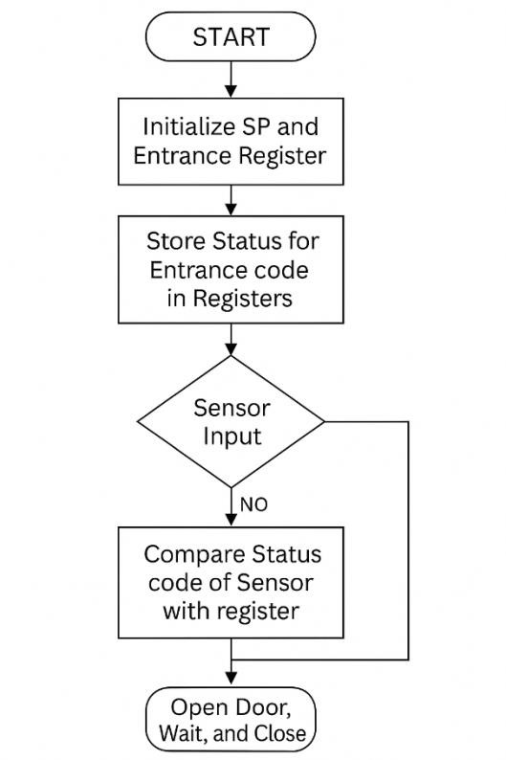

IV. SOFTWARE DESIGN

The system was created using the
Arduino IDE in embedded C. The algorithm follows these logical steps:
1.Initialization of the sensors, LCD, and motor driver.
2.Continuously read values from the ultrasonic and PIR sensors.
3.If an object is detected in the range and confirmed motion, a signal is sent to open the door.
4.Display Entrance Door Opening on the LCD.
5.Wait a fixed delay.
6.Close the door automatically and update the LCD to show Entrance Door Closing.
7.Repeat in a loop indefinitely.
Simulation testing in Proteus software validated the circuit connections and control logic prior to hardware implementation.

V. RESULTS AND DISCUSSION

The microprocessor-based automatic door opener offers users a reliable and efficient automation system. When paired with passive infrared (PIR) or ultrasonic sensors, the system accurately detects the presence of a person or object within a set area and activates the starting mechanism.

VI.OBJECTIVES OF THE PROJECT
The following results are commonly noticed:
The system provides convenience and accessibility while also improving user comfort. It does this by detecting movement or proximity, triggering the start sequence, and closing the door or gate after a set time.

Real-time responses from the microprocessor (like 8051, Arduino, or PICI microcontrollers) minimize the delay in detection and actuation.

In climate-controlled environments, the system helps save energy by limiting the time the door stays open.
The system enhances user convenience and accessibility by precisely detecting motion or proximity, starting the opening sequence, and shutting the door or gate after a predetermined amount of time.

Real-time responses from the microprocessor (like an 8051, Arduino, or PIC microcontroller) reduce the delay between detection and actuation.

In climate-controlled settings, the system helps save energy by reducing the amount of time the door is open.

VII.LITERATURE OVERVIEW

The main purpose of this project is to design and create a contactless automatic door system that works through detecting human presence.
The following goals are additionally included:
- Reduce the spread of infectious diseases through lack of contact with a door handle.
- Design a low-cost and energy-efficient system of automation.
- Assist in accessibility for differently-abled and elderly people.
- Show the use of sensors and microcontrollers to demonstrate a system of intelligent control.
- Give real-time feedback through an LCD.

There are many models proposed for automatic doors.
Older systems use infrared and light-dependent resistors (LDR) with microcontroller circuitry. These worked well inside homes but often trigger false signals due to light changes. Recent developments include the Arduino Microcontroller, which makes programming and connecting simpler.

One example is found in secure entry systems, such as entry counters and real-time clock displays for libraries that use PIR sensors. Another example is the Covid Safe Door Models, which use ultrasonic sensors to detect human movement without people being too close to the door. Recently, microprocessor-based systems have emerged that gather data from various sensors. These systems combine the data to maintain speed and direction control. The system shown in this work features a unique design.

VIII.SYSTEM COMPONENTS

A. Arduino Uno
The Arduino Uno serves as the brain of the system. It is an 8-bit microcontroller board based on the ATmega328P. It processes input data from sensors and outputs control signals to actuate the motor driver. It operates on 5V DC and is programmable using the Arduino IDE.

B. Ultrasonic Sensor (HC-SR04)
This sensor measures the distance between the door and a nearby object using sound waves. It has two modules: a transmitter that sends ultrasonic pulses and a receiver that detects echoes. The Arduino calculates distance using the time difference between sending and receiving signals.

C. Motor Driver (L293D)
The motor driver acts as a bridge between the Arduino and the motor. It amplifies the control signals from the Arduino to drive the DC motor in both forward and reverse directions. This enables smooth door opening and closing.

D. DC Motor
A small geared DC motor converts electrical energy into mechanical motion, which drives the door panel. The motor’s rotation direction determines whether the door opens or closes.

E. Power Supply
A 12V regulated power supply powers the motor and Arduino through a voltage regulator. It ensures stable operation and protects components from voltage fluctuations.

IX.SIMULATION AND TESTING
The circuit was first simulated in Proteus Professional software. The Arduino code was uploaded, and virtual sensors were connected to verify operation. After successful simulation, the circuit was implemented on a breadboard.
Observed Results:
PARAMETER | Measured  Value | EXCPECTED  OUTCOME
Sensor range | 2 meters | Accurate detection
Door response time | 1 second | Immideate
Delay before closing | 7 sec | Adjustable
Power supply | 12 V DC | stable
False triggers | minimal | Reliable Detection

The door consistently opened when a person approached and closed automatically after the delay. The system showed high reliability under different lighting and environmental conditions.
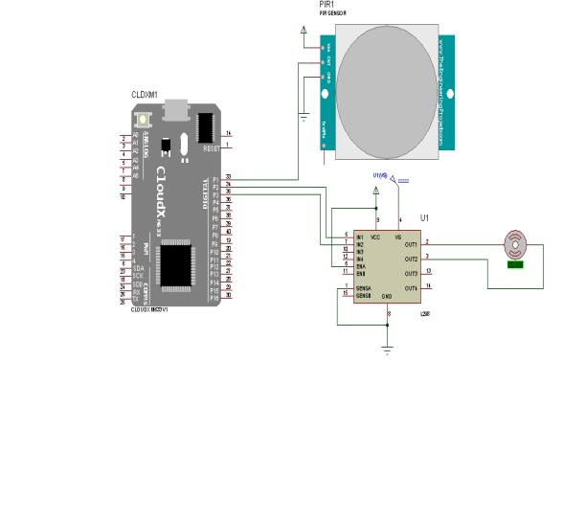
Model Picture of Automatic Door Opener

X.ADVANTAGES
- Touchless Operation: Eliminates disease risk associated with common contact surfaces
- .Energy Efficient: Door only opens when required, eliminating the need for motorized operations while the door is closed, reducing battery energy consumption.
- User-Friendly: Easy to configure and allows for low maintenance.
- Cost-Effective: Electronic components are common electronic components.
- Scalable: Could be used with RFID, or IoT modules for use in smart buildings.

XI.APPLICATIONS
- Hospitals and clinics for hygienic access.
- Libraries and educational institutions.
- Shopping malls and supermarkets.
- Airports, railway stations, and offices.
- Homes for elderly and differently-abled persons.

XII. CONCLUSION
An automatic door control system with low/no contact is fully implemented and functional using Arduino and some sensors. The controllable door will improve safety, hygiene, and convenience without touching. This model can be augmented with advanced functionality such as RFID based access control, IoT based monitoring, and facial recognition for customized security systems. The proposed solution is cost effective and easily adaptable to a modern smart infrastructure.

XIII.REFERENCES
- T. H. Thoung and Z. M. M. Myo, “Implementation of Automatic Door Opening System with Entry Counter for University Library,” IJTSRD, vol. 3, no. 5, 2019.
- I. Kumar, R. Pradhan, and N. Pattnaik, “Automatic Door Opening and Closing,” DogoRangsang Research Journal, vol. 8, no. 1, 2018.
- J. Chaudhary and H. Kumawat, “MicroprocessorBased Automatic Door Opener,” IIT Jodhpur Technical Report, 2011.
- M. McRoberts, Beginning Arduino, 2nd ed., Apress, 2016.
- A. M. Zunger and P. O. Abraham-Attah, “Digital Automatic Sliding Door with Room Light Control,” IJRTE, 2018.

[6] A Deep Learning Approach to Door Open and Close Monitoring Systems
Utilizes an STM32 microcontroller and deep learning for real-time door status monitoring.
[Journal of Microprocessor and Microcontroller
Research, 2024]

[7] An Automatic Sliding Doors Using RFID and Arduino
Designs a sliding door system controlled by RFID for secure access.
[International Journal of Artificial Intelligence &
Robotics, 2020]

[8] Design of Automatic Sliding Door Based on
Arduino Using Ultrasonic Sensors Develops a touchless sliding door system using ultrasonic sensors to prevent COVID-19 transmission.
[DINAMIS, 2021]

[9] Design and Analysis of Automated Pneumatic Door System
Proposes an automated pneumatic door system for buses to enhance passenger safety.
[IJRASET, 2022] \

[10] Elevator Door Automatic Control System
Discusses a microprocessor-based control system for elevator doors using a three-phase inverter.
[Applied Mechanics and Materials, 2011]

[11] Real-Time Activity Recognition and Intention
Recognition Using a Vision-based Embedded System Implements a vision-based system for recognizing human activities and intentions near automatic doors.
[arXiv, 2021]
[12] Toward Smart Doors: A Position Paper Explores the development of smart doors that predict user intentions to optimize energy and access control.
[arXiv, 2022]

[13] A Digital Automatic Sliding Door with a Room Light Control System
Designs an automatic sliding door integrated with a room light control system using infrared sensors.
[arXiv, 2013]

[14] Secure Electronic Lock Using PIC 16F628A Microcontroller
Develops a secure electronic lock system with automatic door opening capabilities using a PIC microcontroller.
[arXiv, 2012]

[15] An Electronic Safe with Automatic Door Opening System
Discusses a project involving an electronic safe with an automatic door opening mechanism using a PIC18F4550 microcontroller.
[Reddit, 2021]

