Online Learning Preferences and Effectiveness: A Quantitative Study of Student Behaviour

Rakesh Kumar
Department of Computer Engineering & Applications
GLA University, Mathura
rakesh.kumar@gla.ac.in
Kanchan Yadav
Department of Electrical Engineering
GLA University, Mathura
kanchan.yadav@gla.ac.in

Abstract— This research investigates student behaviours and preferences for online learning to assess their perceived effectiveness. This study aims to identify the key elements that affect satisfaction and engagement experienced by student in the online learning, particularly considering the shift of learning from classrooms to online e-learning, because of the COVID-19 pandemic. The quantitative approach was used in that data attached from a structured questionnaire was collected from college students that focused on student experience, preference and challenges for online learning. The data is pre-processed and then placed in a algorithm for classification for each of the learning achieved behaviours. The study presents some key research findings that include Accessibility to the technology, Content delivery and Learning styles were determinants of perceived effectiveness in online learning environment. Also, was identified differences in male and female student traffic in their transition to online learning. The conclusions are an important contribution for advances educators and organizations to consider when trying to improve online learning and implement lifetime learning for the e-learning design interventions. Ultimately, it is hoped the overall efficacy of online education will be improved.
Keywords— Online learning, Machine learning in education, Digital education, E-learning preferences, Technological barriers,

Introduction
After the COVID-19 pandemic, wherein educational institutions around the world moved away from more conventional in-person learning to online learning platforms, online education seems to have become an important part of the educational landscape. Many people, however, often have some opinions, whether positive or negative, about the effectiveness of this change and whether students can cope and can thrive in this student learning experience [1]. As the availability of online courses increases in educational institutions, it is essential to consider both the desired learning experience for the learner and the actions engaged in to enhance the online learning it is essential to take into account the experiences and engagements of our learners to enhance on-line learning [2-4]. The aims of the study presented here is to analyse the trends of moving the learning process online, discover what students like and do not like about the online student learning experience, as well as investigate the effectiveness of the online learning environments [5-6].
The aims of this research are to:
- Identify important elements that play a role in students’ preferences toward online learning.
- Examine the effectiveness of online learning platforms from the perspective of student behaviours.
- Evaluate how variations in student learning behaviours impact student learning in virtual classrooms.
- Generate practical recommendations for educators and educational institutions to strengthen the effectiveness of an online learning situation.
This research explores behaviours and preferences towards different online learning platforms of college students. The study employs a quantitative approach through a questionnaire of fixed responses with students regarding their experiences in online learning. The analysis involves categorical and analytical data analysis using a machine learning algorithms. The study explores several themes to include the following, student engagement, access to technology, learning strategies, and learning modalities. It also considers effects of gender on behaviors in the transition to online learning [7-9].

Literature Review

Overview of Online Learning Platforms
In the last two decades, there has been tremendous development in online learning platforms. This is in light of development in the digital technologies and the growing need for better, easy access to education. More and more people are using sites like Moodle, blackboard, Google Classroom and others to teach and attend online classes. Massive Open Online Courses (MOOCs) offered through platforms like Coursera and edX have improved educational access by allowing students from around the world to take part in high-quality courses from some of the most reputable educational institutions. Similarly, online coaching platforms in India, such as Unacademy, Physics Wallah, and Career will, changed the coaching industry, particularly in a post-Covid-19 world [10]. The overall structure and features of the learning interfaces of these platforms played a significant role in facilitating online learning by supporting collaborative work, self-paced study, and accessibility. However, some research suggests the usefulness of the platform was sometimes affected by the design and usability of the user interface, whether or not support was made available, and whether synchronous or asynchronous tools were used for learning; meaning that the design and usability of navigation and learning approaches affected how effective each platform was for learning [11].

Preferences in Online Learning
Student preferences in online learning vary significantly depending on several factors such as individual learning styles, technological accessibility, and prior experience with online education as shown in fig. 1.
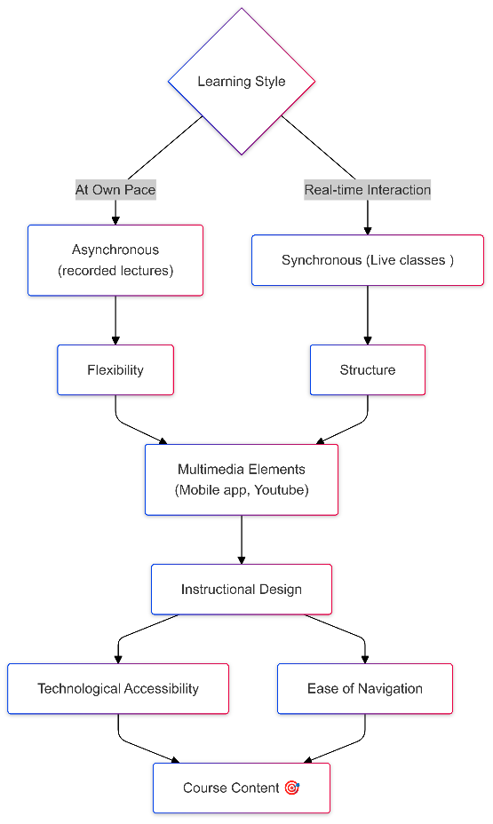
Fig. 1. Learning preferences of students
There are some students who enjoy taking an asynchronous course because it gives them the flexibility to work through course content at their own pace. Other students like taking a synchronous course because they appreciate and value the real-time instructor-student and student-student interaction. Research indicates that while students appreciate flexibility in online courses, they also appreciate the structure provided by regular live sessions and assigned due dates. Research has shown that students interested in e-Learning preferred courses that utilized multimedia such as video lectures, interactive simulations, and discussion forums to enrich their engagement and learning experience [12-14].

Effectiveness of E-Learning
E-Learning warrants consideration in terms of various factors that contribute to its efficacy. Such factors may include the effectiveness of instructional design, learner engagement, and technology infrastructure. Research suggests that online courses that are well-designed and include active learning activities (e.g., quizzes, group discussions or peer feedback) will contribute to more effective learning outcomes. E-Learning efficacy is also related to the support systems in place, both technical and pedagogical. Research demonstrates that if students receive technical support in a timely manner and engage with their academic advisor, it is likely that they will perform better in their online course. Additionally, reliable internet access and appropriate devices were also noted as key factors in the student experience in their uptake of the e-Learning experience [15-16].

Behavioural Aspects of Online Learning
The behavioural factor is a significant predictor of student success in online learning. One of the most important behavioural factors is engagement, self-discipline, and motivation. Research has indicated that students with high degrees of intrinsic motivation and self-regulation will perform better in an online course environment. Conversely, those students who struggle with time management, or do not motivate themselves, will often find it challenging to keep pace with the demands of the online learning environment to be successful in the course.
Students who actively participate with discussion forums, collaborate with classmates about their learning, and have synchronous interaction with their instructors are much more likely to report learning and satisfaction about their studies. Sadly, however, the problem persists for students to develop these behavioural traits while engaged in an online format, and students frequently will feel isolated, disconnected from their learning community [18].

Gaps in Existing Research
Previous research on the efficacy and implementation of online education has been numerous, but there are still many gaps in this field of inquiry [20-21]. To start, many of the current research focus predominately on technical and pedagogical issues of online learning and do not prioritize the understanding of online learning experience of demographic populations, including groups underrepresented. Further, although there are some studies that talk about student preferences for online learning, few studies have explored how preferences change over time or are related to external influences, such as technological advances and changes in the educational landscape [21].
Second, there is a gap in studies focused on the analysis of the behavioural aspects of students in online learning. Researchers need to examine more effectively to identify psychological factors that contribute to student engagement and performance in online learning. There is some evidence suggesting that factors such as self-regulation and motivation are essential for effective online learning. Moreover, there is also limited research investigating the potential long-term benefits of online learning that extends beyond whether a student completed a course, or the type of assessment used immediately after the course is completed [22-24].

Research Methodology

Research Design
As the current paper follows a quantitative approach to the analysis of student behaviour and their preferences as well as the effectiveness of the online learning platforms (see fig. 2). The present study uses a cross-sectional research design to explore the students’ experiences of e-learning and gathers information only once. To become a participant, the person must fill out a structured questionnaire; then, the collected data are analysed by machine learning algorithms, while infrequent ~ patterns of behaviour of students are determined. This design allows the identification of the factors affecting the students’ decisions concerning the online learning modality and the chain effect of such decisions on the students’ performance.
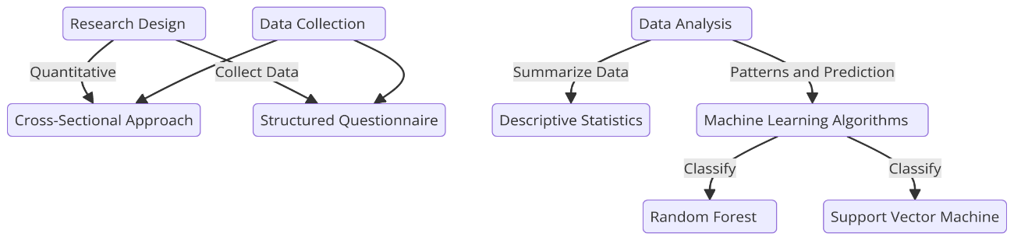
Fig. 2. Research design and data collection

Data Collection
An online self-developed structured questionnaire was created and administered to college students who are actively enrolled in their online classes to obtain data for this study. To ensure maximum cooperation in completing the questionnaire as many individuals as possible, the questionnaire was administered online through email and social media sites. Specifically, the purpose of the study was to determine what type of elements students enjoyed, their level of satisfaction, their level of interest or motivation and the issues faced by students in digital learning environments.

Questionnaire Design
The survey contained closed and open-ended questions that sought to get information about students’ encounter with online learning. It consisted of several sections:
- Demographic Information: Age, gender, academic year, and previous experience with online learning.
- Technology Availability: Access to devices, internet connectivity issues, and experience with online learning.
- Learning Preferences: Preferred learning modes (synchronous and asynchronous), methods of content delivery (video, reading or interactive tools) and types of interaction (discussion forums and/or live sessions).
- Engagement and Motivation: Questions related to self-discipline, motivation levels, and engagement in course activities.
- Effectiveness and Satisfaction: Perceived effectiveness of online learning, satisfaction with course design, and overall learning experience.
The questionnaire used a 5-point Likert scale (ranging from “Strongly Disagree” to “Strongly Agree”) to capture the intensity of students' preferences and experiences. Open-ended questions were also included to provide respondents an opportunity to elaborate on their challenges and suggestions for improvement.

Sample Selection
Participants for this study included Undergraduate and Graduate students, from different fields of specialization, who are presently enrolled for online classes. convenience sampling was used to reduce the need to generalise the results and ensure that all the participants have prior experience in online learning. The survey proposed to sample at least 300 students in the students’ population in order have a large enough sample to conduct statistical analysis. The last sample contained students from public and private educational institutions to achieve variability in their experience with online learning.

Machine Learning Algorithms
To ascertain the relationships in student behaviour and to make a prediction about what may affect the online learning effectiveness, machine classification algorithms were used on the dataset. Therefore, we employed the Random Forest and Support Vector Machine (SVM) algorithms for classification of student’s preferences, engagement and satisfaction. These models were selected because each can accommodate non-linearity in the relationship between the predictor or combination of them and the response variable.
- Random Forest: Decision tree-based ensemble learning method where many decision trees are designed with an aim of reducing the overfitting and enhance the accuracy of the model.
- SVM: An efficient classification technique that identifies the position of the hyperplane that best separations data points into different classes.
The performance of these models was evaluated using metrics such as accuracy, precision, recall, and F1-score. The goal was to identify which factors (e.g., engagement, technological access) had the most significant influence on student satisfaction and learning outcomes.

Data Analysis and Results

Overview of Survey Results
The survey gathered responses from 350 students across different academic disciplines. Of those students surveyed, 60% were female and 40% were male. The respondents were first semester college students and postgraduate students enrolled in online classes. The survey was intended to better understand students’ preferences towards online learning, how their preferences affected the outcomes of the online learning environment and how students conduct themselves in online learning environments. The survey mainly aimed to understand different aspects of the workings of online learning; efficiency of technology, modalities of delivery of content and engagement with online platforms.
The survey indicated that the majority of 75% of students admitted to having a rather positive attitude towards online learning with flexibility and convenience being their primary benefits. However, 40% of the students surveyed indicated that concerns about motivation and interest towards virtual learning environments was a problem. This showed that even while the online learning model is quickly being adopted there are still major challenges that persist when it comes to students’ behavior and learning in the virtual spaces of education.

Student Preferences for Online Learning
The survey conducted among student participants only the data on student preferences revealed several main findings:
- Preference for Content Delivery: Most of the students surveyed preferred both the Synchronous (30%) and Asynchronous (35%) learning modality with 65% choosing either option. The synchronous classes maintain the same atmosphere as the traditional on-campus classes, yet the asynchronous resources allow us to study at our own pace and address our personal needs. The response demonstrates that we, fewer than 20% of us, opted to use a fully asynchronous course delivery which illustrates the significance of real-time interaction when we are online.
- Preference of Multimedia over text notes: More than 70 percent of us like multimedia to text notes. Classes with video lectures, interactive quizzes, and simulation tools were popular with us. The majority of the responses indicated that text-based materials or reading was not as interesting compared to multimedia options.
- Interaction and Collaboration: 60%of students considered discussion forums and group projects a significant part of interactive elements in online learning platforms. Students noted that discussion forums and collaborative experiences were necessary to facilitate community and peer collaborative experiences to optimize motivation in online environments.
- Preferred Platform: Google Classroom and Zoom emerged as the platforms with the highest preference as over half the students described themselves as satisfied with the platforms. Students gave Moodle and Blackboard mixed ratings, feel usability and appearance could improve.

Factors Affecting the Effectiveness of Online Learning
A handful of factors appeared to be key to online learning effectiveness:
- Tech Access: Students indicated good tech access was very important to their overall online learning experiences. 85% reported that having a reliable internet connection and privilege of a laptop or tablet made an enormous difference in online learning effectiveness. Comparatively, students who reported very little or inconsistent access to most of the tech resources indicated a much lower satisfaction level and a much higher frustration level with everyday learning online.
- Instructor Engagement: While the 70% of respondents did find that instructor engagement and personalization did impact overall online learning effectiveness, they also found it impacted their overall experience. Instructors who used multimedia tools, participated in discussions, and gave timely personalized feedback were found to enhance overall student satisfaction with the learning experience.
- Course Design: Those courses that had well-defined objectives, frequent assessments, and multiple assignments and activities turned out to be more effective as opposed to courses without structure and dynamic course content.

Analysis of Student Behaviour in Virtual Learning Environments
The analysis of the behaviours of the surveyed participants highlighted the following trends in students’ participation in the online learning environment:
- Engagement: Many students who participated in the discussion forums, regularly attended live classes, and submitted their work on time reported a greater degree of satisfaction in their learning experience. For instance, 55% of my sample indicated self-discipline was a factor in meeting their success in the virtual learning environment while 45% of my sample reported facing challenges with motivation and engagement in learning without the use of face- to-face interaction.
- Time management: An important disposition was the students under study exhibiting effective time management to be successful in their online learning. Students who used effective time management skills (60% of sample) showed higher performance levels and degree of satisfaction, while students, who were dispositions not effective time management (40% of original sample) had difficulty keeping up with course work.
- Motivation: Intrinsic motivation is considered an important contributor to educational success. Students with relatively high motivation (50%) were identified in the research as likely to participate in active learning and perform positively, while students with lower motivation (30%) were likely to disengage from learning activities.

Gender-Based Behavioural Differences
The results indicated that there were some gender differences regarding behaviours and interests in online learning.
- Engagement: Female learners were more likely to engage in discussion forums and group projects than male learners. 65% of female participants reported the degree to which they participated in collaborative work, while 45% of male students provided a same response.
- Time Management: Female students also exhibited better time management skills. 70% of female students reported the degree to which they were able to manage their time while studying, compared to 55% of male students. This is consistent with past research that female students display higher levels of self-discipline in academics.
- Learning Preferences: Male students (30%) seemed to express a greater preference for asynchronous or online learning than female students (15%), who focused more on the synchronous nature of the interaction rather than the experience of the live or real-time session. This continues to support and grow the understanding that students' gender may play a factor in their preferences regarding how online courses are structured.

Machine Learning Model Accuracy Comparison
Machine learning models were applied to analyze the dataset and classify and predict students' learning preferences and behaviours while interacting with online learning. The two modelling approaches - the Random Forest model and Support Vector Machine (SVM) model - were evaluated based on their predictive ability for student engagement and satisfaction. The results are summarized in Table 1.
Table 1. Performance evaluation
Machine learning technique | Accuracy | Precision | Recall | F1-score
Random forest | 93% | 0.92 | 0.94 | 0.93
SVM | 88% | 0.89 | 0.90 | 0.88

Conclusion
The objective of this research was to study the student behaviour towards E-learning. For this a survey was conducted and machine learning algorithms were applied to that data. The majority of students preferred learning that included some combination of synchronous and asynchronous models of learning, multimedia formats, and interactive tools. Factors that had the most significant positive impact on effectiveness in learning online were access to technology, teachers' engagement, and course design that was interactive and engaging for students. Engaged teachers, managing their time, and intrinsic motivation were all paramount to students' educational success and satisfaction in school. Gender differences indicated that female students showed more engagement and time management skills than did male students. The Random Forest algorithm was best at predicting student satisfaction based on behaviours. This finding supports the potential of using data science to help strengthen online learning. Educators should consider blended learning in the future while increasing teacher engagement, improving access to technology, and supporting students in their motivation to study and good time management skills. Future studies may also want to think about longitudinal studies, intervention based on behaviours, variations in populations, and more complex machine learning algorithms.

References
- Allen, I. E., & Seaman, J. (2017). Digital Learning Compass: Distance Education Enrollment Report 2017. Babson Survey Research Group.
- Hodges, C., Moore, S., Lockee, B., Trust, T., & Bond, A. (2020). The difference between emergency remote teaching and online learning. Educause Review, 27.
- Means, B., Toyama, Y., Murphy, R., & Baki, M. (2013). The effectiveness of online and blended learning: A meta-analysis of the empirical literature. Teachers College Record, 115(3), 1-47.
- Muilenburg, L. Y., & Berge, Z. L. (2005). Student barriers to online learning: A factor analytic study. Distance Education, 26(1), 29-48.
- Singh, V., & Thurman, A. (2019). How many ways can we define online learning? A systematic literature review of definitions of online learning. American Journal of Distance Education, 33(4), 289-306.
- Zhu, X., & Liu, J. (2020). Education in and after Covid-19: Immediate responses and long-term visions. Postdigital Science and Education, 2(3), 695-699.
- Blackmon, S. J. (2018). MOOCs and the Future of Higher Education. *Online Learnin5.
- Sun, A., & Chen, X. (2016). Online education and its effective practice: A research review. Journal of Information Technology Education, 15, 157-190.
- Bao, W. (2020). COVID-19 and online teaching in higher education: A case study of Peking University. Human Behavior and Emerging Technologies, 2(2), 113-115.
- https://www.leadsquared.com/industries/edtech/edtech-companies-in-india/
- Alqurashi, E. (2019). Predicting student satisfaction and perceived learning within online learning environments. Distance Education, 40(1), 133-148.
- Zimmerman, B. J. (2002). Becoming a self-regulated learner: An overview. Theory Into Practice, 41(2), 64-70.
- Song, L., & Hill, J. R. (2007). A conceptual model for understanding self-directed learning in online environments. Journal of Interactive Online Learning, 6(1), 27-42.
- Shea, P., & Bidjerano, T. (2010). Learning presence: Towards a theory of self-efficacy, self-regulation, and the development of a communities of inquiry in online and blended learning environments. Computers & Education, 55(4), 1721-1731.
- Jaggars, S. S. (2014). Choosing between online and face-to-face courses: Community college student voices. American Journal of Distance Education, 28(1), 27-38.
- Garrison, D. R., Anderson, T., & Archer, W. (2000). Critical inquiry in a text-based environment: Computer conferencing in higher education. The Internet and Higher Education, 2(2), 87-105.
- Martin, F., & Bolliger, D. U. (2018). Engagement matters: Student perceptions on the importance of engagement strategies in the online learning environment. Online Learning Journal, 22(1), 205-222.
- Bigatel, P. M., Ragan, L. C., Kennan, S., May, J., & Redmond, B. F. (2012). The identification of competencies for online teaching success. Online Learning Journal, 16(2), 59-77.
- Stone, C. (2017). Opportunity through online learning: Improving student access, participation, and success in higher education. Australian Journal of Adult Learning, 57(2), 286-308.
- Glazier, R. A. (2016). Building rapport to improve retention and success in online classes. Journal of Political Science Education, 12(4), 437-456.
- Kauffman, H. (2015). A review of predictive factors of student success in and satisfaction with online learning. Research in Learning Technology, 23.
- Creswell, J. W., & Creswell, J. D. (2017). Research Design: Qualitative, Quantitative, and Mixed Methods Approaches (5th ed.). SAGE Publications.
- Bryman, A. (2016). Social Research Methods (5th ed.). Oxford University Press.
- Hair, J. F., Black, W. C., Babin, B. J., & Anderson, R. E. (2019). Multivariate Data Analysis (8th ed.). Cengage Learning.

