Cross-Learning Approach for Automated Segmentation of Residential Solar Panels in Satellite Imagery

Puneet Sharma
Department of Computer Engineering & Applications
GLA University, Mathura
puneet.sharma@gla.ac.in
Arti Badhoutiya
Department of Electrical Engineering
GLA University, Mathura
arti.badhoutiya@gla.ac.in

Abstract - The separation of small-scale residential solar panels (RSPs) through the utilisation of satellite imagery has emerged as a significant challenge in the field of data science within the renewable energy industry. The purpose of this paper is to present a cross-learning-driven approach, as well as its extension, adaptive Cross Nets, which is intended for the automatic segmentation of RSPs in satellite imagery. For the purpose of improving the accuracy of RSP segmentation, the proposed methods make use of a collection of generic U-Nets that collaborate with one another. Initially, each generic U-Net that is a part of the Cross Nets ensemble is independently initialised by employing either transfer learning or traditional initialisation techniques. All of these techniques are used. Following that, we put into action a novel training strategy known as cross learning, which serves as a constraint in order to optimise the Cross Nets in a more efficient manner. During this process, every U-Net is responsible for updating its parameters on an individual basis at each epoch. Subsequently, the parameters of the U-Net that has performed the best at particular epochs are adapted. The dependence of generic U-Nets on precise initialisation is reduced through the use of cross learning, which ultimately results in improved optimisation.
Keywords: small scale residential, cross nets, generic , cross learning , u-net , segmentation

INTRODUCTION
In the last twenty years, solar energy has become one of the most promising renewable energy sources, helping to meet the world's increasing energy needs and promote sustainable living. The bulk of solar energy research has focused on a number of topics, such as the design and manufacturing of solar modules, system control technologies, and fault diagnosis and condition monitoring. Among these, photovoltaic (PV) technology has attracted a lot of attention because it can directly convert solar radiation into electricity; as a result, PV installations are growing 40% year over year globally. Small-scale solar panels, especially residential solar panels (RSPs), have been more prevalent on building rooftops in recent years. Therefore, gathering data on RSP installations is essential for analysis and planning the further development of solar energy.
With the help of a multifeatured joint sparse coding model and a spatial relation constrained classifier, Zheng et al. [16] proposed that it would be possible to recognise 21 distinct land-use classes in satellite images. Furthermore, they suggested that this could be accomplished. In their article [17], Yuan and colleagues discuss a method that can automatically remove clouds from satellite images. For the purpose of obtaining local features, a scale-invariant feature transform (SIFT) was utilised, and a bag-of-words model was utilised for the purpose of reducing their size. In order to locate the cloud, a support vector machine (SVM) and the GrabCut algorithm were utilised. These methodologies were based on compressed features. For the purpose of sorting satellite images by pixels, the work that was done by Agrawal and colleagues [18] demonstrated a neural network (NN) model that makes use of multi-objective particle swarm optimisation. In some of the studies that have been reported, the solar panels were separated into groups using the conventional methods. For the purpose of classifying solar panels pixel by pixel using satellite images, Malof et al. [19] utilised the mean and variance of colour statistics to describe pixels by their corresponding neighbours. Additionally, they utilised random forest (RF) to classify solar panels. On the basis of [19], Malof et al. [20,21] demonstrated how to locate solar panels at the pixel level by utilising the same feature descriptor and advanced classifiers that made use of a deep convolutional neural network (CNN) [22]. Despite the fact that CNNs were said to have advantages in [20, 21], the classification of solar panels at the pixel level was not significantly improved and continued to rely heavily on features that were created manually. The process of obtaining features from various RSPs in order to classify each pixel in satellite images is not only difficult to accomplish, but it also takes a significant amount of time and a significant amount of money.
An innovative approach to the separation of solar panels in aerial photographs was proposed. An enhanced FCN backbone serves as the foundation for this network, which is known as the ConvNet. The new deep learning method [29] addresses issues that were present in older computer vision methods, which made it difficult to classify pixels on an individual basis. On the other hand, the careful planning and establishment of network structures has the potential to alter the efficiency with which it operates. To add insult to injury, the feature extraction of FCN that is utilised in ConvNet requires significant jumps in upsampling in order to accommodate the output size, which may result in the loss of information. The literature works that investigate semantic segmentation using satellite images are listed in Table 1, which is a list of related references. Over time, the computer vision techniques that are utilised for semantic segmentation on satellite images have evolved from simpler techniques to more complex ones that are developed using the most recent deep learning techniques.

METHODOLOGY
The technique that is suggested for segmenting RSPs using satellite imagery is a cross-learning-driven U-Net (CrossNets), and an explanation of this technique is provided in this section. As part of CrossNets, we consider the possibility of utilising a community of potential U-Nets in order to develop a more effective U-Net-based model for the RSP segmentation. Uk, where k = 1, 2,..., K, is the kth generic U-Net that is included in the CrossNets community. The number K determines the size of the CrossNets community. Each individual Uk begins with its own unique collection of parameters, denoted as θk. For the purpose of training CrossNets, cross-learning is an interactive method that makes it simpler to locate a superior U-Net, Uo, where o is a number that falls within the range of k. The final RSP segmentation result of CrossNets is made based on the information provided by Uo. It is possible to think of the process of creating CrossNets for RSP segmentation as an optimisation problem within the context of the cross-learning constraint shown in (1). The objective is to get every Uk to perform to the best of its abilities and then select the best one as the U.
$$Uo\left(Θo\right)=maxUk\left(Θk,xk\right), k=1,2,…K$$
$$s.t. Cross\left(Θi||Θj\right),i,jϵk$$
Where Xk represents input data fro kth cross nets.
TABLE 1: SEMANTIC SEGMENTATION USING IMAGES
Objects | Feature Extraction | Decision Methods
Building | Color Statistic | Fuzzy Stacked Generalization
Cloud | SIFT | Spatial Relation
Solar Panel | Spectral Brands | SVM
Solar Panel | Local Color Statistic | RF

DEVELOPMENT PROCEDURE
The steps that will be taken to create the CrossNets that have been proposed are depicted in Figure 1.
From what can be seen in Figure 1, the development of CrossNets is broken down into two distinct stages: the training phase and the learning suspension phase. On the other hand, the Uk,i represents the one-of-a-kind kth generic U-Net, the parameters of which were modified at epoch i. During the beginning stages of the development process, every single Uk in the community begins with a unique collection of parameters. Following that, there will be a phase of training, followed by a phase of learning suspension.
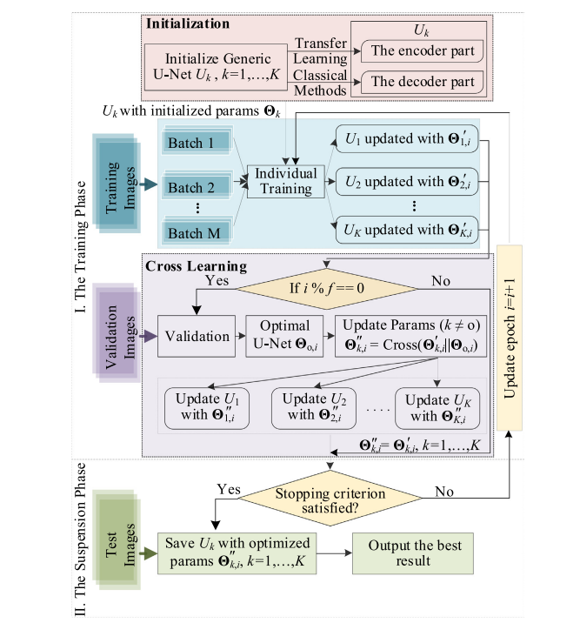
Figure 1 : Process Development Flowchart for the proposed methodology
Step 1: Training Phase
The data batches that are used to train each Uk,i are guaranteed to be the same for each epoch; however, the order in which they are used is subject to random variation. When the epoch i occurs, the updated model parameters for every Uk are displayed by the symbol Θ′ k,i. At the beginning of each Uk, there is a parameter Θk that is initialised. When further optimising each Uk, cross-learning is performed every f epochs as a constraint in order to ensure optimal performance. The learning interval is denoted by the letter f here.
Step 2 : Learning Phase
For the purpose of ensuring that community training does not become overly useful too quickly, a maximum number of iterations is used as a stopping point.
The reason that each UK in the community suspends another is the same, but the manner in which they do so is different from one another. In the event that one of the trainings in the United Kingdom is put on hold because the criteria for stopping it have been satisfied, other members of the community will not be impacted. They are going to proceed to the subsequent round. The optimisation process will come to a halt if all of the United Kingdom meets the conditions for stopping.

Simulation results
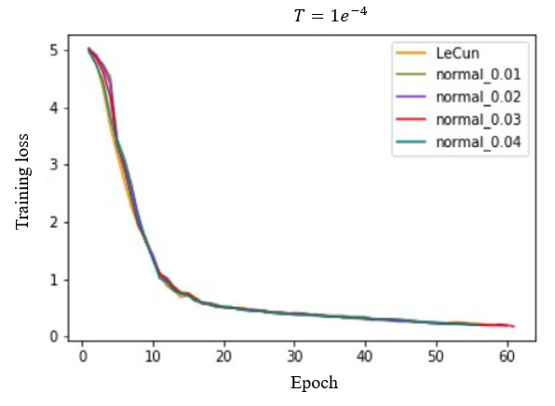
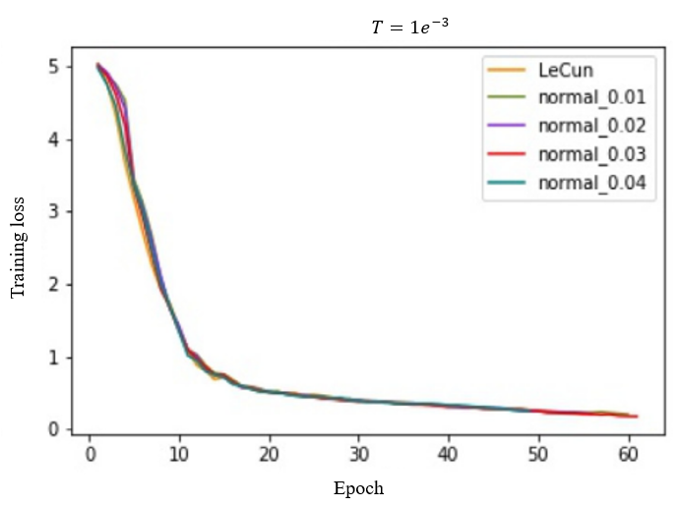
Figure 2 Training processes of adaptive CrossNets based on two different values of T.
The above figure depicts the training process of adaptive CrossNets. According to training processes, every single Uk that is a part of the group of adaptive CrossNets can be improved to the point where there are no issues. On the basis of two distinct Ts, the convergence rate of each Uk is approximately equivalent to one another. When the value of T is equal to 1e-4, this community is effective at segmenting more effectively. The average precision of the segmentation is higher, and the variance is lower than before. Because of this, the value of T is set to 1e-4 in adaptive Cross-Nets in order to provide a better and more stable performance on RSP segments.
TABLE 2: RESULTS FOR CROSSNETS AND ADAPTIVE CROSS NETS
Algo. | Cross-nets | Adaptive cross nets | Factors
IoU | 73.45 | 73.72 | Lowest
IoU | 74.82 | 74.88 | Highest
IoU | 74.25 | 74.28 | Average
IoU | 2.47 | 1.45 | variance

Table 2 above displays the final results, which were selected from the twenty experiments that were carried out. In order to arrive at the final results, the optimal segmentation outcomes from CrossNets and adaptive CrossNets were chosen.

CONCLUSION
This paper developed a cross-learning-driven U-Net called CrossNets and its extension, adaptive CrossNets, to automatically separate RSPs in satellite images.The method that was proposed involved the establishment of generic U-Nets through the utilisation of an initialisation technique that incorporated the most advantageous aspects of both traditional initialisation and transfer learning. It put in a lot of effort to develop the decoder side of things and came up with a way for people to learn from one another. A novel cross-learning mechanism was introduced as a constraint to enhance the performance of CrossNets. General U-Nets in the community were able to modify parameters one by one at each epoch by using cross-learning, and in some epochs, they were able to learn parameters from the top U-Net.Through the implementation of a new criterion known as the threshold T, the adaptive CrossNets training procedure was developed to be more effective. By doing so, it prevented every generic U-Net in the community from gaining an excessive amount of knowledge through interaction. To determine how well the proposed methods could differentiate between different objects, they were initially evaluated using satellite images of the city of Fresno in the United States. In order to integrate the educational experience, an appropriate cross-learning learning interval was chosen for the experiment. Simultaneously, the extra criterion in adaptive cross-learning was carefully chosen to avoid the problem of cross-learning communities becoming overly similar to each other.

REFERENCES
- J. Tao, S. Yu, Review on feasible recycling pathways and technologies of solar photovoltaic modules, Sol. Energy Mater. Sol. Cells 141 (2015) 108–124.
- C.T. Trinh, R. Schlatmann, B. Rech, D. Amkreutz, Progress in and potential of liquid phase crystallized silicon solar cells, Sol. Energy 175 (2018) 75–83.
- A.R. Jordehi, Maximum power point tracking in photovoltaic (PV) systems: A review of different approaches, Renew. Sustain. Energy Rev. 65 (2016) 1127–1138.
- H.H. Alhelou, M.-E. Hamedani-Golshan, R. Zamani, E. Heydarian-Forushani, P. Siano, Challenges and opportunities of load frequency control in conventional, modern and future smart power systems: A comprehensive review, Energies 11 (10) (2018) 2497.
- H. Haes Alhelou, M.E. Hamedani Golshan, T.C. Njenda, N.D. Hatziargyriou, An overview of UFLS in conventional, modern, and future smart power systems: Challenges and opportunities, Electr. Power Syst. Res. 179 (2020) 106054.
- H. Haes Alhelou, M.E. Hamedani-Golshan, T.C. Njenda, P. Siano, A survey on power system blackout and cascading events: Research motivations and challenges, Energies 12 (4) (2019) 682.
- E. Garoudja, F. Harrou, Y. Sun, K. Kara, A. Chouder, S. Silvestre, Statistical fault detection in photovoltaic systems, Sol. Energy 150 (2017) 485–499.
- F. Harrou, Y. Sun, B. Taghezouit, A. Saidi, M.-E. Hamlati, Reliable fault detection and diagnosis of photovoltaic systems based on statistical monitoring approaches, Renew. Energy 116 (2018) 22–37.
- Sarbu, C. Sebarchievici, Chapter 5 - solar water and space-heating systems, in: I. Sarbu, C. Sebarchievici (Eds.), Solar Heating and Cooling Systems, Academic Press, 2017, pp. 139–206.
- M.J.E. Alam, K.M. Muttaqi, D. Sutanto, An approach for online assessment of rooftop solar PV impacts on low-voltage distribution networks, IEEE Trans. Sustain. Energy 5 (2) (2014) 663–672.
- C. Toth, G. Jóźków, Remote sensing platforms and sensors: A survey, ISPRS J. Photogramm. Remote Sens. 115 (2016) 22–36.
- X. Zheng, X. Sun, K. Fu, H. Wang, Automatic annotation of satellite images via multifeature joint sparse coding with spatial relation constraint, IEEE Geosci. Remote Sens. Lett. 10 (2013) 652.
- Y. Yuan, X. Hu, Bag-of-words and object-based classification for cloud extraction from satellite imagery, IEEE J. Sel. Top. Appl. Earth Obs. Remote Sens. 8 (8) (2015) 24197–24205.
- R.K. Agrawal, N.G. Bawane, Multiobjective PSO based adaption of neural network topology for pixel classification in satellite imagery, Appl. Soft Comput. 28 (2015) 217–225.
- J.M. Malof, K. Bradbury, L.M. Collins, R.G. Newell, Automatic detection of solar photovoltaic arrays in high resolution aerial imagery, Appl. Energy 183 (2016) 229–240.
- J.M. Malof, L.M. Collins, K. Bradbury, R.G. Newell, A deep convolutional neural network and a random forest classifier for solar photovoltaic array detection in aerial imagery, in: 2016 IEEE International Conference on Renewable Energy Research and Applications, ICRERA, 2016, pp. 650–654.
- J.M. Malof, L.M. Collins, K. Bradbury, A deep convolutional neural network, with pre-training, for solar photovoltaic array detection in aerial imagery, in: 2017 IEEE International Geoscience and Remote Sensing Symposium, IGARSS, 2017, pp. 874–877.
- . Long, E. Shelhamer, T. Darrell, Fully convolutional networks for semantic segmentation, in: IEEE Conference on Computer Vision and Pattern Recognition, 2015, pp. 3431–3440.
- O. Ronneberger, P. Fischer, T. Brox, U-net: Convolutional networks for biomedical image segmentation, in: Medical Image Computing and Computer-Assisted Intervention – MICCAI 2015, 2015, pp. 234–241.
- G. Wu, et al., Automatic building segmentation of aerial imagery using multi-constraint fully convolutional networks, Remote Sens. 10 (3) (2018) 407

