Innovative Integration of Fuzzy Logic MPPT and Multi-String Inverters for Enhanced Solar Panel Efficiency

Puneet Sharma
Department of Computer Engineering & Applications
GLA University, Mathura
puneet.sharma@gla.ac.in
Yogendra Kumar
Department of Electrical Engineering
GLA University, Mathura
kumar.yogendra@gla.ac.in

Abstract— There is a growing need for renewable energy around the world, we need to find more efficient ways to improve the performance of solar panels. The utilization of fuzzy logic and multi-string inverters is utilized in this research project to enhance solar power systems. Fuzzy logic is analogous to a highly developed brain that is able to modify its methods of operation depending on the circumstances. Regardless of the temperature, your solar panels will continue to generate the maximum amount of electricity feasible, regardless of the temperature it is. Different groups of solar panels are able to function independently thanks to the architecture of the multi-string inverter. This results in a reduction in the amount of energy that is wasted and an increase in the reliability of the power supply. Due to the fact that it is simple to add to and keep up with, this technology is ideal for large solar farms. The experimental solution that we developed, which makes use of fuzzy logic MPPT and multi-string inverters, performed far better than the most effective inverter designs and methods that are currently available. In addition, the combination made solar panels perform significantly better, which led to excellent outcomes. This is a positive sign for the future of solar energy since it shows that technology could improve the efficiency of systems while simultaneously reducing their costs. The study's conclusions show how to make better sustainable energy technologies and give simple tips for anyone who wants to use more solar electricity.
Keywords— solar, energy, efficiency, cooling, panels

Introduction
One promising method of producing power is the use of photosynthetic (PV) cells. One of the main renewable energy sources that has been growing annually around the world is this abundant and pervasive resource. One major problem with solar photovoltaic (PV) generation systems is that, particularly in low irradiation conditions, the conversion efficiency of electric power production is very low—anywhere from 12% in standard units to 42.8% in highly specialized configurations. Another issue is that the amount of electric power that solar arrays produce can be affected by a number of external factors, such as temperature, age, load conditions, and isolation levels (incident solar radiation).
The most common method for maximizing the power output of solar modules is to link them to a maximum-power-point tracker (MPPT), which is a DC/DC converter. Due to the quick temporal fluctuations in solar irradiation, the maximum power point is constantly shifting to other curves. Therefore, the MPPT controller should allow the quickest possible attainment of the Maximum Power Point (MPP) in order to avoid power fluctuations and minimize system power loss[1].
In the context of photovoltaic (PV) systems, MPPT has been researched at length. Among the several strategies that have been suggested, one that should be prioritized is the use of intelligent systems to track the Maximum Power Point (MPP). Methods like perturb and observe (P&O), incremental conductance (IncCond), and hill climbing (HC) have been supplemented or replaced by a new breed of tracking algorithms. Fuzzy logic controller (FLC) models have proven to be incredibly valuable in the implementation of maximum power point (MPP) seeking in both linear and non-linear systems due to its heuristic nature, simplicity, and effectiveness. As a result, there have been a number of studies and applications that integrate FLC with Maximum Power Point (MPP) tracking.
As an example, Godoy demonstrated the superior performance of the fuzzy-based Maximum Power Point Tracking (MPPT) system under various environmental operating situations after integrating fuzzy logic control with MPPT. In addition, the authors record the experimental results of the fuzzy tracker, which demonstrated that the Maximum Power Point Tracking (MPPT) method outperformed the conventional method by more than eight times in terms of tracking speed when employing the P&O technique. In addition, our findings show that a photovoltaic system using the suggested controller can achieve a power efficiency of about 85%. For PV generating systems that are connected to the grid, an MPPT controller was also given as an example of this type of controller. Fuzzy logic control proved to be an excellent tool for increasing grid power extraction. Despite the beneficial results, all of the works share a flaw in the FLC design: they relied on trial and error rather than a methodical approach [2-4].
However, unless you know how to do it, this standard architecture is typically neither quick nor optimal. To overcome this issue, they might improve their Maximum Power Point (MPP) tracker's Fourier Transform (FLC) using the Genetic Algorithms (GAs) tool. Genetic algorithms (GAs) were employed to determine the base lengths and peak positions of the membership functions in the Federated Learning Community (FLC), which had a rule base. However, unless you are well-versed in it, this traditional design is typically neither quick nor efficient. To overcome this issue, they might improve their Maximum Power Point (MPP) tracker's Fourier Transform (FLC) using the Genetic Algorithms (GAs) tool. The base lengths and peak positions of the membership functions were determined by genetic algorithms (GAs) in the Federated Learning Community (FLC), which had a rule base. Active cooling and intelligent control systems, such as fuzzy logic, are simple ways to improve the performance of solar panels. Although solar panels are quite effective at converting sunshine into clean energy, they perform worse when they get too hot. Only a small portion of the energy from sunshine is converted into electrical power by solar panels. The panels get hotter as the remaining energy is converted to heat. The panels lose about 0.5% of their efficiency for every degree Celsius as the temperature rises. It may not seem like much, but it quickly mounts up. Fuzzy logic and active cooling may be useful in this situation. A clever method of controlling things that function similarly to human thought processes is fuzzy logic. The gray areas between on and off can also be managed by it. This is fantastic news because the performance of the panels is dependent on a number of factors, including the intensity of the sun's rays, the temperature of the air, the speed of the wind, and the amount of power required by the panels.
Simple "if-then" logic is used by fuzzy logic controllers to determine when to switch on and off the air conditioner. Based on factors like the temperature and the intensity of the sun, they determine when to freeze the panels. By maintaining the proper temperature, the panels can generate the most electricity. A fuzzy logic controller has to make a decision when the solar panels' temperature rises above a predetermined point. It can activate the cooling system to its maximum level in an attempt to reduce the temperature. This is where it becomes intelligent, though, because it either reduces or stops cooling as soon as it determines that it has cooled down sufficiently to save energy. Because it only operates when absolutely necessary, this clever technique is excellent for cooling the sun. Everything operates swiftly and efficiently, and it is impossible to cool off too much. When you consider how outdated systems only allowed you to adjust the temperature in a few different ways, it's light years ahead of the curve.
Active cooling uses machinery or power to transfer heat away from solar panels. While active cooling makes use of fans, pumps, or specialized coolers, passive cooling only functions when air flows. It's normal practice to cool things down using fluid. This is how coolant or water is delivered to the panels via the tubes behind them. The liquid absorbs the additional heat after passing through a heat exchanger and returns to its initial state. In locations with high levels of sunlight, where the panels become extremely hot, this works fantastically. By lessening heat damage, it keeps things cooler and improves their functionality. Another choice is a thermoelectric cooler. To remove excess heat from the panels, they use the Peltier effect. These devices are small, silent, and stationary, making them ideal for use in solar systems. By adjusting the cooling power according to the weather, a fuzzy logic controller can assist you in fine-tuning these coolers. The panels get hotter as a result of the additional energy being converted to heat. Now consider this: the effectiveness of the panels decreases by roughly 0.5 percentage points for every degree Celsius that the temperature rises. At first glance, it might not seem like much, but it soon mounts up. Fuzzy logic and active cooling are useful in this situation. An intelligent control technique that mimics human thought processes is fuzzy logic. It can deal with the perplexing circumstances that arise when a switch isn't turned on or off. This is excellent for solar panels because their efficiency is dependent on a number of factors, including the amount of sunlight they get, the air temperature, wind speed, and power requirements.
Basic "if-then" rules are used by fuzzy logic controllers to determine when to switch on and off the cooling system. Before determining when to cool the panels, they consider a number of factors, such as the sun's brightness and the panels' temperature. In order for the panels to produce the most electricity possible, this helps maintain the proper temperature. A simple solution to prevent solar panels from overheating is to use a fuzzy logic controller. To reduce the temperature, it has the ability to fully activate the cooling system. When the temperature falls to a safe level, the clever feature turns off the cooling entirely or reduces it to save energy. Because it only activates when necessary, this clever technique is excellent for cooling off in the sun. There is no unnecessary overcooling, and everything runs smoothly. Compared to the previous methods, which did not alter the temperature settings, this new approach is light years ahead.
Active cooling removes heat from solar panels using energy or machinery. Active cooling methods require fans, pumps, or specialized coolers, whereas passive cooling methods only use the air that is already there. Using tubes to transfer coolant or water beneath the panels is a popular method of cooling things down. The operation is repeated once the heat exchanger has cooled the liquid. This is an excellent method to keep panels cool and operating correctly in sunny areas where they could easily overheat. Another option are thermoelectric coolers, which use the Peltier effect to extract extra heat from panels. These devices are perfect for solar arrays because of their small size, silent operation, and absence of moving parts. A fuzzy logic controller is capable of handling these coolers with skill. It can modify the cooling power as needed thanks to real-time weather monitoring.

fuzzy logic
The following are just a few advantages that solar panel systems can offer thanks to fuzzy logic and active cooling:
Active cooling can be used to reduce the working temperature of solar panels. They produce more electricity, which increases their efficiency, especially in hot weather. Fuzzy logic is used to make sure that cooling is done in a way that uses the least amount of energy. By slowing down the degradation process and maintaining the temperatures at which solar panels operate, it is feasible to drastically reduce the amount of thermal stress that these panels experience.. This will result in the solar panels lasting for a longer period of time [7].

Fig. 1. Equivalent circuit diagram of solar cell

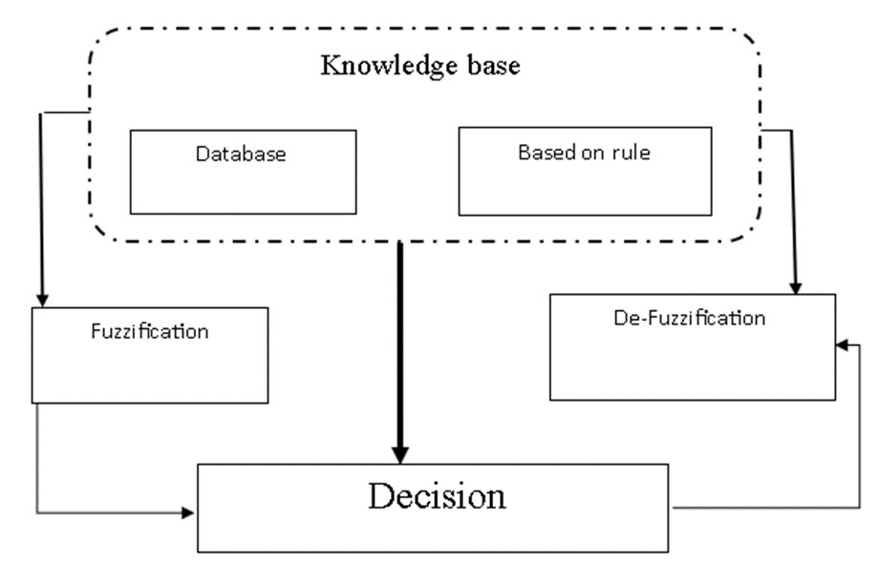
Optimizing Energy Consumption: Fuzzy logic dynamically changes the cooling power to restrict the active cooling system's energy consumption, preventing the usage of unnecessary energy. Real-Time Adaptability: The fuzzy logic control system can respond quickly to the system's current needs by responding to changing external variables, including changes in sunshine or ambient temperature.
The MPP tracker under review benefits from this suggested method's improved performance. Nevertheless, according to a comprehensive review of FLC research, the FLC that has been developed is still lacking in this specific area and could benefit from the assistance of an expert to develop the control rules. A more efficient design for an FLC-based MPPT utilized in standalone PV systems is presented in this paper.
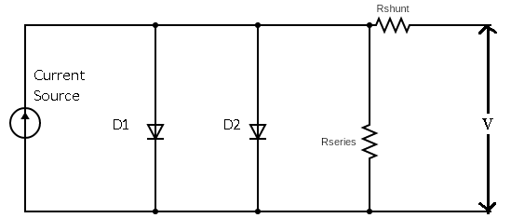
Genetic algorithms (GAs) that simultaneously choose and optimally select membership functions and FLC control rules form the basis of our technique. Using this methodology, creating this kind of Maximum Power Point (MPP) tracker becomes much easier and better. Furthermore, when it comes to independent PV systems in remote rural areas, using a general-purpose computer to run software implementations of specific FLCs as MPPT controllers is not the best design choice [8].
It was usual practice to incorporate the FLC into microcontrollers and/or DSPs in such cases (Akkaya et al., 2007). Although these chips work adequately, they aren't up to the task of implementing the MPPT control function, which is best left to field-programmable gate array (FPGA) chips. Integrating the many electronic operations required by the control unit onto a single FPGA chip eliminates the need for separate processors that can only do software DSP-related calculations, making FPGA implementations more cost-effective than DSP and microcontroller implementations.

Fig. 2. Fuzzy logic system for MPPT

The paper also includes a suggestion for implementing the GA's optimized FLC on an FPGA. Here is how the paper is structured: Section 2 shows how an autonomous PV system uses Maximum Power Point Tracking (MPPT), and Section 3 provides a brief overview of fuzzy logic controllers and genetic algorithm concepts. In Section 4, the use of Genetic Algorithms (GAs) in designing Maximum Power Point Tracking (MPPT) control is introduced as a way to optimize fuzzy controllers. Section 5 presents the results of the simulation conducted utilizing the newly built GA-FLC. The steps to implement the GA-FLC on FPGA and the results are detailed. For standalone photovoltaic (PV) systems, the MPPT algorithm
An MPPT controller, a resistive load, a DC/DC converter, and a solar array make up an autonomous photovoltaic (PV) system. Arrays of photovoltaic cells transform the energy from the sun into usable electricity. At its most efficient operation, the module generates its maximum power output (Pmax) at a peak in its V-P characteristic curve known as the maximum power point (MPP) (see Figure 2). In order to achieve an operating point near to the maximum power point (MPP), it is typical to use a regulated DC/DC converter to integrate the energy flow from the solar module to the load [9].
The MPPT Controller, the control unit, is mostly in charge of running the DC/DC converter and doing MPP searches. Typically, it employs one of the well-known MPP tracking algorithms. According to Götzberger and Hoffmann (2005), this system is designed to analyze the PV module's current and voltage output in real-time, compare it to historical values, and determine the ideal power output for the DC load under all operating and weather situations. A fuzzy logic controller served as the central processing unit (CPU) for this specific application.
Instead of trying to provide a theoretical explanation of fuzzy logic, this section will lay out the groundwork for the analysis that follows. According to Timothy (2004), fuzzy control was built on top of the fuzzy logic paradigm that was first proposed by Zadeh in 1965. A nonlinear control technique, this method seeks to mold a fuzzy logic controller with the help of an experienced user.
There are essentially four main parts to an FLC: to activate rules, the fuzzifier converts real data into fuzzy sets. A series of phrases called an IF-THEN statement defines the rules that control the controller's behavior. (c) The rules that convert input fuzzy sets into output fuzzy sets are applied by the inference engine. (d) The defuzzifier ensures that the output values are transformed from fuzzy to definitive. The rules for FLC operations are represented by fuzzy sets, which are linguistic variables [10].
A number of inference mechanisms are defined in the rule aggregation operator, the implication function, the specific membership functions utilized, the connections used to link the rule antecedents, and the output of the controller. Hardware implementations of fuzzy controllers are the subject of this study. The membership functions associated with FLC linguistic variables frequently display piece-wise linear functions, like trapezoids or triangles.
To make sure the input data covers enough of the target area, trial-and-error methods were used to choose the number and shape of the membership functions for each fuzzy set and the fuzzy logic inference process. This study's reasoning was as follows: keep moving forward in the same direction if the most recent change to the control signal (D) increased power; move backward in the opposite direction if it decreased power.
As will be discussed in more detail later on, the membership functions and rule-base set were then customized using a genetic algorithms (GAs) technique. To guide the solar array's operation point steadily toward the maximum power point (MPP), Mamdani's FLC method employs the min-max operation fuzzy combination rule.
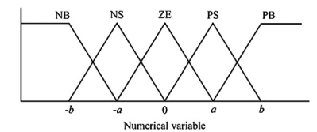
Fig.3 Input and output functions of fuzzy logic controller

$I_{05}=I_{0}R\left(\frac{T}{T_{r}}\exp\left\{\frac{qE_{G}}{Aκ_{B}}\left(\frac{1}{T_{R}}-\frac{1}{T}\right)\right\}\right)$ (1)

$I_{L}=\frac{G}{1000}\left[I_{5C}+k_{T⋅I}\left(T-T_{R}\right)\right]$ (2)

$I={Im}^{-l_{0}}{[}\exp\left(\frac{v+R_{s}I}{av_{t}}\right)-1$ (3)

$-\frac{v⋅ⅆI}{ⅆv}<I$ (4)

$\frac{v⋅ⅆI}{ⅆv}=I$ (5)

$\frac{v⋅ⅆI}{ⅆv}>I$ (6)

Active cooling
Researchers have looked at how different cooling methods affect photovoltaic (PV) system efficiency and energy losses in general and in particular [9] to find new designs to try and test. The majority of the cooling strategies for photovoltaic panels call for water to be used as a coolant for the panels' front or rear surfaces. The authors of the referenced study showed that PV panels can have their power output increased by 19% when evaporative cooling is used [10].
Researchers found that compared to studies using water as a cooling, those employing air produced less power from photovoltaic (PV) panels. One of the most effective cooling methods was found to be submerging the PV panel in water, which resulted in the highest level of heat rejection. Standard PV panels can have their electrical efficiency increased by about 20% when submerged in water.
There was also an improvement in electrical efficiency when photovoltaic (PV) panels were immersed in water at an optimal depth of around 6 cm (the pyranometer was partially submerged in the water during tests). Difficulties in determining the water immersion method's ultimate technological feasibility and its impact on the environment could prevent its broad commercial application [11].
According to the given equations, the panel's power output varies. You can't do quantitative panel modeling in MATLAB without these equations.

$V_{OC}= \frac{kT}{q}lnln \left\{\frac{I_{L}}{I_{0}} +1\right\}$ (7)

$I_{Total}= I_{0}\left\{e^{\frac{qV}{kT}}-1\right\}- I_{L}$ (8)

$F.F=\frac{V_{M}I_{M}}{V_{OC}I_{SC}}$ (9)

$η= \frac{V_{OC}{ I}_{SC} F.F}{ P_{Rad}}$ (10)

$L_{min}=\frac{D \left(1-D^{2}\right) R}{2f}$ (11)

$C_{min}= \frac{D}{R \left(\frac{∆V_{O}}{V_{O}}\right) f}$ (12)

MULTI STRING TOPOLOGY INVERTER
A combination of fuzzy logic and string inverters produced the following: The multi-string inverter topology is a more advanced configuration that is utilized in solar photovoltaic (PV) systems. Its purpose is to extract the maximum amount of energy from the sun and to improve the overall performance of the system. The operation of multi-string inverters is distinct from that of normal inverters, which have the tendency to view all of your solar panels as a single bunch. These panels allow you to link a large number of different strings of panels, and each string has its own tracking mechanism that allows it to determine which power point is the most effective. Because of this, even if one section of your roof is exposed to greater shade or faces a different direction, the string will still be able to perform at its highest level without affecting the performance of the other sections. Due to the fact that each panel group operates independently, it is an excellent choice for residences that have roofs that slope in different directions or that only partially shadow their occupants. The most positive aspect is that even if one of your strings experiences issues, the rest of your system will continue to function normally.
When it comes to achieving the optimal balance between cost and performance, multi-string inverters are widely considered to be the most suitable option. On account of the fact that you do not require a separate inverter for each panel, they are more cost-effective than microinverters. A significant number of the same advantages continue to be available to you, such as reduced energy loss and the capacity to operate with a variety of settings. In addition, the modular design makes it simple to incorporate more components into your system at a later time. This makes it an excellent choice for households, businesses, and smaller utility projects that want to expand over time.
Undoubtedly, multi-string inverters are not without their shortcomings. As a result of the presence of multiple MPPT units, the initial cost of these systems is higher than that of centralized systems. Microinverters are superior to centralized inverters when it comes to dealing with shadow on individual panels; nevertheless, they are not as effective as microinverters when it comes to protecting against shade. On the other hand, the fact that they are able to work with sophisticated setups and make them more energy-efficient has made them a popular choice for many new solar systems. Solar energy is becoming more accessible, and it is also helping to meet our growing demand for environmentally friendly energy solutions by making power generation more dependable and more economical.
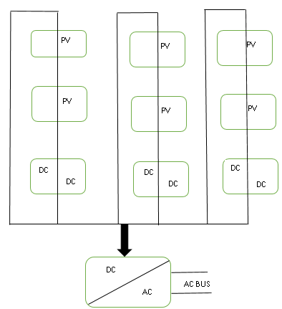
Fig.4 String Inverter circuit diagram

RESULTS & DISCUSSION
TABLE I. VARIATION OF VOLTAGE AND CURRENT
Voltage | Current
4.81 | 9.25
6.53 | 9.22
15.53 | 9.27
18.2 | 9.19
20.3 | 9.11
21.99 | 8.81
22.9 | 8.63
24.45 | 7.71
25.29 | 6.93
25.71 | 6.39
26.14 | 5.82
26.63 | 4.69
27.12 | 3.8
27.4 | 3.05
27.75 | 2.32
27.89 | 1.78
28.07 | 1.4

The MPPT system is bigger than the direct-coupled. It's pretty remarkable that the MPPT system preserves a lovely, smooth curve all day, whereas the direct-coupled system keeps bouncing up and down. The direct-coupled system likewise stops working roughly an hour earlier in the afternoon than the MPPT arrangement. Also, it doesn't move as much water during the day. What does it all mean? MPPT truly makes a big impact in how well everything performs.
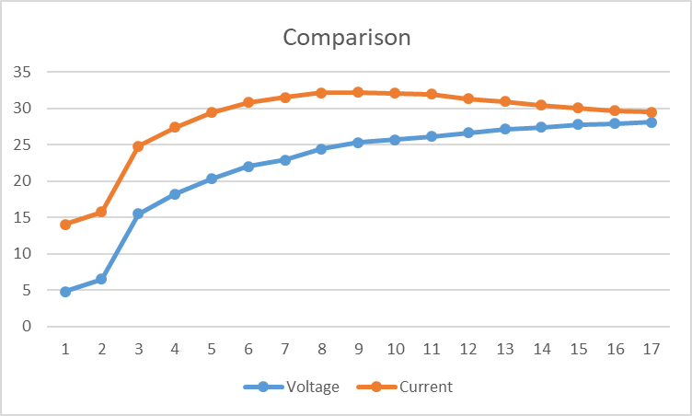

Fig.5. comparison of voltage and currents
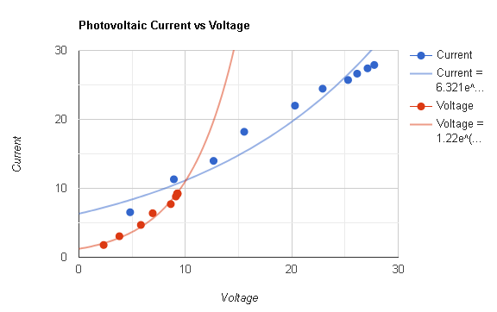

Fig.4 Graphical representation of variation of voltage with current

conclusion
For solar energy systems, the combination of fuzzy logic maximum power point tracking (MPPT) with multi-string inverters is a true game-changer. A fuzzy logic maximum power point tracker (MPPT) is intelligent enough to manage changing weather circumstances such as fluctuating temperatures and shifting sunshine. In comparison to more traditional approaches, it is both quicker and more accurate in tracking the maximum power point, which results in less energy being wasted. Multi-string inverters take this concept one step further by enabling each series of solar panels to function independently of one another. This configuration eliminates the possibility of issues occurring when certain panels are shaded or not working as well as others, so ensuring that each panel string operates at its highest potential. Also, these systems are quite versatile; they are suitable for use on the rooftop of a residential building just as well as they are for use on vast solar farms.
The use of fuzzy logic MPPT in conjunction with multi-string inverters provides solar systems with a much improved ability to work together. This combination improves the overall performance of your system, as well as the efficiency with which it transforms energy, and it additionally makes it more reliable. In spite of the fact that the weather conditions may vary or that certain components of your system may not be in perfect alignment, this is an intelligent method to get the most out of your solar panels. With an eye toward the future, researchers might focus on improving the fuzzy logic algorithms even more and examining how well they function with more recent inverter development technologies. This has the potential to assist us in obtaining even more power from the solar energy systems that are now in use.

REFERENCES
- Purnachandrakumar, D., Mittal, G., Sharma, R. K., Singh, D. B., Tiwari, S., & Sinhmar, H. (2022). Review on performance assessment of solar stills using computational fluid dynamics (CFD). Environmental Science and Pollution Research, 29(26), 38673-38714.
- Chauhan, A., & Saini, R. P. (2017). Size optimization and demand response of a stand-alone integrated renewable energy system. Energy, 124, 59-73.
- Badhoutiya, A. (2023, December). Evaluation of charging power levels in different Hybrid Electric Vehicles. In 2023 International Conference on Innovative Computing, Intelligent Communication and Smart Electrical Systems (ICSES) (pp. 1-6). IEEE.
- Sharma, K., & Shukla, M. (2014). Molecular modeling of the mechanical behavior of carbon fiber-amine functionalized multiwall carbon nanotube/epoxy composites. New carbon materials, 29(2), 132-142.
- Kumar, P., Singh, P. K., Nagar, S., Sharma, K., & Saraswat, M. (2021). Effect of different concentration of functionalized graphene on charging time reduction in thermal energy storage system. Materials Today: Proceedings, 44, 146-152.
- Singh, Y., Singh, N. K., Sharma, A., Singla, A., Singh, D., & Abd Rahim, E. (2021). Effect of ZnO nanoparticles concentration as additives to the epoxidized Euphorbia Lathyris oil and their tribological characterization. Fuel, 285, 119148.
- Negi, A., Verma, R. P., Saxena, A., Ranakoti, L., Bhandari, P., Singh, T., & Tiwari, G. N. (2023). Design and performance of black painted Khes wick modified solar still: An experimental and 5E analysis. International Journal of Thermofluids, 20, 100491.
- Patil, P. P., Gori, Y., Kumar, A., & Tyagi, M. R. (2021). Experimental analysis of tribological properties of polyisobutylene thickened oil in lubricated contacts. Tribology International, 159, 106983.
- Bhandari, P., Padalia, D., Ranakoti, L., Khargotra, R., András, K., & Singh, T. (2023). Thermo-hydraulic investigation of open micro prism pin fin heat sink having varying prism sides. Alexandria Engineering Journal, 69, 457-468.
- Singh, T., Pattnaik, P., Shekhawat, D., Ranakoti, L., & Lendvai, L. (2023). Waste marble dust-filled sustainable polymer composite selection using a multi-criteria decision-making technique. Arabian Journal of Chemistry, 16(6), 104695.7

