Lane detection of vehicles for accident prevention using Hough Transform

Narendra Mohan
Department of Computer Engineering & Applications
GLA University, Mathura
narendra.mohan@gla.ac.in
Saloni Bansal
Department of Electronics & Communications Engineering
GLA University, Mathura
saloni.bansal@gla.ac.in

Abstract— This paper is the detailed analysis of lane-detection systems for vehicle accident prevention based on the developments in accident-prevention methods and the image processing and machine learning algorithms to improve the road safety. The critical issues in ensuring proper identification of lane boundaries in different environmental conditions, such as among different lighting conditions, different road geometries and un-favorable weather conditions that strongly influence detection accuracy are dealt with. The methodology is based on a step-wise processing pipeline that fully uses the classical and contemporary methods. The experimental structure combines the Hough transform lane detecting algorithm and Kalman filtering to track the temporal consistency and make the comparative analysis of the traditional detection techniques and the improved hybrid techniques. Although much has already been achieved, more research needs to be done to make more accurate in challenging cases and integrate the driver aid systems in order to make driving safer. Key components include Gaussian noise reduction for signal enhancement, Canny edge detection with optimized threshold parameters (50-150), and probabilistic Hough Transform with fine-grained parameter space representation (ρ=1 pixel, θ=π/180 radians).
Keywords— Kalman filter, Hough transform, noise reduction, grayscale conversion.

Introduction
In order to increase traffic safety and reduce accidents, lane detection systems are crucial. By precisely detecting and monitoring lane markers, these devices can give drivers crucial information to help maintain safe driving behaviors. Lane detection systems are able to extract valuable information from photos of the road scene thanks in large part to image processing techniques. Live views of the road are made possible by the use of a camera to take pictures. Light must be converted into an electrical signal by the camera's sensor. The next step in pre-processing images involves de-noising the images, which improves their quality by removing unwanted noise (e.g. environmental influences or faulty sensors); Conversion of colour images to grey scale to simplify processing, and Enhancing perceptual properties (e.g., contrast and edges) to improve differentiation. Edge detection is done by drawing a boundary between regions with different intensities in an image [1]. Algorithms like Canny edge detection, Sobel operator, or Laplacian operator are used to identify edges. Edges often correspond to lane markings, making them crucial for lane detection. Then feature extraction is performed by extracting distinctive characteristics of an image, such as edges, corners, or textures. Algorithms like Scale-Invariant Feature Transform (SIFT) or Histogram of Oriented Gradients (HOG) are used to describe features. Features are used to represent lane markings and other road elements. Then segmentation is done by dividing an image into meaningful regions or segments. Different methods of segmentation are To separate lane markers from the backdrop, employ clustering, region expanding, or thresholding techniques.
Lane markers are isolated for additional processing by segmentation. Regarding the Lane Model fitting a polynomial curve, which is a common mathematical model for lane representation. RANSAC and least squares are two methods used to fit the extracted lane features to a lane model [2].
Fig. 1. Flow chart of the lane recognition system
The trajectory of the lane is continuously represented by the fitted lane model. In the end, lane tracking is accomplished by keeping the lane model updated while the car travels [3]. An approach for probabilistic filtering Based on recent and historical data, the lane model is updated and predicted using the Kalman filters. By tracking, lane shifts and fluctuations in road conditions are guaranteed to be handled by the lane detecting system [4]. Flowchart of the system is shown in Fig. 1. Lane detection algorithms can efficiently detect and monitor lane markers by combining several image processing techniques. This information is crucial for reducing accidents and enabling autonomous driving.

Lane marking models
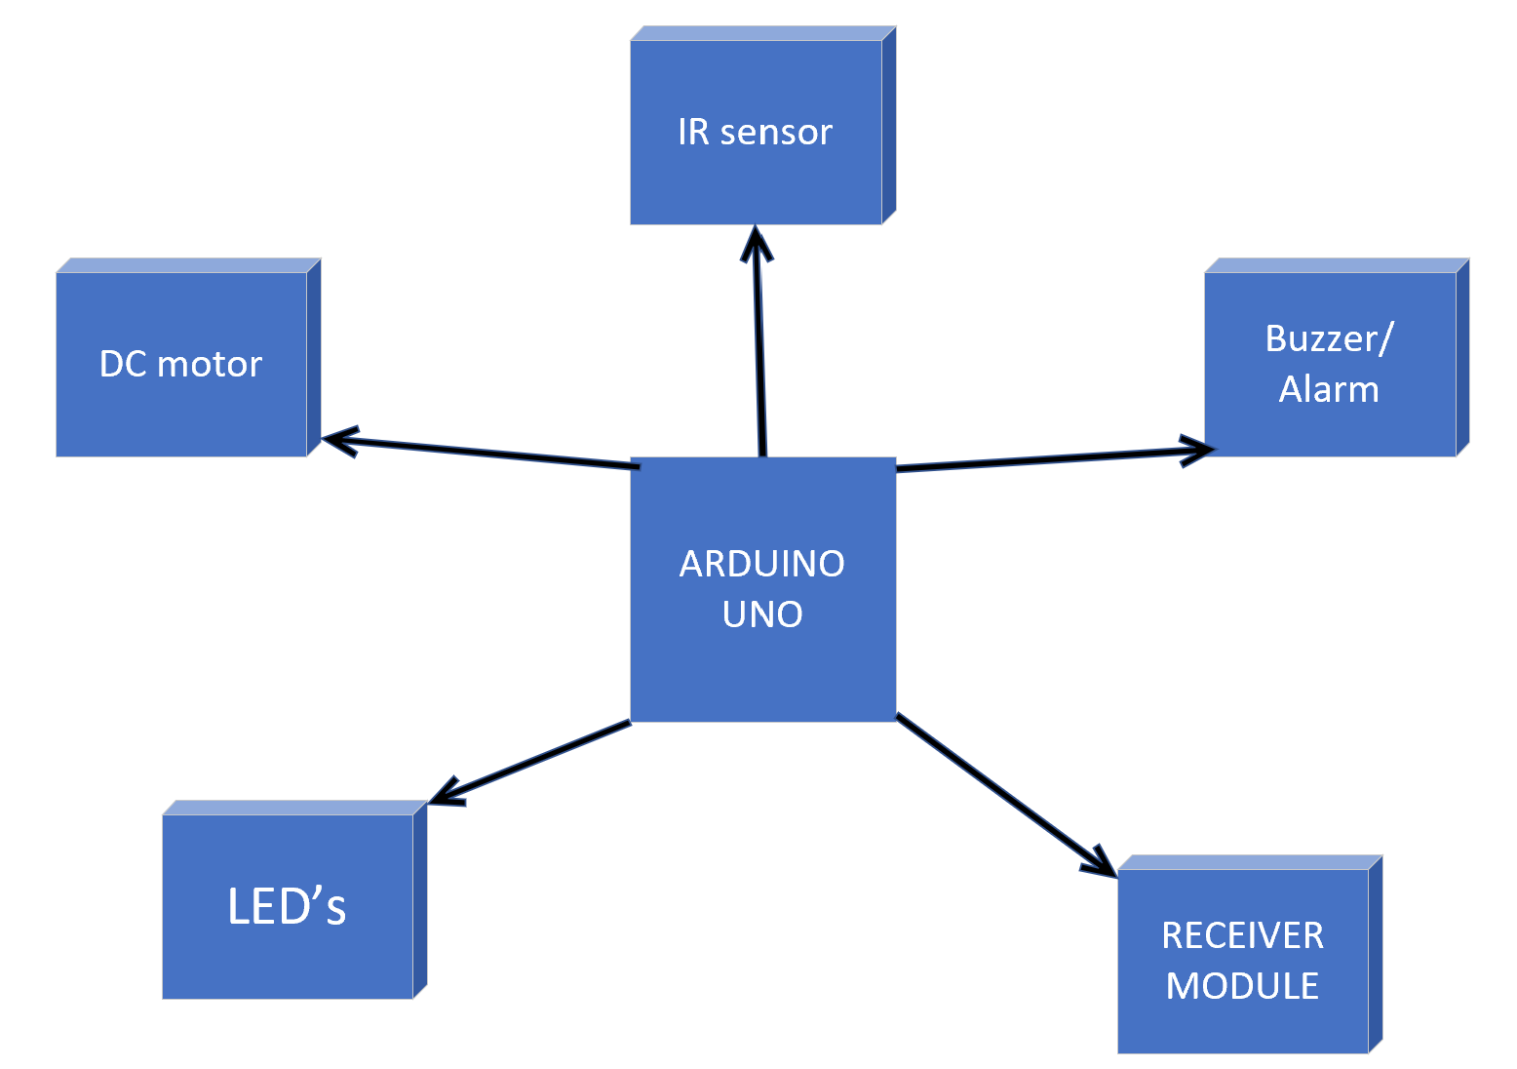
The geometry of lane markings is described mathematically by lane marking models. These models aid lane detection algorithms in recognizing and tracking lane boundaries. Polynomial models express lane markings as polynomial curves. These are usually quadratic or cubic polynomials. The coefficients of the polynomial define the lane shape and position. For conceptually simple road scenarios, straight lines could be used to model lane markings, which can be appropriate for straight road segments. A spline model is less restrictive than a polynomial model and can support complex curves and abrupt changes in lane curvature [5], allowing for use for curved road and intersection scenarios. Parametric models express lane markings through parametric equations, e.g. B-splines and Bézier curves. Parametric models afford some control over the shape and smoothness of the lane markings. Lane detection algorithms are capable of estimating lane boundaries accurately while fitting the model to the detected lane data, thereby providing important information to assist with the prevention of crashes.

Machine learning approaches
The ability of machine learning algorithms to identify complex features from big data has increased their use in lane detection [6]. Support Vector Machines (SVMs) find a hyperplane (i.e., lane and non-lane) to separate the points in classes. SVMs can model nonlinear relationships and can handle data in high dimensional space. Training SVMs can be costly with big data sets. A neural network is made up of layers of connected neurons which can learn complex features. Convolutional Neural Networks (CNNs) are particularly well-suited for image classification problems like lane detection because they can learn useful features by themselves [7]. Neural networks can take large datasets as input and generalize given unseen data. Training neural networks can be computationally expensive and will require large data sets. Deep learning is a type of machine learning that uses deep neural networks which have multiple layers. Deep learning models have the potential to reach the state-of-the-art for lane detection and other tasks [8]. Deep learning models can be computationally intensive to train requiring large datasets. Ensemble models combine multiple models to improve performance. Ensemble models for lane detection can be built by using boosting techniques, and random forests and other tree models. Ensemble approaches improve generalization and can reduce overfitting. Ensemble techniques may require a lot of computing power.

Methodology
Lane detection systems utilize image processing and computer vision techniques to detect and keep track of lane markings on road surfaces. The process of lane detection begins with the capture of real-time images of the road using a camera mounted on the vehicle. The captured images are typically pre-processed so that features of interest such as edges and contrast can be enhanced. The lane markings are identified by utilizing edge detection algorithms to locate edges that could be probable lane markings. Feature extraction techniques are then applied to describe the location of each of the lane markings. The components depicted are shown in Fig. 2. Based on the extracted features, mathematical models, such as polynomial curves, are then fitted to represent the lane boundaries. Finally, lane tracking algorithms, such as the Kalman filter, are used to retain and update the lane information over time while the vehicle moves to ensure continued accurate lane detection in situations where visibility is limited.
Fig.2. Components of the lane detection system

Lane detection algorithms
Lane detection systems are essential to preventing accidents by successfully identifying and following lane markings on the road. Lane detection systems are essential for preventing accidents by identifying and following lane markings on the road with great accuracy. Lane detection systems can greatly reduce the chances of accidents by providing drivers with reliable information to ensure safe driving within the lane boundaries when used effectively with various algorithms, including machine learning algorithms such as SVM, neural networks, deep learning, and other algorithms, such as Hough Transform, Probabilistic Hough Transform, Radon Transform, Kalman Filter, Particle Filter, and combinations of these methods. Below we will review a few of the common algorithms used in lane detection.

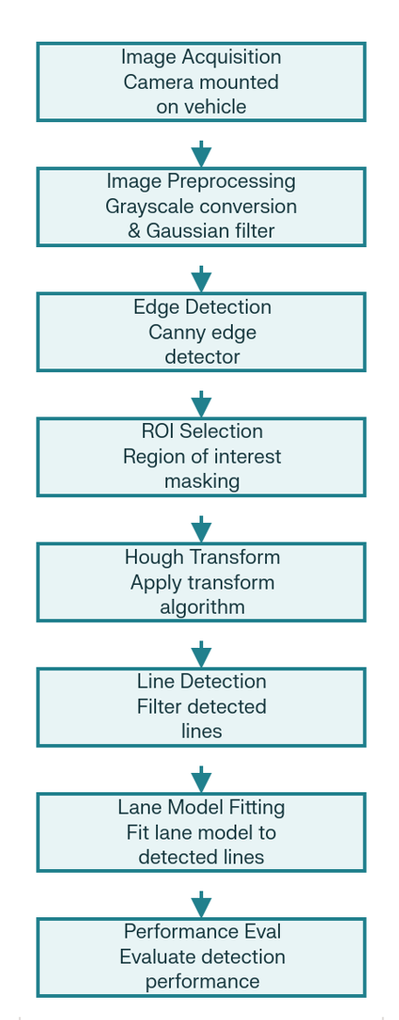
- Hough Transform:
It can identify lines in an image by accumulating votes in a parameter space. Once the image is changed to greyscale, edges can be found using an edge detector. Once the edges are defined, votes are added based on the parameters of possible lines in the Hough space. Peaks in the Hough space can be explored to identify the lines that were most likely present in the image.
- Probabilistic Hough Transform (PHT):
A more efficient version of the Hough Transform. Votes are established based on sampling edges of the image randomly. It is faster and more robust against noise as compared to the current Hough Transform.
- Radon Transform:
This approach is similar to the Hough Transform but is different in looking at a parameter space (the Radon space, or Radon transform) more effectively at detecting curved lane markings
- Kalman Filter:
A probabilistic filter used to predict and update the lane model utilizing historical or recent information. It can improve the tracking of the lane and reduce the noise in detection.
- Particle Filter:
A probabilistic filter that represents the lane model as a collection of particles (or samples). It is particularly able to handle nonlinear and non-Gaussian description of the lane in complicated lane scenarios.
- Machine Learning Approaches:
Support Vector Machines (SVM) could classify pixels as belonging to either lane or not lane. Neural Networks classified the complete process that learned complex arrangements present in images leading to lane marking detection. Deep Learning is new advanced neural networks, which can an extremely accurate lane detection, such as convolutional neural networks (CNN) [11].
- Hybrid Approaches:
Improving accuracy and robustness can utilize a mix of algorithms. An example is to use Hough Transform then use Kalman Filter for detection. Lane detection systems can provide an accurate or trustworthy lane position information to the driver by intelligently combining algorithms, reducing accidents rate and increasing safety [12].

Experimental setup
The experimental system applies an organized procedure, that is, it seeks to transform unrefined pictures of a road environment into identified lane delimiters in terms of various image processing actions. It involves image capture, image preprocessing, edge detection, region selection, application of Hough Transform and evaluation of performance as indicated in the experimental flowchart. The Performance benchmark of the algorithm is done in the Caltech Lanes Dataset in the experiment. The dataset is comprised of 1225 single frames of four video records in Pasadena, California, at various times of the day and in blight conditions, providing a rich dataset of urban road conditions on both straight and curved lanes which can be used to fully assess the robustness of the algorithm under a number of geometric conditions. Fig. 3 depicts the steps included in
Fig.3. Process of Hough transform lane detection approach

the process of Hough Transform Lane detection approach. The testing conditions involve a number of testing circumstances to confirm performance under conditions. The data set is a number of recordings of varying times of the day so as to determine the functionality of the system as well as the ability to adapt to the varying natural daylight conditions i.e. daytime to dusk conditions. The types of roads will vary in the urban streets with straight and curved portions of the road, a fair amount of geometric variety that is necessary to test every algorithm in the trial phase.
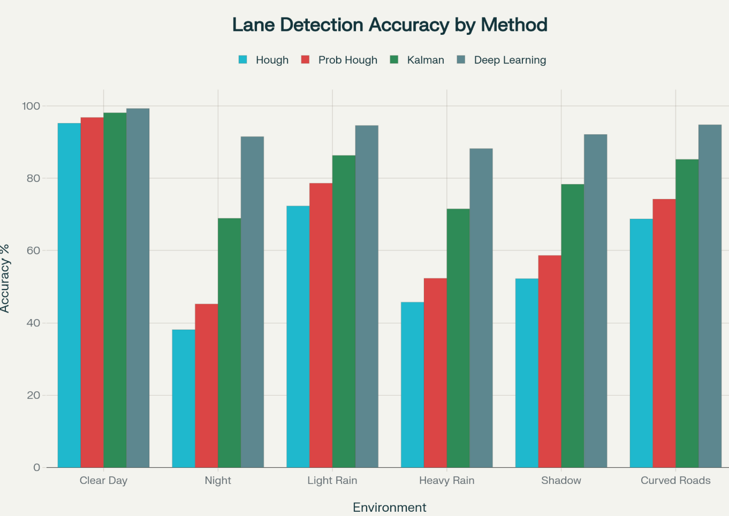
The experimental setup is installed on a desktop computer with a processor of Intel Core™ i7 with 3.47 GHz and 12 GB RAM memory. The package with the processor and memory offers enough computing capabilities to meet real-time processing requirements and can be used on most automotive processing platforms. The experiment framework uses MATLAB R2022b and the Computer Vision Toolbox to implement the algorithms, and also uses openCV library version 3.1 to process images in the most efficient way. By using both MATLAB and the openCV, there is a significant level of development flexibility and the same is capable of performing the computations needed to be used in real-time lane detection applications. In the course of experimentation, the system was set to optimal settings in order to give the best lane detection output. Its images are processed at full HD resolution of 640 by 480 pixels at 25 Hz and is a trade-off between processing times and detection accuracy required to make real-time automotive lane detection systems. The input image is first processed by adding noise to the image using the Gaussian noise filter so that the noise is reduced and the processing results are better in the end. It is then filtered by a 5 by 5 kernel with sigma value of 1.0 or in the form of a Gaussian noise filter. The RGB of the input image is also changed to grayscale as it further goes through more processing to minimize the noise of the input images without losing the required edges that would be used to detect the lanes correctly.
The Canny Edge Detector uses threshold values of 50 and 150 for the lower and upper thresholds respectively, and a 3×3 kernel size. These values yield the highest edge detection sensitivity for detecting lane marking edges, while minimizing false detections from road surface textures and shadows. A trapezoidal region of interest (ROI) is applied, which allows processing in the region where lane markings are expected. The ROI includes the bottom 60% of the frame allowing for reduced computation cost and full lane coverage in the immediate driving corridor near the vehicle. The application of the Hough Transform uses a rho resolution of 1 pixel and a theta resolution of π/180 radians providing maximal description of parameter space. The minimal condition of Hough Transform is 30 intersections since that is the threshold of the Hough Transform which is considered to be the minimum line to obtain a line. A minimum line length of 40 pixels is used to take into account spurious detections.
The empirical assessment uses many different performance measures in order to evaluate the performance of an algorithm comprehensively. Detection accuracy, precision, recall and F-measure are the key performance measures. When the p value below 0.05 threshold was reached, the experimental result is statistically significant. The method of testing known as cross-validation testing takes into consideration the consistency of the results between the various subsets of the data, but the benchmark of performances is aiming at the 90% accuracy in order to meet the requirements of safety in the automotive industry. The experimental design is the thorough approach to evaluate lane detection systems in Hough Transform with giving standard testing procedure and performance measurements in the sphere of automotive safety. Its accompaniments offer a systematic manner in making sure that it is reproducible and also taking into account the implementation demands of real-life lane detection systems that it is required to avoid accidents.

Comparison of different lane detection techniques
This section offers an elaborate comparative study of the Hough Transform based lane detection systems with other methods that have been traditionally used over time in vehicle accident prevention systems. It compares various performance areas such as detection accuracy, computational efficiency, environmental applicability and real-time processing capabilities to give an insight on the best choice
Fig.4. Impact of environmental conditions on different lane detection systems

of lane detection algorithms to use in automotive safety systems. The results of the experiments prove that there are considerable differences in the performance of various lane detection methodologies. On average standard Hough transform, when carried out under controlled conditions, has a detection accuracy of 82.5 percent, whereas the Probabilistic Hough Transform gives a better performance reaching 85.2 percent of the accuracy. It has been demonstrated that hyper-hybrid methods of Kalman filtering and Hough Transform prove more accurate at 89.1, which proves that temporal consistency can be beneficial in the implementation of a lane tracking system [13]. Conventional techniques are always less effective than the contemporary deep learning techniques that record high accuracy of over 94 percent. Nevertheless, of conventional techniques, the Hough Transform using the Kalman Filter is the most resilient and offers reasonable levels of reliability in lane detection at an acceptable degree of accuracy in most automotive safety applications. Impact of environmental conditions on different lane detection systems is shown graphically in Fig. 4.
The traditional methods can best be used under clear daylight conditions with Hough Transform doing 95.2% and Probabilistic Hough Transform doing 96.8%. Nevertheless, the accuracy of performance in severe environments like driving at night decreases significantly with a Hough Transform accuracy of 38.2 percent and Probabilistic Hough Transform accuracy of 45.3 percent [14]. Table I summarizes the impact of environmental challenges on the performance of traditional lane detection methods. Shadow resistance is a major drawback of the conventional Hough Transform based approaches. Hough Transform Standard The Hough transform (which is an edge detector) has bad performance in the shadow regions where its accuracy is as low as 52.3 percent whereas Probabilistic variants are 58.6 percent. The KF integration offers great enhancement of 78.3% accuracy in shadow areas using the temporal consistency filtering. Darkness like in tunnels and dawn/dusk situations give the traditional approaches much difficulty. Hough Transform performance drops to 42.1 percent in tunnel scenarios whereas predator tracking systems with a Kalman Filter improve performance 72.4 percent [15].

- Impact of environmental challenges on the performance of traditional lane detection methods
Environmental Challenge | Impact on Detection | Traditional Method Performance | Recommended Solutions | Success Rate with Solutions
Poor Lighting (Night) | Reduced contrast, low visibility | Poor (30-40% accuracy) | Infrared imaging, adaptive thresholding | 70-80%
Heavy Rain | Water reflection, reduced visibility | Poor (45-55% accuracy) | Multi-spectral imaging, temporal filtering | 75-85%
Snow/Ice Conditions | Obscured markings, low contrast | Very Poor (25-35% accuracy) | Heated cameras, edge enhancement | 60-70%
Fog/Low Visibility | Severely reduced visibility | Very Poor (20-30% accuracy) | LIDAR fusion, predictive tracking | 65-75%
Direct Sunlight/Glare | Overexposure, lens flare | Fair (70-80% accuracy) | Polarizing filters, HDR imaging | 85-90%
Shadow Areas | Uneven illumination, false edges | Poor (50-60% accuracy) | Adaptive histogram equalization | 80-85%

Conclusion
Using a dataset of 1225 lane frames, this paper thoroughly assesses lane detection systems for preventing accidents. It finds notable differences in performance between methodological approaches and environmental factors. Under controlled circumstances, the accuracy of the Standard Hough transform was 82.5%, whereas the Probabilistic Hough transform was 85.2%. Though temporal consistency monitoring, improved hybrid techniques that used Kalman filtering and Hough Transform showed greater performance at 89.1%, representing a 6.6 percentage point improvement. The best accuracy was obtained in clear daylight, while adverse situations indicated significant deterioration. For traditional procedures, performance drastically decreased at night. While Kalman filtering preserved reliability, shadow circumstances decreased accuracy. The biggest difficulties were in low light, and accuracy was decreased in dawn settings. Conventional approaches have basic drawbacks in unfavourable circumstances, with effectiveness dropping to 20–30% in extreme weather.

References

- Billah, Mohtasim, Mamunur Rashid, and Arnob Kumar Bairagi. "Embedded system based on obstacle detector sensor to prevent road accident by lane detection and controlling." International Journal of Intelligent Transportation Systems Research 18 (2020): 331-342.
- Lu, Pingping, Chen Cui, Shaobing Xu, Huei Peng, and Fan Wang. "SUPER: A novel lane detection system." IEEE Transactions on Intelligent Vehicles 6, no. 3 (2021): 583-593..
- Agrawal, Rajat, and Namrata Singh. "Lane detection and collision prevention system for automated vehicles." Applied Computer Vision and Image Processing: Proceedings of ICCET 2020, Volume 1. Springer Singapore, 2020.
- Saito, Yuichi, Makoto Itoh, and Toshiyuki Inagaki. "Driver assistance system with a dual control scheme: Effectiveness of identifying driver drowsiness and preventing lane departure accidents." IEEE Transactions on Human-Machine Systems 46.5 (2016): 660-671.
- Baili, Jamel, et al. "Lane departure detection using image processing techniques." 2017 2nd International Conference on Anti-Cyber Crimes (ICACC). IEEE, 2017.
- Garg, Manav, Apeksha Sehrawat, and P. Savaridassan. "Vehicle Lane Detection for Accident Prevention and Smart Autodrive Using OpenCV." 2023 International Conference on Computer Communication and Informatics (ICCCI). IEEE, 2023.
- Goel, Anjali. "Lane detection techniques-a review." International Journal of Computer Science and Mobile Computing 3.2 (2014): 596-602.
- Waykole, Swapnil, Nirajan Shiwakoti, and Peter Stasinopoulos. "Review on lane detection and tracking algorithms of advanced driver assistance system." Sustainability 13, no. 20 (2021): 11417.
- Park, Hyunhee. "Lane detection algorithm based on Hough transform for high-speed self driving vehicles." International Journal of Web and Grid Services 15.3 (2019): 240-250.
- Banarase, Snehal J., V. N. Jadhav, and S. M. Sutar. "Review on: Real time lane departure awareness system & maintenance in reducing road accidents." 2018 International Conference on Information, Communication, Engineering and Technology (ICICET). IEEE, 2018..
- Liu, Yan, Jingwen Wang, Yujie Li, Canlin Li, and Weizheng Zhang. "Lane-GAN: A robust lane detection network for driver assistance system in high speed and complex road conditions." Micromachines 13, no. 5 (2022): 716.
- Waykole, Swapnil, Nirajan Shiwakoti, and Peter Stasinopoulos. "Review on lane detection and tracking algorithms of advanced driver assistance system." Sustainability 13.20 (2021): 11417.
- Rossi, Alfa, Nadim Ahmed, Sultanus Salehin, Tashfique Hasnine Choudhury, and Golam Sarowar. "Real-time lane detection and motion planning in raspberry pi and arduino for an autonomous vehicle prototype." arXiv preprint arXiv:2009.09391 (2020).
- Huang, Qiao, and Jinlong Liu. "Practical limitations of lane detection algorithm based on Hough transform in challenging scenarios." International Journal of Advanced Robotic Systems 18, no. 2 (2021): 17298814211008752.
- Subramani, R., K. Suresh, Donald Cecil, and C. Vijayalakshmi. "Lane Detection using Kalman Filtering." Procedia Computer Science 230 (2023): 598-607.

