Methods for Increasing the Efficient Operation of Solar Panels by Using Water Cooling and Offline Maximum Power Point Tracking

Narendra Mohan
Department of Computer Engineering & Applications
GLA University, Mathura
narendra.mohan@gla.ac.in
Arti Badhoutiya
Department of Electrical Engineering
GLA University, Mathura
arti.badhoutiya@gla.ac.in

Abstract- This essay discusses how the Maximum Power Point Tracking (MPPT) concepts that are offline, could be used with water cooling to improve the work of photovoltaic (PV) solar panels. In contrast to traditional real-time Maximum Power Point warping (MPPT) methods, offline approaches approximate the Maximum power point (MPPT) to different conditions including sunlight irradiance and temperature with known (pre-calculated) data or algorithms. This eliminates the requirement of constant supervision and it suggests a simpler and cheaper method of power optimization. Simultaneously, a water-cooling system is adopted that will keep the temperature of the solar panels in the best possible work conditions, since very high temperatures can significantly lower their efficiency. Water is spread across the surface of the panel absorbing excessive heat and inhibiting the degradation of performance caused by overheating. The water also serves to minimize dust build-up, raising the total energy take-up. The joint strategy of offline MPPT and water cooling show a great enhancement in generating energy, especially in the warm environments. The solution is an efficient, low maintenance approach to solar panel systems, and a bright avenue into better reliability and performance of renewable energy installations.
Keywords: solar, efficiency, energy, cooling, power
- INTRODUCTION
Three primary sources- coal, oil, and gas- provide most of the energy in the world. Consumption of energy is constantly increasing [1, 2]. The eventual depletion of conventional energy sources may have a dire effect on the quality of life in the entire world. The global energy security is also an issue of concern because only a few countries have a vast greater number of the global oil and gas.
World leaders have increased the search of alternative energy sources because of security reasons. Moreover, global warming, principally caused by the emission of green house gasses through the combustion of fossil fuels, has further increased the need to get other sources of energy.
The exploitation of renewable energy resources and the total conversion efficiency increase is regarded as highly viable ways to solve the energy problem [3, 4]. Renewable energy is power that is produced by the process of replenishment of natural processes such as wind, solar radiation, water, and tides, geothermal heat and other types of biomasses.
These energy sources are also being considered as a way of solving the climate change problem since their effects on nature are minimal [5, 6]. The solar power contributes to almost all the renewable energy. Solar power is one of the renewable energy sources that are completely sustainable. It has no moving mechanical parts; therefore, it is low maintenance and produces a very minimal noise in comparison with other machines.
Put simply, the solar panels are easy to install. Solar power requires a large amount of space, is highly dependent on favourable weather, and requires a large initial investment. Solar photovoltaic (PV) arrays are optimized to operate at maximum power point (MPP) regardless of changes in weather conditions [7, 8]. When the electrical drives are powered by PV, it is extremely crucial to ensure optimal efficiency [8]. Under different weather circumstances, photovoltaic (PV) sources can produce the most power when they are synced with the load. Mechanical and electrical monitoring are the two options for keeping an eye on the Maximum Power Point (MPP). In mechanical monitoring, photovoltaic (PV) panels are physically shifted to follow the sun's movement.
Seasons and day length dictate where PV panels should be positioned. With the use of power electronic components, photovoltaic panels may be electrically monitored by following the P-V or I-V curves, and they are engineered to work in tandem with Maximum Power Point (MPP) [7]. The look-up table method, the curve fitting method, and voltage and current-based Maximum Power Point Tracking (MPPT) approaches are all part of the study's objective to assess the effectiveness of these offline methods.
Different systems are compared according to their applicability, tracking speed, complexity, cost, and number of sensors required. Temperature swings, levels of isolation, and weather conditions are all taken into account. The use of MATLAB®/Simulink to resistance load Maximum Power Point Tracking (MPPT) based on voltage is discussed in this study.
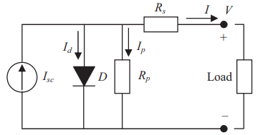
Fig.1 Equivalent solar cell circuit diagram
Due to the quick temporal fluctuations in solar irradiation, the maximum power point is constantly shifting to other curves. Hence, the MPPT controller should allow for rapid attainment of the Maximum Power Point (MPP) to avoid power loss and output power variations. Despite the beneficial results, all of the works share a flaw in the FLC design: they relied on trial and error rather than a methodical approach. This conventional approach to design requires the presence of knowledgeable specialists; on the other hand, without this data, their work is often inefficient and subpar.
- OFFLINE MPPT TECHNIQUES
Different approaches to tracking Multiple Point Tracking (MPPT) are commonly classified as either online, hybrid, or offline, depending on the technology used to measure Maximum Power Point (MPP). The maximum power point (MPP) can be computed offline using technical data collected from photovoltaic (PV) panels. This data includes open circuit voltage, short circuit current, and the P-V and I-V curves. Despite the fact that internet methods are more efficient, offline ones are less expensive. To track MPP, the web-based method used current and voltage readings taken in real-time.
Sun radiation or temperature measurements are not required by this method. The particular model of a solar cell is irrelevant to model-free methods, often called online approaches. The control signal is generated through offline tracking using reference signals such as open circuit voltage (Voc), short circuit current (Isc), temperature, and solar radiation.
The offline method uses the current and voltage readings from photovoltaic (PV) panels in real time to generate a control signal that keeps an eye on the Maximum Power Point (MPP) (Fig. 1). Methods for processing data both online and offline are combined in the hybrid approach. There are two levels of monitoring that the MPP goes through. Stage two of the online method involves fine-tuning the operating point to the MPP, in contrast to stage one of the offline method, which involves keeping the operating point relatively close to the MPP.

$I_{05}=I_{0}R\left(\frac{T}{T_{r}}\exp\left\{\frac{qE_{G}}{Aκ_{B}}\left(\frac{1}{T_{R}}-\frac{1}{T}\right)\right\}\right)$ (1)

Curve Fitting-Based MPPT
An offline method is to use a mathematical model and equation to determine technical data, panel characteristics, and other relevant information, such as the voltage equation for the PV panel output in relation to the maximum power point (MPP). Move the control knob to the MPP setting. A familiarity with the PV model and the theoretical equation is necessary for this approach, despite its apparent ease of use. The enormous amount of calculations requires a large amount of memory, and the computational pace is slow.
Constant Voltage Method
K, the voltage factor, can take on values between 0.7 and 0.95 across a wide variety of temperature and sun insolation situations; the constant voltage technique is based on this linear association between Vmpp and Voc.
According to the literature, there are two main categories of constant voltage techniques [9–11]. One method involves separating the solar panel in order to get the open circuit voltage (Voc). Then, based on the solar cell material, the appropriate operating temperature can be determined using Equation (1). After that, the voltage across the array is adjusted until Vmpp is reached. Finding the optimal value of K is a challenge with this method since it seems to fluctuate between 73% and 80%. In terms of efficiency, it falls short.
One more way to keep the voltage constant is to calibrate the open circuit voltage with a pilot panel. Using a test solar panel with identical specs to the production solar panel allows for an accurate Voc estimate. This method overcomes the previous constant voltage method's drawback—the PV power loss that happens during Voc measurement—by using an alternative methodology. Because an additional pilot panel is needed, the price of this technology is higher.

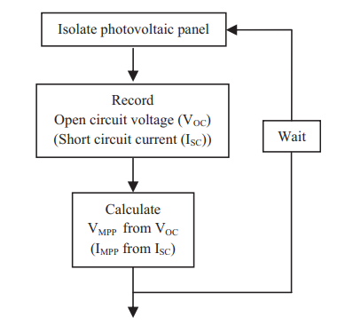
Fig. 2. Flowchart for offline MPPT methods

$I_{L}=\frac{G}{1000}\left[I_{5C}+k_{T⋅I}\left(T-T_{R}\right)\right]$ (2)
$I={Im}^{-l_{0}}{[}\exp\left(\frac{v+R_{s}I}{av_{t}}\right)-1$ (3)

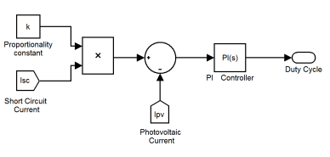
Fig. 3. Block diagram representation of offline MPPT technique

WATER COOLING
Water cooling of solar panels by circulating water above the panel surface is an effective technique to enhance efficiency by managing the panel’s temperature. Solar panels, especially photovoltaic (PV) panels, experience a significant drop in efficiency as their temperature increases, which can be a concern, particularly in high-sunlight areas. Water cooling helps mitigate this effect by absorbing excess heat and maintaining the panel temperature within an optimal range.
The cooling system involves spraying or circulating a thin layer of water over the panels, which then absorbs the heat generated by solar radiation. This water can either be recycled in a closed-loop system or collected for secondary use, such as domestic or industrial purposes. In some designs, water channels or pipes are integrated into the panel surface to maximize thermal contact.
When water flows above the panels, it provides evaporative cooling as the heat transfers from the panel to the water. The flow rate and distribution need to be carefully controlled to ensure uniform cooling across the entire surface. This helps in maintaining consistent power output by keeping the photovoltaic cells at their optimal operating temperature. Additionally, water cooling can prevent dust accumulation, reducing the need for regular cleaning.
By using water for cooling, the overall energy efficiency of the solar system is improved, particularly in hot climates, where temperature fluctuations can severely impact performance. When integrated with technologies like Maximum Power Point Tracking (MPPT), this cooling method allows the system to harness maximum energy under varying environmental conditions.
$I_{05}=I_{0}R\left(\frac{T}{T_{r}}\exp\left\{\frac{qE_{G}}{Aκ_{B}}\left(\frac{1}{T_{R}}-\frac{1}{T}\right)\right\}\right)$ (1)
$I_{L}=\frac{G}{1000}\left[I_{5C}+k_{T⋅I}\left(T-T_{R}\right)\right]$ (2)
$I={Im}^{-l_{0}}{[}\exp\left(\frac{v+R_{s}I}{av_{t}}\right)-1$ (3)
$-\frac{v⋅ⅆI}{ⅆv}<I$ (4)
$\frac{v⋅ⅆI}{ⅆv}=I$ (5)
$\frac{v⋅ⅆI}{ⅆv}>I$ (6)

RESULTS AND DISCUSSION

Table 1. Variation of Power with Voltage at different irradiations

V  (5 KW/M²) | p  (5KW/M²) | V  (1 KW/M²) | P  (1KW/M²)
3.65 | 82.581 | 4.339 | 87.742
5.234 | 118.71 | 5.785 | 77.419
6.749 | 154.839 | 7.438 | 108.387
9.504 | 196.129 | 9.229 | 113.548
13.223 | 268.387 | 11.708 | 103.226
15.565 | 325.161 | 13.774 | 108.387
19.421 | 387.097 | 17.355 | 129.032
23.003 | 464.516 | 21.763 | 149.677
26.997 | 536.774 | 27.548 | 180.645
30.854 | 598.71 | 31.956 | 180.645
34.298 | 629.677 | 35.537 | 160
37.603 | 629.677 | 38.154 | 154.839
40.496 | 480 | 40.014 | 103.226

Without an irradiation sensor, the approach recognizes the abrupt change in irradiance autonomously, as seen by the waveform at the bottom. The array is segregated and new data is saved to monitor the peak power point whenever it receives a high pulse. Maximum Power Point Tracking (MPPT) in the face of changing weather conditions is shown in Figure 10. The best power parameters for various degrees of insolation are shown in Table I. After each step change, the system would record the peak power.
The proportional-integral (PI) controller is then used to calculate the duty cycle based on the quantified error. Following this, the proportional-integral (PI) controller adjusts the duty cycle in order to bring the error down to zero. The proposed method quickly resets the interrupt flag when the fault value reaches zero. The interrupt flag is subsequently continuously monitored.

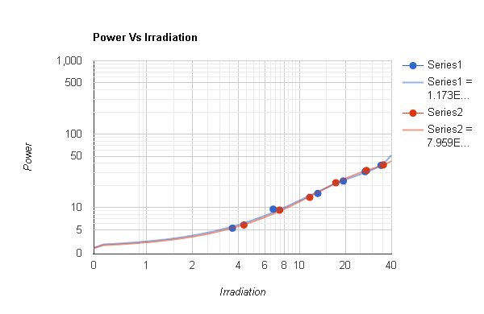
Fig. 3 Graphical representation of power variation with irradiation

V. CONCLUSION
Finally, offline applications of MPPT and water cooling are one of the effective and efficient ways in improving the efficiency of photovoltaic (PV) solar panels. Offline MPPT systems involving pre-computed algorithms or past stored data are simpler and less costly to implement in comparison with real-time tracking techniques. These inventions are enabling it to be easy to keep an eye on things, making the system less complex and the solar panels are working around their Maximum Power Point (MPP), even when weather conditions fluctuate. This system is improved by the addition of cooling with water in order to limit the loss of efficiency with temperature. A water-cooling system is used to avoid overheating of panels and keep the energy conversion a constant. The water flow also facilitates the cleaning of the panel surfaces unlike dust accumulation and it also leads to the optimal increases in the energy output, especially in areas where the temperatures are higher, according to both experiments and simulations. Through offline MPPT method, a lot can be done by water cooling to enhance the production of solar energy. It is affordable, needs minimal maintenance and maybe a solution in large-scale solar systems. This would enhance the reliability and durability of the renewable energy systems.
REFERENCES
- Prakash, A., Veeresha, P., Prakasha, D. G., & Goyal, M. (2019). A homotopy technique for a fractional order multi-dimensional telegraph equation via the Laplace transform. The European Physical Journal Plus, 134, 1-18.
- Padmanaban, M., Chinnathambi, S., Parthasarathy, P., & Pachaivannan, N. (2021). An Extensive Study on Online, Offline and Hybrid MPPT Algorithms for Photovoltaic Systems. Majlesi Journal of Electrical Engineering, 15(3), 1-16.
- Kumar, A., Ibraheem, S., Nguyen, T. A., Gupta, R. K., Maiyalagan, T., & Yasin, G. (2021). Molecular-MN4 vs atomically dispersed M− N4− C electrocatalysts for oxygen reduction reaction. Coordination Chemistry Reviews, 446, 214122.
- Bollipo, R. B., Mikkili, S., & Bonthagorla, P. K. (2020). Critical review on PV MPPT techniques: classical, intelligent and optimisation. IET Renewable Power Generation, 14(9), 1433-1452.
- Anagreh, Y. N., Alnassan, A., & Radaideh, A. (2021). High Performance MPPT Approach for Off-Line PV System Equipped With Storage Batteries and Electrolyzer. International Journal of Renewable Energy Development, 10(3).
- Kumar, A., Vashistha, V. K., & Das, D. K. (2021). Recent development on metal phthalocyanines based materials for energy conversion and storage applications. Coordination Chemistry Reviews, 431, 213678.
- TIRTH, V., ALGARNI, S., IRSHAD, K., ISLAM, S., & ZAHIR, M. H. Investigation of MPPT Techniques Under Uniform and Non-Uniform Solar Irradiation Condition–A Retrospection.
- Ibrahim, H. H., Elsaharty, M. A., Guerrero, J. M., & Ghoneim, A. W. (2022, July). A Smart MPPT Algorithm with a Power Independent Tracking System. In 2022 International Conference on Electrical, Computer and Energy Technologies (ICECET) (pp. 1-8). IEEE.
- Charu, K., Thakur, P., & Ansari, F. (2023). Performance Analysis of Conventional MPPT Techniques for a Solar PV System. Journal of Graphic Era University, 117-132.
- Ali, Z. M., Alquthami, T., Alkhalaf, S., Norouzi, H., Dadfar, S., & Suzuki, K. (2022). Novel hybrid improved bat algorithm and fuzzy system based MPPT for photovoltaic under variable atmospheric conditions. Sustainable Energy Technologies and Assessments, 52, 102156.

