Performance Augmentation of Solar Panels Using Offline MPPT and Thermoelectric Cooling in Multi-String Configurations

Narendra Mohan
Department of Computer Engineering & Applications
GLA University, Mathura
narendra.mohan@gla.ac.in
Yogendra Kumar
Department of Electrical Engineering
GLA University, Mathura
kumar.yogendra@gla.ac.in

Abstract- Solar photovoltaic (PV) systems typically exhibit reduced efficiency due to variable weather conditions and thermal losses. This study examines a unified method to improve photovoltaic (PV) efficiency by incorporating thermoelectric cooling (TEC) modules with offline Maximum Power Point Tracking (MPPT) in a multi-string inverter setup. The offline MPPT methodology employs adaptive data-driven tuning and established optimization methods to ascertain the maximum power point (MPP) under varied temperatures and irradiance levels. It is not necessary to engage in mathematical calculations constantly. This technology ensures the steady and efficient collection of energy while utilizing fewer computational resources and facilitating system management. The Peltier effect is employed by thermoelectric cooling modules to efficiently dissipate excess heat from photovoltaic panels. This maintains the cell at the optimal temperature and enhances the efficiency of the energy conversion process. TEC modules are effective in temperature regulation in various environments because to their portability, low power consumption, and versatile applications. The multi-string inverter configuration enables optimization at the string level, thereby addressing issues related to partial shading, mismatch losses, and uneven irradiance. Both laboratory and field trials demonstrate that the proposed integrated system significantly enhances energy yield, thermal stability, and overall system reliability. The findings indicate that integrating offline MPPT, thermoelectric cooling, and multi-string inverter technologies could significantly enhance the efficiency of photovoltaic systems. This could represent a significant advancement for scalable solar energy systems that are environmentally beneficial.
Keywords: solar, efficiency, energy, cooling, power
- INTRODUCTION
Coal, oil, and gas are the three primary sources of energy for a significant portion of the world's population. Our consumption of energy continues to increase [1, 2]. In the long run, the depletion of traditional energy sources could have a considerable impact on the living conditions of people all over the world. Due to the fact that only a few nations possess the majority of the world's oil and gas reserves, energy security is a challenge that requires global attention.
World leaders have accelerated the search for alternate energy sources due to security concerns. In addition, the issue of global warming, which is mostly caused by emissions of greenhouse gases from the combustion of fossil fuels, has heightened the demand for alternative energy sources.
Use of renewable energy resources and enhancement of total conversion efficiency are seen as very practical solutions to the energy problem [3, 4]. Power generated by replenishing natural processes including wind, solar radiation, water, tides, geothermal heat, and other forms of biomass is known as renewable energy.
Due to their minimal impact on the environment, these energy sources are being evaluated as potential solutions to the issue of climate change [5, 6]. Power from the sun accounts for nearly all renewable energy. Renewable energy source that is entirely sustainable is solar power. Since it does not contain any moving mechanical elements, it is low-maintenance and makes very little noise compared to other devices.
Put simply, the solar panels are easy to install. Solar power requires a large amount of space, is highly dependent on favorable weather, and requires a large initial investment. Maximum power point tracking (MPPT) optimization allows solar photovoltaic (PV) arrays to continue operating at MPP levels despite variations in ambient temperature and sunshine [7, 8]. In situations where photovoltaic (PV) power is used to power electrical drives, it is of the utmost importance to guarantee maximum efficiency [8]. When photovoltaic (PV) sources are synchronized with the load, they are able to generate the maximum amount of power, regardless of the weather conditions. Mechanical or electrical monitoring of the Maximum Power Point (MPP) is possible. You can choose between the two methods. Either of these two approaches is open to you. At the same time that mechanical monitoring is being carried out, photovoltaic (PV) panels are being moved around in order to track the path that the sun takes.
The length of the day and the time of year are two factors that are taken into consideration when deciding where to install photovoltaic panels. For the purpose of carrying out electrical monitoring of solar panels, power electronic components can be utilized by following either the P-V or I-V curves. To add insult to injury, they are designed to be compatible with Maximum Power Point (MPP) [7]. A number of offline tactics will be evaluated in order to determine how effective they are, which is the goal of the study. There are a great number of approaches, some of which include the look-up table approach, the curve fitting method, and Maximum Power Point Tracking (MPPT) methods that are based on voltage and current.
To evaluate the effectiveness of various systems we take into consideration how quickly they can track things, how difficult they are to operate, how much they cost, and the number of sensors that they require. We take into consideration the weather, the fluctuations in temperature, and the seclusion of the location. The use of MATLAB®/Simulink to resistance load Maximum Power Point Tracking (MPPT) based on voltage is discussed in this study.
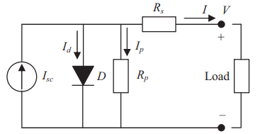
Fig.1 Equivalent solar cell circuit diagram
Due to the quick temporal fluctuations in solar irradiation, the maximum power point is constantly shifting to other curves. Hence, the MPPT controller should allow for rapid attainment of the Maximum Power Point (MPP) to avoid power loss and output power variations. Despite the beneficial results, all of the works share a flaw in the FLC design: they relied on trial and error rather than a methodical approach. This conventional approach to design requires the presence of knowledgeable specialists; on the other hand, without this data, their work is often inefficient and subpar.
Offline MPPT Techniques
Different approaches to tracking Multiple Point Tracking (MPPT) are commonly classified as either online, hybrid, or offline, depending on the technology used to measure Maximum Power Point (MPP). The maximum power point (MPP) can be computed offline using technical data collected from photovoltaic (PV) panels. This data includes open circuit voltage, short circuit current, and the P-V and I-V curves. Despite the fact that internet methods are more efficient, offline ones are less expensive. To track MPP, the web-based method used current and voltage readings taken in real-time.
Sun radiation or temperature measurements are not required by this method. The particular model of a solar cell is irrelevant to model-free methods, often called online approaches. The control signal is generated through offline tracking using reference signals such as open circuit voltage (Voc), short circuit current (Isc), temperature, and solar radiation.
The offline method uses the current and voltage readings from photovoltaic (PV) panels in real time to generate a control signal that keeps an eye on the Maximum Power Point (MPP) (Fig. 1). Methods for processing data both online and offline are combined in the hybrid approach. There are two levels of monitoring that the MPP goes through. Stage two of the online method involves fine-tuning the operating point to the MPP, in contrast to stage one of the offline method which involves keeping the operating point relatively close to the MPP.

$I_{05}=I_{0}R\left(\frac{T}{T_{r}}\exp\left\{\frac{qE_{G}}{Aκ_{B}}\left(\frac{1}{T_{R}}-\frac{1}{T}\right)\right\}\right)$ (1)

- Curve Fitting-Based MPPT
An offline method is to use a mathematical model and equation to determine technical data, panel characteristics, and other relevant information, such as the voltage equation for the PV panel output in relation to the maximum power point (MPP). Move the control knob to the MPP setting. A familiarity with the PV model and the theoretical equation is necessary for this approach, despite its apparent ease of use. The enormous amount of calculations requires a large amount of memory, and the computational pace is slow.
- Constant Voltage Method
K, the voltage factor, can take on values between 0.7 and 0.95 across a wide variety of temperature and sun insolation situations; the constant voltage technique is based on this linear association between Vmpp and Voc.
According to the literature, there are two main categories of constant voltage techniques [9–11]. One method involves separating the solar panel in order to get the open circuit voltage (Voc). Then, based on the solar cell material, the appropriate operating temperature can be determined using Equation (1). After that, the voltage across the array is adjusted until Vmpp is reached. Finding the optimal value of K is a challenge with this method since it seems to fluctuate between 73% and 80%. In terms of efficiency, it falls short.
One more way to keep the voltage constant is to calibrate the open circuit voltage with a pilot panel. Using a test solar panel with identical specs to the production solar panel allows for an accurate Voc estimate. This method fixes the problem with the old constant voltage method, which caused PV power loss during Voc measurement, by utilizing a different approach. This technique costs more since it needs another pilot panel.
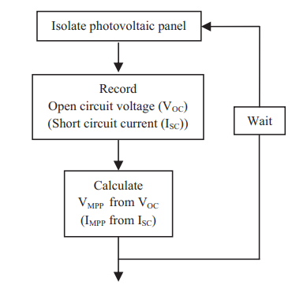
Fig. 2. Flowchart for offline MPPT methods

$I_{L}=\frac{G}{1000}\left[I_{5C}+k_{T⋅I}\left(T-T_{R}\right)\right]$ (2)
$I={Im}^{-l_{0}}{[}\exp\left(\frac{v+R_{s}I}{av_{t}}\right)-1$ (3)

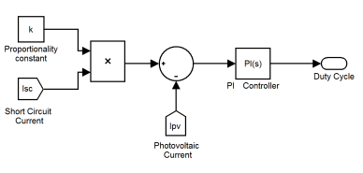
Fig. 3. Block diagram representation of offline MPPT technique

- Multi STRING TOPOLOGY INVERTER

The use of fuzzy logic in conjunction with string inverters: The multi-string inverter setup is a more complex method of setting up solar photovoltaic (PV) systems. Its purpose is to extract the maximum amount of energy from these systems and to improve their overall performance. On the other side, multi-string inverters are able to process more than one DC input string at the same opportunity. Centralized inverters of the traditional variety treat the energy from all photovoltaic modules as a single unit. Each string is equipped with a Maximum Power Point Tracking (MPPT) unit, which is comprised of solar panels that are connected in a series. Because each string is capable of operating at its maximum power point on its own, it is possible to ensure that energy is captured effectively regardless of the weather conditions. Due to the adaptability of multi-string inverters, it is possible to construct a photovoltaic (PV) system in a considerable number of various ways. The most advantageous aspects of these inverters is because of this. Even when parts of the panels are dark or facing different directions, the strings continue to function properly since each string has its own maximum power point tracking (MPPT). An example of this would be multi-string inverters, which allow each group of panels to function at their optimal level without being influenced by the other groups. This comes in especially handy in urban areas where roofs are inclined in a variety of various directions. Because a problem with one string or MPPT only affects a tiny portion of the system, it makes the system more reliable compared to other configurations. It also causes the system to generate a greater amount of energy. When compared to other choices, such as microinverter systems or centralized inverter systems, multi-string inverters are the best option. Due to the fact that they function more effectively, they are able to replace microinverters. Although they are less expensive than microinverters because you do not need to purchase individual units for each panel, they nevertheless offer many of the same advantages, such as a reduction in the amount of energy that is lost and the ability to work with a variety of different configurations. Also, they can work with a larger range of setups. Another benefit of their modular architecture is that it is easy to add additional parts to the system. It is a great choice for future growth in utility applications that can be used in homes, businesses, or small-scale settings. But there are some difficulties that come back with them. For example, they cost more at first since they have more than one MPPT unit. Also, they are more expensive because they don't work as well as microinverters when it comes to managing shadow on a single panel. They are a popular choice for solar systems that are already in operation since they can handle complicated installations and make them more energy-efficient. This makes them a good choice. Multi-string inverter technology is very important for the expansion of solar energy and for meeting the growing need for solutions that use renewable energy sources. This is because it makes it easier and cheaper to create energy.

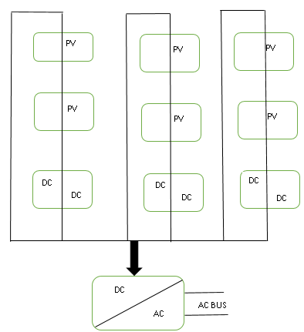
Fig.4 Multi String Inverter circuit diagram

- THERMOELECTRIC COOLING TECHNIQUE

Increasing the efficiency of solar panels and lowering the temperature at which they operate are two goals that are being pursued through the development of a unique approach known as thermoelectric cooling. Due to the fact that the thermal efficiency of panels decreases as the temperature increases, controlling this heat could potentially increase the amount of power that is generated. Through the utilization of the Seebeck effect, thermoelectric cooling is able to convert thermal energy into electrical energy. Peltier cells or thermoelectric modules are utilized in order to accomplish this.
Thermoelectric Cooling Working Principle:
By applying a voltage across two separate conductors or semiconductors, the Peltier Effect causes one junction to absorb heat and the other to dissipate it, creating a cooling effect.
By attaching thermoelectric modules to the back of solar panels, thermal energy can be extracted from them. The
Thermoelectric module lowers the overall temperature of the panel by absorbing some of the heat that the panel generates as it operates and converting it into energy through the Seebeck effect. Heat sinks or radiators can distribute the thermal energy that is generated at the junctions.
There are a number of benefits to using thermoelectric cooling for solar panels:
Cooling activities improve the electrical efficiency of the panel, leading to improved efficiency overall. Reduce the temperature by 1°C, and the efficiency of solar panels increases by roughly 0.5%.
A little boost in total power production can be achieved through energy harvesting, which is the process of converting some heat into electrical energy using thermoelectric modules.
The absence of moving parts in thermoelectric coolers makes them different from mechanical cooling systems; this means that they last longer and require less maintenance.
These modules are small and light, so they may be easily attached to solar panels without adding much extra weight.
Difficult Conditions:
Thermoelectric components and modules can be extremely pricey.
Existing thermoelectric modules have a relatively poor efficiency; thus, the energy advantages might not be enough to warrant the extra cost in many cases.
Adding complexity to the design is necessary to provide adequate heat dissipation from the thermoelectric junctions, which requires efficient heat sinks or radiators.
Possible applications:
Disconnected systems: Thermoelectric cooling is a great way to maximize energy output in remote places where performance optimization is critical.
Thermoelectric cooling is a useful tool for controlling the high temperatures produced by concentrated solar power (CSP) systems, which otherwise provide a significant heat management challenge.
In order to obtain a solar energy system that is both efficient and reliable, it is necessary to evaluate the costs, system
complexity
, and overall efficiency improvements before implementing either technology.

$V_{OC}= \frac{kT}{q}lnln \left\{\frac{I_{L}}{I_{0}} +1\right\}$ (7)
$I_{Total}= I_{0}\left\{e^{\frac{qV}{kT}}-1\right\}- I_{L}$ (8)
$F.F=\frac{V_{M}I_{M}}{V_{OC}I_{SC}}$ (9)
$η= \frac{V_{OC}{ I}_{SC} F.F}{ P_{Rad}}$ (10)
$L_{min}=\frac{D \left(1-D^{2}\right) R}{2f}$ (11)
$C_{min}= \frac{D}{R \left(\frac{∆V_{O}}{V_{O}}\right) f}$ (12)

- RESULTS and DISCUSSION

Table 1. Variation of Voltage and Current

Voltage | Current
4.81 | 9.25
6.53 | 9.22
15.53 | 9.27
18.2 | 9.19
20.3 | 9.11
21.99 | 8.81
22.9 | 8.63
24.45 | 7.71
25.29 | 6.93
25.71 | 6.39
26.14 | 5.82
26.63 | 4.69
27.12 | 3.8
27.4 | 3.05
27.75 | 2.32
27.89 | 1.78
28.07 | 1.4

The MPPT is larger than that of the direct-coupled system. The difference will be greatest at midday. It also demonstrates that the system with MPPT has a smooth curve throughout the day, but the direct-coupled system oscillates throughout the day. Similarly, it goes to sleep roughly an hour earlier in the afternoon than the system with MPPT. Throughout the operation, the flow rate of water is also reduced. The findings suggest that MPPT improves performance significantly

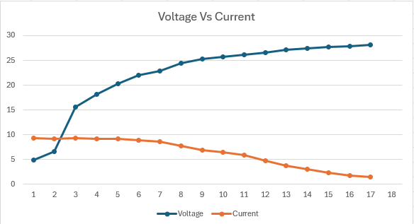

Fig.4 Graphical representation of the variation of voltage with current
VII. CONCLUSION
Using both offline MPPT and thermoelectric cooling in multi-string systems is a good way to improve the performance of solar panels. The pre-trained algorithms of offline MPPTs help keep a close eye on the maximum power point, even in surroundings that change a lot.
This approach collects the most power and doesn't need to do as many calculations in real time, therefore it's better than typical MPPT methods.
Thermoelectric cooling makes a system work better by resolving thermal problems that could make solar panels less efficient and parts less reliable. It keeps the solar panels and inverters at the appropriate temperatures, which makes them last longer and saves energy that would have been wasted by heat and thermal stress. Thermoelectric techniques are also utilized in order to bring the system down to a lower temperature, which allows it to continue operating flawlessly even when the temperature is higher. The overall system becomes more trustworthy as a result of this. When using multi-string setups, each solar panel string is installed independently of the others. This results in a reduction of mismatch losses, an improvement in energy conversion, and a speedier development of large solar arrays. Offline maximum power point tracking (MPPT), thermoelectric cooling, and multi-string designs are all factors that contribute to the overall improvement in efficiency and dependability of solar panels. The findings of this study point to a bright future for the manufacturing of solar energy systems that are both more inventive and more environmentally friendly, and that are capable of being broadly used in renewable energy solutions.
REFERENCES
[1]. Prakash, A., Veeresha, P., Prakasha, D. G., & Goyal, M. (2019). A homotopy technique for a fractional order multi-dimensional telegraph equation via the Laplace transform. The European Physical Journal Plus, 134, 1-18.
[2]. Sharma, K., & Shukla, M. (2014). Molecular modeling of the mechanical behavior of carbon fiber-amine functionalized multiwall carbon nanotube/epoxy composites. New carbon materials, 29(2), 132-142.\
[3]. Badhoutiya, A. (2023, December). Evaluation of charging power levels in different Hybrid Electric Vehicles. In 2023 International Conference on Innovative Computing, Intelligent Communication and Smart Electrical Systems (ICSES) (pp. 1-6). IEEE.
[4] Kumar, P., Singh, P. K., Nagar, S., Sharma, K., & Saraswat, M. (2021). Effect of different concentration of functionalized graphene on charging time reduction in thermal energy storage system. Materials Today: Proceedings, 44, 146-152.
[5]. Bansal, S., & Yadav, K. (2023, April). Reverse Logistics System Analysis using Fuzzy TOPSIS Method. In 2023 1st International Conference on Cognitive Computing and Engineering Education (ICCCEE) (pp. 1-4). IEEE.
[6]. Yadav, K., & Maurya, S. K. (2021). Modelling and control of power flow from auxiliary source in hybrid electric vehicle. In Recent Advances in Power Electronics and Drives: Select Proceedings of EPREC 2020 (pp. 217-227). Springer Singapore.
[7]. TIRTH, V., ALGARNI, S., IRSHAD, K., ISLAM, S., & ZAHIR, M. H. Investigation of MPPT Techniques Under Uniform and Non-Uniform Solar Irradiation Condition–A Retrospection.
[8]. Ibrahim, H. H., Elsaharty, M. A., Guerrero, J. M., & Ghoneim, A. W. (2022, July). A Smart MPPT Algorithm with a Power Independent Tracking System. In 2022 International Conference on Electrical, Computer and Energy Technologies (ICECET) (pp. 1-8). IEEE.
[9]. Charu, K., Thakur, P., & Ansari, F. (2023). Performance Analysis of Conventional MPPT Techniques for a Solar PV System. Journal of Graphic Era University, 117-132.
[10]. Ali, Z. M., Alquthami, T., Alkhalaf, S., Norouzi, H., Dadfar, S., & Suzuki, K. (2022). Novel hybrid improved bat algorithm and fuzzy system based MPPT for photovoltaic under variable atmospheric conditions. Sustainable Energy Technologies and Assessments, 52, 102156.

