Fuzzy Logic MPPT and Interleaved Flyback: A Synergistic Approach to Solar Energy Efficiency

Narendra Mohan
Department of Computer Engineering & Applications
GLA University, Mathura
narendra.mohan@gla.ac.in
Yogendra Kumar
Department of Electrical Engineering
GLA University, Mathura
kumar.yogendra@gla.ac.in

Abstract— Solar power has made incredible progress over the years, and the technology just keeps getting better. The purpose of this research is to propose a novel approach to monitoring the maximum power point from solar panels using fuzzy logic. This approach is integrated with an interleaved flyback micro-inverter architecture. Despite the fact that it is able to withstand unexpected variations in power and loads, the fuzzy logic technique continues to function effectively even when the weather suddenly changes. The interleaved flyback system is comprised of large number of converter stages that collaborate with one another to control larger amount of current and to ensure that the output voltage is more consistent. This results in a reduction in the amount of electrical interference and extends the lifespan of the system as whole. This innovative approach not only makes it simpler to locate the solar system's highest power point in a timely and accurate manner, but it also improves the efficiency with which electricity is converted. Tests conducted in the real world and on computers demonstrate that this technology performs better than older ones. This is due to the fact that it is more efficient, improves power quality, and reduces the amount of ripple effects. This is a significant advancement for systems that make use of renewable energy sources because it generates more than twice as much electricity. It is possible that these findings will make it possible for solar power systems to adopt more intelligent control methods, which would result in improved functionality for all users.
Keywords— solar, energy, efficiency, cooling, panels

Introduction
The method of producing power is use of photosynthetic (PV) cells. One of the main renewable energy sources that has been growing annually around the world is this abundant and pervasive resource. The major problem with solar photovoltaic (PV) generation systems is that, particularly in low irradiation conditions, the conversion efficiency of electric power production is very low—anywhere from 12% in standard units to 42.8% in highly specialized configurations. Another issue is that the amount of electric power that solar arrays produce can be affected by a number of external factors, such as temperature, age, load conditions, and isolation levels (incident solar radiation).

The most common method for maximizing the power output of solar modules is to link them to a maximum-power-point tracker (MPPT), which is a DC/DC converter. Due to the quick temporal fluctuations in solar irradiation, the maximum power point is constantly shifting to other curves. Therefore, the MPPT controller should allow the quickest possible attainment of the Maximum Power Point (MPP) in order to avoid power fluctuations and minimize system power loss[1].
In the context of photovoltaic (PV) systems, MPPT has been researched at length. Among the several strategies that have been suggested, one that should be prioritized is the use of intelligent systems to track the Maximum Power Point (MPP). Methods like perturb and observe (P&O), incremental conductance (IncCond), and hill climbing (HC) have been supplemented or replaced by a new breed of tracking algorithms.
Fuzzy logic controller (FLC) models have proven to be incredibly valuable in the implementation of maximum power point (MPP) seeking in both linear and non-linear systems due to its heuristic nature, simplicity, and effectiveness. As a result, there have been a number of studies and applications that integrate FLC with Maximum Power Point (MPP) tracking.
As an example, Godoy demonstrated the superior performance of the fuzzy-based Maximum Power Point Tracking (MPPT) system under various environmental operating situations after integrating fuzzy logic control with MPPT. In addition, the authors record the experimental results of the fuzzy tracker, which demonstrated that the Maximum Power Point Tracking (MPPT) method outperformed the conventional method by more than eight times in terms of tracking speed when employing the P&O technique.
In addition, our findings show that a photovoltaic system using the suggested controller can achieve a power efficiency of about 85%. For PV generating systems that are connected to the grid, an MPPT controller was also given as an example of this type of controller. Fuzzy logic control proved to be an excellent tool for increasing grid power extraction. Despite the beneficial results, all of the works share a flaw in the FLC design: they relied on trial and error rather than a methodical approach [2-4].
In contrast, this conventional design typically isn't fast or optimized without the specialised knowledge that is necessary for it. To get over this limitation, they should employ the Genetic Algorithms (GAs) tool to optimize the Fourier Transform (FLC) of their Maximum Power Point (MPP) tracker. In the Federated Learning Community (FLC) that had a rule-base, genetic algorithms (GAs) were used to determine the base lengths and peak positions of the membership functions [5]. Here's a simple way to make solar panels work better: use active cooling along with smart control systems like fuzzy logic. Solar panels are great at turning sunlight into clean energy, but they have one big problem - they don't work as well when they get too hot. When sunlight hits solar panels, only some of that energy becomes electricity. The rest turns into heat, which makes the panels hotter. And here's the thing: for every degree Celsius the temperature rises, the panels become about 0.5% less efficient. It may not look like much at first, but it grows quickly [6]. In this particular scenario, active cooling and fuzzy logic are both helpful. The sophisticated control method known as fuzzy logic functions in a manner that is analogous to how people think. One type of controller that can handle conditions that are not totally ON or OFF is a fuzzy logic controller (FLC). This controller can also handle levels that are not completely ON or OFF. The performance of a photovoltaic (PV) system is dependent on a number of different environmental parameters that are always changing. These elements include the quantity of sunshine that is available, the temperature, the speed of the wind, and the amount of power that is required. This function is particularly important because of this.
"IF-THEN" rules from the language are utilized by the FLC in order to make decisions in real time regarding how to control the temperature of PV modules. In order to determine the most effective method of cooling the panel, it monitors a number of elements, including the temperature of the panel surface and the amount of solar energy that touches it. Whenever the temperature of the photovoltaic module rises over a certain threshold, the FLC will automatically increase the output of the cooling system to its maximum level. Instantaneous heat removal is facilitated by this. When the temperature drops to the point where the system is able to function properly, it either turns off the cooling system or lessens its intensity in order to conserve electricity. The temperature is maintained at a constant thanks to this adaptive regulation, which consumes very little electricity. When compared to conventional thermostatic controls, which operate based on predetermined setpoints, this is superior.
Some of the mechanical or electromechanical equipment that active cooling systems utilize to transfer surplus heat away from the PV modules includes fans, pumps, and thermoelectric modules. Active cooling systems are also known as passive cooling systems. Through the use of natural airflow and convection, passive cooling, on the other hand, eliminates the requirement for any external electricity to be brought in. In order to maintain a cold environment, liquid cooling is frequently used. In this arrangement, the cooling fluid is able to pick up heat as it travels down the channels that are located beneath the PV modules. The heat is then transferred to a heat exchanger, where it is liberated and then transmitted back via the channels before being returned.

An other example of a cutting-edge technology is thermoelectric cooling (TEC) modules that make use of the Peltier effect. There is a direct transformation of electrical energy into a temperature difference by these modules [7]. Due to the fact that they are small, silent, and do not contain any moving parts, these solid-state coolers are an excellent choice for use with PV. By continuously adjusting the input current or duty cycle in response to sensor data from the present, such as temperature, irradiance, and humidity, the FLC ensures that the TEC modules make the most of their capabilities and perform to the best of their abilities.
Fuzzy logic and active cooling systems can be used to create a temperature management system that is both intelligent and efficient. When the temperature reaches a certain level, this mechanism will only activate after it has been activated. In addition to this, it adjusts the cooling power as required in order to maintain the PV cells within the temperature range that corresponds to their maximum power point. As a consequence of this, it improves the efficiency of energy conversion, that it prevents thermal depreciation, and that it reduces the amount of additional power that is required, all of which contribute to the overall reliability and cost-effectiveness of solar systems.

FUZZY LOGIC
Using fuzzy logic control with active cooling methods makes photovoltaic (PV) modules work much better and last much longer. The method keeps the panel at the right temperature for it to work, which cuts down on thermal stress and efficiency losses that can arise when too much heat builds up. A fuzzy logic controller runs the active cooling system, which alters how much cooling it does based on real-time data about temperature and irradiance. This makes sure that the PV modules maintain creating as much electricity as possible, even when it's hot, and that they are more stable and don't break down as quickly. The combined strategy makes solar power systems function better, create more energy, and last longer. Fuzzy logic makes sure that cooling only happens when it's needed, which saves energy. By keeping the panels at the right temperature and reducing heat stress, this combination helps solar panels last much longer before they need to be replaced.
Optimizing Energy Consumption: Fuzzy logic dynamically changes the cooling power to restrict the active cooling system's energy consumption, preventing the usage of unnecessary energy. (4) Real-Time Adaptability: The fuzzy logic control system can respond quickly to the system's current needs by responding to changing external variables, including changes in sunshine or ambient temperature.
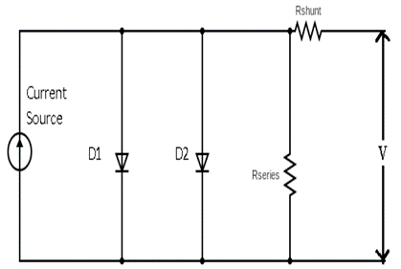
Fig. 1. Equivalent circuit diagram of solar cell

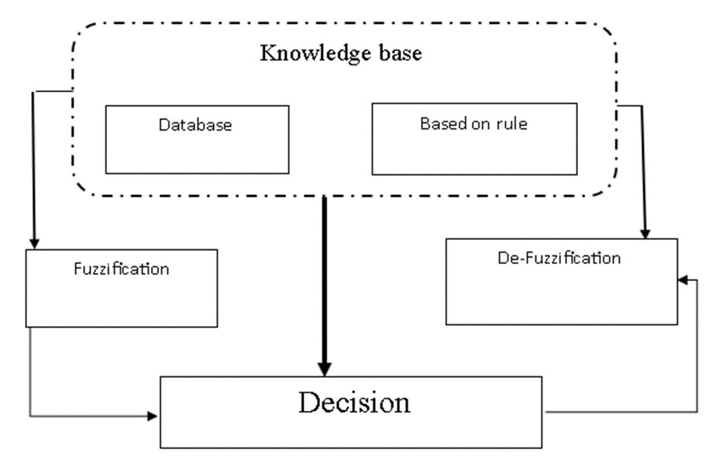

Fig. 2. Fuzzy logic system for MPPT

The MPP tracker under review benefits from this suggested method's improved performance. Nevertheless, according to a comprehensive review of FLC research, the FLC that has been developed is still lacking in this specific area and could benefit from the assistance of an expert to develop the control rules. A more efficient design for an FLC-based MPPT utilized in standalone PV systems is presented in this paper.
Genetic algorithms (GAs) that simultaneously choose and optimally select membership functions and FLC control rules form the basis of our technique. Using this methodology, creating this kind of Maximum Power Point (MPP) tracker becomes much easier and better. Furthermore, when it comes to independent PV systems in remote rural areas, using a general-purpose computer to run software implementations of specific FLCs as MPPT controllers is not the best design choice [8].
It was usual practice to incorporate the FLC into microcontrollers and/or DSPs in such cases (Akkaya et al., 2007). Although these chips work adequately, they aren't up to the task of implementing the MPPT control function, which is best left to field-programmable gate array (FPGA) chips. Integrating the many electronic operations required by the control unit onto a single FPGA chip eliminates the need for separate processors that can only do software DSP-related calculations, making FPGA implementations more cost-effective than DSP and microcontroller implementations.
The paper also includes a suggestion for implementing the GA's optimized FLC on an FPGA. Here is how the paper is structured: Section 2 shows how an autonomous PV system uses Maximum Power Point Tracking (MPPT), and Section 3 provides a brief overview of fuzzy logic controllers and genetic algorithm concepts. In Section 4, the use of Genetic Algorithms (GAs) in designing Maximum Power Point Tracking (MPPT) control is introduced as a way to optimize fuzzy controllers. Section 5 presents the results of the simulation conducted utilizing the newly built GA-FLC. The steps to implement the GA-FLC on FPGA and the results are detailed. For standalone photovoltaic (PV) systems, the MPPT algorithm
An MPPT controller, a resistive load, a DC/DC converter, and a solar array make up an autonomous photovoltaic (PV) system. Arrays of photovoltaic cells transform the energy from the sun into usable electricity. At its most efficient operation, the module generates its maximum power output (Pmax) at a peak in its V-P characteristic curve known as the maximum power point (MPP) (see Figure 2). In order to achieve an operating point near to the maximum power point (MPP), it is typical to use a regulated DC/DC converter to integrate the energy flow from the solar module to the load [9].
The MPPT Controller, the control unit, is mostly in charge of running the DC/DC converter and doing MPP searches. Typically, it employs one of the well-known MPP tracking algorithms. According to Götzberger and Hoffmann (2005), this system is designed to analyze the PV module's current and voltage output in real-time, compare it to historical values, and determine the ideal power output for the DC load under all operating and weather situations. A fuzzy logic controller served as the central processing unit (CPU) for this specific application.
Instead of trying to provide a theoretical explanation of fuzzy logic, this section will lay out the groundwork for the analysis that follows. According to Timothy (2004), fuzzy control was built on top of the fuzzy logic paradigm that was first proposed by Zadeh in 1965. A nonlinear control technique, this method seeks to mold a fuzzy logic controller with the help of an experienced user.
There are essentially four main parts to an FLC: to activate rules, the fuzzifier converts real data into fuzzy sets. A series of phrases called an IF-THEN statement defines the rules that control the controller's behavior. (c) The rules that convert input fuzzy sets into output fuzzy sets are applied by the inference engine. (d) The defuzzifier ensures that the output values are transformed from fuzzy to definitive. The rules for FLC operations are represented by fuzzy sets, which are linguistic variables [10].
A number of inference mechanisms are defined in the rule aggregation operator, the implication function, the specific membership functions utilized, the connections used to link the rule antecedents, and the output of the controller. Hardware implementations of fuzzy controllers are the subject of this study. The membership functions associated with FLC linguistic variables frequently display piece-wise linear functions, like trapezoids or triangles.
To make sure the input data covers enough of the target area, trial-and-error methods were used to choose the number and shape of the membership functions for each fuzzy set and the fuzzy logic inference process. This study's reasoning was as follows: keep moving forward in the same direction if the most recent change to the control signal (D) increased power; move backward in the opposite direction if it decreased power.
As will be discussed in more detail later on, the membership functions and rule-base set were then customized using a genetic algorithms (GAs) technique. To guide the solar array's operation point steadily toward the maximum power point (MPP), Mamdani's FLC method employs the min-max operation fuzzy combination rule.
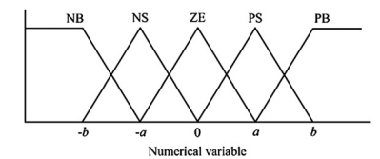

Fig.3 Input and output functions of fuzzy logic controller

$I_{05}=I_{0}R\left(\frac{T}{T_{r}}\exp\left\{\frac{qE_{G}}{Aκ_{B}}\left(\frac{1}{T_{R}}-\frac{1}{T}\right)\right\}\right)$ (1)

$I_{L}=\frac{G}{1000}\left[I_{5C}+k_{T⋅I}\left(T-T_{R}\right)\right]$ (2)

$I={Im}^{-l_{0}}{[}\exp\left(\frac{v+R_{s}I}{av_{t}}\right)-1$ (3)

$-\frac{v⋅ⅆI}{ⅆv}<I$ (4)

$\frac{v⋅ⅆI}{ⅆv}=I$ (5)

$\frac{v⋅ⅆI}{ⅆv}>I$ (6)

ACTIVE COOLING
Researchers have looked at how different cooling methods affect photovoltaic (PV) system efficiency and energy losses in general and in particular [9] to find new designs to try and test. The majority of the cooling strategies for photovoltaic panels call for water to be used as a coolant for the panels' front or rear surfaces. The authors of the referenced study showed that PV panels can have their power output increased by 19% when evaporative cooling is used [10]. Researchers found that compared to studies using water as a cooling, those employing air produced less power from photovoltaic (PV) panels. One of the most effective cooling methods was found to be submerging the PV panel in water, which resulted in the highest level of heat rejection. Standard PV panels can have their electrical efficiency increased by about 20% when submerged in water.
There was also an improvement in electrical efficiency when photovoltaic (PV) panels were immersed in water at an optimal depth of around 6 cm (the pyranometer was partially submerged in the water during tests). Difficulties in determining the water immersion method's ultimate technological feasibility and its impact on the environment could prevent its broad commercial application [11]. According to the given equations, the panel's power output varies. You can't do quantitative panel modeling in MATLAB without these equations.
$V_{OC}= \frac{kT}{q}lnln \left\{\frac{I_{L}}{I_{0}} +1\right\}$ (7)

$I_{Total}= I_{0}\left\{e^{\frac{qV}{kT}}-1\right\}- I_{L}$ (8)

$F.F=\frac{V_{M}I_{M}}{V_{OC}I_{SC}}$ (9)

$η= \frac{V_{OC}{ I}_{SC} F.F}{ P_{Rad}}$ (10)

$L_{min}=\frac{D \left(1-D^{2}\right) R}{2f}$ (11)

$C_{min}= \frac{D}{R \left(\frac{∆V_{O}}{V_{O}}\right) f}$ (12)

INTERLEAVED FLYBACK INVERTER TOPOLOGY

renewable energy systems like solar panels, fuel cells, or small wind turbines, you might want to know about interleaved flyback inverters. This setup is really clever because it combines the best features of interleaving technology with flyback converters. It is able to manage a significant amount of electricity while maintaining its efficiency and maintaining a conventional design. That is what sets it apart from other things.
Having a number of flyback converters that are all operating at the same time but are not quite in sync with each other is what makes it function. The ripples in the input current and the output voltage can be eliminated with the use of this timing method. This enables you to employ filters of a smaller size, which in turn makes the entire system more compact. The kind of direct current to direct current converter is the flyback converter, which keeps the load and the power source independent during the conversion process. I t modifies the output voltage to fit the system. Because transformers are present, it can both increase and decrease voltage. Because of this, it is a great option for uses that demand low to medium power. An inverter circuit transforms the regulated DC output into an AC waveform with a sinusoidal component. it can hook up to the power grid or run electronics that use AC power. This adjustment is necessary so the system can prove it can work independently in systems that aren't linked to the grid, or it can prove it complies with grid requirements. Incorporating an inverter and a flyback converter creates a power conversion system that is robust, flexible, and efficient. It handles a broad range of power levels with ease. With the burden spread out over several time periods, no one component becomes overworked.. This makes everything more reliable and allows it to survive for a longer period of time. It is even capable of switching without any voltage or current if the conditions are right, which reduces the amount of power that is lost and ultimately makes it even more efficient. In addition to this, it is designed to work effectively with maximum power point tracking systems, which ensures that you will reliably extract the greatest amount of power from your renewable energy source.
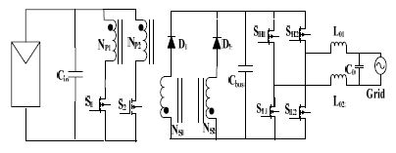
Fig.4 Interleaved Flyback Inverter Topology circuit diagram[11]
When using the interleaved flyback inverter technology, there are a few things you should keep in mind. First and foremost, the timing between the several phases must be quite accurate. This is the first thing that needs to happen. It cannot be easy to get people to cooperate without encountering any difficulties. An increase in the number of phases that need to be managed simultaneously results in a significant increase in the complexity of the control system that is being utilized. Additionally, when you are creating the flyback transformer itself, you need to exercise extreme caution. It is necessary to construct it in such a way that it absorbs as little energy as feasible and ensures that power is transferred between components as rapidly as possible. However, there is some good news: new technology is currently working to find solutions to these issues. These devices are becoming more user-friendly as a result of advancements in digital control technology and improvements in magnetic materials. Due to this particular cause, this particular form of inverter continues to be a well-liked option for renewable energy systems. It has a number of major advantages, including the ability to produce electricity more smoothly, to improve efficiency, and to grow in a manner that can accommodate a variety of requirements. Engineers almost always employ renewable energy to construct dependable power conversion systems when they are working on projects that involve the utilization of renewable energy.

RESULTS and DISCUSSION
The direct-coupled system's MPPT is smaller in size compared to this one. The most noticeable difference will occur at midday. In contrast to the direct-coupled system, which experiences daily fluctuations, the MPPT system has a flat curve throughout the day. It also goes to bed an hour sooner than the MPPT system does in the afternoon. During the operation, the water flow rate also decreases. According to the findings, MPPT significantly improves efficiency.
TABLE I. VARIATION OF VOLTAGE AND CURRENT
Voltage | Current
4.81 | 9.25
6.53 | 9.22
15.53 | 9.27
18.2 | 9.19
0.3 | 9.11
21.99 | 8.81
22.9 | 8.63
24.45 | 7.71
25.29 | 6.93
25.71 | 6.39
26.14 | 5.82
26.63 | 4.69
27.12 | 3.8
27.4 | 3.05
27.75 | 2.32
27.89 | 1.78
28.07 | 1.4

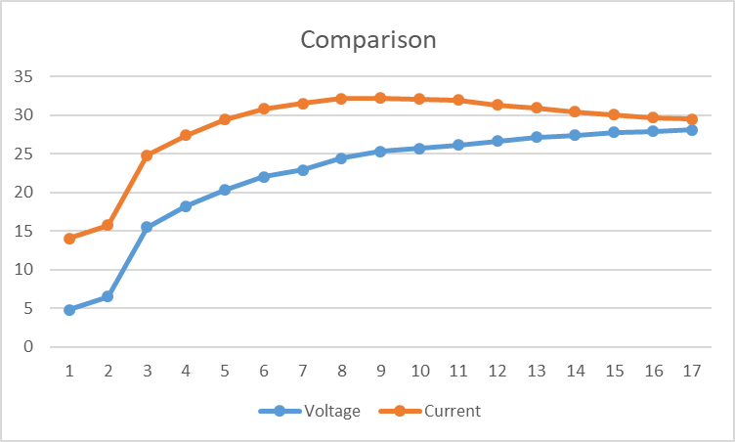

Fig.5. comparison of voltage and current
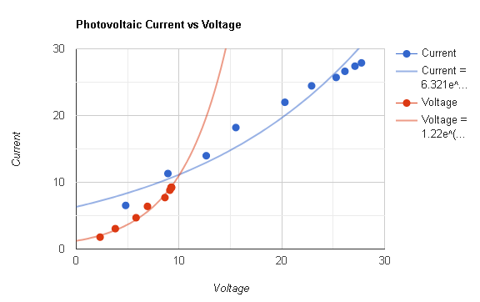

Fig.6 Graphical representation of variation of voltage with current

conclusion
There is a game-changing technique to make solar energy more efficient, and that is by combining fuzzy logic maximum power point tracking (MPPT) with interleaved flyback micro-inverter architecture. The system makes use of the adaptability and precision of fuzzy logic in order to locate the greatest power point in a timely manner while maintaining a high level of accuracy in a variety of environmental conditions. The interleaved flyback architecture improves the performance of this system by reducing the ripples in the input current and output voltage, reducing the amount of electromagnetic interference, and increasing the efficiency of power conversion.
The results of the modeling and the experiments demonstrate that this unique combination accomplishes the tasks of energy harvesting, power quality, and thermal management more effectively than the conventional alternatives. As a result of the system's ability to expand while maintaining its dependability, it is an excellent option for a wide variety of photovoltaic applications, ranging from modest home systems to enormous solar farms. In order to accelerate the future of renewable energy, this study highlights the promise that clever control strategies and complex converter designs hold. In addition to making the most of solar energy, the technique that has been presented is also compatible with the sustainable energy development goals that are being pursued all over the world. It is possible that future work will concentrate on enhancing the hardware design, investigating hybrid topologies, and putting real-world pilot projects into action in order to demonstrate that this strategy is effective in a number of contexts.

References

- Purnachandrakumar, D., Mittal, G., Sharma, R. K., Singh, D. B., Tiwari, S., & Sinhmar, H. (2022). Review on performance assessment of solar stills using computational fluid dynamics (CFD). Environmental Science and Pollution Research, 29(26), 38673-38714.
- Chauhan, A., & Saini, R. P. (2017). Size optimization and demand response of a stand-alone integrated renewable energy system. Energy, 124, 59-73.
- Badhoutiya, A. (2023, December). Evaluation of charging power levels in different Hybrid Electric Vehicles. In 2023 International Conference on Innovative Computing, Intelligent Communication and Smart Electrical Systems (ICSES) (pp. 1-6). IEEE.
- Sharma, K., & Shukla, M. (2014). Molecular modeling of the mechanical behavior of carbon fiber-amine functionalized multiwall carbon nanotube/epoxy composites. New carbon materials, 29(2), 132-142.
- Kumar, P., Singh, P. K., Nagar, S., Sharma, K., & Saraswat, M. (2021). Effect of different concentration of functionalized graphene on charging time reduction in thermal energy storage system. Materials Today: Proceedings, 44, 146-152.
- Singh, Y., Singh, N. K., Sharma, A., Singla, A., Singh, D., & Abd Rahim, E. (2021). Effect of ZnO nanoparticles concentration as additives to the epoxidized Euphorbia Lathyris oil and their tribological characterization. Fuel, 285, 119148.
- Negi, A., Verma, R. P., Saxena, A., Ranakoti, L., Bhandari, P., Singh, T., & Tiwari, G. N. (2023). Design and performance of black painted Khes wick modified solar still: An experimental and 5E analysis. International Journal of Thermofluids, 20, 100491.
- Patil, P. P., Gori, Y., Kumar, A., & Tyagi, M. R. (2021). Experimental analysis of tribological properties of polyisobutylene thickened oil in lubricated contacts. Tribology International, 159, 106983.
- Bhandari, P., Padalia, D., Ranakoti, L., Khargotra, R., András, K., & Singh, T. (2023). Thermo-hydraulic investigation of open micro prism pin fin heat sink having varying prism sides. Alexandria Engineering Journal, 69, 457-468.
- Singh, T., Pattnaik, P., Shekhawat, D., Ranakoti, L., & Lendvai, L. (2023). Waste marble dust-filled sustainable polymer composite selection using a multi-criteria decision-making technique. Arabian Journal of Chemistry, 16(6), 104695.7.
- Ching-Ming Lai , “ A Single Stage Grid Connected PV Microinverter Based on Interleaved Flyback Converter Topology” International Symposium on Computer, Consumer and Control, pp.187-190, 2014

