A Novel Approach to PV Power Maximization: AI-Controlled MPPT and PCM Cooling

Mridul Dixit
Department of Computer Engineering & Applications
GLA University, Mathura
mridul.dixit@gla.ac.in
Saloni Bansal
Department of Electronics & Communications Engineering
GLA University, Mathura
saloni.bansal@gla.ac.in

Abstract- The present paper describes a new method of optimizing the operation of photovoltaic (PV) systems and AI and PCM cooling devices. The main objective is to reach the optimum level of power production and effective thermal control.An efficient tracker of the maximum power point (MPPT) control is obtained and applied to the technologies of artificial intelligence (AI) or, in other words, machine learning (ML). The artificial intelligence (AI) model can identify the most desirable operating point by monitoring real time measurements of photovoltaic (PV) modules resulting in high efficiency improvement in power generation. The phase change material (PCM) cooling systems can be used to cool the photovoltaic (PV) systems in a sustainable manner. Phase change materials (PCMs) are substances that capture and release the latent heat during the phase changing process to keep the photovoltaic (PV) modules in a constant operating temperature. The addition of the PCM cooling and AI-based MPPT that may help to make the system more efficient and reliable, in general. The efficiency of the proposed approach is also made sure because of the results of the experiment. The AI-operated PCM system of cooling systems offers a better output of power and reduction of operating temperature compared to passive cooling systems and other conventional means of MPPT. The research will contribute to the existing knowledge on photovoltaic (PV) technology and will offer specific data that can be used in designing and implementing renewable energy infrastructure in future.
Keywords: solar, energy, cooling, MPPT, efficiency
- INTRODUCTION
Photovoltaic (PV) systems can be used to transform solar energy into electrical power. Both systems that are interconnected to the grid and those that are not, use them. The working efficiency of the maximum power point (MPP) represents the key factor that dictates the performance of the photovoltaic (PV) systems. One of the ways that have been used to improve photovoltaic PV systems is to use maximum power point tracking (MPPT), which is a control loop that ensures that the Pdc power output remains at its maximum regardless of the load or the environmental conditions. The expensive nature of the solar power systems has been observed to be one of the biggest barriers to the substitution process of fossil energy with renewable sources of power. This has however been virtually wiped out with the advent of more efficient photovoltaic (PV) technology [1].
The majority of grid-connected power systems based on the Maximum Power Point Tracking (MPPT) control systems rely on dc boost converters. The duty cycle is modified in response to environmental variations like changes in temperature and solar radiation to the cell. Three common algorithms were used to perform maximum power point tracking (MPPT): incremental conductance (INC), hill climbing and perturb-and-observe. It is also worth noting that the artificial intelligence (AI) control technologies would enable the MPPT control system of autonomous and grid-connected PV systems to be much more efficient.
Genetic algorithm (GA) and fuzzy logic control enhanced the work of MPPT. Some optimization algorithms like the particle swarm optimization and the Ant colony optimization method were applied to improve the performance of Maximum Power Point Tracking (MPPT) systems. The new approaches are combined with the traditional ones in the artificial intelligence-based systems, including Maximum Power Point Tracking (MPPT).
We have defined the use of AI algorithms to enhance the functioning of photovoltaic (PV) systems classifying and comparing the conventional and AI maximum power point tracking (MPPT) technique. When properly trained, artificial neural networks (ANNs) are capable of producing accurate, efficient and robust solutions and have numerous applications in various areas [3].
We play with input signals and topologies extremely in order to run Artificial Neural Networks (ANNs) to track Maximum Power on many settings. It is possible to combine the ANN and the Genetic Algorithm (GA) in order to improve the MPP search process.
The use of genetic algorithm (GA) will seek to optimize training data of the artificial neural network (ANN). Maximum Power Point Tracking (MPPT) uses Artificial Neural Networks (ANNs) and this research study aimed to enhance ANNs architecture in two ways. The first thing that should be done is to replace two old inputs of ANN, G and Tc, with two others. These other inputs are calculated using the derivative of Pdc and the PV voltage( Vpv ). The latter is markedly lacking in ANN-based MPPT as compared to fuzzy logic-based MPPT.
The artificial neural network (ANN) result is that the choice of these inputs depends on their sensitivity to the deviation of the point of maximum power. The second step of the process of developing the artificial neural network (ANN) design to trace the maximum power point (MPPT) is the optimization of the genetic algorithm (GA), instead of the manual or trial-and-error based design.
Some of the variables that can be considered to optimize the mean square error (MSE) objective function are the number of hidden layer (HL) neurons, the activation function, and the learning method. This is how the current document is designed. We give the diode single diode approach to PV array modeling. When the climatic circumstances are considered to be changing, the cause of the increased dispersion at the Maximum Power Point (MPP) is attributed.
As a point of comparison, an outline of a basic methodology (INC methodology) is presented. We talk about the construction of ANN manually and the application of ANN to Maximum Power Point Tracking (MPPT). Section IV deals mostly with improving the ANN to a MPPT system. Comparative analysis may be employed as a means of highlighting the gains that have been made. Lastly, the conclusion, which has been prepared, is inserted in Section IV.
- PV ARRAY MODELING
To put it simply, photovoltaic (PV) cells are the building blocks of solar arrays. The connection between cells and panels is determined by the voltage and power requirements. Modelling photovoltaic arrays begins with PV cell modeling. Various methods exist for depicting a photovoltaic (PV) cell. In order to fulfill the criteria for PV cell simulation, a straightforward and compliant diode model is offered.
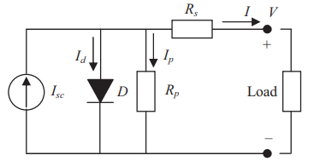
Fig.1 Equivalent solar cell circuit diagram
﻿ The equations show how a PV cell's current (I) and voltage (V) relate to one another as
$I=Iph-I_{d}-I_{P}$ (1)
$I_{L}=\frac{G}{1000}\left[I_{5C}+k_{T⋅I}\left(T-T_{R}\right)\right]$ (2)
$I={Im}^{-l_{0}}{[}\exp\left(\frac{v+R_{s}I}{av_{t}}\right)-1$ (3)

I stands for photocurrent, I stands for diode current, I stands for current in parallel resistance (R), and I stands for saturation current.
The variables in this equation are short circuit current (I), open circuit voltage (Voc), solar irradiation (G), cell temperature (Tc), semiconductor material band gap (Eg) (J), Boltzmann constant (k), electron charge (q), and ideal factor (an) [17]. The results were obtained under standard test circumstances, with air mass (AM) equal to 1.5, Tc C 25° =, and 2 G Wm = 1000 /, as shown by the subscript n. The series resistance (Rs) represents contact and internal cell resistance, whereas the parallel resistance () represents leakage current.
The characteristics of voltage versus output power of a PV panel were used to demonstrate the dependence of the MPP on various environmental factors such as G and Tc. These relations are revealed in Figure 2 and Figure 3 (variable G and variable Tc respectively) [6]. The model uses SUNPOWER 305 solar panel that has 96 all-back-contact solar cells. These numbers indicate the maximum power point which varies with the surrounding conditions. Due to the constantly evolving nature of the environmental factors, PV arrays demand a monitoring control system that ensures the production of maximum power in any given situation.
Artificial Neural Networks for MPPT
The capability of artificial neural networks (ANNs) to solve complex mathematical problems in an efficient and precise way has been proved in numerous fields. Artificial neural networks (ANNs) are employed in Machine Predictive Control (MPPT) systems because they are able to react to a broad range of environmental variables very rapidly and with high accuracy. A myriad of possible activation functions [7-9] can be employed. the solar array voltage (Vpv), duty cycle (D), and the inverter direct current (Vdc). This model has a voltage source converter (VSC) to control the inverter but the importance of the inverter voltage fluctuations is not emphasized in this paper. Maximum Power Point Tracking (MPPT) involves the usage of the Artificial Neural Network (ANN), where the PV model, inputs, and objectives outlined in Section II, were used as the training data. Once the trained ANN is at a performance level specified by the mean square error (MSE), the ANN is prepared to do maximum power point tracking (MPPT). The flow diagram below illustrates the process of training an artificial neural network (ANN) to do Maximum Power Point Tracking (MPPT) [10]. The manual design of the maximum power point tracking (MPPT) ANN architecture is an ANN consisting of a hidden layer (HL) of 10 neurons, G and Tc as input variables, and D as an output variable. The weights are adjusted using the Levenberg-Marquardt algorithm to minimise the mean square error (MSE) between the objective and the ANN output. Maximum Power Point Tracking (MPPT): To apply an Artificial Neural Network (ANN) in generating the maximum power point, a modified form of the 100-kW grid-connected PV array model in the MATLAB library was used. The structure of the system consists of a grid, inverter, DC-DC boost converter, duty cycle regulation control circuit and solar array. Figure 7 shows the schematic architecture of the simulated system. A neural network (ANN) instructs D to have the dc-dc 99 boost converter put into play to maintain an eye on the maximum power output and control Vpv.
PCM COOLING
Finding out how phase change material (PCM) can lower the temperature of a conventional photovoltaic (PV) panel while simultaneously increasing its electrical efficiency is the primary goal of this research. Photovoltaic (PV) panels must have a phase change material (PCM) layer because PVs work better when the cell temperatures are lower. To improve the thermal efficiency of the PV cells, the PV-PCM layer dissolves in response to incident solar energy that is not being converted into electrical energy, lowering the temperature of the PV cells. The typical photovoltaic (PV) panel can benefit from the latent cooling features of phase change material (RT28HC), which is one of the aims of this work. How much that E. The cooling effect of the phase change material (PCM) allowed the photovoltaic (PV) panel to produce more electricity than a conventional PV panel. To determine how well the PV panels performed in the simulation, an evaluation was carried out for a full year. Varieties in the panel's power output can be achieved by utilizing various formulae. This MATLAB panel mathematical model relies on the following equations.
.

.
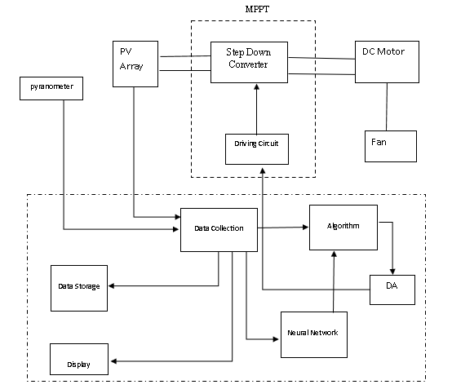
Fig. 2 Arrangement of artificial intelligence in MPPT technique

RESULTS AND DISCUSSION
Table 1. Variation of Power of PV panel with time for a sunny day
Time | Power
11.018 | 29.053
11.118 | 30
11.476 | 33.158
12.102 | 37.579
12.55 | 39.789
12.684 | 41.053
13.288 | 41.368
13.466 | 40.105
13.556 | 39.158
13.981 | 35.368
14.093 | 33.158
14.585 | 28.737
14.808 | 26.211
15.479 | 21.789
15.703 | 17.684
15.837 | 13.579
16.005 | 11.368

Table 2. Variation of Power of PV panel with time for a cloudy day
Time | Power
10.883 | 17.684
11.163 | 18
11.812 | 22.105
12.214 | 25.895
12.952 | 29.684
13.176 | 30.316
13.31 | 28.105
13.645 | 26.211
13.914 | 23.684
14.16 | 20.842
14.495 | 18.316
14.942 | 13.263
15.166 | 12.947
15.468 | 12

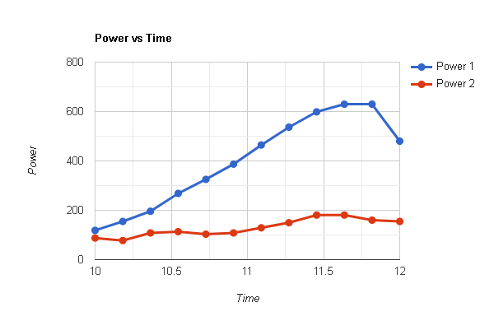
Fig. 1. Variation of Power with time
A performance evaluation of the MPPT can be carried out by employing the matching factor. The matching factor is the ratio achieved by dividing the maximum power generated by the photovoltaic (PV) module by the power used by the maximum power point tracking (MPPT) system, which is responsible for tracking the power flow from the PV module to the load. The graph illustrates that the Maximum Power Point Tracking (MPPT) system optimally functions at approximately 97% of the actual maximum power generated. Similar findings are noted on days marked by overcast sky. This rise is explained by the exact alignment of the direct current (DC) demand of the photovoltaic (PV) module. Mean daily percentage growth in system energy output over a month for the Maximum Power Point Tracking (MPPT) system.
CONCLUSION
Photovoltaic (PV) systems have a basis of Maximum Power Point Tracking (MPPT) to guarantee that they are functioning at their highest efficiency through enhancing the DC power output. Various conventional Maximum Power Point Tracking (MPPT) algorithms are used to maintain the voltage and the output power to their optimum values. Since properly trained artificial neural networks can yield superior results than traditional techniques, they are slowly supplanting them. This research has demonstrated that phase change material (PCM) cooling methods together with AI can be used to make photovoltaic (PV) systems even more efficient. An AI-based maximum power point tracking (MPPT) method is used to identify the optimal operating point, and it would greatly improve power generation efficiency. Simultaneously, the PCM-based cooling system will ensure the efficiency and long-term operation of the heating control solution, which will ensure the best performance of the PV module. The combination of artificial intelligence (AI) and phase change material (PCM) cooling has enhanced photovoltaic (PV) system power generation and lowered its operational temperatures. This research contributes significantly to the literature of photovoltaic (PV) technology and also illuminates the ways of designing and realizing sustainable energy systems in future. ANNs are developed to be more suitable in maximum power point tracking (MPPT). We seek to have this improvement by having less-than-optimal inputs, which are more dependable to the power threshold. Another innovation is the genetic algorithm optimization in the construction of the ANN structure. The findings and the comparisons of the results of the simulations indicate that the enhanced structure of the artificial neural network (ANN) improves the performance of the ANN in maximum power point tracking (MPPT) and more DC power is made available, which makes the PV array more efficient.
REFERENCES
- Yap, K. Y., Sarimuthu, C. R., & Lim, J. M. Y. (2020). Artificial intelligence based MPPT techniques for solar power system: A review. Journal of Modern Power Systems and Clean Energy, 8(6), 1043-1059.
- Kalaiarasi, N., Subhranshu, S. D., Paramasivam, S., & Bharatiraja, C. (2021). Investigation on ANFIS aided MPPT technique for PV fed ZSI topologies in standalone applications. Journal of Applied Science and Engineering, 24(2), 261-269.
- Belkhiri, D., Ajaamoum, M., Cherifi, K., Elidrissi, A., & Alaoui, M. R. E. M. (2023, May). Artificial Intelligence-based MPPT Techniques in Wind Energy Systems: A Literature Review. In 2023 3rd International Conference on Innovative Research in Applied Science, Engineering and Technology (IRASET) (pp. 1-6). IEEE.
- Eshak, M. M., Khafagy, M. A., Makeen, P., & Abdellatif, S. O. (2020, October). Optimizing the performance of a stand-alone PV system under non-uniform irradiance using Gray-Wolf and hybrid neural network AI-MPPT algorithms. In 2020 2nd Novel Intelligent and Leading Emerging Sciences Conference (NILES) (pp. 600-605). IEEE.
- Raj, S. A., & Samuel, G. G. (2022, January). Survey of AI based MPPT algorithms in PV systems. In 2022 4th international conference on smart systems and inventive technology (ICSSIT) (pp. 597-604). IEEE.
- Taylor, A., & Musa, S. M. (2022, October). Evaluation of Hybrid AI-based Techniques for MPPT Optimization. In 2022 International Conference on Green Energy, Computing and Sustainable Technology (GECOST) (pp. 371-375). IEEE.
- Suyanto, S., Mohammad, L., Setiadi, I. C., & Roekmono, R. (2019, October). Analysis and evaluation performance of MPPT algorithms: Perturb & observe (P&O), firefly, and flower pollination (FPA) in smart microgrid solar panel systems. In 2019 International Conference on Technologies and Policies in Electric Power & Energy (pp. 1-6). IEEE.
- Hichem, L., Amar, O., & Leila, M. (2023). Optimized ANN-fuzzy MPPT controller for a stand-alone PV system under fast-changing atmospheric conditions. Bulletin of Electrical Engineering and Informatics, 12(4), 1960-1981.
- Rana, Y., Pratush, P., Ansari, S., Jaiswal, S., Singh, G., & Virmani, R. (2022, November). Performance Comparison of Conventional and AI based MPPT in Solar PV System. In 2022 IEEE 10th Power India International Conference (PIICON) (pp. 1-6). IEEE.
- Sharma, A. K., Pachauri, R. K., Choudhury, S., Minai, A. F., Alotaibi, M. A., Malik, H., & Márquez, F. P. G. (2023). Role of metaheuristic approaches for implementation of integrated MPPT-PV systems: a comprehensive study. Mathematics, 11(2), 269.

