A Hybrid Approach to Enhancing Efficiency in Solar Photovoltaic (PV) Systems through the Use of Offline Maximum Power Point Tracking (MPPT) Control and Nanofluid-Based Cooling

Krishna Kant Dixit
Department of Electrical Engineering
GLA University, Mathura
krishnakant.dixit@gla.ac.in
Mridul Dixit
Department of Computer Engineering & Applications
GLA University, Mathura
mridul.dixit@gla.ac.in

Abstract- This paper investigates a hybrid approach to improving the efficiency of solar photovoltaic (PV) systems by combining an offline Maximum Power Point Tracking (MPPT) technique with nanofluid-based cooling. Solar panels are subject to efficiency losses due to both suboptimal power point tracking and increased operating temperatures under high irradiance. While traditional MPPT methods such as Perturb and Observe or Incremental Conductance are widely used, they often require continuous tracking and may struggle with rapid environmental changes, leading to efficiency losses.The proposed offline MPPT technique relies on pre-recorded data to optimize power point tracking without continuous real-time adjustment, reducing system complexity and computational demand. To further enhance performance, nanofluid cooling—utilizing fluids enhanced with nanoparticles—maintains the panel temperature within an optimal range, preventing thermal degradation and increasing energy output.Through simulation and experimental analysis, this dual approach demonstrates notable improvements in both power extraction and thermal management. The results highlight the potential of combining offline MPPT with nanofluid cooling to provide a cost-effective, efficient solution for maximizing solar PV system performance, especially in regions with stable climatic conditions. This research contributes to the development of sustainable and advanced techniques for enhancing renewable energy generation
Keywords: solar , efficiency, energy, cooling ,power

- INTRODUCTION
The majority of the world's energy comes from three main sources: coal, oil, and gas. Energy consumption is continuously on the rise [1, 2]. The worldwide quality of life could be severely impacted by the eventual exhaustion of traditional energy sources. Worldwide energy security is a cause for concern due to the fact that a handful of nations hold the vast majority of the world's oil and gas reserves.
The search for alternate energy sources has been accelerated by world leaders due to security concerns. In addition, the issue of global warming, which is mostly caused by emissions of greenhouse gases from the combustion of fossil fuels, has heightened the demand for alternative energy sources.
Use of renewable energy resources and enhancement of total conversion efficiency are seen as very practical solutions to the energy problem [3, 4]. Power generated by replenishing natural processes including wind, solar radiation, water, tides, geothermal heat, and other forms of biomass is known as renewable energy.
Due to their minimal impact on the environment, these energy sources are being evaluated as potential solutions to the issue of climate change [5, 6]. Power from the sun accounts for nearly all renewable energy. One renewable energy source that is entirely sustainable is solar power. Since it does not contain any moving mechanical elements, it is low-maintenance and makes very little noise compared to other devices.
Put simply, the solar panels are easy to install. Solar power requires a large amount of space, is highly dependent on favorable weather, and requires a large initial investment. Solar photovoltaic (PV) arrays are optimized to operate at maximum power point (MPP) regardless of changes in weather conditions [7, 8]. When the electrical drives are powered by PV, it is extremely crucial to ensure optimal efficiency [8]. Under different weather circumstances, photovoltaic (PV) sources can produce the most power when they are synced with the load. Mechanical and electrical monitoring are the two options for keeping an eye on the Maximum Power Point (MPP). In mechanical monitoring, photovoltaic (PV) panels are physically shifted to follow the sun's movement.
Seasons and day length dictate where PV panels should be positioned. With the use of power electronic components, photovoltaic panels may be electrically monitored by following the P-V or I-V curves, and they are engineered to work in tandem with Maximum Power Point (MPP) [7]. The look-up table method, the curve fitting method, and voltage and current-based Maximum Power Point Tracking (MPPT) approaches are all part of the study's objective to assess the effectiveness of these offline methods.
Different systems are compared according to their applicability, tracking speed, complexity, cost, and number of sensors required. Temperature swings, levels of isolation, and weather conditions are all taken into account. The use of MATLAB®/Simulink to resistance load Maximum Power Point Tracking (MPPT) based on voltage is discussed in this study.
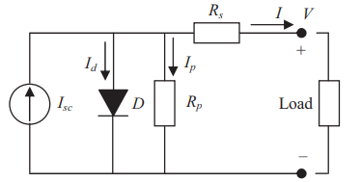
Fig.1 Equivalent solar cell circuit diagram
Due to the quick temporal fluctuations in solar irradiation, the maximum power point is constantly shifting to other curves. Hence, the MPPT controller should allow for rapid attainment of the Maximum Power Point (MPP) to avoid power loss and output power variations. Despite the beneficial results, all of the works share a flaw in the FLC design: they relied on trial and error rather than a methodical approach. This conventional approach to design requires the presence of knowledgeable specialists; on the other hand, without this data, their work is often inefficient and subpar.
Offline MPPT Techniques
Different approaches to tracking Multiple Point Tracking (MPPT) are commonly classified as either online, hybrid, or offline, depending on the technology used to measure Maximum Power Point (MPP). The maximum power point (MPP) can be computed offline using technical data collected from photovoltaic (PV) panels. This data includes open circuit voltage, short circuit current, and the P-V and I-V curves. Despite the fact that internet methods are more efficient, offline ones are less expensive. To track MPP, the web-based method used current and voltage readings taken in real-time.
Sun radiation or temperature measurements are not required by this method. The particular model of a solar cell is irrelevant to model-free methods, often called online approaches. The control signal is generated through offline tracking using reference signals such as open circuit voltage (Voc), short circuit current (Isc), temperature, and solar radiation.
The offline method uses the current and voltage readings from photovoltaic (PV) panels in real time to generate a control signal that keeps an eye on the Maximum Power Point (MPP) (Fig. 1). Methods for processing data both online and offline are combined in the hybrid approach. There are two levels of monitoring that the MPP goes through. Stage two of the online method involves fine-tuning the operating point to the MPP, in contrast to stage one of the offline method, which involves keeping the operating point relatively close to the MPP.

$I_{05}=I_{0}R\left(\frac{T}{T_{r}}\exp\left\{\frac{qE_{G}}{Aκ_{B}}\left(\frac{1}{T_{R}}-\frac{1}{T}\right)\right\}\right)$ (1)

- Curve Fitting-Based MPPT
An offline method is to use a mathematical model and equation to determine technical data, panel characteristics, and other relevant information, such as the voltage equation for the PV panel output in relation to the maximum power point (MPP). Move the control knob to the MPP setting. A familiarity with the PV model and the theoretical equation is necessary for this approach, despite its apparent ease of use. The enormous amount of calculations requires a large amount of memory, and the computational pace is slow.
- Constant Voltage Method
K, the voltage factor, can take on values between 0.7 and 0.95 across a wide variety of temperature and sun insolation situations; the constant voltage technique is based on this linear association between Vmpp and Voc.
According to the literature, there are two main categories of constant voltage techniques [9–11]. One method involves separating the solar panel in order to get the open circuit voltage (Voc). Then, based on the solar cell material, the appropriate operating temperature can be determined using Equation (1). After that, the voltage across the array is adjusted until Vmpp is reached. Finding the optimal value of K is a challenge with this method since it seems to fluctuate between 73% and 80%. In terms of efficiency, it falls short.
One more way to keep the voltage constant is to calibrate the open circuit voltage with a pilot panel. Using a test solar panel with identical specs to the production solar panel allows for an accurate Voc estimate. This method overcomes the previous constant voltage method's drawback—the PV power loss that happens during Voc measurement—by using an alternative methodology. Because an additional pilot panel is needed, the price of this technology is higher.

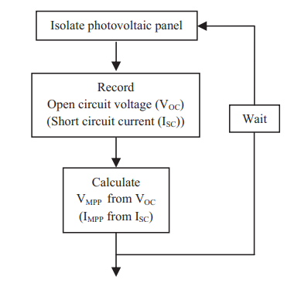

Fig. 2. Flowchart for offline MPPT methods

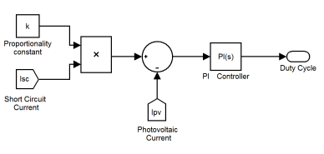
Fig. 3. Block diagram representation of offline MPPT technique

$I_{L}=\frac{G}{1000}\left[I_{5C}+k_{T⋅I}\left(T-T_{R}\right)\right]$ (2) $I={Im}^{-l_{0}}{[}\exp\left(\frac{v+R_{s}I}{av_{t}}\right)-1$ (3)

- NANOFLUID COOLING TECHNIQUE
Engineered suspensions of nanoparticles in liquids are known as nanofluids. Nanoparticles of metal or metal oxide, typically ranging in size from one hundred nanometers to one thousand nanometers, are disseminated in a base fluid. When compared to older solid-liquid mixtures that contained bigger particles, new colloidal solutions made of nanoparticles distributed in a base fluid have demonstrated the ability to reduce erosion, sedimentation, and clogging.
One way in which nanoparticles can alter a base fluid's thermo-physical properties is by increasing its thermal conductivity. Nanoparticles improved the heat transfer efficiency of the liquid-cooled, single-phase system by as much as 20%.
The purpose of this white paper is to provide engineers with an in-depth understanding of nanofluids and nanoparticles by covering a variety of topics, such as an introduction to the subject, engineering terminology and selection criteria, pricing points, market trends, basic applications, challenges, and conclusions. The article concludes with a list of sources and a glossary of terms that define key concepts.
A nanofluid formulation requires nanoparticles in addition to a base fluid. To make colloidal mixtures more stable, surfactants are sometimes used. Metal ions, metal oxides, carbides, and carbon nanotubes are the most common nanoparticles used in nanofluids. Fluids such as water, ethylene glycol, and oil are acknowledged by most as being fundamental. When nanoparticles are mixed with a base fluid, a colloidal structure is created.
The thermal conductivity and viscosity of the resulting nanofluids are enhanced by adding nanoparticles to the host fluid. How much improvement you can expect depends on a number of things, such as the particle's shape and the volume % you're adding. The amplification has been attributed to a number of microscopic processes, such as particle clustering, liquid layering on nanoparticle surfaces, and the particle dynamic effect.
$C_{PV}\frac{dT_{PV}}{dt}=$Effective Irradiance (I_{reff}) – Radiation (Q_{R}) – Power (P_{E}) – Convection (Q_{CV}) – Heat stored by nanofluid (Q_{H}) (7)
$V_{OC}= \frac{kT}{q}lnln \left\{\frac{I_{L}}{I_{0}} +1\right\}$ (8)
$I_{Total}= I_{0}\left\{e^{\frac{qV}{kT}}-1\right\}- I_{L}$ (9)
$F.F=\frac{V_{M}I_{M}}{V_{OC}I_{SC}}$ (10)
$η= \frac{V_{OC}{ I}_{SC} F.F}{ P_{Rad}}$ (11)

RESULTS AND DISCUSSION

Table 1. Variation of Power with Voltage at different irradiations

V  (5 KW/M²) | p  (5KW/M²) | V  (1 KW/M²) | P  (1KW/M²)
3.65 | 82.581 | 4.339 | 87.742
5.234 | 118.71 | 5.785 | 77.419
6.749 | 154.839 | 7.438 | 108.387
9.504 | 196.129 | 9.229 | 113.548
13.223 | 268.387 | 11.708 | 103.226
15.565 | 325.161 | 13.774 | 108.387
19.421 | 387.097 | 17.355 | 129.032
23.003 | 464.516 | 21.763 | 149.677
26.997 | 536.774 | 27.548 | 180.645
30.854 | 598.71 | 31.956 | 180.645
34.298 | 629.677 | 35.537 | 160
37.603 | 629.677 | 38.154 | 154.839
40.496 | 480 | 40.014 | 103.226

Without an irradiation sensor, the approach recognizes the abrupt change in irradiance autonomously, as seen by the waveform at the bottom. The array is segregated and new data is saved to monitor the peak power point whenever it receives a high pulse. Maximum Power Point Tracking (MPPT) in the face of changing weather conditions is shown in Figure 10. The best power parameters for various degrees of insolation are shown in Table I. After each step change, the system would record the peak power.
The proportional-integral (PI) controller is then used to calculate the duty cycle based on the quantified error. Following this, the proportional-integral (PI) controller adjusts the duty cycle in order to bring the error down to zero. The proposed method quickly resets the interrupt flag when the fault value reaches zero. The interrupt flag is subsequently continuously monitored.

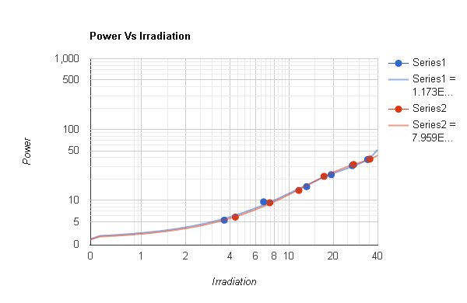
Fig. 3 Graphical representation of power variation with irradiation

V. CONCLUSION
In conclusion, the integration of an offline MPPT technique with nanofluid-based cooling presents a promising solution for enhancing the efficiency of solar photovoltaic (PV) systems. The offline MPPT approach simplifies system operation by utilizing pre-recorded environmental data, minimizing real-time computational demands and offering a stable power extraction strategy. This technique proves especially advantageous in environments where climatic conditions remain relatively stable, reducing the need for constant tracking and adjustments.
Additionally, the nanofluid cooling system effectively addresses the issue of temperature-induced efficiency losses by maintaining an optimal operating temperature. Nanofluids, due to their superior thermal conductivity, significantly improve the heat dissipation process, allowing solar panels to perform at their peak efficiency even under high-irradiance conditions.
The combined approach has demonstrated through simulations and experiments that it can significantly improve both the electrical and thermal performance of solar PV systems. By reducing thermal degradation and optimizing power output, this hybrid technique offers a cost-effective, sustainable solution for increasing energy generation in solar PV applications. Future research could focus on the scalability of the nanofluid cooling system and explore its performance in more variable climatic conditions, ensuring broader applicability across diverse solar energy projects.

REFERENCES
- Prakash, A., Veeresha, P., Prakasha, D. G., & Goyal, M. (2019). A homotopy technique for a fractional order multi-dimensional telegraph equation via the Laplace transform. The European Physical Journal Plus, 134, 1-18.
- Padmanaban, M., Chinnathambi, S., Parthasarathy, P., & Pachaivannan, N. (2021). An Extensive Study on Online, Offline and Hybrid MPPT Algorithms for Photovoltaic Systems. Majlesi Journal of Electrical Engineering, 15(3), 1-16.
- Kumar, A., Ibraheem, S., Nguyen, T. A., Gupta, R. K., Maiyalagan, T., & Yasin, G. (2021). Molecular-MN4 vs atomically dispersed M− N4− C electrocatalysts for oxygen reduction reaction. Coordination Chemistry Reviews, 446, 214122.
- Bollipo, R. B., Mikkili, S., & Bonthagorla, P. K. (2020). Critical review on PV MPPT techniques: classical, intelligent and optimisation. IET Renewable Power Generation, 14(9), 1433-1452.
- Anagreh, Y. N., Alnassan, A., & Radaideh, A. (2021). High Performance MPPT Approach for Off-Line PV System Equipped With Storage Batteries and Electrolyzer. International Journal of Renewable Energy Development, 10(3).
- Kumar, A., Vashistha, V. K., & Das, D. K. (2021). Recent development on metal phthalocyanines based materials for energy conversion and storage applications. Coordination Chemistry Reviews, 431, 213678.
- TIRTH, V., ALGARNI, S., IRSHAD, K., ISLAM, S., & ZAHIR, M. H. Investigation of MPPT Techniques Under Uniform and Non-Uniform Solar Irradiation Condition–A Retrospection.
- Ibrahim, H. H., Elsaharty, M. A., Guerrero, J. M., & Ghoneim, A. W. (2022, July). A Smart MPPT Algorithm with a Power Independent Tracking System. In 2022 International Conference on Electrical, Computer and Energy Technologies (ICECET) (pp. 1-8). IEEE.
- Charu, K., Thakur, P., & Ansari, F. (2023). Performance Analysis of Conventional MPPT Techniques for a Solar PV System. Journal of Graphic Era University, 117-132.
- Ali, Z. M., Alquthami, T., Alkhalaf, S., Norouzi, H., Dadfar, S., & Suzuki, K. (2022). Novel hybrid improved bat algorithm and fuzzy system based MPPT for photovoltaic under variable atmospheric conditions. Sustainable Energy Technologies and Assessments, 52, 102156.

