Investigating Cd-Te alloys for better absorption and improved bandgap tunability of solar cells

Krishna Kant Dixit
Department of Electrical Engineering,
GLA University, Mathura
krishnakant.dixit@gla.ac.in
Yogendra Kumar
Department of Electrical Engineering,
GLA University, Mathura
kumar.yogendra@gla.ac.in

Abstract—Due to its abundance and environmental benefits, solar energy has gained popularity as an alternative to conventional fossil fuel supplies over time. Diverse solutions have been developed to enhance the efficiency and cost-effectiveness of solar energy use. Flexible thin-film solar cells are small and mechanically robust. With the rapid development of battery technologies, flexible solar panels will see the creation of specialised products, which require lightweight and physically flexible features, which can be shaped into complex forms. The small material requirements and the increased performance of the thin film solar cells make them desirable. Cd-Se-Te and Cd-S-Te alloy may be studied to progress optoelectronic materials that have better light absorption and variable bandgaps. Photovoltaic, photodetectors and light emitting devices require these alloys. Selenium doping causes the bandgap to become narrower, and sulfur provides a greater amount of energy photons. They are synthesized efficiently and exhibit improved charge carrier dynamics, allowing increased efficiency and increased lifetime in renewable energy technologies and semiconductor technologies. This paper has analyzed and categorized the evolution of solar cell material. Also, thin film Cd-Te solar cells and doping of these cells with different elements are introduced.
Keywords— BSF (Back Surface Field), CIGS, Cd-Te cells, photoelectrochemical systems.

Introduction
Steady progress in innovative optoelectronic technologies applied in solar energy conversion and photodetection increases the need for development of materials with the best indicators of optoelectronic properties. Cadmium chalco-salcides including the CdTe, CdSe, and CdS have been earlier identified as potential candidates owing to their high absorption coefficients, tunable bandgaps and good electronic properties. However, their individual shortcomings of fixed bandgaps and less than optimum absorption ranges have encouraged research into ternary alloys such as Cd-Se–Te and Cd-S–Te alloys [1]. These alloys adapt favorable features of binary constituents, and the flexibility in tuning bandgap and absorption characteristics for tailored applications is additionally provided.
These alloys are ideal for the next generation of photovoltaics and photonic devices because the bandgap can be tuned depending on the amount of selenium (Se) or sulfur (S) incorporated into the CdTe. As an example, the introduction of Se with CdTe will alter the band gap where the near-infrared light absorption can be achieved, As in the case of S it will increase the band gap until it reaches the blue and ultraviolet region. This tunability is especially preeminent in the structure of multi-junction solar cells, during which the uptake of photons of various wavelengths would be crucial in the optimal energy conversion [2]. Moreover, their charge carrier dynamics are superior and losses to recombination are less, which is an issue with other materials.
Besides the optoelectronic properties, the Cd-Se-Te and Cd-S-Te alloy semiconductor possess improved mechanical and thermal stability, which is compatible in harsh conditions. The necessity to explore these alloys is of high urgency in the context of growing utilization of the renewable energy technologies and the high-performance optoelectronic devices in the context of the sustainable development of the future [3]. They possess a significant architectural and electronic potential which must be completely exploited in order to realize future energy and semiconductor technologies and this can be realised only through possessing a holistic knowledge of their architectural and electronic characteristics.
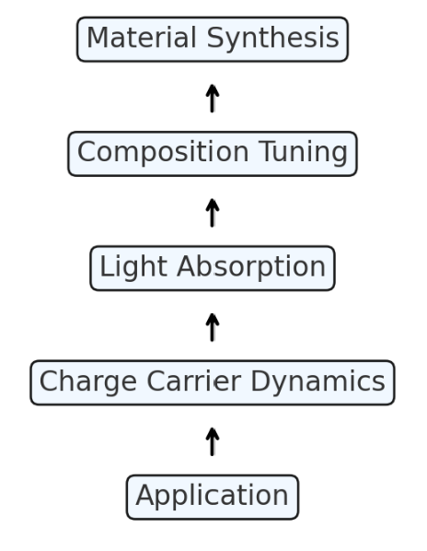
Fig.1. Cd-Te solar cell infrastructure

Presently available doping of Cd-Te cells

Other cadmium chalcogenide alloys like CdSeTe and CdSTe have been of considerable interest in optoelectronic devices especially when used as photovoltaic and photodetector modes. These materials have good variety properties of the band gap and high optical absorption which is due to its composition electronic and optical properties [4]. The research suggests that the alloy of CdTe with selenium or sulfur to create solid solutions will provide more opportunity to control their bandgap, an advantage in multi-junction solar cells and other semiconductors. Indicatively, Se incorporation in CdTe leads to reduction in bandgap to increase absorption in near-Infrared region without reducing absorption in the spectral region of high absorption co-efficiency. Similarly, as the composition of the sulfur is increased, the energy bandgap increases and thereby its use in blue and ultraviolet wavelengths.

The experimental studies indicate that both the lattice parameters and crystal structures for Cd-Se-Te and Cd-S-Te alloys have relatively small compositional variations when going from one binary constituent to the other, thus reducing strain-generation related defects. Recent thin film deposition technologies, like MBE, sputtering etc have helped in the better control of composition and thereby improved the thin films used and the performance of the devices [5]. These DFT calculations show that Se or S incorporation affects the density of states near the band edges in a way that improves the charge carrier dynamics and minimizes recombination.
Recent works focus more on improving the stability of the alloy as well as its adhesion to different substrates. For instance, perovskite-sensitized tandem solar cells have reported efficiency improvements due to optimal band alignment in CdSeTe alloys. Likewise, there is a study on CdSTe alloys as possible for high-temperature applications and radiation tolerance [6]. Future work and development that needs to be addressed include doping of WS2/transition metal contacts, passivation of defects and cost-effective synthesis of the materials to be utilized in commercial applications. In summary, it can be concluded that both Cd-Se-Te and Cd-S-Te alloys hint at the development of future semiconductor technologies.

Operation of Cd-Se-Te and Cd-S-Te Alloys for Improved Absorption and Bandgap Tunability

Cd-Se-Te and Cd-S-Te alloys, therefore, relate to the overlying composition of their constituent elements—Cd, Se, Te, and S—through composition control and use the unique electronic properties of their constituent elements to optimise their function. Such alloys may be deposited using deposition techniques such as Molecular Beam Epitaxy, Chemical Vapor Deposition or sputtering. The alloy composition ratio has an effect on its bandgap which spans both ends of the bandgap like the small gap of CdTe and the wider gaps of CdSe and CdS [7]. This tunability has enabled the ability to capture light in visible region to near-infrared regions, hence enabling it to serve the requirements of various optoelectronic devices.
It begins immediately after thin layers of Cd-Se-Te or Cd-S-Te grow on substrate plates. In growth the lattice structure of the CdTe layer is also optimized so as to reduce concentrations of defects as well as to supply an appropriate distribution of Se or S atoms in the matrix [8]. The bandgap of this alloy is controlled by either increasing or decreasing the concentration of Se or S and as a result selenium incorporation enhances low energy photon absorption, while S incorporation enhances high energy photon absorption.

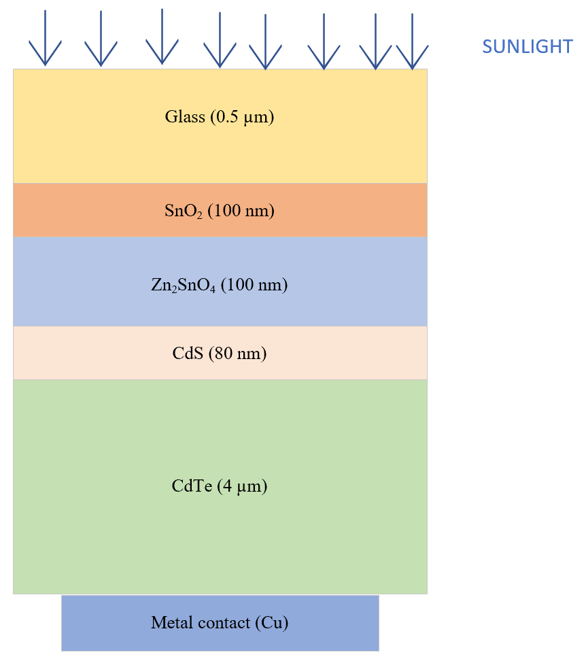
Fig.2. Steps included in formation of Cd-Te alloys

However, photons with energy, greater than the bandgap of the material when illuminated, create electron hole pairs in the material. Good band alignment in these alloys also promotes spatial separation of the charge carriers and reduces losses through recombination. Third, the gradual variation in composition across CdTe and CdSe or CdS layers gives less strain and dislocations, thereby enhancing performance [9]. These alloys are used in multi-junction tandem solar cells, acting as middle layers inclusive of certain spectral ranges of the photons, as well as in photodetectors corresponding to different wavelengths.

Comparative analysis of different types of doping in Cd-Te solar cells

The following table 1 summarises various doping approaches in Cd-Te solar cells, the analysis parameter and the pros and cons of each of them. These doping types correspond to specific performance demands, indicating that doping strategies must be well-coordinated for achieving maximum efficiency of the solar cell.

Table.1. Table showing different types of doping approaches in Cd-Te solar cells

Type of Doping | Dopant Material | Doping Method | Analytical Parameters | Advantages | Challenges
n-type Doping | Chlorine (Cl), Iodine (I) | Diffusion, Ion Implantation | - Carrier Density: 10¹⁵-10¹⁷ cm⁻³  - Resistivity: Low  - Bandgap: Maintains base material properties | - Improves electrical conductivity  - Enhances junction formation  - Boosts carrier mobility | - Can create defects  - Requires precise control to avoid overcompensation
p-type Doping | Copper (Cu), Arsenic (As) | Thermal Diffusion, Ion Implantation | - Carrier Density: 10¹⁵-10¹⁷ cm⁻³  - Band Bending: Enhanced  - Lattice Strain: Minimal with proper doping | - Enhances hole concentration  - Improves back contact performance  - Reduces recombination losses | - Stability issues with Cu  - Difficulty achieving high p-doping concentration
Intrinsic Doping | Cd vacancies (Cd-v), Te interstitials (Te-i) | Controlled growth conditions | - Intrinsic Carrier Concentration: Moderate  - Defect Levels: Low  - Bandgap: Unaltered | - Simplifies material processing  - Reduces external impurities | - Limited by native defect levels  - Lower electrical performance than extrinsic doping
Doping with Selenium (Se) | Selenium (Se) | Co-evaporation, Diffusion | - Bandgap Tuning: 1.5 eV (ideal)  - Absorption Coefficient: High  - Lattice Strain: Compatible with CdTe | - Broadens absorption spectrum  - Enhances stability | - Needs precise Se/CdTe ratio  - Risk of phase segregation
Doping with Sulfur (S) | Sulfur (S) | Co-evaporation, Diffusion | - Bandgap Tuning: Up to 1.6 eV  - Carrier Mobility: Improved  - Absorption: UV and visible regions | - Enables wider bandgap  - Increases efficiency in tandem cells | - Complex growth dynamics  - High-temperature requirements
Doping with Halogens | Chlorine (Cl), Fluorine (F) | Chemical Vapor Deposition (CVD), Diffusion | - Carrier Density: Higher with Cl  - Grain Size: Increased  - Defect Density: Reduced | - Enhances grain boundary passivation  - Improves photoconversion efficiency | - High-temperature diffusion  - Potential environmental concerns

Analysis and Discussions

The analysis of doping methods in CdTe solar cells proves that doping is a crucial factor in enhancing the performance of the solar cell. Each doping type has its advantages and drawbacks, and hence the choice of doping has to be based on the requirements of the specific application and the parameters that have to be achieved. n-type doping with dopants like chlorine or iodine enhances the conductivity and carrier mobility which is vital for formation of junction [10].
Yet, controlling doping is challenging due to the risk of introducing defects or even over-compensing; p-type doping, materials such as copper or arsenic increase hole concentration and thus, minimizing recombination losses, but Cu is unstable.

Intrinsic doping involves utilizing native defects as doping sources, which is advantageous since it is easy to control and results in less complication due to the presence of impurities than in the case of extrinsic doping although the improvement of electric properties is not as high as in the case of extrinsic doping [11]. Selenium or sulfur doping shows the usefulness of bandgap tuning in CdTe-based alloys, expanding the range of wavelengths the material can absorb. Selenium is mainly beneficial for enhancing infrared absorption and stability, while sulfur is suitable for UV and visible light, which are considered the ideal elements for tandem solar cells. Both techniques require good compositional control to inhibit phase segregation and assure material compatibility. Halogen (such as chlorine and fluorine) end point doping is valuable because it gives rise to grain boundary passivation and enhanced photo conversion efficiency yet it causes high temperature regime and other environmental issues. In addition, CdTe solar cells doping optimization is approximately in the improvement of optical and electrical characteristics of the material, a higher level of complexity and stability in its fabrication. Increased advances in doping and the precise control and manufacturability of the structure of CdTe along with the development of new fabrication methods are all paramount issues in the improvement of performance and cost efficiency of CdTe based solar cells in the current renewable energy market 12].

Conclusion
The present research has analyzed and categorized the evolution of solar cell materials. Furthermore, thin film Cd-Te solar cells and their doping with various elements are discussed. The study of Cd-Se-Te and Cd-S-Te alloys could significantly advance the development of optoelectronic materials with higher light absorption and adjustable bandgaps. These alloys have unique characteristics due to their compositional flexibility, allowing them to be used in photovoltaic, photodetectors, and light emitting devices. Selenium doping narrows the bandgap, allowing better absorption in the near IR range, while sulfur adds higher energy photons. These alloys are essential for multi-junction solar cells and ultrahigh-performance optoelectronic devices. Future work should focus on optimizing doping profiles, enhancing material stability, and manufacturability to enable widespread application in commercial products. These alloys could be key to fostering novel optoelectronic applications for compact, efficient, and low-cost semiconductor technologies.

References

- R. K. Koech, M. Kigozi, A. Bello, P. A. Onwualu and W. O. Soboyejo, "Recent advances in solar energy harvesting materials with particular emphasis on photovoltaic materials," 2019 IEEE PES/IAS PowerAfrica, Abuja, Nigeria, 2019, pp. 627-632, doi: 10.1109/PowerAfrica.2019.8928859.
- Xiaoyue Li, Peicheng Li, Zhongbin Wu, Deying Luo, Hong-Yu Yu, Zheng-Hong Lu, Review and perspective of materials for flexible solar cells, Materials Reports: Energy, Volume 1, Issue 1, 2021, 100001, ISSN 2666-9358.
- Lee, Taesoo D., and Abasifreke U. Ebong. "A review of thin film solar cell technologies and challenges." Renewable and Sustainable Energy Reviews 70 (2017): 1286-1297.
- Mykhailo, Kirichenko, et al. "Influence of Functional Layers Thickness on CdTe Based Flexible Solar Cells Efficiency." 2019 IEEE 8th International Conference on Advanced Optoelectronics and Lasers (CAOL). IEEE, 2019.
- Dey, Mrinmoy, et al. "Design of high performance and ultra-thin CdTe solar cells with SnTe BSF from numerical analysis." 2015 18th International Conference on Computer and Information Technology (ICCIT). IEEE, 2015.
- Dey, Mrinmoy, et al. "High efficient and stable ultra-thin CdTe solar cell with a potential copper telluride BSF." 2016 9th International Conference on Electrical and Computer Engineering (ICECE). IEEE, 2016.
- Mrinmoy Dey, Maitry Dey, M. A. Matin and Nowshad Amin, “High performance and stable molybdenum telluride PV cells with Indium Telluride BSF,” in Proceedings of the 4th International Conference on Developments in Renewable Energy Technology, Dhaka, Bangladesh, January 2016.
- Grover, Sachit, et al. "Comparison of P, As & Sb doped Polycrystalline CdTe Solar Cells." 2019 IEEE 46th Photovoltaic Specialists Conference (PVSC). IEEE, 2019.
- Evani, V., et al. "Phosphorus doping of polycrystalline CdTe." 2016 IEEE 43rd Photovoltaic Specialists Conference (PVSC). IEEE, 2016.
- Chatratin, Intuon, Shagorika Mukherjee, and Anderson Janotti. "Hybrid Functional Calculations for Antimony Doping in CdTe." 2022 IEEE 49th Photovoltaics Specialists Conference (PVSC). IEEE, 2022
- Bansal, Saloni, Birendra Kr Saraswat, and Vijay Kr Sharma. "Analysis of machine learning: enhancing performance and interpretability through deep neural network." Sustainability in Digital Transformation Era: Driving Innovative & Growth. CRC Press 76-80,
- Yadav, Kanchan, et al. "Digital Dimensions: Unveiling the Potential of E-Design and Virtual Prototyping." E3S Web of Conferences. Vol. 453. EDP Sciences, 2023.

