Implementation of Perturbation and Observation Algorithm for MPPT and Phase Change Material Cooling in Solar Panels

Kanchan Yadav
Department of Electrical Engineering
GLA University, Mathura
kanchan.yadav@gla.ac.in
Rakesh Kumar
Department of Computer Engineering & Applications
GLA University, Mathura
rakesh.kumar@gla.ac.in

Abstract- We will show in this work how we will combine PCM cooling with the Perturbation and Observation (P&O) strategy to the Maximum Power Point Tracking (MPPT) in order to maximize the efficiency of solar panels. Regulating the operating voltage and monitoring the overall power generation, P&O algorithm guarantees best energy recovery even under the conditions of the environmental change. Absorption and storage of excess heat using phase change material (PCM) to control the temperature in the panel assists in reducing heat losses and enhances the system to work more efficiently. Regarding the results, it becomes obvious that such combined strategy can improve efficiency of energy conversion and minimize effects of temperatures on solar panels and their degradation. Maximum Power Point Tracking (MPPT) by combination of P and O cooling with Phase Change Material (PCM) cooling is a powerful and economical way of enhancing the performance and stability of solar power systems. The contribution to the design of advanced solar technology in this research has the advantages of solar technology in terms of improved energy sustainability and reliability amid diversity of climates.
Keywords: solar, energy, efficiency, cooling, hybrid.
- INTRODUCTION
Our daily survival depends on energy. The world's energy usage has recently experienced a significant upsurge. Then there's the matter of energy and the occurrence of climate change. Research into renewable energy sources is a viable solution to the problems listed above. Renewable energy sources provide a number of benefits over traditional fossil fuel energy sources, the most notable of which are that they do not pollute, are always available, and will be around for a long time.
The term "renewable energy" describes power that comes from naturally occurring sources that can be replenished, such as the sun, wind, water, and waves. One of the most significant and often utilized renewable energy sources is solar power. There is more than enough energy emitted by the sun every day to meet all of humanity's energy needs. Solar power, in addition to wind, tidal, and wave power, is the main generator for most renewable energy sources.
Solar energy is quite common to drive households and other business organizations to generate a source of heat, light and power. Photovoltaic (PV) technology uses photovoltaic (PV) effect which transforms photons into power directly and thus, it is an extremely important technological development [1]. Two challenges are however linked with solar photovoltaic generator panels. Solar photovoltaic (PV) cells have very low initial conversion efficiency which can range between 9 and 17 percent especially in low-irradiance conditions.
Second, solar PV panels are able to offer a variable quantity of energy, which varies according to the seasons and the weather. Moreover, irradiance and temperature also introduce the variations in the V-I characteristic of the solar cells that are non-linear [2]. Generally, there is some point along the V-I curve or V-P curve where the Maximum Power Point (MPP) occurs. This implies that the solar photovoltaic (PV) system is going to operate at its optimum potential leading to the utmost power generation that can be attained.
The maximum power point (MPP) is not present on either the voltage-current or voltage perpendicular curve (V-I and V-P). Search algorithms that could be used to determine it are the photonic crystal oscillator (P&O) algorithm, the incremental conductance (IC) algorithm, the constant voltage (CV) algorithm, the artificial neural network (ANN) algorithm, the fuzzy logic (FL) algorithm and the particle swarm optimization (PSO) algorithm [3].
One of the most obviously relevant Maximum Power Point Tracking (MPPT) methods is the basic P&O algorithm. It is ideal for adapting to situations of more variable solar irradiance and temperature, has a simple design, is easy to apply, and is less affected by the intrinsic capacitance of solar PV panels [4].
Nevertheless, it betrays unpredictable behaviour when confronted with abrupt changes in air conditions, leading to a slowed reaction time, oscillation about the MPP, and, on rare occasions, the relocation of the operating point away from the MPP. The P&O algorithm underwent multiple rounds of development as a result. An improved P&O MPPT is detailed in [5] that takes into account the supplied diode factor and reverse saturation current of every solar cell.
The adaptive algorithm that changes the reference step size and hysteresis bandwidth for power comparison in the Maximum Power Point Tracking (MPPT) methodology [6] is the basis of a more advanced P&O technology. In addition, a new P&O MPPT algorithm implementation was introduced, which speeds up system response and decreases oscillations around maximum power points by using peak current control, small perturbation values, and instantaneous values instead of averaged values [7].
Each of the current approaches has its pros and cons when considering ease of use, convergence speed, cost, and the number of machines required. The current study suggests a better P&O algorithm that might be used to track the V-I characteristic of an MPP in a PV panel more efficiently. We compare the results of the advanced P&O algorithm's simulations to those of the classic P&O method to ensure that the suggested algorithm is both successful and beneficial. The following is the organizational scheme of the sections that follow in this book.
In Section II, the mathematical model for photovoltaic panels is explicated. In Section III, on the basis of the sophisticated P&O algorithm, a novel idea is put forth. Section IV's reported simulation results subsequently support the proposed approach. In addition, when contrasting it with the conventional P&O algorithm in a DSP, the advantages of the new approach become more apparent.
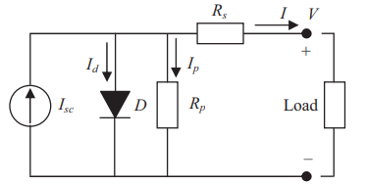
Fig.1 Equivalent solar cell circuit diagram

- PERTURBATION AND OBSERVATION ALGORITHM
To provide accurate results from photoplethysmography (P&O), it is necessary to set up the maximum power point tracking (MPPT) method with estimated Vm and Im values before starting the procedure or after a large change in irradiation. To speed up the tracking response of photovoltaic (P&O) systems in the event of an abrupt step change in irradiation, it is common practice to sample the open-circuit voltage (Voc) or short-circuit current (Isc) in order to estimate the impedance (Im) and polarization voltage (Vm). The fractional open-circuit voltage method and the fractional short-circuit current method are two popular mathematical approaches.
Although alternative tracking systems outperform traditional P&O in terms of response time, they do come with a downside: power discontinuity occurs during Isc or Voc sampling since these systems directly monitor Isc or Voc by disconnecting the PV module from the load. Particularly in cases of rapid variations in the irradiation, this power discontinuity causes power loss. Despite the fact that reference suggests a method to reduce the number of times PV modules disconnect from the load, the power loss caused by routinely measuring Isc is still there.
In , an approximation equation is employed to estimate Isc, which helps to reduce the power loss that results from regularly sampling Isc. But these approaches aren't without their flaws either: In order to estimate Isc, a PV module parameter called STC must be present. STC is defined as a temperature of 25 C and an irradiation of 1000 W/m2. This statistic is not applicable to all solar modules or arrays. Accurate estimation of Im and Vm under various irradiation regimes and temperatures is not possible using the author's approximation of a constant ratio of Isc to Im. The power loss caused by consistently sampling Voc is efficiently reduced in reference by using formulae to compute the value of Voc and the ratio of Voc to Vm. Unfortunately, determining the Voc requires a temperature sensor, which is an expensive and impractical option.
It takes a lot of computational power to solve a nonlinear differential equation using the finite element method in order to determine the Voc to Vm ratio. In order to estimate the values of Vm and Im, the authors sample irradiation and temperature. As a result, the DC-DC converter's On-Demand Ratio (ODR) at the MPP can be ascertained in a flash.
By using the PV array model and the sample data for I, V, and T from reference, we may estimate Vm and Im. The methods proposed in references appear to be a good way to calculate Vm and Im without power loss, but they need additional sensors to measure temperature and irradiation, which is a downside. In addition to adding unnecessary complexity to the system, this demand is also not economically viable.

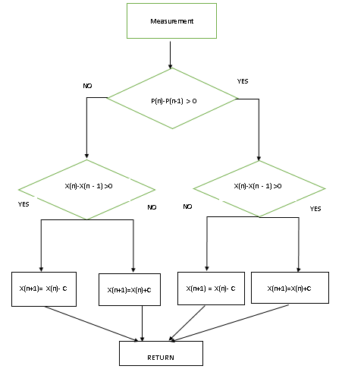
Fig.2 Working of Perturbation and Observation algorithm
.$I_{05}=I_{0}R\left(\frac{T}{T_{r}}\exp\left\{\frac{qE_{G}}{Aκ_{B}}\left(\frac{1}{T_{R}}-\frac{1}{T}\right)\right\}\right)$ (1)
$I_{L}=\frac{G}{1000}\left[I_{5C}+k_{T⋅I}\left(T-T_{R}\right)\right]$ (2)
$I={Im}^{-l_{0}}{[}\exp\left(\frac{v+R_{s}I}{av_{t}}\right)-1$ (3)
$-\frac{v⋅ⅆI}{ⅆv}<I$ (4)
$\frac{v⋅ⅆI}{ⅆv}=I$ (5)
$\frac{v⋅ⅆI}{ⅆv}>I$ (6)

- PCM COOLING
Finding out how phase change material (PCM) can lower the temperature of a conventional photovoltaic (PV) panel while simultaneously increasing its electrical efficiency is the primary goal of this research. Photovoltaic (PV) panels must have a phase change material (PCM) layer because PVs work better when the cell temperatures are lower. To improve the thermal efficiency of the PV cells, the PV-PCM layer dissolves in response to incident solar energy that is not being converted into electrical energy, lowering the temperature of the PV cells. The typical photovoltaic (PV) panel can benefit from the latent cooling features of phase change material (RT28HC), which is one of the aims of this work. How much that E. The cooling effect of the phase change material (PCM) allowed the photovoltaic (PV) panel to produce more electricity than a conventional PV panel. To determine how well the PV panels performed in the simulation, an evaluation was carried out for a full year. Varieties in the panel's power output can be achieved by utilizing various formulae. This MATLAB panel mathematical model relies on the following equations.
- RESULTS AND DISCUSSION
Table 1. Variation of Volatge and current with irradiation
VB | I  (5KW/M²) | V  (3 KW/M²) | I  (3KW/M²) | V  (1 KW/M²) | I  (1KW/M²)
5.698 | 37.764 | 8.547 | 25.342 | 3.603 | 12.174
7.207 | 37.516 | 15.251 | 24.845 | 6.872 | 11.677
9.888 | 37.764 | 20.95 | 24.845 | 11.229 | 12.671
12.235 | 37.267 | 26.145 | 24.845 | 15.922 | 12.174
13.24 | 39.255 | 29.33 | 25.59 | 22.793 | 11.925
14.413 | 38.012 | 33.352 | 25.342 | 26.816 | 11.925
17.263 | 37.764 | 36.704 | 24.845 | 32.011 | 12.671
21.453 | 38.261 | 38.883 | 24.845 | 34.86 | 12.174
25.81 | 38.012 | 40.726 | 24.348 | 37.877 | 11.429
30.335 | 37.764 | 43.073 | 23.851 | 40.391 | 11.429
34.693 | 37.267 | 45.754 | 22.857 | 43.575 | 10.932
39.05 | 37.019 | 47.43 | 19.876 | 45.922 | 8.696

Table 2. Variation of Power with Voltage at different irradiations
V  (5 KW/M²) | p  (5KW/M²) | V  (3 KW/M²) | P  (3KW/M²) | V  (1 KW/M²) | P  (1KW/M²)
3.65 | 82.581 | 4.063 | 82.581 | 4.339 | 87.742
5.234 | 118.71 | 5.51 | 108.387 | 5.785 | 77.419
6.749 | 154.839 | 6.474 | 123.871 | 7.438 | 108.387
9.504 | 196.129 | 7.989 | 144.516 | 9.229 | 113.548
13.223 | 268.387 | 10.606 | 165.161 | 11.708 | 103.226
15.565 | 325.161 | 13.774 | 211.613 | 13.774 | 108.387
19.421 | 387.097 | 16.804 | 252.903 | 17.355 | 129.032
23.003 | 464.516 | 21.212 | 283.871 | 21.763 | 149.677
26.997 | 536.774 | 23.416 | 325.161 | 27.548 | 180.645
30.854 | 598.71 | 27.686 | 366.452 | 31.956 | 180.645
34.298 | 629.677 | 31.129 | 402.581 | 35.537 | 160
37.603 | 629.677 | 34.16 | 402.581 | 38.154 | 154.839
40.496 | 480 | 37.328 | 392.258 | 40.014 | 103.226

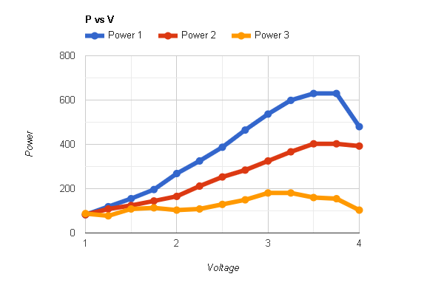
Fig. 3. Graphical representation of variation of power for different irradiations
Consequently, a single-chip microcontroller can incorporate the proposed P&O and use the traditional P&O MPPT algorithm, which results in a more cost-effective solution. With a perturbation period of 0.04 seconds longer than the system's settling time, this test can examine both the over-drift rate (ODR) estimate process and drift avoidance phenomena. This is accurate for both P&O approaches. Two major changes to the irradiation step at 2 and 8 seconds initiate the ODREA. The ODREA sends four duty ratios—0.2, 0.25, 0.5, and 0.55—to the boost power converter in response to changes in irradiation, such as a drop from 1000 W/m2 to 300 W/m2.
V. CONCLUSION
The performance of solar panels in the maximum power point tracking (MPPT) can be improved considerably by incorporating Perturbation and Observation (P&O) technique together with the Phase Change Material (PCM) cooling into the system. P&O algorithm is used to extract as much energy as possible by adapting the operating voltage both in response to new and changing external conditions to ensure the efficient operation of the solar panels. The inclusion of phase change material (PCM) decreases the thermal strain on the panels and therefore the heat that is absorbed cools down the excess heat and consequently fuel efficiency losses caused by temperature, and improves the operating life of the system. This is an emerging hybrid solution that enhances generation of energy and provides an economical solution to make solar power system more reliable and friendly. To continue the further development of renewable energy technology, the further research could examine how the methodology could be enhanced and experimented on large-scale solar systems.
REFERENCES
- Mousa, H. H., Youssef, A. R., & Mohamed, E. E. (2021). State of the art perturb and observe MPPT algorithms-based wind energy conversion systems: A technology review. International Journal of Electrical Power & Energy Systems, 126, 106598.
- Jately, V., Azzopardi, B., Joshi, J., Sharma, A., & Arora, S. (2021). Experimental Analysis of hill-climbing MPPT algorithms under low irradiance levels. Renewable and Sustainable Energy Reviews, 150, 111467.
- Yuan, J., Zhao, Z., Liu, Y., He, B., Wang, L., Xie, B., & Gao, Y. (2021). DMPPT control of photovoltaic microgrid based on improved sparrow search algorithm. IEEE Access, 9, 16623-16629.
- Sadick, A. (2023). Maximum power point tracking simulation for photovoltaic systems using perturb and observe algorithm.
- Kamran, M., Mudassar, M., Fazal, M. R., Asghar, M. U., Bilal, M., & Asghar, R. (2020). Implementation of improved Perturb & Observe MPPT technique with confined search space for standalone photovoltaic system. Journal of King Saud University-Engineering Sciences, 32(7), 432-441.
- Bhattacharyya, S., Samanta, S., & Mishra, S. (2020). Steady output and fast tracking MPPT (SOFT-MPPT) for P&O and InC algorithms. IEEE Transactions on Sustainable Energy, 12(1), 293-302.
- Zhang, H., Chen, H., Xiao, C., Li, B., Liu, M., Boning, D., & Hsieh, C. J. (2020). Robust deep reinforcement learning against adversarial perturbations on state observations. Advances in Neural Information Processing Systems, 33, 21024-21037.
- Liang, J., Ge, S., Qu, B., Yu, K., Liu, F., Yang, H., ... & Li, Z. (2020). Classified perturbation mutation based particle swarm optimization algorithm for parameters extraction of photovoltaic models. Energy Conversion and Management, 203, 112138.
- Manoharan, P., Subramaniam, U., Babu, T. S., Padmanaban, S., Holm-Nielsen, J. B., Mitolo, M., & Ravichandran, S. (2020). Improved perturb and observation maximum power point tracking technique for solar photovoltaic power generation systems. IEEE Systems Journal, 15(2), 3024-3035.
- Li, J. Y., Zhan, Z. H., Wang, H., & Zhang, J. (2020). Data-driven evolutionary algorithm with perturbation-based ensemble surrogates. IEEE Transactions on Cybernetics, 51(8), 3925-3937
.

