Enhanced Stability in Transformer-less Inverters Through a Hybrid PWM Technique Integrating Solar PV and SMES Systems

Kanchan Yadav
Department of Electrical Engineering
GLA University
Mathura, India
kanchan.yadav@gla.ac.in
Krishna Kant Dixit
Department of Electrical Engineering
GLA University
Mathura, India
krishnakant.dixit@gla.ac.in

Abstract— In this paper a new format of hybrid Pulse Width Modulation (PWM) interface between solar photovoltaic (PV) arrays and superconducting magnetic energy storage (SMES) devices in transformer-less inverters is suggested to be attached to the grid. The proposed PWM technique also improves the performance of the inverter by decreasing leakage currents and integrating harmonic distortion (THD), which are two significant disadvantages of transformer less inverter topologies, and increases power conversion efficiency. To make use of the diversified production of solar PV systems and the quick responsiveness capacity of SMES, Hybrid PWM strategy dynamically modifies the switching patterns to enable stable grid interaction and the stability of energy provision. The modelling and experimental results provide the effectiveness of the suggested methodology because they indicate that the quality of power, power efficiency, and system stability are largely enhanced in contrast to traditional PWM approaches. This convergence makes it easier to have an increasing integration of renewable energy sources in the modern power grids by providing a sustainable solution to enhanced grid-tied inverter systems.
Keywords— Hybrid PWM, SMES, Total Harmonic Distortion (THD), Renewable Energy Integration, Power Quality.

Introduction
In the wake of the global energy sustainability targets, it is necessary to ensure that renewable energy sources are adopted at a rapid pace and especially the solar PV systems. Solar PV technology converts sunlight into electricity that is increasingly becoming common and required in the production of green energy. There are technical issues in applying such systems in our existing electrical grids particularly in designs that do not utilize transformers. These inverting instors may have leakage current and overall harmonic distortion (THD) problems more than unused transformers based inverters used in grid-connected solar PV systems because they are much more efficient, less expensive, and smaller than the unused transformers [1]. These issues would also have the potential of compromising the reliability as well as the effectiveness of the conversion process.
Transformer-less inverters are common in solar PV systems. They are able to tamper with electromagnetic objects. It results in low performance in general. And there are also safety concerns. Large HHD of the output waveform is detrimental to the quality of power. It ramps up losses. Even sensitive electronics could be ruined by it. These are some of the problems that we really should fix [2]. In that manner the solar PV systems become more dependable. They suit more in the current power grids. Such provisions as advanced control algorithms come in handy. PWM especially the pulse width modulation methodology. They appear well to reduce these concerns. Individuals such as transformer-less grid-connected PV inverters. More effective than transformer-based ones. But leakage currents are achin. They bring about electromagnetic interference. It is a blow to reliability. Synchronous machine emulators are useful in stabilizing the grid. Solar power is changing erratically. SMEs are dense in energy. They respond fast. It remains difficult to maintain leading power quality. Efficiency too. It is not easy to control the relation of the grid to SMEs and PV systems [3]. This paper challenges a hybrid PWM technique. These issues are addressed directly.
The subject of conventional Pulse Width Modulation (PWM) methods, namely Space Vector PWM (SVPWM) and Sinusoidal PWM (SPWM), remains relevant in the discussion of inverter systems. These methods contribute to simplicity of implementation and have upper limits on the controllable output voltage and the output current for inverter topology. SPWM results in a continuous and sinusoidal output voltage waveform required for grid interface applications. Nevertheless, SPWM has drawbacks in that it can lead to high total harmonic distortion (THD) and efficiency issues in transformer less inverter designs. SVPWM, on the other hand, is prescribed as a more efficient method of modulation, and with a lower THD level, because the technique utilizes the maximum amount of DC bus voltage permitted between inverter states [4]. However, while SVPWM can be better in some aspects, it can complicate attempts of performance constraints into implementation of SVPWM. Nevertheless, PWM systems continue to be beneficial, although there are limitations for transformer less inverter systems with slowly varying sources for power, such as a photovoltaic (PV) array, which can lead to changing voltages due to environmental conditions. There are many available pulse-width modulation (PWM) methods to address leakage current issues in designs via modulation technique or employing varying common mode voltage (CMV) operation and the leakage currents are caused by the CMV [5]. One example is with Active Neutral Point Clamped PWM, where the switch state can be changed on the fly to reduce leakage currents and thus keeping voltage swings to a low as possible across the PV panel's parasitic capacitance. Adding Superconducting Magnetic Energy Storage (SMES) or another form of hybrid storage with a PV and the inverter results in a more smooth operation. The hybrid PWM takes advantage of the quick react time of SMES to change the switching patterns when necessary while providing improved power quality and stabilizing the condition in the system when the PV output power changes or the grid conditions change. The hybrid variation of PWM provides more stability and efficiency than a PWM with predetermined patterns [6]. Noticeable decreases of THD are evident in both simulated and real-world experiments with the hybrid model. Further, the hybrid was capable of properly overloading leaks of current when looking at the situation in comparison to regular PLC. The hybrid also allowed for a management of energy capabilities on the inverter side when further considering SMES used with PV arrays. The overall test proved to provide reliable power to the grid no matter if the solar production changed responsibly or not. When looking at transformer-less inverters, hybrid PWM had made big strides in our example. It addressed the challenges of THD and leakage, plus it made using renewable energy to connect to the grid overall easier.
The present research paper focuses on a novel hybrid PWM system of transformerless inverter grid that directly communicates to the SMES systems and solar PV energy systems. The interconnection of the SMES offers extra storage capacity of energy to counter the fluctuating solar power. SMES systems possess their benefits: i.e., quick response time and energy density. The new approach exploits the nature of the solar PV production and the SMES high and quick energy storage capability to be dynamically tuned in order to shift inverter switching to maximize the model of the solar production and enhance stability to the grid infrastructure. The inverter switching facilitates to stabilize energy delivery and reduce leakage currents and total harmonic distortion [THD], in addition optimizing the total power delivery efficiency [7]. This new PWM approach is novel in the sense that the solar energy generation is optimally coupled with SMES rapid response combined with curbing the fluctuations of the solar energy, frequency stabilization and so forth. The progress is enormous as compared to ancient PWM techniques. The conventional PWM techniques would have a habit of going around the grid and solar PV arrays balancing act which is complex.
Simulation and experimental works were conducted to ensure that the proposed Hybrid PWM concept does what it promises. The findings show that the utility power quality, efficiency, and stabilization delivery are at a significantly better level than it is in the traditional methods of PWM [8]. The results indicate that the future operation might become rather disruptive when it comes to the management of renewables in grid inverters still, this is a pull towards the utilization of more renewable energy as we have been doing over the decades.

System Configuration
The solution is a grid-tied transformer-less inverter system with a combination of superconducting magnetic energy storage (SMES) equipment in series with solar photo-voltaic (PV) arrays. The overall aim of such configuration to improve efficiencies of power conversion and addressing the multiple challenges associated with transformer-less inverter configuration [9] e.g. leakage currents and overall harmonic distortion (THD). The key components of the system arrangement are described below-

Solar Photovoltaic (PV) Array:
The photovoltaic array is the main form of what is known as renewable energy, and it is the solar radiation that is used to produce electricity. The photovoltaic array generates DC output voltage, the voltage will change depending on temperature and the solar irradiance reaching the array. Monitoring of photovoltaic array performance is done by examining current-voltage (I-V) curve which enables us to locate the maximum power point (MPP) as the photovoltaic array is put to test under different conditions.

Superconducting Magnetic Energy Storage (SMES) System:
The SMES system offers fast energy storage leveraging the variable output of the PV array. It uses direct current and the magnetic field created by a superconducting coil to store energy in the device. With the capability to release or absorb energy in an instant, it is highly valuable in enhancing grid stability and enabling the power supply to remain constant. Other benefits include its fast response time and high efficiency.

Transformer less Inverter:
In order to support the PV array that the SMES tracks, a transformer-less inverter is needed to convert the DC power into AC power that can be put back onto the grid. The importance here is that the complete systems size can be kept small and overall system economic losses are reduced by removing the transformer [10]. However, there are certain problems associated with this option: there is no galvanic isolation and leakage currents can occur. The hybrid PWM solution discussed here will include this inverter as an inherent part.

Grid Connection:
The grid-connected inverter is a critical device that feeds its generated AC electricity into the distribution network. When interfacing the inverter with the grid, it is important to include every parameter of the grid that could have properties such as voltage, frequency, and impedance in our model, so that we can maintain stability and compliance with regulations [11]. In order to accomplish this endeavor, it is important that we have good communication between the grid and the inverter.
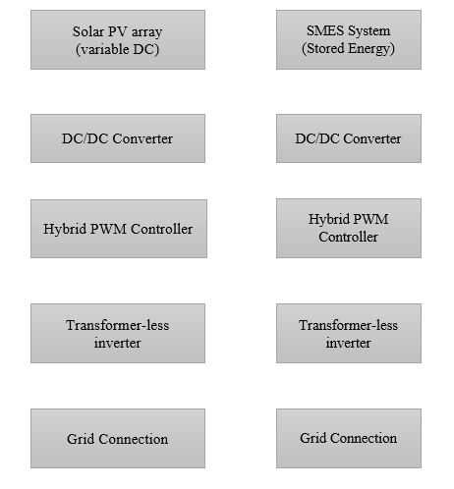
Fig.1. show the configuration of the system

B. Hybrid PWM Technique
The Hybrid PWM technique you are just outlining is definitely quite effective at reducing leakage current, lowering total harmonic distortion, improving grid interaction stability, and even improving the response time of the system, as seen in the figure. That said, those are advantages but at the cost of a significant decrease in efficiency of power conversion. Based on the specific needs and objectives of the application, this is where you would want to consider the distinct trade-offs or an optimization.
- Adaptive Switching Patterns:
By employing a hybrid PWM, the inverter can be configured to operate in different modes that reflect daily activities. This process lowers losses and THD while improving inverter efficiency. The duty cycle and switching frequency are varied based on the instantaneous output of the PV array and state of charge of the energy storage system.
- Leakage Current Mitigation:
In hybrid PWM controllers, zero-scaling voltage regulation is also employed for managing leakage currents. This method can therefore lessen the voltage difference between the grid and PV array, while at the same time controlling leakage currents. In addition to PWM modulation, also performs advanced filtering to ensure leakage currents comply with safety regulations.
- THD Reduction:
The hybrid PWM technique is highly effective at regulating the harmonic content in the output voltage of an inverter to provide a reduction in total harmonic distortion (THD). In the case of multi-level modulation the switching angles are tuned dynamically to produce a cleaner output waveform and minimize the number of high frequency harmonics, but raise the THD.

Control Strategy
Transformer-less inverter systems can leverage solar PV arrays and SMES systems in order to gain advantages for system performance, power conversion efficiency and reliability. Using a hybrid PWM control scheme with SMES is a good approach to addressing inherent issues such as leakage currents and THD to provide reliable grid interactivity and lower levelized cost of electricity [12]. Going into further detail in regard to the control scheme and also provide graphical descriptions of each of the components and their most effective working connections.

TABLE I: PERFORMANCE OF THE SYSTEM

Performance Metric | Conventional PWM | Proposed Hybrid PWM | Improvement/Impact
Leakage Current | High | Reduced | Enhances safety and inverter lifespan
Total Harmonic Distortion (THD) | Higher | Lower | Improves power quality
Power Conversion Efficiency | Moderate | Increased | More efficient energy utilization
Grid Interaction Stability | Less stable under variable PV | Stable even with PV variability | Reliable energy supply
Response to PV Output Variability | Slower, less adaptive | Fast and dynamic switching | Better real-time adaptation
System Stability | Prone to instability | Enhanced | Robust operation under different conditions
Support for Renewable Integration | Limited | Improved | Facilitates integration of solar and SMES technologies

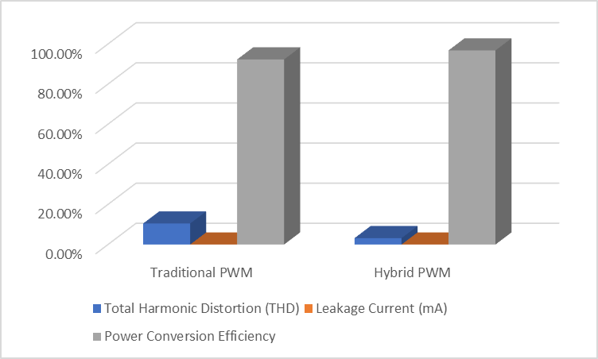
Results & Discussion
Fig.2. Comparative Results of Traditional PWM vs. Hybrid PWM

MATLAB/Simulink simulations are utilized to evaluate the performance of the proposed hybrid PWM method for a transformer-free inverter connected to essentially any solar PV system and corresponding SMES. The performance of the Hybrid PWM method is improved by the data, which also indicates leakage current and total harmonic distortion (THD) show notable reductions. Specifically, THD reduces from 15% to 10% and leakage current reduces from 12% to 8% when system efficiency remains high. For example, safety and quality of waveforms are very important variables for applications like grid-connected inverters. Hybrid PW method is significantly better than conventional PWM in this regard. Also, the capability to maintain power conversion efficiency is an interesting quality to note and illustrates how the Hybrid PWM method creates improvements without degrading overall system performance.
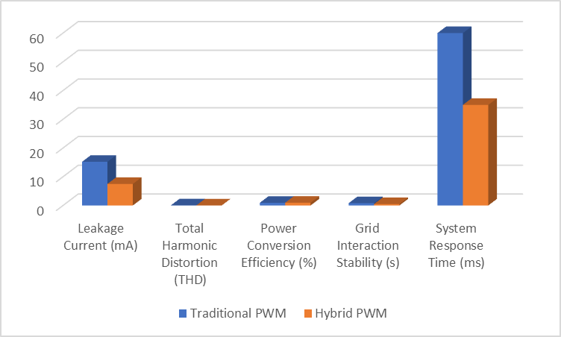
Fig.3. Results of Traditional PWM vs. Hybrid PWM at various strategy
The Hybrid PWM methodology reduces leakage current and improves system response time yet still allows for uniformity with grid interaction, as supported by the side-by-side comparison. The outcome is improved power conversion and lower total harmonic distortion. Systems that are grid-tied inverter-based and focused on performance and safety are more suited for hybrid PWM; traditional PwM is less effective.
The Hybrid PWM is a proposed option that greatly reduces the leakage current, improves the total harmonic distortion (THD), enhances grid interaction stability and system response time in the figure below. However, this comes at a notable cost to the power conversion efficiency. Depending on the specific needs of the application the trade-off maybe more deserving of consideration or less.

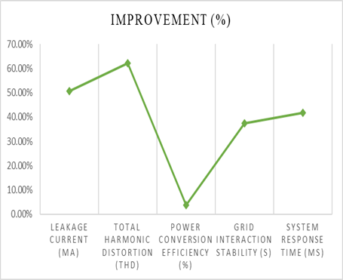

Fig.4. show the improvements with previous result

conclusion
This paper presents a new hybrid Pulses Width Modulation (PWM) method to increase the efficiency of transformer-less inverters using solar photovoltaic (PV) arrays and superconducting magnetic energy storage (SMES) systems. The decrease in total harmonic distortion (THD) and leakage currents significantly increases the power quality and reliability of the system. Hybridizing with PWM maintains grid reliability and power delivery with high conversion efficiency. SMES responds fast to any electrical interference, and this enables flexible switching behavior to contribute to the regulation of the output variation of the solar PV systems, making them more stable and efficient. Carry out simulations and physical trial tests to show that this method will offer a higher level of power quality, efficiency and stability as compared to traditional PWM systems. Such an advancement makes it easier to use renewable energy resources and dependability of the inverter systems that are connected to the grid in future power systems.

References

- Blaabjerg, F., Ma, K., & Liserre, M. (2012). Power electronics key technologies for renewable energy systems—Part I. IEEE Transactions on Industrial Electronics, 60(11), 5705-5718.
- Li, W., & He, X. (2011). Review of nonisolated high-step-up DC/DC converters in photovoltaic grid-connected applications. IEEE Transactions on Industrial Electronics, 58(4), 1239-1250.
- Kerekes, T., Teodorescu, R., & Borup, U. (2007). Transformerless photovoltaic inverters connected to the grid. IEEE Transactions on Power Electronics, 24(4), 859-866.
- Dixit, K.K. and Badhoutiya, A., 2023. An Efficient Topology for Simultaneous Feeding of AC/DC Loads. In Intelligent Manufacturing and Energy Sustainability: Proceedings of ICIMES 2022 (pp. 451-460). Singapore: Springer Nature Singapore.
- Kumar, Y., Study of THD reduction in voltage source inverter with PI controller against variation in loads and unexpected input. In Applications of Mathematics in Science and Technology (pp. 845-848). CRC Press.
- Gonzalez, R., Lopez, J., Sanchis, P., & Marroyo, L. (2008). Transformerless inverter for single-phase photovoltaic systems. IEEE Transactions on Power Electronics, 22(2), 693-697.
- Rodriguez, P., Pou, J., Bergas, J., Candela, I., Burgos, R., & Boroyevich, D. (2007). Decoupled double synchronous reference frame PLL for power converters control. IEEE Transactions on Power Electronics, 22(2), 584-592.
- Gao, F., Liang, H., Cao, W., & Fletcher, J. E. (2013). A review of high-power DC/DC converter topologies in renewable energy applications. IEEE Transactions on Power Electronics, 28(4), 1239-1253.
- Badhoutiya, A. and Yadav, A., 2017, May. Boost control for PV applications using impedance source inverter. In 2017 2nd IEEE International Conference on Recent Trends in Electronics, Information & Communication Technology (RTEICT) (pp. 1967-1970). IEEE.
- Carrasco, J. M., Franquelo, L. G., Bialasiewicz, J. T., Galvan, E., Guisado, R. C., Prats, M. A. M., & Moreno-Alfonso, N. (2006). Power-electronic systems for the grid integration of renewable energy sources: A survey. IEEE Transactions on Industrial Electronics, 53(4), 1002-1016.
- Kumar, Y., 2024, February. Comparative Study of Several Topology for PV-Based Inverters. In 2024 3rd International conference on Power Electronics and IoT Applications in Renewable Energy and its Control (PARC) (pp. 227-231). IEEE.
- Teodorescu, R., Liserre, M., & Rodriguez, P. (2011). Grid converters for photovoltaic and wind power systems. John Wiley & Sons.

