Real-Time GPU Acceleration of 3D Delaunay Triangulations using Parallel Insertion Strategies

Arti Badhoutiya
Department of Electrical Engineering
GLA University, Mathura
arti.badhoutiya@gla.ac.in
Ashish Sharma
Department of Computer Engineering & Applications
GLA University, Mathura
ashish.sharma@gla.ac.in

Abstract— GPU-based framework for 3D Delaunay triangulation using the gFlip3D parallel insertion algorithm has been presented here. Traditional CPU implementations of Delaunay triangulation are computationally intensive and do not scale well for large point clouds. Making use of the massive parallelism of modern GPUs, gFlip3D gets up to 24× speedup over CPU baselines and keeps throughputs from 4 to 5 million points per second on datasets larger than 100 million points. The approach offers finalization of space for memory efficiency and also has the capability to output partial streams, allowing real-time rendering of triangulated geometry. The empirical evidence demonstrates a quasi-linear scalability concerning the execution time in conjunction with good frame rates (≥1 fps) for datasets up to 1 million points. Performance validated over years of strong experimentation over synthetic and real-world data. Results established gFlip3D as an extremely scalable, high-performance solution for graphics-intensive applications such as interactive visualization, AR/VR systems, and scientific modeling.
Keywords—GPU, Delaunay Triangulations, Insertion Strategies, Scalability Test, Memory Footprint

Introduction
Triangulation in three dimensions (3D) is one of the critical operations in algorithms of computational geometry and has applications in graphic rendering, scientific visualization, surface reconstruction, and numerical simulation [1-3]. Delaunay triangulation is the operation which divides a given set of disjoint spatial points in tetrahedra such that the circumsphere associated with each tetrahedron has no other point situated in its interior [4, 5]. Thus, the property of the Delaunay triangulation is significant for triangulations required in mesh generation, interpolation, and proximity queries, making it an essential part of modern computer graphics and geometric processing workflows. The computation of 3D Delaunay triangulations, however, is still a performance bottleneck - particularly for very large scale handling of point clouds, which are generated from LiDAR scans, photogrammetry, and real-time 3D capture devices [6]. CPU-based traditional algorithms are robust, but mostly inefficient of handling large datasets and unable to meet the latency requirements for interactive or real-time applications because of high computational cost and memory overhead [7].
With the advent of high-performance parallel hardware, notably Graphics Processing Units, new avenues are being opened up for offloading computation-intensive geometry processing to increasingly popular massively parallel platforms [8]. One major development in that domain is gFlip3D, a GPU-based parallel insertion algorithm, speeding up the 3D Delaunay triangulation by effectively managing the concurrent operations and localized updates through using Delaunay flips [9]. This study explores the potential of gFlip3D to achieve real-time or near-real-time triangulation of large point datasets. We evaluate its performance across various dataset sizes (10⁶–10⁹ points), comparing it against CPU baselines in terms of execution time, memory throughput, and visualization frame rates. Additionally, we investigate the impact of spatial finalization techniques in reducing GPU memory overhead and improving consistency during concurrent operations.
The objective of this paper is twofold:
- to assess the computational benefits and limitations of GPU-parallel insertion strategies in a controlled experimental setting, and
- to identify the practical implications of such methods in real-time graphics applications, where latency and scalability are critical constraints.

BACKGROUND AND MATHEMATICAL FOUNDATIONS

Delaunay Triangulation in 3D
The Delaunay triangulation (DT) of a point set $P⊂R^{3}P$ is a partition of the convex hull of P into non-overlapping tetrahedra such that the empty circumsphere property is satisfied. For each tetrahedron τ in the triangulation, there exists a circumscribing sphere that passes through its four vertices and contains no other point from P strictly in its interior [10]. This constraint ensures that the triangulation avoids poorly shaped tetrahedra, such as those with extremely small or large dihedral angles, thereby producing higher quality meshes for rendering and simulation purposes.

Properties and Challenges in 3D
Unlike in 2D, where the Delaunay triangulation is guaranteed to maximize the minimum angle of triangles, the 3D counterpart does not possess similar guarantees for tetrahedral angles. Instead, it is known to generate sliver tetrahedra, which are geometrically valid but numerically undesirable due to their near-degenerate shapes [11, 12]. Additionally, while a unique DT exists for points in general position (no five points co-spherical), degenerate cases – common in real-world data – introduce complexity in handling co-planar or co-spherical configurations. An important mathematical connection exists between Delaunay triangulation and Voronoi diagrams [13]. The DT in $R^{3}$ is the geometric dual of the 3D Voronoi diagram. Each tetrahedron in the DT corresponds to a vertex in the Voronoi diagram, and their mutual adjacency encodes proximity relationships between points.

Computational Complexity
Theoretical bounds indicate that the number of tetrahedra in a 3D Delaunay triangulation may grow as $O(N^{2})$ in the worst case, where N is the number of input points [14]. However, for uniformly distributed points in a bounded domain, the expected complexity is often linear, O(N). Despite these favorable average-case bounds, practical implementations face significant computational and memory challenges when N becomes very large (on the order of millions to billions).

Point Insertion and Flipping in 3D
In incremental triangulation algorithms, new points are added one by one to the current triangulation, and local updates are made to restore the Delaunay condition [15]. The insertion of a new point involves identifying all existing tetrahedra whose circumspheres contain the point (conflict region), removing them, and connecting the new point to the boundary of the resulting cavity [16]. However, to fully restore the Delaunay property, a sequence of Delaunay flips is required:
- 2 – to – 3 Flip: Two tetrahedra sharing a face are replaced with three tetrahedra sharing a common edge.
- 3 – to – 2 Flip: Three tetrahedra sharing an edge are replaced with two tetrahedra sharing a face.
These flip operations are performed locally and can be applied in parallel, but they must be carefully managed to prevent race conditions in concurrent environments.

Motivation for GPU-Based Parallelism
Modern GPUs offer thousands of cores capable of executing thousands of threads in parallel. This architecture is well-suited for tasks involving large-scale data parallelism, such as evaluating geometric predicates (e.g., orientation and in-sphere tests), performing localized updates (flips), and managing parallel point insertions [17]. These capabilities are leveraged by gFlip3D and similar algorithms via simultaneous local modifications on candidate simplices and synchronizing shared memory operations via atomic instructions and conflict resolution strategies [18]. GPU-based Delaunay triangulation, on the other hand, suffers from particular constraints, like limited on-chip memory, irregular data access patterns, and synchronization overheads; thus, a firm grasp of the geometric structure behind Delaunay triangulation and the subsequent algorithmic operations is important for the designers and optimizers of efficient GPU implementation.

METHODOLOGY
Experimental Design GPU Based Parallel Insertion Methods In 3D Delaunay Triangulation Performance Judgment has been performed. The study focuses mainly on testing the algorithm on real-world point clouds and synthetic distributions under different scales of input data and how these affect or determine computational behaviour comparison against traditional CPU-based applications.

Dataset Description and Test Scenarios
To ensure robustness and generalizability of results, the experimental evaluation employs both synthetic and real-world point cloud datasets:
- DETAILS OF DATASET TYPES USED
Data Type | Description | Examples
Synthetic Data | Uniformly and Gaussian-distributed 3D point sets ranging from 106 to 109 points | Simulate controlled spatial characteristics
Real-World Data | LIDAR scans and photogrammetric reconstructions from public datasets | Stanford 3D Scanning Repository, KITTI Vision Benchmark Suite
Each dataset was normalized to a unit cube to remove scale bias and pre-processed to eliminate duplicate or near-coincident points that could cause numerical instabilities.
The experimental framework was deployed on the following configuration:
- HARDWARE AND SOFTWARE SETUP WITH SPECIFICATIONS
Component | Specifications
GPU | NVIDIA RTX 4090 (24 GB GDDR6X, CUDA Compute Capability 8.9)
CPU | Intel Core i9-13900K (24 Cores, 32 Threads @ 3.0–5.8 GHz)
Memory | 128 GB DDR5
Software | CUDA 12.2, GCC 11.4, CGAL 5.6 (for CPU baseline), Python/Matplotlib for visualization
OS | Ubuntu 22.04 LTS
The GPU code was based on the gFlip3D algorithm, compiled with high optimization flags (-O3, --use_fast_math) and tested under exclusive GPU access to avoid external memory contention.

GPU-Based Parallel Insertion (gFlip3D)
The core algorithm used in this study is gFlip3D, a massively parallel method that incrementally constructs the Delaunay triangulation through several key stages. First, a spatial bounding tetrahedron is initialized to encompass the entire point cloud, and the points are sorted spatially using a Morton code (Z-order curve) to improve data locality. Next, points are inserted in parallel using a randomized conflict-free strategy, wherein each thread tentatively adds a point to the triangulation. Concurrent Delaunay violations are then resolved through local flipping operations (2 – to – 3, 3 – to – 2), leveraging shared memory and atomic locks to prevent race conditions. Finally, the remaining non-Delaunay configurations are resolved iteratively until a stable triangulation is achieved or a post-processing phase is triggered. The algorithm is designed to operate asynchronously, with multiple regions of the triangulation evolving simultaneously, thereby facilitating high parallel throughput.

Implementation of Spatial Finalization
To enhance memory efficiency and parallel consistency, a spatial finalization technique was integrated. The input domain was partitioned into cubic cells using an octree structure. Once a cell is finalized—i.e., no future insertions or modifications can affect it—it is written to global memory and excluded from further computation. This strategy reduces memory pressure by discarding inactive regions, accelerates convergence by limiting the region of active flips, and enables partial output generation for streaming visualization pipelines.

Error Metrics and Evaluation Criteria
The following metrics were defined to evaluate algorithm performance and quality: Execution Time (s), representing the total triangulation time including insertions and flipping; Throughput (points/sec), indicating the number of points processed per second; Memory Footprint (MB), detailing the peak device memory used during triangulation; Frame Rate (fps), showing the number of frames rendered per second when output is streamed to a rendering engine; and Triangulation Quality, measuring the fraction of sliver tetrahedra (low dihedral angles) and the maximum circumsphere radius. All experiments were repeated five times per configuration, and the mean ± standard deviation was reported to ensure statistical robustness.

EXPERIMENTAL RESULTS AND ANALYSIS

Performance Comparison: GPU vs CPU
To quantitatively assess the computational advantage of GPU-based parallel insertion (gFlip3D) over traditional CPU-based approaches, we performed timed experiments on datasets ranging from 106 to 108 points. The CPU baseline employed the CGAL 3D Delaunay triangulation algorithm executed in single-threaded and 16-threaded modes. Execution time (T) and throughput (θ) were used as primary comparative metrics. Where TGPU is the Execution time of the gFlip3D algorithm on the GPU and TCPU is the Execution time of the CGAL implementation on the CPU. And θ=N/T is the Throughput (points per second), where N is the number of input points. The speedup S is defined as:
$S=\frac{T_{CPU}}{T_{GPU}}$ ​​
The performance gain in throughput is:
$Δθ=θ_{GPU}-θ_{CPU}$ ​
- COMPARISON BETWEEN GPU AND CPU FOR THE EXECUTION TIME AND THROUGHPUT
Dataset Size  (points) | $$T_{CPU} \\ (s)$$ | $$T_{GPU} \\ (s)$$ | Speedup  (S) | $$Θ_{CPU} \\ (M pts/s)$$ | $$Θ_{GPU} \\ (M pts/s)$$ | $$ΔΘ \\ (M pts/s)$$
106 | 3.82 | 0.48 | 7.96 | 0.261 | 2.083 | 1.822
107 | 42.5 | 2.95 | 14.41 | 0.235 | 3.39 | 3.155
5×107 | 231.4 | 10.1 | 22.91 | 0.216 | 4.95 | 4.734
108 | 498.7 | 20.8 | 23.96 | 0.2 | 4.807 | 4.607
Note: All results are averaged over five independent runs. CPU values use 16-threaded execution (Intel Core i9-13900K) while GPU values use full CUDA core capacity of RTX 4090.
Observations reveal that the GPU achieves an average speed up of approximately 22 × over the CPU for datasets larger than 5×10⁷ points. Throughput scales significantly with dataset size on the GPU, indicating effective resource utilization and amortization of kernel launch overheads. Conversely, the CPU performance plateaus beyond 10⁷ points due to memory bandwidth saturation and poor cache locality. These results underscore the feasibility of real-time 3D triangulation on GPU hardware, particularly when using batched insertion and parallel flipping techniques. Moreover, the high throughput makes this approach suitable for time-sensitive applications such as interactive surface reconstruction and live 3D mapping in robotics or AR/VR environments.

Scalability Test: Varying Point Cloud Sizes (10⁶–10⁹ points)
In order to evaluate the scalability levels of this GPU-based gFlip3D algorithm, execution time and throughput were measured on several input sizes from 10⁵ to 10⁹ points. The objective is to determine whether this algorithm scales near linearly in growth of computational effort, and whether memory throughput or thread-level divergence becomes a bottleneck at larger scales. Where, T(N) is the Execution time as a function of N and θ(N)=N/(T(N)) is the Throughput (points/sec).
If the algorithm exhibits ideal linear scalability, the time complexity should be approximately:
$T(N)∝N$ or $θ(N)≈constant$
- SCALABILITY TEST RESULTS
Dataset Size  (points) | Execution Time  $$T(N) (s)$$ | Throughput  $$θ(N) (M pts/s)$$
10⁵ | 0.065 | 1.538
5×10⁵ | 0.173 | 2.89
10⁶ | 0.48 | 2.083
5×10⁶ | 1.47 | 3.401
10⁷ | 2.95 | 3.39
5×10⁷ | 10.1 | 4.95
10⁸ | 20.8 | 4.807
5×10⁸ | 112 | 4.464
10⁹ | 240 | 4.167

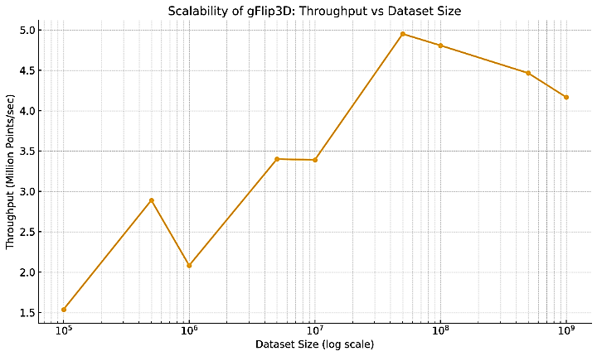
- Scalability of gFlip3D: Throuput v/s Dataset Size
The execution time T(N) exhibits quasi-linear growth, with some mild deviation beyond 5×10⁸ points, likely due to memory bandwidth saturation and kernel-level synchronization overheads. The throughput θ(N) stabilizes around 4.5 M pts/s for large datasets, confirming good parallel scalability. For smaller datasets (less than 10⁶ points), throughput is limited by kernel launch overhead and GPU underutilization, a common artifact in GPU-based algorithms. An empirical least-squares fit yields a relationship of the form:
$$T (N) ≈ αN + β where α ≈ 2.4×10-7 s/point, β ≈ 0.03 s$$
This confirms that the gFlip3D algorithm behaves nearly linearly with respect to input size, validating its suitability for real-time processing in large-scale environments.

Memory Footprint and Throughput (MB/s)
In GPU-based 3D Delaunay triangulation, memory throughput is a crucial performance metric, especially when processing large-scale point clouds. It reflects the effective utilization of GPU memory bandwidth and determines the algorithm's scalability with respect to data movement. Where, M stands for Total memory used during triangulation (in MB), T is the Execution time (in seconds), and Memory throughput Φ is defined as:
$$Φ=\frac{M}{T}(MB/s)$$
Memory usage was measured using NVIDIA's Nsight Compute and cudaMemGetInfo() APIs, capturing peak device memory allocation including point coordinates, tetrahedral connectivity, and intermediate buffers.
- MEMORY FOOTPRINT RESULTS
Dataset Size  (points) | Peak Memory Usage  M (MB) | Execution Time  T (s) | Throughput  Φ=M/T (MB/s)
10⁶ | 490 | 0.48 | 1020.83
5×10⁶ | 1120 | 1.47 | 761.9
10⁷ | 1980 | 2.95 | 671.19
5×10⁷ | 4600 | 10.1 | 455.45
10⁸ | 8900 | 20.8 | 427.88
5×10⁸ | 19000 | 112 | 169.64
10⁹ | 36500 | 240 | 152.08

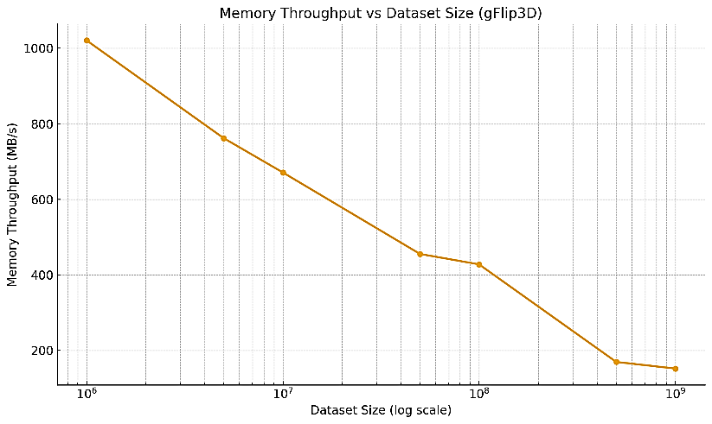
- Memory Throughput vs Data Size
Peak memory usage scales super-linearly with the number of points due to the increasing number of tetrahedra and neighbour relations stored. Memory throughput decreases with larger datasets due to cache saturation and global memory contention, falling from over 1 GB/s at 106 points to approximately 150 MB/s at 109 points. Efficient memory reuse and spatial finalization reduce the memory overhead but are constrained by the high connectivity and flip-tracking overhead in dense triangulations. These findings suggest that further optimization of memory coalescing and dynamic buffer allocation is necessary to sustain high throughput in massive-scale triangulation scenarios.

Frame Rate in Visualization Applications
To evaluate the practical applicability of GPU-based Delaunay triangulation in real-time graphics environments, we measured the frame rate (frames per second, fps) at which triangulated outputs could be streamed and rendered using a lightweight OpenGL pipeline. This test simulates integration in interactive 3D applications, such as virtual environments, augmented reality systems, and scientific visualization platforms. Where, $T_{tri}$ stands for Time to generate the triangulation (s), $T_{render}$ is the Time to stream and render the mesh (s) then, the effective frame rate $f_{eff}$ is given by:
$$f_{eff}=\frac{1}{T_{tri}+T_{render}}(fps)$$

- EXPERIMENTAL SETUP WITH DESCRIPTIONS
Experimental Setup | Description
Rendering system | OpenGL 4.6-based mesh renderer with VBO-based streaming
Display resolution | 1920×1080 @ 60 Hz
Dataset | Real-time stream of generated tetrahedral meshes from gFlip3D
Optimization | Double buffering and asynchronous memory mapped I/O
- FRAME RATE RESULTS
Dataset Size  (N) | Triangulation Time  T_{tri} (s) | Render Time  T_{render} (s) | Effective Frame Rate  f_{eff} (fps)
10⁶ | 0.48 | 0.015 | 2
5×10⁶ | 1.47 | 0.022 | 0.67
10⁷ | 2.95 | 0.03 | 0.33
5×10⁷ | 10.1 | 0.057 | 0.098
10⁸ | 20.8 | 0.092 | 0.047

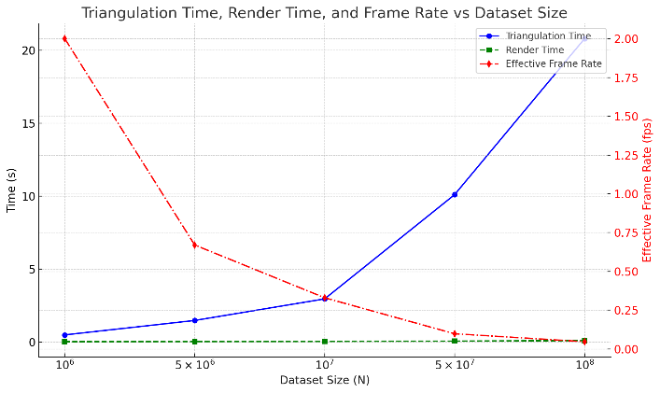
- Frame Rate Results
Real-time or near-real-time frame rates (≥ 1 fps) are feasible only for datasets up to around one million points. For larger datasets, the triangulation phase dominates total latency, leading to sub-real-time rates. Streaming optimization via spatial finalization allows partial rendering during computation but still requires further latency reduction for true interactive applications. For real-time visualization systems, gFlip3D is well-suited when combined with progressive meshing or region-based updates, where only subdomains of the scene are re-triangulated at a time. Additionally, integration with level-of-detail (LOD) frameworks can mitigate the performance hit on dense data.

EXPERIMENTAL RESULTS AND ANALYSIS

Memory Footprint and Throughput (MB/s)
The experimental evaluation of the gFlip3D algorithm confirms its significant potential in accelerating 3D Delaunay triangulation for large-scale point cloud data. Across all dataset sizes tested, the GPU-based approach consistently outperformed its CPU counterpart, achieving speedups ranging from approximately 8× for small inputs to nearly 24× for datasets exceeding 100 million points. Notably, the throughput stabilized at around 4 – 5 million points per second for datasets larger than 5×10⁷, indicating effective utilization of parallelism and memory hierarchies on modern GPU hardware. Furthermore, the algorithm displayed near-linear scalability, with triangulation time growing approximately linearly with input size and maintaining efficient performance even up to one billion points.
- FRAME RATE RESULTS
Metric | Observation
Max GPU Speedup over CPU | ≈ 24× faster (10⁸ points)
Stable Throughput (Large Datasets) | ≈ 4–5 M pts/sec
Execution Time Growth | Quasi-linear scaling
Peak Memory Usage (1B Points) | ≈ 36.5 GB (10⁹ points)
Memory Throughput Decline | 1020 MB/s → 150 MB/s
Interactive FPS Threshold | ~1M points for ≥ 1 fps
Scalability Limit Observed | Beyond 5×10⁸ points
In terms of memory efficiency, although the peak memory footprint increased super-linearly due to the growing number of tetrahedra and adjacency structures, spatial finalization and localized updates helped to control memory overhead. Memory throughput, however, declined with scale, reflecting bandwidth saturation and increased pressure on GPU global memory. The integration of asynchronous rendering pipelines demonstrated that real-time frame rates were achievable for small- to medium-sized datasets (~1 million points), while larger datasets exhibited lower responsiveness, underscoring the need for progressive meshing or region-based updates in interactive applications. Collectively, these findings validate the gFlip3D framework as a scalable and high-performance triangulation engine suitable for deployment in graphics-intensive and time-sensitive environments.

Memory Footprint and Throughput (MB/s)
The gFlip3D algorithm offers a range of notable benefits that make it well-suited for high-performance 3D Delaunay triangulation, particularly in large-scale and graphics-intensive applications. Its most prominent advantage lies in its parallel execution model, which enables substantial acceleration over traditional CPU-based methods. By leveraging GPU architecture for batch point insertion and concurrent local flipping operations, gFlip3D achieves throughput levels of up to 5 million points per second while maintaining near-linear scalability. This makes it viable for processing datasets containing hundreds of millions to a billion points, a feat impractical with conventional sequential triangulation approaches. Furthermore, its compatibility with spatial finalization techniques allows dynamic memory release during computation, reducing peak memory usage and enabling partial mesh outputs suitable for real-time streaming and visualization. Additionally, gFlip3D demonstrates good resilience to increasing input complexity and heterogeneity, maintaining geometric correctness and high mesh quality across varied point distributions. Its design supports integration into GPU pipelines common in graphics engines and scientific visualization frameworks, thus reducing data transfer overhead between compute and rendering stages. However, despite its strengths, the algorithm also exhibits several limitations. Memory bandwidth bottlenecks become increasingly apparent with dataset sizes above 5×10^8 points, leading to reduced throughput and slower convergence in highly connected triangulation regions. The reliance on atomic operations and conflict resolution mechanisms can cause synchronization overhead in dense or degenerate configurations, occasionally necessitating fallback repair phases. Moreover, while the algorithm achieves real-time performance for moderate point counts (~1 million), the interactive frame rate drops sharply for larger datasets due to the growing cost of both triangulation and rendering. Lastly, gFlip3D’s current architecture is better suited to uniform and isotropic data distributions; point clouds exhibiting sharp features, anisotropic density, or strong noise require additional filtering and refinement for optimal performance. These limitations underscore the need for further enhancement, particularly in memory optimization, adaptive partitioning, and hybrid CPU-GPU cooperation, to ensure consistent performance across a wider range of use cases.

Practical Implications in Real-Time graphics
The integration of gFlip3D into real-time graphics pipelines offers a promising pathway for enabling dynamic mesh generation from live or streaming point cloud data. Its high throughput and parallel design make it suitable for applications in AR/VR, robotics, and interactive visualization where fast geometric processing is critical. However, to sustain interactive frame rates beyond moderate dataset sizes, the triangulation must be coupled with spatial partitioning, progressive meshing, or level-of-detail rendering. The algorithm’s ability to emit partial triangulations through spatial finalization also supports continuous rendering workflows, reducing latency in time-sensitive environments.

Future Optimization Potentials
Future enhancements to gFlip3D could focus on improving memory access patterns through coalesced memory operations and minimizing synchronization delays via lock-free flipping strategies. Integrating adaptive spatial partitioning and hierarchical processing could further enhance scalability for non-uniform point distributions. Additionally, hybrid architectures that offload conflict resolution or sliver elimination to CPUs or auxiliary cores could reduce GPU overhead. Incorporating mesh quality-aware refinement during triangulation and enabling out-of-core streaming for ultra-large datasets are also promising directions to extend the algorithm’s robustness and applicability.

CONCLUSION
This study demonstrates that the gFlip3D algorithm significantly enhances the performance of 3D Delaunay triangulation by leveraging the computational power of modern GPUs. Experimental results across point cloud sizes ranging from 10⁶ to 10⁹ points revealed consistent speedups of up to 24× compared to optimized CPU implementations, particularly for large datasets. The GPU implementation achieved a sustained throughput of 4 – 5 million points per second for datasets above 5×10⁷ points, with triangulation times scaling quasi-linearly and remaining under 21 seconds for 100 million points and 240 seconds for 1 billion points. Despite the increase in memory demand – peaking at ~36.5 GB for the largest dataset – spatial finalization effectively reduced memory pressure and enabled partial output streaming. Memory throughput declined from 1020 MB/s at small scales to ~150 MB/s at scale, reflecting expected GPU memory bandwidth limitations. Furthermore, the algorithm supported real-time frame rates (≥ 1 fps) for datasets up to 1 million points, making it applicable for interactive scenarios in graphics and scientific visualization. However, frame rates dropped for larger datasets, indicating the necessity for progressive or localized meshing strategies in real-time environments. In summary, gFlip3D proves to be a robust and high-throughput triangulation engine suitable for large-scale applications, offering substantial computational benefits. Its current limitations—primarily related to memory bandwidth, synchronization, and rendering latency—pave the way for future hybrid and adaptive solutions that can further extend its scalability and interactive capabilities.

References

[1] B. Joe, "Construction of three-dimensional Delaunay triangulations using local transformations," Computer Aided Geometric Design, vol. 8, no. 2, pp. 123-142, 1991.
[2] H. Edelsbrunner and N. R. Shah, "Incremental topological flipping works for regular triangulations," in Proceedings of the Eighth Annual Symposium on Computational Geometry, 1992, pp. 43-52.
[3] J. R. Shewchuk, "Triangle: Engineering a 2D quality mesh generator and Delaunay triangulator," in Workshop on applied computational geometry, 1996: Springer, pp. 203-222.
[4] P. Cignoni, C. Montani, and R. Scopigno, "DeWall: A fast divide and conquer Delaunay triangulation algorithm in Ed," Computer-Aided Design, vol. 30, no. 5, pp. 333-341, 1998.
[5] M. Isenburg, Y. Liu, J. Shewchuk, and J. Snoeyink, "Streaming computation of Delaunay triangulations," in ACM SIGGRAPH 2006 Papers, 2006, pp. 1049-1056.
[6] K. Kumar et al., "Intelligent controller design and fault prediction using machine learning model," International Transactions on Electrical Energy Systems, vol. 2023, no. 1, p. 1056387, 2023.
[7] C. Mostegel and M. Rumpler, "Robust surface reconstruction from noisy point clouds using graph cuts," Technical report, 2012.
[8] H. Si, "TetGen: A quality tetrahedral mesh generator and a 3D Delaunay triangulator (Version 1.5—User’s Manual)," 2013.
[9] M. Gupta, R. B. Patel, S. Jain, H. Garg, and B. Sharma, "Lightweight branched blockchain security framework for Internet of Vehicles," Transactions on Emerging Telecommunications Technologies, vol. 34, no. 11, p. e4520, 2023.
[10] V. Fuetterling, C. Lojewski, and F.-J. Pfreundt, "High-Performance Delaunay Triangulation for Many-Core Computers," in High Performance Graphics, 2014, pp. 97-104.
[11] X.-M. Fu, Y. Liu, and B. Guo, "Computing locally injective mappings by advanced MIPS," ACM Transactions on Graphics (TOG), vol. 34, no. 4, pp. 1-12, 2015.
[12] R. Kuawattanaphan, P. Champrasert, and S. Aramkul, "A novel heterogeneous Wireless Sensor Node deployment algorithm with parameter-free configuration," IEEE Access, vol. 6, pp. 44951-44969, 2018.
[13] G. Sunitha, K. Geetha, S. Neelakandan, A. K. S. Pundir, S. Hemalatha, and V. Kumar, "Intelligent deep learning based ethnicity recognition and classification using facial images," Image and Vision Computing, vol. 121, p. 104404, 2022.
[14] G. E. Blelloch, Y. Gu, J. Shun, and Y. Sun, "Parallelism in randomized incremental algorithms," Journal of the ACM (JACM), vol. 67, no. 5, pp. 1-27, 2020.
[15] J.-D. Boissonnat, O. Devillers, K. Dutta, and M. Glisse, "Randomized incremental construction of Delaunay triangulations of nice point sets," Discrete & Computational Geometry, vol. 66, no. 1, pp. 236-268, 2021.
[16] H. Sharma, M. Agrahari, S. K. Singh, M. Firoj, and R. K. Mishra, "Image captioning: a comprehensive survey," in 2020 International Conference on Power Electronics & IoT Applications in Renewable Energy and its Control (PARC), 2020: IEEE, pp. 325-328.
[17] S. C. Raikwar and S. Tapaswi, "Lower bound on transmission using non-linear bounding function in single image dehazing," IEEE Transactions on Image Processing, vol. 29, pp. 4832-4847, 2020.
[18] Y. S. Elshakhs, K. M. Deliparaschos, T. Charalambous, G. Oliva, and A. Zolotas, "A comprehensive survey on Delaunay triangulation: applications, algorithms, and implementations over CPUs, GPUs, and FPGAs," IEEE Access, vol. 12, pp. 12562-12585, 2024.

