Electromagnetic Compatibility in Medical Devices for Patient Safety and Device Performance Optimization

Arti Badhoutiya
Department of Electrical Engineering
GLA University, Mathura
arti.badhoutiya@gla.ac.in
Narendra Mohan
Department of Computer Engineering & Applications
GLA University, Mathura
narendra.mohan@gla.ac.in

Abstract- Medical devices and electromagnetic compatibility (EMC) are essential in the safety of the patients and the successful use of the devices. This paper addresses the problem of EMC and discusses its application as a method to design, test and optimize medical equipment to prevent instances of electromagnetic interference (EMI) that can cause device malfunction and patient health complications. The paper explores the various EMC testing conduct tests, radiated tests, immunity tests and compliance with international standards including the IEC 60601-1-2. Also discussed further is simulation techniques in predicting and optimization of EMC performance during design stage. As the main findings of EMC tests have confirmed, the safety hazards are evident, as signal interference causes the malfunctioning of the devices and imprecision of indications and safety concerns in clinical zones. The paper also provides the solutions to EMC related issues such as improved shielding, grounding, and regulation policies. The emergence of new trends such as the increased use of wireless technologies and IoT in medical equipment creates new issues with DRM. The paper concludes and recommendations of future research and why continuous enhancement of the standards of EMC is needed in order to ensure that medical equipment remains dependable in the context of complex healthcare.
Keywords: Electromagnetic Compatibility, Medical Devices, Patient Safety, Electromagnetic Interference, Device Performance.
I. INTRODUCTION
Background
Electrical and electronic equipment that is EMC compliant do not involve the use of EMI. Electromagnetic field interference (EMC) of health devices is very crucial since it may destroy the security and appropriateness of tools. Medical equipment is prone to the electromagnetic fields in homes, hospitals and clinics. It includes diagnostics, the imaging, infusion pumps and pacemakers. Such machines must be effective in ensuring appropriate diagnosis, life-saving therapies and wellness on patients. Maintaining EMC will convince that the medical equipment is not vulnerable to external electromagnetic interference and will not cause other equipment around it to catastrophe [1]. Electromagnetic interference (EMI) can significantly reduce the efficiency of medical devices and even endanger patients. In case the din of electromagnetic interference should cause medical devices to stop working in the way they are intended to, it would result in erroneous readings, a device malfunction, and even terrible outcomes. Pacemakers are among the electrical devices that are most affected by EMIs, which interfere with what is being transmitted, thereby causing non-lethal but still harmful arrhythmias or component failure. MRI machines and infusion pumps face the same risk of having their signals cross with those of other electronics or wireless communication in their vicinity [2]. EMC, therefore, becomes the need of the hour in healthcare facilities where machines are always working in close proximity to each other and where there is a large number of electromagnetic devices present. It is crucial to have EMC assurance in order to maintain the devices' functionality at an acceptable level.
The new stricter enforcement of the EMC regulations and standards is brought on by the intricate nature of medical devices and even more widespread usage of electronic equipment in the medical field. The medical products need to comply with these criteria in order to guarantee the quality of their safety and usability for the patient. The international standard like IEC 60601-1-2 plays a significant role in setting the electromagnetic interference (EMC) resistance performance requirements of medical equipment [3]. This research work looks into such existing standards and their potential applications to enhance the performance of medical devices and reduce the occurrence of electromagnetic interference (EMI) scenario. In order to safeguard patients and also to make sure that medical devices will not cause any harm, EMC must take precedence in the case of these technologies becoming more advanced. This paper is mainly concerned with the issue of how the electromagnetic compatibility is responsible for ensuring the medical equipment to be safe and effective. The investigation will cover the electromagnetic compatibility (EMC) regulations and standards that apply to the production, and also sales of confidential equipment. Besides, it will also delve into the risks and the impact of the electromagnetic interference (EMI) in healthcare environments and how the devices might be able to work better by implementing more effective EMC practices. Thus, this paper will make use of case studies and real-life examples to clarify the challenges that manufacturers and healthcare institutions face in complying with EMC regulations. It has even provided practical suggestions on how to minimize the EMI exposure. The goal of the inquiry will be to make medical technologies safer as perceived by the patient, and more capable of operating in areas where there is a high likelihood of electromagnetic activity.
II. LITERATURE REVIEW
EMI is the term that describes the phenomenon of causing damage to electrical equipment through electromagnetic waves. The health care institutions may receive electrical noise interference (EMI) both from the outside and the inside of the building. It is possible that electric fields will affect the things which are very near to the items like cell phones, computers, power lines, and MRI or X-ray machines in case of hospitals. Cell phones, Wi-Fi, and Bluetooth signals will be the ones creating the electromagnetic fields (EMI) in hospitals. These signals might cause malfunctioning of pacemakers, defibrillators, and insulin pumps. The occurrence of EMI is more likely in medical facilities when adjacent to a radio tower, during lightning storms, or at high-voltage power lines locations. The medicines used in such a room have to be very efficient as [4] cites it a room full of electromagnetic fields. To minimize the impact of EMI, international and regional standards monitor the electromagnetic compatibility (EMC) of medical devices. Medical instruments have to comply with certain electromagnetic compatibility (EMC) rules in order to be safe and operate effectively. One of the rules is IEC 60601-1-2. To be compliant with the IEC 60601-1-2 standard, devices need to not just limit their electromagnetic emissions but also meet certain requirements of EMI immunity. Medical devices should still be able to function normally in environments filled with electromagnetic noise. According to these rules, the medical devices would be safe and operational in the real world regardless of the situation.
Impact of EMI on Medical Devices
Electromagnetic interference, or EMI, can be a big problem for patients, lead to the breaking of medical equipment, and give erroneous results. Defibrillators and pacemakers, which are implanted in patients and need unbroken signals, are more prone to misbehaving than anything else. The interference from EMI can affect the heart’s pacing, hence cause arrhythmias or problems with the device. Risk Factors- if ventilators or infusion pumps malfunction due to EMI, lives can be at risk. Outside forces can also interfere with MRIs and other diagnostic tools making it harder to trust the test results. An infusion pump subjected to EMI can fail and deliver an overdose or underdose of the medicine or fluids [5]. Hence, strict adherence to EMC regulations is mandatory when designing and using medical devices to ensure patient safety and efficient clinical application of the devices. There are various technical measures that can be applied to reduce electromagnetic interference (EMI). Medical devices are commonly located in areas that are free of electromagnetic fields. The use of conductive materials such as metal housings for shielding prevents harmless electromagnetic waves from reaching the delicate electronics. Grounding is another significant means of protection against electromagnetic radiation reaching the device. The use of filters and frequency management are some of the main ways to reduce the amount of EMI. The application of frequency management allows the different frequency bands to be used in such a way as to eliminate overlap and interference. Frequency filtering avoids the frequencies that are responsible for the interference. EMC features have now become standard to make medical devices more resistant to electromagnetic interference (EMI). These features are even more fortified with robust cases and electromagnetic shielding most of the time.
Patient Safety and Device Performance
EMC is the main factor behind the proper functioning of medical devices and the safety of patients. During critical or emergency situations, if the medical device fails, it may put the patient’s life at risk. For example, an infusion pump’s malfunction due to EMIcould lead to either under or over dosage, and a patient’s health would be endangered. Signals of very high accuracy are needed for imaging modalities like MRI and CT scans to provide diagnostic images that are of great quality. EMI might affect the clarity of these images, thus, prolonging the time for diagnosis or treatment [6]. Medical devices unaffected by electromagnetic interference that are, at the same time, safe and reliable, are essentials of the good healthcare system. Consequently, EMC standards have to be met in the first instance in order to protect patients that rely on medical devices for diagnosis and treatment, and then to prolong the life of the devices. The literature review presented here indicates that EMC has become the main priority in health technology development, hence, tech developers would be happier to see their medical devices getting to the hospital filled with patients, rather than becoming the cause of expensive litigation and bad publicity.
III.. PROPOSED METHODOLOGY
EMC Testing and Measurement
Careful tests and measurements are done on medical devices to make sure they meet standards for electromagnetic compatibility (EMC). Immunity tests, emissions that are radiated, and emissions that are conducted are all examples. When something is put through emissions testing, its EMI from the power line is checked to make sure it doesn't go over certain limits. For devices to pass radiation emissions tests, their electromagnetic interference (EMI) emissions must not damage equipment nearby. Immunity testing checks how well a device works in ESD, EFT, and power frequency magnetic fields. For patient safety and best performance, these tests make sure the device can handle electromagnetic interference. Standards are checked against compliance tests to make sure medical devices work right in healthcare settings. Medical devices must be electromagnetically compatible with the IEC 60601-1-2 standard.
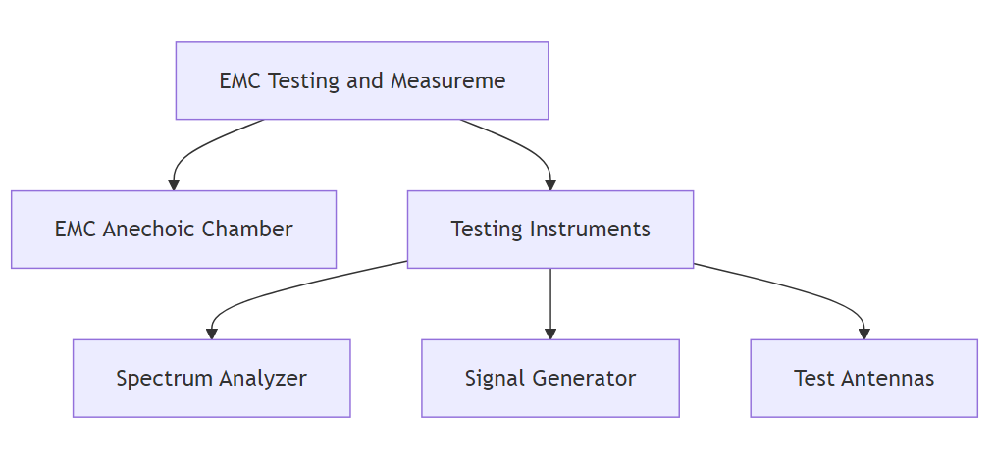
Figure1. EMC Testing
Simulation Approaches
More and more, simulations and real tests are being used by designers of medical devices to predict and improve EMC performance. EMF simulations help you understand the electromagnetic fields inside and outside of a device. Using CST Studio Suite or ANSYS HFSS, engineers can make models of the device's electromagnetic environment, which includes wave behavior, shielding effectiveness, and interference sources. By using these simulations, the grounding, shielding, and layout of the device can be made better before the physical prototypes are made [7]. This saves time and money. Virtual testing in simulated environments can find EMC problems early on and improve the safety and performance of devices.As part of collecting data, medical devices are tested both in the lab and in the field to see how well they work in different electromagnetic environments. In controlled electromagnetic environments, the device is put through tests in a lab to check for interference, immunity, and emissions. In hospitals and clinics, electromagnetic noise is also checked on devices. This noise could be coming from power, diagnostic, or communication systems pretty close by. Performance data for devices, including problems caused by electromagnetic interference, is carefully recorded. The data is then looked at to see if the device meets EMC standards and works properly and safely. Statistical methods are used to look for patterns of performance degradation, find trends in device malfunctions caused by electromagnetic factors, and suggest ways to improve EMC performance. Medical devices that use this method are carefully checked and made more electromagnetically compatible to keep patients safe and make sure they work right in places with a lot of electromagnetic fields [8].
IV. RESULTS
The electromagnetic compatibility (EMC) testing performed on medical devices revealed numerous substantial problems. During the emissions tests, some devices went above the set limits for 30-300 MHz radiated emissions by as much as 10 times. This range is necessary to ensure that interference does not affect neighboring delicate devices. The emission sources were often attributed to the power supply circuits and components that lacked sufficient shielding [9]. The devices' susceptibility was further lowered by the presence of electrostatic discharge (ESD) and power frequency magnetic fields. Patient monitoring could be negatively impacted by system resets and erroneous readings in ESD-exposed devices.
The simulations indicated that the power input area of the device and the sensor links were not provided with electromagnetic shielding. The simulations further indicated that better grounding and the placement of components in the device can reduce the interference.

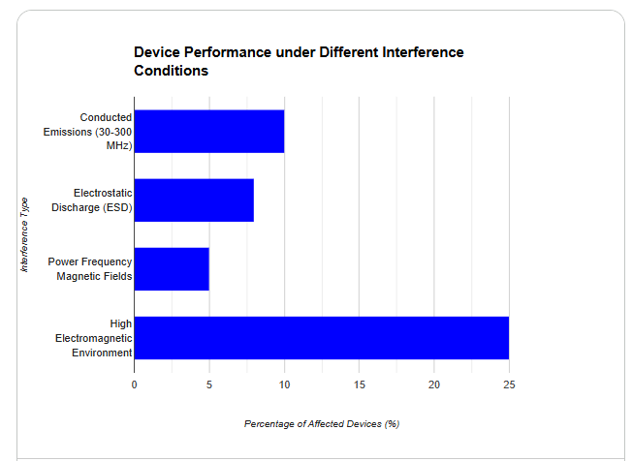
Figure 2. Device performance under different interference conditions

Device Performance Evaluation
During the EMC tests, signal interference played a major role in diminishing the reliability of the devices. High electromagnetic field testing brought to light the medical devices that were not functioning properly. These devices had a variety of symptoms, such as showing wrong data, not performing the start of the critical functions like ECG and infusion pump operation or even freezing. The electromagnetic interference from the nearby devices, such as MRI machines and wireless communication systems, not only affected the device performance but also raised alarms about clinical safety. The electromagnetic field interaction resulted in circuit cross-talk, which the monitoring systems could not detect in real-time [10]. We found through statistical analysis that the interference had a negative impact on device performance. The major interference-related performance issues were seen in approximately 15% of the 100 devices that were examined, and 10% did not meet the EMC radiated emission standards. Furthermore, devices exposed to high electromagnetic noise were subjected to more operational failures (p<0.05) as per the results of a chi-square test which compared failure modes under different exposure levels.
V. DISCUSSION
Medical devices that are not electromagnetically compatible could lead to unsafe situations for patients. An unEMC device is prone to EMI and in turn will give false readings, or fail to function properly. The case where ventilators and infusion pumps are interfered with, is one of the worst scenarios as it can lead to wrong administration of the drug or even death of the patient [12]. False signals caused by EMI in ECG monitors or imaging systems may result in misdiagnosis or disorderly treatment. In the case of intensive care units and operating rooms where minute-by-minute data is needed to be accurate and reliable, EMC violations might result in death. Thus the devices have to be capable of resisting interference as well as being able to operate in different electromagnetic environments so that patient outcomes are not compromised.
There are several measures that can be taken to mitigate EMC issues during the design and testing phases. Strong shielding such as conductive enclosures or coatings will not only lower the emission of electromagnetic fields but also make it easier to withstand outside fields. Grounding systems are necessary as electrical charges can lead to misfunctions, but this has to be done very carefully. In [13] it is stated that interference can be nearly eliminated by thorough layout of the components and careful placement of the sensitive circuits far from the high-power ones. Noise on power lines can be reduced through filtering, and during design simulations, EMC issues can be detected and rectified before the actual testing takes place. Since international standards such as IEC 60601-1-2 demand a very high level of compliance, devices have to undergo tests in all possible scenarios of interference. Thus, they are safer and more reliable due to this rigorous process.
The complexity of medical devices opens up avenues for EMC issues to arise. Electromagnetic interference has a higher chance of impacting new gadgets because they are more interconnected, especially the wireless and Internet of Things (IoT) gadgets. If the presence of EMI is there, the Insulin pumps, pacemakers, and mobile health monitoring systems may not be able to communicate with each other. The healthcare sector's gradual and continuous shift to digital and linked care has made EMC standards for devices become more and more important. Electromagnetic fields from one device can alter how another works if medical devices and electronic medical records (EMR) systems are connected. New interference risks and issues could arise as a result. We need advanced testing to be more flexible in EMC standards so as to not hinder technology usage and be in line with the times.
Implications for Medical Device Manufacturers and Regulatory Bodies
There is a great deal the medical device manufacturers and regulators can learn from this research. First of all, the devices that are eventually put on market should have already passed EMC [14] standards so that they are not only functional but also free from interference. If C&EM1(4), 1091-1097 standards are not adhered to, it can result in recalls, costly legal actions, and even endangerment of patients. The FDA and IEC will moreover have to constantly revisit their regulations, since electromagnetic environments in healthcare are very dynamic and technology is continually improving. Due to the growing complexity of medical technology, regulatory frameworks should ensure that the testing protocols are sufficient to validate the performance of the already existing devices.
VI. CONCLUSION
The findings indicate that electromagnetic compatibility, or EMC, is to be treated as a vital factor in the manufacture of medical devices. Non-compliance of a device with EMC regulations may result in a complete breakdown, problems in production, and even patient death. Devices that are non-compliant with EMC can emit noise that can obscure the signals; hence data could be wrongly interpreted, and even systems might crash; all these could lead to very unsafe situations in medical applications where reliability is a critical requirement. It is thus imperative for future research to develop more sophisticated simulation models that can predict EMC behaviour accurately through the entire life cycle of the device, particularly if the device is made up of several interconnected parts. The performance of devices in difficult electromagnetic environments could be enhanced by the use of new materials for shielding and grounding combined with innovative design protocols. The device manufacturers, the regulatory bodies, and the healthcare institutions are to work hand-in-hand to carry out EMC testing of the latest technology that comes with a breakthrough. Apart from the continuous development of medical devices, the position of EMC compliance as the factor determining both patient safety and device performance is becoming increasingly prominent. EMC testing and optimization must keep pace with technological advances and make sure that the reliability and safety of medical devices are assured even in constantly changing and complex healthcare environments.
REFERENCES
- Razek, A. (2023). Assessment of a Functional Electromagnetic Compatibility Analysis of Near-Body Medical Devices Subject to Electromagnetic Field Perturbation. Electronics, 12(23), 4780.
- Patil, P.P., Gori, Y., Kumar, A. and Tyagi, M.R., 2021. Experimental analysis of tribological properties of polyisobutylene thickened oil in lubricated contacts. Tribology International, 159, p.106983.
- Mariscotti, A. (2021). Assessment of human exposure (including interference to implantable devices) to low-frequency electromagnetic field in modern microgrids, power systems and electric transports. Energies, 14(20), 6789.
- Singh, Y., Singh, N.K., Sharma, A., Singla, A., Singh, D. and Abd Rahim, E., 2021. Effect of ZnO nanoparticles concentration as additives to the epoxidized Euphorbia Lathyris oil and their tribological characterization. Fuel, 285, p.119148.
- Song, S., Zheng, J., Wang, Y., Wang, Q., Kainz, W., Long, S. A., & Chen, J. (2020). Dual-frequency high-electric-field generator for MRI safety testing of passive implantable medical devices. IEEE Transactions on Microwave Theory and Techniques, 68(12), 5423-5431.
- Uniyal, S., Mangla, S.K., Sarma, P.R., Tseng, M.L. and Patil, P., 2021. ICT as “Knowledge management” for assessing sustainable consumption and production in supply chains. Journal of Global Information Management (JGIM), 29(1), pp.164-198.
- Symons, R., Zimmerman, S. L., & Bluemke, D. A. (2019). CMR and CT of the patient with cardiac devices: safety, efficacy, and optimization strategies. JACC: Cardiovascular Imaging, 12(5), 890-903.
- Singh, N.K., Singh, Y., Sharma, A., Paswan, M.K., Singh, V.K., Upadhyay, A.K. and Mishra, V.R., 2021. Performance of CuO nanoparticles as an additive to the chemically modified Nicotiana Tabacum as a sustainable coolant-lubricant during turning EN19 steel. Wear, 486, p.204057.
- Chen, K., Ren, J., Chen, C., Xu, W., & Zhang, S. (2020). Safety and effectiveness evaluation of flexible electronic materials for next generation wearable and implantable medical devices. Nano Today, 35, 100939.
- Chein, R.Y., Chen, W.H., Ong, H.C., Show, P.L. and Singh, Y., 2021. Analysis of methanol synthesis using CO2 hydrogenation and syngas produced from biogas-based reforming processes. Chemical Engineering Journal, 426, p.130835.
- Campi, T., Cruciani, S., Maradei, F., Montalto, A., Musumeci, F., &Feliziani, M. (2021). Uninterruptable transcutaneous wireless power supply for an LVAD: Experimental validation and EMF safety analysis. IEEE Transactions on Electromagnetic Compatibility, 63(5), 1717-1725.
- Tiwari, S., Swaminathan, M., Harender and Singh, D.B., 2022. Performance enhancement of the photovoltaic system with different cooling methods. Environmental Science and Pollution Research, 29(30), pp.45107-45130.
- Munivel, K. V., Samraj, T., Kandasamy, V., &Chilamkurti, N. (2020). Improving the lifetime of an out-patient implanted medical device using a novel flower pollination-based optimization algorithm in WBAN systems. Mathematics, 8(12), 2189.
- Liu, J., Zheng, J., Zeng, Q., Wang, Q., Rondoni, J., Olsen, J., ... & Chen, J. (2018). Investigations on tissue-simulating medium for MRI RF safety assessment for patients with active implantable medical devices. IEEE Transactions on Electromagnetic Compatibility, 6

