Advanced Technologies for Prosthetic Limbs: A New Frontier in Rehabilitation

Arti Badhoutiya
Department of Electrical Engineering
GLA University, Mathura
arti.badhoutiya@gla.ac.in
Puneet Sharma
Department of Computer Engineering & Applications,
GLA University, Mathura
puneet.sharma@gla.ac.in

Abstract— The fact that hi-tech prosthetics now allow amputees to live a more healthy and functional life was one of the major advancements towards researching on the technology of rehabilitation. This research presents a design incorporating certain new features and technologies that are adaptive algorithms, sensor-controlled, improved sensory and control since easy to use. Direct connection between the intentions of the user and the activities of the prosthetic can be attained using electrodes to read muscle impulses sensor-based control techniques. The tactile and proprioception sensors assist in providing the information regarding the touch and the location of the limbs, enhancing the interaction of the user and the environment. The adaptive control algorithm allows the prosthetic to suit the needs and interests of the individual using it hence providing better performance over time. One of the most significant technological changes in the field of the rehabilitation technology is advanced prosthetics, a step towards a more comfortable, natural and functional experience of amputees. Such design would make the life of people who are suffering in the means of their limbs, much better with the recent assistance and technology.
Keywords— Brain-computer interfaces, intuitive control options, sensory feedback, rehabilitation technology.

Introduction
Prosthetic limbs have been innovated and developed using silicon technology at a rate that nothing has ever been seen before. The creation of numerous contemporary prosthetic limbs is evolving incredibly fast, as simple substitutes, to become as effective as high functioning, and transform the life of the amputed persons, due to the progress achieved in the domains of materials science, robotics, artificial intelligence, and biomechanics [1]. The invention of the bionic limbs comprises one of the latest percentages of the technology of the prosthetic limbs. These devices are designed to mimic the action and feel of an actual limb using sensors, actuators and microprocessors. The amazing precision and easy feel of the bionic limbs is achieved through electromyography sensors (EMG) which measure the electrical impulses produced by the muscles. This has enabled the amputees to perform most of the tasks like walking, running, playing a musical instrument and sports.
The invention of new highly sophisticated materials that can be used to create prosthetic limbs has also been enhanced. Light weight but strong and biocompatible materials such as carbon fibre and titanium, among others, have replaced the traditional materials, which include metal and wood. These materials will provide comfort and the aesthetics to the limbs employed as a prosthetic besides their strength and long-lasting nature [2]. It has also helped in avoiding the increase in the bacteria and other germs by developing the better surfaces and covering, the presence of which reduced the possibilities of becoming infected and other issues. Another field where artificial intelligence (AI) is rather dependent is the development of prosthetic limbs. Artificial intelligence (AI) algorithms will help assess a sensor and actuator data and enable the prosthetic limb to react to different activities and situations [3]. The prosthetics, including the ones developed with the help of AI, are capable of changing their walking habits to the surface that allows the amputees to walk on irregular surfaces with ease. Besides, the AI can help simplify and simplify control interfaces, which can be easily operated by amputees since they have an easily operated prosthesis. It is a demonstration prototype of the prosthetic limb where the control is as shown in fig.2.
The other trend of importance is the inclusion of wearable technology into the prosthetic limbs. Prosthetics can collaborate with smart watches, phones and other wearables to keep track of the type of activity being performed and the vital signs and provide real time feedback to make the prosthetic limbs more comfortable and functional [4]. Moreover, the technology may help amputees to talk and interact with the devices that will result to more free and normal lives.
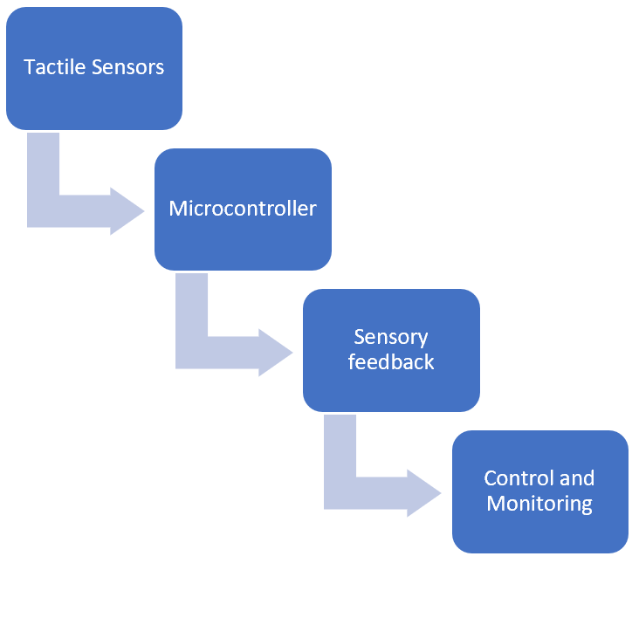
Fig.1. Operation of the prototype of prosthetic limb

Advanced features included in the prosthetic limbs

Tactile and proprioceptive sensors are becoming more common, but fully integrated systems that provide a seamless sensory experience are still under development. These sensors can provide information about the limb's position and movement, improving control and reducing the risk of injury [5]. They include the senses of position and movement of our limbs and trunk, the sense of effort, the sense of force, and the sense of heaviness. Receptors involved in proprioception are located in skin, muscles and joints. Gyroscopes are heading sensors used to determine the robot’s orientation and inclination. They preserve their orientation concerning a fixed reference frame, providing an absolute measure of the robot’s heading [6]. While energy harvesting technologies are being explored, they have not yet become a practical solution for powering prosthetics. Although prosthetic limbs are now more effective, have better tactile characteristics, and weigh less, their allure is lessened by the lengthy charging period [7]. The idea of a prosthetic piezoelectric energy harvester has come to light as a creative way to solve these problems and improve the usability and energy economy of prosthetic devices. With the use of this innovative technology, the prosthetic device will be able to be powered by converting the mechanical energy produced by the user's movements into electrical energy. Piezoelectric elements can be integrated into the prosthetic limb, such as in the joints or the foot. When the limb moves, the piezoelectric material generates electricity, which can be stored in a battery or capacitor using a step-down converter [8].

TABLE 1. GLOBAL MARKET DATA FOR PROSTHETIC LIMBS

Region/Segment | 2024 Market Size (USD) | 2032 Market Size (Projected, USD) | CAGR % | Notable Features
Global Prosthetics Market | $1.76B-$2.05B | $2.74B-$3.07B | 5.1%–5.7% | Growth driven by materials/AI/biomechanics, increased amputation rates
India Prosthetics Market | $56.9M | $86M (by 2033) | 4.7% | Increased accessibility; demand for affordable and advanced technology
Lower Limb Prosthetics | $1.8B | $2.5B | 6.0% | Growth due to diabetes & vascular disease prevalence
Upper Limb Prosthetics | $848.8M | $1.35B+ (by 2032) | 5% | Advancements in sensor/control technology
AI-powered Prosthetics | $833M | $3.05B | 17.6% | Fastest-growing segment, rapid AI/robotics adoption

Operation of the prototype
New prosthetics are made in such a way that it mimics the feel and utilization of a natural human limb. To do this, they usually incorporate a combination of a number of mechanical elements, sensors and control systems. The electrodes are wired over the other muscles surrounding the site of amputation to capture the electrical impulses generated due to the contractions of the muscles [9]. Such signals are examined to determine the movement to be made. With the attachment of tactile sensors to the prosthetic limb, the user will be capable of touching the objects, and manipulate them in a more natural and safer way. Proprioception sensors are considered to enhance control and lessen the danger of injury by providing the information regarding the position and movement of the limb. Users can directly utilize their prosthetics (directly through their thought) in BCIs, which makes the experience more natural and instinctive. Brain-computer interfaces (BCIs) are highly user-friendly and have an interface that can be directly used to make prosthetic limbs directly manipulated through direct brain-reading [10]. The operation of prosthetic limb is shown in fig.2.
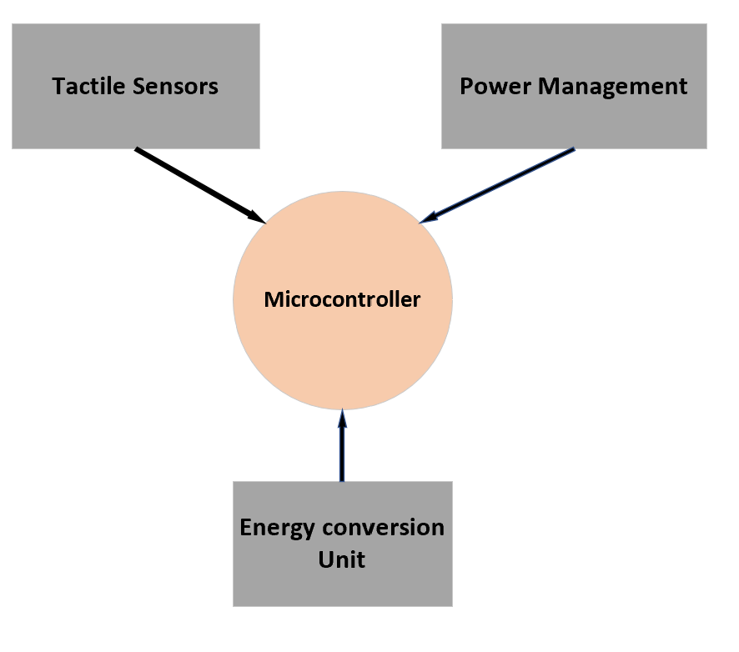
Fig.2. Prosthetic limb module
A sensor information is gathered and then processed by a microcontroller to conclude the intention of the user. Actuators process and regulate the signals that drive the prosthetic limb which can be electric motors or an air cylinder. Mechanical joints and linkages are used to make the artificial limb move in the same manner as a human one. Tactile sensors help the user touch objects in a less strainful way as they provide the user with a sense of touch during an action. Table 1 shows the global market data for prosthetic limbs and Table 2 depicts adoption metrics and technology Integration.

TABLE 2. Adoption Metrics and Technology Integration
Technology/Feature | Current Market Share or Status (2024) | Key Trends/Outcomes
AI & Machine Learning | Non-implantable AI prosthesis: ~85.5% share | AI enables adaptive control, gesture commands, remote monitoring
Myoelectric Control | High adoption in advanced markets | Offers intuitive muscle-based control, increasing functionality
Sensor/Feedback Integration | Growing, especially for tactile/proprioception | 3D-printed sensors, textile coverings, improved life-like motion
Energy Harvesting (Piezo) | Experimental to early practical | Max power ~2.4mW per limb at 0.75Hz; peak density ~22 μW/cm³, 16.9 μW/g

TABLE 3. LIMITING FACTORS AND SOCIAL TRENDS
Challenge/Barrier | Fact/Statistical Data | Implications
Cost | $20k–$100k per advanced device | Major barrier in LMICs; affordable models in demand
Accessibility | AI/robotic prosthetics less available in lower-income regions | Increased need for insurance/NGO interventions
Device Abandonment | 40–45% of users may stop using basic prosthetics | ML, AI, and customized fit enhance adoption & quality of life
Energy Consumption | Traditional: frequent battery changes; Piezo harvesters: small-scale, intermittent power | Hybrid & energy-harvesting tech reduce dependency

Table 3 shows the limiting factors and social trends in adopting prosthetic limbs. Cutting-edge prosthetics are able to continuously modify their control schemes in response to feedback from sensors and user actions [11]. The prosthetic limb incorporates piezoelectric components into its joints and foot, for example. The piezoelectric material in the limb produces energy when it moves, and this electricity can be stored in a battery or capacitor by utilising a step-down converter [12]. The prosthetic's internal components can be powered by the energy gathered, decreasing the requirement for external batteries and boosting the device's autonomy.
IV. Conclusion
Prosthetic limb technology is undergoing a revolution, enabling amputees to experience never-before-seen levels of comfort, functionality, and quality of life. It is anticipated that as research and development proceed, even more cutting-edge and complex prosthetic devices will be created, enabling people who have lost limbs to lead more productive lives. Modern prosthetics are made to mimic the sense of touch and functionality of an actual limb. To accomplish this, the prosthetic limb in this instance combines mechanical parts, sensors, and control systems. Information on muscle activity, touch, and limb position is provided by sensors such as proprioception and tactile sensors. An immersive and more natural experience is offered by tactile and proprioceptive sensors. More organic and intuitive control choices are provided by muscle-based control and brain-computer interfaces. The goal of advanced prosthetics is to increase amputees' quality of life and independence by giving them a more natural, comfortable, and functional experience. Furthermore, it is self-sufficient since piezoelectric sensors are used to generate energy. This paper provides a design that incorporates a number of innovative characteristics and technology.

References

- LeMoyne, Robert. "Advances for prosthetic technology." Tokya, Japan: Springer (2016).
- Rajan, Lintu. "Advanced materials and technologies for touch sensing in prosthetic limbs." IEEE Transactions on NanoBioscience 20.3 (2021): 256-270.
- Wolf, Erik J., et al. "Advanced technologies for intuitive control and sensation of prosthetics." Biomedical engineering letters 10 (2020): 119-128.
- Myers, Harley, et al. "Targeted muscle reinnervation to improve electromyography signals for advanced myoelectric prosthetic limbs: a series of seven patients." ANZ journal of surgery 90.4 (2020): 591-596.
- Johannes, Matthew S., et al. "The modular prosthetic limb." Wearable robotics. Academic Press, 2020. 393-444.
- Yu, Kristin E., et al. "Clinical evaluation of the revolutionizing prosthetics modular prosthetic limb system for upper extremity amputees." Scientific reports 11.1 (2021): 954.
- Beckerle, Philipp, et al. "Prosthetic limbs." Biomechatronics. Elsevier, 2019. 235-278.
- Bansal, Saloni, Birendra Kr Saraswat, and Vijay Kr Sharma. "Analysis of machine learning: enhancing performance and interpretability through deep neural network." Sustainability in Digital Transformation Era: Driving Innovative & Growth. CRC Press 76-80,
- Hobusch, Gerhard M., et al. "Advanced techniques in amputation surgery and prosthetic technology in the lower extremity." EFORT Open Reviews 5.10 (2020): 724-741.
- Yadav, Kanchan, et al. "Digital Dimensions: Unveiling the Potential of E-Design and Virtual Prototyping." E3S Web of Conferences. Vol. 453. EDP Sciences, 2023.
- Ngan, Catherine GY, Rob MI Kapsa, and Peter FM Choong. "Strategies for neural control of prosthetic limbs: from electrode interfacing to 3D printing." Materials 12.12 (2019): 1927.
- Perry, Briana N., et al. "Virtual integration environment as an advanced prosthetic limb training platform." Frontiers in neurology 9 (2018): 785.

