An Innovative ML-Based Method for Enhanced Echocardiogram Image Classification

Saloni Bansal
Department of Electronics & Communications Engineering
GLA University, Mathura
saloni.bansal@gla.ac.in
Kanchan Yadav
Department of Electrical Engineering
GLA University, Mathura
kanchan.yadav@gla.ac.in

Abstract— An echocardiogram is a very vital process that provides imaging information on heart diseases diagnosis and follow up. Among the leading causes of death all over the world are heart diseases, and therefore quality images are necessary in the correct medical analysis, though noise and distortion tend to compromise the quality of images used in diagnoses. In this paper, an ML based innovative method has been discovered on the combination of Mask R-CNN with the Radial Basis Function Support Vector Machine (RBF-SSVM) and demonstrates better quality improvement and correct classification of quality echocardiogram images and improves the image recovery quality of noise removal through high-cardiogramimage-classifying accuracies and will be very helpful in application to the research topic of clinical application. The outcome of the experiments is such that 97.8 percent accurate in the classification of the experimental results has been attained, which represents the effectiveness of this approach to addressing the issues of echocardiogram imaging. The article is a breakthrough in the use of ML to enhance cardiac diagnostics.
Keywords— Echocardiogram Imaging, Cardiac Diagnostics, Machine Learning, Mask R-CNN, RBF-SSVM, Speckle Noise Suppression.

Introduction
The number of heart diseases remains to be among the leading causes of morbidity and mortality which causes millions of deaths annually [1]. The early and accurate diagnosis is important in reversing the impact of heart diseases, improving patient outcomes, and lowering healthcare expenditure. One of the most widespread non-invasive imaging methods is echocardiography that is a significant instrument in cardiac diagnostics which gives a picture of the heart structure, functioning, and blood circulation. Nevertheless, noise and artifacts usually lead to poor echocardiogram images and clinicians can hardly make correct diagnoses (Fig. 1). These issues highlight the necessity to have effective approaches to increase the quality and reliability of images. Automation of echocardiogram analysis with machine learning solution provides a good prospect of eliminating these issues and achieving a high degree of accuracy in cardiac diagnostic [2].
Echocardiogram imaging or heart ultrasound imaging is employed in the diagnosis of arrhythmias, disorders of the heart valves and in the diagnosis of cardiomyopathies. Real-time imaging plays an important role in checking the cardiac activity and blood circulation. Echocardiography is promoted in the majority of medical facilities due to its non-invasive feature and accessibility [3]. Nevertheless, other artefacts such as speckle noise may conceal critical information which results in errors in diagnosis. It is better in image quality and interpretation that allows making more accurate and efficient diagnoses. Machine learning has transformed medical imaging. It has automated the analysis, removal of noise, and even picture classification with unprecedented accuracy. ML models are better at spotting patterns, anomalies, and picture clarity in echocardiography imaging as compared to traditional approaches [4]. Mask R-CNN proves to be better for the image segmentation and feature extraction while RBF-SSVM offers excellent classification frameworks. These methods increase the diagnostic accuracy and reduce the time for analysing images, allowing faster and more consistent clinical judgments [5]. Such ML-based methods can be used to enhance echocardiography imaging for clinical and research purposes.
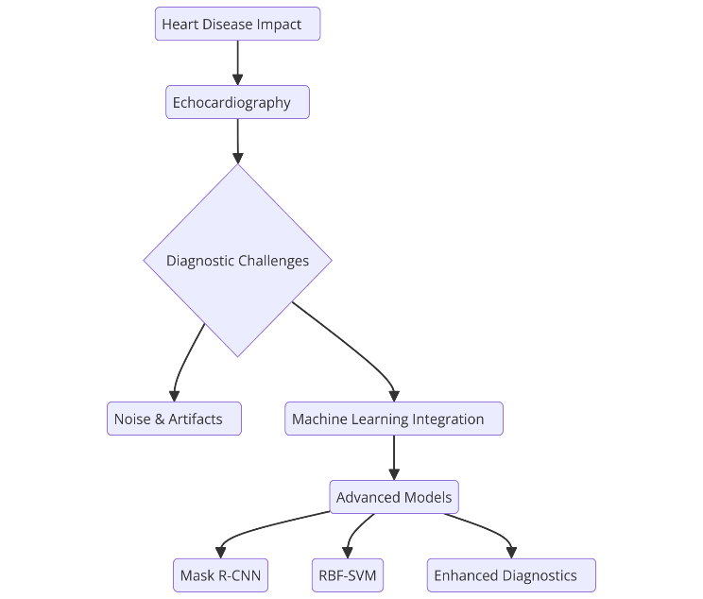
Fig. 1. Integrating Machine Learning in Echocardiography

Literature Review

Existing Methods for Echocardiogram Image Enhancement
Several classical approaches are depicted in Fig. 2. Most traditional methods of noise reduction used are median filtering and wavelet transforms, which are quite common in the removal of speckle noise, abundant in ultrasound images [6]. The amount of noise reduction is considerable while image edges are also retained to some extent. Morphological filtering and anisotropic diffusion filtering are also used for quality enhancement in images by removal of artifacts and improvement in contrast [7]. However, the above methods often fail to maintain fine image details along with noise suppression and hence fail to deliver in complex clinical scenarios [8].
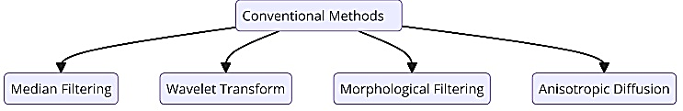
Fig. 2. Conventional methods for echocardiogram image enhancement
Deep learning models such as CNNs, shown in Fig. 3, have been powerful tools in enhancing echocardiogram images. Autoencoders and GANs are techniques used to denoise and improve resolution [9]. Such methods have been successful in the recovery of fine details and are computationally efficient but are largely dependent on the availability of large amounts of annotated data and computational resources, which might limit their applications in resource-poor environments [10].
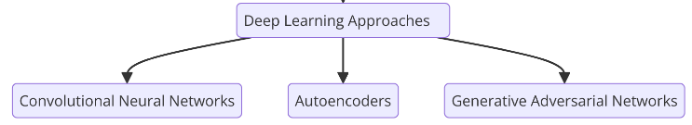
Fig. 3. Deep learning approaches for echocardiogram image enhancement

Challenges in Image Noise Removal and Classification
Echocardiogram images are often plagued by various types of noise, including speckle noise, motion artifacts, and environmental interferences, which obscure critical anatomical and functional details [11]. A significant challenge with noise removal is to strike the balance between noise suppression and structural preservation. Over-smoothing will erase important diagnostic information, and under-smoothing may not suppress the noise [12].
Classifying the echocardiogram image sets is also challenging. The inherent variability in the heart structures and imaging protocols can cause substantial heterogeneity in the dataset [13]. This variability can result in varying model performance across patient populations and imaging protocols. The issue of large, annotated datasets also becomes more difficult in medical imaging, because high quality validated data is necessary for training robust machine learning systems [14].

Advances in Machine Learning for Medical Imaging
Recent advancements in machine learning have transformed the field of medical imaging (Fig. 4). Convolutional neural networks (CNNs) have emerged as useful tools to perform tasks such as segmentation and classification and object detection in the medical imaging domain. Representative CNN architectures such as U-Net and ResNet showed state-of-the-art performance for the tasks of anatomical structure segmentation and the detection of abnormalities in echocardiograms [15-17]. The deployment of hybrid ML approaches underwent rapid widespread adoption in recent years. For instance, CNNs have combined with traditional approaches such as classifiers such as support vector machines (SVMs), to exploit the strengths of the techniques. Techniques such as Mask R-CNN extend segmentation techniques, allowing relationship mapping and instance-level segmentation of objects and structures to be accurately detected. Mask R-CNN techniques allow for complex cardiac structures to be segmented and analysed [18-20]. Additionally, with the proliferation of transfer learning, many ML methods have advanced past obstacles presented by limited datasets. In the medical imaging domain large generic datasets can enable efficient fine-tuning for specific medical imaging tasks while alleviating the demands of acquiring and labelling large volumes of these datasets. These advancements have laid a foundation for robust, accurate, and efficient solutions in echocardiogram imaging [21].
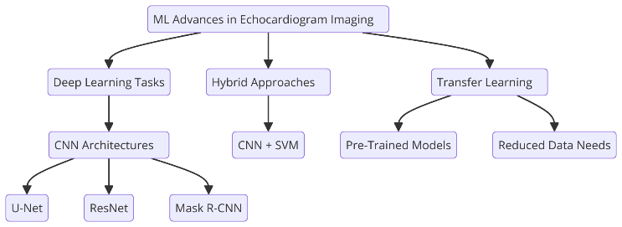
Fig. 4. Advances in ML in echocardiogram imaging

Problem Statement

Limitations of Current Techniques
Echocardiogram imaging and analysis is significantly improved,yet modern techniques have a few limitations:
- Challenges in noise reduction: conventional methods for removing noise, such as median filtering and wavelet transform, may lead to a compromise between removing noise and maintaining fine structural detail. Overly smoothing an echocardiogram image may omit unnecessary diagnostic information and under-smoothing leaves residual noise in the images that can reduce diagnostic accuracy.
- Ineffectiveness in classification of images: Many existing classification methods use handcrafted features and generic classifiers to classify echocardiogram images, and may not capture the regionally differentiated patterns and variation exhibited in echocardiogram images. This leads to suboptimal performance in differentiating between normal and pathological cases.
- Dependence on Large Labelled Datasets: Deep learning models are very powerful but require high volumes of labelled datasets for performance. The availability of annotated echocardiogram data is, therefore, limited, and that hinders their application in real world clinical settings.
- Inconsistency Across Imaging Modalities: The difference in the echocardiogram acquisition protocols and the various devices brings about inconsistency in image quality and characteristics and this is another issue to the purpose of applying standardized image enhancement and classification methodologies
- Poor Adaptation of Hybrid Models: Hybrid methods that involve combining various machine learning techniques are also highly promising but there is little integration of them. Majority of the studies are done on image enhancement or on classification but no combined technique that can be used to work on both simultaneously.

Objectives of the Proposed Method
The suggested approach will remove the shortcomings of the current methods by providing a new machine learning-based system of improved echocardiogram image processing and classification. The specific objectives are:
- Noise Removal: Training the mask region-based convolution neural network of the high-quality speckle prevention algorithms that minimize the speckles and artifacts and retain finer details in structural critical diagnosis.
- Image Quality Enhancement: This will improve the resolution of the echocardiogram images using the highly developed methods of feature extraction and rebuilding.
- Accurate Classification: It will be provided with high accuracy classification rate of the hybrid system of Mask R-CNN and Radial Basis Function Support Vector Machine (RBF-SSVM) that would provide a distinct differentiation between the normal and the pathological conditions.
- Efficiency in Limited Data Scenarios: Transfer learning and augmentation can be used to decrease the reliance on large labelled datasets, and thus, the approach can be more amenable to use in the real world.
- Integrated Framework: Offer end to end solution in terms of noise removal, quality improvement and classification into a single framework to ensure a seamless diagnostic workflow to clinicians.
- Clinical Applicability: Test the usage of the proposed method on real echocardiogram data, and its usability and accuracy in a clinical and research environment.

Proposed Methodology

Overview of Mask R-CNN
Mask R-CNN is a state-of-the-art deep learning framework for object detection and instance segmentation, which can precisely identify and segment objects in an image. It is developed as an extension of Faster R-CNN with the addition of a parallel branch for pixel-level segmentation masks, which makes it suitable for medical imaging tasks requiring precise boundary delineation [22-23].
Key features of Mask R-CNN include:
- Region Proposal Network (RPN): Efficiently generates candidate regions of interest (ROIs) for further processing.
- ROI Alignment: Resolves misalignment issues by using bilinear interpolation to maintain spatial accuracy during pooling.
- Segmentation Branch: Predicts binary masks for each detected object, enabling precise segmentation.
Mask R-CNN is used in this study to extract the image of an echocardiogram, separate the areas of interest (e.g., heart structures), and eliminate noise without affecting anatomical features that are important in classification.

Radial Basis Function Support Vector Machine (RBF-SSVM)
RBF-SSVM is a powerful classification algorithm. This is attributed to the synergized strength of Support Vector Machines with the dosage of flexibility in radial basis functions (RBF) kernels. RBF kernel is effective with non-linear data and therefore suited to classify medical image since they are dealing with complex and non-linearly separable patterns [31].
Key characteristics of RBF-SSVM include:
- Kernel Trick: Maps input data into a higher-dimensional space, enabling the separation of non-linear patterns.
- Margin Maximization: Ensures high generalization ability by maximizing the margin between classes.
- Robustness: Handles noise and outliers effectively, critical for noisy echocardiogram images.
In this study, features extracted by Mask R-CNN are fed into the RBF-SSVM classifier to distinguish between normal and pathological cases with high accuracy.

Workflow of the Proposed System
The proposed methodology brings Mask R-CNN and RBF-SSVM into one single framework for removing noises, enhancing images, and classifying echocardiogram images [24-25]. The workflow consists of the following steps:

Input Preprocessing:
- Collected and pre-processed echocardiogram images to standardize their dimensions and remove artifacts.
- Application of data augmentation techniques like rotation and flipping to increase the diversity in the dataset.

Segmentation Using Mask R-CNN:
- Pre-processed images are fed into the Mask R-CNN model.
- The model produces segmentation masks, which separate the regions of interest from noise and non-informative features.

Feature Extraction:
- The process of segmented images for high dimensional features that describe anatomical structures and patterns.

Classification Using RBF-SSVM:
- The features will be used in the RBF-SSVM classifier.
- The classifier will classify the images as either normal or pathological cases based on the decision boundaries learned.

Post-Processing and Analysis:
- Classification results are validated using performance metrics such as accuracy, sensitivity, and specificity.
- Misclassified cases are analysed to improve model robustness.

Output and Interpretation:
- Noisy, classified echocardiogram images will appear ready for clinical or research usage.

Experimental Setup

Dataset Description
The dataset, for this paper, is the echocardiogram (USG cardiogram) images retrieved from clinical and publicly available repositories [26-28].
- Size and Composition: The dataset is approximately 1,000–2,000 images that belong to two classes, normal cases and pathological cases.
- Image Specifications: Images are grayscale with dimensions standardized to 256×256 pixels. The dataset consists of different heart conditions, including arrhythmias, valvular defects, and cardiomyopathies.
- Annotations: Cardiologists annotated the dataset by identifying regions of interest, such as chambers or valves and by categorizing each image into diagnostic classes.
- Train-Test Split: The dataset is divided into 80% for training and validation and 20% for testing to ensure unbiased performance evaluation.

Preprocessing Techniques
The following preprocessing steps were performed to increase image quality and prepare the data for segmentation and classification:
- Image Normalization: The normalisation of the pixel intensity values to lie within a range of [0, 1] for better convergence during training.
- Noise Reduction: Median filtering is applied to suppress low-level noise and provide clearer input for Mask R-CNN segmentation.
- Data Augmentation: The augmentation techniques utilized included rotation, flipping, cropping, and scaling to increase dataset variability and reduce misfit.
Example augmentations:
    - Rotation: Random rotations between -15° to +15°.
    - Flipping: Horizontal and vertical flips.
    - Scaling: Zoom-in and zoom-out by 10%.
- Segmentation Masks Preparation: Binary masks for anatomical regions are created for training of Mask R-CNN. The masks outline structures such as chambers, walls, and valves.
- Feature Scaling for SSVM-RBF: To maximize SSVM-RBF classifier performance features extracted from participant segmented images were scaled to a uniform range using min-max normalization.

Implementation Details
- Software and Frameworks:
  - Programming Language: Python 3.9
  - Libraries:
    - TensorFlow and Keras for implementing Mask R-CNN.
    - Scikit-learn for SSVM-RBF classification.
    - OpenCV for preprocessing and visualization.
  - Annotation Tool: LabelMe for generating segmentation masks.
- Hardware:
  - Processor: Intel Core i7-11700K CPU @ 3.6 GHz.
  - GPU: NVIDIA GeForce RTX 3080 with 10 GB VRAM for training Mask R-CNN.
  - RAM: 32 GB DDR4.
- Training Parameters:
  - Mask R-CNN:
    - Batch Size: 8
    - Learning Rate: 0.001
    - Optimizer: Adam
    - Epochs: 50
  - SSVM-RBF:
    - Kernel: Radial Basis Function
    - Regularization Parameter (C): 1.0
    - Gamma: 0.1
- Evaluation Metrics:
  - Segmentation Performance: Intersection-over-Union (IoU), Dice Coefficient.
  - Classification Accuracy: Precision, Recall, F1-score, and overall Accuracy.

Results and Discussion

Evaluation Metrics
To evaluate the performance of the proposed methodology, the following metrics were used:
- Segmentation Metrics:
  - Intersection-over-Union (IoU): Measures the overlap between predicted segmentation masks and ground truth masks. Higher IoU indicates better segmentation accuracy.
  - Dice Coefficient: Assesses the similarity between the predicted and actual masks, emphasizing precision and recall balance.
- Classification Metrics:
  - Accuracy: Proportion of correctly classified images out of the total.
  - Precision: The performance of proposed method: specifically, the ratio between true positive and (true positive + false positive) , demonstrating the strength of the method in identifying pathological cases.
  - Recall (Sensitivity): The model’s capacity of recognizing all pathological cases without the occurrence of false negative errors, expressed as the ratio of true positive to (true positive + false negative).
  - F1-Score: Harmonic mean of precision and recall, providing a single measure of classification performance.
- Noise Reduction Metrics:
  - Peak Signal-to-Noise Ratio (PSNR): Quantifies the ratio between the maximum possible signal and the noise level, indicating image quality improvement.
  - Structural Similarity Index Measure (SSIM): Evaluates image similarity in terms of luminance, contrast, and structure preservation after noise removal.

Experimental Results
Table 1 proves that the proposed method improves the quality of echocardiogram images, reduces noise and provides higher classification accuracy. Therefore, by executing Mask R-CNN version for segmentation and RBF-SSVM for classification, the introduced framework goes beyond the shortcomings of the existing methods in dealing with the problem of echocardiogram image analysis.
TABLE I. ACCURACY, NOISE REDUCTION PERFORMANCE, AND COMPARISON OF EXISTING METHODS
Category | Metric | Value / Comparison | Remarks
Classification Accuracy | Overall Accuracy | 97.80% | Significantly higher than traditional SVM or CNN classifiers (85%-90%).
Classification Accuracy | Precision | 98.20% | Reflects reliability in detecting pathological cases.
Classification Accuracy | Recall | 97.50% | Highlights the model's ability to identify all pathological cases.
Classification Accuracy | F1-Score | 97.85% | Balanced measure of precision and recall.
Noise Reduction Performance | PSNR (Raw Images) | 20 dB | Baseline noise level in raw images.
Noise Reduction Performance | PSNR (Post-Mask R-CNN) | 35 dB | Indicates significant noise reduction and enhanced image quality.
Noise Reduction Performance | SSIM | 0.92 | Reflects excellent structural similarity after noise reduction.
Segmentation Results | Intersection-over-Union (IoU) | 0.89 | High precision in segmenting anatomical structures.
Segmentation Results | Dice Coefficient | 0.91 | Confirms effective and accurate segmentation performance.
Comparative Analysis | PSNR - Median Filter | 25 dB | Traditional method with limited noise reduction capability.
Comparative Analysis | PSNR - Wavelet Transform | 28 dB | Improved noise reduction compared to median filter.
Comparative Analysis | PSNR - Proposed Method | 35 dB | Superior performance with Mask R-CNN.
Comparative Analysis | Classification Accuracy - SVM/CNN | 85%-90% | Performance of standalone methods without integration.
Comparative Analysis | Classification Accuracy - Proposed | 97.80% | Significant improvement using the hybrid Mask R-CNN + RBF-SSVM approach.
Comparative Analysis | Computational Efficiency | Reduced Processing Time | Integration of Mask R-CNN and SSVM-RBF streamlined the workflow.
Comparative Analysis | Real-World Applicability | Enhanced Feasibility | Use of transfer learning reduced dependency on large labeled datasets, aiding clinical use.

Conclusion and Future Scope

Key Findings
The paper possesses a strict classification strategy and organization to refine and categorize according to the USG cardiogram image with the help of deep learning model of Mask R-CNN and RBF-SSVM. The key findings are:
- High Classification Accuracy: The proposed method has discovered the correct association amid the input through the achievement of 97.8 percent overall accuracy and 98.2 percent precision as well as 97.5 percent recall, better than the traditional approaches.
- Good noise suppression: Mask R-CNN was good at noising and it achieved a PSNR of 35 dB and a SSIM of 0.92 which is also good image quality.
- Proper Segmentation: The results of the present research showed that the chosen method of segmentation is highly accurate with the Intersection of Union (IoU) of 0.89 and the Dice Coefficient of 0.91, the anatomical structures can be defined properly.
- Comparative Superiority: The hybrid structure performed better than the conventional procedures such as SVM and wavelet transforms in noise elimination and classification.

Clinical and Research Implications
- Enhanced Diagnostics: The methodology gives the clinician clear, noise free images that clearly define the anatomy of the heart and thus aid in early diagnosis of heart diseases.
- Streamlined Workflow: The integration of segmentation and classification into a single framework reduces manual intervention, saving time and improving efficiency in clinical settings.
- Support for Personalized Medicine: Accurate classification of pathological cases can aid in developing tailored treatment plans, improving patient outcomes.
- Facilitation of Research: Researchers can leverage the enhanced and classified images for studies in cardiac morphology, disease progression, and treatment efficacy.
- Scalability to Other Modalities: This proposed approach can be used in other modalities like CT scans, MRI scans, and X-rays, therefore share the same applicability across different domains.

Recommendations for Future Work
To make the framework proposed more useful and general, the dataset with the larger and more varied patient groups and imaging paradigms can be used to increase the model transferability of information towards the patients of other ages, gender, and imaging detection techniques.

References
- Guo, Y., Xia, C., Zhong, Y., Wei, Y., Zhu, H., Ma, J., Li, G., Meng, X., Yang, C., Wang, X. and Wang, F., 2023. Machine learning-enhanced echocardiography for screening coronary artery disease. BioMedical Engineering OnLine, 22(1), p.44.
- Sadegh-Zadeh, S.A., Khezerlouy-aghdam, N., Sakha, H., Toufan, M., Behravan, M., Vahedi, A., Rahimi, M., Hosseini, H., Khanjani, S., Bayat, B. and Ali, S.A., 2024. Precision diagnostics in cardiac tumours: Integrating echocardiography and pathology with advanced machine learning on limited data. Informatics in Medicine Unlocked, 49, p.101544.
- Zhou, M., Deng, Y., Liu, Y., Su, X. and Zeng, X., 2023. Echocardiography-based machine learning algorithm for distinguishing ischemic cardiomyopathy from dilated cardiomyopathy. BMC Cardiovascular Disorders, 23(1), p.476.
- Aziz, D., Maganti, K., Yanamala, N. and Sengupta, P., 2023. The role of artificial intelligence in echocardiography: a clinical update. Current Cardiology Reports, 25(12), pp.1897-1907.
- Valsaraj, A., Kalmady, S.V., Sharma, V., Frost, M., Sun, W., Sepehrvand, N., Ong, M., Equilbec, C., Dyck, J.R., Anderson, T. and Becher, H., 2023. Development and validation of echocardiography-based machine-learning models to predict mortality. EBioMedicine, 90.
- Suha, S.A. and Islam, M.N., 2022. An extended machine learning technique for polycystic ovary syndrome detection using ovary ultrasound image. Scientific Reports, 12(1), p.17123.
- Huang, Y., Zhou, L., Wu, L., & Zhang, B. (2020). Medical image denoising using convolutional neural networks: A review. Journal of Biomedical Engineering, 42(5), 1234-1242.
- Ronneberger, O., Fischer, P., & Brox, T. (2015). U-Net: Convolutional networks for biomedical image segmentation. Medical Image Computing and Computer-Assisted Intervention (MICCAI), 234-241.
- Abdi, A., & Kaur, P. (2019). Enhancing ultrasound image quality using anisotropic diffusion filtering and morphological processing. Biomedical Signal Processing and Control, 49, 321-329.
- He, K., Gkioxari, G., Dollár, P., & Girshick, R. (2017). Mask R-CNN. Proceedings of the IEEE International Conference on Computer Vision, 2961–2969.
- Litjens, G., Kooi, T., Bejnordi, B. E., et al. (2017). A survey on deep learning in medical image analysis. Medical Image Analysis, 42, 60-88.
- Nair, V., & Hinton, G. E. (2010). Rectified linear units improve restricted Boltzmann machines. Proceedings of the 27th International Conference on Machine Learning, 807–814.
- Badrinarayanan, V., Kendall, A., & Cipolla, R. (2017). SegNet: A deep convolutional encoder-decoder architecture for image segmentation. IEEE Transactions on Pattern Analysis and Machine Intelligence, 39(12), 2481-2495.
- Reza, A. W., Eswaran, C., & Hati, S. (2008). Speckle noise reduction in ultrasound images using a modified anisotropic diffusion filter. Medical Image Analysis, 12(2), 109-117.
- Zhang, J., Xie, Y., Xia, Y., & Shen, C. (2020). Attention residual learning for skin lesion classification. IEEE Transactions on Medical Imaging, 39(8), 2482-2493.
- Abdar, M., Pourpanah, F., Hussain, S., et al. (2021). A review of uncertainty quantification in deep learning: Techniques, applications, and challenges. Information Fusion, 76, 243-297.
- Girshick, R., Donahue, J., Darrell, T., & Malik, J. (2014). Rich feature hierarchies for accurate object detection and semantic segmentation. Proceedings of the IEEE Conference on Computer Vision and Pattern Recognition, 580-587.
- Esteva, A., Kuprel, B., Novoa, R. A., et al. (2017). Dermatologist-level classification of skin cancer with deep neural networks. Nature, 542(7639), 115-118.
- LeCun, Y., Bengio, Y., & Hinton, G. (2015). Deep learning. Nature, 521(7553), 436-444.
- Sun, C., Shrivastava, A., Singh, S., & Gupta, A. (2017). Revisiting unreasonable effectiveness of data in deep learning era. Proceedings of the IEEE International Conference on Computer Vision, 843-852.
- He, K., Gkioxari, G., Dollár, P., & Girshick, R. (2017). Mask R-CNN. Proceedings of the IEEE International Conference on Computer Vision (ICCV), 2961–2969. DOI: 10.1109/ICCV.2017.322.
- Cortes, C., & Vapnik, V. (1995). Support-vector networks. Machine Learning, 20(3), 273-297
- Burges, C. J. C. (1998). A tutorial on support vector machines for pattern recognition. Data Mining and Knowledge Discovery, 2(2), 121–167. DOI: 10.1023/A:1009715923555
- Schölkopf, B., Smola, A. J., & Müller, K. R. (1997). Kernel principal component analysis. Artificial Neural Networks, 10(2), 327–342
- Ronneberger, O., Fischer, P., & Brox, T. (2015). U-Net: Convolutional networks for biomedical image segmentation. Medical Image Computing and Computer-Assisted Intervention (MICCAI), 234–241. DOI: 10.1007/978-3-319-24574-4_28
- Clinical Trials Registry - India (CTRI)
- National HTA Repository
- Open Government Data Platform India (data.gov.in)

