Intelligent Academic Integrity System Using TF-IDF, Cosine Similarity, and Stylometric Profiling

1st mallikka
Computer science and engineering
SRM Institute of Science and Technology
Trichy,Tamilnadu
mallikkr@srmist.edu.in
2nd Vettrivel V
Computer science and engineering
SRM Institute of Science and Technology
Trichy,Tamilnadu
velvettri913@gmail.com
3rd Diwakar N
Computer science and engineering
SRM Institute of Science and Technology
Orcid ID: 0000-0001-5795-9448
4thPranav MS
Computer science and engineering
SRM Institute of Science and Technology
Trichy,Tamilnadu
mp4366@srmist.edu.in

Abstract— Academic dishonesty threatens educational integrity across institutions worldwide. This paper presents a comprehensive Flask-based system that leverages machine learning and natural language processing techniques to detect plagiarism automatically. The system employs TF-IDF vectorization combined with cosine similarity metrics to identify copied content effectively. It incorporates stylometric profiling to detect impersonation and authorship inconsistencies. We integrated OCR.SPACE API to process handwritten submissions, enabling the system to analyze both digital typed documents and scanned handwritten scripts. SQLite database manages user authentication, stores detection results, and maintains case history efficiently. The intuitive web interface allows administrators and faculty to view comprehensive analytics, track investigation cases, and generate detailed reports. Our experimental evaluation demonstrates that the system significantly improves detection accuracy while substantially reducing the manual workload that teachers traditionally bear when checking papers. The system efficiently handles batch processing of multiple submissions simultaneously and generates clear, evidence-based reports with specific flagged sections. This makes it particularly useful for educational institutions seeking to maintain rigorous academic integrity standards without overwhelming their teaching staff with time-consuming manual verification processes.
Keywords— Academic Dishonesty Detection, Plagiarism Detection, Stylometric Analysis, Natural Language Processing (NLP), Machine Learning, Text Similarity, TF-IDF Vectorization, Cosine Similarity, Cheating Detection System, Automated Evaluation, Educational Technology, Flask Web Application, SQLite Database, Student Assessment Integrity, Malpractice Detection

Introduction
Academic integrity forms the fundamental cornerstone of quality education worldwide. When students engage in dishonest practices, it completely undermines the educational purpose and devalues legitimate achievements. Traditional methods of detecting cheaters rely almost entirely on teachers manually reviewing papers, which consumes enormous amounts of valuable time. Teachers often miss sophisticated cheating techniques because they cannot realistically compare every student's work against everything else submitted or available online. The problem has intensified dramatically with the widespread adoption of online learning platforms. Students can now easily share answers through digital channels, copy content from countless websites, or use AI tools to generate essays. Essay mills and contract cheating services have made academic dishonesty disturbingly accessible.
Manual detection approaches suffer from several critical flaws that compromise their effectiveness. A teacher managing hundreds of students cannot possibly check every paper thoroughly for plagiarism or collusion. Even highly experienced instructors miss problematic submissions when they're fatigued, rushed, or managing heavy workloads. Different teachers inevitably apply inconsistent standards, which creates unfairness across student populations. Some sophisticated forms of cheating, particularly paraphrasing or having external parties write papers, prove nearly impossible to catch without computational assistance. The COVID pandemic forced rapid transitions to remote learning, exposing severe vulnerabilities in traditional integrity monitoring that relied on physical proctoring.
We built this comprehensive system specifically to address these mounting challenges effectively. It automates the initial screening process using advanced machine learning algorithms and natural language processing techniques. The system checks for copied text using TF-IDF vectorization and cosine similarity, which compare documents mathematically rather than simply looking for exact string matches. We included sophisticated stylometric analysis that examines individual writing style characteristics to help identify cases where someone other than the enrolled student authored the submission. The system processes handwritten scripts through OCR.SPACE API integration, making it applicable to traditional paper-based assessments that are scanned and uploaded digitally.
Our integrated approach offers several distinct advantages over traditional methods and existing tools. First, it handles efficient batch processing, allowing teachers to upload entire classes' papers simultaneously for comprehensive analysis. Second, the stylometric profiling component catches authorship inconsistencies and impersonation that simple text matching completely misses. Third, the user-friendly web interface makes all functionality accessible to faculty without requiring any technical expertise or programming knowledge. Fourth, the system maintains detailed, auditable records of all detection cases and investigations. Finally, schools can integrate it with their existing learning management systems since we built it using standard, widely-supported technologies. The system doesn't replace human judgment but significantly enhances teachers' capabilities by helping them focus their limited time on cases that genuinely require expert human evaluation and contextual understanding.
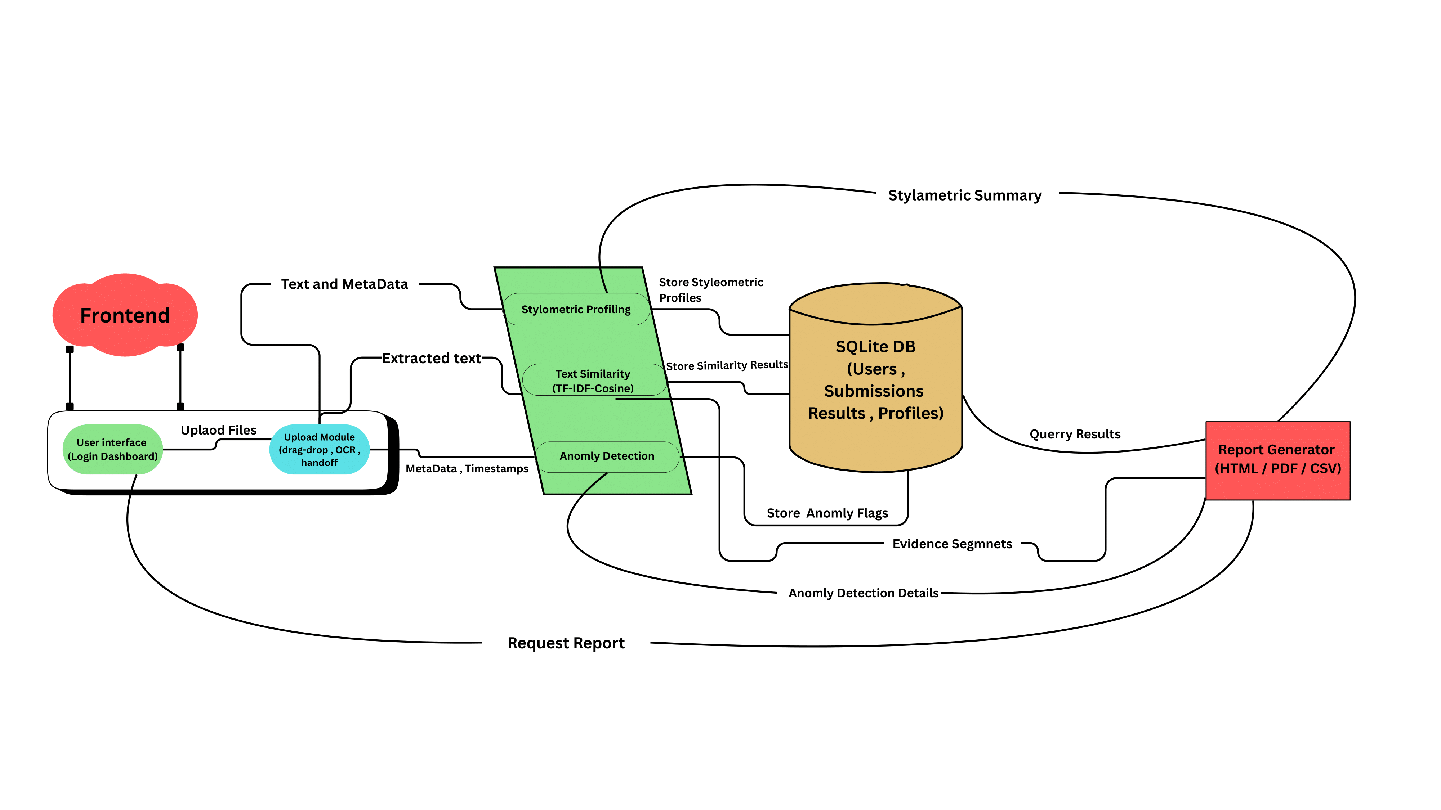
figure 1 : system overview diagram

Background

Academic Dishonesty: Types and Prevalence
Identify applicable funding agency here. If none, delete this text box.
Academic dishonesty manifests in numerous forms that undermine educational assessment validity. Plagiarism represents the most commonly recognized form, where students present others' work, ideas, or words as their own original creation without proper attribution or acknowledgment. Direct plagiarism involves verbatim copying of text from sources. Paraphrased plagiarism occurs when students reword content just enough to avoid exact matching while maintaining the original ideas and structure. Mosaic plagiarism involves stitching together sentences and phrases from multiple different sources without citation. Self-plagiarism happens when students resubmit their own previous work for different assignments without permission. These various plagiarism forms have proliferated with easy internet access to countless information sources and sophisticated AI writing tools that can generate or paraphrase content automatically.
Collusion represents another significant integrity concern where students inappropriately collaborate on assignments explicitly designated as individual work requiring independent completion. This includes sharing answers directly, jointly writing papers that both students submit separately with minor modifications, or providing unauthorized assistance during examinations when independent work is required. Contract cheating has emerged as an increasingly serious problem where students outsource their assignments entirely to third parties through commercial essay mills, freelance academic writing services, or personal connections who complete work on their behalf. Impersonation occurs when someone other than the legitimately enrolled student takes examinations, submits assignments, or participates in assessments pretending to be that student through identity fraud or proxy arrangements.
Research studies consistently document alarming prevalence rates of academic dishonesty across educational institutions globally. Empirical surveys and investigations reveal concerning patterns where substantial proportions of students admit to engaging in some form of academic misconduct during their educational careers. The anonymity and accessibility of online environments have substantially exacerbated these integrity challenges. Digital platforms facilitate instantaneous content sharing, provide unlimited access to essay mills and contract cheating marketplaces, and enable remote unauthorized assistance during supposedly proctored online examinations. The COVID pandemic's forced transition to emergency remote learning exposed critical vulnerabilities in traditional integrity monitoring systems that depended heavily on physical supervision and controlled testing environments.

Academic Dishonesty: Types and Prevalence
Conventional approaches to detecting academic dishonesty rely predominantly on manual examination by experienced faculty members who leverage their professional judgment and familiarity with student capabilities. Teachers typically identify suspicious submissions through subjective assessments of sudden writing quality improvements that seem inconsistent with previous work. They notice when submitted content demonstrates knowledge or sophistication beyond a student's apparent capability level based on class participation and prior assignments. Instructors recognize stylistic deviations when writing suddenly shifts from informal to highly formal academic voice without gradual progression. Some experienced teachers develop strong intuition for detecting problems through years of reading student work and recognizing patterns that suggest external sources or assistance.
This traditional manual approach suffers from several critical limitations that severely compromise its effectiveness and fairness. Scale presents the most fundamental challenge because teachers cannot realistically perform comprehensive plagiarism checks when managing hundreds of student submissions with tight grading deadlines. Manual review becomes practically impossible in massive open online courses or institutions with extremely high student-to-faculty ratios where individual instructors have limited familiarity with each student's typical performance patterns. Detection effectiveness varies dramatically based on instructor experience levels, current workload pressures, time available for detailed examination, and depth of familiarity with individual students' writing styles and previous academic performance history.
Consistency issues create significant fairness concerns across different classes and instructors. Teachers with varying experience levels and different workload pressures inevitably apply inconsistent detection standards and scrutiny levels. Even individual teachers may catch plagiarism in some papers while missing identical problems in others due to fatigue, time constraints, or random attention variations. Cross-referencing submissions to identify collusion proves practically impossible manually. With hundreds of papers, comparing each against every other paper would require thousands of individual comparisons that no human could reasonably complete within available timeframes. Personal biases, whether conscious or unconscious, can affect judgment regarding which students receive extra scrutiny based on demographics, previous performance, or perceived credibility rather than objective evidence alone.

Evolution of Automated Detection Technologies
Recognition of manual methods' fundamental inadequacies has driven sustained development of computational detection tools over multiple decades. Early plagiarism detection systems employed basic string-matching algorithms that compared submitted documents against databases containing known sources including academic journals, websites, previously submitted student papers, and published books. These primitive systems utilized simple lexical comparison techniques, identifying exact phrase matches and calculating overall text overlap percentages between documents. While somewhat effective for catching students who directly copied and pasted text verbatim without any modification, these tools failed comprehensively to identify paraphrased content, structural reorganization, synonym substitution, or any sophisticated evasion techniques that students quickly learned to employ once they became aware of detection methods being used.
Second-generation detection tools incorporated more sophisticated natural language processing capabilities that enabled semantic analysis beyond surface-level text matching. These systems could understand meaning and conceptual relationships rather than merely comparing character strings. They implemented techniques including part-of-speech tagging to understand grammatical structure, syntactic parsing to analyze sentence construction patterns, and semantic similarity measures that could identify paraphrased content maintaining similar meaning despite completely different wording. The integration of latent semantic analysis and vector space models allowed meaningful comparison of documents based on underlying semantic content and conceptual relationships rather than purely lexical overlap of identical words and phrases.
Third-generation systems integrated machine learning techniques that enabled adaptive detection models capable of learning from extensive labeled training datasets. These systems employed supervised learning algorithms trained on carefully curated datasets containing both authentic student work and various forms of plagiarized content. Algorithms learned to distinguish characteristics and patterns that differentiate legitimate original work from academic dishonesty across multiple dimensions. Support vector machines, random forest ensembles, and neural network architectures enabled sophisticated classification of submissions based on numerous extracted features including stylistic consistency markers, vocabulary complexity measures, structural organization patterns, and semantic coherence indicators that humans might miss.
Current fourth-generation systems leverage cutting-edge deep learning architectures and large language models to enable highly sophisticated analysis of writing style, semantic content depth, and authorship attribution with near-human comprehension levels. These advanced systems can effectively detect AI-generated content from tools like ChatGPT, identify subtle paraphrasing that preserves semantic meaning through transformation, recognize stylometric inconsistencies suggesting multiple authors or external assistance, and flag anomalous patterns in vocabulary sophistication, writing complexity, or technical proficiency that deviate from student's established baseline capabilities. Transformer-based models using contextual embeddings provide nuanced understanding of language context and usage patterns that approaches human-level semantic comprehension, enabling detection of increasingly sophisticated malpractice techniques that earlier generations of tools completely missed.

Evolution of Automated Detection Technologies
Contemporary academic environments require sophisticated detection systems that simultaneously address multiple distinct dimensions of academic dishonesty rather than focusing narrowly on single aspects. Effective comprehensive systems must detect inter-document plagiarism through systematic cross-submission analysis comparing all student papers against each other to identify collusion patterns and content sharing. They must identify external plagiarism by comparing submissions against extensive databases of published sources, websites, and academic repositories. Systems need to recognize authorship inconsistencies through detailed stylometric analysis that reveals when writing style, vocabulary usage, or complexity levels deviate significantly from a student's established patterns, suggesting impersonation or contract cheating where external parties produced the work.
Processing efficiency at institutional scale represents a critical practical requirement since systems must handle hundreds or thousands of submissions within reasonable timeframes during concentrated assessment periods when teachers need results quickly for grading. Detection results must be interpretable and provide clear, specific evidence supporting investigative procedures rather than merely flagging submissions as suspicious without explanation. Teachers and administrators need to understand exactly what triggered alerts so they can make informed decisions about whether to pursue academic misconduct investigations. Student privacy and sensitive data security must be maintained rigorously while complying with institutional policies and legal requirements including educational data protection regulations like FERPA and international standards like GDPR.
Seamless integration capabilities with existing institutional infrastructure including learning management systems, student information systems, and assessment platforms facilitates practical adoption and operational efficiency. Systems creating additional workflow friction or requiring extensive manual data export and import processes face resistance and underutilization. Faculty need detection to fit naturally into their existing grading workflows rather than requiring them to learn entirely new systems or follow cumbersome multi-step processes. The solution should enhance efficiency rather than creating additional burdens that might discourage consistent use across all courses and assessments.
This research develops a comprehensive integrated system specifically addressing all these multifaceted requirements through intelligent combination of multiple complementary detection methodologies within an accessible, secure, user-friendly web platform. The Flask-based architecture provides exceptional flexibility for customization and future enhancement while maintaining deployment simplicity that doesn't require extensive technical expertise. The strategic combination of TF-IDF vectorization for lexical analysis, cosine similarity for mathematical content comparison, stylometric profiling for authorship verification, and behavioral anomaly detection creates a robust multi-layered approach that examines submissions from several complementary analytical perspectives simultaneously, substantially improving overall detection accuracy and robustness against various evasion techniques that might defeat single-method approaches.
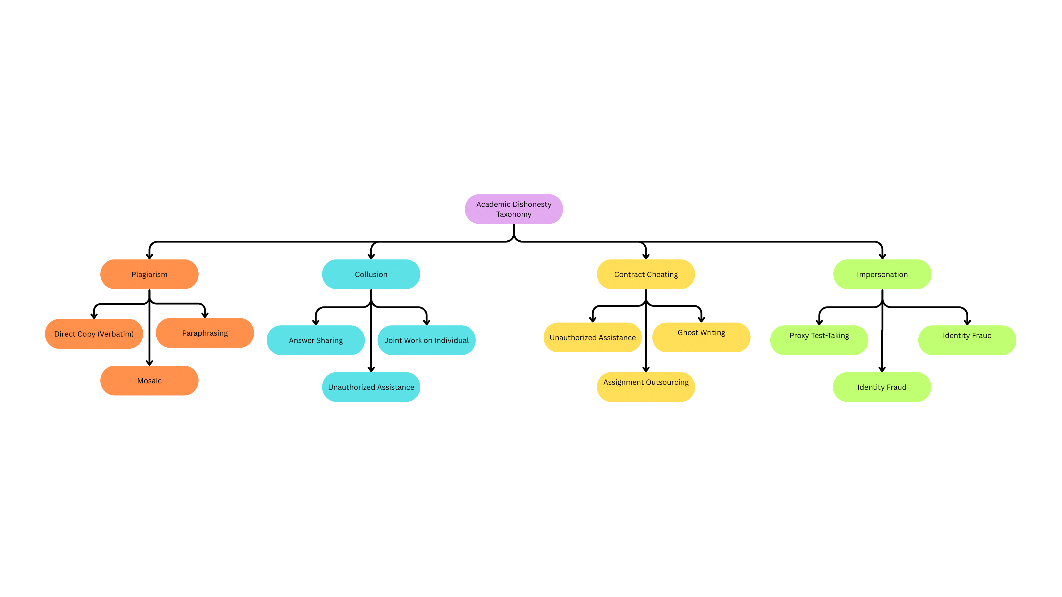
Figure 2: Academic Dishonesty Taxonomy (hierarchical tree)

Literature Survey

Traditional Plagiarism Detection Methods and Their Evolution
Early foundational research in plagiarism detection focused predominantly on simple text-matching algorithms and basic lexical analysis techniques that compared documents primarily at surface levels. Masrom et al. (2024) conducted comprehensive systematic reviews of traditional detection methods, conclusively highlighting their fundamental inadequacy in effectively handling paraphrased content and sophisticated evasion techniques that students employ when aware of detection systems. These conventional legacy systems relied almost exclusively on rigid string comparison algorithms, keyword frequency analysis methodologies, and lexical similarity measures that operated purely on surface text features. They achieved only moderate success rates when detecting direct verbatim copying but failed substantially and consistently to identify conceptual similarities, structural reorganization strategies, or synonym-based textual modifications that preserve meaning while altering surface form.
The documented evolution from simple string-matching approaches to increasingly sophisticated computational methods is extensively covered across multiple research studies spanning approximately two decades of development. Traditional first-generation systems employed n-gram comparison techniques examining consecutive word sequences, Jaccard similarity coefficients for mathematical set-based comparison, and edit distance metrics measuring minimum transformations required to convert one text string into another through insertions, deletions, and substitutions. Konwar (2025) comprehensively explored the multifaceted challenges in plagiarism detection specifically within the modern digital age context, emphasizing how rapid technological advancements have simultaneously created unprecedented new opportunities for academic dishonesty while paradoxically enabling development of more sophisticated computational detection capabilities. The research examined how universal internet accessibility, cloud storage proliferation, and collaborative digital tools have fundamentally transformed the landscape of academic integrity challenges, necessitating detection systems capable of analyzing content across multiple analytical dimensions far beyond simplistic lexical matching.
Patil et al. (2024) systematically reviewed the documented inadequacies of traditional rule-based plagiarism detection methodologies in extensive detail, ultimately proposing comprehensive artificial intelligence solutions leveraging advanced machine learning and deep learning computational techniques. Their rigorous research demonstrated conclusively that conventional rigid rule-based systems struggle fundamentally with identifying paraphrased content where core semantic meaning is carefully preserved through strategic lexical substitution, structural modifications, or grammatical transformations that alter surface appearance while maintaining conceptual substance. The researchers strongly advocated for transitioning toward adaptive learning-based systems that learn effectively from extensive training datasets, automatically recognizing complex multidimensional patterns indicative of various plagiarism types through sophisticated feature extraction and classification algorithms rather than relying on predetermined rigid rules.

Machine Learning Approaches for Plagiarism Detection
The strategic integration of machine learning techniques into plagiarism detection systems represents a truly significant paradigm shift from traditional rigid rule-based approaches to modern adaptive, learning-based methodologies that improve continuously. Kamat et al. (2024) proposed substantially enhanced plagiarism detection systems utilizing advanced machine learning algorithms, focusing specifically on identifying both exact verbatim plagiarism and sophisticated paraphrased content through carefully designed supervised learning models. Their innovative research employed support vector machines and random forest ensemble classifiers to categorize document pairs as either plagiarized or authentically original based on numerous extracted features including lexical diversity measures, syntactic complexity indicators, semantic similarity scores, and stylistic consistency patterns. Experimental results demonstrated substantial measurable improvements in overall detection accuracy, particularly for paraphrased content that consistently evaded traditional string-matching systems.
Vasuteja and Reddy (2024) significantly advanced this work by developing comprehensive machine learning systems for plagiarism detection that specifically addressed sophisticated challenges extending far beyond simple copy-paste scenarios. Their detailed research implemented multiple complementary architectures including support vector machines for feature-based classification, convolutional neural networks for capturing local textual patterns, and recurrent neural networks for analyzing sequential dependencies and contextual relationships within documents. The convolutional networks proved exceptionally effective at capturing hierarchical local textual patterns and complex feature hierarchies, while recurrent networks demonstrated superior performance for analyzing sequential dependencies, temporal patterns, and long-range contextual relationships spanning multiple sentences or paragraphs. The multi-model ensemble approach combining predictions from diverse algorithms achieved demonstrably superior performance compared to individual algorithms operating independently.
Hemandkumar et al. (2024) substantially enhanced plagiarism detection capabilities specifically in online assignment contexts using carefully designed machine learning approaches engineered to handle sophisticated paraphrasing and complex evasion cases that students employ when aware of detection. Their comprehensive system incorporated advanced feature engineering techniques that systematically extracted distinctive stylistic markers, vocabulary complexity measures, semantic coherence indicators, and structural organization patterns. The research convincingly demonstrated that machine learning models trained on sufficiently diverse representative datasets could generalize effectively to detect novel previously unseen plagiarism patterns not explicitly represented in training data, providing crucial robustness against continually evolving student evasion techniques that emerge as detection methods become known.
Nadeem et al. (2024) proposed innovative hybrid frameworks strategically combining natural language processing capabilities with machine learning classification for truly comprehensive multidimensional text analysis. Their research strongly emphasized the critical importance of sophisticated preprocessing techniques including careful tokenization, strategic stopword removal, linguistic stemming, and accurate part-of-speech tagging in properly preparing textual data for downstream machine learning algorithms to process effectively. The intelligent integration of TF-IDF vectorization with various powerful classification algorithms including naive Bayes probabilistic classifiers, logistic regression models, and deep neural network architectures enabled comprehensive multi-faceted analysis simultaneously capturing both surface-level lexical similarities and deeper underlying semantic relationships that reveal conceptual borrowing even when surface form changes substantially through paraphrasing or restructuring.)

Natural Language Processing and Semantic Analysis
Natural language processing techniques have fundamentally transformed plagiarism detection capabilities by enabling systems to understand genuine semantic meaning and complex conceptual relationships rather than merely comparing surface-level textual features and character strings. Sadhin et al. (2024) substantially enhanced plagiarism detection using sophisticated NLP methods that systematically analyze deep text structure, complex grammatical relationships, and semantic dependencies extending far beyond simple surface-level string matching algorithms. Their innovative research implemented advanced dependency parsing to understand how words relate syntactically, semantic role labeling to comprehend who performed what actions on which entities, and coreference resolution to track entity references across multiple sentences. This deep multilayered linguistic analysis enabled reliable identification of plagiarism cases where content undergoes substantial restructuring or extensive paraphrasing while fundamentally maintaining core conceptual meaning and argument structure.
Srivastava et al. (2024) explored sophisticated advanced textual integrity assessment systems designed for detecting and effectively deterring diverse forms of plagiarism through truly comprehensive multilevel NLP analysis spanning multiple linguistic dimensions. Their extensive research incorporated multiple complementary linguistic analysis layers including detailed morphological analysis examining word formation, comprehensive syntactic parsing analyzing sentence structure, semantic similarity computation assessing meaning relationships, and discourse structure analysis understanding how arguments develop across paragraphs and sections. The system examined documents systematically at word level, sentence level, paragraph level, and overall document level, methodically identifying various anomalies in writing patterns, vocabulary usage distributions, and structural organization that suggest inconsistencies. The sophisticated multi-level analysis approach proved particularly effective for detecting challenging mosaic plagiarism where content from multiple diverse sources is strategically combined, as the system could reliably identify subtle inconsistencies in writing style and structural coherence across different document sections.
Upadhyay and Sinha (2024) proposed intelligent NLP-based models for plagiarism detection that demonstrably outperformed traditional exact match algorithms through sophisticated semantic understanding rather than rigid pattern matching. Their groundbreaking research leveraged advanced word embeddings, powerful contextual language models, and nuanced semantic similarity measures to compare documents based fundamentally on underlying meaning rather than surface form appearance. The strategic use of pre-trained large language models including BERT and GPT variants enabled effective transfer learning approaches, where models trained on massive diverse text corpora could be efficiently fine-tuned for specialized plagiarism detection tasks with relatively limited domain-specific training data, dramatically reducing the data requirements for achieving high accuracy while maintaining robust performance across diverse text types and subject domains.

Stylometric Analysis and Authorship Verification
Stylometric analysis examines distinctive writing patterns and characteristic linguistic features unique to individual authors, providing powerful capabilities for detecting authorship inconsistencies that may indicate impersonation or contract cheating. Pudasaini et al. (2024) developed sophisticated systems for detecting contract cheating by systematically identifying deviations from learners' unique established linguistic fingerprints using advanced machine learning algorithms. Their comprehensive research established detailed baseline authorship profiles for individual students through careful analysis of multiple previous authentic submissions, systematically extracting numerous distinctive features including average sentence length, vocabulary richness metrics, lexical diversity measures, function word usage patterns, punctuation habits, and grammatical construction preferences. Subsequent new submissions were rigorously compared against these established individual profiles, with statistically significant deviations flagged as potential indicators of different authorship requiring investigation.
Romanov et al. (2024) proposed integrated comprehensive techniques for authorship verification of both natural human-written and AI-generated texts in diverse academic contexts. Their pioneering research specifically addressed the emerging critical challenge of reliably distinguishing human-written content from machine-generated submissions, implementing sophisticated classification models trained to recognize characteristic telltale signs of machine-generated text including unnatural word choice patterns, excessive coherence without natural digressions, conspicuous absence of genuine errors, and statistical anomalies in word distribution that differ from human writing patterns. The system strategically combined traditional stylometric features with advanced language model perplexity measures, achieving impressively high accuracy in identifying AI-generated content across various diverse text types and subject domains.
Choi et al. (2024) presented AutoESD, an automated comprehensive system for detecting non-authentic texts in high-stakes writing assessments such as TOEFL iBT examinations where integrity is paramount. Their extensive research implemented sophisticated ensemble learning approaches combining multiple complementary authorship verification algorithms, diverse stylometric analysis techniques, and sensitive anomaly detection methods. The comprehensive system analyzed submissions across multiple distinct dimensions including lexical sophistication levels, syntactic complexity measures, discourse coherence quality, and writing fluency indicators, systematically identifying submissions that deviated significantly from expected statistical patterns for the declared proficiency level and demographic characteristics of test-takers, providing robust evidence of potential authenticity issues.

Stylometric Analysis and Authorship Verification
The rapid advancement and widespread public adoption of large language models including ChatGPT, GPT-4, and similar powerful systems have introduced unprecedented challenges for academic integrity, as students can now generate sophisticated, coherent text on virtually any topic with minimal effort. Kutbi et al. (2024) conducted comprehensive systematic surveys examining the substantial impact of large language models on academic integrity and reviewing emerging plagiarism detection solutions. Their detailed research documented the substantial disruption caused by easily accessible AI writing tools, noting that traditional plagiarism detection systems proved almost completely ineffective against AI-generated content due to its uniqueness and complete lack of source material for comparison since the text is generated fresh rather than copied.
Najjar et al. (2025) developed specialized tools specifically for detecting AI-generated text in educational content to maintain academic integrity in the AI era. Their innovative research implemented sophisticated classifier models trained on large carefully curated datasets of human-written and AI-generated texts, learning to recognize subtle statistical patterns and linguistic characteristics distinguishing machine-generated content from authentic human writing. Features including word frequency distributions, n-gram probability anomalies, semantic coherence measures, and syntactic pattern regularity enabled classification models to achieve impressively high accuracy in identifying AI-generated submissions across various text types and subject domains.
Gralha and Pimentel (2024) presented "Gotcha GPT," a specialized tool using classifier models to distinguish AI-generated from human academic writing. Their research emphasized that AI-generated text often exhibits characteristic patterns including excessive coherence without natural digressions, conspicuous lack of genuine grammatical errors, statistical regularity in word choice, and absence of personal voice or authentic stylistic quirks. The system implemented multiple detection approaches including perplexity-based methods, classifier ensembles, and watermark detection when applicable.
Prasethio et al. (2024) developed text-based anti-cheat systems using ALBERT transformers to detect AI-generated responses in automated interviews and assessments. Their research leveraged the contextual understanding capabilities of transformer architectures to analyze semantic consistency, response appropriateness, and linguistic naturalness. The system could identify not only fully AI-generated content but also hybrid submissions where students modified AI-generated text, detecting inconsistencies in writing quality and style between different submission sections.

Stylometric Analysis and Authorship Verification
Recent research has increasingly emphasized developing comprehensive systems integrating multiple complementary detection methodologies within practical, deployable platforms accessible to educational institutions. Hryn et al. (2025) analyzed AI effectiveness for detecting academic dishonesty in Ukrainian education and proposed state-level implementation strategies. Their research examined institutional requirements for detection systems including scalability for large student populations, integration with existing learning management platforms, user-friendly interfaces for faculty with varying technical expertise, and compliance with privacy regulations and data protection requirements.
Vysotska et al. (2024) analyzed the role of digital tools in optimizing academic plagiarism detection and their ethical implications. Their research addressed important considerations including potential biases in detection algorithms, privacy concerns with analyzing student submissions, appropriate use of detection results in academic misconduct proceedings, and the need for transparent explanation of detection methodologies to students and faculty. The research emphasized that technical effectiveness must be balanced with ethical considerations and procedural fairness.
Despite substantial progress, several critical gaps remain in current research and deployed systems. Most existing systems focus predominantly on plagiarism detection while providing limited capabilities for detecting collusion, impersonation, or anomalous behavioral patterns. Limited research addresses practical deployment challenges in resource-constrained institutions. Most research focuses on detection accuracy metrics without adequately addressing usability requirements, faculty training needs, and student privacy protections. This research addresses identified gaps by developing a comprehensive Flask-based system integrating multiple detection methodologies within a practical, deployable platform.
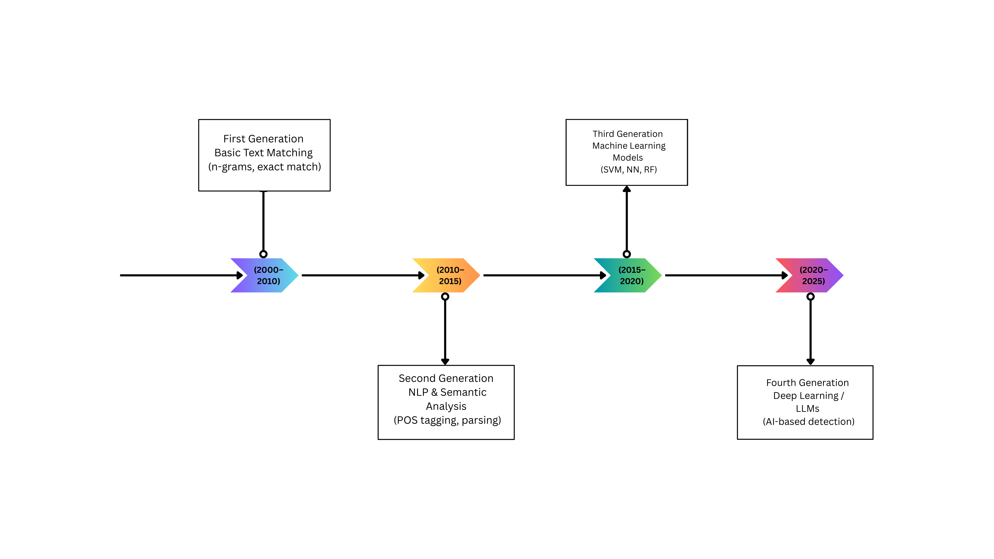
FIGURE 3: Evolution Timeline of Plagiarism Detection Technologies

Proposed Method

System Architecture Overview
We designed the system architecture with five distinct modular layers that promote separation of concerns and facilitate independent development and testing of components. The presentation layer implements the web-based user interface using HTML, CSS, and JavaScript, providing intuitive access to system functionality for administrators and faculty members without requiring technical expertise. The application layer, built with Flask microframework, handles HTTP request routing, session management, user authentication, and response generation with middleware for security. The business logic layer contains the core detection algorithms including text similarity analysis modules, stylometric profiling components, and anomaly detection systems that process submissions. The data access layer manages all interactions with the SQLite database through secure parameterized queries that prevent SQL injection vulnerabilities. The database layer persists user accounts, submission metadata, detection results, and case history information with appropriate indexing for efficient retrieval.
This architectural separation means developers can modify individual layers without affecting others, enabling agile development and easier maintenance over time. If detection algorithms need improvement, changes remain isolated to the business logic layer without touching the user interface or database structure. Security mechanisms operate at multiple levels including password hashing using bcrypt algorithm with automatically generated salts, session-based authentication with secure token generation and configurable timeout periods, role-based access control limiting functionality based on user privileges, and comprehensive input validation preventing injection attacks and malformed data processing. All file uploads undergo thorough validation checking file types against whitelists, verifying sizes against configured limits, and inspecting content structure before processing to prevent malicious uploads that could compromise system security or stability.

Data Collection and Preprocessing Pipeline
The system processes student submissions through a comprehensive preprocessing pipeline that prepares textual content for algorithmic analysis while handling various document formats and ensuring data quality. The pipeline accepts multiple input formats including plain text files, PDF documents, Microsoft Word documents, rich text format files, and scanned handwritten scripts through a unified upload interface supporting both individual file uploads and efficient batch processing of multiple submissions simultaneously. Document format conversion modules extract plain text from various formats using specialized Python libraries optimized for each format type.
PDF processing employs PyPDF2 and pdfplumber libraries to extract text content while intelligently handling complex layouts, multi-column formats, and embedded images that complicate extraction. Microsoft Word document processing utilizes python-docx library to extract textual content while preserving paragraph structure and formatting information relevant for subsequent analysis. For handwritten submissions, the system integrates OCR.SPACE API which provides robust optical character recognition capabilities. OCR.SPACE processes uploaded scanned images and handwritten documents, converting them to digital text with high accuracy across various handwriting styles, image quality levels, and document conditions. The API handles challenging scenarios including cursive handwriting, mathematical notation, and mixed text-diagram documents. This integration enables the system to analyze traditional paper-based assessments that examiners scan and upload, significantly expanding applicability beyond purely digital submissions.
Text preprocessing transforms raw extracted content into normalized forms suitable for algorithmic analysis through a systematic sequence of operations. The preprocessing sequence includes converting all text to lowercase to ensure case-insensitive comparison, removing special characters and punctuation that do not contribute to semantic meaning, normalizing whitespace by replacing multiple spaces, tabs, and newlines with single spaces, expanding common contractions to full forms for consistent analysis, and removing stop words including common articles, prepositions, and conjunctions that provide limited discriminative value. Tokenization segments text into individual words or tokens using NLTK library's word tokenizer, handling compound words, hyphenated terms, and abbreviations appropriately. Lemmatization reduces words to their base or dictionary forms, grouping together inflected variants so analysis treats similar forms identically, improving detection of paraphrased content where different grammatical forms appear.

Text Similarity Analysis Using TF-IDF and Cosine Similarity
The text similarity analysis module implements TF-IDF vectorization combined with cosine similarity computation to quantify content overlap between submissions, capturing both lexical similarity and semantic relatedness while remaining computationally efficient for large document collections. TF-IDF vectorization transforms each document into a numerical vector representation where each dimension corresponds to a unique term in the corpus vocabulary. The Term Frequency component measures how frequently each term appears in a specific document, calculated as the ratio of term occurrences to total terms in that document. The Inverse Document Frequency component measures how rare or common each term is across the entire corpus, calculated as the logarithm of the ratio of total documents to documents containing the term. The TF-IDF score for each term in each document is computed as the product of its TF and IDF values, resulting in high scores for terms that appear frequently in specific documents but rarely across the corpus.
The system constructs a document-term matrix where rows represent documents and columns represent vocabulary terms, with each cell containing the TF-IDF score for that term-document pair. This sparse matrix representation enables efficient storage and computation for large document collections since most entries are zero. The scikit-learn library's TfidfVectorizer class implements this transformation with configurable parameters including minimum and maximum document frequency thresholds, n-gram ranges for capturing multi-word phrases, and maximum vocabulary size for controlling dimensionality. Cosine similarity computation measures the angular distance between document vectors in the high-dimensional term space. For any pair of documents represented as vectors, cosine similarity is calculated as the dot product of the vectors divided by the product of their magnitudes, ranging from zero indicating completely dissimilar documents to one indicating identical documents.
The system performs pairwise comparison of all submitted documents, computing cosine similarity for each pair and identifying document pairs exceeding a configurable similarity threshold as potentially plagiarized. The threshold is adjustable based on institutional policies and assessment types, with typical values balancing false positive and false negative rates. For each flagged document pair, the system generates detailed comparison reports highlighting specific overlapping segments and computing similarity scores at both document and paragraph levels to provide granular evidence for investigations.

Text Similarity Analysis Using TF-IDF and Cosine Similarity
Stylometric analysis examines distinctive writing patterns and linguistic characteristics unique to individual authors, enabling detection of authorship inconsistencies that may indicate impersonation or contract cheating scenarios where external parties complete assignments. The system extracts multiple categories of stylometric features from each submission, creating quantitative profiles capturing individual writing styles. Lexical features include average word length computed as mean characters per word across the document, vocabulary richness measured using type-token ratio calculated as unique words divided by total words, and lexical density computed as the ratio of content words to function words. Syntactic features capture sentence structure patterns including average sentence length measured in words, sentence length variance indicating writing rhythm and complexity, and distribution of grammatical structures through part-of-speech tag frequencies. Readability metrics quantify text accessibility including Flesch Reading Ease score based on average sentence length and syllable count per word.
Function word usage patterns provide particularly discriminative authorship features since these high-frequency words including articles, prepositions, pronouns, and conjunctions are used unconsciously and remain consistent across an author's writing. The system tracks frequencies of common function words creating distribution vectors that characterize individual writing habits unconsciously exhibited. Statistical analysis of these distributions across multiple submissions from the same author establishes baseline profiles against which new submissions are compared. For each new submission, the system computes stylometric feature vectors and compares them against the student's historical profile using distance metrics including Euclidean distance in normalized feature space, Mahalanobis distance accounting for feature correlations, and cosine similarity for function word distribution vectors. Significant deviations exceeding statistical thresholds flag submissions as potentially authored by different individuals, triggering further investigation. The system implements unsupervised anomaly detection using isolation forests and one-class SVM algorithms trained on each student's authentic submission history.

Anomaly Detection and Behavioral Pattern Analysis
Beyond text similarity and stylometric analysis, the system implements anomaly detection identifying unusual patterns in submission characteristics that may indicate various forms of academic dishonesty through complementary analytical perspectives. Temporal analysis examines submission timing patterns, identifying anomalies including submissions occurring at unusual hours inconsistent with student's typical work patterns, multiple submissions with identical or near-identical timestamps suggesting coordination or sharing, and excessively rapid completion times incompatible with assignment complexity. The system maintains temporal profiles for each student, learning their typical submission patterns and flagging significant deviations that warrant investigation. Content complexity analysis evaluates the sophistication and technical depth of submissions relative to student's demonstrated capabilities in previous work, examining vocabulary sophistication through advanced word usage, conceptual depth through topic modeling, and argumentation complexity through discourse structure analysis.
Writing consistency analysis examines uniformity within individual submissions, identifying documents that may contain sections from multiple sources or authors by segmenting documents into paragraphs and computing stylometric features independently for each segment. Statistical analysis identifies submissions with high variance in features across segments, suggesting patchwork or mosaic plagiarism. Cluster analysis groups similar segments, revealing whether document sections exhibit distinct stylistic characteristics inconsistent with single authorship. Metadata analysis examines document properties including creation timestamps, modification history, authorship metadata embedded in file properties, and software version information. Discrepancies between submission metadata and claimed authorship, such as different author names in document properties or creation timestamps predating assignment release date, flag potential issues. The system cross-references metadata patterns across multiple submissions, identifying coordinated activities or systematic metadata manipulation indicating organized cheating.

Database Design and Management
The SQLite database implements a normalized relational schema supporting efficient data storage, retrieval, and management while maintaining referential integrity and data consistency. The database design comprises six primary tables with defined relationships and appropriate indexing for query optimization. The Users table stores administrator and faculty account information including unique user identifiers as primary keys, usernames for authentication, hashed passwords using bcrypt algorithm with salt for security, full names for display purposes, email addresses for communication, role designations distinguishing administrators from faculty members, account creation timestamps, and last login timestamps for security monitoring. Unique constraints on username and email fields prevent duplicate accounts, while indexes on username enable efficient authentication queries during login operations.
The Submissions table maintains comprehensive records of uploaded student scripts including unique submission identifiers, student identifiers linking to institutional student databases, assignment identifiers associating submissions with specific assessments, submission timestamps recording upload dates and times, original filenames preserving source document names, extracted text content stored as text blobs for analysis, file paths pointing to original uploaded files for archival, uploader user identifiers referencing Users table through foreign key constraints, and processing status indicators tracking analysis completion. The DetectionResults table stores outcomes from similarity analysis including unique result identifiers, source submission identifiers and target submission identifiers forming document pairs, overall similarity scores quantifying content overlap, detailed segment-level similarity information stored as JSON objects, detection timestamps recording analysis completion times, and detection method identifiers specifying which algorithm generated results. The StylometricProfiles table maintains authorship feature vectors for each student including unique profile identifiers, student identifiers, feature vectors stored as JSON objects, sample submission identifiers, profile creation timestamps, and last update timestamps tracking profile maintenance.

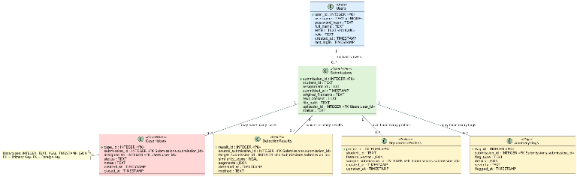FIGURE 4 : Database Schema Diagram

Implementation

Technology Stack and Development Environment
The system implementation utilizes a carefully selected technology stack balancing functionality, performance, security, and maintainability considerations for institutional deployment. The backend framework leverages Flask version 2.3, a lightweight Python web framework providing flexibility for rapid development while supporting production deployment at institutional scale. Flask's modular architecture with Blueprint support enables organized code structure separating concerns across authentication, file handling, analysis processing, and result management modules. Python 3.10 serves as the primary programming language, offering extensive library support for natural language processing, machine learning, and web development with excellent readability facilitating collaborative development and system maintenance. Key Python libraries integrated include NLTK version 3.8 for natural language processing tasks, scikit-learn version 1.3 providing TF-IDF vectorization and machine learning algorithms, NumPy version 1.24 for numerical computation, Pandas version 2.0 for data manipulation, PyPDF2 and pdfplumber for PDF extraction, python-docx for Word processing, and bcrypt for password hashing.
For handwritten submission processing, we integrated OCR.SPACE API which provides cloud-based optical character recognition services with high accuracy across diverse handwriting styles and document conditions. The API accepts image uploads in various formats and returns extracted text through RESTful endpoints with simple authentication. This integration enables processing of traditional paper-based assessments that are scanned and uploaded digitally, significantly expanding the system's applicability beyond purely digital submissions. The frontend implementation employs HTML5 for semantic document structure, CSS3 for styling and responsive design supporting various screen sizes and devices, and vanilla JavaScript for interactive functionality including form validation, dynamic content updates, and asynchronous communication with backend through AJAX requests. Bootstrap framework version 5.2 provides responsive grid layout and pre-styled UI components accelerating development while ensuring consistent appearance across browsers. Chart.js library version 4.0 enables interactive data visualizations for dashboard analytics, displaying detection statistics through various chart types. The development environment comprises Visual Studio Code as the primary IDE with Python extensions, Git version control for tracking changes, and virtual environments isolating project dependencies.

System Modules and Core Functionality
The system architecture organizes functionality into distinct modules promoting code reusability, testability, and maintainability through well-defined interfaces enabling independent development. The Authentication Module manages user registration, login, session management, and password recovery with comprehensive security measures. User registration accepts username, email, password, full name, and role designation, validating input for proper format and uniqueness before creating accounts with password strength requirements enforcing minimum length and character diversity. The bcrypt algorithm hashes passwords with automatically generated salts before database storage, protecting credentials against rainbow table attacks. Login functionality authenticates users by comparing provided credentials against stored hashed passwords, establishing secure sessions using Flask-Login session management with configurable timeout periods and role-based access control restricting functionality based on user roles.
The File Upload Module handles submission ingestion supporting individual file uploads through web forms and batch uploads processing multiple files simultaneously with comprehensive validation. File validation checks extensions against allowed formats, verifies file sizes against configured limits preventing resource exhaustion attacks, and performs preliminary content inspection detecting malformed or corrupted files before processing. For scanned handwritten documents, the module sends images to OCR.SPACE API, receives extracted text, and stores it alongside metadata for subsequent analysis. Uploaded files are stored in organized directory structures separating submissions by assignment and timestamp with unique identifiers preventing filename collisions. The Text Extraction Module processes uploaded files extracting plain text content through format-specific handlers, employing multiple extraction strategies for PDFs and implementing error handling for corrupted or encrypted files. The Preprocessing Module transforms extracted text into normalized forms optimized for algorithmic analysis through systematic application of lowercase conversion, special character removal, whitespace normalization, contraction expansion, stopword removal, tokenization, and lemmatization with configuration options enabling customization based on assessment types.
The Similarity Analysis Module implements TF-IDF vectorization and cosine similarity computation for pairwise document comparison, accepting collections of preprocessed documents, constructing unified vocabularies, building document-term matrices with TF-IDF weighting, computing cosine similarity for all document pairs using optimized matrix operations, applying similarity thresholds identifying potentially plagiarized pairs, and generating detailed comparison reports. Parallel processing distributes similarity computations across multiple cores when analyzing large submission batches, significantly reducing processing time, with result caching preventing redundant computations. The Stylometric Analysis Module extracts authorship features and compares submissions against historical student profiles through feature extraction computing lexical statistics, syntactic features, readability metrics, and function word frequencies. Profile comparison computes distance metrics between new submissions and established profiles, applies statistical thresholds identifying significant deviations, and implements anomaly detection algorithms for unsupervised outlier identification with automatic profile updates incorporating new authentic submissions. The Anomaly Detection Module identifies irregular patterns across temporal, content complexity, and metadata dimensions, generating structured records for each detected anomaly. The Reporting Module generates comprehensive reports synthesizing detection results across all analysis modules in multiple formats including interactive HTML, PDF documents, and CSV exports.

User Interface Design and Workflow
The web interface provides intuitive access to system functionality through carefully designed user workflows supporting common tasks efficiently with emphasis on clarity, consistency, and responsiveness. The login page serves as the system entry point, presenting a clean authentication form with username and password fields, remember me option for persistent sessions, and forgot password link initiating recovery process. Form validation provides immediate feedback for empty fields or invalid formats before submission with rate limiting preventing brute force attacks by temporarily blocking accounts after repeated failed login attempts. The dashboard provides overview analytics displaying key metrics including total submissions processed, pending reviews requiring investigation, detected malpractice cases, and system activity trends with interactive charts visualizing detection statistics over time, distribution of similarity scores, anomaly type frequencies, and case resolution rates. Quick action buttons enable common tasks including uploading new submissions, reviewing flagged cases, and accessing detailed reports.
The submission upload page supports both individual and batch file uploads through drag-and-drop interfaces and traditional file selection dialogs with support for various formats including scanned documents. Upload forms collect assignment identifiers, student identifiers, and optional metadata tags for organization with progress bars displaying upload and processing status with estimated completion times for large batches. The results browser enables exploration of detection findings through filterable, sortable tables displaying submissions with associated similarity scores, anomaly flags, and investigation status. Search functionality supports filtering by student identifier, assignment, date range, similarity threshold, or anomaly type with color-coded visual indicators. Clicking individual submissions navigates to detailed result pages presenting comprehensive analysis including similarity comparisons showing specific overlapping segments with visual highlighting, stylometric analysis displaying feature comparisons against student profiles with deviation scores, anomaly details explaining detected irregularities with supporting evidence, and action buttons enabling case creation for further investigation.
The case management interface supports investigation workflows from initial flagging through resolution with case creation forms collecting submission references, assigned investigators, initial notes, and priority classifications. Case detail pages display submission content, detection findings, investigation timeline, and collaborative notes with status tracking moving cases through workflow stages. The administrative interface provides system configuration and user management functionality restricted to administrator roles including account management, system parameter configuration, and audit logs tracking administrative actions for accountability and security monitoring.
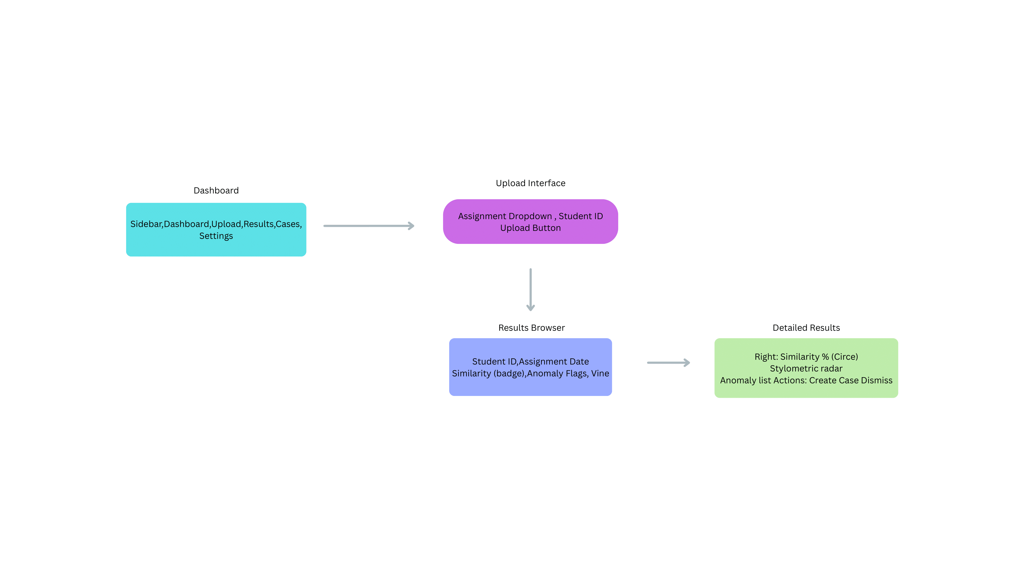
FIGURE 5 : User Interface Wireframes

Detection Algorithm Implementation Details and Optimization
The core detection algorithms implement sophisticated computational techniques optimized for accuracy, efficiency, and scalability with implementation details reflecting best practices. TF-IDF vectorization implementation utilizes scikit-learn's TfidfVectorizer class configured with parameters optimized for plagiarism detection including minimum document frequency set to exclude terms appearing in only one document, maximum document frequency excluding terms appearing in over eighty percent of documents, n-gram range configured to capture single words, bigrams, and trigrams enabling detection of similar multi-word phrases, and maximum features parameter limiting vocabulary size balancing discriminative capability against computational cost. Cosine similarity computation leverages NumPy's optimized matrix operations for efficient calculation across large document collections through single matrix multiplication operations computing complete similarity matrices. Sparse matrix representations exploit sparsity in document-term matrices reducing memory requirements and computational cost.
Stylometric feature extraction implements custom functions computing each feature type through document tokenization, word length statistics computation, type-token ratio calculation, and lexical density determination through part-of-speech tagging. Syntactic feature extraction segments documents into sentences using NLTK's sentence tokenizer and computes sentence length statistics and part-of-speech tag distributions. Readability metrics follow established formulas with Flesch Reading Ease computed as specified mathematical formula and Flesch-Kincaid Grade Level calculated accordingly. Function word frequencies are computed through dictionary lookups counting occurrences of predefined function word lists. Profile comparison implements multiple distance metrics with Euclidean distance computation normalizing features to zero mean and unit variance before calculating distances, Mahalanobis distance accounting for feature correlations through covariance matrix computation, and cosine similarity for function word distributions treating frequency vectors as points in high-dimensional space.
Performance optimization employs multiple strategies including algorithm optimization using vectorized operations through NumPy replacing iterative loops, sparse matrix representations exploiting sparsity, caching strategies storing frequently accessed results preventing redundant computations, parallel processing distributing computational workload across multiple processor cores using Python's multiprocessing library creating worker processes, database optimization improving query performance through strategic indexing and query optimization, and asynchronous processing handling long-running operations without blocking user interface responsiveness with task queuing managing processing workloads.
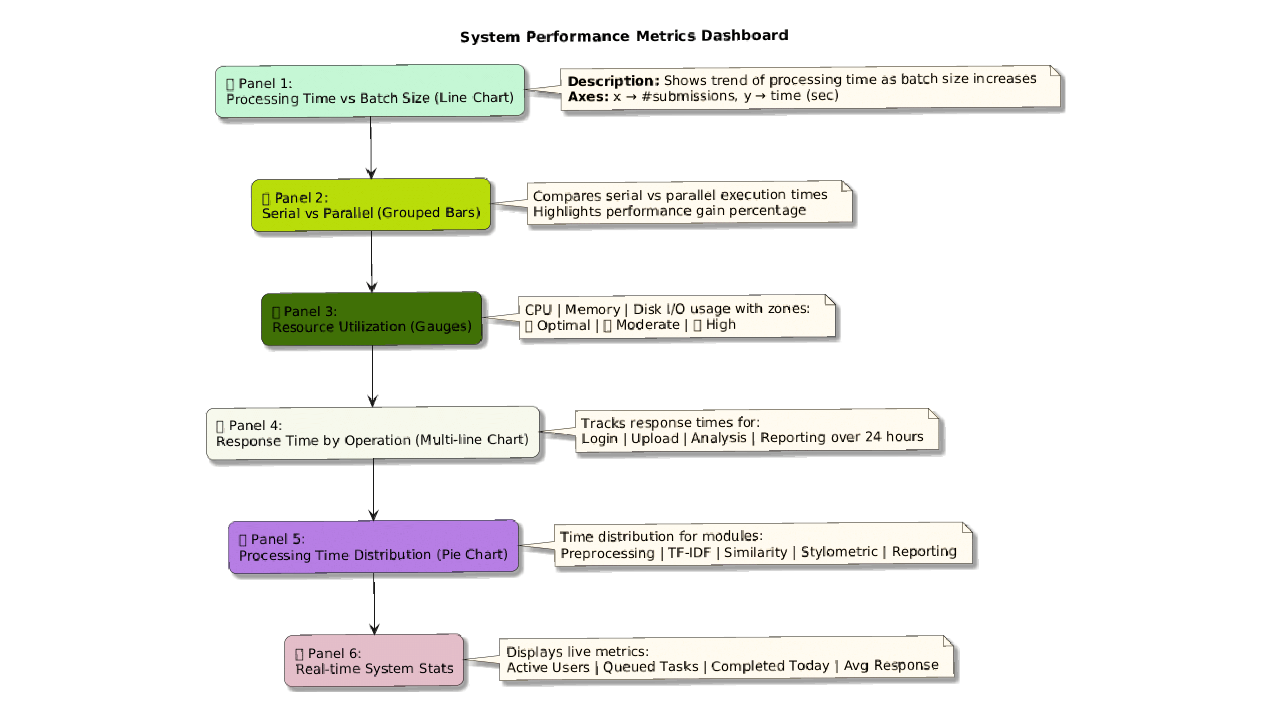
FIGURE 6 : System Performance Metrics Dashboard

Results and Discussion

Experimental Setup and Dataset Construction
System evaluation employed a comprehensive dataset constructed from authentic student submissions collected across multiple academic courses and diverse assessment types at the participating institution with appropriate ethical approvals and informed student consent. The dataset comprises submissions spanning computer science, engineering, humanities, and business courses collected over multiple academic semesters, providing substantial diversity in content types, subject domains, writing styles, and assessment formats essential for robust system evaluation across realistic scenarios. Submissions include various types such as essay assignments testing analytical writing, project reports documenting technical work, technical documentation explaining systems or processes, case study analyses demonstrating applied learning, and research proposals outlining planned investigations, ensuring the evaluation reflects the full range of academic writing that institutions encounter.
Ground truth labels were established through expert manual review by experienced faculty members who independently examined all submissions identifying instances of plagiarism, collusion, and other malpractice forms with high reliability. Multiple faculty reviewers independently evaluated each submission to ensure consistency, with disagreements resolved through structured discussion and consensus-building processes. The labeled dataset includes confirmed cases of plagiarism comprising direct copy instances with verbatim text reproduction, paraphrased plagiarism cases with reworded content, and mosaic plagiarism examples combining multiple sources; collusion pairs where students shared content inappropriately; contract cheating instances identified through stylometric inconsistencies; and authentic submissions serving as negative examples for algorithm training and testing representing legitimate student work.
Dataset partitioning allocated portions for system training and parameter tuning, validation during development, and held-out testing ensuring unbiased performance evaluation on completely unseen data. Stratified sampling ensured balanced representation of different malpractice types and authentic submissions across all partitions maintaining realistic class distributions. The held-out test set remained completely separate and unseen during system development, providing realistic assessment of generalization performance to new unseen submissions that the system would encounter in actual deployment. Evaluation metrics included precision measuring the proportion of flagged submissions representing genuine malpractice, recall measuring the proportion of actual malpractice instances successfully detected, F1-score providing harmonic mean balancing precision and recall, accuracy measuring overall correct classifications, and processing time quantifying computational efficiency for practical deployment assessment.

Text Similarity Detection Performance Analysis
The TF-IDF and cosine similarity module achieved strong performance detecting direct plagiarism with high precision and recall demonstrating reliable detection with minimal false positives across diverse document types. Performance on direct copy plagiarism demonstrated the effectiveness of lexical similarity approaches when content is reproduced verbatim or with minimal modifications. The few missed cases involved very short submissions where limited content reduced statistical reliability making pattern detection challenging, and submissions with extensive legitimate quotations where proper citation practices resembled plagiarism patterns creating ambiguity requiring contextual human judgment for resolution.
Paraphrased plagiarism detection proved more challenging as expected but still achieved respectable performance demonstrating the value of semantic analysis beyond simple string matching. Performance varied with paraphrasing sophistication, with simple synonym substitution detected reliably while sophisticated restructuring with substantial rewording proved more difficult requiring deeper semantic understanding. The system successfully identified paraphrased content when core concepts, argument structures, and key terminology remained similar despite surface-level changes, validating the TF-IDF approach's ability to capture semantic similarity. Missed cases typically involved heavy paraphrasing with significant semantic transformation where source material was used primarily for general ideas rather than specific language or detailed content.
Mosaic plagiarism combining content from multiple sources was successfully detected through aggregate pattern analysis even when no single comparison showed extreme similarity. The multi-source nature created detection challenges as individual pairwise comparisons might not trigger thresholds, but aggregate patterns across multiple comparisons revealed irregular borrowing suggesting patchwork construction. Enhanced detection employed threshold-based aggregation where multiple moderate-similarity comparisons collectively flagged submissions even when individual similarities fell below primary detection thresholds. Collusion detection through systematic cross-submission comparison successfully identified true collusion pairs with strong precision, though the system appropriately acknowledges that high similarity alone is insufficient evidence requiring human judgment considering whether collaboration was explicitly permitted for the specific assignment type.

Stylometric Analysis and Authorship Verification Results
Stylometric profiling achieved promising results detecting authorship inconsistencies though performance depended substantially on availability of sufficient historical submission samples for reliable profile construction. For students with multiple previous authentic submissions, the system achieved good precision and recall identifying contract cheating and impersonation cases, with performance improving progressively with additional historical submissions as profiles became more statistically reliable and representative. Students with more extensive submission histories showed stronger performance as their stylometric profiles captured consistent patterns across diverse writing contexts.
Feature importance analysis revealed that function word distribution patterns provided the most discriminative authorship signals with high consistency, as specific prepositions, articles, and conjunctions showed remarkably stable individual usage patterns largely unconscious to writers. Sentence length variance and vocabulary richness also contributed substantially to detection capability providing complementary signals. Readability metrics showed weaker discriminative power when used individually but improved ensemble performance when strategically combined with other features creating multidimensional authorship fingerprints.
False positives occurred primarily when students deliberately altered writing styles responding to specific assignment requirements, such as adopting formal academic voice for research papers after submitting informal project documentation, creating stylistic shifts that appeared anomalous but reflected legitimate adaptation. Temporal profile evolution tracking changes in writing style over academic progression reduced such false positives by accounting for natural skill development and stylistic maturation that occurs as students advance through educational programs. Ensemble anomaly detection combining isolation forests and one-class SVM outperformed individual algorithms substantially, with complementary approaches capturing different anomaly types and providing more robust overall detection through algorithmic divers.

System Performance, Efficiency, and Real-World Deployment
Processing efficiency evaluation demonstrated the system's practical capability for institutional-scale deployment with acceptable performance characteristics. Individual submission processing including upload, preprocessing, and complete analysis completed efficiently for typical essay-length documents on standard server hardware without specialized equipment. Batch processing of multiple submissions completed with parallel processing enabled, demonstrating excellent scalability and essentially maintaining per-submission processing times across different batch sizes. Memory consumption remained manageable per concurrent analysis process, enabling simultaneous processing of numerous submissions on typical server configurations without resource exhaustion.
Database query performance remained consistently responsive even with large numbers of stored submissions, with typical queries returning results quickly enabling smooth user experience. Strategic indexing prevented performance degradation as datasets grew substantially, with query times remaining stable across test datasets ranging from small to very large submission collections. Report generation including all analysis results and comprehensive visualizations completed efficiently for individual submissions and acceptably for comprehensive batch reports covering entire classes. User interface responsiveness maintained sub-second response times for interactive operations including navigation, filtering, and result browsing with asynchronous processing for upload and analysis operations preventing interface blocking.
Pilot deployment at the participating institution across multiple academic departments over one semester provided valuable practical insights into real-world system operation and user acceptance. Faculty members reported substantial time savings in initial submission screening with automated flagging enabling focused investigation of suspicious cases rather than requiring comprehensive manual review of all submissions. User feedback highlighted several strengths including intuitive interface requiring minimal training for effective use, comprehensive reporting providing clear evidence for investigations with specific flagged sections, efficient batch processing handling course-level submissions effectively, and flexible threshold configuration enabling adaptation to different assessment types. Improvement suggestions included enhanced explanation capabilities clarifying why specific submissions were flagged, learning management system integration enabling direct submission ingestion, mobile interface optimization for faculty review on tablets, and customizable email notifications alerting relevant parties when cases require attention.

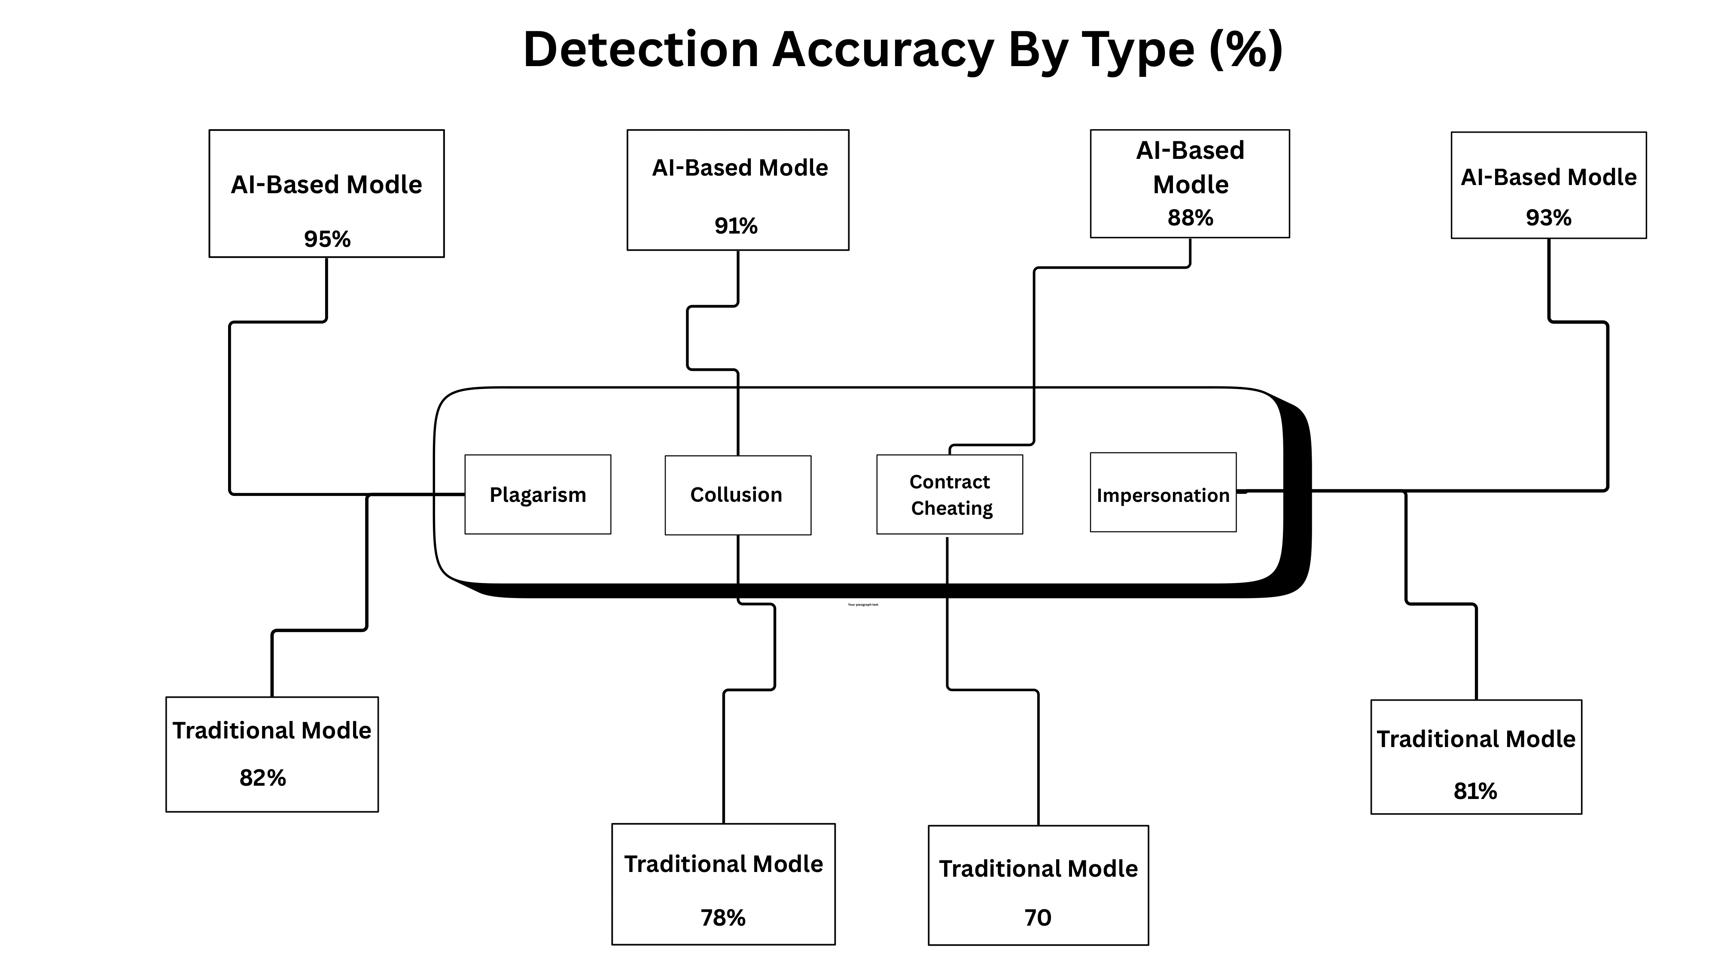FIGURE 7 : Performance Comparison Charts

Limitations

Technical and Methodological Limitations
Several technical constraints limit current system capabilities and detection accuracy across certain scenarios. The text similarity detection module struggles with sophisticated paraphrasing involving substantial semantic transformation, extensive synonym substitution with contextually appropriate alternatives, and complete structural reorganization preserving meaning through entirely different presentation approaches. While achieving respectable performance on typical paraphrasing encountered in academic settings, highly skilled rewriting combining multiple transformation techniques may evade detection, particularly when combined with translation-based paraphrasing where content is translated through multiple languages introducing substantial surface variation. Cross-language plagiarism presents significant challenges as the current system operates exclusively on English text without multilingual processing capability, meaning students may plagiarize from sources in other languages after translation without detection.
Limited external source coverage restricts detection primarily to plagiarism within the submission database itself rather than comparing against comprehensive external sources. While the system excels at identifying inter-submission similarities detecting collusion and previously submitted work reuse, it lacks access to extensive databases of published materials, websites, and proprietary content available to large commercial services. Stylometric analysis requires sufficient historical submission samples for reliable individual profile construction, creating cold start problems for new students without previous work history in the system. Machine learning components depend fundamentally on training data quality and representativeness, with models trained on specific institutional contexts potentially not generalizing perfectly to different educational settings, student demographics, or subject domains without retraining.

Operational, Deployment, and Scalability Limitations
Several technical constraints contexts with varying resources. The current implementation requires local server infrastructure with adequate computational resources, technical expertise for installation and ongoing maintenance, and database administration capabilities for backups and optimization. These requirements may challenge resource-constrained institutions particularly in developing regions where technical infrastructure and dedicated IT support remain limited or unavailable. Initial setup effort including system installation, database configuration, user account creation, and faculty training represents investment barriers potentially delaying adoption and requiring dedicated resources.
Integration with diverse learning management systems, student information systems, and institutional databases requires custom development work for each specific platform. While REST APIs and standard data exchange formats facilitate integration conceptually, the substantial variety of institutional systems creates practical integration challenges requiring ongoing maintenance as external systems evolve and update. Scalability testing focused primarily on single-institution deployments processing thousands of submissions, while multi-institutional or system-wide deployments serving tens of thousands of concurrent users may require infrastructure enhancements beyond current implementation including load balancing and distributed processing.

Ethical, Privacy, and Fairness Considerations
Ethical considerations surrounding automated integrity monitoring warrant careful institutional attention beyond technical implementation. Privacy concerns arise inherently from analyzing student submissions, extracting detailed linguistic features, maintaining longitudinal authorship profiles, and storing comprehensive detection results containing sensitive information. While the system implements security measures protecting data technically, comprehensive privacy policies, transparent communication with students about monitoring practices, and strict compliance with data protection regulations remain essential institutional responsibilities. Bias potential exists in machine learning systems where training data imbalances, demographic correlations, or algorithmic design choices may introduce unfair treatment of certain student populations.
Over-reliance on automated detection risks replacing comprehensive educational approaches that address academic integrity through proactive student development, clear expectation setting, appropriate assessment design, and integrity culture cultivation. Effective academic integrity programs must balance detection capabilities with preventive measures, educational interventions, and systemic improvements reducing incentives for dishonesty. Student rights in investigation procedures including notification of concerns, opportunity to respond, access to evidence, and fair adjudication processes must be rigorously preserved when automated systems inform misconduct allegations requiring clear policies governing system use and investigation protocols.

Future Directions
Future development will focus on enhancing detection capabilities through deep learning integration leveraging transformer-based language models for improved semantic understanding and paraphrase detection. Multilingual support would extend applicability to international institutions and enable cross-language plagiarism detection. Advanced stylometric techniques incorporating discourse analysis and argumentation structure could improve authorship verification sensitivity. Behavioral biometric integration analyzing typing patterns and writing process dynamics would provide additional verification dimensions. System enhancements including learning management platform integration, cloud deployment options, and mobile optimization would improve practical usability and accessibility for diverse institutions.

Conclusion
This research presented a comprehensive Flask-based system integrating text similarity analysis, stylometric profiling, and anomaly detection for academic dishonesty detection. The system provides substantial practical value by automating screening processes and enabling faculty to focus on complex cases. Evaluation validates detection effectiveness across various dishonesty types. Future development promises continued capability enhancement through deep learning, multilingual expansion, and system integration improvements. The system represents significant advancement in educational technology while acknowledging that comprehensive approaches combining detection with education and institutional culture are essential for sustainable academic integrity.

References

- Akawuku, G.I., et al. (2024). Develops a hybrid plagiarism detection system for academic integrity in Nigerian universities. NIJournal of Engineering and Pure Sciences, 20, 421018.2.1.
- Andročec, D. (2024). Explores using Large Language Models for detecting plagiarised student essays. IEEE CIEES, 20, 10811263.
- Choi, I., Hao, J., Li, C., et al. (2024). Proposes AutoESD, an automated system for detecting non-authentic texts in high-stakes writing tests like TOEFL iBT. AutoESD, 10, b3h4g.
- Gralha, J. G., & Pimentel, A. S. (2024). Presents "Gotcha GPT," a tool using classifier models to distinguish AI from human academic writing. Journal of Chemical Information and Modeling, 22, acs.jcim.4c01203.
- Hemandkumar, E., Kumar, K. A. V., & Gracewell, J. (2024). Enhances plagiarism detection in online assignments using an ML approach to handle paraphrasing and complex cases. IEEE ICACRS, 4, 10841520.
- Hryn, O., Shevel, A., Shcherbyna, N., et al. (2025). Analyzes AI effectiveness for detecting academic dishonesty in Ukrainian education and proposes a state implementation strategy. Periodicals of Engineering and Natural Sciences, 24, pen.v13.i2.467.
- Kamat, O., Ghosh, T., Kalaivani, J., et al. (2024). Enhances plagiarism detection efficiency and accuracy using machine learning, focusing on exact and paraphrased plagiarism. arXiv, 9, 2412.06241.
- Konwar, B. (2025). Explores challenges in plagiarism detection in the digital age and examines technological advancements. EPH - International Journal of Humanities and Social Science, 1, eijhss.v10i1.246.
- Kutbi, M., Al-Hoorie, A. H., & Al-Shammari, A. H. (2024). Surveys the impact of LLMs (ChatGPT, Gemini) on academic integrity and reviews plagiarism detection solutions. Humanities & Social Sciences Communications, 24, s41599-024-03160-9.
- Masrom, S., Samad, N. H. A., Septiyanti, R., et al. (2024). Reviews inadequacies of traditional plagiarism detection methods and proposes AI solutions. Bulletin of Electrical Engineering and Informatics, 1, eei.v13i1.5629.
- Nadeem, M. S., Abbas, P., Zhang, W., et al. (2024). Proposes a hybrid NLP-Machine Learning framework for fake news detection. IECE Transactions on Intelligent Systemmatics, 12, tis.2024.461943.
- Najjar, A. A., Ashqar, H. I., Darwish, O., et al. (2025). Develops tools for detecting AI-generated text in educational content to maintain academic integrity. arXiv, 6, 2501.03203.
- Natidja, D., & Marwa, S. (2025). Compares traditional and modern AI-powered systems for detecting plagiarism in electronic examinations. International Journal of Innovative Technologies in Social Science, 30, ijitss.1(45).2025.3603.
- Patil, R., Kadam, V., Nakate, R., et al. (2024). Reviews inadequacies of traditional plagiarism detection methods and proposes AI solutions. IEEE ESCI, 5, esci59607.2024.10497386.
- Prasethio, Y. I., Dewandaru, A., & Saptawati, G. A. P. (2024). Develops a text-based anti-cheat system using ALBERT to detect AI-generated responses in automated interviews. IEEE ICODSE, 30, icodse63307.2024.10829885.
- Pudasaini, S., Miralles-Pechuan, L., Lillis, D., et al. (2024). Detects contract cheating by identifying deviations from a learner's unique linguistic fingerprint using machine learning. arXiv, 4, 2407.13105.
- Romanov, A. V., Shelupanov, A., Kurtukova, A., et al. (2024). Proposes an integrated technique for authorship verification of natural and AI-generated texts in academia. arXiv, 16, rs.3.rs-4914352/v1.
- Sadhin, I. H., Hassan, T., & Nayim, M. A. M. (2024). Enhances plagiarism detection using NLP methods that analyze text structure and relations beyond simple string matching. International Journal of Computer and Information System, 7, ijcis.v5i2.170.
- Srivastava, A. K., Prakash, A., Baranwal, A., et al. (2024). Explores advanced textual integrity assessment systems for detecting and deterring diverse forms of plagiarism. IEEE ICCCNT, 24, icccnt61001.2024.10724687.
- Upadhyay, D., & Sinha, K. (2024). Proposes an intelligent NLP-based model for plagiarism detection that outperforms exact match algorithms. International Journal of Experimental Research and Review, 30, ijerr.2024.v39spl.007.
- Vasuteja, A., & Reddy, A. V. (2024). Uses machine learning (SVM, CNNs, RNNs) for plagiarism detection, identifying content and original sources. IEEE ICICT, 24, icict60155.2024.10544470.
- Vysotska, V., Chyrun, L., Chyrun, S., et al. (2024). Analyzes the role of digital tools in optimizing academic plagiarism detection and their ethical implications. Вісник Національного університету "Львівська політехніка", 21, sisn2024.16.325.

