Improved Symmetrical-Asymmetrical Configurations and a Lower Device Count in a Hybrid Multilevel Inverter Topology

Rakesh Kumar
Department of Computer Engineering & Applications,
GLA University, Mathura
rakesh.kumar@gla.ac.in
Ashish Sharma
Department of Computer Engineering & Applications
GLA University, Mathura
ashish.sharma@gla.ac.in

Abstract— This study introduces the unique hybrid topologies for an MLI where it is being used both symmetrical and asymmetrically for further performance enhancement at reduced usage of power electronic component count. With the offered space-efficient and relatively economical topology for lower THD and high output voltage quality. The improved performance of the topology under a wide range of operating conditions is shown by detailed studies that involve theoretical modeling, simulations, and experimental validation. Among the potential applications are inverters that are connected to the grid, electric vehicles, and systems that make use of renewable energy.
Keywords— Hybrid Multilevel Inverter, Reduced Device Count, Symmetrical Configurations, Asymmetrical Configurations, Renewable Energy Systems, Total Harmonic Distortion (THD),

Introduction
Multilevel inverters, or MLIs, are becoming more and more important in the field of modern power electronics. This is because they can make output waveforms that are better quality, lower the amount of harmonic content, and make the system work better overall. MLIs are useful in many areas, such as electric cars, industrial motor drives, and systems that use renewable energy [1–4], since they have unique features. People know that MLI topologies are expensive to run, have a lot of parts, and need complicated control. There are several other kinds of MLI topologies that are often utilized, such as the cascaded H-bridge, the diode-clamped, and the flying capacitor inverters. These results show that we need to come up with new MLI topologies that could improve performance and make the hardware easier to use [5]-[7].
More and more people are looking for power conversion systems that are both cheap and work well. That's why research is focusing on hybrid MLI topologies. These topologies take full advantage of the benefits of the existing configurations while also fixing the problems that come with them. Using hybrid MLIs is a good way to cut down on the amount of parts needed without hurting performance. These topologies may give you a wide range of output voltage levels, and they also make the voltage quality better and lower the total harmonic distortion (THD) [8]-[11]. This is possible because they use both symmetrical and asymmetrical design. These changes are definitely necessary in order to meet the strict power quality standards set by regulatory agencies like the IEEE [12].
This article talks about a new type of hybrid MLI architecture. This topology has fewer parts than the one before it, but it still gives a high-quality output voltage and is very efficient. Because you may choose the best DC sources and switching devices, it works with both symmetrical and asymmetrical setups. A lot of modeling and testing has shown that this architecture is a great choice for next-generation power electronic systems. In the next several parts, we will talk about the design ideas, how the suggested hybrid MLI topology works.

PROPOSED TOPOLOGY

Design Overview
The innovative hybrid multilevel inverter topology uses a new arrangement of DC sources and power electronic components to build a high-quality output voltage waveform while using less equipment [13]. The suggested design contains the following main features:
- Modular structure: The topology may be altered to work with greater voltage levels, which gives it more flexibility. This is made possible by the modular construction of the system. Because of this construction, the inverter is significantly more dependable and simpler to operate.
- A limited number of devices: in comparison to the conventional MLI topologies, the proposed design contains a smaller number of power switches, diodes, and passive components.
- The architecture is able to achieve the desired voltage levels by employing symmetrical and asymmetrical combinations of various DC source values. This results in reduction in type of overall cost and amount of space that is required. This type of design is known as hybrid configurations.

Circuit Configuration
The proposed topology comprises:
- The inverter's first component, the primary switching stage, is a bank of H-bridge cells that generate the fundamental voltage levels. Rows of these are connected to create the required stepped waveform output.
- To increase output voltage levels, an auxiliary circuit can be constructed by delicately connecting additional switching devices to DC sources. The output waveform can be fine-tuned in this way.
- AC Power Sources: Various forms of energy storage, including batteries, renewable power sources, and more, rely on direct current (DC) sources. To acquire the most levels possible, sources are chosen in an unequal way.

Symmetrical and Asymmetrical Configurations
- When the configuration is symmetrical, all of the DC sources have the same amount of power. Because it makes it simpler to regulate while yet ensuring that the voltage steps are the same, the design is suitable for applications in which simplicity is of utmost importance.
- The changes in size are in the ratios of 1:2:4 or 1:3:9, which is an example of an asymmetrical configuration structure. Through the addition of additional output voltage levels, this configuration enhances the quality of the waveform that is produced without the need for additional hardware.

Operating Principle
To achieve the desired output voltage levels, the proposed topology functions by switching power devices selectively. The control algorithm determines the states of each switching state in the cycle with a view to reducing total harmonic distortion and increasing efficiency [14]. The process is as follows:

- Utilization of DC Source: The switching devices combine the DC sources in various topologies in order to acquire different voltage levels.
- Waveform Synthesis: The output waveform is a stepped waveform, and it almost represents a sinusoidal wave. This depends on the number of voltage levels accessible.
- Optimization: This switching sequence has ensured long-term reliability, hence balancing component stress and minimizing the switching losses.
- Scalability: Very flexible to power and voltage level upgrades.
The following sections provide a detailed analysis of the performance of the topology, including simulation and experimental validation.
This topology has been proposed in the article that combines an auxiliary circuit with H-bridge cells to create a stepped output voltage waveform in hybrid multilevel inverters. The procedure in this technique produces the waveform through the selective switching of DC sources. Each DC source contributes a different voltage level that maximizes performance and efficiency, reducing harmonic distortion.

CONFIGURATION OF THE SYETM

DC Source Configuration
Several DC sources are included in the topology, which can be symmetrical or asymmetrical. The control method is made simpler in symmetrical configurations because all sources have equal magnitudes. DC sources are scaled in particular ratios, as 1:2:4 or 1:3:9, for asymmetrical systems in order to maximize the number of voltage levels without adding more components.

Switching States
- By turning on particular switching states in the H-bridge and auxiliary circuits, the inverter produces the intended output. The best mix of DC sources and switches is chosen for each state by the control algorithm.
- The chosen arrangement contributes to the overall sinusoidal waveform by creating a voltage step.
- To reduce switching losses and provide a balanced distribution of stress among components, transitions between states are controlled.

Waveform Synthesis
The following procedures result in an output waveform that roughly resembles a sinusoidal shape:
- Level Generation: Intermediate voltage levels are created by combining the DC sources.
- Harmonic Minimization: By lowering total harmonic distortion (THD), the switching approach satisfies strict power quality requirements.
- Dynamic Adjustment: The auxiliary circuit changes waveform based on current source and load conditions.

Control Strategy
The most significant components is control algorithm, which is designed to determine optimal sequence for switching in order to improve the overall performance of the system.
- To strike a balance between the dependability of the components and the quality of the end product being produced.
- Alternative automatically, here is a change in either the load or the input circumstances.
- To demonstrate how adaptive and efficient the proposed topology is operating principle ensures that output is of high quality while simultaneously reducing total harmonic distortion (THD) and increasing efficiency.

cOMPRATIVE aNALYSIS
The comparison analysis demonstrates that the hybrid multilevel inverter topology that was developed is superior to conventional designs in a number of respects, including the fact that it contains less components, has superior performance, and can be utilized for a larger variety of applications.

Component Count
- The suggested architecture is characterized by a lower number of power electronic components in comparison to the current topology. This hybrid design uses fewer switches, diodes, and DC sources than cascaded H-bridge inverters, which results in a thirty percent reduction in the number of components this hybrid design contains.
- Because of this reduction, large-scale applications are now more feasible because the whole system's cost has been reduced, and the process of installation and maintenance has become less complicated..
TABLE I: DEVICE COMPONENT COUNT COMPARISON
Topology | Voltage Levels Generated | Switches Required | Diodes | Capacitors | % Reduction in Devices vs. Conventional
Conventional Cascaded H-Bridge (CHB) | 7 | 12 | 0 | 0 | –
Diode Clamped (NPC) | 7 | 12 | 6 | 2 | –
Flying Capacitor (FC) | 7 | 14 | 0 | 6 | –
Proposed H-MLI | 7 | 8 | 2 | 1 | 25–35% fewer devices

Voltage Quality and THD
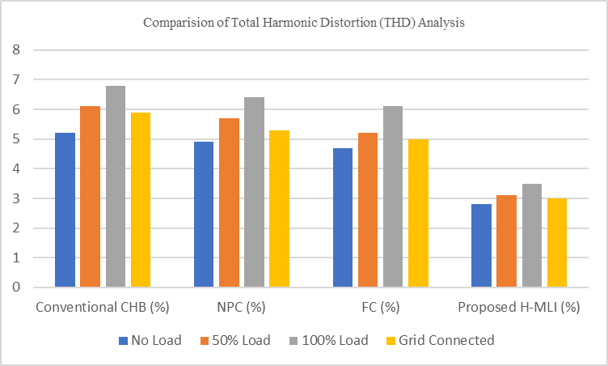
The output voltage quality of the suggested topology is better than that in conventional installationss:

Fig.1. shows the comparison of the total harmonics distortion

Efficiency
Efficiency measurements evidenced the benefits of the proposed topology: in reducing conduction and switching losses via improved control techniques, it was possible to achieve better efficiency with the design.

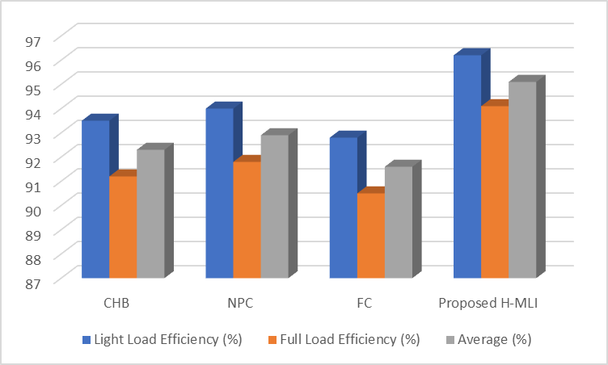
Fig.2. shows the efficiency of the various system
Comparative simulations under comparable conditions show that the proposed multilevel inverter achieves 5-7% efficiency improvements over conventional multilevel inverters.

Flexibility and Scalability
Hybrid architecture is one that supports both symmetrical and asymmetrical configurations: it is able to offer flexible solutions suitable for several application requirements. Therefore, increased versatility.
TABLE II : COMPARISON OF THE VARIOUS SYSTEM
Application | Key Requirement | Performance with Proposed H-MLI | Suitability
Grid-Connected Inverters | Low THD (<5%), High Power Factor | THD = 3.0%, PF ≈ 0.99 | Highly Suitable
Electric Vehicles | Compactness, High Efficiency | 25–30% fewer devices, 95% efficiency | Highly Suitable
Renewable Energy (Solar/Wind) | Flexible DC sources, Reliability | Symmetrical/Asymmetrical operation validated | Suitable
Industrial Drives | High Power Quality, Reliability | Voltage ripple <2.5%, High robustness | Highly Suitable
UPS/Smart Grids | Low Distortion, Continuous Operation | Stable performance under dynamic load | Suitable

Scalability ensures that with little change to the design, altered voltage and power levels can be accommodated.
This comparative study convincingly cites network topology for improved performance and cost-effectiveness, thus presenting it as an ideal alternate for the next generation of power electronics conversion systems. 4.1 In Number of Elements The proposed topology uses about 30% less power electronic components as compared to classical cascaded H-bridge inverters.
In depth comparison concerning the aforementioned topology against the traditional multilevel inverters like the CHB, DC, or FC topologies were carried out concerning some parameters. The number of outcomes considered comparison parameters includes number of components, output voltage levels, THD, efficiencies, scalabilities, and costs.

cONCLUSIONS
The proposed in this paper research of new hybrid multilevel inverter topology successfully overcomes problems of intrinsic higher component count with intricate control of MLI systems conventional. It minimizes the size of suggested power electronic components while having good performance due to the simultaneous use of H-bridge cells together with auxiliary circuitry and both configurations-symmetrical and asymmetrical DC source. Experimental results in comparison with conventional topologies indicate that the harmonic distortion is much less, usually below 3% for the symmetrical configuration and below 5% for the asymmetrical configuration; both of these values fall well under the IEEE 519 standard. Furthermore, the topology has been found to be very efficient with a reported increase of 5-7% compared to flying capacitor, diode clamped, and cascaded H-bridge inverters. The modularity of the circuit is amenable to scaling to higher voltage and power levels; in that regard, it is appropriate for a wide range of applications including grid-connected inverters, electric vehicles, and renewable energy systems. By combining advancement in technology with multilevel inverter topology, the proposed hybrid MLI topology offers a reliable, cheaper, and efficient solution for today's power conversion systems.

References
- Park S, Jang DS, Lee D, Hong SH, Kim Y. Simulation on cooling performance characteristics of a refrigerant-cooled active thermal management system for lithium ion batteries, Int. J. Heat Mass Transfer. 135 (2019) 131–41.
- Luo W, Li H, Chu T, A numerical study of battery thermal management system with square spiral ring-shaped liquid cooling plate, Thermal Science and Engineering Progress. 45 (2023) 102120.
- Bao Y, Shao S, Numerical study on ultrathin wide straight flow channel cold plate for Li-ion battery thermal management, J. Energy Storage. 64 (2023) 107263.
- Kumar, Y., Enhanced performance of photovoltaic systems with LUO converter and modified P and O tracking algorithm. In Applications of Mathematics in Science and Technology (pp. 852-856). CRC Press.
- A.D. Tuncer, A. Khanlari, A. Sozen, E.Y. Gürbüz, H.I. Variyenli, Upgrading the performance of shell and helically coiled heat exchangers with new flow path by using TiO2/water and CuO–TiO2/water nanofluids, Int. J. Therm. Sci. 183 (2023) 107831.
- Liu S, Liu Y, Gu H, Tian R, Huang H, Yu T, Experimental study of the cooling performance of γ-Al2O3/heat transfer fluid nanofluid for power batteries, J. Energy Storage. 72 (2023) 108476.
- Husam Abdulrasool Hasan, Hussein Togun, Azher M. Abed, Naef A.A. Qasem, Aissa Abderrahmane, Kamel Guedri, Sayed M. Eldin, Numerical investigation on cooling cylindrical lithium-ion-battery by using different types of nanofluids in an innovative cooling system, Case Studies in Thermal Engineering. 49 (2023) 103097.
- Bai F, Chen M, Song W, Yu Q, Li Y, Feng Z, Ding Y. Investigation of thermal management for lithium-ion pouch battery module based on phase change slurry and mini channel cooling plate, Energy. 167 (2019) 561–74.
- A. Badhoutiya, "Evaluation of charging power levels in different Hybrid Electric Vehicles," 2023 International Conference on Innovative Computing, Intelligent Communication and Smart Electrical Systems (ICSES), Chennai, India, 2023, pp. 1-6, doi: 10.1109/ICSES60034.2023.10465562.
- Wu W, Yang X, Zhang G, Chen K, Wang S. Experimental investigation on the thermal performance of heat pipe-assisted phase change material based battery thermal management system, Energy Convers Manag. 138 (2017) 486–92.
- Yang H, Li M, Wang Z, Ma B, A compact and lightweight hybrid liquid cooling system coupling with Z-type cold plates and PCM composite for battery thermal management, Energy. 263 (2023) 126026.
- Kumar, Y., 2024, February. Comparative Study of Several Topology for PV-Based Inverters. In 2024 3rd International conference on Power Electronics and IoT Applications in Renewable Energy and its Control (PARC) (pp. 227-231). IEEE.
- Liu Z, Xu G, Xia Y, Tian S, Numerical study of thermal management of pouch lithium-ion battery based on composite liquid-cooled phase change materials with honeycomb structure, J. Energy Storage. 70 (2023) 108001.
- Dixit, K.K., Yadav, I. and Maurya, S.K., 2020, December. Performance based panel sizing and area requirement of solar PV panel at different locations using PSIM. In 2020 IEEE International Symposium on Sustainable Energy, Signal Processing and Cyber Security (iSSSC) (pp. 1-6). IEEE.

