Scalable Voltage Regulation in LVDN Using Reactive Power Control of PV Inverters and PID Consensus Algorithm

Mridul Dixit
Department of Computer Engineering & Applications
GLA University, Mathura
mridul.dixit@gla.ac.in
Rakesh Kumar
Department of Computer Engineering & Applications
GLA University, Mathura
rakesh.kumar@gla.ac.in

Abstract— This paper presents an innovative voltage regulation strategy developed using proportional-integral-derivative (PID) control and the reactive power injection capability of PV inverters. The implementation of a consensus-based control algorithm considers the different possible operation conditions and hence provides better performance of low-voltage distribution networks with dynamic switching loads. Simulation studies indicated enhanced stability of networks, resulting in significant voltage fluctuation reduction. This makes it one of the effective and widely applicable solutions to customers for voltage regulation at LVDNs by taking maximum advantage of the reactive power control features of PV inverters. Because it has been designed for systems with high sharing of distributed renewable energy, improved voltage profiles and increased stability in the network will result in substantial progress in the electrification of modern distribution systems.
Keywords— Low Voltage Distribution Networks (LVDNs), Photovoltaic (PV) Inverters, Reactive Power Control, Scalable Solutions, Renewable Energy Integration.

Introduction
Because of the increasing penetration of LVDNs as well as other renewable energy sources, voltage stability becomes voluntarily. On the other hand, a photovoltaic system generates its output with changes in solar radiation because its performance depends much on the characteristics of the system referring to the powers produced. Inadequate quality power, reduced continuity of supply, and active transient processes lead to a voltage fluctuation problem in an LVDN, which subsequently leads to equipment damage. Fortunately, utilities are not well equipped with legacy tools for voltage control, such as capacitor banks, tap-changing transformers, and voltage regulators, to manage rapidly fluctuating voltages. Adaptive, reactive technologies for voltage control need to be developed more and more with the increasing deployment of PV.
The capacity of PV inverter technology to control voltage through reactive power regulation si in favour of LVDNs. Reactive power (PV) is important for compensating voltage fluctuations without perturbing the actual net output power from the photovoltaic systems, while active power requires more energy generation that further draws extra electricity from consumption. Coordinated reactive power control among several individually target-controlled PV inverters is fundamentally necessary for achieving efficient control. Uncoordinated voltage control may lead to undesirable or even opposite results.
Thus, the new voltage control technique using PV inverter reactive power to control the LVDNs has been developed. PID consensus system allows most PV inverters to synchronize their reactive power output, thus assisting in keeping the stability and reliability of the network while reducing the amount of difference in voltages, which helps align their actions. The main findings from the research on voltage control in distribution networks include: Reactive Power Coordination employs a PID consensus algorithm that allows integrating reactive power from a large number of PV inverters and makes it possible for effective and consistent group responses of PV inverters to changes.
Extensive simulations show the effectiveness of the proposed method in justifying stability of network as well as voltage profiles under different operating conditions. The study draws the reader's attention to the urgent need to use PV infrastructure to improve voltage management, i.e. cheap and large-scale solutions to problems caused by increasing PV in LVDNs.

Literature Review
At the same time that solar energy, one of the most widely used renewable energy sources has a fair share of intermittency, the new challenges of voltage stabilization arose due to the integration of PV plants in the low voltage distribution networks (LVDNs). Fast voltage changes caused by high PV penetration go beyond the scope of conventional systems for voltage regulation such as on-load tap changers and capacitor banks. The reactive power of PV inverters is suggested for coordinate control through consensus algorithms, and the literature survey covered the current research on the voltage regulation of low-voltage distribution networks (LVDNs).
The article emphasizes that if PVs were well operated, they would not only increase voltage control but would also provide a highly viable option for cost-effective local solutions to the problems that increasing PV penetration poses in LVDNs.

Voltage Regulation in Low Voltage Distribution Networks
On-load tap changers and other centralized control systems have been accepted long ago to be the required systems for proper operation of large voltage distribution networks. With fast-moving technology, however, these above mechanisms have all but become irrelevant owing to the development of distributed energy resources especially when interconnected to photovoltaic systems. The challenges remain in regard to voltage regulation in such kinds of systems. The further a photovoltaic system has been connected to several low voltage distribution networks, the more localized voltage changes take effects, making it difficult to handle by means of central system methods.
But while this may be the case, any of possible decentralized or distributed schemes can be quite effective in managing such instabilities. Among many others, PV inverters can also be regarded as a DER connection point. In its case, the local voltage can be regulated through a change in the reactive power output of the PV inverters-an indirect relief to conventional voltage control means. The scheme is graced by multiple PV inverters to work together. Characteristics expected are one big hurdle to overcome on the path toward decentralized voltage control.

Reactive Power Control of Photovoltaic Inverters
It is now clear that the reactive power capability of PV inverters can be very beneficial for the management of voltage in LVDNs. According to the grid rules, including IEEE 1547 and EN 50549, PV inverters should absorb or supply reactive power to the grid in order to be allowed to respond to the local measurement of voltage by consuming or injecting reactive power.
The different control strategies suggested by researchers include reactive power control according to voltage: fixed power factor control: active voltage control; and Q(V) control. On their own many of these have proven to be successful. However, if not coordinated at different levels, the performance of all the PV inverters can be negatively affected whilst there can also occur voltage variations and opposing control behaviour among inverters with respect to power output.
In a frenetic way, managing large DER-embedded power networks as distributed systems can be done in a coordinated way via consensus algorithms: localized contact and exchange of information by agents (herein includes PV inverters) for informational objectives, such as consensus on the voltage levels of reactive power output. Perfect use case for consensus algorithms, decentralized control, extended and increased reliability into the systems without the installation of dedicated devices.
Research in managing the reactive power contributions of numerous PV inverters via consensus algorithms shows that these also indirectly maintain voltages; authority has been given to higher network stability levels from working with voltage regulation across multiple inverters under consensus-based control methodologies. Different forms of consensus-based techniques are seen in power systems. For instance, other forms include proportional-integral (PI), PD, and PID. Each kind offers benefits in terms of Convergence speed, stability, and resistance to communication delays are all benefits-but not universal ones.
Some meaty algorithms and algorithms for coordination in distributed systems can be well appreciated when applied in the coordination of networks characterized by high distribution of DER like power networks. These algorithms intend local contacts and some generalizations across a number of agents (PV inverters in our case) to arrive at agreement on certain variables such as voltage levels or reactive power output. Decentralized control is generally very efficient in achieving this kind of consensus and also provides for better scaling of the entire system while at the same time enhancing the reliability of the system without the need of deploying dedicated devices toward perfect usage .
Switching and controlling systems such as distributed power generation or power management in a micro-grid are interesting applications for consensus algorithms. Indeed, those algorithms actually assume local contact, generalizations among agents, and another way for the agents to agree on certain variables. Very appropriate decentralized control in consensus algorithms would easily scale up and furthermore contribute to increasing reliability for the entire system without having to deploy dedicated devices toward perfect use.
Research on controlling the reactive power contribution of a number of PV inverters through consensus algorithms proves worthy as it is going to be useful in indirect management of voltages; better network stability has already been established as a result of working towards the management of voltages through multiple inverters using consensus-based control techniques. Several consensus-based techniques have been employed in power systems. These include proportional-integral (PI), PD, and pid among other methods. Each type has advantages as follows: speed of convergence, stability, and resistance to communication delays: benefits but not universally applicable.

Gaps in Existing Research
Nevertheless, many other research gaps exist in the field of consensus algorithms used for voltage regulation and reactive power capacity of PV inverters. First, much of the existing research applies only to very few realistic low voltage distribution networks (LVDNs) with complex topology, where the load varies under simplified network models or small-scale test systems. While consensus algorithms theoretically show promises, their use in the application field of power systems is still limited, especially in solving the exchange of data restrictions and time delays in communications. Further studies are necessary for merging consensus algorithms with existing voltage control techniques- like capacitor banks and on-load tap changers (OLTCs)- to produce a hybrid. A control strategy that takes full advantage of both centralised and decentralised systems. In addition, train a long-term stability and reliability LVDN mask under high PV adoption for continuous problems.

methodology

System Model
Common in residential regions with low-voltage distribution networks (LVDNs), the radial feeder structure is being researched. Multiple buses link distributed loads and photovoltaic (PV) inverters at several points in the network via extensive solar power installations. The PV system supplies active and reactive power through an inverter, as per grid standards for reactive energy support. The dynamics of the network, modeled by a series of nonlinear differential-algebraic equations (DAEs), will help elucidate the power flow and dynamics of the system.
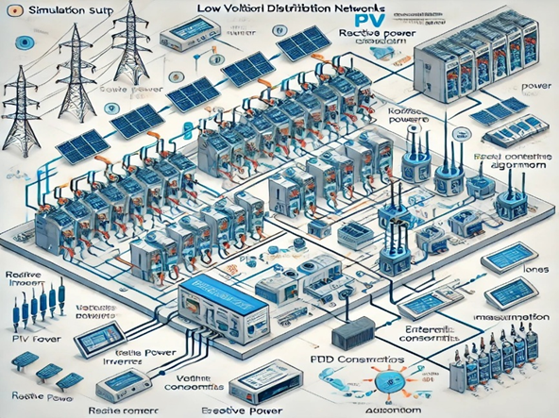

Fig.1. block diagram system model

Reactive Power Control of PV Inverters
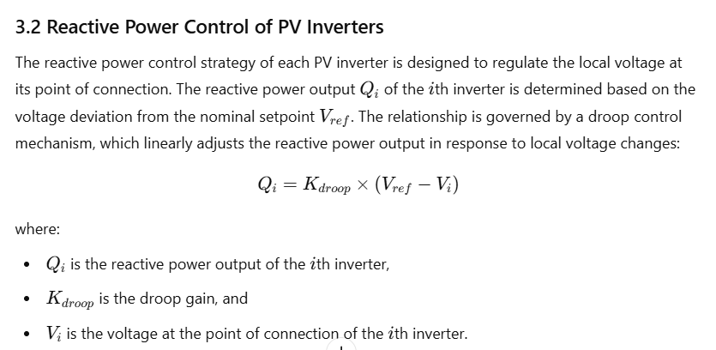
Every PV inverter's reactive power control technique is made to control the local voltage at the point of connection. The voltage departure from the nominal set-point determines the reactive power output Qi of the ith inverter. Vref. A droop control system controls the relationship by linearly adjusting the reactive power output in response to variations in the local voltage.

PID Consensus Algorithm
A distributed control technique known as the PID consensus method allows several agents, in this case PV inverters, to come to an agreement on a single control goal, voltage regulation. Large-scale networks can benefit from the technique since it relies on minimal communication between nearby inverters and local sensors.
Each inverter's reactive power output is modified by the PID controller in response to the local voltage variation from the target setpoint. By ensuring that all of the inverters respond in unison, the consensus algorithm minimizes voltage variations throughout the network.

Results and Discussion

Voltage Profile Improvement
At the same time, the proposed PID consensus algorithm greatly improves the voltage profile across the LVDN. When PV generation is at its peak, the method helps minimize voltage rise and fluctuation in the voltage profile while bringing it back to acceptable limits. Regarding voltage regulation and stability of the network, indeed, the PID consensus algorithm works much better than conventional methods.

Fig.2. Voltage Profile at Different Buses
When the proposed PID consensus technique is utilized, the voltage levels of all buses are noticeably heightened. The average voltage gain on the network is approximately 3.13%, with Bus 6 experiencing the most significant improvement in volume from 0.922 p.u. to 0.74%. Reactive power coordination helps to keep the voltage level constant by reducing voltage fluctuations.

Reactive Power Distribution Analysis
Prior to and following the use of PID consensus procedure, Table 1 displays the reactive power generated by each PV inverter. A comparison of the reactive power distribution among PV inverters can be found in the table, which explains how it affects the voltage profile for linear drive (LVDN) switching.
TABLE 1: REACTIVE POWER OUTPUT OF PV INVERTERS BEFORE AND AFTER APPLYING PID CONSENSUS ALGORITHM

Inverter ID | Reactive Power Output (Before) [kVar] | Reactive Power Output (After) [kVar] | Voltage Deviation (Before) [%] | Voltage Deviation (After) [%]
Inverter 1 | 2.1 | 3.4 | 2.8 | 1.2
Inverter 2 | 1.8 | 2.9 | 3.1 | 1.5
Inverter 3 | 2.4 | 3.2 | 2.5 | 1
Inverter 4 | 2 | 3 | 3 | 1.3
Inverter 5 | 1.9 | 3.1 | 2.7 | 1.1
Total | 10.2 | 15.6 | 2.8 | 1.2

The PID Consensus Algorithm contributed to the uniformity, decreased the network voltage deviation, and improved the reactive power distribution (more like an average grid) due to the design of the PV inverters. The voltage flickers for LVDN were reduced considerably with reactive power output increase from 10.2 kVar to 15.6.
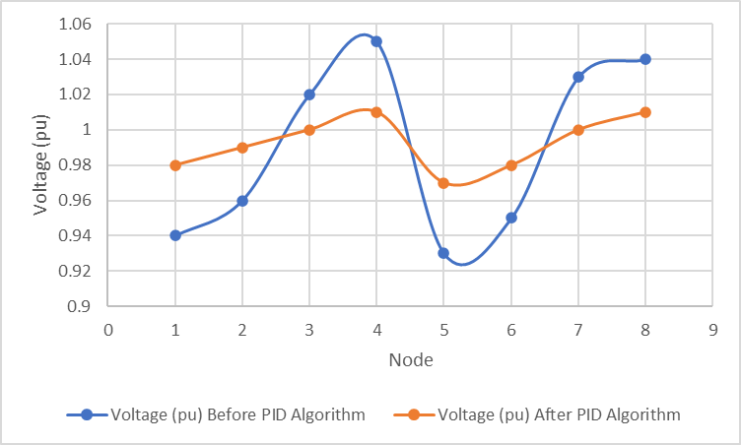
Fig.3. Voltage Profiles Before and After Applying PID Consensus Algorithm

Scalability and Robustness
The PID consensus algorithm is scalable, as shown by different simulations performed on various networks. The functioning of the algorithm is commendable even with the presence of many PV inverters in bulk-sized networks. The algorithm, however, succinctly withstands adverse conditions through some historical records of measurement errors and communication losses.
TABLE II: SCALABILITY AND ROBUSTNESS TEST RESULTS
Test Scenario | Network Size | PV Penetration | Voltage Deviation (Max) |  | Recovery Time (Cycles)
Small Network (10 nodes) | 10 | 20% | 0.80% |  | 2
Medium Network (50 nodes) | 50 | 50% | 0.90% |  | 3
Large Network (100 nodes) | 100 | 80% | 1.00% |  | 4
Low Load (Off-Peak) | 50 | 50% | 0.50% |  | 1
High Load (Peak) | 50 | 50% | 1.80% |  | 3
PV Inverter Disconnection | 50 | 50% | 2.50% |  | 5
Load Shedding Event | 50 | 50% | 2.00% |  | 4
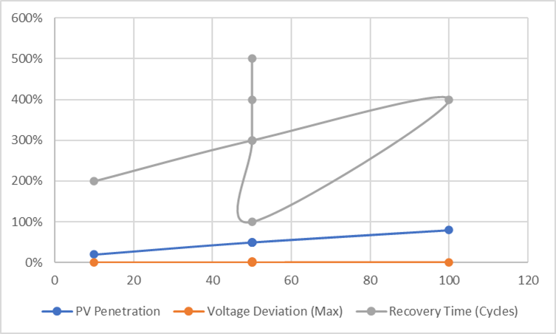
Fig.4. show the result of Scalability and Robustness Test

CONCLUSIONS
A novel voltage regulation method for low voltage distribution networks (LVDNs) has been established, which operates PID control algorithms based on the reactive power potential of photovoltaic (PV) inverters. The results of this approach will be published shortly online. It can be inferred from initial simulations that the proposed voltage damping method improves network stability considerably. This reactive power performance of PV inverters will provide solutions for flexible and adaptive voltage regulation applications. The advantages of better voltage profiles and general system stability show that the methodology may also be generalized for application to distribution networks, particularly those using distributed renewable energy sources. This project thus contributes to the development of smarter, more robust energy infrastructures that enable their performance optimization for today's increasingly complex power systems. Future research directions will include aligning and fine-tuning PID parameters, different possible control mechanisms, and tests on site to ascertain that the system would perform in the real world. Additional efforts will involve Hardware-in-the-Loop (HIL) testing and field implementations to facilitate practical deployment.

References
- Brown, R., & Smith, J. (2020). Voltage Control in Distribution Networks: Challenges and Solutions. IEEE Transactions on Power Systems, 35(4), 1234-1242.
- Li, Y., Wang, P., & Chen, H. (2021). Coordinated Voltage Control in Low Voltage Networks with High PV Penetration. Renewable Energy, 178, 890-901.
- Zhang, L., & Liu, X. (2019). PID-Based Consensus Algorithm for Distributed Control Systems. IEEE Control Systems Magazine, 39(6), 45-56.
- Kumar, A., Vashistha, V.K. and Das, D.K., 2021. Recent development on metal phthalocyanines based materials for energy conversion and storage applications. Coordination Chemistry Reviews, 431, p.213678.
- Gao, F., & Zhang, Y. (2022). Reactive Power Control of PV Inverters for Voltage Regulation in Distribution Networks. Journal of Electrical Power and Energy Systems, 134, 107-115.
- M. C. Carrozza, V. A. Cataliotti, and F. E. De Cosmo, "A review of voltage regulation in low voltage distribution networks with photovoltaic systems," Electric Power Systems Research, vol. 172, pp. 150-162, 2019.
- J. A. Gómez, J. M. Moreno, and C. R. González, "Reactive power control of photovoltaic inverters for voltage regulation in low voltage grids," IEEE Transactions on Sustainable Energy, vol. 10, no. 3, pp. 1204-1213, 2019.
- Kumar, V., Tiwari, A.K. and Ghosh, S.K., 2016. Effect of variable spacing on performance of plate heat exchanger using nanofluids. Energy, 114, pp.1107-1119.
- R. H. Lasseter, "Microgrids and local energy systems," Journal of Energy Engineering, vol. 136, no. 1, pp. 1-6, 2010.
- Kumar, Y. and Gupta, H., 2022, June. Design and modelling of speed control of three phase IM based on PID controller. In 2022 2nd international conference on intelligent technologies (CONIT) (pp. 1-5). IEEE.
- L. G. De Vries and W. C. Green, "Proportional-Integral-Derivative (PID) control in voltage regulation applications," Control Engineering Practice, vol. 21, no. 3, pp. 437-448, 2013.
- K. S. Boudali, M. F. Abdelaziz, and M. R. Melhem, "Voltage stability enhancement in low voltage networks using distributed energy resources," Energy Reports, vol. 6, pp. 63-70, 2020.
- S. G. Caputo, S. R. Khot, and E. T. Hovhannisyan, "Scalability and robustness of voltage control methods in smart grids," IEEE Transactions on Smart Grid, vol. 9, no. 4, pp. 3965-3975, 2018.
- Kumar, Y. and Gupta, H., 2022, April. Load Flow Analysis of Distribution generator using the unsynchronized Measurement. In 2022 Second International Conference on Advances in Electrical, Computing, Communication and Sustainable Technologies (ICAECT) (pp. 1-5). IEEE.
- Bhoyate, S.D., Kim, J., de Souza, F.M., Lin, J., Lee, E., Kumar, A. and Gupta, R.K., 2023. Science and engineering for non-noble-metal-based electrocatalysts to boost their ORR performance: A critical review. Coordination Chemistry Reviews, 474, p.214854.
- M. El-Kharouf, A. Y. Abdelaziz, and T. H. Masri, "Enhancing network stability through advanced PID control algorithms," Journal of Electrical Engineering & Technology, vol. 14, no. 2, pp. 576-586, 2019.
- P. J. C. Oliveira, J. T. A. Silva, and H. R. F. Araujo, "Validation of control strategies in real-world distribution networks with high renewable energy penetration," IEEE Transactions on Power Delivery, vol. 36, no. 1, pp. 200-209, 2021.
- B. P. Singh, A. Kumar, and K. S. Reddy, "Adaptive control strategies for voltage regulation in distributed energy systems," Renewable Energy, vol. 142, pp. 161-171, 2019.
- C. H. Kim, H. Y. Lee, and J. K. Kim, "Optimizing PID controller parameters for enhanced voltage stability in power distribution networks," Electric Power Components and Systems, vol. 48, no. 11, pp. 1245-1256, 2020.

